Design and implementation of Smart Home

Joshua Batchelor – P1802076

ACDA5005 - Smart & Connected Devices I

Dr Kapilan Radhakrishnan

Table of Contents
Task 1 – Research 3
Thermostats 3
Hive [2] 3
Tado [5] 4
Smart Doorbells 6
RING Doorbell 2 [6] 6
Arlo video Doorbell[7] 7
Smart CCTV 8
Arlo Pro 2 CCTV [8] 8
Swann Smart CCTV[9] 9
Security Risks 10
Task 2 – Implementation 10
References 11

Figure 1 - SMART Devices Concept 3
Figure 2 - Hive Thermostat 3
Figure 3 - Tado Thermostat 4
Figure 4 - Tado Thermostat Services 4
Figure 5 - RING Doorbell 6
Figure 6 - Arlo Doorbell 7
Figure 7 - Arlo Smart CCTV 8
Figure 8 - Swann Smart CCTV 9
Figure 9 - SMART Home 10

Task 1 – Research

In 2011 Cisco predicted that 50 billion Internet of Things would be connected to the internet by 2020[1]. The SMART devices are proliferating across all sectors and becoming an marketplace weapon, as how beneficial these devices are to both internal and external industries across the world[1]. These SMART devices have the capability to adapt to change based on the different operation changes that happen overtime. All SMART devices have a backbone network that they sit on to require to operate. This requires a constant internet connection, so the devices can constantly communicate with the servers within the backbone of the network.
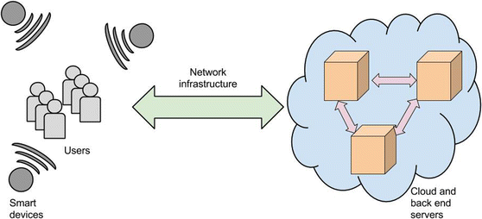
Figure 1 - SMART Devices Concept

Thermostats

Hive [2]
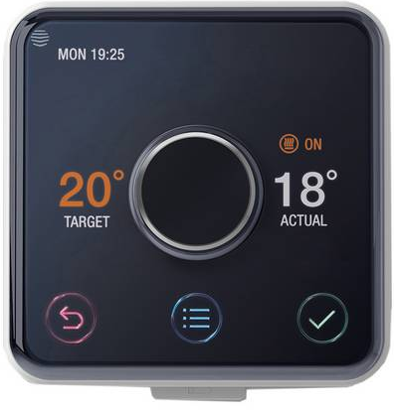
Figure 2 - Hive Thermostat

What is Hive
Hive is a smart thermostat that is connected to your boiler or central heating system. This will enable the users to turn on and off the heating instead of going to the thermostat and manually edit the current status of the thermostat[3]. This type of smart thermostat will allow the users to control what time they want the heating to turn on and they can enable this by using a smartphone if they have got an internet connection. By using this smart thermostat, you do not need your heating on all day, as Hive allows the user to pick a time schedule that turns on / off the heating at certain times. The Hive system allows smart speakers to connect to it such as Amazons Alexa and Google Home. This enables the users to interact with the Hive system through a range of speech instructions[2]. Hive also has the capabilities to connect to light bulbs to change the mood of the occasion. Hive also offers smart security systems such as smart cameras or motion sensors to be connected and controlled through Hive.
Benefits of Hive
- Turns on / off the heating at time schedule – saves money
- Allows the user to connect other smart devices to the system
- British gas states that you can ‘Save up to £120 a year’ on gas if you have a Hive smart meter installed[4]

Tado [5]
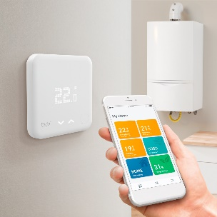
Figure 3 - Tado Thermostat

What is Tado

Tado is a smart thermostat that allows you to control your boiler without going to a physical thermostat to change the temperature. This type of smart system allows you to control your boiler or each of your rooms by downloading the Tado App, which then lets the users to customize the temperatures for each of the rooms or to adapt the boiler temperature. This can be done through the app. The Tado smart system does not just have the capability to connect to the internet. It also adapts to your behaviours to make sure that you have the right room climates. This smart system works with Apple Homekit, Google Assist, Alexa and eNet.

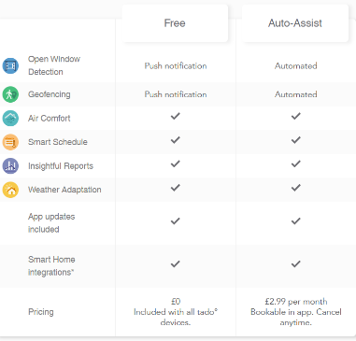
Tado offers two types of services with its products. You have the free version which gives the users the basic functionalities to control the boiler. Which will then send you notifications to update the users. The other paid service controls the operations automatically, so the users do not need to operate the controls as the system will change the settings when needed to such as when the there’s nobody in the house it will lower the heating as there’s no one in. By doing this it will save money as the household is not burning gas when it’s not needed to[5].
Figure 4 - Tado Thermostat Services

Benefits of Tado
- Allows the users to control the thermostat at any time even outside of the house
- The Tado system will learn the user’s actions to adapt for further actions that will be taken
- The Tado device will automate the tasks for the users such as lower the temperature when people leave the house. This is a big benefit as this will help to save energy and save money on bills

I think that both thermostats are great smart devices to include into your home surroundings. As this type of smart device is the most beneficial to you as you can set your thermostat in a remote location before you get home. I think that the Tado system is the better smart thermostat to use because the Tado system offer more beneficial features such as it adapts to your actions that you take. The Tado system offer two types of services that will give the user two different options. As the paid service will alter the temperatures for the user such as when you leave the house it will lower the temperature as there is nobody home. This will benefit as the heating will still be on, but it will save money as its burning energy that does not need to be used, as the household is empty. Personally, I would pick the Tado thermostat as it gives the users more functionality/features that can be used.

Smart Doorbells

RING Doorbell 2 [6]
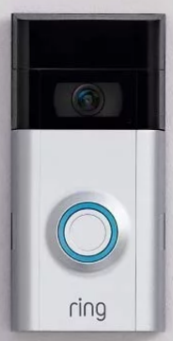
Figure 5 - RING Doorbell

What is RING Doorbell 2
RING Doorbell 2 is a smart doorbell that notifies you when somebody is at the door. Once the person presses the button it allows you to see who is at the door as it has got a built-in camera and microphone. It allows you to speak to the people as it notifies you through a phone notification. This smart doorbell has a 1080p camera which can be used in the day or in the night as the camera has also got infrared night vision. The doorbell can either be hard wired into the wall or the doorbell can be running of battery powered. The RING doorbell also offers a package called RING Protect. This service allows you to record, save and share your recordings that have been saved on the RING cloud. Also, it is easy to install.

Benefits of RING Doorbell 2
- The RING doorbell allows you to see who is at the door by using your smartphone
- RING doorbell allows you to save your recordings and share them if needed
- Overall, the doorbell adds extra security to your home

Arlo video Doorbell[7]
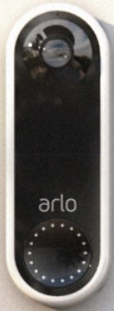
Figure 6 - Arlo Doorbell

What is Arlo Smart Doorbell
The Arlo video doorbell is a smart doorbell that is designed to capture video data through the build in camera. This doorbell offers one to one communication using notifications that pop up on your smartphone when somebody presses the doorbell. It allows 180֯ recording which can be made day or night as the camera on the doorbell has got night vision. The Arlo Doorbell is fully waterproof and can be hard-wired to the electric board to get constant power. The doorbell has a feature that allows you to trigger an alarm siren at a certain event period. This can be done remotely. The Arlo smart doorbell has a cloud storage platform called Arlo Smart. This cloud platform allows you to view saved camera footage and has a feature that calls your friend if the alarm goes off.

Benefits of Arlo Smart Doorbell
- Has an alarm deterrent system that can be activated
- The camera records in a 180֯ radius
- Adds extra security to your home

I think that these two smart doorbells have similar features that make them similar in certain areas. I think that the RING doorbell has a better camera than the Arlo doorbell. So, the RING doorbell will give a clear picture of the footage than the Arlo camera. The RING services will be beneficial as the RING Protect provides more features than Arlo’s smart cloud service that just provides cloud storage for the footage. The RING Protect service can provide services to all your RING smart devices. Arlo smart service only gives you services up to 5 devices. I personally would go for the RING doorbell as I think that you will get more features through the RING Protect and it provides you will more smart devices that can be connected to the RING Protect app.

Smart CCTV

Arlo Pro 2 CCTV [8]
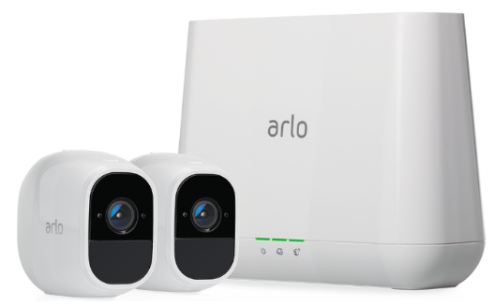
Figure 7 - Arlo Smart CCTV

What is Arlo Pro 2 CCTV
Arlo Pro 2 is a smart CCTV system that gives you true flexibility. This smart system will give you 1080p camera quality with crisp HD picture. This CCTV system will allow you to highlight certain areas which you want to know when somebody is within that area. So, the activity zones feature will alert you through a notification through sound alerts when somebody is in that active zone. This will let you know when people are in the activity zone areas. With this CCTV system you have got the option to have the CCTV to only record when it sees motion, or you can enable the cameras to continually record on a 24/7 basis. The Arlo CCTV system has a flexible powering options, as you can run the cameras off rechargeable battery packs which can be recharged, or you can plug the cameras into power sockets to receive advanced options. The cameras are IB-45 certified which means they are waterproof, cold proof and sun proof. The cameras have a 2-way communication system as you can talk and listen through the camera by using your smartphone. The cameras will adapt to dark climates as the cameras have night vision. The base station has the capability to add extra backup storage through USB local backup memory that can be added. This system can also be controlled through smart AI technology[8].

Benefits of Arlo Pro 2
- Records footage in 1080p
- Allows you to have optional recording options
- Captures footage 3 seconds faster to see the footage from start to finish
- Allows users to have 2-way communication through the cameras
- Allows local external backup storage
- Works with AI technologies

Swann Smart CCTV[9]
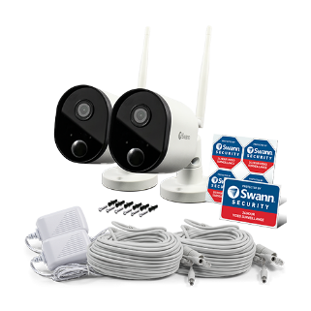
Figure 8 - Swann Smart CCTV

What is Swann Smart security camera
The Swann security camera is a smart CCTV system that is used over your household internet. This camera system records in 1080p picture quality. This makes sure that the footage will be taken as clearly as possible day or night. The cameras are fitted with a heat sensor which will pick up heat from a person’s body and it will alert you if heat was detected. The camera system can be connected to the internet over a wireless connection or a wired connection. This will eliminate the use of a hub or DVR. The cameras are fully weatherproof making sure it withstands all types of weather conditions. The cameras have got built in memory which will hold up to 7 days of short clips and all the rest of the footage will be saved on the cloud storage that is available. This will make sure that the clips are available for 30 days instead of just 7 days. This smart camera system will also allow AI Technologies to communicate from the user to the CCTV system.

Benefits of Swann Smart security camera
- The main benefit is that this smart CCTV system does not need a hub or DVR box and connects straight to the internet
- The cameras on this system have a heat sensor to detect motion and notifies you if human heat is detected
- Swann app lets you to connect multiple Swann devices to the same network of smart devices

These two Smart cameras have similar functionalities that makes these cameras so beneficial. There are some advantages about each individual smart system that makes that system more appealing than the other CCTV system. The advantages about the Swann CCTV system is that the individual camera will connect straight to the internet router, so it does not need hub or DTV box in-between to connect the cameras to the internet. The Swann cameras also have a heat sensor fitted, which will source any heat that will be created by any humans or animals. The heat sensor will only report back human detection from the amount of heat that is detected. It will not report any other heat detection such as animals. All the footage will be stored remotely for the users to access. The advantages about the Arlo Smart CCTV system is that the system allows you to record in a range of different ways. The cameras will record 3 seconds before the footage happens. This will allow you to capture the full footage. This CCTV system uses a hub to connect the cameras too before connecting to the internet. This allows the users to connect extra external storage, so the system can store more footage over a longer period. The system works with different AI technologies, so the users can instruct the system do certain tasks at different times. This makes this system more user friendly as the users can use AI technologies to instruct certain tasks. I think that both these CCTV smart systems are beneficial and have similarities and that the other system does not have. I would go for the Arlo system as there is more useful benefits that the Swann system does not have such as records footage 3 seconds before the incident happens.

Security Risks
The smart devices listed above give a big security risk to people’s security and privacy data because people can hack into these devices and control them remotely and collect privacy data that they collect. These smart devices have big benefits to users but also have a big security risk as anybody can access these devices over the internet. It is up to the person if they want to include these smart systems but need to consider the security risks that might arise from having these devices.

Task 2 – Implementation

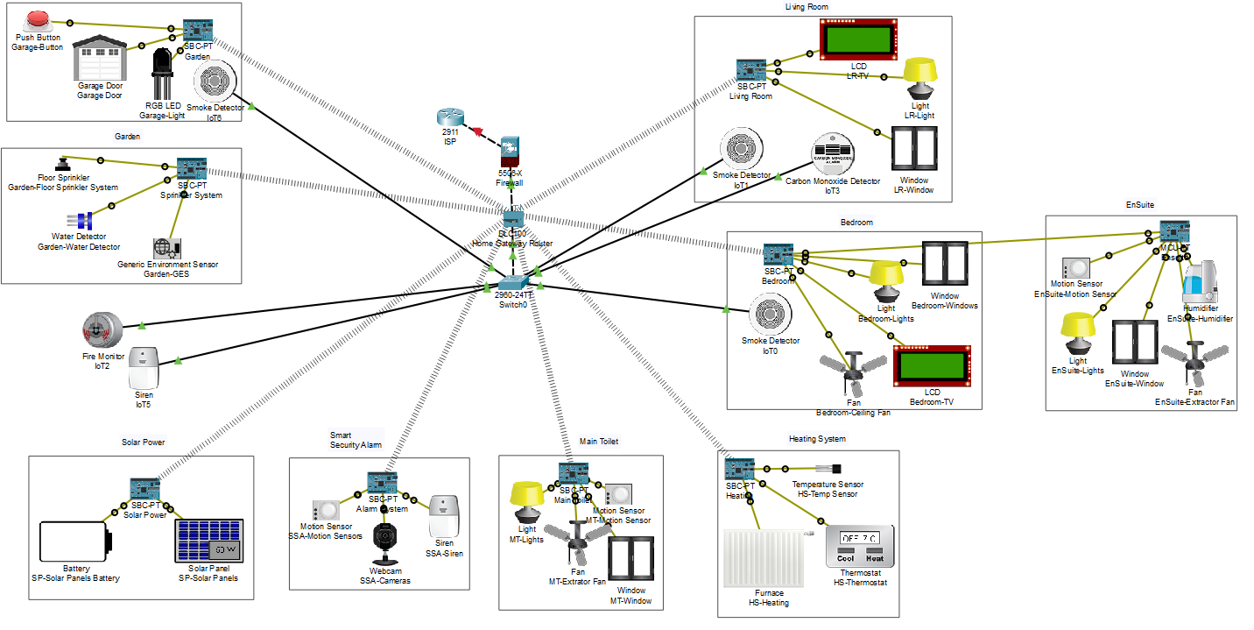
Figure 9 - SMART Home

References

[1] M. Silverio-fernández, S. Renukappa, and S. Suresh, “What is a smart device ? - a conceptualisation within the paradigm of the internet of things,” 2018.
[2] “Hive Active Heating - Smart Hive Thermostat & Heating Control | Hive Home.” [Online]. Available: https://www.hivehome.com/products/hive-active-heating. [Accessed: 09-Apr-2020].
[3] “A Beginner’s Guide to the Hive Smart Heating System | BT Shop Blog.” [Online]. Available: https://shop.bt.com/blog/a-beginners-guide-to-the-hive-smart-heating-system/. [Accessed: 09-Apr-2020].
[4] “Smart Home - Hive active heating - British Gas.” [Online]. Available: https://www.britishgas.co.uk/smart-home/hive-heating.html. [Accessed: 28-Apr-2020].
[5] “The Smart Thermostat for your heating system - That’s how it works! ︱tado°.” [Online]. Available: https://www.tado.com/gb/thermostat-heating. [Accessed: 13-Apr-2020].
[6] “Video Doorbell 2 – Ring.” [Online]. Available: https://en-uk.ring.com/products/video-doorbell-2. [Accessed: 11-May-2020].
[7] “Arlo: Wireless & AC-Powered Security Cameras.” [Online]. Available: https://www.arlo.com/uk/products/arlo-video-doorbell/default.aspx. [Accessed: 14-Apr-2020].
[8] “Rechargeable Wireless Security Camera: Arlo Pro 2 | Arlo.” [Online]. Available: https://www.arlo.com/uk/products/arlo-pro-2/default.aspx. [Accessed: 14-Apr-2020].
[9] “Wi-Fi Outdoor Security Camera 2 Pack UK.” [Online]. Available: https://www.swann.com/uk/swwhd-outcampk2. [Accessed: 11-May-2020].

