Responsive Web Design and Development
  - Lecture 9 Lab Tutorial Exercise

Cross-Platform Mobile Development with Apache Cordova and AngularJS

Objectives
In today’s exercise, you will use the Camera plugin API.
Note: This lab exercise is a continuation from the previous exercise.

Exercise 1: Getting Started
- Open up your notes app project.
- First, you need to add the Camera API to your project.
- Double-click on the config.xml file in the www folder.
  - Select the Plugins menu option from the right sidebar menu.
  - Make sure the Core tab is selected from the menu at the top.
  - Scroll through the list of plugins and look for the one called Camera. Click the Add button on the right to add the plugin to your project.
  - When done, close the file.
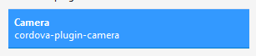

Exercise 2: The Custom Service
- Open up your service.js file and add the following new custom service definition to it.
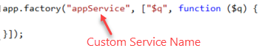
- Next, add the following getPicture method to it. The method accepts one parameter – options, to set the options for the camera.
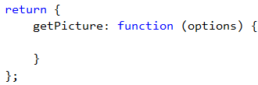
- Add the following steps to the getPicture function.
  - Start an async process using Angular’s $q
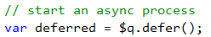
  - Check if the options specified are okay, if not set some default values
// check if the camera options have been specified,
// if not set some defaults
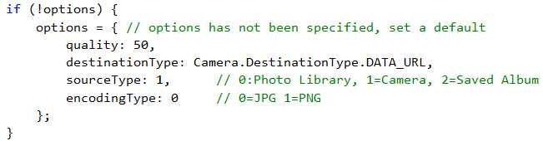
  - Call the camera API’s getPicture function, defining functions for on success and on failure and also pass in the camera options to use.
// call the camera API's get picture method
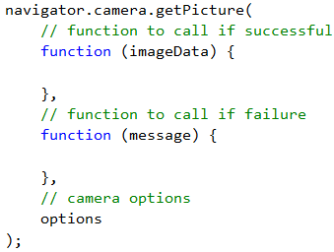
  - Add the following to the success function.
// set the return value for the deferred async promise
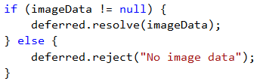
  - Add the following to the failure function.
// unable to fulfil async promise
  - Now, locate the end of the getPicture function and add the following (highlighted box) as the last statement to return the deferred promise.
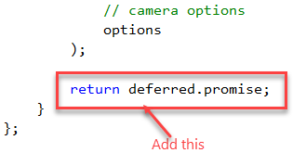
- Save your changes.

Exercise 3: Updating the View
- Open up index.html and replace the existing “<meta http-equiv…/>” with the following line, otherwise the browser will complain when you try and load the camera pictures.
<meta http-equiv="Content-Security-Policy" content="default-src *; style-src 'self' http://* 'unsafe-inline'; script-src 'self' http://* 'unsafe-inline' 'unsafe-eval'" />
- Now, open up your edit view. You need to make a couple of changes.
- Locate the following code.
  - At the moment, it is saying show if the note has a picture (ng-show=”note.Picture”)
  - However, it is also saying hide if the note has a picture (ng-hide=”note.Picture”), so it is contradicting itself.
  - Delete the highlighted ng-hide…
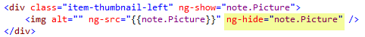
- Save your changes.
- Just after the code in the previous step, you will notice that there are two buttons – one to add a picture and one to change a picture.
- The buttons are supposed to call a capture() function when clicked. You need to define this function in your edit controller.

Exercise 4: Updating the Edit Controller
- Now open up your controller.js file and locate the Edit Controller.
- You need to inject the new custom service (appService or whatever you called yours) created earlier into the controller as shown below (don’t forget the commas):
- Add the following to define the Capture function.
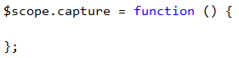
- The following steps should be added to the capture function.
  - First define the options to be used by the camera – modify as you wish.
// define the options for the camera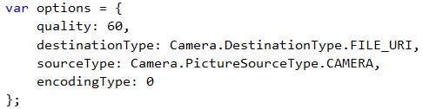
  - Next, call the custom service’s getPicture method passing in the options.
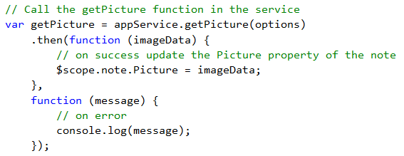
- Save your changes and test.
- Hmmm, did you notice the following:
  - You can only select an image from a file.
  - If you do select an image, it displays as a broken image shown below. If you right-click on the broken image and select “Open image in new tab”, you actually get to see the image.
  - The problems are as a result of the limitations of the Ripple Emulator. Testing on an Android device emulator produces better results.
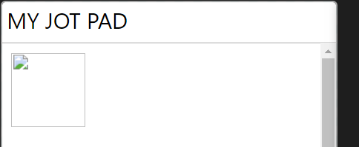
- That’s all for today.

