Hospitality and Guest Services

Module ID: International Hotel Management

Module Code: BMIH4003

Student Name: Constantin Alin Nanu

Student ID:2206483

Lecture's name:Kathryn Flynn

Table of Contents
Introduction 3
Introduction of the hotel Holiday Inn 4
Hotels Targeted customers 4
Nature of the guest's services in the Holiday Inn 4
Scope the guest's services in the Holiday Inn 5
Role of the guest's services in the Holiday Inn 5
Role and functions of the guest services 5
The importance of the hospitality 5
Hotels meet and exceed the expectation of their targeted segment 6
Conclusion 7
References 8

Introduction
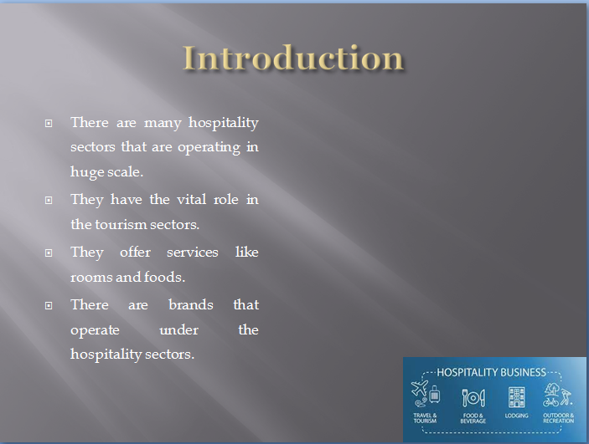
Hospitality sectors operate worldwide. These sectors provide services to their customers who are considered guests. This sector can also be considered a vital part of the tourism sector. The services that are provided by this sector are room facilities for the tourists and also include breakfasts, lunches and dinners. There are many luxury brands and there are also many non-luxurious brands that are operating in this sector. These brands charge their customers according to the quality services that are provided by hotels. Guests can afford this hotel according to their gross incomes that they earn.

Introduction of the hotel Holiday Inn
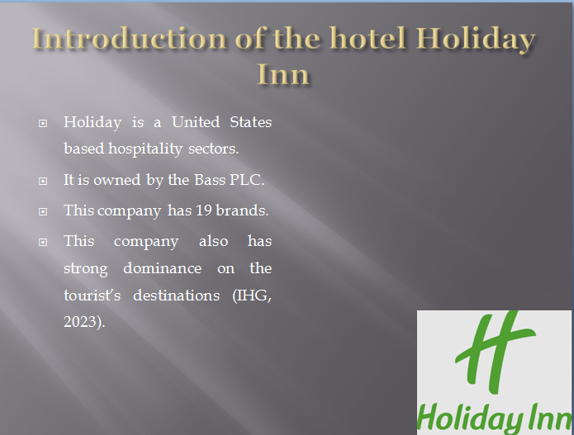
Holiday Inn is actually a United States-based hospitality sector which also has its operation in the United Kingdom (IHG, 2023). This hospitality sector was founded in the late 80s when the “Wilson” decided to open a motel. The founder was disappointed by the poor services of the motels during his holiday with the family. And during the early 90s, this company was bought by the United Kingdom Bass PLC. This happened when Wilson sold his interests to Bass PLC and the company was renamed the Holiday Inn worldwide (Rafahat, 2022). Currently, this company is conducting its operations worldwide and has both hotels and resorts which are named Holiday Inn Hotel suites and Holiday Inn resorts. There are approximately 19 hotel brands that are under this company which are operating in more than 5000 tourist destinations (IHG, 2023). This hotel is operating in more than 99 countries and which are in Europe, North America and also in some parts of Asia.

Hotels Targeted customers
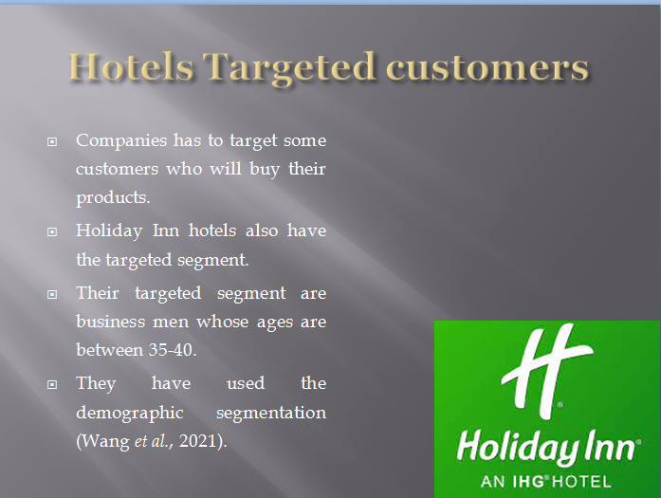
Companies while operating there are certain customers which are targeted (Çınar et al., 2020). These targeted customers will definitely buy the products or services that are provided by the company. And for the Holiday Inn, there are targeted segments which have been determined by this company. They have targeted customers who lie between the ages of 35-40. This means that the customers are targeted through demographic segmentation. This segmentation is used when the company targets its customers through the ages (Wang et al., 2021). The people that lie between these ages are the businessmen who book hotels at the last minute. The services that are offered by this company have forced them to determine their customers according to their ages. This targeted segment is for their hotels and for their hotels they basically target people of every age (Çınar et al., 2020). They want to offer their customers an affordable hotel.

Nature of the guest's services in the Holiday Inn
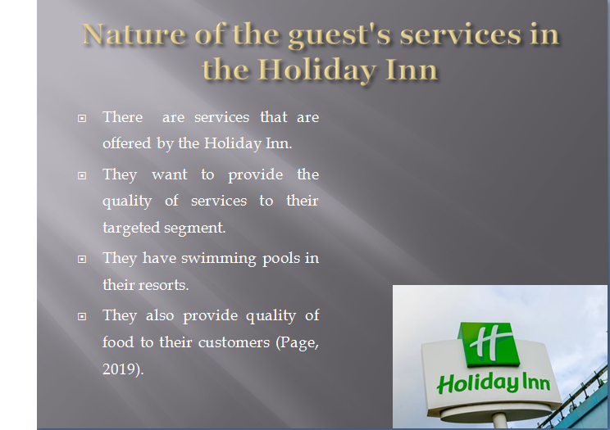

There are many services that are provided by the Holiday Inn. The role of these services is to attract the targeted segment and also to earn profits at the end of the financial year (Page, 2019). They want their customers to enjoy their holidays. They provide an atmosphere which can be fruitful for conducting business meetings. This is due to their targeted segment which has been analysed by the company (Page, 2019). They also have resorts which operate under their brand. They have swimming pool food for the kids and suites which are suitable for the kids. They have restaurants which also provide quality food.

Scope the guest's services in the Holiday Inn
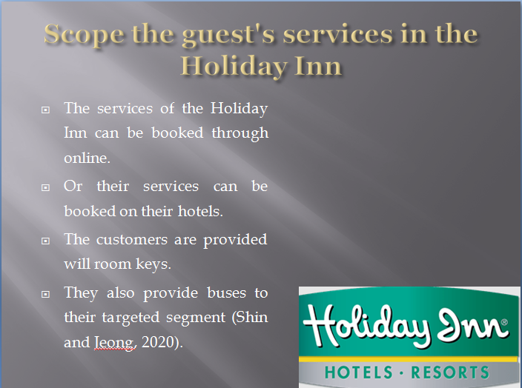
As mentioned above there are many services that are provided by the Holiday Inn. These services can either be booked online or can be booked directly at the hotel by the customers (Shin and Jeong, 2020). The customers who are registered online will get the room keys which are cleaned by the housekeeping departments of the company. The location of the hotels will be provided to the guests online and also about the services that are provided by this company (Shin and Jeong, 2020). This company also provides travelling services, likewise, they have buses which take their guests to the airports and also drive their customers to the hotel location.

Role of the guest's services in the Holiday Inn
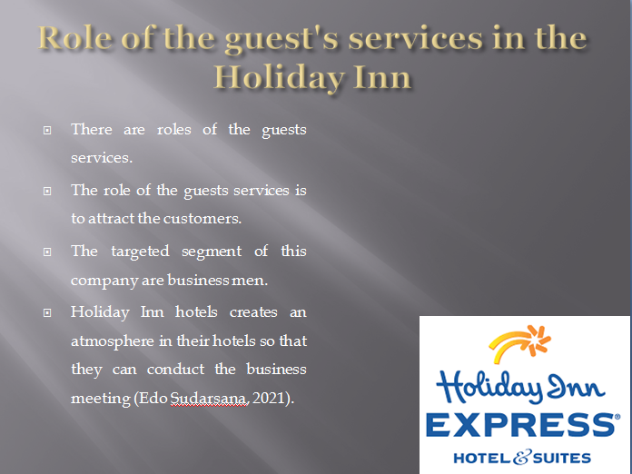

There are many roles of guest services that are provided by the hotels that are operating globally (Edo Sudarsana, 2021). The role of the guest services that are provided by the Holiday Inn is to attract customers and also help the guests at the hotel. They have to provide the details about the services that will be offered by the company. There are specific needs of every guest which must be fulfilled by the Holiday Inn hotels (Edo Sudarsana, 2021). Their targeted segment is the businessmen so they have to create an atmosphere in which they can conduct their meetings in the hotels.

Role and functions of the guest services
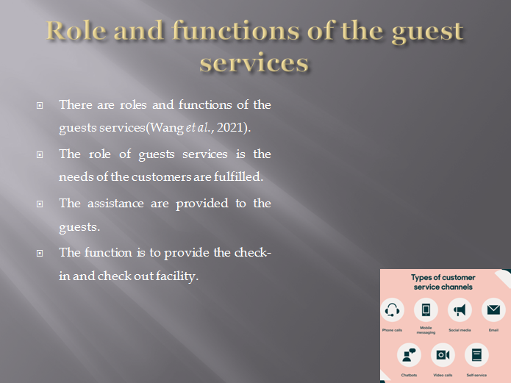
There are various roles and functions of the guest services that are provided by the hotels (Wang et al., 2021). The role of the guest services that are provided by the hotels is to ensure that the needs of the guests are fulfilled (Wang et al., 2021). There are targeted segments of the companies and satisfying this targeted segment is given top priority by the companies. The role of these guest services is to satisfy their customers and also to provide assistance to their customers. The function of these guests’ services is to provide a check-in and check-out facility to the customers also to help the guest in an efficient manner.

The importance of the hospitality
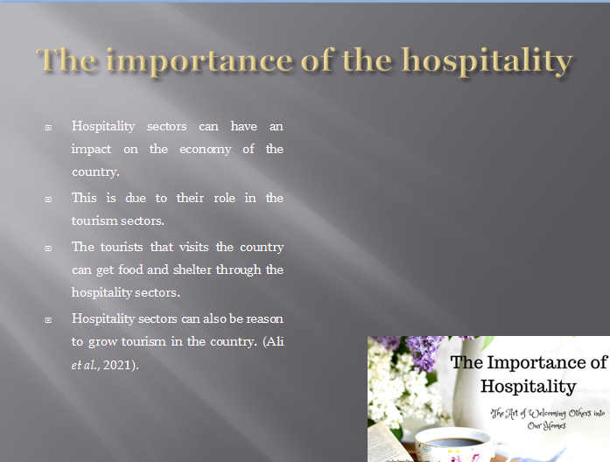
Hospitality sector can have an impact on the economy of the country as they are also a part of the tourism sector (Ali et al., 2021). Tourism sectors have an important role in the development of the economy of the country. And on the other hand, the hospitality sector provides food and shelter for tourists that visit the country during a specific season (Ali et al., 2021). Hospitality in every sector means growth which means that the hospitality sectors have an important role in the growth of the tourism sector.

Hotels meet and exceed the expectation of their targeted segment
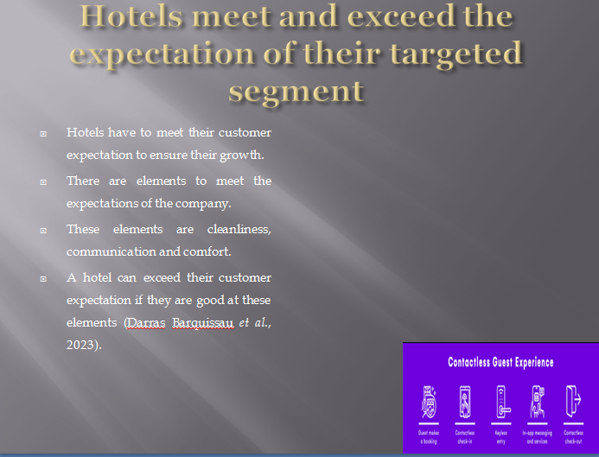
Hotels have to meet the expectations of their customers to ensure the growth of the company. There are mainly three elements which are expected by the customers. These elements help companies to exceed their customer's expectations (Darras Barquissau et al., 2023). The first element is cleanliness, the rooms of the hotels must be clean and this element has been given importance since the pandemic broke out (Chan et al., 2021). The second element is communication; this can be related to communicating with the staff about the hotel services or about the issues that are faced by the company. The last element is comfort which is also considered important (Darras Barquissau et al., 2023). How comfortable the hotel rooms determine the future of the company. Fulfilling these elements can secure the future of the company.

Conclusion
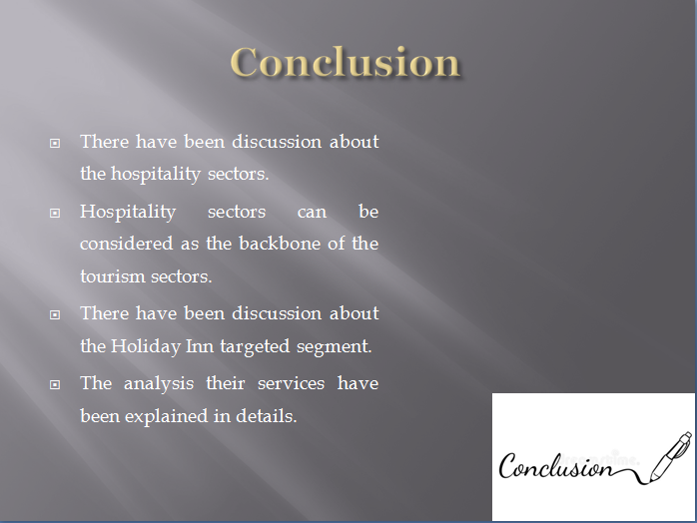In the above report, there has been a discussion about the hospitality sector. The hospitality sectors are the backbone of tourism. They provide their guests with food and shelter and all other services that are necessary for tourists. A particular hotel has been selected for this report. And the services and their targeted segment have been explained in detail. There are discussions about the role, scope and nature of the guest's services provided by the selected hotel. The functions and role of guest services have been explained generally and also about how the expectations of the customers are met.

References
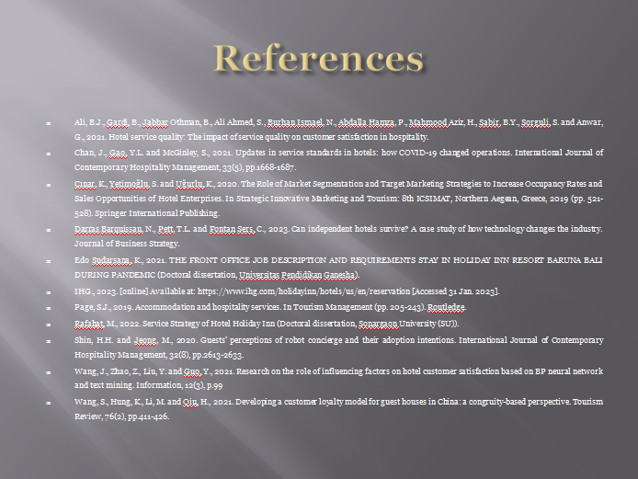Ali, B.J., Gardi, B., Jabbar Othman, B., Ali Ahmed, S., Burhan Ismael, N., Abdalla Hamza, P., Mahmood Aziz, H., Sabir, B.Y., Sorguli, S. and Anwar, G., 2021. Hotel service quality: The impact of service quality on customer satisfaction in hospitality.
Chan, J., Gao, Y.L. and McGinley, S., 2021. Updates in service standards in hotels: how COVID-19 changed operations. International Journal of Contemporary Hospitality Management, 33(5), pp.1668-1687.
Çınar, K., Yetimoğlu, S. and Uğurlu, K., 2020. The Role of Market Segmentation and Target Marketing Strategies to Increase Occupancy Rates and Sales Opportunities of Hotel Enterprises. In Strategic Innovative Marketing and Tourism: 8th ICSIMAT, Northern Aegean, Greece, 2019 (pp. 521-528). Springer International Publishing.
Darras Barquissau, N., Pett, T.L. and Fontan Sers, C., 2023. Can independent hotels survive? A case study of how technology changes the industry. Journal of Business Strategy.
Edo Sudarsana, K., 2021. THE FRONT OFFICE JOB DESCRIPTION AND REQUIREMENTS STAY IN HOLIDAY INN RESORT BARUNA BALI DURING PANDEMIC (Doctoral dissertation, Universitas Pendidikan Ganesha).
IHG., 2023. [online] Available at: https://www.ihg.com/holidayinn/hotels/us/en/reservation [Accessed 31 Jan. 2023].
Page, S.J., 2019. Accommodation and hospitality services. In Tourism Management (pp. 205-243). Routledge.
‌Rafahat, M., 2022. Service Strategy of Hotel Holiday Inn (Doctoral dissertation, Sonargaon University (SU)).
Shin, H.H. and Jeong, M., 2020. Guests’ perceptions of robot concierge and their adoption intentions. International Journal of Contemporary Hospitality Management, 32(8), pp.2613-2633.
Wang, J., Zhao, Z., Liu, Y. and Guo, Y., 2021. Research on the role of influencing factors on hotel customer satisfaction based on BP neural network and text mining. Information, 12(3), p.99
Wang, S., Hung, K., Li, M. and Qiu, H., 2021. Developing a customer loyalty model for guest houses in China: a congruity-based perspective. Tourism Review, 76(2), pp.411-426.

