Demo of PannotinaCo Mobile Website

Home Page
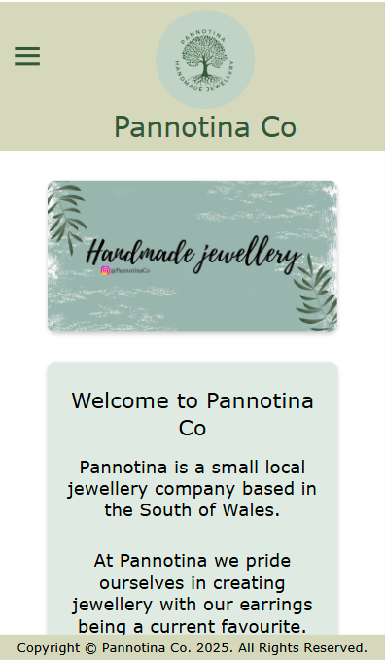
Figure 1 – Top of Home Page

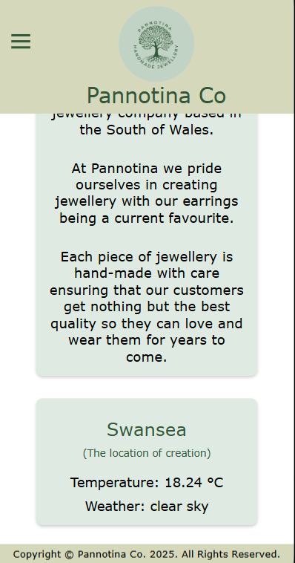
Figure 2 - Bottom of Home Page and Weather API
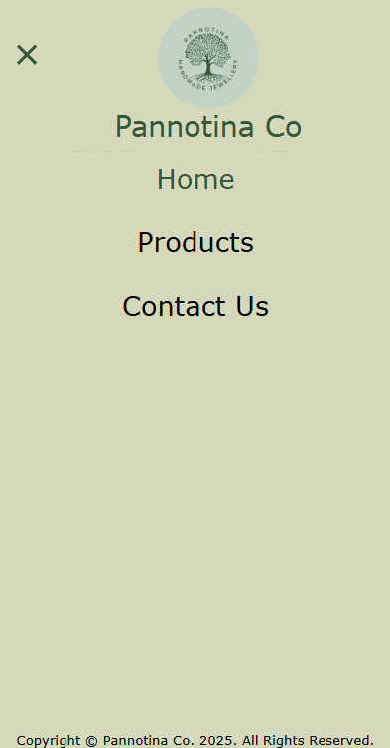
Figure 3 - Website Navigation for Expanded Menu on Home Page

Products Page
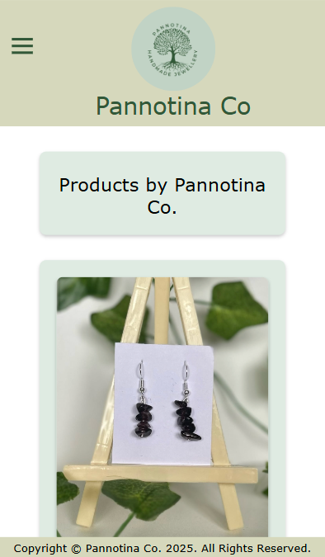
Figure 4 - Products Page Part 1
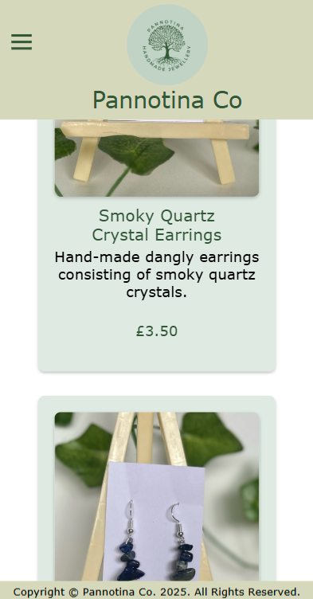
Figure 5 - Products Page Part 2

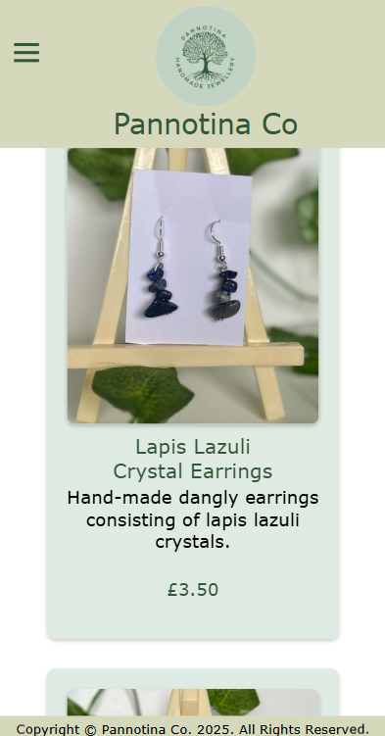
Figure 6 - Products Page Part 3
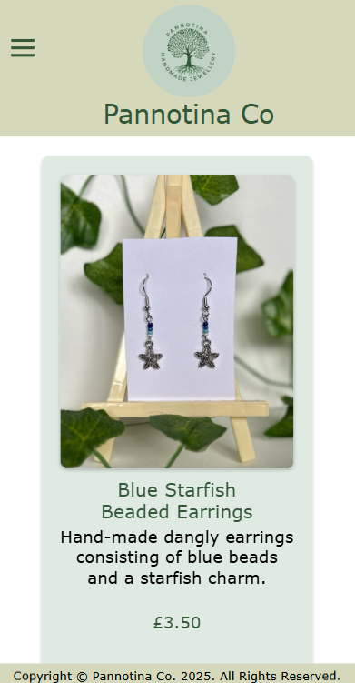
Figure 7 - Products Page Part 4

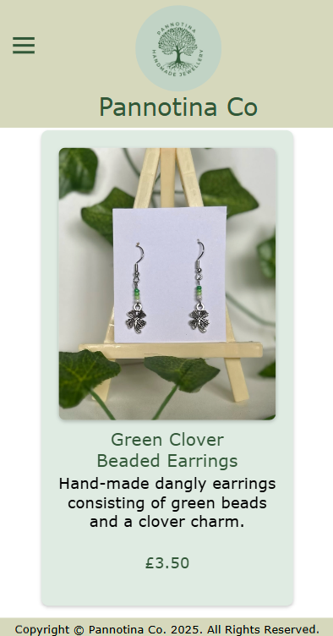
Figure 8 - Products Page Part 5
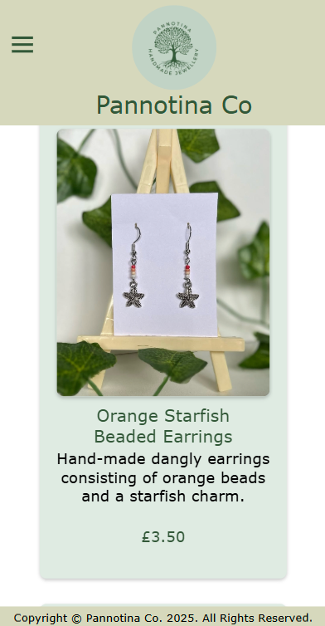
Figure 9 - Products Page Part 6

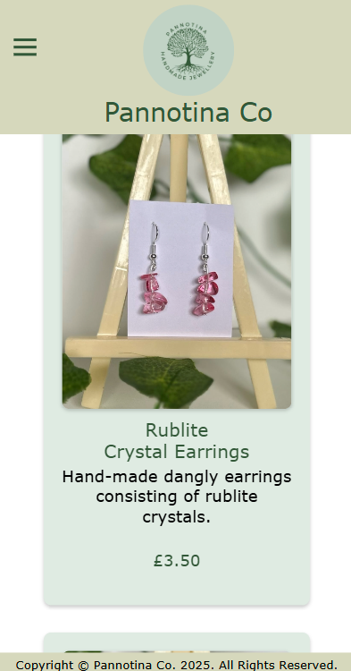
Figure 10 - Products Page Part 7
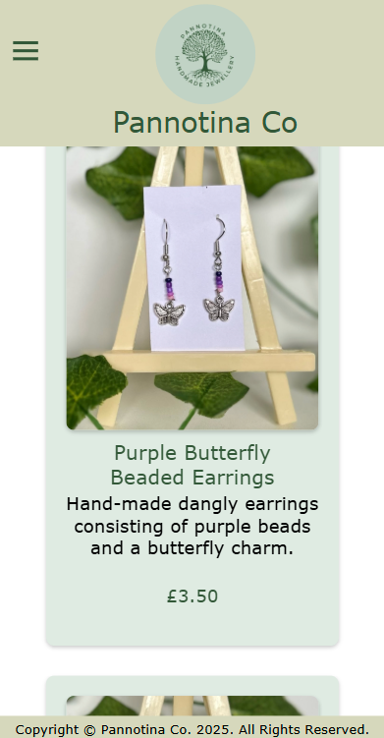
Figure 11 - Products Page Part 8

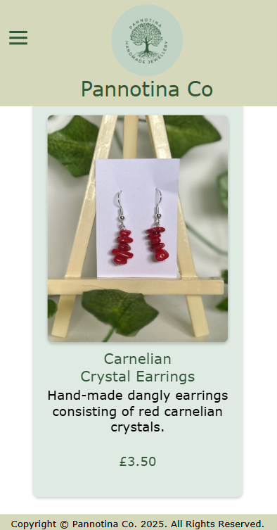
Figure 12 - Products Page Part 9
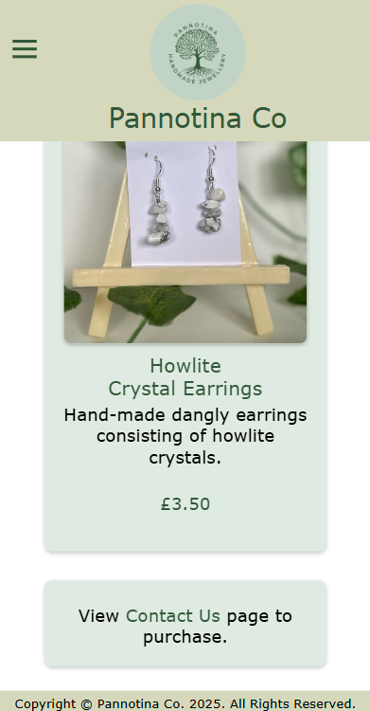
Figure 13 - Bottom of Products Page with Link to Contact Us Page

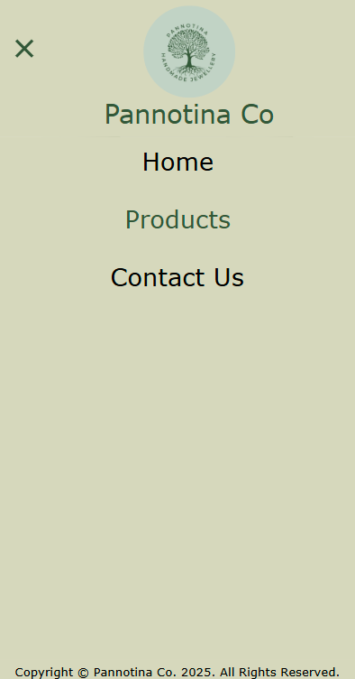
Figure 14 - Website Navigation for Expanded Menu on Products Page

Contact Us Page
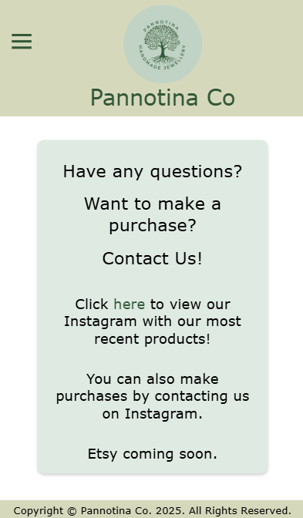
Figure 15 - Contact Us Page with link to Instagram Page

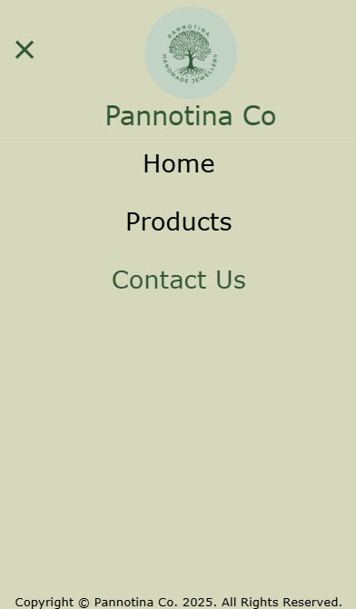
Figure 16 - Website Navigation for Expanded Menu on Contact Us Page
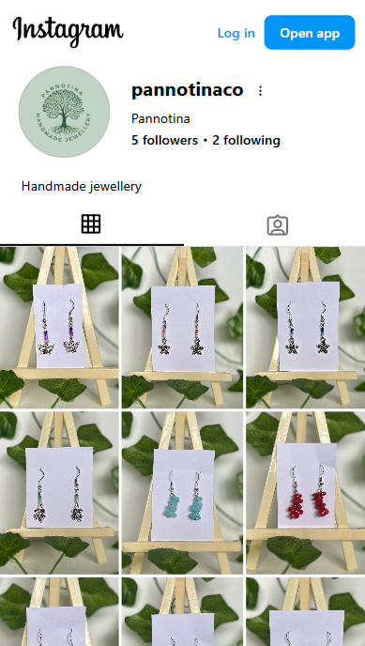
Figure 17 - Instagram Page shown when the link on the Contact Us Page is clicked

