Thomas Molner
1804565
Data Centre Technologies
A research report on Data centre
Sadeque Shaikh

Assignment
A research report on Data centre

A research report on Data centre
Abstract - Data centers are described as pools of computing resources that are dedicated to host and provide the resources and services whenever required. This aspect of on-demand service delivery has been brought into the data center scene as a result of cloud computing becoming a major part of data centers. Over time, data has been on a positive trajectory growing into a massive amount of data that the conventional data storage, processing, and analysis could not handle. This is the cause for the necessity to come up with data storage and processing mechanisms such as data centers to be implemented in the computing domain.

Introduction
Data and information systems are said to be the largest components of the cyber-space. They make the most of the entire information system and the cyber-space as a whole [1]. The increase in the volumes of data in businesses has resulted in the development of data processing and storage mechanisms. This is owed to the fact that the normal data processing and storage technologies are incapable of handling massive amounts of data. The importance of data in business environments cannot be quantified enough [2]. Data is the driving feature in businesses as it forms a major anchor for business decisions. This is an important part of business intelligence and analysis. Business intelligence encompasses data collection, storage, analysis, and visualization through analytics and visualization tools and techniques such as python tools. In a nutshell, business intelligence can be defined as an aspect of business that normally leverages software programs and services to transform data into actionable insights. The increase in the amounts of data in organizations has necessitated the design and innovation of alternative storage mechanisms like data centers [3]. A data center is described as a dedicated space in which data is stored.

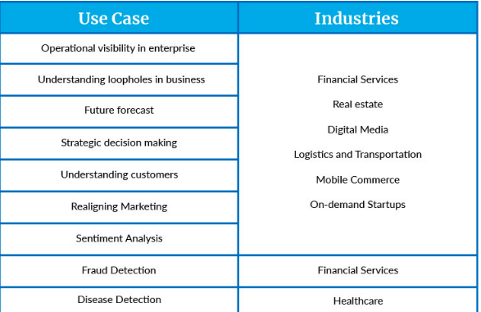

Research Objectives
To breakdown the topic, in general, this research aims at discussing data, its storage, and analysis as far as business organizations and their data usage are concerned. To achieve the general objective, the research seeks at satisfying the following specific objectives.
- Understand Walmart business case and its data usage, storage, and analysis
- Define and understand what data center is
- Define and understand Big data and its usage
- Understand the Relationship between Big data and data center
- Illustrate the usage of data center

Research Methodology
To achieve the above-listed objectives, this research shall be approached using the qualitative approach to dig into the objectives and data center as discussed in this section [4]. This qualitative research is dependent on first-hand data focusing on the experimental results installation and usage of data.

Data and Collection Method
This research is based on first-hand data as mentioned earlier, the data that will be used in this research is assorted using the experimentation method [5]. This is achieved by setting up labs and illustrating how data centers are configured and used virtually as the study case emulating the business case of Walmart and its data centers installation and usage. The essence of using first-hand data is informed by the need to understand how data centers are used in businesses to lighten their burdens of data storage [6], analysis, and usage in the efforts of handling large amounts of data.

Walmart Business Case
Walmart is an online store that deals in the sale of lots of products ranging from groceries, clothing, electronics, construction materials, shoes, and anything one would want. The store operates mostly in the United States with a customer base of all the U.S states [7]. This forms a large customer base with massive amounts of data such as credit card information, authentication credentials, shopping information, location. This is vital information as far as the cyber-space is concerned [8]. The information from various customers forms the bulk of the company’s data, storage of this data becomes a real challenge with normal storage ways such as conventional databases. This makes the company face difficulty in managing the customers and making data-based decisions in business intelligence. Normally, the company would use conventional data storage means such as relational databases like MySQL database systems [9]. Conventional database systems would be difficult as such would require central storage of data for cloud deployment given the nature of the company's business and its activities. Walmart largely relies on the internet and it must have a central repository or data warehouse from which the company's operations can be founded [10].
Due to the large volumes of data used in online stores like Walmart for this instance, data centers are preferred in handling the company's data. Data centers are described as described in the section above are described as centralized locations in which computing and the computing, networking equipment are saturated for the sole reason of assorting, storing [11], processing, and analyzing data. These are the key aspects of data stored in data centers for any business organization to derive business values. For a company like Walmart to derive business values, extensive techniques to collect, store, process, and analyze data are required.

Data collection
In online stores like in the case of Walmart, most of its data is collected from the internet at the registration stage of customers. At this stage, the customer provides all the required information and that may include credit card info, order information, and other personal information that is related to the e-commerce situation [12].
Related Works

Data storage
The collected data comes in large volumes. This presents a storage challenge that the normal storage tools and techniques cannot handle. Also due to the need to have a central access point for data, the conventional storage tools and techniques are not appropriate for this case [13]. This, therefore, requires alternative storage mechanisms that will facilitate the central storage of large volumes of data. Data centers are closely associated with cloud computing and cloud storage techniques [14]. This is because they are mostly leveraged over the clouds under Infrastructure as a Service and Platform as a Service (IaaS and PaaS). Cloud computing aspect is eminent in the data processing and analysis parts of data centers, by definition, cloud computing is defined as the on-demand computing service delivery over the internet [15]. The on demand covers the aspects of computing from any location at any given time thus making data centers accessible from anywhere provided there is a stable internet connection to facilitate the access and usage.
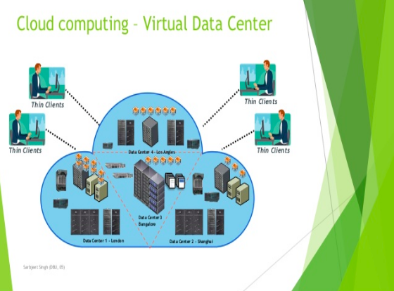
Virtualizing data centers has for a long time been the best option in implementing data centers for remote access to central data storage and data warehouses.

Data processing
Processing data is important in businesses, this is where the respective businesses derive their business values. Data processing in data centers is usually handled by sophisticated processing tools and techniques [16]. Processing of data is defined as the conversion of raw facts and figures (data) into meaningful information that can benefit a given business organization. The processing process essentially begins with data collection. This process is more eminent in the cleansing phase. In this phase [17], things like normalization and re-organization of data take place. In data cleansing, a data lake is used, it is described as a container in which raw facts and figures are stored. It is a major part of the data source with filters to help in the data processing. In processing, data redundancy is reduced or done away with completely. This is preceded by data preprocessing comprises the structuring of the processed data into the required formats and types [18]. Normally the data in the data lake is unstructured. Data preprocessing is usually done by the use of machine learning algorithms and models.

Data analysis
It is usually assumed that data analysis is a part of data processing, whilst this may be true, data analysis refers to the process of inspecting, cleansing, transforming, and modeling data to dig up very useful information for major business decisions and values. Data analysis is approached in various techniques such as data mining [19]. It focuses on statistical techniques that concentrate on knowledge discovery. Business intelligence is also a part of data analysis whose main focus is on the aggregation of business information. Procedurally, data analysis can be broken down into the following sections;
- Data requirements
- Data collection
- Data processing
- Data cleansing
- Modeling and algorithms
Data analysis pipeline

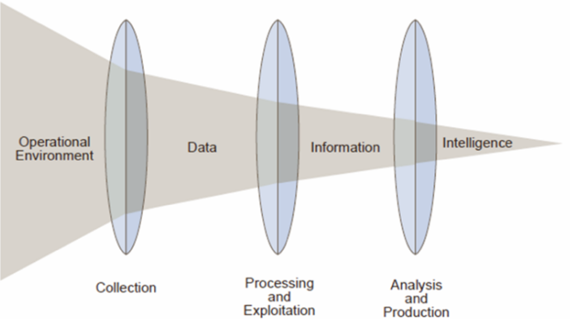

Big Data & its Usage
Data beyond petabytes is categorized under big data. This is a part of data center storage that handles massive amounts of data. Big data on its own comprises of collection, analysis, processing, and visualization of data. Big data handles both structured and unstructured data. According to Doug Laney, big data is defined in three Vs namely; Volume, Velocity, and Variety.

Volume
Companies collect data from a diversity of sources and that comprises business transactions, social media platforms and charts and information from sensor or machine-to-machine data. In the past, data storage would have been an issue – but new technologies like Hadoop and Apache Hive have eased the burden [20]. The name 'Big Data' itself is related to an enormous size. The size of data plays a very crucial role in determining the business values out of data. Also, whether a given date can be considered as Big Data or not, is reliant on upon volumes of data thus volume is one feature that requires to be considered while dealing with 'Big Data'.

Velocity
Data streams in the un-intended speed should always be handled in a timely way. The term velocity describes the speed and swiftness of the generation of data. This handles how fast data is generated and processed to handle the user requirements [21], demands, and establishes the potential in the respective data. Big data velocity, therefore, handles the speed at which data flows into the data processing part and how fast the processed data is retrieved from the big data.

Variety
Data in big data and data centers usually are presented in various formats, variety in big data refers to the heterogeneous sources, this covers both structured and unstructured data. Before big data and data centers, spreadsheets and databases were the primary sources and means of handling data, this used to be a challenge when dealing with some other formats of data like videos.
Big data is majorly applied in the analytical parts of data and business in which data is analyzed and advertising as a business value is derived. In a company like Walmart, advertising is an important part of the business as it is the foundation on which the business is formed. Walmart can use this to optimize the store's products' searches per user or customer. This shortens the search periods and queries as it helps the users get to what they wanted.

Datacenter
The applications and computing technologies that are currently in use and on the rise have facilitated the concepts and paradigms of cloud computing, mobile computing and the rampant internet of things (IoT) have led to the generation of massive amounts of data that have become a challenge in storage, processing, and exchange. This has resulted in innovative ways of dealing with the rise in the volumes of data that is currently in the cyber-space.
Data centers trace back to the 1940s in huge computer rooms (ENIAC). These were more physical data centers with numerous cables and hardware components that were connected everywhere in the rooms [22]. This lasted until the mid-1990s where companies needed fast connectivity and access to data due to increased business and the general power of computing. During this era, data centers were founded on the internet and were commonly referred to as Internet data centers (IDCs). The advantage of IDCs is that they offered crossover backups. This has been in use for quite a while until the discovery of cloud computing and its capabilities that is currently in use [23]. Cloud data centers are currently the most used type of data centers given the nature of businesses today. Walmart for instance requires a central data warehouse and storage facility to facilitate the central access of the resource.
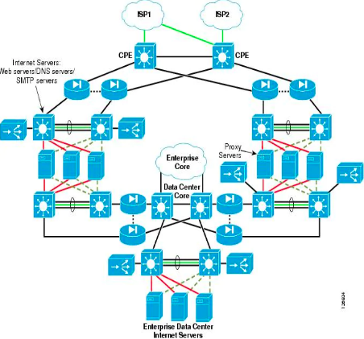
The above picture illustrates a basic data center architecture. Data centers are usually implemented in levels and tiers. There four major tiers in data centers namely, tier-one/ level one, tier two/ level two, tier three/ level three, and tier four/ level four data center.

Tier one/ Level one data center
Tier one data centers are usually not so complicated. Tier one data center offers its clients a guaranteed uptime and 2N times operation time for cooling and redundant power and infrastructure [24]. Power consumption in computing is usually a debatable issue with some computing technologies being serious power consumers than others. Data centers and virtualization for instance are said to be one of the most power-consuming computing technologies that are currently under research to cut down power consumption. Tier one data centers are usually the go-to for small companies and SMEs in general. In a nutshell, tier-one data center depicts the following characteristics:
- Availability of about 99.671 percent
- Vulnerable to disruptions
- Solitary power path
- No redundant components

Tier two/ Level two data center
Tier two data center is a colocation type of data center that is more robust than a tier-one data center. Tier two data centers allow the customers to customize them. This aspect of level two data center makes it more cost-efficient whilst offering the best of services at the same time. Level two data centers are almost alike to level one data centers. There is a slight difference between the two in that level two data center offers the following attributes to the customers.
- Offers a 99.741 percent availability
- It is less vulnerable to disruptions compared to level one data center
- Similar to level one data center, level two data center also offers a single path for power
- Unlike level one data centers, level two data centers have redundant components

Tier three/ Level three data center
Level three data centers are tailored to perform mending without necessarily showing any disruptions. Level three data centers are said to offer N + 1 availability for its users. Level three data centers are generally more fault-tolerant than the other levels of data centers. Level three data centers are characterized by the following characteristics:
- Availability of 99.982 percent
- Less of no disruptions due to planned activities
- Has numerous paths for power
- Level three data centers also have redundant components

Tier four/ Level four data center
Tier four data centers are also considered to be fault-tolerant:
- A 99.995 percent availability
- Tier four data centers are tailored towards withstanding at least one worst-case event
- Has numerous power paths
- Also has redundant components
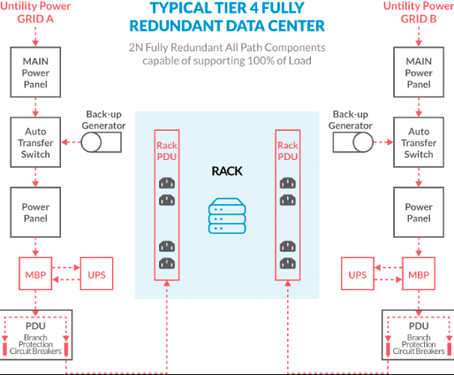
The above screenshot illustrates a tier four data center.

Relationship Between Big Data and Data Center
Big data and data centers are all concepts in the information system domain that deals with the respective company's data. Big data is a concept that is more analytical and involves processing whilst the data center is a concept that describes dedicated storage places. Big data is therefore a huge part of the data center whose main purpose is to aid in the processing. As described, data centers are dedicated places for data storage, they are pools of data storage facilities that are pooled together to form one storage pool.

Data Center Design
The data center design process is usually inclined towards availability, site location, modularity, and flexibility aspects. Availability is an aspect of the data center and indeed in all computing facilities and resources whose main focus is on the uptime and downtime of a given resource. Downtimes are scenarios in which a given computing service is unavailable due to various factors including human influence such as attacks [25]. Site location in designing and implementing a data center is an important part of the process that takes into consideration the closeness to power sources, networking infrastructure, and telecommunication infrastructure. Data centers are said to consume a lot of power thus a reliable power source is needed in whichever location of a data center has been selected or implemented. Data centers are also designed towards the adoption of modularity and flexibility [26], modularity aspect of data center allow the data center to grow in terms of size to fit the specific business needs. Flexibility is the enabling factor on which modularity is founded on. In the design of data centers, it is usually not easy to find all the factors favourable, this therefore requires one to make some trade-offs in the choices of where and how to design a data center.

Data Center & Virtualization
Virtualization is a twin concept in the current strategies for the implementation of data centers. In virtualized environments, data centers are deployed in virtual platforms and cloud computing technologies. In this approach, the implementation primarily is involved in the virtualization of physical servers. Virtualized data centers are seemingly becoming very necessary for companies since the traditional implementation of data centers does not meet the modern business requirements like the big data requirements [27]. The adoption of virtualized data centers is attributed to the following benefits in businesses.

Reduction of operational costs
The traditional implementation of multiple servers to form data centers is usually very costly as it would require maintenance and operation for each server. Virtualization covers these operational costs by providing a mechanism for the separation of applications and services from the hardware components. Business organizations thus do not need to buy many servers, they instead need to use virtualization to host many of them thus minimizing the overall costs of implementation and maintenance

Minimal Downtime.
Downtime is usually expensive and costly for any organization in terms of how slow business processes will be in the unfortunate case they occur in the respective organization. Downtimes can be prevented in two major approaches; the implementation of business continuity plans and disaster recovery plans. These two ensure there are fewer or no disruptions in the data center facilities.

Business Continuity
Business continuity in simple terms can be described as the aspect of the business to pick up and proceed with its normal services in all circumstances. The major objective of business continuity if ensure that there are little or no disruptions in the respective business operations. Server failures are a common disruption that can bring business operations to their knees [28]. Virtualizing data centers cuts down the cases of server failures in virtualized environments as maintenance is easier in the virtual environments than in physical environments.

Disaster Recovery
Disaster recovery is usually a twin concept to the business continuity, in disaster recovery, businesses can pick the last stable state that the business was in before a disaster struck. The occurrence of disasters in business can be very hurtful the businesses in that they can cause the loss of critical data in the organization thus affecting the business and sometimes tamper with the data integrity in the respective business organization [29]. Virtualized data centers and especially in cloud computing technologies relieve the organizations from the responsibility of handling the servers thus their respective data servers are safe in the virtualized data centers and the cloud computing hosting services for servers.

Reduced Heat Buildup
Heat dissipation and control in data centers is a great challenge for physical data centers. Several pieces of research have been conducted in the efforts to find a solution to this, so far, an efficient cooling mechanism is what has been adopted. As stated earlier, data centers are the second most computing technologies that consume most power after block-chain consensus. Virtualized and cloud-hosted data centers tend to consume less power compared to the physically implemented data center. These researches are however promising in the dimensions of server synchronization and capacity load, reduced cooling dependencies, and variations in the hosting temperatures. Hypothetically, lowered temperatures are said to cut down the heat buildup and consequently the power consumed by the respective computing technology such as data centers as discussed.

Synchronization of server capacity and load
This is important in merging loads to optimize the data center capacity. The optimization leverages loads to servers thus resulting in fewer servers running and consequently, power consumption is tremendously reduced. Also, in the efforts to uphold the aspect of green computing, the use of renewable sources of energy in such technologies is rampant in data centers. This section illustrates the power consumption in the United States as of 2010.
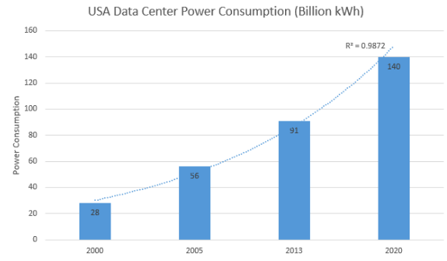
Virtualization technologies that are commonly used in data centers include the following: VMware fusion, Azure cloud, Amazon cloud, Red Hat, Cisco, and Microsoft Windows Servers.
Concerning power consumption, data centers are designed using the Power Flow Model, in this model, a PFM algorithm is instrumental in modeling power consumption. A good illustration of PFM is the CLUMEQ data center, (Consortium Laval-UQAM-McGill and Eastern Quebec). Below is an illustration for the CLUMEQ Power flow model for modeling an efficient power consumption data center.
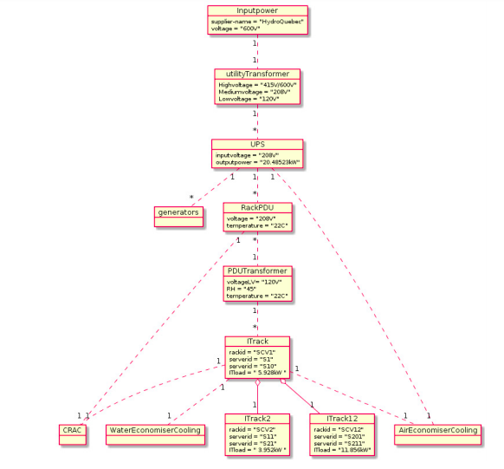
According to this model, the following pictures illustrates the power consumption in the CLUMEQ DCMM data center.
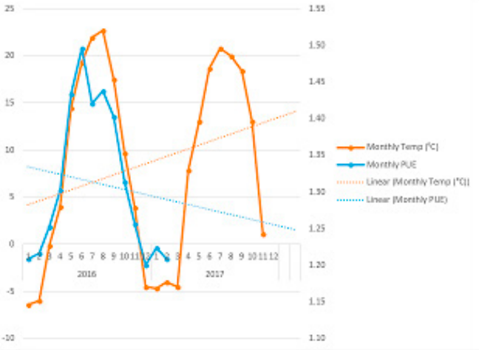

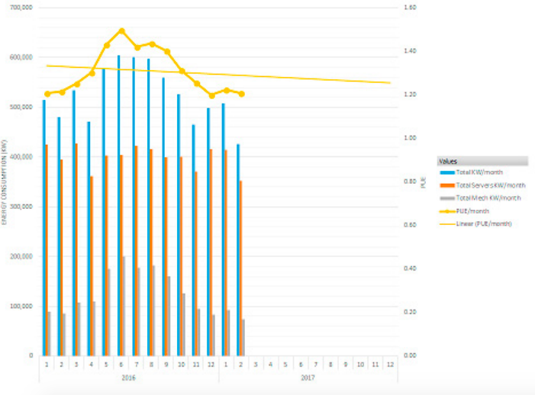

Security in Data Centers
Just like any other computing infrastructure, data centers are vulnerable to numerous attacks that are as a result of server vulnerabilities and network systems on which the data centers are hosted. This is a part of the vast cyber-space and its security practices. Security in data centers are usually policies, cautions, and practices that have been put in place to avert any unauthorized entrée and manipulation of the resources in the data centers. The most common threats in data centers include Denial of Service, Data theft, and Identity theft. This is the greatest challenge in data centers that exposes them to security attacks [30]. Denial of service in data centers denies services to the data center users in a manner that the services are entirely or partially down. This prevents the users from accessing their data and data center services over the network system. Denial of service occurs in two forms, distributed denial of service and the normal denial of service. A distributed form of denial of service is one that is usually is not easy to control. In this case, the flood requests or packets originate from multiple sources and they simply freeze the attacked resource. Unauthorized access in data centers occurs when the attackers gain access into the respective data centers without being authenticated. The attackers in this case are illegal users whose main intentions are to tamper with the data centers either by compromising the integrity or simply infecting the data centers with malicious programs and codes. Eves dropping in data centers are usually tailored towards the compromisation of data integrity between the data centers and their users. All of these threats and vulnerabilities in data centers are enabled by weak network systems that are vulnerable to facilitate unauthorized access into the data centers. Illustration for data center security attack.
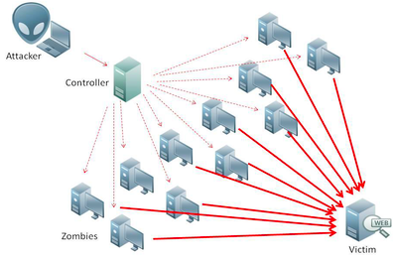

Conclusion
In conclusion, data centers are sophisticated systems that provide platforms in which information and IT technologies and equipment are hosted. Data centers are classically composed of numerous components and that includes servers, storage systems, network resources, and other non-IT infrastructures like power dissemination and cooling equipment. So that a data center can work properly, every part of it has to be configured in the right way, this is usually not the case in most cases since most of the configurations and the inter-dependencies of data center sub-systems do create issues in the modeling approach that upholds design and quantitative evaluation of their respective energy efficiencies. This is geared towards taming the complexities of data centers and consistencies in the design. It is always important to design data centers in the aforementioned aspects of best practices as far as data centers are concerned. This is done to cut down the cost of operation and increase the efficiency of the data centers in their respective usage.

Reference List
[1]. D.Sledgianowski, M.Gomaa, and C.Tan. Toward an integration of Big Data, technology, and information systems competencies into the accounting curriculum. Journal of Accounting Education, 2017, 38, pp.81-93.
[2]. M.M.Fischer, H.J.Scholten, and D.Unwin. Geographic information systems, spatial data analysis, and spatial modeling: an introduction. In Spatial Analytical (, 2019, pp. 3-20). Routledge.
[3]. R.S.Kirby, E.Delmelle, and J.M.Eberth. Advances in spatial epidemiology and geographic information systems. Annals of epidemiology, 27(1), 2017, pp.1-9.
[4]. J.Park and M.Park. Qualitative versus quantitative research methods: Discovery or justification?. Journal of Marketing Thought, 3(1), 2016, pp.1-8.
[5]. K.Mortensen and T.L.Hughes. Comparing Amazon’s Mechanical Turk platform to conventional data collection methods in the health and medical research literature. Journal of General Internal Medicine, 33(4), 2018, pp.533-538.
[6]. E.Paradis, B.O'Brien, L.Nimmon, G.Bandiera, and M.A.Martimianakis. Design: a selection of data collection methods. Journal of graduate medical education, 8(2), 2016, pp.263-264.
[7]. P.J.Wu and K.C.Lin. Unstructured big data analytics for retrieving e-commerce logistics knowledge. Telematics and Informatics, 35(1), 2018, pp.237-244.
[8]. S.Akter and S.F.Wamba. Big data analytics in E-commerce: a systematic review and agenda for future research. Electronic Markets, 26(2), 2016, pp.173-194.
[9]. S.Chan. Membuat Aplikasi Database dengan PowerBuilder 12.6 dan MySQL. Elex Media Komputindo, 2017.
[10]. F.M.Kromann. Securing MySQL. In Beginning PHP and MySQL (2018, pp. 605-636). Apress, Berkeley, CA.
[11]. B.D.C.Members. Database resources of the BIG Data Center in 2019. Nucleic Acids Research, 47(Database issue), p.D8, 2019.
[12]. C.Blumenberg and A.J.Barros. Response rate differences between web and alternative data collection methods for public health research: a systematic review of the literature. International journal of public health, 63(6) 2018, pp.765-773.
[13]. A.Siddiqa, A.Karim, and A.Gani. Big data storage technologies: a survey. Frontiers of Information Technology & Electronic Engineering, 18(8), 2017, pp.1040-1070.
[14]. D.Deibe, A.Amor, and R.Doallo. Big data storage technologies: a case study for web-based LiDAR visualization. In 2018 IEEE International Conference on Big Data (Big Data) (pp, 2018, 3831-3840). IEEE.
[15]. M.Adhikari and T.Amgoth. Heuristic-based load-balancing algorithm for IaaS cloud. Future Generation Computer Systems, 81, 2018, pp.156-165.
[16]. M.Zaharia, R.S.Xin, P.Wendell, T.Das, M.Armbrust, A.Dave, X.Meng, J.Rosen, S.Venkataraman, M.J.Franklin, and A.Ghodsi. Apache spark: a unified engine for big data processing. Communications of the ACM, 59(11), 2016, pp.56-65.
[17]. S.P.Singh, A.Nayyar, R.Kumar, and A.Sharma. Fog computing: from architecture to edge computing and big data processing. The Journal of Supercomputing, 75(4), 2019, pp.
2070-2105.
[18]. A.Jabbar, P.Akhtar, and S.Dani. Real-time big data processing for instantaneous marketing decisions: A problematization approach. Industrial Marketing Management, 90, pp, 2020, 558-569.
[19]. K.Cho, H.Chang, Y.Jung, and Y.Yoon. Economic analysis of data center cooling strategies. Sustainable Cities and Society, 31, 2017, pp.234-243.

[20]. R.Herschel and V.M.Miori. Ethics & big data. Technology in Society, 49, 2017, pp.31-36.
[21]. A.M.Al-Salim, T.E.El-Gorashi, A.Q.Lawley and J.M.Elmirghani. Greening big data networks: Velocity impact. IET Optoelectronics, 12(3), 2017, pp.126-135.
[22]. L.Peterson, A.Al-Shabibi, T.Anshutz, S.Baker, A.Bavier, S.Das, J.Hart, G.Palukar, and W.Snow. Central office re-architected as a data center. IEEE Communications Magazine, 54(10), 2016, pp.96-101.
[23]. W.Xia, P.Zhao, Y.Wen, and H.Xie. A survey on data center networking (DCN): Infrastructure and operations. IEEE communications surveys & tutorials, 19(1), 2016, pp.640-656.
[24]. Z.Yang, M.Hoseinzadeh, a.Andrews, C.Mayers, D.T.Evans, R.T.Bolt, J.Bhimani, N.Mi, and S.Swanson. AutoTiering: automatic data placement manager in multi-tier all-flash datacenter. In 2017 IEEE 36th International Performance Computing and Communications Conference (IPCCC), 2017, (pp. 1-8). IEEE.
[25]. P.Sharma, P.Pegus II, D.Irwin, P.Shenoy, J.Goodhue, and J.Culbert. Design and operational analysis of a green data center. IEEE Internet Computing, 21(4), 2017, pp.16-24.
[26]. A.Celik, A.Al-Ghadhban, B.Shihada, and M.S.Alouini. Design and provisioning of optical wireless data center networks: A traffic grooming approach. In 2018 IEEE Wireless Communications and Networking Conference (WCNC), 2018, (pp. 1-6). IEEE.
[27]. K.Kondepu, C.Jackson, Y.Ou, A.Beldachi, A.Pagès, F.Agraz., F.Moscatelli, W.Miao, V.Kamchevska, N.Calabretta, and G.Landi. Fully SDN-enabled all-optical architecture for data center virtualization with time and space multiplexing. IEEE/OSA Journal of Optical Communications and Networking, 10(7), 2018, pp.90-101.
[28]. M.Niemimaa, J.Järveläinen, M.Heikkilä, and J.Heikkilä. Business continuity of business models: Evaluating the resilience of business models for contingencies. International Journal of Information Management, 49, 2019, pp.208-216.

[29]. V.Rayamajhee, V.H.Storr, and A.K.Bohara. Social entrepreneurship, co‐production, and post‐disaster recovery. Disasters, 2020.
[30]. B.M.Schultz, P.R.Gaddehosur, M.Garg and J.S.Rajwan, Microsoft Technology Licensing LLC. User-Aware Datacenter Security Policies, 2017. U.S. Patent Application 14/839,829.

