University of Wales Trinity Saint David – Swansea – Abertawe: BSc (Hons) Professional Policing Practice.
Honours Project Title:
‘An investigation into how police incidents impact the mental health of operational police officers and what support is implemented within police forces now compared to five years past’
___________________________________________________________________
Student: Carla Louise Woodruff
Student number: 1921044
Word count: 8785 Main Body – 16,096 in total

Declaration

This work has not previously been accepted in substance for any degree and is not being concurrently submitted in candidature for any degree.
Signed: Carla Woodruff
Date: 09.01.2023

Statement 1
This dissertation is being submitted in partial fulfilment of the requirements for the degree of BSc (Hons) Professional Policing Practice
Signed: Carla Woodruff
Date: 09.01.2023

Statement 2
This dissertation is the result of my own independent work/investigation, except where otherwise stated.
Other sources are acknowledged by footnotes giving explicit references. A bibliography is appended.
Signed: Carla Woodruff
Date: 09.01.2023

Statement 3
I hereby give consent for my dissertation, if accepted, to be available for photocopying and for interlibrary loan, and for the title and summary to be made available to outside organisations.
Signed: Carla Woodruff
Date: 09.01.2023

Statement 4
I hereby give consent for my dissertation, if accepted, to be available on the university’s IT system to those who have consent to use the system.
Signed: Carla Woodruff
Date: 09.01.2023

‘An investigation into how police incidents impact the mental health of operational police officers and what support is implemented within police forces now compared to five years past’
___________________________________________________________________

Acknowledgements
___________________________________________________________________
Firstly, I’d like to thank my dissertation supervisor Samantha McAlister Wilson who has provided support and guidance to myself throughout the duration of the research project.
Secondly, I’d like to thank my colleagues who have maintained support and assistance throughout the duration of the research project and aided myself whenever necessary.
Finally, I would like to say a very special thank you to my partner, Daniel, son Theo and my immediate family for providing continued support and encouragement throughout the duration of the project.

Abstract

In spite of inordinate amounts of academic literature encasing mental health amongst serving police officers within police forces, it is reasonable to propose that the mainstream of this research focuses on studies conducted in varied forces over varied periods of time as opposed to an individual force.
This research project aims to establish how police incident impact the mental health of operational police officers. The researcher aimed to identify this by investigating what mental health is defined as and what the leading causes are in developing poor mental health, also, the researcher aimed to distinguish what operational stressors police officers are exposed to and whether those stressors directly link as a contributing factor upon police officers’ mental health. Furthermore, the researcher paid attention to investigating whether police officers are placed at higher risk of developing mental health issues, and finally, what support is available to police officers with mental health issues and how does this support differ to what was available to police officers five years past.
The researcher carried out a comprehensive analytical scrutiny of appropriate and existing academic literature surrounding the matter. The researcher then directed their own primary research in the form of questionnaires to gather quantitative data, which was then likened to the existing data to see if any themes arose.
The verdict from this project was then recorded, and consequently, recommendations were crafted to support in developing awareness and to advance support services for police officers who are experiencing mental health issues and how they can gain access to the most appropriate support for their needs. It is hoped that these commendations may facilitate in destigmatising perceptions and improve reporting.

Contents
Declaration 2
Acknowledgements 4
Abstract 5
(1.0) Chapter one: Introduction 8
(2.0) Chapter Two: Literature review 9
(2.1) Introduction into the chapter 9
(2.2) What is Mental Health and what are the leading causes in developing poor Mental Health? 10
(2.2.1) Definition of Mental Health 10
(2.3) What are the operational stressors in which Police Officers are exposed to and do these stressors directly link as a contributing factor upon Police Officers Mental Health? 11
(2.3.1) Mental Health statistics in policing in England and Wales 11
(2.3.2) Survey: Table One 12
(2.3.4) Survey: Figure One 13
(2.4) Are Police Officers placed at higher risk of developing Mental Health issues? 14
(2.5) What support is available to police officers with Mental Health issues and how does this support differ to support that was available to Police Officers five years past? 15
(2.6) Conclusion 17
(3.0) Chapter 3: Research Methodology 18
(3.1) Introduction into the chapter 18
(3.2) Research methodology models 19
(3.2.2) Research Onion 19
(3.2.3) Figure 1.2: The Research Onion 20
(3.3) Research viewpoint 20
(3.4) Research Approach 20
(3.5) Research Strategy 21
(3.6) Research Choices 21
(3.7) Timeframe 22
(4.0) Techniques 22
(4.1) Data Collection 22
(4.2) Data Analysis 23
(4.3) Limitations 23
(4.4) Conclusion 23
(5.0) Results chapter 24
(5.1) Introduction into the chapter 24
(5.2) Survey one: Question One 25
(5.2.1) Survey one: Question Two 27
(5.2.2) Survey one: Question Three 27
(5.2.3) Survey one: Question Four 29
(5.2.4) Survey One: Question Five 30
(5.2.5) Survey One: Question six 31
(5.2.6) Survey One: Question Seven 32
(5.2.7) Survey One: Question Eight 33
(5.2.8) Survey One: Question Nine 34
(5.2.9) Survey One: Question Ten 35
(5.3) Survey Two 36
(5.3.1) Survey Two: Question One 36
(5.3.2) Survey Two: Question Two 37
(5.3.4) Survey Three: Question Three 38
(5.3.5) Survey Two: Question Four 39
(5.3.6) Survey Two: Question Five 40
(5.3.7) Survey Two: Question Six 41
(5.3.8) Survey Two: Question Seven 42
(5.3.9) Survey Two: Question Eight 43
(5.3.10) Survey Two: Question Nine 44
(5.3.11) Survey Two: Question Ten 45
(5.4) Results chapter: Conclusion 46
(6.0) Findings and Conclusion 47
(6.1) Introduction 47
(6.2) Achievement of objectives 47
(6.3) Main findings 48
(6.3.1) – Research question 1 – What is mental health and what are the leading causes in developing poor mental health? 49
(6.3.2) – Research question 2 – What are the operational stressors in which police officers are exposed to and do these stressors directly link as a contributing factor upon police officers’ mental health? 49
(6.3.3) – Research question 3 – Are police officers placed at higher risk of developing mental health issues? 49
(6.3.4) – Research question 4 – What support is available to police officers with mental health issues and how does this support differ to support that was available to police officers five years past? 50
(7.0) Recommendations 51
(7.1) Recommendation One: Completing further research 51
(8.0) Conclusion 53
(9.0) Bibliography 54
(10) Appendices 60
(10.1) Appendix One: Survey One 60
(1.2) Appendix Two: Survey Two 63
(10.3) Appendix Three: Survey one results 66
(11) Appendix Three: Dissertation proposal 76
(12) Appendix Four: Ethic form 81
Outline any anticipated risks that may adversely affect any of the participants, the researchers and/or the University, and the steps that will be taken to address them. 92
Full risk assessment completed and appended? 92
Yes 92
☐ 92
No 92
☒ 92

Chapter one: Introduction

This dissertation will explore how police incidents impact the mental health of operational police officers and what support is implemented within police forces now compared to five years past. It will confer the potential links to mental health and operational stressors present for serving police officers and whether the support in place is sufficient to meet police officers’ needs within the current climate and how this support has differed compared to five years past.
Existing research outlines that support networks available to serving police officers has improved in recent years, with access to such now easier to access with less negative stigma attached to recognising and addressing mental health issues mental health issues amongst police officers and police forces alike. The objective of this research is to ascertain whether police officers are placed at higher risk of experiencing mental health issues through exposure to operational stressors that may present because of their role and whether police officers feel that there is enough profile-raising and sustenance available regarding such issues and whether access to support and the support systems in place currently differ from those imposed compared to five years past.
Furthermore, police officers respond to traumatic incidents daily which ultimately serves as a significant component of everyday policing. It would be favourable for serving police officers to be able to identify what support networks are in place to access mental health support to chaperon them in right direction for support.
This project was chosen by the researcher as it is something that they have experienced and is a vital topic and one in which the researcher holds the belief that more familiarity and appreciation is needed in. Mental health is important at every stage of life, from childhood and adolescence through adulthood (Centers for Disease Control and Prevention, 2021) and holds no discrimination and can be felt by any person at any time, it is not specific and can present in many forms.

(2.0) Chapter Two: Literature review

(2.1) Introduction into the chapter

A literature review is imperative within research as it offers former studies and information related to the chosen theme of study, mental health within policing. This analysis will include key studies relative to the topic. This chapter is divided into five sections; the first section will provide an overview of the literature surrounding mental health and developing poor mental health. Section two will explore operational stress factors and the connection to mental health. Section three will inspect whether police officers placed at higher risk of developing Mental Health issues. Ensuing is section four which will determine, what support is available to police officers with mental health issues and how does this support differ to support that was available to police officers five years past. Finally, section five will outline a conclusion to concur this chapter. To begin this literature review, starting promptly into section one, a definition of mental health will now follow:

(2.2) What is Mental Health and what are the leading causes in developing poor Mental Health?

(2.2.1) Definition of Mental Health

Section 1 of The Mental Health Act (1983) describes the term “Mental Health” as “Any disorder or disability of the mind which includes brain injury”. To explore further, The World Health Organisation (WHO), (2022) defines mental health as “A state of mental well-being that enables people to cope with the stressors of life, realise their abilities, learn well and work well and contribute to their community”. Mental health is determined by an intricate chemistry built of social, and operational stressors combined with psychological and biological factors which fortifies a persons’ ability to function within society (WHO, 2022). Mental health is not a ‘one size fits all’ term, mental health is a broad spectrum and there are many diagnoses and issues that can affect an individual with an array of symptoms that can present under the mental health umbrella. Entities experiences with mental health can vary and not all persons suffering with mental health will experience the same symptoms or feelings (Mind Charitable Association, 2022).
Mental health difficulties can stem from an extensive assortment of causes. To elaborate, the succeeding features which incorporate but do not encompass the exhaustive list of mental health issues could hypothetically result in a stint of declining mental health; drug and alcohol misuse, adverse childhood experiences (ACES), stress, poverty, adult trauma or social issues including unemployment or homelessness (Mind Charitable Association, 2022). Furthermore, Kutcher, Wei & Coniglio (2016) prophesise that poor mental health is associated with abundant adverse health and social incidences, including but not exhaustive to; heightened rates of chronic illness; decreased access health services, amplified demand on health care and early mortality.
In England and Wales, there is an increased focus on mental health, not just within policing, but in all aspects of life; furthermore, the stigma has decreased. This is a prevalent matter which has been broadly communicated about in recent years in the United Kingdom (UK), and more precisely the question is asked whether police officers have access to sufficient support to assist them in coping with feelings after attendance at traumatic calls. The researchers’ premise at this point is that police officers’ mental health needs are not supported enough by policing organisations, additionally, the deficiency of specially equipped resources to deliver mental health support to police officers within forces is also posing a substantial dispute.

(2.3) What are the operational stressors in which Police Officers are exposed to and do these stressors directly link as a contributing factor upon Police Officers Mental Health?

(2.3.1) Mental Health statistics in policing in England and Wales

Mental health problems are becoming more evident amid current operative police officers which is amounting to a collective trepidation being felt by police officers and the police service united, resulting in police officers experiencing unjustified volumes of burden to manage which is undesirably affecting the mental health and welfare of serving officers (The Police Federation, 2016).
Mental health issues within England and Wales is a cumulative dilemma. “Anxiety and depression are the reoccurring issues, with around one in ten people routinely affected at any given time. Anxiety and depression can be severe and prolonged and have a mass impact upon an individual’s ability to progress with life” (Mental Health Foundation, 2019). Stefanik (2017) stresses that “Police officers have one of the toughest jobs in the nation, every day, they risk their lives to keep the peace and protect our neighborhoods from criminals. Due to the stressful nature of their occupations, police officers need better access to mental health services to improve their mental health and help alleviate the anxiety that is a byproduct of their jobs”. Butterworth (2021) adds substance to this claim who states that “seventy-seven percent of officers reported facing difficulties with their mental health during the last year with ninety percent saying it was due to work”. Butterworth (2021), goes on to further elaborate stating that operational stressors including heavy workloads, pay freezes and budget cuts resulting in officer shortages are playing a substantial part towards the declining mental health of police officers.
According to Shane (2010), operational stressors within policing encompass but are not limited to; exposure to workplace violence, dealing with complex crimes, management of offenders, shift work and pay cuts. As a result, persons employed within a policing profession responding as an emergency service worker are at an increased risk of cultivating operational stress which in turn can have an impact upon the persons work ethic and output (Setti & Argentero, 2013).

(2.3.2) Survey: Table One

Marshall et al (2021) completed a mental health screening amongst a total of 90 serving police officers of alternative rank in the UK to determine what percentage of police officers have reported suffering with mental health issues as a result of being exposed to operational stressors. The research was completed through issuing identical surveys, the table below shows the sample of officers who participated within the survey:

Variable Number % of sample
Gender
Female 28 31.11
Male 62 68.89
Age
18-24 2 2.22
25-34 12 13.33
35-44 25 27.78
45-54 45 50.00
55-70 6 6.67
Rank
Constable 1 1.11
Senior Constable 22 24.44
Sergeant 23 25.56
Senior Sergeant 6 6.67
Inspector 17 18.89
Superintendent 3 3.33
No data 18 20.00

Table 1 – Description of the sample of police officers used within the study.

(2.3.4) Survey: Figure One

Figure 1 below displays the visual of findings in respect of the screening completed amongst participants who responded, and the most reported mental health problems experienced by the involved police officers.

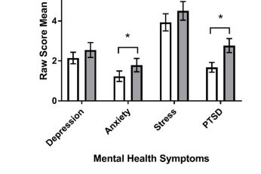

Figure 1 – Level of mental health symptoms reported by the same individuals completing the mental health screening.

The results of the screening found that police officers under-reported symptoms of mental health disorders when finalising screening, with only 76% of symptoms of mental health declared. Under-reporting ensued irrespective of gender and symptom. Less senior staff and those with severe Post-Traumatic Stress Disorder (PTSD) and mental disorder symptoms were suggestively more probable to under-report symptoms. Furthermore, the research also found that police officers are more likely than the general population to experience psychological distress due to the direct link to exposure to trauma within their work, and the added factor of operational stressors through lack of staffing, hence leading them improbable to seek specialised help through participant responses.

Further studies conducted by Narvekar & D’Cunha (2020) support the ideology that operational stressors directly impact the mental health of police officers who state that several aspects of police work and duties are directly linked to high levels of stress being suffered. Subsequently, a study commenced whereby a review took place of 130 appointed police officers using a series of questionnaires in an attempt to identify links between operational stressors and serving police officers, the study findings concluded that irrespective of age, gender and length of service of those surveyed, operational stressors have a direct negative impact on the mental health of participants. As a result of the survey, Narvekar & D’Cunha (2020) proposed that intervention strategies need to be implemented to tackle the stress and pressure being experienced by officers’ head on.

(2.4) Are Police Officers placed at higher risk of developing Mental Health issues?

As established throughout the course of this review, police officers respond to disturbing events and assist in providing provision to vulnerable individuals. The tactic taken by police officers and forces alike in response to such episodes have been extensive and as time lapses, countless active police officers are exposed to high profile and contentious incidents, all whilst being expected to deal with such occurrences in full public view (Collins, M., 2019). A study conducted by Mind Charitable Organisation, (2019) specified that “91% of police have experienced stress and poor mental health at work” nevertheless, police officers rarely take time off work for issues relating to mental health stressors in contrast to other professions.

The Police Federation (2016) completed a study into mental health suffered by police officers in the United Kingdom (UK). The survey of 17,000 police officers unfolded a perturbing set of statistics regarding the mental health of police officers. The research concluded that 39% of those surveyed sought assistance in managing their mental health because of exposure to trauma whilst being employed in post. In addition, Goodlatte (2017) forecasts that police officers risk their lives on the quotidian to preserve peace and maintain the equilibrium of justice within humanity, yet, states that this comes at a heavy cost for police officers who, in return are experiencing anxiety and mental health decline and called for enhanced access to mental health facilities to support officers in completing and continuing in exercising policing duties, furthermore, to augment mental permanency and welfare of police officers outside of duty.
Additional revisions were accomplished by Cambridge University whereby Miller (2019), decrees that research was conducted through a survey of 16,857 police officers to ascertain whether they were experiencing mental health issues was compiled through responses of those that took part. The responses were examined, and results unearthed that 90% of police officers surveyed had been subjected to trauma upon arrival to police incidents, which contributed to the deteriorating of their mental health. One in five surveyed described feeling (PTSD) upon being imperilled to such ordeal.
The College of Policing, (2019) testify that “There are frequent calls for better training on mental health issues to be given to police officers“, in a bid to address such claim have devised a strategy, namely ‘The National Strategy on Policing and Mental Health’ to tackle mental health needs felt amongst officers. The strategy aims to understand the demand and challenges placed upon serving personnel in line with the ‘Policing Vision 2025’ and support police officers through declining mental health.

(2.5) What support is available to police officers with Mental Health issues and how does this support differ to support that was available to Police Officers five years past?

Police Care UK (2019) acknowledges that improved provision is required even now to the present day to support police officers through trauma resilience in current policing and sequentially provided funding to a team within Cambridge University to offer “training material, evidence-based insight to bring change to trauma management amongst police personnel”.
Gwent Police have shaped a support grid for police officers who have been involved in any traumatic event in efforts to offer tailored care to those who may be enduring poor mental health through prolonged acquaintance with trauma. Trauma Risk Management (TRiM) was established by two mental health nurses who operated within the military, together they formulated a process to best support professionals who face exposure to traumatic instances within post. TRiM has been modified for Gwent Police through administering of training to a significant quantity of police officers across Gwent Police as a force to provide this support through completion of the training in becoming a qualified TRiM practitioner. Its devotion is the prompt detection of pressure and stress which, if left ignored or raw could lead to potential chronic psychological complications in police officers (Gwent Police, 2022).
A Police Crime, sentencing and courts bill through the new Police Covenant was also introduced and implemented by the government in May 2022 with an aim to provide officers with sustained provision as they perform their duties, with an emphasis on health, mental health and wellbeing, physical safety, and family support. Furthermore, the bill aims to reduce serious violence and increase the penalty for assaults on emergency workers with a mandatory life sentence to be enforced for the manslaughter of any emergency worker (Legislation.UK, 2022). Additionally, the government has committed £7.5m of investment into the National Police Wellbeing Service to recognise and tackle impacts of mental health on police officers. Further attempts to support the police have been applied by the government through recruitment of an additional 20,000 police officers over three years to support the existing 9,000 operational officers throughout England and Wales, with recruitment having commenced in 2019 (Butterworth, 2021).
According to Williamson (2020), “There is a wide range of mental support services on offer to police personnel at present compared to time ago, with unprecedented accessibility and slowly decreasing stigmas surrounding therapy and mental health problems more generally. It is argued that mental health was not recognised throughout police forces and senior management teams which often left officers to face their mental health unsupported which in turn was left to fester (Police Firearms Officers Association, 2017). Police officers strived to preserve a “’tough’ image, even whilst battling with personal mental health struggles, which ultimately led to officers suppressing feelings, hence becoming reluctant to speak out and seek help. However, with increased approachability when addressing mental health coupled with more funding from the government and recognition that mental health does not fall under a narrow spectrum it could be argued that mental health services within policing have advanced compared to how mental health was viewed some five years ago (Help for Heroes, 2022).

(2.6) Conclusion

The purpose of this research project if to determine whether police officers have enhanced access to mental health support and resource within their respected policing organisations compared to that of some five years prior and aims to identify what gaps, if any, are present within current existing literature in relation to the research project. The literature included within this review displays how officers are exposed to operational stressors because of their role and how this impacts their mental health, furthermore, it also displays what mental health support officers have access to and how this differs from years prior. The aim of this project is to understand how officers encompassed under Gwent Police feel in regard to being supported when experiencing mental health issues and aims to identify whether the resources available for mental health issues amongst officers have differed from perhaps policing mental health culture previously. This literature review gives an overview of mental health within police personnel and an insight into the research that has previously been carried out in respect of this topic.

(3.0) Chapter 3: Research Methodology

(3.1) Introduction into the chapter

‘Research’ is defined as “A process of systematic inquiry that entails collection of data; documentation of critical information; and analysis and interpretation of that data or information, in accordance with suitable methodologies set by specific professional fields and academic disciplines” (Hampshire College, pp, 31-33, 2022). Furthermore, The Cambridge Dictionary (2022) describes ‘research’ as “A detailed study of a subject, in order to discover information or reach an understanding”. The primary objective of this chapter encompasses chosen research methods that are intended to be used to progress this academic study through the project of; ‘An investigation into how police incidents impact the mental health of operational police officers and what support is implemented within police forces now compared to five years past’.
The research will be completed with the intention of identifying how police officers are left feeling post attendance of policing incidents and what support is now in place to assist with the officers’ mental health needs and how this has changed in the past five years. Previous studies, as identified within the literature review of this academic study have identified that police have historically brushed their mental health needs aside (College of Policing, 2017) through perhaps a ‘tough stance’ culture (Police Federation, 2016). However, the literature review has also outlined a gap within the literature in identifying how police are supported in house through their organisations regarding their mental health more recently, to be exact in the past five years to the present day.

(3.2) Research methodology models

Research methods are often used within academic studies as they can identify existing problems within research at hand, to formulate problems identified within research there is need for a literature review to commence, hence a research process can assist in answering the study’s questions (Research Articles, 2010).;

(3.2.2) Research Onion

Another recognised research method, known as the ‘Research Onion’ was developed by Saunders et al, (2007) which describes the different processes that are commenced upon conducting research. This method is designed on the idea of unpeeling ‘each layer’ of the ‘onion model’ to reach the next stage of developing a research strategy with each layer providing a further in-depth description of the unfolding process (Saunders, 2007).

(3.2.3) Figure 1.2: The Research Onion

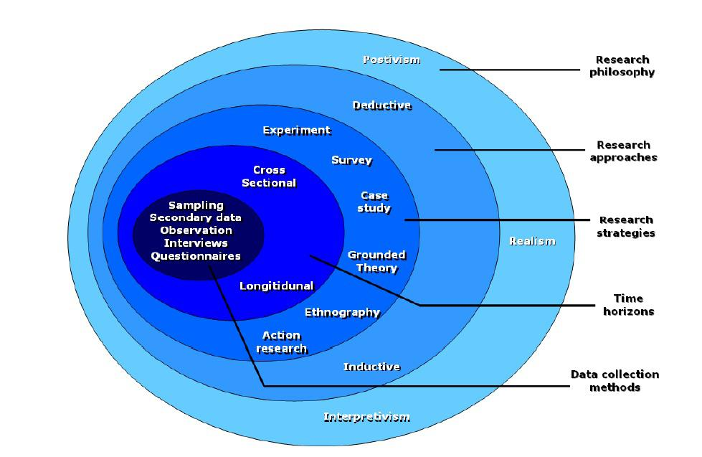
(Institut Numerique, 2012, n.p.).

(3.3) Research viewpoint

The purpose of the research in question is to determine the viewpoint of the mental health of serving police officers and what support they believe are available and how this has differed in the past five years. Hammond (2017) describes ‘pragmatism’ in philosophy as an approach that assesses models and opinions in terms of the triumph of their applied request, hence, if we refer back to the ‘research onion’ this would be taking a ‘pragmatic’ approach which in turn allows for a fluid style towards both qualitative and/or quantitative research (Business Research Methodology, 2022). Dudovskiy (2022) theorises that there is a need for researchers to “modify their philosophical assumptions over time and move to a new position on the continuum”, therefore a further ‘interpretive’ approach may also need to be utilised which is the chosen method adopted by the researcher for this project.

(3.4) Research Approach

This academic study will best suit an ‘inductive’ approach. ‘Inductive Research’ is described as an inquiry that starts with an observation of a problem and aims to analyse ideas related to the problem, hence, inductive research begins with figures that have already been collated and uses that to develop the data (Indeed, 2021). “Inductive research is an approach which the researcher utilises for performing investigation on such type of research topic on which there is little or no existing literature that exists” (Wong, 2020). Albeit, as determined within the literature review, there is literature available documenting mental health amongst police officers, it has also highlighted that little is known in respect of how police are supported within their organisations, so, to concur, this ‘inductive’ approach will unpeel the next layer of the onion which in turn will provide quantitative data to the project.

(3.5) Research Strategy

At this stage, considerations could be made on the particulars of the study perhaps through the ‘deductive approach’. This stage of the ‘research onion’ is associated with data capturing generally through the production and distribution of surveys, such surveys tend to be associated with a quantitative approach to research projects through sampling of the research participants, which in turn licences the accumulation of varied data which can be used to address the aims of the research question (Bryman 2012).
The main aim for this research project is to collect data, through the distribution of an online survey. Gaille (2020) prophesises that utilising surveys when conducting research allows for data collection from various sources with few barriers in place hence the ‘deductive approach’ will be best suited for data collection within this project.

(3.6) Research Choices

The next layer of the ‘onion’ model is choices within research, within this project a survey is the chosen choice. The project will consist of two surveys will entail various questions to facilitate a fluid approach to collect quantitative data. This research method can assist with obtaining a well-rounded view of the project as opposed to an unrelated quantitative or qualitative study, as it mixes benefits of both methods (George, 2021).

(3.7) Timeframe

To conclude, the exhausted layer of the ‘onion’ framework is the ‘Time Horizon’ layer, this stage details how the intended research data will be collected in terms of a timeline (Thisismind, 2019). This section incorporates two methods, ‘longitudinal’ and ‘cross-sectional’ data capturing. ‘Cross-sectional’ data capturing refers to capturing data from numerous participants on one occasion (Simkus, 2021), therefore, a ‘cross-sectional’ approach will be utilised within this project. Within this project, the researcher aims to create two bespoke surveys which will be distributed via Gwent Police internal internet facilities whereby the links to each survey will remain live for a total of ten days before closing for results to be analysed.

(4.0) Techniques

(4.1) Data Collection

Two online surveys will be utilised for this academic project. The surveys will be generated using ‘Survey Monkey’ which is an online survey generator open to creation and distribution of bespoke questionnaires (SurveyMonkey, 2022). The surveys will consist of 10 questions respectively. One survey will be distributed electronically via email amongst serving police officers within Gwent Police of a range of service and rank with the aim to distribute to 10 police personnel. The remaining survey will consist of the same set of 10 questions and will be distributed via email but will be distributed to 10 employees who serve under the ‘wellbeing’ department at Gwent Police. The timeframe window for completion of this survey will be set to ten days.

(4.2) Data Analysis

Analysis of data is fundamental within research projects as ultimately it provides the view to the results gathered from the data collected in relation to a project (Grant, 2020). Data analysis is described as the process in which data is collected, reviewed, and analysed for the purpose of identifying results of an aim (Grant 2020). Data analysis will take place within the project through drawing results gathered from the two surveys and placing the data into graphs using Microsoft Office to facilitate.

(4.3) Limitations

All data collection incurs limitation (Voxco, 2022). Limitations could present within this project due to the survey only being distributed to Gwent Police personnel, this automatically narrows the research into a singular force so the results may not be generalizable. Also, issues may present through the reliability of officers’ engagement if questionnaires are left unresponsive. Furthermore, ethical implications may arise due to the sensitive nature of the surveys and the audience being limited to the wellbeing team within the second survey.

(4.4) Conclusion

To conclude, this methodology has outlined the utmost applicable research suited to the project in hand with the chosen research method being distinguished as an online survey. This survey will aim to address the projects’ question and provide data to support as evidence with the view of answering questions within the study.

(5.0) Results chapter

(5.1) Introduction into the chapter

To collect data for the dissertation, two separate surveys were created by the researcher.
Survey one consisted of ten questions which were anonymous and disseminated on 15th October 2022 amongst fifty serving employees within a well-being post employed at Gwent Police via a link to the survey monkey platform in which the survey was recorded. The link remained live for a total of ten days and gathered a total of twenty-one responses.
Survey two consisted of again, ten questions which were also anonymous and disseminated on 15th October 2022 amongst fifty serving police officers of different rank ranging from Police Constable to Chief Inspector within Gwent Police via a link to the survey monkey platform in which the survey was recorded. The link remained live for a total of ten days and gathered a total of twenty-four responses. Upon closure of the links results were gathered from responses made to the surveys.
The results gathered could pose as an issue within my research and dissertation as the data captured is reflected through lack of envisioned responses. The results are displayed within graphs below.

(5.2) Survey one: Question One

Q1. 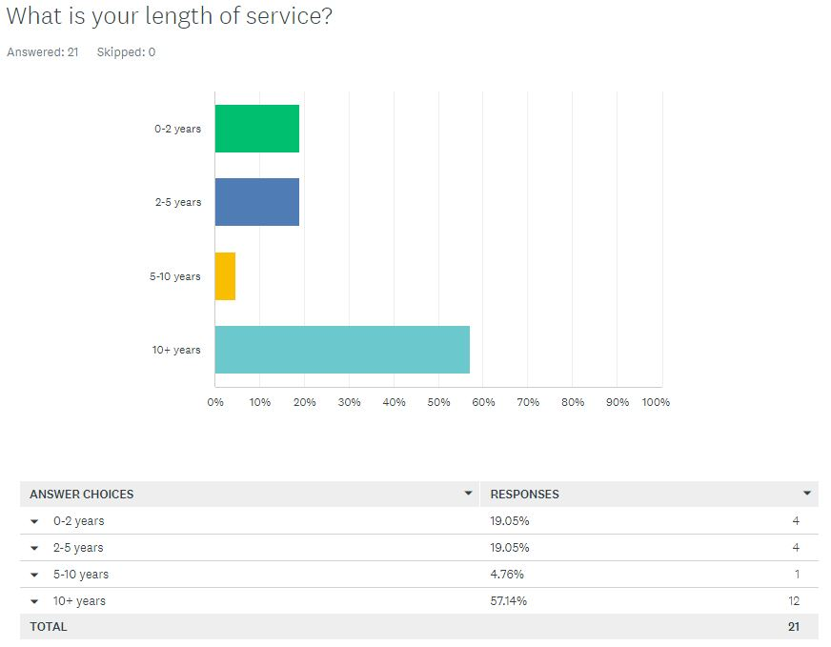
The results in this graph show that 19.05% of responses fell under the ‘0-2 years’ bracket, 19:05% of responses fell under the ‘2-5 years’ bracket, 4.76% of responses fell under the ‘5-10 years’ bracket and 57.14% of responses fell under the ‘10+ years’ bracket.

(5.2.1) Survey one: Question Two

Q2. 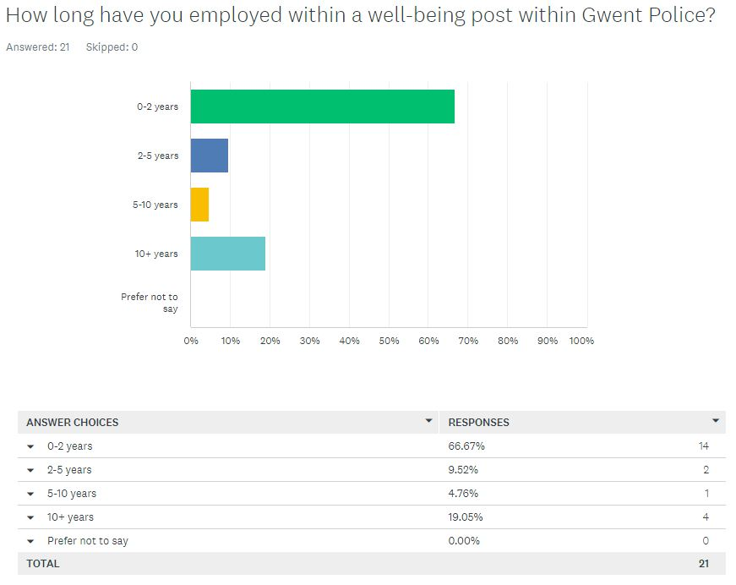
The results in this graph show that 66.67% of responses fell under the ‘0-2 years’ bracket, 9.52% of responses fell under the ‘2-5 years’ bracket, 4.76% of responses fell under the ‘5-10 years’ bracket and 19.05% of responses fell under the ‘10+ years’ bracket. No participants selected the ‘prefer not to say’ bracket.

(5.2.2) Survey one: Question Three

Q3. 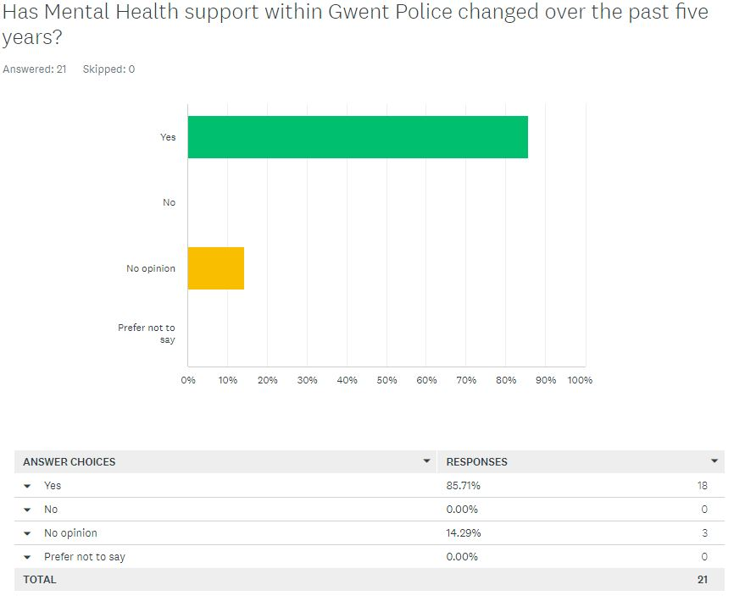
The results in this graph show that 85.71% of responses fell under the ‘yes’ bracket, no responses were gathered under the ‘no’ bracket, 14.29% of responses fell under the ‘no opinion’ bracket. No responses were recorded under the ‘prefer not to say’ bracket.

(5.2.3) Survey one: Question Four

Q4. 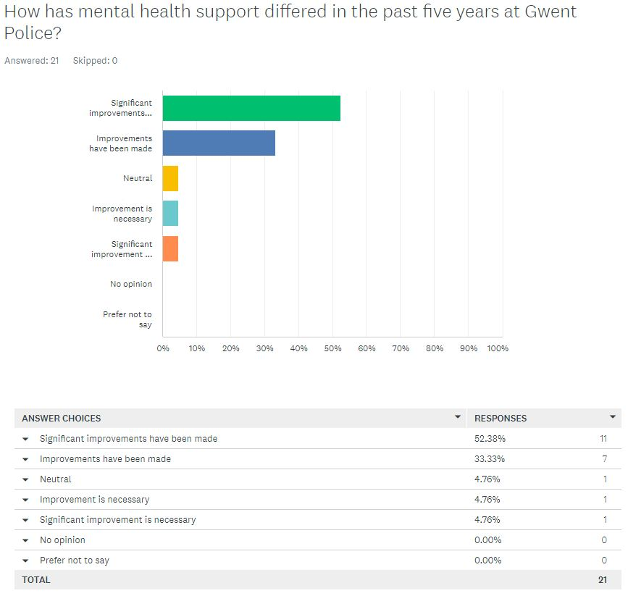
The results in this graph show that 52.38% of responses fell under the ‘significant improvements have been made’ bracket, 33.33% of responses fell under the ‘improvements have been made’ bracket, 4.76% of responses fell under the ‘neutral’ bracket, likewise for both the ‘improvement is necessary’ and ‘significant improvement is necessary’ bracket. No participants selected the ‘no opinion’ and ‘prefer not to say’ bracket.

(5.2.4) Survey One: Question Five

Q5. 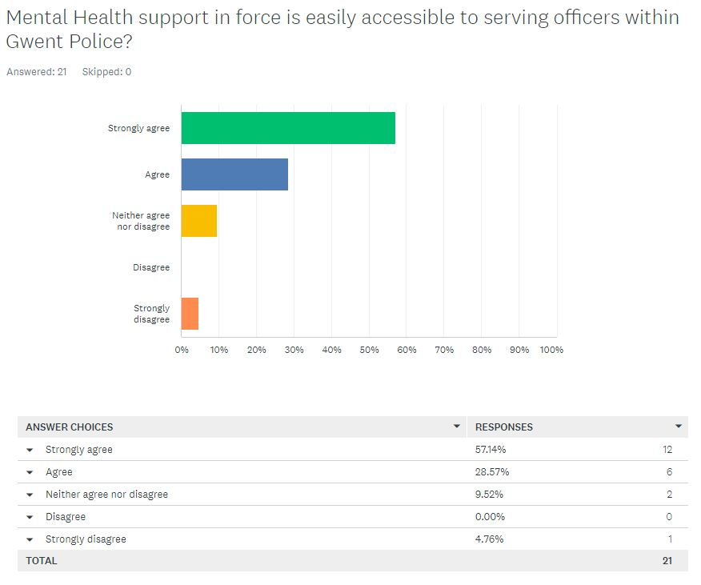
The results in this graph show that 57.14% of responses fell under the ‘strongly agree’ bracket, 28.57% of responses fell under the ‘agree’ bracket, 9.52% of responses fell under the ‘neither agree nor disagree’ bracket, 4.76% of responses fell under the ‘strongly disagree’ bracket. No responses were recorded under the ‘disagree’ bracket.

(5.2.5) Survey One: Question six

Q6. 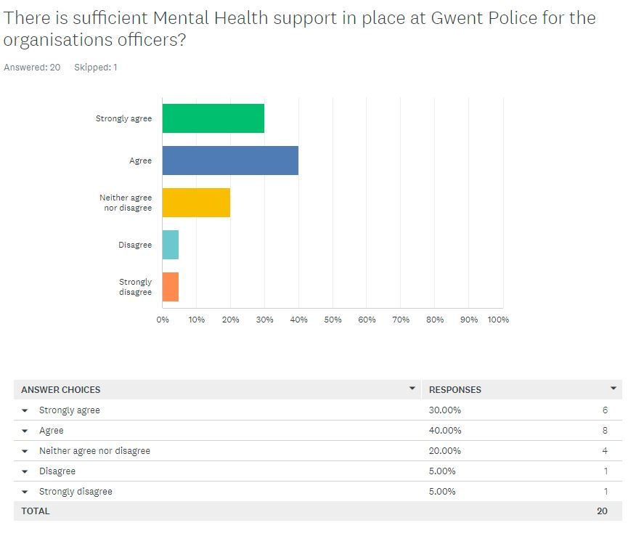
The results in this graph show that 30% of responses fell under the ‘strongly agree’ bracket, 40% of responses fell under the ‘agree’ bracket, 20% of responses fell under the ‘neither agree nor disagree’ bracket, 5% of responses were recorded under the ‘disagree’ bracket, likewise for the ‘strongly disagree’ bracket.

(5.2.6) Survey One: Question Seven

Q7. 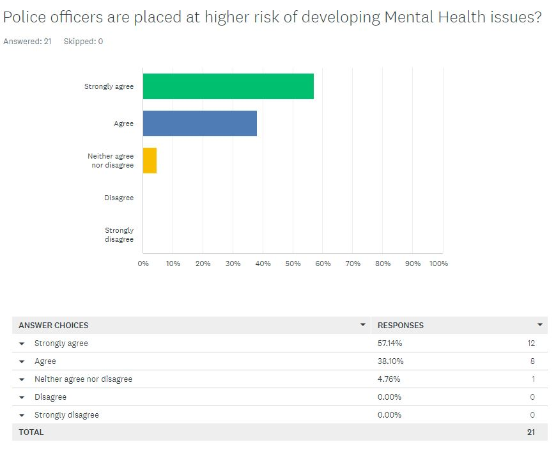
The results in this graph show that 57.14% of responses fell under the ‘strongly agree’ bracket, 38.10% of responses fell under the ‘agree’ bracket, 4.76% of responses fell under the ‘neither agree nor disagree’ bracket, no responses were recorded under both the ‘disagree’ and ‘strongly disagree’ brackets.

(5.2.7) Survey One: Question Eight

Q8. 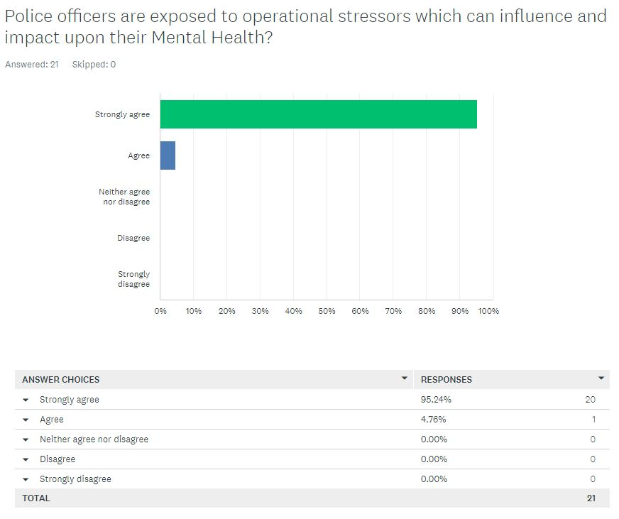
The results in this graph show that 95.24% of responses fell under the ‘strongly agree’ bracket, 4.76% of responses fell under the ‘agree’ bracket, no responses were recorded under ‘neither agree nor disagree’, ‘disagree’ and ‘strongly disagree’ brackets.

(5.2.8) Survey One: Question Nine

Q9. 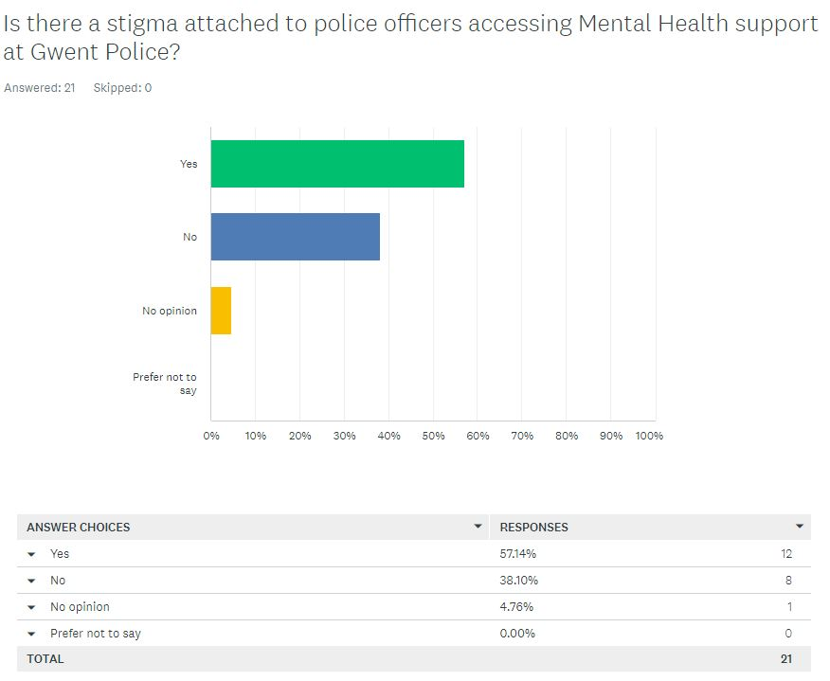
The results in this graph show that 57.14% of responses fell under the ‘yes’ bracket, 38.10% of responses fell under the ‘no’ bracket, 4.76% of responses fell under the ‘no opinion’ bracket. No participants selected the ‘prefer not to say’ bracket.

(5.2.9) Survey One: Question Ten

Q10. 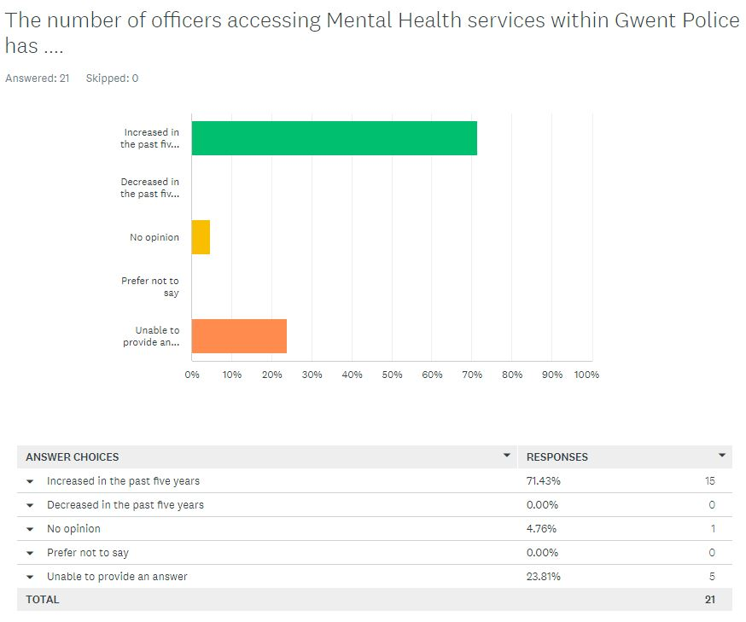
The results in this graph show that 71.43% of responses fell under the ‘increased in the past five years’ bracket, no responses were recorded under the ‘decreased in the past five years’ bracket, 4.76% of responses fell under the ‘no opinion’ bracket, 4.76%, No responses were recorded under the ‘prefer not to say’ bracket, 23.81% of responses fell under the ‘unable to provide an answer’ bracket.

(5.3) Survey Two

(5.3.1) Survey Two: Question One

Q1. 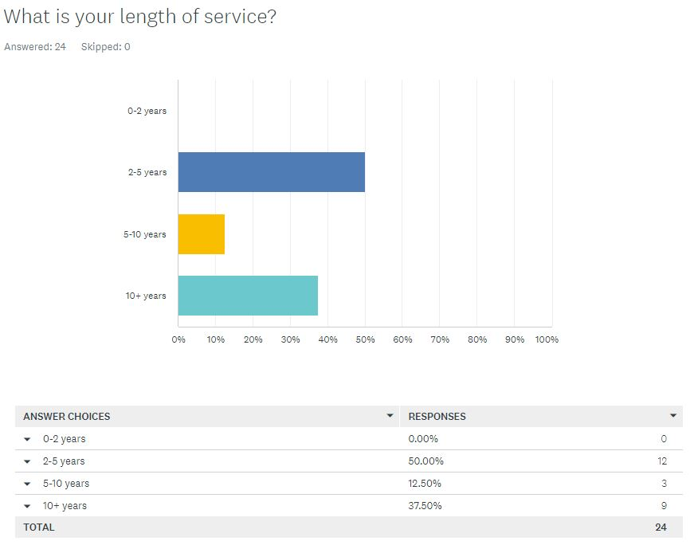
The results in this graph show that 50% of responses fell under the ‘2-5 years’ bracket, 12.50% of responses fell under the ‘5-10 years’ bracket and 37.50% of responses fell under the ‘10+ years’ bracket. No responses were recorded under the ‘0-2 years’ bracket.

(5.3.2) Survey Two: Question Two

Q2. 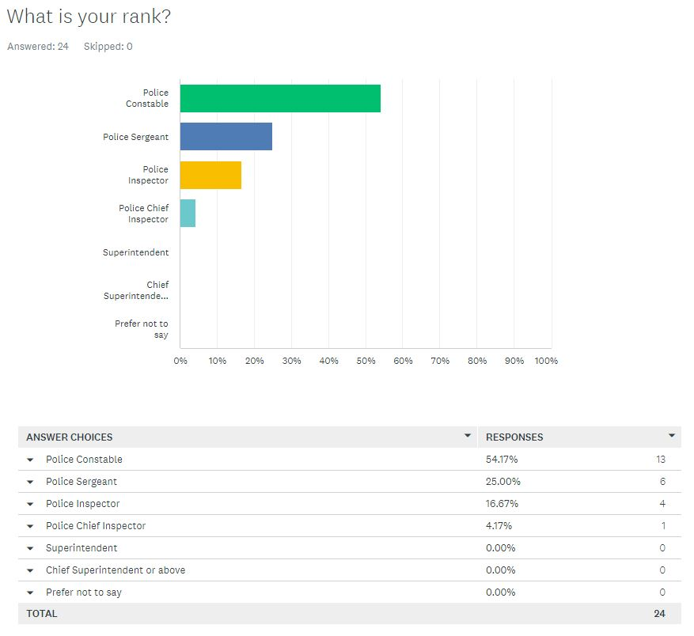
The results in this graph show that 54.17% of responses fell under the ‘police constable’ bracket, 25% of responses fell under the ‘police sergeant’ bracket, 16.67% of responses fell under the ‘police inspector’ bracket, 4.17% of responses were recorded under the ‘police chief inspector’. No participants selected the ‘superintendent’, ‘chief superintendent or above’ or ‘prefer not to say’ brackets.

(5.3.4) Survey Three: Question Three

Q3. 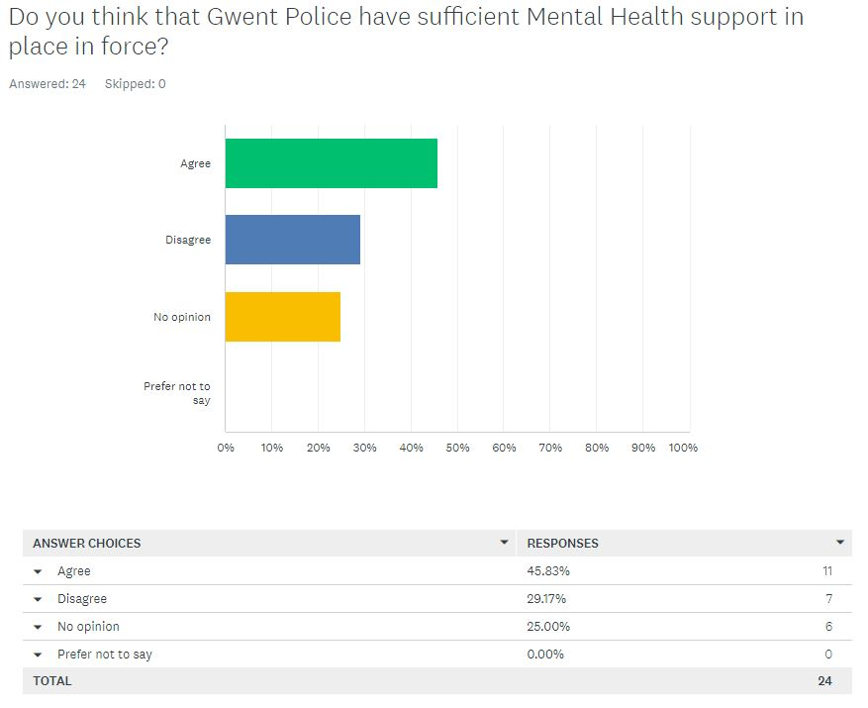
The results in this graph show that 46.83% of responses fell under the ‘agree’ bracket, 29.17% of responses fell under the ‘disagree’ bracket, 25% of responses fell under the ‘no opinion’ bracket. No responses were recorded under the ‘prefer not to say’ bracket.

(5.3.5) Survey Two: Question Four

Q4. 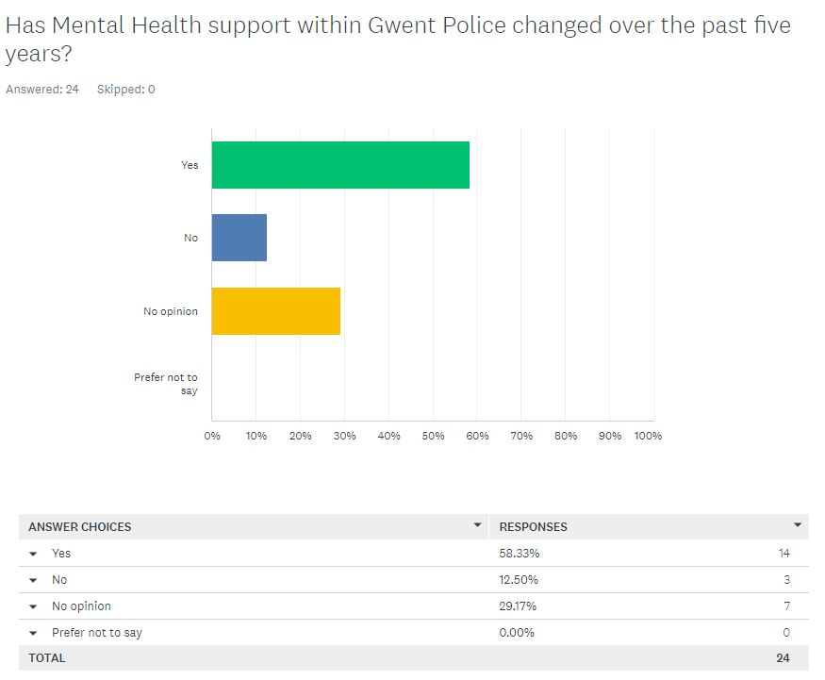
The results in this graph show that 58.33% of responses fell under the ‘yes’ bracket, 12.50% of responses fell under the ‘no’ bracket, 29.17% of responses fell under the ‘no opinion’ bracket. No participants selected the ‘prefer not to say’ bracket.

(5.3.6) Survey Two: Question Five

Q5. 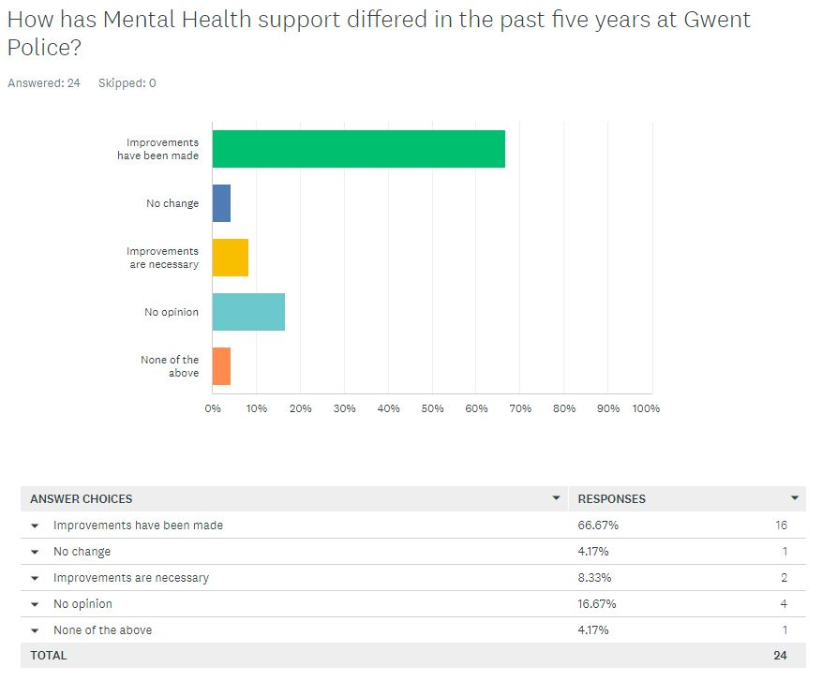
The results in this graph show that 66.67% of responses fell under the ‘improvements have been made’ bracket, 4.17% of responses fell under the ‘no change’ bracket, 8.33% of responses fell under the ‘improvements are necessary’ bracket, 16.67% of responses fell under the ‘no opinion’ bracket and 4.17% of responses fell under the ‘none of the above’ bracket.

(5.3.7) Survey Two: Question Six

Q6. 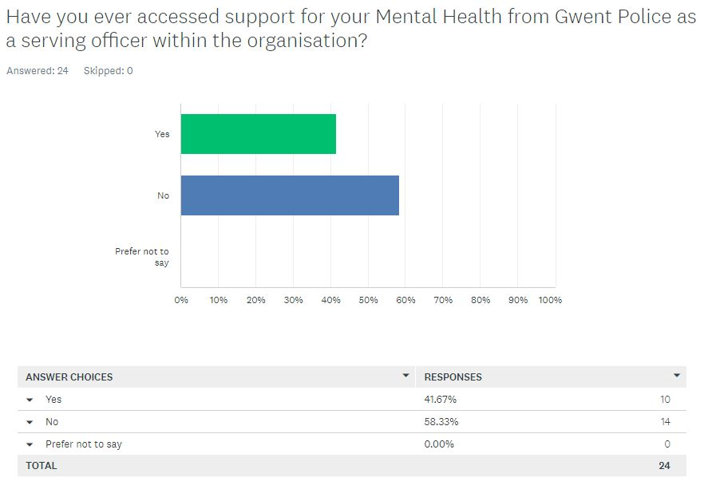
The results in this graph show that 41.67% of responses fell under the ‘yes’ bracket, 58.33% of responses fell under the ‘no’ bracket. No responses were recorded under the ‘prefer not to say’ bracket.

(5.3.8) Survey Two: Question Seven

Q7. 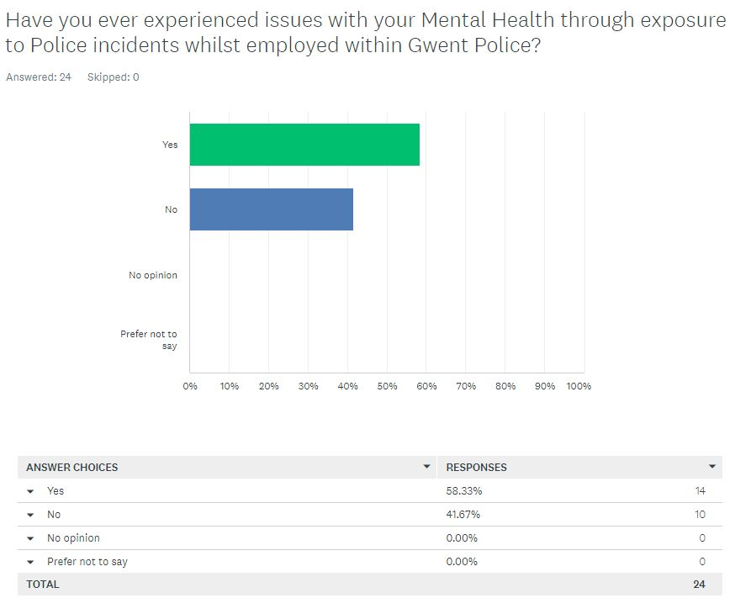
The results in this graph show that 58.33% of responses fell under the ‘yes’ bracket, 41.67% of responses fell under the ‘no’ bracket. No responses were recorded under the ‘prefer not to say’ and ‘no opinion’ brackets.

(5.3.9) Survey Two: Question Eight

Q8. 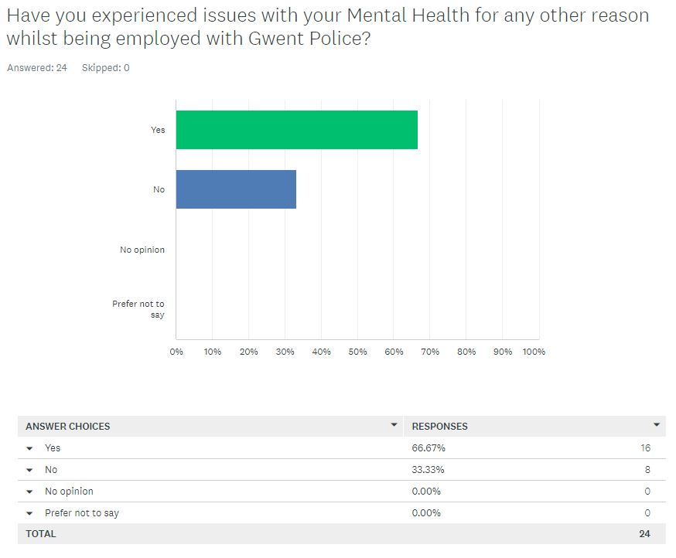
The results in this graph show that 66067% of responses fell under the ‘yes’ bracket, 33.33% of responses fell under the ‘no’ bracket. No responses were recorded under the ‘prefer not to say’ and ‘no opinion’ brackets.

(5.3.10) Survey Two: Question Nine

Q9. 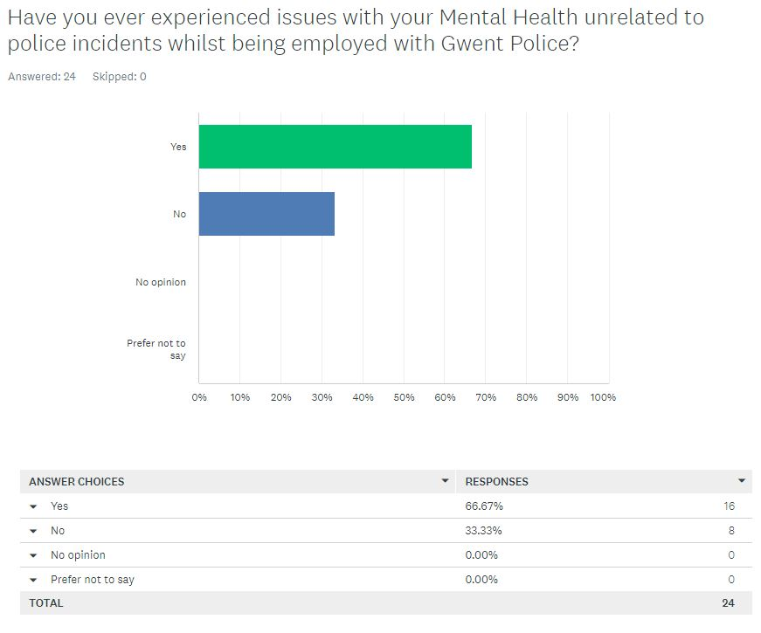
The results in this graph show that 66.67% of responses fell under the ‘yes’ bracket, 33.33% of responses fell under the ‘no’ bracket. No responses were recorded under the ‘prefer not to say’ and ‘no opinion’ brackets.

(5.3.11) Survey Two: Question Ten

Q10. 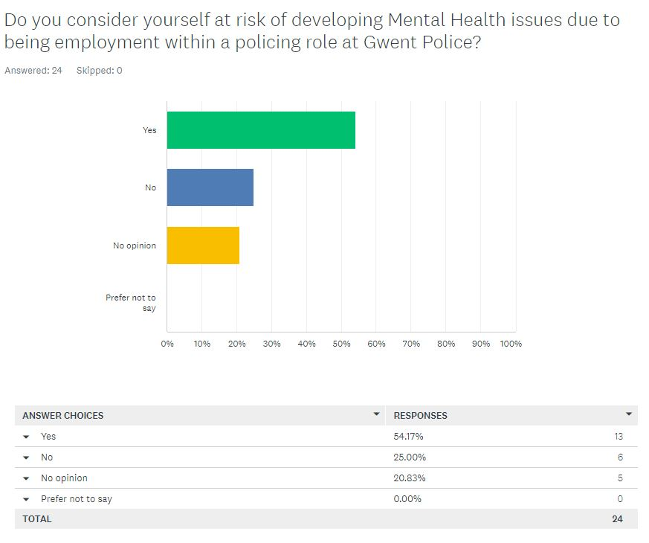
The results in this graph show that 54.17% of responses fell under the ‘yes’ bracket, 25% of responses fell under the ‘no’ bracket, 20.83% of responses fell under the ‘no opinion’ bracket. No responses were recorded under the ‘prefer not to say’ and ‘no opinion’ brackets.

(5.4) Results chapter: Conclusion

In conclusion, the researcher has identified through their research that current serving police officers employed within Gwent Police believe that mental health issues are still present which are a direct impact because of being exposed to trauma through incidents that present under part of their job role. However, the results also detailed that the respondents believe that access to mental health services within the workplace have improved.
Furthermore, this viewpoint was also shared by respondents employed under a well-being post within Gwent Police as figures from the results have displayed that even though such respondents still recognise that there is still stigma around accessing mental health services within the police, more employees are accessing the support compared to that of five years prior.
The succeeding chapter will observe the collated data in larger complexity to discover any themes or patterns, hence, tolerating recommendations to be made for raising cognizance in mental health access and support for serving police officers.

(6.0) Findings and Conclusion

(6.1) Introduction

The earlier chapters of the research project have run fluently, beginning with the introduction, into a literature review, through into research methods, preparation, and examination of completed research with the preceding chapter studying the results from the primary data collected through the quantitative research. As a result of the quantitative data analysis, bulbous themes emerged that meticulously resemble to comparable findings reported in the research project's literature review. This chapter will rely on these specifically detail these predispositions and will provide recommendations. This finalise this chapter a conclusion will be included by the researcher in relation to issues that were experienced with police officers reporting and accessing support for their mental health, as well as dictating whether any further academic research is necessary within this topic.

(6.2) Achievement of objectives

The aim of this research project was to identify the following objectives;
- Identify police incidents that have happened in the past which have had a detrimental effect on the public perception of policing and what links such incidents could have imposed upon the mental health of police officers.

- Determine any differences through research data and literature in mental health support available to police officers, time scale between present day and five years past.

The above objectives were accomplished through expelling a thorough literature review which absorbed and identified existing academic literature tackling the stigma that is attached to mental health amongst serving police officers and the support that is available to police officers to address their mental health needs currently compared to that of previous years. The literature has also revealed previous police incidents and the mental health impact that police officers have been left with post incidents.

- Complete two individual surveys with Police officers and employees within wellbeing roles employed under Gwent Police to gather their viewpoints and reflections on mental health and support within Gwent Police.

Objective three was completed by utilising the research onion (Saunders et al, 2016). The research onion method provided the researcher with a strategy to methodically collate data via two surveys to collect information from participants to assist with the validation or renunciation of viewpoints discussed within the literature review chapter of the project.
- To gather, investigate and parade collated data from the research completed via the surveys to establish themes and make recommendations.

The fourth objective was fulfilled through the researcher distributing two separate bespoke surveys amongst a total of one hundred employees under Gwent Police utilising the ‘Survey Monkey’ online platform and ultimately sharing the survey using the internal emailing system. This research method allowed the researcher to collate quantitative data for scrutiny. The data was in turn, compared to existing literature and studies to identify any themes and pave the way for the researcher to make recommendations.

(6.3) Main findings

Based on the results collated by the researcher in relation to this research project, it is apparent that mental health issues are still present amongst police officers but are now more recognised. The primary data supports the secondary data in the literature review. The researcher compared the two sets of research and identified that there although support for mental health for police officers is more recognised in modern day society, there is still a degree of stigma in accessing it.

(6.3.1) – Research question 1 – What is mental health and what are the leading causes in developing poor mental health?

The findings from the secondary data outlined that mental health can present in many forms and is not discriminatory. The data collected from the primary research method suggested that not all respondents may have viewed the questions within the surveys the same as the data collated did not marry up to an obvious theme, hence the researcher was unable to identify a generalised reflection from the primary results on the viewpoints of the respondents in relation to this question. This may suggest that there is a gap in the primary research, hence further research is needed to address this question in more depth.

(6.3.2) – Research question 2 – What are the operational stressors in which police officers are exposed to and do these stressors directly link as a contributing factor upon police officers’ mental health?

The findings from the secondary research method adopted suggested that there is a link between the mental health status of police officers upon attendance of traumatic and high-tension incidents. The findings within the primary research conducted complimented the existing literature and displayed a strong response with a total of 33 out of 45 respondents ‘strongly agreeing’ that police officers are exposed to operational stressors which can influence and impact their mental health.

(6.3.3) – Research question 3 – Are police officers placed at higher risk of developing mental health issues?

The findings of the quantitative research primarily complimented the literature review of the project through detached statistics of mental health present amongst police officers, the researcher explored this further through both surveys. Survey one contained the question – ‘Police officers are placed at higher risk of developing mental health issues’. Findings from the collated data exposed that 57.14% of respondents ‘strongly agreed’ with this statement, additionally 38.10% of respondents ‘agreed’ with the statement. Finally, 4.76% of respondents ‘neither agreed nor disagreed’ with the claim.
Subsequently, survey two posed the question ‘Have you ever experienced issues with your mental health through exposure to police incidents whilst employed within Gwent Police’ to active participants. Figures collated from the survey outlined that 88.83% of responses answered ‘Yes’ and 41.67% of participants answered ‘No’ to the question.
However, there could be a degree of anomaly from the results as these results only reflect the viewpoints of the participants that engaged within the surveys. As previously identified, the researcher had forecast for a total of 100 responses but only 45 were achieved.

(6.3.4) – Research question 4 – What support is available to police officers with mental health issues and how does this support differ to support that was available to police officers five years past?

According to Butterworth (2021) “Police forces are facing a mental health crisis like never before”. The succeeding objective for attainment within the project was to identify any changes within mental health services endorsed within Gwent Police. The data collated from the primary research allowed the researcher to obtain knowledge from serving police officers and staff which would in turn help the researcher and reader of the study to gain an understanding. Albeit a total of 26 out of 45 respondents shared the viewpoint that ‘significant improvements have been made’ within mental health support at Gwent Police in the past five years. However, there may be some degree of collusion within this data as it only reflects opinions of serving officers within Gwent Police, further research is needed to understand how exactly the support has changed.

(7.0) Recommendations

The subsequent recommendations reflect perceptions that have presented from findings within this research project. The assessment from respondents of the primary research surveys outlined that mental health issues are still apparent amongst police officers in modern day policing, albeit improvements have been made for access to support to tackle such issues being experienced compared to five years past. Although judgement from the participants reflects that improvements have been made, the common theme appears to be that there is recognition that police officers are subject to stressors as an impact of their role which in turn sustains the need for support as mental health issues are more likely to present due to the nature of their job. It is apparent that recommendations will need to be made to continue to make improvements. This can be achieved through:

(7.1) Recommendation One: Completing further research

Research conducted by Elite Research (2022) dictates that several things could go wrong when collecting data which in turn may frustrate the project through distorted findings. The views collated from the research methods utilised by the researcher within this project represent views of participants specific to Gwent Police as this was the chosen police force to utilise for the purpose of this project. Additionally, it was acknowledged by the researcher that using the data collated from the participants of the surveys within permitted the researcher to lecture principal points of information for analysis to further present for debate, caveat being that the data retrieved was limited to the representations and views of personnel employed within Gwent Police and not retrospective of other forces in the United Kingdom. Not all the gathered figures will be deliberated due to conflictions through time restraints and boundaries of word count
The researcher found that a problem had presented itself within the data collection of this research project through lack of envisioned responses. The researcher projected a response from all participants of both surveys, in survey one was sent to a total of fifty persons and returned a response from only twenty-one participants. Survey two was sent out to a total of fifty persons also and returned a response from only twenty-four participants.

(8.0) Conclusion

To conclude from studying the primary and secondary research, it reveals that police officers are exposed to traumatic incidents which in turn has an impact upon their mental health, however, it is more recognised in modern day society and further support is in place to address the topic compared to previous years. This verifies that the project hypothesis is correct.
The dissertation has concentrated on the impact of operational stressors that police officers are subject to and has identified the support in place now, compared to five years past. The researcher has implemented an unbiased attitude and has emphasised the profits of the current level of backing. Through the creation of this research project, the researcher has identified gaps in both primary and secondary data which has been addressed within the study. These gaps hold the capacity to be researched and investigated further to assistance in developing further information and data to increase care and consciousness within the topic. This research project has provided attentiveness and familiarity to the existing matters surrounding the topic, with the optimism that additional resources would be announced to recognise future care and provision needs that may present to provide future support to police officers experiencing mental health issues.

(9.0) Bibliography

Bryman, A. (2012). Social research methods (5th ed.). Oxford: Oxford University Press.
Butterworth, B., (2021) Police officers face mental health crisis with three-quarters having difficulties in last year. [online] inews.co.uk. Available at: <https://inews.co.uk/news/uk/more-than-three-quarters-police-officers-struggled-with-mental-health-last-year-report-finds-1119989> [Accessed 27 June 2022].
CDC., (2021) Mental Health. Centers for Disease Control and Prevention. Retrieved January 7, 2023, from https://www.cdc.gov/mentalhealth/learn/index.htm#:~:text=Mental%20health%20includes%20our%20emotional,others%2C%20and%20make%20healthy%20choices.&text=Mental%20health%20is%20important%20at,childhood%20and%20adolescence%20through%20adulthood.
Collins, M., (2019) National Strategy on Policing and mental health. [online] Npcc.police.uk. Available at:<https://www.npcc.police.uk/Mental%20Health/Nat%20Strat%20Final%20v2%2026%20Feb%202020.pdf> [Accessed 23 July 2022].
Craigie, R., 2022. Manchester Arena bombing: Lessons learnt from a mass casualty incident. BMJ Military Health, 166(2).
Crime Investigation. (2022) Raoul Moat - Crime Files. [online] Available at: <https://www.crimeinvestigation.co.uk/crime-files/raoul-moat> [Accessed 7 May 2022].
Debois, S., (2022) 10 Advantages and Disadvantages of Questionnaires - Survey Anyplace. [online] Survey Anyplace. Available at: <https://surveyanyplace.com/blog/questionnaire-pros-and-cons/> [Accessed 7 May 2022].
Dictionary.cambridge.org. (2022). research. [online] Available at: <https://dictionary.cambridge.org/dictionary/english/research> [Accessed 4 September 2022].
Dudovskiy, J., (2022). The ultimate guide to writing a dissertation in business studies. 1st ed. United Kingdom: Research Methodology, pp.22-25.
Elite research (2022) - What are some data collection challenges and how do you overcome them? (part 1), Elite Research Statistical Consulting - What Are Some Data Collection Challenges and How Do You Overcome Them (1)? [Available at: https://eliteresearch.com/what-are-some-data-collection-challenges-and-how-do-you-overcome-them-1] (Accessed: November 13, 2022).
Gaille, L., (2020). 20 Advantages and Disadvantages of Survey Research. [online] Vittana.org. Available at: <https://vittana.org/20-advantages-and-disadvantages-of-survey-research> [Accessed 4 September 2022].
George, T., (2021). Mixed Methods Research | Definition, Guide & Examples. [online] Scribbr. Available at: <https://www.scribbr.com/methodology/mixed-methods-research/> [Accessed 4 September 2022].
Goodlatte, B., (2017) The Importance of Mental Health Among Police Officers. [online] www.gop.gov. Available at: <https://www.gop.gov/the-importance-of-mental-health-among-police-officers/> [Accessed 23 July 2022].
Grant, A., (2020). What Is Data Analysis and Why Is It Important?. [online] MUO. Available at: <https://www.makeuseof.com/tag/what-is-data-analysis/> [Accessed 4 September 2022].
Gwent Police and Crime Commissioner. (2017) Commitment to Mental Health Well-Being. [online] Available at: <https://www.gwent.pcc.police.uk/en/news-room/commitment-to-mental-health-well-being/> [Accessed 23 July 2022].
Hammond, M., (2017). what is pragmatism. [online] Warwick.ac.uk. Available at: <https://warwick.ac.uk/fac/soc/ces/research/current/socialtheory/maps/pragmatism/> [Accessed 4 September 2022].
Hampshire College. (2022). What is Research?. [online] Available at: <https://www.hampshire.edu/what-research> [Accessed 4 September 2022].
Heddlu Gwent Police. (2022) Overview. [online] Available at: <https://www.gwent.police.uk/police-forces/gwent-police/areas/about-us/about-us/overview/> [Accessed 7 May 2022].
Help For Our Heroes. (2022) The Impact of Mental Illness on Police Officers - Help For Our Heroes. [online] Available at: <https://helpforourheroes.com/the-impact-of-mental-illness-on-police-officers/#:~:text=For%20years%2C%20police%20officers%20tried%20to%20maintain%20a,This%20ends%20up%20discouraging%20help-seeking%20behaviors%20when%20needed.> [Accessed 23 July 2022].
Indeed Career Guide. (2021). Inductive Research: What It Is, Who Uses it and How. [online] Available at: <https://www.indeed.com/career-advice/career-development/inductive-research#:~:text=Inductive%20research%20is%20an%20investigation%20that%20begins%20with,a%20hypothesis%20on%20what%20led%20to%20the%20data.> [Accessed 4 September 2022].
Institut-numerique.org. (2012). CHAPTER 3: RESEARCH METHODOLOGY. [online] Available at: <https://www.institut-numerique.org/chapter-3-research-methodology-4ffbd6e5e3391> [Accessed 4 September 2022].
Jansen, D., (2021). Saunders' Research Onion: Explained Simply (+ Examples) - Grad Coach. [online] Grad Coach. Available at: <https://gradcoach.com/saunders-research-onion/> [Accessed 4 September 2022].
Kutcher, S., Wei, Y. and Coniglio, C., (2016) Mental Health Literacy. The Canadian Journal of Psychiatry, 61(3), pp.154-158.
Legislation.gov.uk. (2022). Mental Health Act 1983. [online] Available at: <https://www.legislation.gov.uk/ukpga/1983/20/section/1> [Accessed 23 July 2022].
Legislation.gov.uk. (2022) Police, Crime, Sentencing and Courts Act 2022. [online] Available at: <https://www.legislation.gov.uk/ukpga/2022/32/contents/enacted> [Accessed 23 July 2022].
Marshall, R., Milligan-Saville, J., Petrie, K., Bryant, R., Mitchell, P. and Harvey, S., (2021) Mental health screening amongst police officers: factors associated with under-reporting of symptoms. BMC Psychiatry, 21(1).
Mental Health Foundation. (2019) Mental Health Foundation | Good mental health for all. [online] Available at: <https://www.mentalhealth.org.uk/> [Accessed 23 July 2022].
Miller, J., (2019) Police workforce: almost one in five suffer with a form of PTSD. [online] University of Cambridge. Available at: <https://www.cam.ac.uk/policeptsd> [Accessed 23 July 2022].
Mind.org.uk. (2017) Police - How to manage stress and anxiety - Blue light programme. [online] Available at: <https://www.mind.org.uk/media-a/4183/blue-light-stress-anxiety-police-2017.pdf> [Accessed 28 April 2022].
Mind.org.uk. (2019) Mental health amongst emergency services. [online] Available at: <https://www.mind.org.uk/media-a/4849/2019-survey-police-service-summary.pdf> [Accessed 23 July 2022].
Mind.org (2022) What causes Mental Health problems. [online] Available at: <https://www.mind.org.uk/information-support/types-of-mental-health-problems/mental-health-problems-introduction/causes/> [Accessed 27 June 2022].
Model, T., (2010). The Research Process Model - Helping Research writing for student & professional researchers. [online] Helping Research writing for student & professional researchers. Available at: <http://researcharticles.com/index.php/research-process-model/> [Accessed 4 September 2022].
Narvekar, H. and D’Cunha, T., (2020) Operational Stress Levels and Adjustment-Neuroticism Among Police Personnel in Goa. Journal of Police and Criminal Psychology, 36(2), pp.159-169.
NHS.UK. (2022) Stress - Every Mind Matters. [online] Available at: <https://www.nhs.uk/every-mind-matters/mental-health-issues/stress/> [Accessed 28 April 2022].
Npcc.police.uk. (2019) The National Strategy on Policing and Mental Health. [online] Available at: <https://www.npcc.police.uk/Mental%20Health/Nat%20Strat%20Final%20v2%2026%20Feb%202020.pdf> [Accessed 23 July 2022].
Pidd, H., (2012) Worlds Collide: The Manchester Bombing review – an agonising string of missed opportunities | Television | The Guardian. [online] Amp.theguardian.com. Available at: <https://amp.theguardian.com/tv-and-radio/2022/apr/11/worlds-collide-the-manchester-bombing-review-an-agonising-string-of-missed-opportunities> [Accessed 7 May 2022].
Police Care UK., (2019) - Rebuilding lives for a brighter future. 2019. Mental health strategy for policing urgently required - Police Care UK. [online] Available at: <https://www.policecare.org.uk/mental-health-strategy-for-policing-urgently-required/> [Accessed 23 July 2022].
Polfed.org. (2016) Mental Health. [online] Available at: <https://www.polfed.org/mentalhealth> [Accessed 23 July 2022].
Police Firearm Officer Association PFOA. (2017) Police Mental Health sickness up by 47%. [online] Available at: <https://www.pfoa.co.uk/blog/police-mental-health-sickness-up-by-47> [Accessed 23 July 2022].
Research-Methodology. (2022). Pragmatism Research Philosophy - Research-Methodology. [online] Available at: <https://research-methodology.net/research-philosophy/pragmatism-research-philosophy/> [Accessed 4 September 2022].
Setti, I. and Argentero, P., (2013) The influence of operational and organizational stressors on the well-being of municipal police officers. [online] PubMed. Available at: <https://pubmed.ncbi.nlm.nih.gov/24180085/> [Accessed 23 July 2022].
Shane, J., (2010) Organizational stressors and police performance. Journal of criminal justice, 38(4), pp.807-818.
Simkus, J., (2021). Cross-Sectional Study | Definition, Designs & Examples - Simply Psychology. [online] Simplypsychology.org. Available at: <https://www.simplypsychology.org/what-is-a-cross-sectional-study.html> [Accessed 4 September 2022].
Stefanik, E., (2017) The Importance of Mental Health Among Police Officers. [online] www.gop.gov. Available at: <https://www.gop.gov/the-importance-of-mental-health-among-police-officers/> [Accessed 27 June 2022].
SurveyMonkey. (2022). SurveyMonkey: The World’s Most Popular Free Online Survey Tool. [online] Available at: <https://www.surveymonkey.com/> [Accessed 4 September 2022].
Thisismind. (2019). The Research Onion. [online] Available at: <https://thesismind.com/analysis-of-saunders-research-onion/> [Accessed 4 September 2022].
Thompson, C., (2022). How to Use a Theory to Frame Your Research Study - Nursing Education Expert. [online] Nursing Education Expert. Available at: <http://nursingeducationexpert.com/theory-frame-research/> [Accessed 4 September 2022].
Voxco.com. (2022). Limitations of survey research. [online] Available at: <https://www.voxco.com/blog/the-methodological-limitations-of-survey-research/> [Accessed 4 September 2022].
Watson, L. and Andrews, L., (2018) The effect of a Trauma Risk Management (TRiM) program on stigma and barriers to help-seeking in the police. International Journal of Stress Management, 25(4), pp.348-356.
Who.int. (2022) Mental health: strengthening our response. [online] Available at: <https://www.who.int/news-room/fact-sheets/detail/mental-health-strengthening-our-response> [Accessed 27 June 2022].
Wong, A., (2020). Inductive Research. [online] Singapore Assignment Help. Available at: <https://www.singaporeassignmenthelp.com/blogs/inductive-research/#:~:text=Inductive%20is%20a%20research%20approach%20which%20the%20researcher,investigator%20design%20theory%20after%20completion%20of%20the%20study.> [Accessed 4 September 2022].

(10) Appendices

(10.1) Appendix One: Survey One

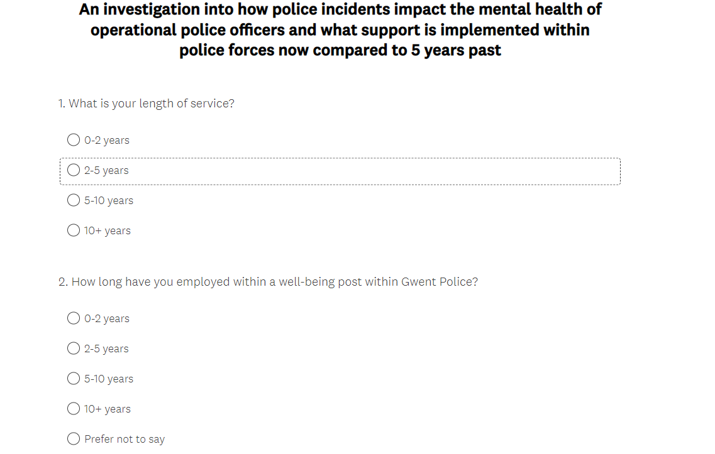

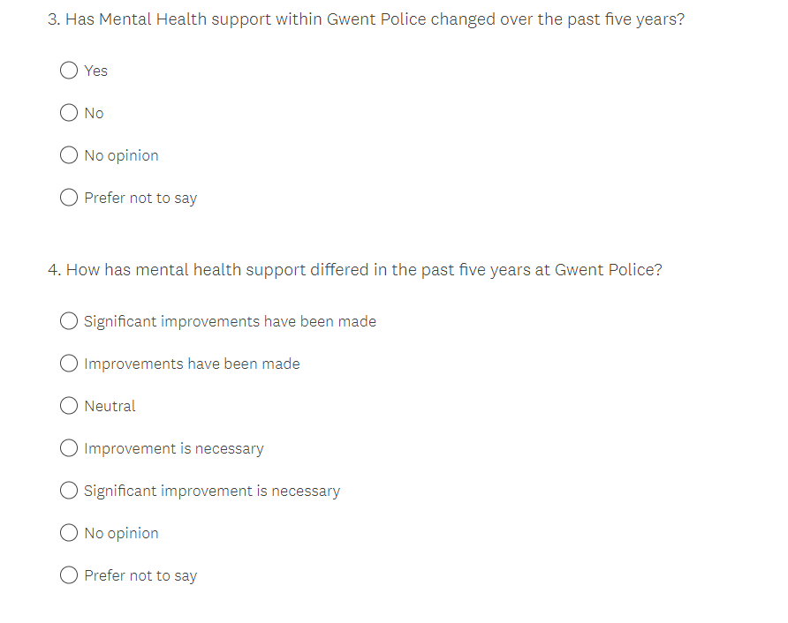
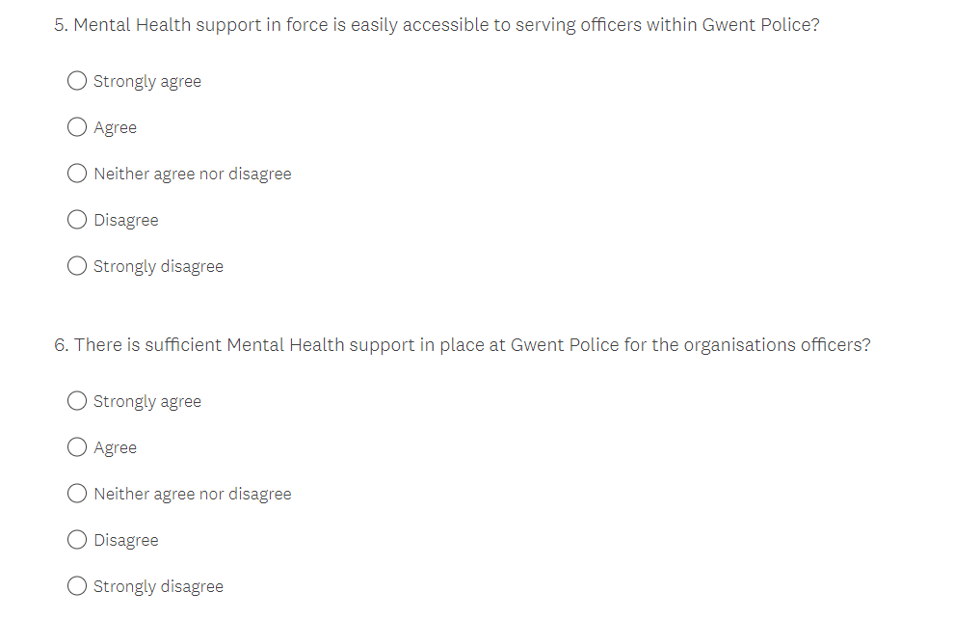

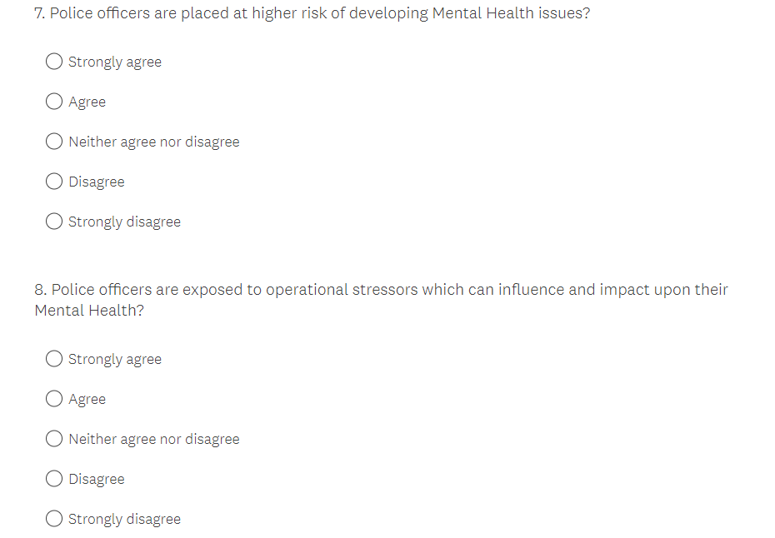

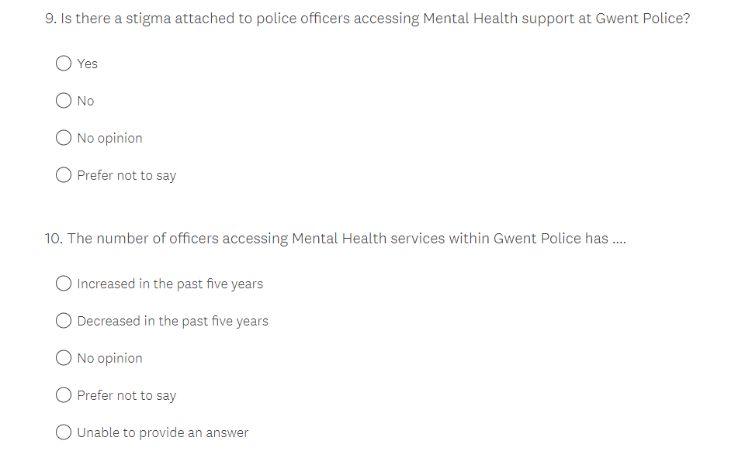

(1.2) Appendix Two: Survey Two

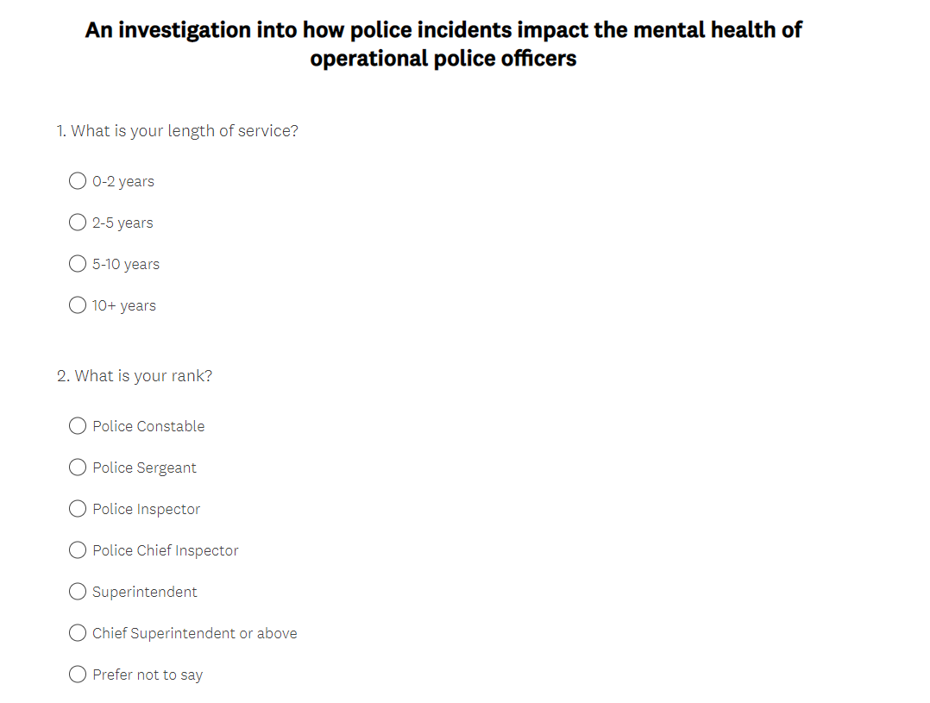
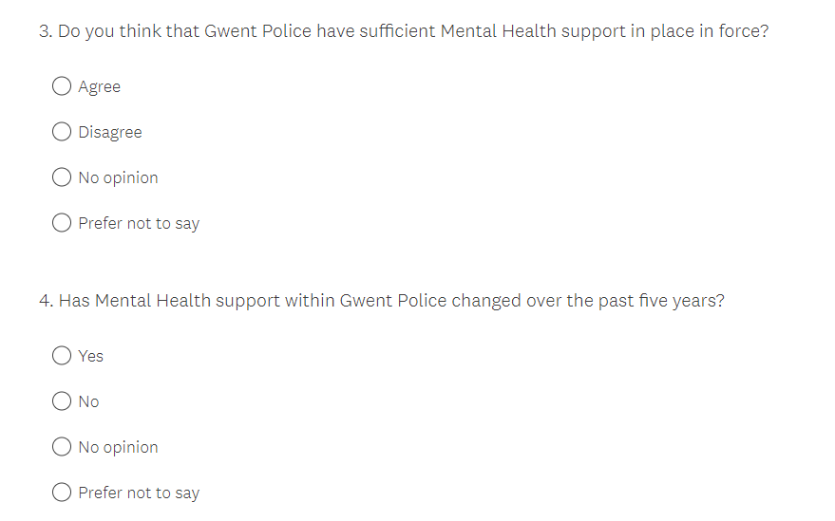

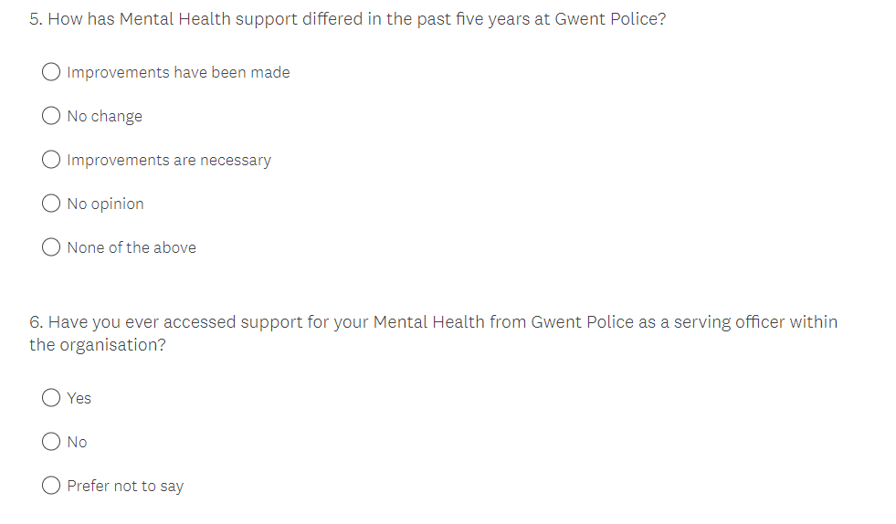
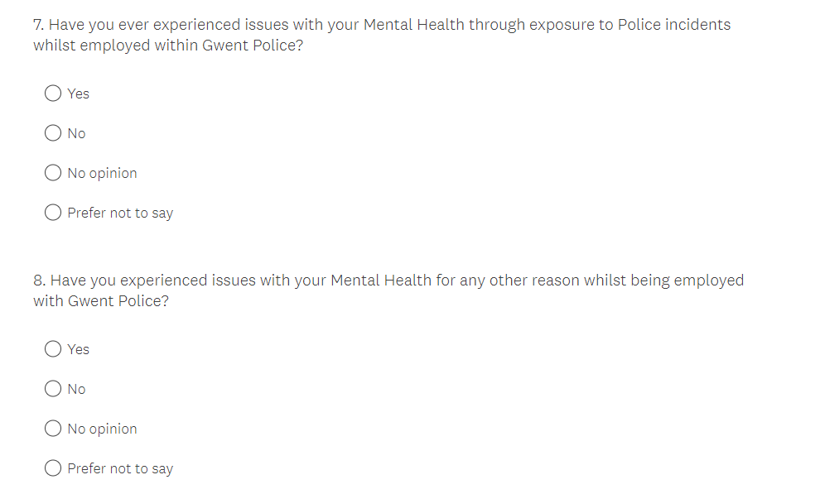

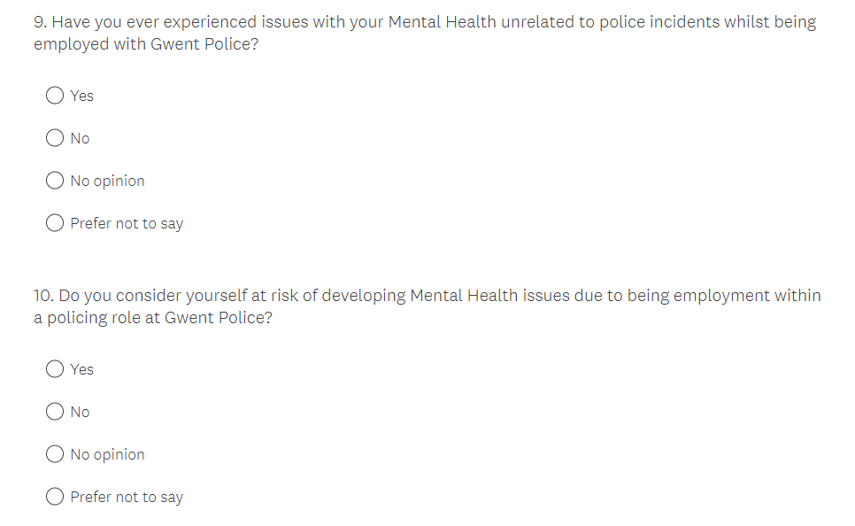

(10.3) Appendix Three: Survey one results

Appendix Four: Survey two results

(11) Appendix Three: Dissertation proposal

An investigation into how police incidents impact the mental health of operational police officers and what support is implemented within police forces now compared to five years past.

Introduction
This dissertation will explore how police incidents impact the mental health of operational police officers and what support is implemented within police forces now compared to five years past. It will confer the potential links to mental health and operational stressors present for serving police officers and whether the support in place is sufficient to meet police officers’ needs within the current climate and how this support has differed compared to five years past.

Summary of research objectives
Objectives of research activity:
- Identify police incidents that have happened in the past which have had a detrimental effect on the public perception of policing and what links such incidents could have imposed upon the mental health of police officers.

- Understand what support was available to police officers to support them and assist with their mental health needs at that given point in time (time scale between present day and five years past).

- Determine any differences through research data and literature in mental health support available to police officers, time scale between present day and five years past.

- Complete two individual surveys with Police officers and employees within wellbeing roles employed under Gwent Police to gather their viewpoints and reflections on mental health and support within Gwent Police.
Background/Literature review
Research conducted by Mind Charitable Organisation, (2017) details that “91% of police have experienced stress and poor mental health at work” however, police personnel are seldom to take time off work in comparison to other occupational workplaces. So, what is meant by the term “stress”? The National Health Service (NHS), (2022) defines stress as being “the body’s reaction to feeling threatened or under pressure” which can directly affect the mental health of all persons who may be experiencing or have experienced stress.
Stress could impact operational police officers upon attendance at incidents that incur pressure at times where a dynamic approach is necessary, or in incidents where police don’t have much control over the outcome, for example, incidents of suicide. This, coupled with unparalleled budget cuts experienced within the police service have ultimately placed modern day police officers under incredible strain which has not been experienced to such extent in the past as officers are under further pressure with rising workloads with less staffing, hence, having an impact upon officers mentally (The Police Federation, 2016).

The researcher will aim to review existing literature for the purpose of this project by analysing information from academic books and journals, key reports from reputable organisations and good practice from police services and personnel. The researcher has identified that whilst there is a vast array of literature available in relation to the topic of the project, there may also be gaps within the literature which the research will look to fulfil through implementing research methods specific to the project to gather information.

Summary of research
The primary research for this project will consist of two surveys, survey one is intended to be distributed amongst serving Police officers and survey two distributed amongst members of the wellbeing team employed within Gwent Police respectively. The figures derived from the surveys will then be subject to quantitative research to inspect the project subject.
The key discoveries will then be presented in charts form and compared to existing studies in attempts to identify any common themes and/or gaps in data, furthermore, from here, recommendations can be endorsed. It is imperative that each survey is finalised whereby the questions are neither leading or subject to interpretation to yield an accurate response from respondents.
Summary of sampling framework
The researcher will create and circulate two bespoke surveys utilising the online platform ‘Survey Monkey’ and distribute via the internal emailing system within Gwent Police. The surveys will be advertised amongst Microsoft Teams platform bespoke to Gwent Police and advertised on the police intranet system for completion. Thus, as Gwent Police spans across five council areas (Gwent Police, 2022) it is more convenient for surveys to be disseminated electronically. The researcher intends to gain a total of fifty responses from each survey equating to one hundred responses in total. The researcher will gain access to the surveys and survey results upon completion through access to the online ‘Survey Monkey’ system.
If intermittent digital errors arise, contingencies will be used via paper surveys which will be distributed via internal mail; however, this could incur costs and impact upon timeframe and agenda.
Ethical issues
There are no anticipated ethical issues apparent at this stage within the project. However, due to the nature of the topic of discussion, thought will be given into limiting potential harm to participants from engaging within the research of the project through identifying signposting services and making relevant referrals on behalf of participant(s) should they require. The researcher will also consider their own mental health and wellbeing in case they are exposed to traumatic information because of the project and utilise such services should they be required.

Timescale

TIMESCALE:
As time is limited due to the shift pattern of working six days in work ranging between two morning shifts, two afternoon shifts and two nights shifts, then going into four rest days within my employment as an operational police officer, coupled with family and social demand it is pivotal that a timeline to conduct research and completion of the dissertation requirements is enforced. Hence, a projected curriculum has been generated to ensure planning and progress is sought within the required timeframe (Figure 1).

No | Project Name | Apr | May | Jun | Jul | 2022  Aug | -  Sep | 2023  Oct | Nov | Dec | Jan | Feb
 | DISSERTATION
1 | Proposal
 | Define research aims, objectives and methodology
2 | Literature Review
 | Carry out extensive research
 | Compile and distribute questionnaire
3 | Findings and Analysis
 | Analyse questionnaire results
 | Analyse gaps in research and compile further questionnaires
 | Collate and analyse feedback
 | Conclusion
4 | Submission Preparation
 | Consultation with supervisor
 | Proof-reading and editing
 | Binding
 | Submission
(Figure 1 – Timescale of dissertation agenda)

Word Count: 1100 words

(12) Appendix Four: Ethic form

APPLICATION FOR ETHICAL APPROVAL

In order for research to result in benefit and minimise risk of harm, it must be conducted ethically. A researcher may not be covered by the University’s insurance if ethical approval has not been obtained prior to commencement.

The University follows the OECD Frascati manual definition of research activity: “creative work undertaken on a systematic basis in order to increase the stock of knowledge, including knowledge of man, culture and society, and the use of this stock of knowledge to devise new applications”. As such this covers activities undertaken by members of staff, postgraduate research students, and both taught postgraduate and undergraduate students working on dissertations/projects.

The individual undertaking the research activity is known as the “principal researcher”.

Ethical approval is not required for routine audits, performance reviews, quality assurance studies, testing within normal educational requirements, and literary or artistic criticism.

Please read the notes for guidance before completing ALL sections of the form.

This form must be completed and approved prior to undertaking any research activity. Please see Checklist for details of process for different categories of application.

Delete the Guidance Notes at the end of the form BEFORE submitting your application

SECTION A: About You (Principal Researcher)
Full Name: |  | Carla Louise WOODRUFF
Tick all boxes which apply: |  | Member of staff: | ☐ | Honorary research fellow: | ☐
Undergraduate Student | ☒ | Taught Postgraduate Student | ☐ | Postgraduate Research Student | ☐

Institute/Academic Discipline/Centre: | IMH
Campus: | University of Wales, Trinity St Davids - Swansea
E-mail address: | 1921044@student.uwtsd.ac.uk
Contact Telephone Number: | 07890521498
For students:
Student Number: | 1921044
Programme of Study: | BSc (Hons) Professional Policing Practice
Director of Studies/Supervisor: | Jane THOMAS

SECTION B: Approval for Research Activity
Has the research activity received approval in principle?  (please check the Guidance Notes as to the appropriate approval process for different levels of research by different categories of individual) |  | YES | ☒ | NO | ☐
 |  |  |  | Date
If Yes, please indicate source of approval (and date where known): Approval in principle must be obtained from the relevant source prior to seeking ethical approval | Research Degrees Committee |  | ☒
 | Institute Research Committee |  | ☐
 | Other (write in) |  | ☐

SECTION C: Internal and External Ethical Guidance Materials
Please list the core ethical guidance documents that have been referred to during the completion of this form (including any discipline-specific codes of research ethics, and also any specific ethical guidance relating to the proposed methodology). Please tick to confirm that your research proposal adheres to these codes and guidelines.
UWTSD Research Ethics & Integrity Code of Practice | ☒
UWTSD Research Data Management Policy | ☒
 | ☐

SECTION D: External Collaborative Research Activity
Does the research activity involve collaborators outside of the University? |  | YES | ☐ | NO | ☒
If Yes, please provide the name of the external organisation and name and contact details for the main contact person and confirmation this person has consented to their personal data being shared.as part of this collaboration.
Institution
Contact person name
Contact person e-mail address

Has this individual consented to sharing their details on this form? |  | YES | ☐ | NO |  |  | ☒
Are you in receipt of a KESS scholarship? |  | YES | ☐ | NO |  |  | ☒
Is your research externally funded |  | YES | ☐ | NO |  |  | ☒
Are you specifically employed to undertake this research in either a paid or voluntary capacity? | Voluntary | YES | ☐ | NO |  | ☒
 | Employed | YES | ☒ | NO |  | ☐
Is the research being undertaken within an existing UWTSD Athrofa Professional Learning Partnership (APLP) | If YES then the permission question below does not need to be answered. | YES | ☐ | NO |  |  | ☒
Permission to undertake the research has been provided by the partner organisation | (If YES attach copy)  If NO the application cannot continue | YES | ☐ | NO |  |  | ☒

Where research activity is carried out in collaboration with an external organisation
Does this organisation have its own ethics approval system? | YES | ☐ | NO | ☒
If Yes, please attach a copy of any final approval (or interim approval) from the organisation

SECTION E: Details of Research Activity
Indicative title: | An investigation into how police incidents impact the mental health of operational police officers and what support is implemented within police forces now compared to five years past
Proposed start date: | March 2022 | Proposed end date: | March 2023
Introduction to the Research (maximum 300 words)
Ensure that you write for a Non-Specialist Audience when outlining your response to the three points below:
- Purpose of Research Activity
- Proposed Research Question
- Aims of Research Activity
- Objectives of Research Activity
Demonstrate, briefly, how Existing Research has informed the proposed activity and explain
- What the research activity will add to the body of knowledge
- How it addresses an area of importance.
Purpose of Research Activity

This research addresses the case of my proposed research study in which I propose to complete studies upon the following topic;
“An investigation into how police incidents impact the mental health of operational police officers and what support is implemented within police forces now compared to five years past”

The purpose of the research activity is to identify and understand how police incidents impact the mental health of operational police officers and what support police forces across the United Kingdom (UK) have implemented to support police officers whilst undertaking their duties in force. The research activity will focus particularly on what mental health support is available to officers in the present as opposed to five years past.

The research activity will have a number of aims;
- Identify police incidents that have happened in the past which have had a detrimental effect on the public perception of policing and what links such incidents could have imposed upon the mental health of police officers.

- Determine any differences through research data and literature in mental health support available to police officers, time scale between present day and five years past.

- Complete two individual surveys with Police officers and employees within wellbeing roles employed under Gwent Police to gather their viewpoints and reflections on mental health and support within Gwent Police.

- To gather, investigate and parade collated data from the research completed via the surveys to establish themes and make recommendations.

Proposed research body will be ascertained through the electronic distribution of surveys. Historically, surveys have been used for data capturing and analysis when making attempts to understand the impact of policing incidents upon police officers as demonstrated by The Police Federation (2016) who completed a survey using a questionnaire method which proved useful in gaining valuable statistics on mental health needs of serving officers.
The use of questionnaires will be particularly useful in identifying any gaps in the research and can also easily be distributed by electronic means to reach the research market relevant to the project.

Research Questions

Q1: What is mental health and what are the leading causes in developing poor mental health?
Q2: What are the operational stressors in which police officers are exposed to and do these stressors directly link as a contributing factor upon police officers’ mental health?
Q3: Are police officers placed at higher risk of developing mental health issues?
Q4: What support is available to police officers with mental health issues and how does this support differ to support that was available to police officers five years past?

Aims of Research Activity

The research aims to identify and understand how police incidents impact the mental health of operational police officers and what support police forces across the United Kingdom (UK) have implemented to support police officers whilst undertaking their duties in force. The research activity will focus particularly on what mental health support is available to officers in the present as opposed to five years past. This will be completed through addressing the following aims;

- Identify police incidents that have happened in the past which have had a detrimental effect on the public perception of policing and what links such incidents could have imposed upon the mental health of police officers.

- Determine any differences through research data and literature in mental health support available to police officers, time scale between present day and five years past.

- Complete two individual surveys with Police officers and employees within wellbeing roles employed under Gwent Police to gather their viewpoints and reflections on mental health and support within Gwent Police.

- To gather, investigate and parade collated data from the research completed via the surveys to establish themes and make recommendations.

Objectives of Research Activity
The four research questions are intended to be used to collect quantitative research to achieve the project objectives and will be run in correlation with a timeframe programme in order to remain on track to complete the project as intended within the required time allocation.

Proposed methods (maximum 600 words)
Provide a brief summary of all the methods that may be used in the research activity, making it clear what specific techniques may be used. If methods other than those listed in this section are deemed appropriate later, additional ethical approval for those methods will be needed.
In this research, upon considering a range of research methods, the methods selected as most appropriate to compile a neutral and specific stance during the research and project is through a quantitative research method of completing surveys. A quantitative research method holds individual assets and liabilities and the approach will be utilised within this project by the researcher. It is important to note that a quantitative approach to research methods may succumb to interruptions and become subject to bias, potentially through beliefs and opinions of the clientele subject to survey. Thus, sensitivity and attention to detail will be taken to prevent disclosure of any leading questions present upon the surveys. Surveys will also be circulated amongst an array of participants.
The research intends to use appropriate methods to meet the aims of the project. The methods used will be, firstly, the execution of an extant literature review of the project which intends to be completed through conducting an extensive literature research. The literature review intends to scrutinise research that has already been excelled and is available through studies and wider literature through surveys and work previously completed within the field available.

The research will be carried out for the purpose of the project through the compiling of two tailored surveys for circulation to a total participating audience of one hundred serving police personnel ranging in rank. The surveys are intended for circulation and completion electronically by means of Survey Monkey, however a contingency will be utilised in the event of any technical issues through compiling and distribution of the same questionnaire via Gwent Police internal mailing systems.

Additionally, once the results of the surveys are gathered, there will be intention for analysis of the results to take place. Analysis will take place to determine the extent of naturally occurring gaps within the research and further compiling of additional surveys where and if appropriate will take place to gather any outstanding data.

If any further research methods should arise and become appropriate whilst conducting research, then consideration must be made for the proportionality of the research method(s) and additional ethical approval could be sought for the research method(s) to take place.

Location of research activity
Identify all locations where research activity will take place.
GWENT POLICE – CWMBRAN POLICE STATION - TORFAEN

Research activity outside of the UK
If research activity will take place overseas, you are responsible for ensuring that local ethical considerations are complied with and that the relevant permissions are sought. Specify any local guidelines (e.g. from local professional associations/learned societies/universities) that exist and whether these involve any ethical stipulations beyond those usual in the UK (provide details of any licenses or permissions required). Also specify whether there are any specific ethical issues raised by the local context in which the research activity is taking place, for example, particular cultural and/or legal sensitivities or vulnerabilities of participants.
I am familiar with the cultural and legal context in the country in which I am researching. In reference to my research, this will not be extended to organisations outside of the UK.

Use of documentation not in the public domain: Are any documents NOT publicly available? | NO | ☒
 | YES | ☐
If Yes, please provide details here of how you will gain access to specific documentation that is not in the public domain and that this is in accordance with prevailing data protection law of the country in question and England and Wales.

Not applicable.

(this box should expand as you type)

SECTION F: Scope of Research Activity
Will the research activity include: | YES | NO
Use of a questionnaire or similar research instrument? | ☒ | ☐
Use of interviews? | ☐ | ☒
Use of diaries? | ☐ | ☒
Participant observation with their knowledge? | ☒ | ☐
Participant observation without their knowledge? | ☐ | ☒
Use of video or audio recording? | ☐ | ☒
Access to personal or confidential information without the participants’ specific consent? | ☐ | ☒
Administration of any questions, test stimuli, presentation that may be experienced as physically, mentally or emotionally harmful / offensive? | ☐ | ☒
Performance of any acts which may cause embarrassment or affect self-esteem? | ☐ | ☒
Investigation of participants involved in illegal activities? | ☐ | ☒
Use of procedures that involve deception? | ☐ | ☒
Administration of any substance, agent or placebo? | ☐ | ☒
Working with live vertebrate animals? | ☐ | ☒
Other primary data collection methods, please explain in this box  For example, ‘focus groups’. Please indicate the type of data collection method(s) in this box and tick the accompany box. | ☐ | ☒
Details of any other primary data collection method:  (this box should expand as you type) | ☐ | ☒
If NO to every question, then the research activity is (ethically) low risk and may be exempt from some of the following sections (please refer to Guidance Notes).

If YES to any question, then no research activity should be undertaken until full ethical approval has been obtained.

SECTION G: Intended Participants
Who are the intended participants: | YES | NO
Students or staff at the University? | ☐ | ☒
Adults (over the age of 18 and competent to give consent)? | ☒ | ☐
Vulnerable adults? | ☐ | ☒
Children and Young People under the age of 18? (Consent from Parent, Carer or Guardian will be required) | ☐ | ☒
Prisoners? | ☐ | ☒
Young offenders? | ☐ | ☒
Those who could be considered to have a particularly dependent relationship with the investigator or a gatekeeper? | ☐ | ☒
People engaged in illegal activities? | ☐ | ☒
Others (please identify specifically any group who may be unable to give consent) please indicate here and tick the appropriate box. | ☐ | ☒
Other – please indicate here:  (this box should expand as you type) | ☐ | ☒

Participant numbers and source
Provide an estimate of the expected number of participants. How will you identify participants and how will they be recruited?
How many participants are expected? | A total of one hundred participants are expected.
Who will the participants be? | Two survey’s circulated electronically via Survey Monkey and in the event of issues occurring circulated through a contingency of surveys sent via internal mail will be performed. Survey one is intended for serving police officers employed by Gwent Police. Survey two is intended for personnel employed under Gwent Police under the ‘well-being’ department.
How will you identify the participants? | The participants will be selected with purposive sampling techniques: for the survey population to be experts including, mental health and wellbeing personnel employed under Gwent Police, and attested police officers ranging between Police Constable and Chief Inspector rank whom are, at the time of the survey, serving police officers.

Information for participants: | YES | NO | N/A
Will you describe the main research procedures to participants in advance, so that they are informed about what to expect? | ☒ | ☐ | ☐
Will you tell participants that their participation is voluntary? | ☒ | ☐ | ☐
Will you obtain written consent for participation? | ☒ | ☐ | ☐
Will you explain to participants that refusal to participate in the research will not affect their treatment or education (if relevant)? | ☐ | ☐ | ☒
If the research is observational, will you ask participants for their consent to being observed? | ☐ | ☐ | ☒
Will you tell participants that they may withdraw from the research at any time and for any reason? | ☒ | ☐ | ☐
With questionnaires, will you give participants the option of omitting questions they do not want to answer? | ☒ | ☐ | ☐
Will you tell participants that their data will be treated with full confidentiality and that, if published, it will not be identifiable as theirs? | ☒ | ☐ | ☐
Will you debrief participants at the end of their participation, in a way appropriate to the type of research undertaken? | ☒ | ☐ | ☐
If NO to any of above questions, please give an explanation
(this box should expand as you type)

Information for participants: | YES | NO | N/A
Will participants be paid? | ☐ | ☒ | ☐
Is specialist electrical or other equipment to be used with participants? | ☐ | ☒ | ☐
Are there any financial or other interests to the investigator or University arising from this study? | ☐ | ☒ | ☐
Will the research activity involve deliberately misleading participants in any way, or the partial or full concealment of the specific study aims? | ☐ | ☒ | ☐
If YES to any question, please provide full details
(this box should expand as you type)

SECTION H: Anticipated Risks

Outline any anticipated risks that may adversely affect any of the participants, the researchers and/or the University, and the steps that will be taken to address them.

If you have completed a full risk assessment (for example as required by a laboratory, or external research collaborator) you may append that to this form.
Full risk assessment completed and appended? |  | Yes | ☐
 |  | No | ☒
Risks to participants
For example: emotional distress, financial disclosure, physical harm, transfer of personal data, sensitive organisational information
Risk to Participant:  Refer to Flinders’ Ethical framework (1992) to discuss the risks to participants from the three main stages of the study.  Stage 1: the recruitment. The participants could be emotional distressed when they recall the harsh times they have experienced.  Stage 2: the fieldwork. The participants could concern about the questions related to sensitive organisational information.  Stage 3: Reporting. The participants could concern about confidentiality and anonymity of personal data. | How will you mitigate the Risk to Participant  1.If the participant becomes expressive at any stage of the engagement within the study, the emotional distance strategy needs to be considered. The participant will be assured that their participation is completely voluntary, and their involvement can be withdrawn at any stage. Further support can be offered to the participant where applicable and the participant will be assured that this support will be widely available. A full debrief post participation will also be conducted upon completion of the questionnaire.  2.The topic of mental health will fall under a protected characteristic and additional care will be sought to protect the confidential data collected from all participants who are involved within the data collection area of research.  3. Protection of the the confidentiality of research data and conform to instruction under the Data Protection Act 2018. The development of science and technology also allows for data to be stored remotely under enhanced security measures.
If research activity may include sensitive, embarrassing or upsetting topics (e.g. sexual activity, drug use) or issues likely to disclose information requiring further action (e.g. criminal activity), give details of the procedures to deal with these issues, including any support/advice (e.g. helpline numbers) to be offered to participants. Note that where applicable, consent procedures should make it clear that if something potentially or actually illegal is discovered in the course of a project, it may need to be disclosed to the proper authorities
If any disclosure is made by participant(s) throughout the collection of data via the questionnaire system, all effort will be made to conform to correct procedures and may be disclosed further for any subsequent proceedings. All information will be analysed with confidentiality and upmost honesty and integrity will be held. Further support will be provided to participants should it be required through decimation of helpline and support details and referrals could be made for ongoing support.

(this box should expand as you type)
Risks to investigator
For example: personal safety, physical harm, emotional distress, risk of accusation of harm/impropriety, conflict of interest
Risk to Investigator:  1. Risk of personal costs being incurred whilst distributing questionnaires for data capturing.  2. Self-disclosure and objective displays of emotion during the interviews.  3. Contingencies may become relevant in the event of running into logistical errors. For instance, participants may experience technical difficulties through their involvement within completion of the intended research. Time may also become a factor, for instance, incompletion of research against allocated time due to unforeseen circumstances. | How will you mitigate the Risk to Investigator:  1. Keep a running log of costing to manage cost expenditure.  2. The emotional distance strategy needs to be considered.  3. Plan for all scenarios and have a contingency in place. Complete a time map/table to ensure time restraints are being considered and time keeping is upheld.
University/institutional risks
For example: adverse publicity, financial loss, data protection
Risk to University:  A negative impact on the university.  (this box should expand as you type) | How will you mitigate the Risk to University:  The good standing and reputation of the university will be considered throughout the duration of the project.  (this box should expand as you type)

Disclosure and Barring Service
If the research activity involves children or vulnerable adults, a Disclosure and Barring Service (DBS) certificate must be obtained before any contact with such participants. | YES | NO | N/A
Does your research require you to hold a current DBS Certificate? | ☐ | ☒ | ☐

SECTION I: Feedback, Consent and Confidentiality
Feedback
What de-briefing and feedback will be provided to participants, how will this be done and when?
The feedback will take place on a shared free wordpress.com site after completion of the research activity.

Informed consent
Describe the arrangements to inform potential participants, before providing consent, of what is involved in participating. Describe the arrangements for participants to provide full consent before data collection begins. If gaining consent in this way is inappropriate, explain how consent will be obtained and recorded in accordance with prevailing data protection legislation.
The researcher will ensure that both the consent process and the consent form must be approved by the ethic committee. The potential participants who are capable of volunteering to participate in a research study must be given sufficient information to allow them to make an informed decision about participation. I will make sure that the participant understands all the important elements of the consent form at the time the consent form is written signed, and all during the research study. For those online questionnaires, before the questions start, potential participants will be presented (either verbally or in writing) with the same information required in a written consent document.

Confidentiality / Anonymity
Set out how anonymity of participants and confidentiality will be ensured in any outputs. If anonymity is not being offered, explain why this is the case.
Confidentiality and anonymity will be guaranteed by the researcher.
The researcher will employ a number of methods to keep my subjects' identity confidential and anonymous. Foremost, keep their records secure through the use of password protected files, encryption when sending information over the internet. Do not record information in a way that links subject responses with identifying information (usually by use of a code known only to them). And ensure removing the contributor's name as the basic step to protect a participant's identity. Besides, avoiding more pieces of information that are presented together, for example: job title, age, gender, length of service, membership of clubs, and strongly expressed opinions. The researcher will often only report aggregate findings, not individual-level data, to the public.

SECTION J: Data Protection and Storage
In completing this section refer to the University’s Research Data Management Policy and the extensive resources on the University’s Research Data Management web pages (http://uwtsd.ac.uk/library/research-data-management/).
Does the research activity involve personal data (as defined by the General Data Protection Regulation 2016 “GDPR” and the Data Protection Act 2018 “DPA”)? | YES | NO
“Personal data” means any information relating to an identified or identifiable natural person (‘data subject’). An identifiable natural person is one who can be identified, directly or indirectly, in particular by reference to an identifier such as a name, an identification number, location data, an online identifier or to one or more factors specific to the physical, physiological, genetic, mental, economic, cultural or social identity of that natural person. | ☒ | ☐
If YES, provide a description of the data and explain why this data needs to be collected:
To provide an evaluation of how appropriate these determinants are perceived by a defined sample of tourists to the area, age, gender, position, location data, experience will be part of the research.

Does it involve special category data (as defined by the GDPR)? | YES | NO
“Special category data” means sensitive personal data consisting of information as to the data subjects’ –  (a) racial or ethnic origin,  (b) political opinions,  (c ) religious beliefs or other beliefs of a similar nature,  (d) membership of a trade union (within the meaning of the Trade Union and Labour Relations (Consolidation) Act 1992),  (e) physical or mental health or condition,  (f) sexual life,  (g) genetics,  (h) biometric data (as used for ID purposes), | ☐ | ☒
If YES, provide a description of the special category data and explain why this data needs to be collected:
(this box should expand as you type)
Will the research activity involve storing personal data and/or special category data on one of the following: | YES | NO
Manual files (i.e. in paper form)? | ☐ | ☒
University computers? | ☐ | ☒
Private company computers? | ☐ | ☒
Home or other personal computers? | ☒ | ☐
Laptop computers/ CDs/ Portable disk-drives/ memory sticks? | ☒ | ☐
“Cloud” storage or websites? | ☐ | ☒
Other – specify: | ☐ | ☒
For all stored data, explain the measures in place to ensure the security of the data collected, data confidentiality, including details of password protection, encryption, anonymisation and pseudonymisation:
1.Take technical and organisational measures to prevent any unauthorised access. The way to verify the identity of a user is a strong password. Key aspects of a strong password: length (the longer the better), a mix of letters (upper and lower cases), numbers and symbols with no ties to your personal information, and no dictionary words.
2. Establish clear access rules. Make the mechanism to allow or deny access to certain data: based on predefined user lists and access rights, e.g. only myself and my supervisor can access data, based on the functions of each user within the project.
3. Organise the processing in a way that gives you the best possible control, for
example by allowing for tracking of access (logbook)
4. All the participants information will not be recorded in a way that links subject responses with identifying information (usually by use of a code known only to them).

All Data Storage
Will the research activity involve any of the following activities: | YES | NO
Electronic transfer of data in any form? | ☒ | ☐
Sharing of data with others at the University? | ☐ | ☒
Sharing of data with other organisations? | ☐ | ☒
Export of data outside the European Union or importing of data from outside the UK? | ☒ | ☐
Use of personal addresses, postcodes, faxes, emails or telephone numbers? | ☐ | ☒
Publication of data that might allow identification of individuals? | ☐ | ☒
Use of data management system? | ☒ | ☐
Data archiving? | ☒ | ☐
If YES to any question, please provide full details, explaining how this will be conducted in accordance with the GDPR and DPA (and/or any international equivalent):
1. Ensure the storage security. Storage concerns are equally important even when my data are on my local PC, portable storage device or in the cloud storage. For instance, operating system controls (authentication & access control), use of passwords to access electronic files (e.g. use the text editor function to save a document password-protected), local encrypted storage (enable the full disk encryption, enable the file system, enable the text editor encryption), database encryption: turning data into a form that makes them unintelligible (for anyone not having access to the key)
2. Endure safe electronic communication for transferring the data. For instance, encrypted communication (SSL/TLS); (e.g. use web services whose URL starts with ‘https://’ and not only http://), firewall systems and access control lists (e.g. make sure the firewall service is enabled
on my PC), anti-virus & anti-malware systems protect data and data carriers when they are physically transferred (paper notes, laptop etc.).
3. Ensure other IT technical controls. PC configuration: security-aware settings at user level (e.g. installing security updates, anti-virus protection, local back-ups, blocking of certain software installation, etc.).

List all who will have access to the data generated by the research activity:
The researcher.

List who will have control of, and act as custodian(s) for, data generated by the research activity:
Only myself

Give details of data storage arrangements, including security measures in place to protect the data, where data will be stored, how long for, and in what form. Will data be archived – if so how and if not why not.
Research data must be stored in a managed environment that protects against data loss and corruption, unauthorised access and modification, and complies with relevant legal, regulatory, contractual, and other obligations for the period that it needs to be kept. In my circumstance where institutional storage is not available, I should take steps to maintain the integrity of the data, and ensure that appropriate security measures are in place to prevent unauthorised access. The research data must be transferred into a managed storage environment at the earliest opportunity. Data will be stored on my local PC, portable storage device and in the cloud storage on the University Office 365 system with a strong password to verify the user authentication. Unauthorised access will be prevented through operating system controls, full local data and database encryption, turning data into a form that makes them unintelligible. The data will be stored until the completion of the project and then deleted.

Please indicate if your data will be stored in the UWTSD Research Data Repository (see https://researchdata.uwtsd.ac.uk/ ). If so please explain. (Most relevant to academic staff)
(this box should expand as you type)
Confirm that you have read the UWTSD guidance on data management (see https://www.uwtsd.ac.uk/library/research-data-management/) | YES | ☒
 | NO | ☐
Confirm that you are aware that you need to keep all data until after your research has completed or the end of your funding | YES | ☒
 | NO | ☐

SECTION K: Declaration
The information which I have provided is correct and complete to the best of my knowledge. I have attempted to identify any risks and issues related to the research activity and acknowledge my obligations and the rights of the participants.

In submitting this application I hereby confirm that I undertake to ensure that the above named research activity will meet the University’s Research Ethics and Integrity Code of Practice which is published on the website: https://www.uwtsd.ac.uk/research/research-ethics/
Signature of applicant: | C L WOODRUFF | Date:  08/05/2022

For STUDENT Submissions:
Director of Studies/Supervisor: |  | Date:
Signature: |  | Date:

For STAFF Submissions:
Academic Director/ Assistant Dean: |  | Date:
Signature: |  | Date:

Checklist: Please complete the checklist below to ensure that you have completed the form according to the guidelines and attached any required documentation:
☒ | I have read the guidance notes supplied before completing the form.
☒ | I have completed ALL RELEVANT sections of the form in full.
☒ | I confirm that the research activity has received approval in principle
☒ | I have attached a copy of final/interim approval from external organisation (where appropriate)
☒ | I have attached a full risk assessment (and have NOT completed Section H of this form) (where appropriate) ONLY TICK IF YOU HAVE ATTACHED A FULL RISK ASSESSMENT
☒ | I understand that it is my responsibility to ensure that the above named research activity will meet the University’s Research Ethics and Integrity Code of Practice.
☒ | I understand that before commencing data collection all documents aimed at respondents (including information sheets, consent forms, questionnaires, interview schedules etc.) must be confirmed by the DoS/Supervisor, module tutor or Academic Director.
☒ | I have deleted the guidance notes before submitting the PG2 for consideration

RESEARCH STUDENTS AND STAFF ONLY
All communications relating to this application during its processing must be in writing and emailed to pgresearch@uwtsd.ac.uk , with the title ‘Ethical Approval’ followed by your name.
You will be informed of the outcome of your claim by email; therefore it is important that you check your University and personal email accounts regularly.

STUDENTS ON UNDERGRADUATE OR TAUGHT MASTERS PROGRAMMES should submit this form (and receive the outcome) via systems explained to you by the supervisor/module leader.

This form is available electronically from the Academic Office web pages: https://www.uwtsd.ac.uk/academic-office/appendices-and-forms/

Application Process

All staff research projects and all research students must submit the Ethical Approval Form to the University Research Ethics Committee via the Academic Office (pgresearch@uwtsd.ac.uk). Staff research directly in relation to personal study for taught undergraduate or Masters programmes should be submitted via the Institute procedures explained below.

Taught masters and taught undergraduate research Ethical Approval Forms are considered within Institutes. Institutes will provide details of the specific processes for this. Where the Ethical issues within any single ethical application are of particular concern the Institute will refer these to the University Research Ethics Committee. Any student activity that involves the collection of primary data needs to undergo Ethical approval, this includes assignment work as well as dissertations.

