
Programme: Master of Business Administration
Module: Marketing Management
Module code: LCMB7024
Chosen Brand Extension: Sustainable Brand Extension: Samsung Galaxy EcoLoop
Student Name: Surti Fennyben Vijaykumar
Student ID: 2534403

Table of Contents
Element 1: Sustainable Brand Extension Poster 3
Element 2: Segmentation, Targeting, Differentiation and Positioning (STDP) 4
2.1 Segmentation 4
2.2 Targeting 5
2.3 Differentiation 5
2.4 Positioning 6
Element 3: Marketing Mix (7Ps) 6
3.1 Product 8
3.2 Price 8
3.3 Place 8
3.4 Promotion 9
3.5 People 10
3.6 Process 10
3.7 Physical Evidence 10
Element 4: Reflection 10
4.1 Concrete Experience 11
4.2 Reflective Observation 12
4.3 Abstract Conceptualization 12
4.4 Active Experimentation 13
Reference List 14
Poster 14
Report 14
Appendix: Element 1 Content 17

Element 1: Sustainable Brand Extension Poster
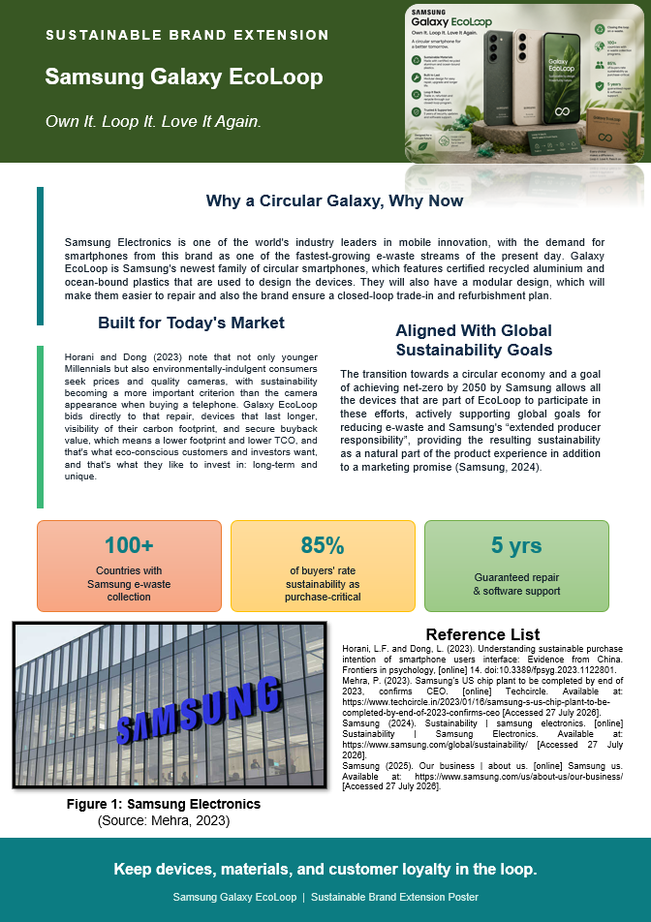
SN: This poster is an introduction to Samsung Galaxy EcoLoop, which is a sustainable brand extension in response to the demand for environmentally conscious smartphones. Aside from the high-class technology, it is circular, embracing recycled and certified aluminium, ocean-bound plastics, and a modular design to facilitate easier repair and upgrade of the device. EcoLoop also comprises of a closed-loop T&B program, making for a longer product life and reduction of electronic waste. Studies reveal that sustainability is a major factor for purchase, especially for younger consumers who prefer things to last longer, be transparent, and have value. Samsung has initiated measures to move toward a net zero without CO₂ emissions by 2050 and do more to support EPR. Galaxy EcoLoop provides a glimpse into the potential of sustainability not only as a cost-savings strategy but also as a driver of customer loyalty and brand reputation, thereby creating a long-term competitive edge.

Element 2: Segmentation, Targeting, Differentiation and Positioning (STDP)

2.1 Segmentation
The theory of brand development opines that a brand extension can only succeed when the market segment is ready to value it. However, segmentation needs to go beyond simple demographics, as values, income, and behaviour (Yadav and Kumari, 2024) are all shaping green purchasing intention—sustainable-product purchasing has increased year on year, with nearly half of consumers reporting a sustainable product purchased in the last month (Deloitte, 2025). Based on that, Galaxy EcoLoop's market is segmented into 4 variables, which is summarized in Table 1.
Segmentation Variable | Description
Geographic | Urban markets in North America, Western Europe, and East Asia that have already had e-waste collection infrastructure and circularity regulation (Firmansyah, Rizki and Ullah, 2025).
Demographic | 22–40 years old and with medium-high income, technology-upgrading adults, working professionals, or students who have some experience working with technology once every 1 to 2 years.
Psychographic | Environmentally conscious consumers, technologically knowledgeable, who value transparency and take a very pragmatic, minimal perspective on both design and brand ethics rather than novelty alone (Theocharis and Tsekouropoulos, 2025).
Behavioural | Users with a very high rate of upgrading for trade-in value, users who continually use Samsung products, and early adopters of sustainability-labelled products.
Table 1: Segmentation of the Galaxy EcoLoop market
(Source: Self-Created)

2.2 Targeting
Galaxy EcoLoop takes a different approach to targeting by focusing on the psychographic segment of “conscious upgraders” without having to leave the existing set of Samsung users behind. This aligns with research showing that sustainability-cutting segmentation strategies show greatest success in sorting out the most environmentally open-minded consumers and not in attempting to capture the entire market (Nguyen et al., 2025). The size of the segment is borne out by the fact that the vast majority of consumers around the world believe sustainability to be important when buying new phones (as revealed by industry data from the Global Survey on Mobile Screens 2025); and overall, for the industry, sales of mobile phone refurbishment and circular services are on the increase while sales of new phones are declining. This is because emphasizing them allows Samsung to charge higher prices for its Green Galaxy products, and such exposure is likely to help build the brand's long-term consumption, with green and sustainability-aware consumers having a higher willingness to pay (WTP) and being more likely to re-purchase (RP) (Nguyen et al., 2025). A second objective is also considered: institutional and corporate procurement buyers and companies starting their journey towards sustainability reporting are growing in interest of the credibility of their supplier base when it comes to circular-economy characteristics.

2.3 Differentiation
Galaxy EcoLoop, available for purchase, gives customers an option to own a phone as fashionable as it is smart and circular, proven with innovative design and the use of certified recycled material, modular repair, and a guaranteed buy-back scheme, and very much part of the Samsung ecosystem. While some competitors highlight one of the critical characteristics of sustainability, EcoLoop integrates material sourcing, repairability, and end-of-life recycling into its offering, decreasing the potential of greenwashing that hurts consumer confidence when claims cannot be substantiated (Rahman, Hu and Fung, 2023). This is also what distinguishes EcoLoop from “green” campaigns that deal exclusively with digital elements; the circularity is not only communicated through advertising but is also embedded in the product itself (Palmieri, Boccia and Covino, 2024).

2.4 Positioning
Galaxy EcoLoop will be “the circular Galaxy designed for those who will not sacrifice performance or the planet”. This claim is positioned on a perceptual map that measures commitment to sustainability and product performance, placing it between premium performance brands and niche eco-brands. Samsung's positioning in this regard is mediated by corporate brand credibility, which is achieved via the already established e-waste collected by Samsung in more than one hundred countries, and is translated as Corporate Social Responsibility (CSR) into believable brand value (Nguyen et al., 2025). Also, it is communicated through visual and verbal identity, such as all communication channels, both retail and digital, as well as packaging channels, where the sustainability claim becomes a part of the brand, in line with current trends in brand management that talk about integrating sustainability at the heart and not the periphery of the brand (Wijaya, Rahayu and Hendrayati, 2024).

Element 3: Marketing Mix (7Ps)
Besides green product design, green signals should be communicated consistently within other marketing mix components which includes people, place, pricing, promotion, physical evidence, and process; for green CBBE to occur (Nguyen et al., 2025). The extended 7Ps model as applied to Galaxy EcoLoop is summarized in Table 2 and then discussed on a per-element basis.
Mix Element | Application to Galaxy EcoLoop
Product | Fully repairable modular smartphone, made from certified recycled aluminium and ocean-bound plastics, with a 5-year software and repair guarantee.
Price | Refunding part of the purchase price for users at premium positioning and refurbishing their previous device. (This is where the circularity credit comes in.)
Place | Authorized retailers, on Samsung's own stores and on its website, as well as co-locating take-back kiosks that are established as e-waste collection points.
Promotion | Clear CO₂ labelling, influencer- and documentary-style content, and a “Loop Rewards” trade-in campaign.
People | Staff trained in advice on the circular economy; cooperation with certified repair technicians for the circular economy, community repair cafés.
Process | End-to-end reverse logistics process starting from collection, grading, refurbishment, resale, or material recovery while using a digital passport (Hariyani et al., 2026).
Physical Evidence | Minimal packaging, which can be recycled and composted, and material take-home samples at stores and publicly verified sustainability and carbon-impact reports.
Table 2: The 7Ps marketing mix for Galaxy EcoLoop
(Source: Self-Created)

3.1 Product
The key idea here is a purpose-built device that can be serviceable instead of disposable: the modularity allows for a battery, camera and screen to be swapped out individually, thereby lengthening the average lifespan of a device and decreasing its footprint throughout its lifespan (80% of a smartphone's carbon footprint occurs in its manufacture [Maldonado-Romo et al., 2024]). This is a direct response to growing requirements for products to be “green” to truly show environmental performance that is measurable and demonstrable rather than symbolic (Rahman, Hu and Fung, 2023).

3.2 Price
When the environmental message is believable and pronounced, sustainability-marketed products routinely sell for a price premium when authorized by a premium pricing strategy. By turning an intangible sustainability commitment into a tangible monetary reward, the circularity credit further underscores consumers' self-interest in sustainability while providing the incentivizing effect observed in green marketing mix studies (Nguyen et al., 2025).

3.3 Place
Distribution leverages Samsung's worldwide retail and collection infrastructure that has been operational with e-waste takeback operations in over 100 countries, reduces the need to establish new takeback infrastructure, and provides greater brand credibility through prominent and easy-to-reach touchpoints (Samsung, 2025).
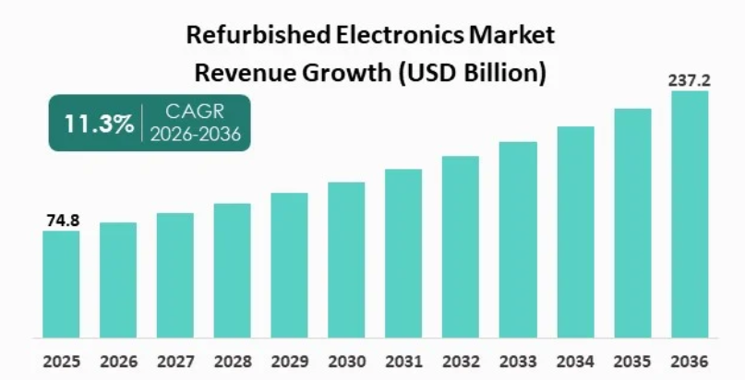
Figure 1: Refurbished Electronics Market
(Source: Transparencymarketresearch.com, 2026)
This is an indication of the overall refurbished-device market that has expanded significantly and is projected to reach 237.2 billion by 2036 and is commercially viable at scale (Transparencymarketresearch.com, 2026).

3.4 Promotion
Focusing on carbon-footprint data showing on the displays as concrete information helps mitigate the perceived risk of greenwashing and boosts brand trust, whereas promotional communication using generic environmental terms will be ineffective (Rahman, Hu and Fung, 2023). The narrating of authentic accounts of repair and refurbishments fosters the authenticity desired by sustainability-seeking audiences (Abdelmeguid, Afy-Shararah and Salonitis, 2024). Messaging varies clearly by channel: short-form video conveys messages to younger conscious upgraders, while documentary-style content serves as evidence for funders, and there is evidence of the different effects of message framing across channels on green purchase intention.

3.5 People
Employees and repair partners are trained as visible ambassadors of the circular proposition; despite efforts to optimize energy consumption or cut back on plastic or metal waste, research on green marketing mixes indicates that “green people” significantly shape perceived brand quality and loyalty, staff competence becomes a differentiator within the framework of a circular proposition and is not only a background factor in operationalization.

3.6 Process
A digital product passport documents all the materials that constitute the components of each product, its participation in the RPA process, and the routes it takes when it ends its useful life, thereby implementing the principles of the circular economy increasingly mandated by extended producer responsibility legislation and allowing Samsung to demonstrate auditable sustainability effects instead of aspirational targets (Maldonado-Romo et al., 2024). This mirrors the approach for device-as-a-service, or leasing models, which have been experimented with in several industries in the mobile market to help drive up loyalty and lower the overall cost of owning a device.

3.7 Physical Evidence
Tangible cues such as recyclable packaging, displays of in-store recycled materials, and publicly reported impact information provide the sensory and documentary evidence that taps a skeptical consumer, which has historically received less attention than product, price, and promotion aspects of the green marketing mix (Nguyen et al., 2025). Together, the seven elements make the sustainability promise of Galaxy EcoLoop into a reality for customers, backed by facts.

Element 4: Reflection
Reflecting has enabled me to evaluate my learning, decision-making, and development process throughout the project, which targets the Samsung Galaxy EcoLoop sustainable brand extension. The Kolb model of the reflective practice cycle will be used to critically reflect on my experience, analyze important skills learned, and reflect in relation to the improvement of my marketing practice in the future.
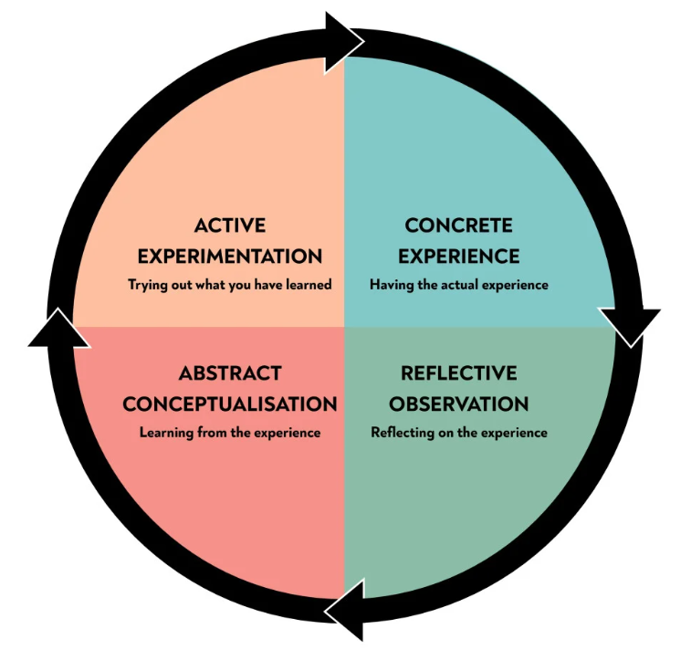
Figure 2: Kolb's Reflective Cycle
(Source: Mcleod, 2025)

4.1 Concrete Experience
The creation of an extension brand, Samsung Galaxy EcoLoop, was an excellent learning experience that imbued me with knowledge on how to build a brand strategically and sustainably. The project involved me creating an innovative brand extension complete with a detailed STDP analysis, in conjunction with a 7Ps marketing mix, as well as a compelling poster presentation. In the process, I utilized current academic literature and industry evidence to support my strategic decisions rather than making any assumptions. In the beginning, I had difficulty in ensuring that the design for the extension would be not only ecologically beneficial but also commercially viable, incorporate the brand of Samsung, and help preserve its current image. The assignment was also to take complex strategic information and turn it into an I created an “eye-catching” poster and presented it confidently to the audience, which also enhanced my analytical and communication abilities. The exercises closely resembled the assessment requirements of creating a sustainable brand extension as well as reflecting on the presentation experience.

4.2 Reflective Observation
Retrospectively, I realized there was a significant learning curve for me in the way the market has been segmented throughout the project. Initially, I had planned to mainly describe the demographic variables, but then I decided to also describe the psychographic and behavioural variables because I noticed from Yadav and Kumari (2024) that these variables are more effective in identifying environmentally conscious consumers. Similarly, the 7Ps marketing mix development showed that for sustainability, all of the marketing elements have to fall into place to repeat the environmental value proposition to the consumer. The literature from Rahman, Hu and Fung (2023) has even been brought to my attention when it comes to the question of greenwashing, to which I have tried to validate every mention or claim of sustainability with proper sources. The process of creating a poster presentation also re-emphasized the significance of conveying complex marketing concepts along with an engaging and succinct method to an audience with varying levels of marketing knowledge.

4.3 Abstract Conceptualization
The experience was particularly valuable because it made me see that marketing is not just a theoretical issue; it is also a business decision-making issue. Transforming experience into knowledge, a principle that Kolb argues also holds true, became evident. Having a customer-centric outlook on how effective targeting leads to better value for customers was beneficial to understand the 7Ps marketing mix wherein consistency of brand presence & customer touchpoints are essential for good, sustainable branding. Furthermore, Ardiansyah and Alnoor (2024) highlighted that promoting sustainability in a brand strategy is not sufficient; it must also serve as a strategy. I have applied some thinking skills to evaluate freely available academic evidence to inform my selection of the marketing approaches. I used to rely more on intuition than that. This experience has enabled me to use academic research to substantiate my recommendations and has boosted my self-confidence in applying marketing theory to real-life organizational situations. Moreover, learning about sustainable branding also boosted my consciousness about circular economy concepts and their growing relevance for the competitiveness of companies in the world.

4.4 Active Experimentation
In future marketing projects I would make more research efforts to validate customer preferences in surveys or interviews, along with secondary research. This will enhance the confidence in strategic recommendations as well as consumer insights. I will also aim to be more systematic in the visual design and ensure that the written analysis is closely aligned with the presentation design, creating a completer and more compelling product. In addition, I will continue developing my presentation and story-telling techniques by training myself to communicate more succinctly and to utilize visual communication more effectively. These changes will further enhance my confidence of talking about complex sustainability policies in the school context and in workplace scenarios. This project as a whole has greatly enhanced my understanding of strategic marketing, critical evaluation skills, the process of academic research, and professional communication competence. More than anything else, it has made me understand that successful sustainable branding needs to be a joint senior marketing effort rather than a split or function-driven effort to align evidence-based decision-making, customer value creation, and communication to reach a sustainable brand, equipping me for the challenges in sustainable brand management and strategic marketing.

Reference List

Poster
Horani, L.F. and Dong, L. (2023). Understanding sustainable purchase intention of smartphone users interface: Evidence from China. Frontiers in psychology, [online] 14. doi: 10.3389/fpsyg.2023.1122801
Mehra, P. (2023). Samsung’s US chip plant to be completed by end of 2023, confirms CEO. [online] Techcircle. Available at: https://www.techcircle.in/2023/01/16/samsung-s-us-chip-plant-to-be-completed-by-end-of-2023-confirms-ceo [Accessed 27 July 2026].
Samsung (2024). Sustainability | samsung electronics. [online] Sustainability | Samsung Electronics. Available at: https://www.samsung.com/global/sustainability/ [Accessed 27 July 2026].
Samsung (2025). Our business | about us. [online] Samsung us. Available at: https://www.samsung.com/us/about-us/our-business/ [Accessed 27 July 2026].

Report
Abdelmeguid, A., Afy-Shararah, M. and Salonitis, K. (2024). Towards circular fashion: Management strategies promoting circular behaviour along the value chain. Sustainable production and consumption, [online] 48, pp.143–156. doi: 10.1016/j.spc.2024.05.010
Ardiansyah, M. and Alnoor, A. (2024). Integrating corporate social responsibility into business strategy: Creating sustainable value. Involvement international journal of Business, [online] 1(1), pp.28–41. doi: 10.62569/iijb.v1i1.5
Deloitte (2025). Sustainability has staying power. [online] Deloitte Insights. Deloitte. Available at: https://www.deloitte.com/us/en/insights/topics/environmental-social-governance/sustainable-consumption-trends.html [Accessed 27 July 2026].
Firmansyah, M.L., Rizki, I.N. and Ullah, N. (2025). Recent advances in Urban mining technology: A focus on electronic waste recycling potential in Indonesia. Cleaner waste systems, [online] 10, pp.100239–100239. doi: 10.1016/j.clwas.2025.100239
GSMA (2025). 70% Of consumers are willing to pay a premium for environmentally friendly phones, finds new GSMA report. [online] Newsroom. Available at: https://www.gsma.com/newsroom/press-release/70-of-consumers-are-willing-to-pay-a-premium-for-environmentally-friendly-phones-finds-new-gsma-report/ [Accessed 27 July 2026].
Hariyani, D., Hariyani, P., Choudhary, S. and Mishra, S. (2026). Leveraging digital technologies in e-waste management. Environmental management: Engineering and technology, [online] 1(2), p.100007. doi: 10.1016/j.jemet.2026.100007
Maldonado-Romo, J., Méndez, J.I., Rojas, M., Montesinos, L., Ponce, P. and Molina, A. (2024). Circular economy strategy based on digital technologies and the S4 framework: A case study on smartphones. International journal of sustainable engineering, [online] 17(1), pp.1–11. doi: 10.1080/19397038.2024.2336008
Mcleod, S. (2025). Kolb’s learning styles and experiential learning cycle. [online] Simply Psychology. Available at: https://www.simplypsychology.org/learning-kolb.html [Accessed 27 July 2026].
Nguyen, K.M., Thi, L., Ngo, T.T., Thi, T., Dinh, P., Pham, H. and Nguyen, N.T. (2025). The impact of 7Ps green marketing mix on customer commitment and willingness to pay a premium price: Evidence from Vietnam. Journal of Promotion management, [online] 31(4), pp.1–42. doi: 10.1080/10496491.2025.2484712
Palmieri, N., Boccia, F. and Covino, D. (2024). Digital and green behaviour: An exploratory study on italian consumers. Sustainability, [online] 16(8), pp.3459–3459. doi: 10.3390/su16083459.
Rahman, O., Hu, D. and Fung, B. (2023). A systematic literature review of Fashion, sustainability, and consumption using a mixed methods approach. Sustainability, [online] 15(16), pp.12213–12213. doi: 10.3390/su151612213
Samsung (2025). Samsung retail solutions for Future of Retail | samsung business india. [online] Samsung india. Available at: https://www.samsung.com/in/business/industries/retail/?srsltid=afmbooqum4mzx3vqtur_q5bx_gwtgee90hbzw96c_msxqjwzaufjwbdx [Accessed 27 July 2026].
Shams, R., Chatterjee, S. and Chaudhuri, R. (2024). Developing brand identity and sales strategy in the digital era: Moderating role of consumer belief in brand. Journal of business research, [online] 179(114689), pp.114689–114689. doi: 10.1016/j.jbusres.2024.114689
Theocharis, D. and Tsekouropoulos, G. (2025). Sustainable consumption and branding for Gen z: How brand dimensions influence consumer behavior and adoption of newly launched technological products. Sustainability, [online] 17(9), p.4124. doi: https://doi.org/10.3390/su17094124
Transparencymarketresearch.com (2026). Refurbished electronics market. [online] www.transparencymarketresearch.com. Available at: https://www.transparencymarketresearch.com/refurbished-electronics-market.html [Accessed 27 July 2026].
Wijaya, F., Rahayu, A. and Hendrayati, H. (2024). Brand management strategies for Sustainability: Insights from a systematic review. Journal of Business management education (JBME), [online] 9(3), pp.341–358. doi: 10.17509/jbme.v9i3.76042.
Yadav, S. and Kumari, V. (2024). Segmenting green: Exploring market segmentation and targeting strategies in sustainable marketing. International journal of advanced research, [online] 12(03), pp.450–455. doi: 10.21474/ijar01/18413.

Appendix: Element 1 Content
Why a Circular Galaxy, Why Now?

Figure 1: Samsung Electronics
(Source: Mehra, 2023)
Samsung Electronics is one of the world's industry leaders in mobile innovation, with the demand for smartphones from this brand as one of the fastest-growing e-waste streams of the present day. Galaxy EcoLoop is Samsung's newest family of circular smartphones, which features certified recycled aluminium and ocean-bound plastics that are used to design the devices. They will also have a modular design, which will make them easier to repair and also the brand ensures a closed-loop trade-in and refurbishment plan.
Built for Today's Market
Horani and Dong (2023) note that not only younger Millennials but also environmentally-indulgent consumers seek prices and quality cameras, with sustainability becoming a more important criterion than the camera appearance when buying a telephone. Galaxy EcoLoop bids directly to that repair, devices that last longer, visibility of their carbon footprint, and secure buyback value, which means a lower footprint and lower TCO, and that's what eco-conscious customers and investors want, and that's what they like to invest in: long-term and unique.
Aligned with Global Sustainability Goals
The transition towards a circular economy and a goal of achieving net-zero by 2050 by Samsung allows all the devices that are part of EcoLoop to participate in these efforts, actively supporting global goals for reducing e-waste and Samsung's “extended producer responsibility”, providing the resulting sustainability as a natural part of the product experience in addition to a marketing promise (Samsung, 2024).

