World Building
– Scott Smith

Mitchell Newman –
1702455

Creative Computer Games Design

Word count - 1954

World Building – Scott Smith
Borderlands 2 was released on the 18th September 2012 and is a controversial video game that lets common sense and sensitivity take a back seat as you find yourself laughing about ridiculous scenes ranging from a psycho asking you to shoot him in the face to the most bizarre dialog ever heard within a game using the word “badonkadonk” more than once. The story line is that you are a vault hunter who is trying to find a vault which is basically a giant treasure chest full of loot and weaponry, however your plans to find this vault is foiled by Handsome Jack the Villain with the world of Pandora. This essay will be comparing and contrasting the difference between how death is viewed within Borderlands compared with real life.

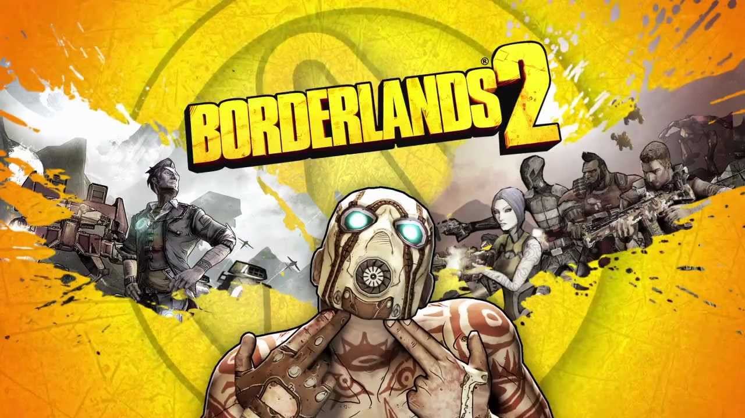

In life death is usually seen as a morbid topic (depending on what you believe in) that we as a species try to avoid if it comes up in a conversation, because we see losing a loved one as a negative thing (Grimby, 1992)and not a part of life. Even though one day everything must die or pass on, we all know this, however we push it down inside of us and focus on the happier things in life. In Borderlands 2 death is dealt with in a casual fashion, as it is a topic that is discussed on a day to day basis, this is because the majority of jobs in the world of pandora involve killing or being killed, this is even shown when the main doctor in Borderlands 2 kills the patient to get a stone that was worth value out of the patients stomach. This comes off as unnatural if you do not live in western society, because in Eastern society death is part of life such as in Buddhism, they believe that if they are good in this life then they will be reincarnated in to a great animal that reflects how they acted in their previous life (F.P., 2018). We are all animals, and in the animal kingdom you are constantly watching your back for a predator or looking for food and water to survive however, we in Western society have evolved with the privilege of having water and food everywhere and no natural predators. Is this why we fear death so much because to us it is just a nightmare that we can avoid. In our eyes technology and medicine is advancing so quickly that there’s always a slight chance that we might be that one generation who finds a cure for death.
As most religions see death as a resting place for the dead or just an extension to their life on earth (F.P., 2018) you think that we would not be as sad, however the people who do not have a religion to comfort them with their loss sometimes revert to showing their grief in other ways a lot of the time they will use humour to cover up their true feelings. People who do this can not help it, their brain just compulsively projects their feelings out of their body through jokes as a way of almost crying, to some people this is offensive however it is psychological way of grieving. In the world of Borderlands death is always seen as funny and is almost always dealt with in a humorous manor, such as strapping two stuffed bunnies too two rockets too blow up a train, there was no need to attach the stuffed bunnies to the rockets that killed a dozen people however it makes the situation funnier.
Studies show that elderly people accept their death and have a strong belief in the afterlife as they get older (Handal, 2003), this is due to the patient having death anxiety, death anxiety is when the person knows they are going to die and starts worrying about what happens next, for example is there a god or an afterlife.
In Mexico they celebrate a holiday called the Day of The Dead, this is where everyone celebrates the memories of their deceased family and friends by dressing up as skeletons using colourful face paints, lighting candles underneath photographs of their deceased loved ones and ceremonial dancing with people on stilts dressed up as skeletons using rubber masks (Marchi, 2009). This is done to form a passage way from the afterlife, so the dead could come back temporarily to visit their family. This is a completely different way of looking at death compared to popular religions such as Christianity because they mourn death rather than celebrating the deceased life, which is morbid and can cause a lot of heart ache, however when celebrating the life of the deceased death is celebrated because you know your loved one can come back to see you once a year.
“Staff invoke humour to move away from a macho attitude in their interactions with aggressive patients. Humour also bolsters staff solidarity through playful inversions of the usual patterns of authority.” - (Kuhlman, 2006)
As Kuhlman sates above people use humour to get away from the stereo typical “macho man” persona when a crisis usually happens, this is sometimes a good think because it sometimes stops the person from turning to aggression to deal with crisis and instead projects their emotions through jokes. (Kuhlman, 2006) this can also help the other grieving friends and family because it can lighten the mood and allow them to avert their focus from the grief.
Death within the world of Borderlands is a fairly common thing that everyone in the world is used to, as there is a war between the Hyperion’s lead by Handsome Jack and the rebels, this is evident whilst on your travels. Throughout the world of Pandora, you are faced with killing both sides of the war, as your character doesn’t really care who wants what the only thing your character cares about is getting to the vault for his or her loot. Amongst the many missions there is a side mission called Face Mcshooty, this mission is as straight forward as it sounds, there is a Pyscho begging you to “shoot him in the face” and gives the player money and experience to do so, so naturally as it’s a game you do it and he rewards you with the money and a quick brief “thank you!” as you pull the trigger. as you can tell death is almost funny in the game as this mission is not the only one where someone begs to be killed. Your character is also introduced to a 11-year-old girl named Tiny Tina, she sings a nursery rhyme whilst skipping towards an explosive lever that blows up a person begging for their life right in front of the player. (Gallegos, 2012)
Paramedics deal with death on a daily basis and they suggest that the best ways too deal with death and grief is by: “educational desensitization, humour, language alternation, scientific fragmentation, escape into work, and rationalization.” (Palmer, C.E.,) these signs are shown within the world of Borderlands 2 however they are magnified by 100%, because if someone uses educational desensitization they will become a mad scientist and create some over the top scientific weapon, if someone uses humour to deal with grief in the world of Borderlands they will go insane and take everything as a joke even their life. Purves, Y. and Edwards suggest that sudden death within a family robs the loved ones of grieving because the death happens so quickly there is no time to brace yourself for what is to come, this deny people the biochemical reactions so the shock may overwhelm the bereaved to such an extent that they feel regressed and unable to function'. This can cause stress and anxiety for the family member which can cause a decline in their health. In the world of Borderlands 2 there is no shock when people or loved ones die as it is such a savage planet that people can get sick unexpectedly or can even get eaten unexpectedly so when someone passes away it is more of a “I didn’t expect that too happen so soon” rather than a grieving process. The more you see a dead body according to Houlden, the more desensitised you become to them, as he is a doctor he sees dead bodies almost every day, wrapped up with a see through plastic sheet over them, I feel this is the same in the world of borderlands as they would see dead bodies on a daily basis so they just become desensitised to them all.
Because death in Borderlands 2 is such a common subject and is everywhere this can have an impact on the people playing the game especially if the player is a young child, this may confuse them in the real world, and may affect their grieving process if someone close to them does pass away they may just brush it off like its no big deal, this could be said for a lot of games, however I chose Borderlands 2 in particular because of how violent and gory the overall game is and its fixation with death as a humour topic. However, There is many other games and films just as gory such as gears of war, where the player can saw a person in half with the chainsaw attached to the end of their weapon or there is The Saw franchise where people torcher themselves in order to escape from traps, so death and gore is a common theme in most young peoples lives.
Borderlands 2 is a first-person shooter this means that the player is more immersed and phytologically aroused within the game because it’s almost as if they are doing the actions themselves (Bradley, 2004). So, if the player buys a game actively knowing that the game involves violence, they should have some idea as to how or if this may impact the players outlook and view on death, especially with Borderlands 2 because of how much violence and gore is involved in the story and plot of the game. Parents and guardians are the main worrier when it comes to children playing violent video games however studies have shown that television and movies have more of an impact on younger acting out compared to video games (Sherry, 2006) A lot of people believe that a good video game has to involve guns, violence and of course killing/death, to certain extent these people aren’t wrong from the amount of attention these violent games get. According to Metacritic’s top list of games for 2018 (Anon., 2018) the top 3 games of 2018 are violent to some extent, and the top game being a first-person shooter like borderlands 2.

In conclusion we as people are fine with death being portrayed in a funny humour in games such as Borderlands 2, however when a serious crisis happens in real life such as an intense situation or a close relative passing away, people get offended when people react in a humours way even though it is them psychologically dealing with he situation by telling jokes, and if their don’t vent their emotions in this way they may lash out in an aggressive way. Furthermore, in other societies death isn’t necessarily a bad experience and is seen as a passing to another life or a reincarnation, which can be celebrated for remembering the deceased life and not mourning their death.
Moreover, video games do not have a huge impact on how people see death, this is proven by (Sherry, 2006) in the research showing that movies and television have a more destructive impression on the people watch them when compared to violent video games.

References
Metacritic 2018. Metacritic. [Online]
Available at: https://www.metacritic.com/browse/games/score/metascore/year/all/filtered
[Accessed 03 December 2018]. website
Author: Bradley, E. F. S. A. L. M. S. S. D., 2004. Death with a Story: How Story Impacts Emotional, Motivational, and Physiological Responses to First-Person Shooter Video Games. volume 30, issue 3 ed. s.l.:Human Communication Research. Article
Author: Kori Lee 2018. Owlcation. [Online]
Available at: https://owlcation.com/humanities/Japanese-Suicide-Death-before-Dishonor
[Accessed 03 December 2018]. Article
Author: Gallegos, A., 2012. IGN. [Online] Borderlands 2 Funny moments
Available at: https://www.gamespew.com/2015/01/borderlands-2-funny-moments/
[Accessed 22 Novemeber 2018].
Author: Grimby, A., 1992. Bereavement among elderly people: grief reactions, post‐bereavement hallucinations and quality of life. [Online]
Available at: https://onlinelibrary.wiley.com/doi/abs/10.1111/j.1600-0447.1993.tb03332.x
[Accessed 03 Decemeber 2018]. Journal
Author: Handal, M. F. J., 2003. Religion, Death Attitudes, and Belief in Afterlife in the Elderly: Untangling the Relationships. [Online] Journal
Available at: https://link.springer.com/article/10.1023/A:1022216828508
[Accessed 03 Decemeber 2018].
Author: Kuhlman, T. L., 2006. Gallows Humor for a Scaffold Setting: Managing Aggressive Patients on a Maximum-Security Forensic Unit. [Online]
Available at: https://ps.psychiatryonline.org/doi/abs/10.1176/ps.39.10.1085
[Accessed 22 Novemeber 2018].Article
Author: Marchi, R. M., 2009. Title: Day of the Dead in the USA: The Migration and Transformation of a Cultural Phenomenon. San Fransisco: Rutgers University Press. Book
Author: Obrdlik, A. J., 1942. Gallows Humour - A sociological Phenomenon. [Online]
Available at: https://www.journals.uchicago.edu/doi/abs/10.1086/219002
[Accessed 21 Novemebr 2018]. Journal
Author: Sherry, J. L., 2006. The Effects of Violent Video Games on Aggression: A Meta-Analysis. [Online] Article
Available at: https://academic.oup.com/hcr/article-abstract/27/3/409/4554758
[Accessed 03 December 2018].
Author: Snaith, K., 2015. Gamespew. [Online]
Available at: https://www.gamespew.com/2015/01/borderlands-2-funny-moments/
[Accessed 22 Novemeber 2018]. Website
Author: ‎Anthony Burch. Game: Borderlands 2. Date: September 18, 2012
Palmer, C.E., 1983. A note about paramedics' strategies for dealing with death and dying. Journal of occupational psychology, 56(1), pp.83-86.
https://scholar.google.co.uk/scholar?hl=en&as_sdt=0%2C5&q=how+paramedics+see+death&btnG=#d=gs_cit&p=&u=%2Fscholar%3Fq%3Dinfo%3A7Wn4bSNs7ocJ%3Ascholar.google.com%2F%26output%3Dcite%26scirp%3D0%26hl%3Den
Purves, Y. and Edwards, S., 2005. Initial needs of bereaved relatives following sudden and unexpected death: pre-hospital practitioners need education and training to help suddenly bereaved relatives begin the grieving process. Emergency nurse, 13(7), pp.28-35.
Houlden, R., 2018. Seeing my first death. BMJ supportive & palliative care, pp.bmjspcare-2018.
Article

