Searching for Records

Filtering Records Based on Search Criteria
It’s all well and good to display a bunch of data to a user, but no matter how nicely you format it and how elegantly you divide it up so users can page through it, users will always want the ability to search for—and find—exactly what they’re looking for. For this example, we’ll need two new pages: one for allowing the user to enter search criteria, and another for displaying the search results.
We’ll create the search page first:
- On a new, blank page called search.asp, add a form .
- In the Property Inspector, call the form “frmSearch”. In the Action field, enter the name of the search results page. We’re using searchresults.asp:
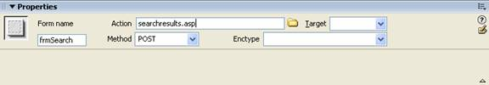
When the user clicks the submit button, Dreamweaver will post the data to the searchresults.asp page, which will use the data to locate the matching records.
- Add a text field to the form and call it “txtContactName”.
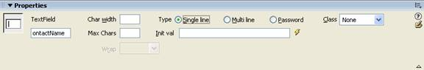
- Add a submit button to the form.
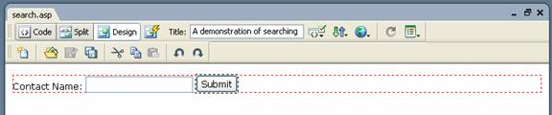
If you like, use the Property Inspector the change the button’s label to “Search”.
- Save the page.
- Next, open the search results page. This is where we need to create a recordset containing the records being searched.
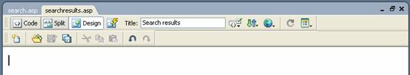
- Add a recordset using the table that contains the records users will be searching. We’re going to use our Clients table to allow users to search for client records. Keep the Recordset dialog open.
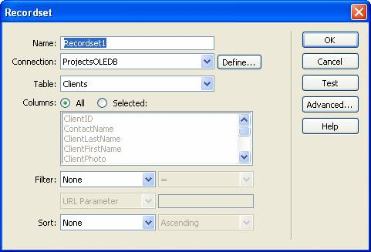
- Earlier, we mentioned that the Filter fields in the dialog can be used for filtering the data in the recordset based on the criteria you specify. We’re going to use these fields to filter the recordset based on the criteria the user specified on the search form—namely, the client’s last name.
From the Filter menu, we’re going to select ContactName. This is the field where the page will look for matching records.
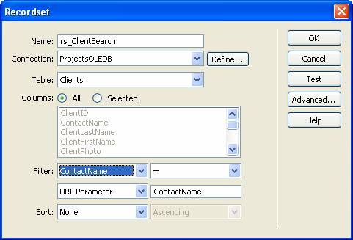
- Naturally, not all users may know exactly what they’re looking for, so we’re going to change the = next to the Filter field to contains:
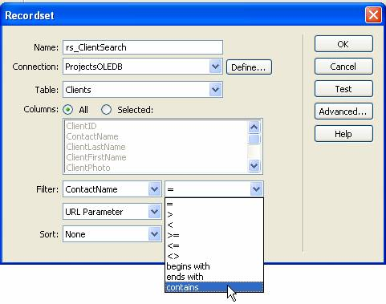
This ensures that records of clients with contact names beginning with the letters the user entered are included in the matching result set.
- Note the options available for passing the search criteria:
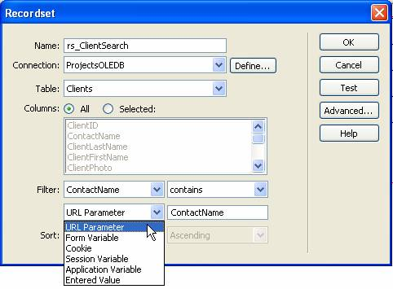
We need to select Form Variable, since we’re using a form to pass the criteria.
- Next to Form Variable, enter the name of the text field on your form—the field into which the user will be entering his or her search criteria:
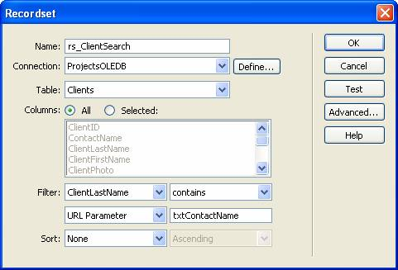
- Finally, we want to display the matching records in ascending order by contact name, so we’ll specify these in the Sort menus:
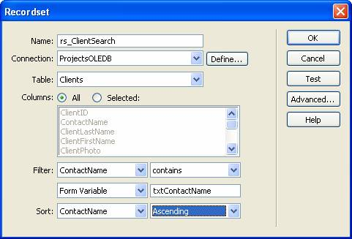
- Click OK.
The recordset now appears in the bindings:
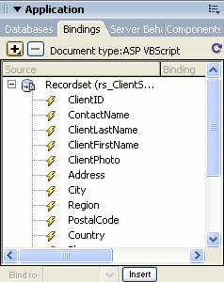
The recordset will automatically handle the job of retrieving matching records based on the data submitted from the form.
- The last thing we need to do is create a table for displaying the search results. The easiest way to do this is to insert a dynamic table: Open the Insert menu and select Application Objects, then Dynamic Data, and then Dynamic Table.
- In the Dynamic Table dialog, enter the properties you want for the table and click OK.
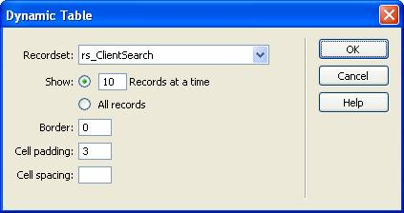
The dynamic table is inserted into the page. Since we only want to display the client ID and the contact name, we’re deleting all the other columns. Your page should now appear something like this:
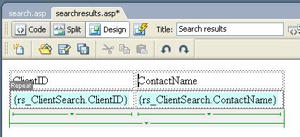
- Test the search functionality by previewing the search page. Enter your search term and click the Submit button.
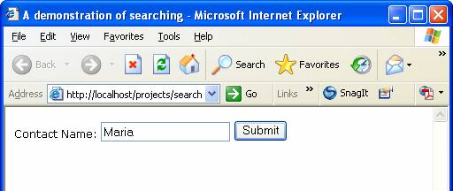
The results should appear in the results page:


