Strategic Management for SMEs

(BMSK6004_LON)

Student: Samsul Alom
Student ID: 1605852

Table of Contents
1.0 Introduction 3
2.0 Internal Environmental Analysis of Uber 4
2.1 SWOT analysis of Uber 5
2.2 McKinsey’s 7S model 6
3.0 External Environmental Analysis of Uber 9
3.1 PESTEL Analysis of Uber. 10
3.2 Porter’s Five Forces Analysis of Uber 12
4.0 Stakeholder’s expectations of Uber 15
5.0 Recommended Growth Strategy for Uber 17
5.1 Porter’s Generic Strategy as growth strategy of Uber 17
6.0 Conclusion 22
References 23

1.0 Introduction
The term ‘Strategic Management’ is mainly concerned with the development of strategic vision, settings and objectives, determining strategies and implementing them in order to meet the strategic goal of the organisation (Birkinshaw, 2011). Strategic management has two primary objectives and the first one is to act as the strategic guideline for the organisation to survive the environmental changes of the business and another is getting competitive advantage in the marketplace by doing so. There are four stages of the entire strategic management process and they are setting strategic intent (mission, vision and objectives of the strategy), formulation of the strategy, implementation of the strategy and controlling and evaluating the strategy.This particular paper will be highlighting the strategic management of Uber in the scenario for increasing competition in the marketplace. In this context, the internal and external environmental components of the company will be analysed along with the stakeholder’s expectations and finally, a recommended growth strategy will be provided which can be undertaken by the company for attaining sustainable growth in the market. Uber is a technology-based American multinational ride-sharing organisation having its headquarter in San Francisco. The company offers several services such as peer to peer ridesharing, food delivery, bicycle-sharing and ride service hailing in more than 785 metropolitan area worldwide through mobile applications and its website.

2.0 Internal Environmental Analysis of Uber
Before starting to develop the strategies to meet and defend the increased competition in the marketplace, the management of Uber is highly required to analyse its internal environment. The internal environment of Uber is several components of the organisation which is present within the company and which can affect or be affected by any decision, choice or activity of the company (Birkinshaw, 2011). In other words, the internal environment of Uber consists of the corporate culture, events held within or by the company, members and other factors associated with the company which can be influential to the decisions made by the company (Dills and Mulholland, 2017). In simple words, the internal environment determines what the company has and what the company is for. The following diagram shows the different components of the internal environment of Uber.
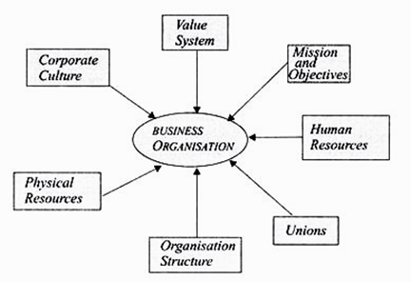
Figure 1: Components of the internal environment of Uber
Source: (Dills and Mulholland, 2017)
It is important for the management of Uber to analyse the internal business environment of the company because, it determines the strengths and weaknesses, cost positioning and opportunities, potential threats in the market and competitive viability of the organisation (Birkinshaw, 2011). The management of Uber can analyse the internal environment of the company using different analytical model. In this case, to develop a strategy to defend the increased competition in the market, Uber will be using SWOT analysis and McKinsey’s 7S model to analyse the internal environment of the company.

2.1 SWOT analysis of Uber
SWOT analysis is regarded as one of the most effective analytical tools to analyse the internal environment which stands for S = strengths, W = weakness, O = Opportunities, and T = Threats (Dills and Mulholland, 2017). Through the SWOT analysis model, the management of Uber will be able to find out the internal strengths and weakness of the organisation which determines the ability of the organisation to operate and perform (Dills and Mulholland, 2017). Also, this particular analytical model identifies potential external opportunities and threats in the market which may influence the strengths, weaknesses and performance of the company. The SWOT analysis of Uber is as follows:
Table 1: SWOT analysis
Strengths | Weaknesses
- Uber is currently the largest ride-sharing technology.  - The network of this technology-based company is massive with 40 million monthly users in 760 metropolitan area.  - Low fixed investment.  - Strong brand recognition.  - Adaptive nature of the company.  - The company has a strong logistic support  - Dynamic pricing strategy which is ‘Higher the Demand, Higher the Price’.  - Supportive interaction between customers and drivers.  - Low price compared to that of the competitors. | - Although the revenue of the company is increasing, Uber is facing losses since 2009 (Dills and Mulholland, 2017).  - Negative media coverage due to multiple scandals.  - High dependency on the workforce.  - High public backlash due to overpricing.
Opportunities | Threats
- Uber can ensure maximum accountability and performance by tracking the performance level of the drivers.  - Digitalisation as the company itself is a technology-based company.  - The company is aiming at venturing driverless technology and other services as part of its differentiation process such as a driverless ambulance.  - The company has strong logistic support and aiming at launching movers and packers service of its own for the convenience of the public. | - Increasing competition in the marketplace such as Lyft, Ola cabs and so on.  - Retention of the customers and employees can be a threat to the company with rising competition.  - There are almost 300,000 lawsuits against Uber filed by its employees regarding the minimum wage policy of the company (Dills and Mulholland, 2017).

Source:(Own)
The above table demonstrates different internal strengths and weaknesses and external opportunities and threats of the company which can be an influential factor in terms of decision making by the management of Uber. Though the company has a lot of strengths in terms of the number of employees, customers, effective user interface and so on, the company has a lot of weaknesses such as negative media coverage due to multiple scandals, high dependency on the workforce, high public backlash due to overpricing. To overcome these weaknesses, Uber has some market opportunities such as strong logistic support, innovative employees, effective medium to appraise the performance level of the employees but there are some threats restraining its recovery are there as well low retention of employees, increased competition in the marketplace, bad public image due to several scandals and so on.

2.2 McKinsey’s 7S model
The 7s model introduced by McKinney is an analytical tool which determines 7 essential components within an organisation in order to understand various situations associated with the organisation (Birkinshaw, 2011). In the 7s model of McKinney, there are two types of components and they are hard elements and soft elements. The 7 elements in the model include strategy, structure, systems, shared values, skills and styles.
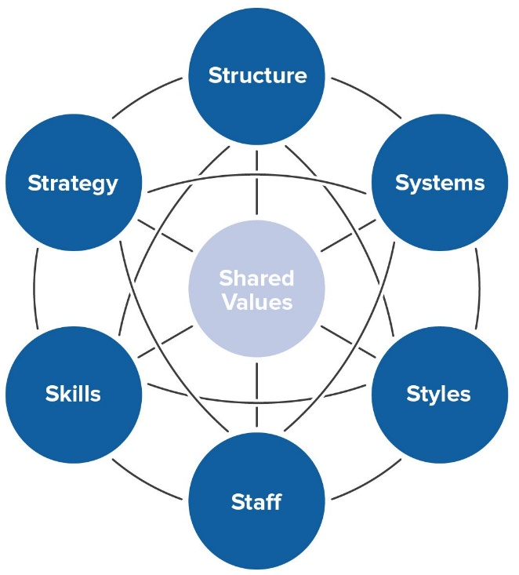
Figure 2: McKinney’s 7s model
Source: (Birkinshaw, 2004)
Strategy: As its business strategy, Uber follows the cost leadership strategy (Cohen and Zhang, 2017). Especially, the ride-hailing sector of the business gains a lot of cost advantage due to the nature of the business of Uber which is internet-based releases the customers from the difficulties of traditional taxi services (Ultius, 2019). Apart from this, the management of Uber puts a high emphasis on the convenience of its users.
Structure:The structure of Uber is hierarchical and for this, the company has to face several disadvantages such as ineffective communication throughout different departments of the organisation which may create rivalry among the functional departments and may compromise high-level bureaucracy and long term growth visions of the organisation (Cohen and Zhang, 2017).
Systems: Uber has to follow several operational and functional systems in operating the company. Among all the system, the primary function of the company is performed by Uber apps. Apart from this, the company follows team development and orientation systems, employee recruitment and selection system, customer relationship management system and so on (Ultius, 2019).
Shared value: This includes the corporate culture, centre value of the company while established and the core value of the company and these factors illustrates the corporate culture of the company and its general work ethics.
Style: In the management of Uber, there is a hierarchical leadership style followed by democratic leadership (Cohen and Zhang, 2017). Though the leadership style followed by the company is highly effective there remains a gap between different departments which hinders the development of bonding between employees.
Staff: Mainly the staff of Uber who performs the actual role in the company are the drivers and they are selected in terms of their capabilities and standards required for driving by the state.
Skill: Despite several scandals made by the employees, they are skilled to drive in the road as required by the state. Every employee of Uber is highly skilled in terms of the requirements and standards set by the government and other agencies as required (Ultius, 2019).
Considering the internal environment of Uber through McKinney’s 7S model, it has been found that though Uber has a strong position in all the components of the model except the structure of the company and its leadership style which is one of the causes among many for the organisation to lose its competitive advantage in the market.

3.0 External Environmental Analysis of Uber
While internal environmental analysis assists the organisation to understand the position of its internal components of the company, the external business environment consists of different external factors which affect the decisions of the management body of the organisation (Dills and Mulholland, 2017). The external business environment includes all the factors or influences outside the organisation which have an impact on the operation of the business (Grant, Hackney and Elgar, 2012). Those outside factors which consist the external environment may often change and with the change in the external environment, the organisation needs to act or react accordingly (Dills and Mulholland, 2017). Failure to do so may cost an organisation to lose its performance level and competitive advantages in the marketplace.
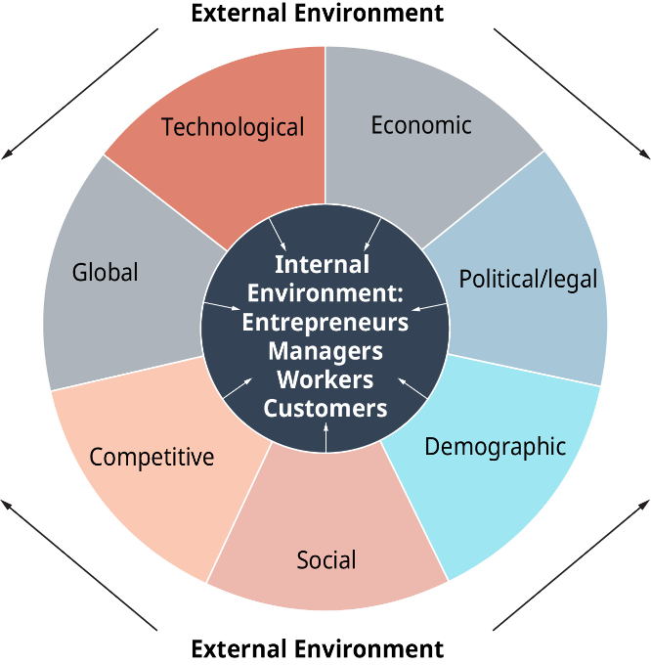
Figure 3: External business environment
Source: (Vecchiato, 2012)
The above figure shows the elements of the external business environment and these remains outside the company but with a little change in these factors, Uber needs to adapt to this changes and for that, it has to develop strategies to cope with the particular change. As the internal environment is the elements which consist the company and external elements affect the performance and operation of the company(Emerald Group Publishing., 2013). Therefore, the external environmental elements affect the internal business environmental elements as well(Emerald Group Publishing., 2013). It is crucial for Uber to analyse its external environment to identify what outside factors has influenced the increased competition in the marketplace and determine its strategy accordingly. In order to analyse the external business environment, Uber can follow different analytical models. In this case, Uber will be following two popular analytical models of analysing the external environment and they are PESTEL Analysis and Porter’s Fiver Forces Analysis.

3.1 PESTEL Analysis of Uber.
The acronym of PESTEL, which is a strategic analytical tool, stands for political, economic, social, technological, legal and environmental factors around an organisation that influences the operation and decision of the company with its change(Emerald Group Publishing., 2013).
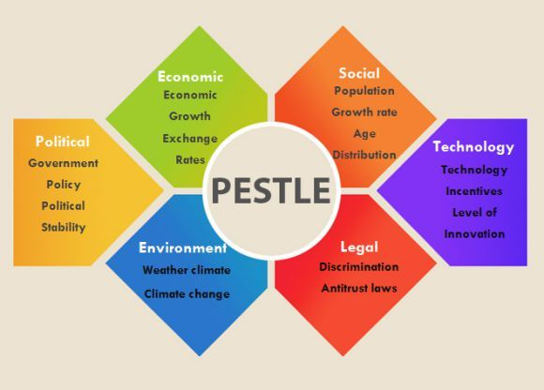
Figure 4: PESTEL Analysis Model
Source: (Vecchiato, 2012)
Political: Uber has confronted several discussions. In its underlying advancement, Uber didn't have clear guidelines (Ultius, 2019). It was hard to pinpoint protection lie in if there is a catastrophe, is the Uber driver to blame, or the organisation itself? They have confronted extra investigation around the world; France documented charges dependent on promoting, the Netherlands controlled against Uber for their drivers not having Taxi licenses, restraining orders from Portland, with extra boycott contemplations in Asian nations (Ultius, 2019). Also, there were political exchanges about the lowest pay permitted by law laws in the taxi business, and whether Uber was maintaining these guidelines (Frue, 2019). The administration requires business licenses also, requiring Uber to give that documentation.
Financial: The business that Uber works in is the sharing economy. It implies that this economy depends on sharing physical or scholarly assets (Frue, 2019). For this situation, Uber enlists drivers to react to client and drive them to an area. It's regularly considered less expensive than taxicabs and simpler to plan an arrangement. Uber has developed exponentially since its underlying report. In any case, nations have prohibited or limited its management due to Uber having an out of line rivalry against ordinary taxicabs (Frue, 2019). Different organisations in this industry face banter, however, Uber's quick improvement has driven them to be the centre point (Ultius, 2019).
Individuals are considering whether this sort of economy brings new profession openings or removes them from existing positions (Uber versus customary taxi driving). On the other hand, acquiring new chances however for lower pay. One thing is sure, Uber has developed at a disturbing rate appearing there is monetary potential in this market. Be that as it may, as Uber becomes bigger, different stages like Lyft must battle to remain pertinent.
Social: Clients of Uber enjoys the digital platform which is really easy to use. Picking an arrangement and get that in time is simply utilizing the application on cell phones. It requires no correspondence as opposed to a couple of presses on the mobile. The less expensive cost is alluring to many, which has prompted the blast of Uber's development all over North America (Ultius, 2019). As shoppers making the most of their rides, they posted about their experience through web-based networking media destinations. Verbal spread mindfulness rapidly (Frue, 2019). Be that as it may, with the increment in bad reputation, costs in significant urban areas rose as well. In any case, in view of the usability, clients pick Uber as often as possible. The greater availability Uber gives; a bigger number of individuals will utilize its administrations instead of taxicabs or even open transportation (Frue, 2019).
Technological: Uber spread quickly through web-based life and individuals clarifying their riding encounters online spread and offer stories urged new clients to do likewise (Frue, 2019). Purchasers are scanning for less expensive transportation alternatives and Uber satisfied this need. Buyers make arrangements through the application. A device for the ride cost can show up in the application it relies upon numerous elements like drop off area, traffic and climate (Ultius, 2019). They can pay for the ride in advance through the application as well. What're more, drivers who are on obligation react and get the travellers to take them to their goal.The application is incredibly imperative to Uber and it can't work if the application goes down or endures troubles so, the organisation must guarantee everything is working, solid and all set (Frue, 2019). Numerous drivers use 4G systems to interface with the application it's considered basic to carry out their responsibilities.
Legal: Legitimate components were addressed under the political factor some portion of this investigation and Uber faces a lot of analysis, bans and endeavoured bans in areas around the world so, the organisation must observe specialized use laws, copyright laws, work and representative security laws (Frue, 2019).
Environmental: Uber's impact on the earth is consistently moving. Many trusts it expands traffic jam and fuel consumption. Be that as it may, considers have indicated Uber hasn't expanded blockage. Individuals may utilize Uber rather than open transportation. Examiners should think about Uber fuel utilization versus open travel versus possess transportation for an exhaustive examination of Uber's ecological effect.

3.2 Porter’s Five Forces Analysis of Uber
Understanding the system of potential development and engaging quality in the US's vehicle industry requests the utilization of Porter’s Five Forces Analysis (Grant, Hackney and Elgar, 2012). Uber is a developing transportation firm with an instructing nearness in New York. Within a short period of time, the association has client devotion and this has guaranteed its quick extension and arrangement of better ride-sharing administrations (Pratap, 2019). In any case, it faces a tough challenge from others similarly as other firms like Lyft.
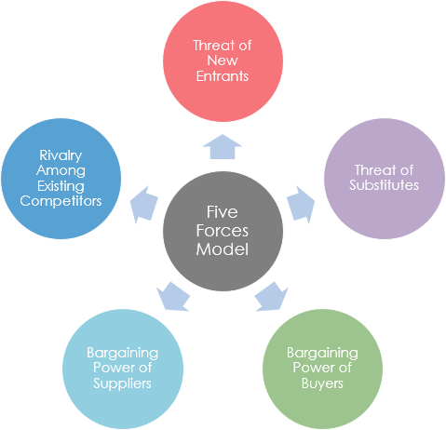
Figure 5: Porter’s Five Forces Model
Source:(Grant, Hackney and Elgar, 2012)
A Threat of Potential Market Entrants (High): Uber needs assurance from new ride-sharing firms that can unjustifiably charge less for a similar ride. At the hour of its foundation, Uber's prime supporters separated with a sizeable measure of capital. Then again, forthcoming opponents are relied upon to lesser introductory money to do their tasks. Uber's arrangement is to offer their application programming for nothing to willing clients (Ultius, 2019). The administrations can be exchanged at zero expense. As the need to counter-balance cost gets fast approaching, Uber isn't insensitive to raising rates, henceforth making it simpler for different firms to enter the business (Ultius, 2019). This is a solid power since it decides the firm's endurance in the segment.
Supplier Bargaining Power (High): Uber claims no vehicle among its fleets. In that capacity, the organisation's plan of action is profoundly reliant on drivers and accomplices owning their very own rides (Ultius, 2019). In fact, Uber uses a re-appropriating procedure for its work and resources for people that meet the terms and conditions for utilization of their lady web application. It is likewise difficult to substitute specific drivers. Vehicle proprietors are agreed the opportunity to pick between the association and adversaries along these lines can consult for a superior thoughtfulness regarding the organisation's cost (Pratap, 2019). Along these lines, it is unquestionable that the providers have a high ground in affecting Uber's presentation. When contrasted with other forces of the model, this one is moderate for Uber's situation.
Buyer Bargaining Power (High): Clients don't really require Uber benefits all the time. Indeed, just explicit conditions like a delay for work or a planned occasion specially make the clients its directions. Clients can completely pick between Uber, Lyft, or other rising ride-sharing origins. The exchanging cost is additionally lower for clients on the grounds that Uber's free application programming just requests client enrolment. Uber's clients are touchy to value changes given the nearness of substitutes and competitors. Considering these elements, the purchasers' enormous power can constrain the measure of income for the organisation, subsequently setting it as a solid power (Thompson, Scott and Martin, 2017).
The Threat of Substitutes (High):A threat of substitute is a typical power in aggressive business situations (Grant, Hackney and Elgar, 2012). Transportation Industry is a body that various part associations that can substitute Uber. Taxi administrations, for example, is the nearest rival and a potential substitute. Taxi administration is customary to urban areas with ride-sharing activities like New York. In that capacity, their plenitude is sufficient to confine Uber from raising the administration rates. It is remarkable that a slight increment of Uber rates can bring about client grasp of its nearest adversaries and substitutes. Plus, open methods for transport that offer comparative administrations at a less expensive expense can undermine Uber's presence or tasks (Thompson, Scott and Martin, 2017). A steady danger of substitutes is presently a weak power on account of Uber.
Rivalry with other Competitors (High): Lyft is one of the significant competitors of Uber. The organisation has a practically vague plan of action and tasks. Not exclusively are the two firms competing in the same industry for almost the same goal yet in additionto the providers (Thompson, Scott and Martin, 2017). An advanced business condition requests companies to focus on a client base inside a given situation to cut on the activity cost (Vecchiato, 2012). This is the situation for Lyft and Uber. Uber has arooted business system and enormous capital speculation. Fundamentally, it is a market head, yet immaterial separation techniques limit the association's potentials. The rivalry is a slighter power given to Uber's strength.
Uber is undoubtedly a predominant power in the ride-sharing industry. Nonetheless, there is a requirement for the headway of its development systems to increase an upper hand. The transport industry in the US has numerous substitutes and contending elements. To endure, it is basic to bring down the expense of activity to abstain from raising client charges.

4.0 Stakeholder’s expectations of Uber
An organisation is required to manage the expectations of its stakeholders based on the feedback of those stakeholders in terms of the performance of the company. In order to do that the company needs to communicate with the stakeholder’s, analyse their needs, addressing different issues and manage conflicts among them.
Uber is made up of two different kinds of stakeholders namely internal stakeholders and external stakeholders where the internal stakeholders are the employees of the organisation and the external stakeholders are the customers (Ultius, 2019). The customer base of the company is a diverse group and bring unique challenges with them. Uber brings together both their customers and employees through the efficient feedback system of their mobile application and their website. Such an efficient feedback system has been possible to implement for one of their stakeholders, the research and development team of the company (Ultius, 2019).
The internal stakeholder's group consists of the employees working in the organisation to operate the functions of the company such as HRM, R&D, Accounting departments and so on and another group of internal stakeholders is the drivers who are mainly implementing the function of this ride-sharing platform (Sakas and Konstantopoulos, 2010). There have been several issues regarding the drivers working within the company that they are not considered as employees of the organisation and are paid on a very low scale (Sijabat, 2019). Some of the drivers have complained that the percentage that Uber deducts from the actual fare of the bride is too high which is enabling the competitors to get advantages in the marketplace. Apart from this, there have been more than 300,000 lawsuits on the company filed by the drivers in terms of their wage and other issues (Ultius, 2019). If the driver’s expectations are analysed it will be found that these particular stakeholders expect a reasonable wage rate and be treated as employees of the organisations. As Uber, as a company, does not own any vehicles and completely dependent on the drivers sharing rides and lots of competitors in the marketplace, the company should consider the expectations of this particular group of stakeholders and make decisions accordingly.
On the other hand, another important group of stakeholder of the company is the customer base of the company which is a huge number around the world. It is difficult for the company to meet all the needs and demands of the customers but with the effective digital interface that the company has and with a huge number of employees available around different countries, the company is successfully operating their business (Sijabat, 2019). Alongside, there are some issues coming from the customers as well. One of them is several scandals have been occurred by the drivers which got a huge media coverage at different places had a devastating impact on the image of the company. Other than that many customers of the company are found unsatisfied with the pricing strategy of the company which is the core strategy regarding pricing ‘Higher the demand, higher the price. With the increased competition level, the company should be highly concerned regarding this issue as there are lots of alternatives in the market and there is no cost issue regarding switching from one company to another (Sijabat, 2019).These above factors should be considered seriously by the management of Uber in order to have a better competitive position in the marketplace.

5.0 Recommended Growth Strategy for Uber
Considering the issue that the competition is getting high in the market and analysing the internal and external business environment of the company which could affect the operation of the company and be affected, the company will have to choose an appropriate growth strategy to get rid of the issue (Sakas and Konstantopoulos, 2010). In this regard, the management of Uber may consider Porter’s Generic Growth Strategy to achieve sustainable growth in the marketplace.

5.1 Porter’s Generic Strategy as a growth strategy of Uber
In the theory of Generic strategy, Porter suggested four effective growth strategies which can be adopted by organisations in different situations to get a competitive advantage in the marketplace (Petit, 2012). The procedures identify with the degree to which the extent of a business' exercises are narrow versus broad and the degree to which a business looks to differentiate its product line (Petit, 2012). The key vital test for most organisations is to discover a method for accomplishing a manageable upper hand over the other contending items and firms in a market.
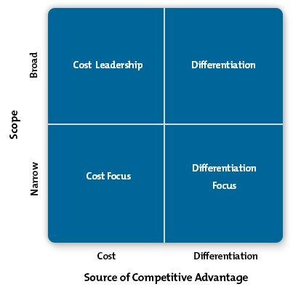
Figure 6: Porter’s Generic Strategy Model.
Source: (Grundy, 2014)
Cost Leadership
This is a typical business technique, and it is most likely one that various associations consider as they attempt to increase advantage over the competition (Lowson, 2017). Cost initiative implies that an association is going to lead the market in controlling costs somehow (McGee, Thomas and Wilson, 2016).
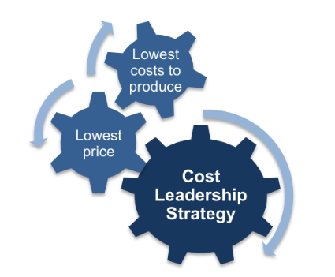
Figure 7: Cost leadership strategy
Source: (Grundy, 2014)
Inside this methodology, in any case, there are really two different ways they can go; one choice for Uber in this procedure is to offer the goods or services at a lower cost than the competitors, persuading purchasers to pick the item essentially in light of the fact that it is the most affordable decision on the racks, again, it could pick to take a cost administration technique by creating its units for the most minimal expense while as yet charging normal costs for the products (McGee, Thomas and Wilson, 2015). Along these lines, Uber will make a bigger edge on every deal than will the competitors, so it can win over the long run regardless of whether it doesn't sell fundamentally more units (Lowson, 2017). In fact, Uber may even have the option to win by selling fewer units if the overall revenues are huge enough. While it may appear to be a simple decision to just sell the items at the least conceivable cost, the organisation needs to ensure that it can continue this strategy as time goes on (McGee, Thomas and Wilson, 2015). For example, if there is a bigger rival in this market, they may choose to undermine Uber for a while so as to force the company to leave the business. Here the management of Uber needs to choose whether the organisation can support such risk, if indeed, it can embrace this procedure generally the organisation ought to go for different systems or mix them.
Differentiation
From various perspectives, the differentiation methodology is actually the inverse from the cost authority alternative (Jukić, 2019). With this strategy, Uber will attempt to take up control over the market from a quality and usefulness viewpoint, as opposed to just attempting to sell the most economical thing in the market.
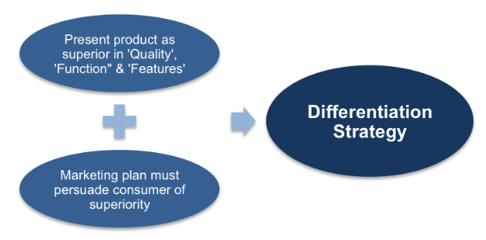
Figure 8: Differentiation strategy
Source: (Grundy, 2014)
At the point when One considers differentiation, he ought to consider luxury brands. For example, how does aluxury brand sell its product for $500 or more when a lot of organisations sell theirs for $20? They persuade the market that the quality and style that is offered by their item merits the more significant expense. They have differentiated themselves from the lower cost choices effectively, and they prevail thus. Obviously, it isn't actually simple to differentiate the organisation from a quality or usefulness point of view (Lasserre, 2015). Not just Uber needs to have aunique item to offer, it additionally needs to have solid advertising intend to illuminate purchasers about your thing. If all else fails, organisations are going to get to the most reasonable decision, so Uber should have the option to teach them about the item and everything that it can do. Without an effective advertising plan and group, Uber will most likely be left with a costly thing that is stuck on the market.
Cost Focus
This particular strategy in this piece of the model is equivalent to the cost leadership strategy, aside from Uber will be centred around one obvious speciality of the market (Jukić, 2019). As opposed to attempting to offer to everybody, Uber is just going to attempt to offer to a little part of the market that is centred around purchasing a one of a kind item in this strategy.
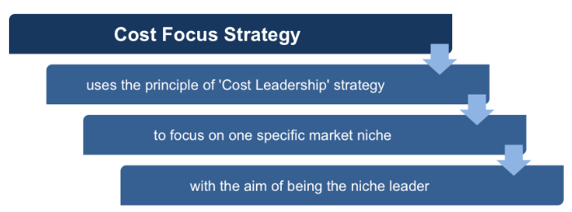
Figure 9: Cost Focus Strategy
Source: (Grundy, 2014)
While this technique probably won't have the development potential that the organisation will discover when managing the more extensive market, it will have the chance to turn into the significant player inside the industry, along these lines, tying down the spot of the organisation for a considerable length of time to come (Lowson, 2017). On the off chance that Uber can get into a little speciality with an item that is sold for not exactly some other, it will stand an incredible opportunity to succeed.
Differentiation Focus
As one may imagine, the differentiation focus system is like cost focus system, aside from he is getting down to business inside a speciality platform while attempting to stand apart on a quality idea (Jones and Tilley, 2013). The management of Uber probably won't be the most economical item available indeed, it may be the costliest item available, however, that isn't the point. For whatever length of time that the organisation can give purchasers something they are searching for, and it can justify the more significant expense of its items or administrations, it might have the option to grab a huge portion of the market.

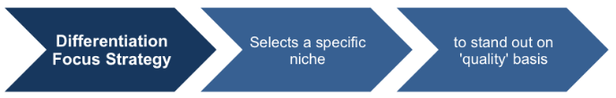
Figure 10: Differentiation Focus Strategy
Source: (Grundy, 2014)
Porter’s Generic strategyis an extraordinary method to consider the general situating of a business organisation (Grundy, 2014). An association positively wouldn't like to wander aimlessly into the market, planning to luck out and discover a spot for the organisation to flourish (Jones and Tilley, 2013). Keeping in mind, the present situation of Uber facing an increased amount of competition and all the internal and external components of the company, the most appropriate strategy for Uber is differentiate strategy. In this strategy, Uber will have to develop the quality of its services including innovations in its service which will differentiate them from the competitors within a reasonable price range and also the company will have to undertake different effective marketing strategy to let the people know more about the company.

6.0 Conclusion
It is common for the organisation to face changes due to the changes in the business environment and if the organisation can adapt to the change by using effective strategic planning and implementing the strategy (Grundy, 2014). While determining and undertaking the strategic planning process, an organisation should properly analyse its internal and external business environment which may affect the operation and performance of the business or by which the change has been occurred(Jones and Tilley, 2013). Once the analysis of done, the organisation now will have to choose a strategic growth option from different growth analysis model to change its operation or performance in accordance with the position of internal and external environmental analysis (Pratap, 2019). With the successful implementation of the growth strategy, the company will be able to adapt its operation and performance to the change and have a competitive advantage in the marketplace otherwise, Uber will lose its competitive position in the market.

References
Birkinshaw, J. (2011). Strategic management. Northampton, MA: Edward Elgar Pub.
Cohen, M. and Zhang, R. (2017). Coopetition and Profit Sharing for Ride-Sharing Platforms. SSRN Electronic Journal.
Dills, A. and Mulholland, S. (2017). Ride-Sharing, Fatal Crashes, and Crime. SSRN Electronic Journal.
Emerald Group Publishing. (2013). Strategic Management. Emerald Group Publishing.
Frue, K. (2019). PESTLE Analysis of Uber. [online] PESTLE Analysis. Available at: https://pestleanalysis.com/pestle-analysis-uber/ [Accessed 3 Nov. 2019].
Grant, K., Hackney, R. and Elgar, D. (2012). Strategic information systems management.
Grundy, T. (2014). Strategic project management and strategic behaviour. International Journal of Project Management, 18(2), pp.93-103.
Jones, O. and Tilley, F. (2013). Competitive advantage in SMEs. Chichester: Wiley.
Jukić, D. (2019). Strategic analysis of corporate marketing in culture management. Strategic Management, 24(1), pp.10-18.
Lasserre, P. (2015). Global strategic management.
Lowson, R. (2017). Strategic operations management. New York: Routledge.
McGee, J., Thomas, H. and Wilson, D. (2015). Strategic management. [Limerick]: McGraw-Hill.
Petit, Y. (2012). Advancing project and portfolio management research: applying strategic management theories. Strategic Direction, 28(9).
Pratap, A. (2019). Generic and Intensive Growth Strategies of Uber. [online] notesmatic. Available at: https://notesmatic.com/2017/11/uber-generic-intensive-strategies/ [Accessed 3 Nov. 2019].
Sakas, D. and Konstantopoulos, N. (2010). Marketing and management sciences. London: Imperial College Press.
Sijabat, R. (2019). Sharing Economy: A Study on the Factors Influencing Users' Motivation to Use Ride Sharing Platforms. DeReMa (Development Research of Management): Jurnal Manajemen, 14(1), p.65.
Thompson, J., Scott, J. and Martin, F. (2017). Strategic Management. Andover: Cengage.
Ultius. (2019). Sample Strategic Business Analysis of Uber. [online] Available at: https://www.ultius.com/ultius-blog/entry/sample-strategic-business-analysis-of-uber.html [Accessed 3 Nov. 2019].
Vecchiato, R. (2012). Strategic foresight: matching environmental uncertainty. Technology Analysis & Strategic Management, 24(8), pp.783-796.

