LCBB4003
INTRODUCING THE MODERN WORKPLACE

ORGANIZATIONAL STRUCTURE, CULTURE AND PERFORMANCE

Student name: Carmen Elena Albert
Student ID:2014069
Lecturer name: Gregory Cowan

Table of Contents
Introduction 3
Relationship between structure, culture, people and organizational performance 3
Nature of managerial work and role of leadership 6
Behavioral approach to management 8
Conclusions 9
Reference List 11

Introduction
The importance of organizational structure lies in allocation of roles and responsibilities and also monitoring the work process through influencing flow of communication between different departments. The goals of an organization determine the organizational structure which further determines the way in which the goals shall be fulfilled. A centralized organizational structure is reflective of effective decision-making by allocating equal roles and responsibilities to different departments and there is close monitoring and controlling of the tasks. On the other hand, a decentralized structure is characterized by delegation of decision-making power to lower levels that help in providing satisfaction and value to the lower-level employees. The impact of organizational structure on organizational processes is much and as such, it influences culture, people and performance of an organization to a great extent. The current study aims to analyze the impact of organizational structure on managerial powers and responsibilities in terms of organizational behavior, culture and performance.
Relationship between structure, culture, people and organizational performance
Some of the commonest structures followed by a majority of organizations in the world are functional, divisional, matrix, hierarchy, market and others. In the opinion of Nikpour (2017), functional structure is characterized by division of teams and departments in an organization as per their functions and as such, each of the departments is entrusted with a specific function. This is one of the most common structures followed in organizations across the world. On the other hand, divisional structure is associated with random allocation of people in different departments and therefore, there are different skill sets in different departments. The amalgamation of both functional and divisional structure is matrix structure where teams are allocated with specific tasks and roles for a temporary period and last for specific projects. These teams are managed by project managers for each project.

Figure 1: Types of organizational structure
(Source: created by Carmen Elena Albert)
The structure of an organization determines the extent to which goals of an organization are fulfilled. As stated by Lopes et al. (2017), the purpose of organizational structure is to ensure appointment of adequate staff for each of the tasks so that every task is completed with equal outcome. The impact of structure is also witnessed on behavior of people associated with organizations and thus, their attitude, perception, traits and behaviors are also influenced by type of organizational structure. As such, when employees are delegated to work on a specific task as per the structure of the organization, it also influences their communication and interaction procedure. In functional structure, the communication process is more effective as different teams rely on each other for information and decision-making. In contrast to this, the flow of communication in hierarchy structure takes place from senior positions to junior positions. The way people interact or communicate among them forms a major factor of organizational culture. As influenced by Shanker et al. (2017), structure is one of the most important frameworks shaping culture in an organization. Thus, it is always important for managers to focus on the kind of organizational structure they are opting for as it has an enormous impact on culture that would further influence behavior, attitude, thought process and the satisfaction levels of people.
Taking an organization adhering to functional organizational structure, it can be stated that the way in which business performance is influenced is through time taken for flow of communication through different levels. According to Groysberg et al. (2018), if amount taken for communication is huge, that would result in poor performance of the organization coupled up with new technology, economy, cultural changes and organizational politics. The narrow span of control shall result in restricting individual expression and power that is likely to cause dissatisfaction and lack of motivation of people. The impact of dissatisfaction is most likely to be witnessed on poor performance of employees leading to negative organizational behavior. It is important for managers and leaders to understand the wider impact of employees’ satisfaction and how that culminates in efficient individual performance. The limited communication among members in an organization is indicative of poor organizational culture and thus, they lack clarity regarding goals and objectives of the organization. Furthermore, poor communication is also indicative of lack of assistance from managers and higher authorities that results in creating a poor perception of employees towards their organization. As mentioned by Felipe, Roldán and Leal-Rodríguez (2017), this leads to negative employee relations, thereby, culminating in lack of organizational goals fulfillment and poor performance.
On the contrary, there is more flexibility in an organization when it opts for a divisional structure due to indulgence in low levels of management. As viewed by Odor (2018), divisional structure is characterized by increased competency as it makes the organization adaptive to changes as per the needs and expectation of customers. Furthermore, the power to decision-making relies on employees mostly and thus, the managers; role is limited in decision-making. A divisional structure also fosters greater communication where employees have the freedom to communicate and interact among themselves freely. The power and allowance given to employees in divisional structure culminates in greater satisfaction and positivity and thus, they work in a comparatively healthy environment. This is also indicative of a strong organizational culture due to free communication that allows flow of information and thus, each of the departments can make informed decisions. As studied by Pawirosumarto, Sarjana and Gunawan (2017), motivated employees contribute positively to work culture and performance by enhancing their productivity and loyalty towards the organization. They take active participation in fulfilling organizational goals and therefore, there is continuous growth and development of the organization. When employees are satisfied, there is also a lesser chance of their turnover, thereby, constituting retention of employees. Thus, in this way, structure influences organizational culture that further influences people and performance to contribute to a better working environment and work relationships.
Considering matrix structure, there is a redefinition to culture and structure where organizational power is used to make decisions. However, as opined by Groysberg et al. (2017), the unique factor in this form of structure is entrusting the skillful and expertise employees to take part in decision-making. Thus, unlike functional and divisional structure, this structure is not identified in terms of confining decision-making power to one category only. Instead it relies on the skill level and expertise of employees so that there is effectiveness of decision taken. One of the major factors characterizing matrix structure is lack of identifying the leader and therefore, each of the members have an equal role to play in decision-making. This calls for a positive work environment among the members fostering individual participation and group identity. This influences performance of an organization in a positive way and therefore, employees work with motivation (Paais and Pattiruhu, 2020). Moreover, the indulgence of employees in decision-making due to their skill level and expertise further motivates them and they are driven towards enhancing their skills more. This results in creating a workplace environment that supports continuous growth and development of employees leading to organizational effectiveness and competency.
Nature of managerial work and role of leadership
The roles and responsibilities of leaders and managers can be segregated into various types based on priority typology. As studied by Kangas et al. (2018), some of the most important roles and responsibilities of managers include conservative role that helps in solving the issues occurring on a daily basis, creative role that aims at expansion and competency of the organization by adapting to continuous change and accord with dynamic business environment. Therefore, a manager or a leader must take part in strategic role that helps in fulfilling organizational goals and objectives and to adhere to business mission and vision. Therefore, managers develop a structure that best suit the vision of the organization and will contribute to smooth functioning to fulfill the objectives. In the course, leaders ensure efficient management of people so that they work with satisfaction and motivation and contribute to better work relationships and low risk of conflict occurrence. Prior to selecting the most appropriate business structure, leaders and managers must consider the various organizational structures and analyze the benefits and disadvantages of each of the structures. As influenced by Gochhayat, Giri and Suar (2017), a manager must ensure that different members in hierarchy behave the same way and take active participation in communication and decision-making so that there is a similar role establishment for each of the members. However, in a hierarchical structure, the managers are at the top with gradual flow of information to lower levels that would often incur a sense of superiority among top levels in an organization. This creates an imbalance in an organization and employees often work under the guidance of their managers and leaders instead of working with the freedom on their own. This creates a negative work culture and the way in which people behave in these organizations is through authoritarian leadership.
The decision role of a manager and leader is associated with identification of opportunities and possibilities that would culminate in betterment and development of an organization through change management, employee encouragement and extracting innovative ideas from employees. As stated by Sunarsi (2020), this managerial role is also associated with resolution of conflicts by the manager so that there is a better workplace environment and the employees work with a stable mental state. The way in which managers constitute conflict management is through improving organizational structure and solving the complaints or issues faced by customers. Furthermore, resources available to an organization also determine the type of structure that it opts for. For instance, if an organization is acquainted with technological resources such as IT or IS tools, it would lead to a better communication system through integrated communication systems. Thus, the organization shall opt for necessary structure that would contribute to its competitiveness without worrying about a poor communication system. Organizations that are equipped with greater resources have more opportunities to work efficiently and handle the issues faced by employees. These organizations have a better workplace culture that contributes to people management, and betterment of their performance. In view of Kangas et al. (2018), finance is an important resource to a company and thus, it helps in providing financial benefits to employees as a form of motivation that helps in talent management and acquisition.
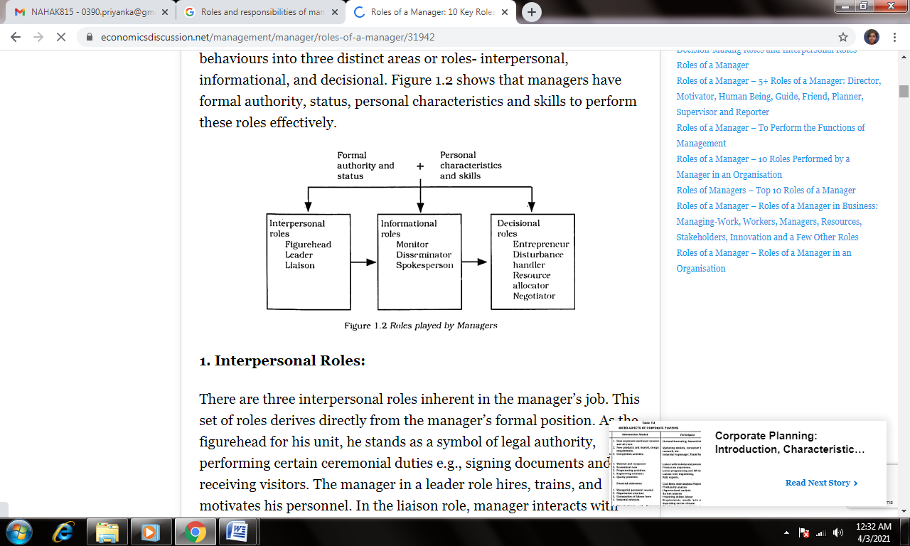
Figure 2: Managerial roles
(Source: Sunarsi, 2020)
Behavioral approach to management
The behavioral approach rests on human relations and addresses the dimensions in which humans work. In the organizational context, the implementation of behavioral management theory helps in analyzing the relationship existing between employees of an organization that influences various factors related to motivation, expectations, conflicts and group dynamics that further influences their productivity and performance. According to Torchia et al. (2018), human relations approach is an important wing of behavioral approach that determines the connection and interaction between managers and their subordinates. This is hugely determined by the prevalent organizational structure. As such, hierarchy organizational structure restricts a direct communication between higher authorities and lower level employees. On the other hand, communication is closer in divisional or matrix structures. The crux of human relation approach lies in managers identifying the needs and expectations of employees so that there is social acceptance.
The aspect of behavioral science approach provides value to performance, behavior and attitude of employees and groups within an organization. As put forward by Lucini and Pagani (2021), it is suggested that the relationship existing between managers, leaders and employees have a direct impact on their performance, motivation, communication and participation in organizational affairs. Therefore, it is important that divisional or matrix structure is followed in organizations to establish a close connection between the different members and this also allows the members to voice their issues and grievances effectively. On the other hand, if organizations are relying on functional or hierarchical structure, then the upper managerial department should ensure providing communication platforms to employees to communicate about their opinion, issues and grievances.
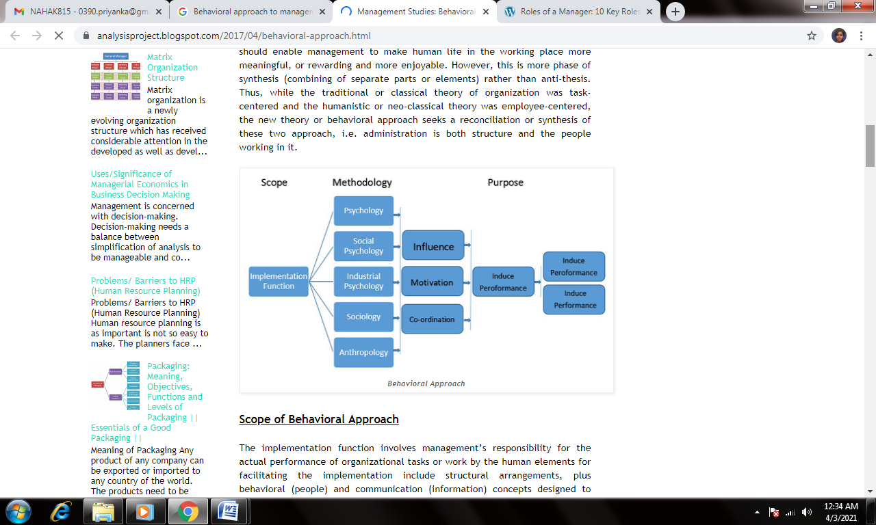
Figure 3: Behavioral approach to management
(Source: Torchia et al. 2018)
Conclusions
To conclude, the competitive advantage of an organization rests entirely on structure and organizational culture. Organizations should always opt for a culture that provides equality to all employees and does not create a sense of superiority or inferiority. The employees should be allowed to communicate, and they should be motivated as part of people management. That would contribute effectively to betterment of performance and lead to growth.

Reference List
Felipe, C.M., Roldán, J.L. and Leal-Rodríguez, A.L., (2017). Impact of organizational culture values on organizational agility. Sustainability, 9(12), pp.2354-2410.
Gochhayat, J., Giri, V.N. and Suar, D., (2017). Influence of organizational culture on organizational effectiveness: The mediating role of organizational communication. Global Business Review, 18(3), pp.691-702.
Groysberg, B., Lee, J., Price, J. and Cheng, J., (2018). The leader’s guide to corporate culture. Harvard business review, 96(1), pp.44-52.
Kangas, M., Kaptein, M., Huhtala, M., Lämsä, A.M., Pihlajasaari, P. and Feldt, T., (2018). Why do managers leave their organization? Investigating the role of ethical organizational culture in managerial turnover. Journal of Business Ethics, 153(3), pp.707-723.
Lopes, C.M., Scavarda, A., Hofmeister, L.F., Thomé, A.M.T. and Vaccaro, G.L.R., (2017). An analysis of the interplay between organizational sustainability, knowledge management, and open innovation. Journal of Cleaner Production, 142, pp.476-488.
Lucini, D. and Pagani, M., (2021). Exercise Prescription to Foster Health and Well-Being: A Behavioral Approach to Transform Barriers into Opportunities. International Journal of Environmental Research and Public Health, 18(3), pp.968-987.
Nikpour, A., (2017). The impact of organizational culture on organizational performance: The mediating role of employee’s organizational commitment. International Journal of Organizational Leadership, 6, pp.65-72.
Odor, H.O., (2018). A literature review on organizational learning and learning organizations. International Journal of Economics & Management Sciences, 7(1), pp.1-6.
Paais, M. and Pattiruhu, J.R., (2020). Effect of motivation, leadership, and organizational culture on satisfaction and employee performance. The Journal of Asian Finance, Economics, and Business, 7(8), pp.577-588.
Pawirosumarto, S., Sarjana, P.K. and Gunawan, R., (2017). The effect of work environment, leadership style, and organizational culture towards job satisfaction and its implication towards employee performance in Parador Hotels and Resorts, Indonesia. International Journal of Law and Management.
Shanker, R., Bhanugopan, R., Van der Heijden, B.I. and Farrell, M., (2017). Organizational climate for innovation and organizational performance: The mediating effect of innovative work behavior. Journal of vocational behavior, 100, pp.67-77.
Sunarsi, D., (2020). The Analysis of the Work Environmental and Organizational Cultural Impact on The Performance and Implication of The Work Satisfaction. Jurnal Ilmiah Ilmu Administrasi Publik, 9(2), pp.237-246.
Torchia, M., Calabro, A., Gabaldon, P. and Kanadli, S.B., (2018). Women directors contribution to organizational innovation: A behavioral approach. Scandinavian Journal of Management, 34(2), pp.215-224.

