DS 1: My Digital Life

My Screenshots/Photos

Screenshot/Photo 1
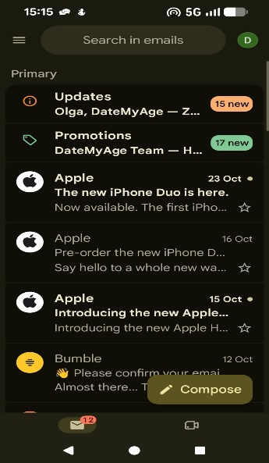
I use Gmail to send and receive emails. It helps me communicate clearly and keep a record of conversations.

Screenshot/Photo 2
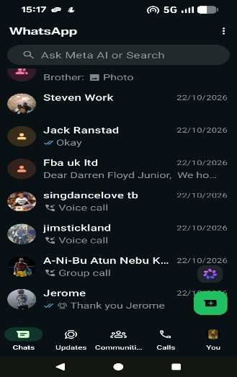
I use WhatsApp to exchange messages and share information quickly. Group chats have helped me stay in contact with classmates and discuss study activities.

Screenshot/Photo 3
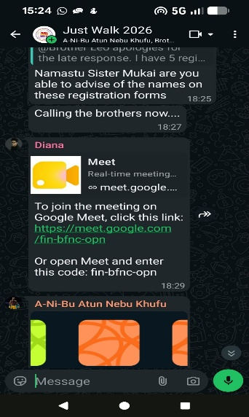
I use Google Meet to attend my online classes and participate in group discussions.

Screenshot/Photo 4
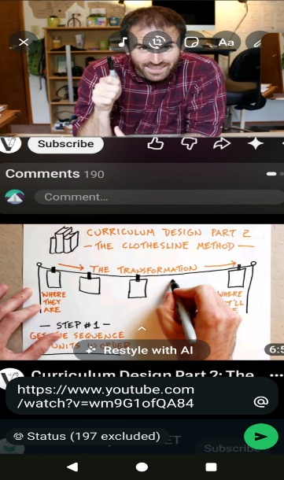
I use YouTube to watch educational videos and learn how to complete new tasks.

My Short Reflection
I use digital tools daily for my studies and communication. For formal communication and organising important information, I use Gmail and for quick updates with classmates, I use WhatsApp. Google Meet helps with online classes and group discussions and YouTube lets me learn at my own pace by pausing and rewinding tutorials. While these tools enable communication and learning to be more flexible, I also need to ensure the accuracy of information found online and safeguard my privacy. Digital competence involves communicating and collaborating online, managing information and using technology safely and responsibly (Vuorikari et al., 2022). I want to work on how I organise myself digitally and feel more confident using digital tools effectively in my learning.

Reference
Vuorikari, R., Kluzer, S. and Punie, Y. (2022). DigComp 2.2: The digital competence framework for citizens. Publications Office of the European Union. https://doi.org/10.2760/115376 [Accessed 25 October 2026].

