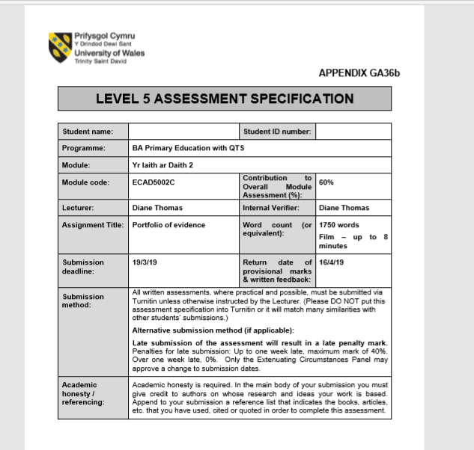
1600411

TASK 1 – Rationale
The rationale behind my choice of book was primarily to engage the children in the Welsh language using a topic that was familiar to them. This would promote their use of oracy, listening and understanding and reading the Welsh language. The choice of book for this assignment was related to the series of PODthat they were working through in class. Therefore, they had prior knowledge of some aspects of sentence structure and patterns. The school was working towards their silver award in the SiarterIaith. The Welsh Government (2015) state that the Welsh Language Charter is a project that aims to encourage more Welsh in the primary schools in Wales and that “Communication is at the heart of modern life.” (Welsh Language Charter, 2015) Iread the book to a higher ability year 4 group of children. As they were the most confident using Welsh and that it would incorporate parts of the SiarterIaith. However, the language that both I and the children used was not of a year 4 standard. This is because the children in the class were at more of a year 3 standard. In conversation with the class teacher it was decided that the book would be of a year 4 standard to challenge them, but vocabulary would vary whichever would best help them. Among the topics undertaken for the class theme was the moon landing. I therefore felt using a book relating to space would be effective for their learning as they would be able to use the vocabulary elsewhere. The learning objective of the session was to identify planets when given clues as the book was based around a character flying around the solar system. See appendix 1 for written vocabulary.

TASK 2 – VIDEO
https://m.youtube.com/watch?v=NaoDdyv2TJc

TASK 3 - Reflection
The Welsh government’s ‘Cymraeg 2050’ strategy is to create a million speakers by 2050 as “The Welsh language is one of the treasures of Wales. It is part of what defines us as people and as a nation.” (Welsh Assembly Government, 2017, p.2) It is thereforecrucial that children in school are immersed in the language from a young age. Reading a Welsh book to a child exposes them to the language and allows them to identify key words relating to a topic thus increasing their Welsh language development. The Welsh Government (2017) recognise this in their action plan and states that they understand the importance that the early years play in a child’s development of the Welsh language. For this strategy to be successful there is a need to promote Welsh in schools and for a change in pupils’ and teachers’ attitude toward Welsh as a subject. Welsh in schools is not seen as a core subject and is seen as one that isn’t valuable or needed later in life. After reviewing reports, it is clear to see that Welsh needs to be given the same level of importance as other core subjects. The one language for all report states that “The most important recommendation of all is the necessity for the subject to be accorded the same status as core subjects in schools.” (Welsh Government, 2013, p.2)
In the introduction to the session they carried out drilio; these were key words which related to the topic of space where the children would repeat the word three times while carrying out an action. These words included astronaut, star and moon, all of which were in the book. I said the words initially and the children repeated them. To engage the children further, I asked one child to say the words and the rest to repeat them. This promotes not only their Welsh oracy but their listening and understanding skills, as they needed to identify what action had to be carried out. For example, if the word was sun, they would carry out an action to represent sun.
Using positive reinforcement after drilio created a friendly environment for the children, thus encouraging them to develop their Welsh by imitating the sounds and actions. Behaviourists such as Skinner support positive reinforcement and, in his experiments, would “Break tasks down into small steps, each step reinforced and rewarded as it was learned.” (Pound, 2006, p.43) Patsy (1993) suggests by using Skinner’s theory in a friendly learning environment, surrounding the child with good quality Welsh as well as consistent positive reinforcement should shape and develop a child’s language behaviour. However, Chomsky disagreed with Skinner’s theory and stated that we are born with a ‘language acquisition device’ which enables us to have an inbuilt understanding and knowledge of language structures (Pound, 2006, p.43). I feel that the repetition and positive reinforcement helped the children with their Welsh development as their confidence grew. I found that the positive reinforcement then helped with their development in other subjects and in future Welsh lessons. As they were seeking praise, they were more engaged in the lessons and contributed more to class discussions and questioning. In Welsh lessons taken after this session, I repeated one of the activities to see how much they could remember. The children remembered the new sentence patterns and learnt new vocabulary quicker. However, on reflection if I were to do this again, I would have the activity more child led allowing them to take control of their own learning and create their own drilio words. I would ask the children to choose key vocabulary that they would like included in the drilio and then look it up in the Welsh dictionary, writing down the word and making an action for it.
In key stage 2 children are expected to “Build on the skills, knowledge and understanding acquired during the Foundation Phase” (Welsh Government, 2015, p.9). Considering this, reading a book to a key stage 2 class would benefit their learning of a language as they would have been surrounded by it in the foundation phase. Reading a story to a class allows for a calm natural environment where the child is happy and comfortable to learn. The book I chose related to their topic in class allowing it to have a meaning and purpose in the session. Hood and Tobutt (2015) support this as they suggest that learning a language should not be taught by just one strategy and that the activity should connect with the class context in a meaningful way.
As this was a challenging book, there were some sentence patterns that the children had not experienced. I therefore chose to expose them to these by reading a book as they would be able to process it easier than in written form. Hood and Tobutt support this and state that “Children are much more likely to manage more challenging texts if it comes in the form of a story.” (Hood and Tobutt, 2015, p.72). On reflection, I feel I could have made the experience more meaningful by portraying enthusiasm and positivity about the book into the tone of my voice and using my voice more effectively to emphasise different words or parts of the book to engage the children further. It is clear that I could have made more of a point of the new sentence patterns and asked the children to repeat them after me and included questioning on the meaning of the sentence and what the answer could be. This would have enabled them to use their oracy and listening and understanding skills.
During the activity I used questioning to further the children’s learning. By questioning the children, I was able to activate any prior knowledge they had and stimulate recall. Identifying where a child is in their learning and where they need to go is crucial for a child to progress. Ausubel (1978) supports this in a statement which said “The most important single factor influencing learning is what the learner already knows. Ascertain this and teach him/her accordingly.” (Wragg and Brown, 2001, p.6) For questioning to be effective there needs to be a use of both open and closed questions. If there is no understanding of where a child is or needs to be in their learning, then it is difficult unclear to know what to teach next. In Wragg’s (1993) study he found that the most successful questions were those which contained a sense of looking ahead. Using questioning in my activity I was able to do this and incorporated all four strands of the curriculum into their learning. Barnes, however, believes that teacher questioning is detrimental to a child’s learning as they don’t gain much from it. Instead he spoke more about the importance of communication in the classroom as “Teacher questions dominated and that pupils rarely initiated exchanges or asked questions of their own.” (Moyles et al. 2003, p.16) On reflection, I did not allow the children to communicate with each other as much as they should, and I dominated a large part of the video with my questioning. This is not beneficial to the children as they are not developing their use of the Welsh language. I would change this aspect, and would ask the children to read out the clues regarding the planet under discussion. This would allow them to question each other in Welsh. This would improve their listening, understanding and oracy skills.
In the session I used the task-based learning method where the activity is directly linked to the book and included Welsh language that children could use in other lessons such a science as the book was about the solar system. The tasks also allowed the children to use the drilio vocabulary which they had acquired beforehand. Both these activities had a sense of problem solving. Firstly, where they were given written clues to identify the planet, and the secondly by matching the correct planet to the Welsh name. I used problem solving skills as children are more involved with problem solving activities and in turn engaged in learning new information. Dewey (2015) supports this and states that children should be personally involved with the making of their new knowledge and understanding which can be through problem solving. In learning Welsh through the story, the children were also being exposed to a cross-curricular style of teaching with science elements in the session. I chose to teach them Welsh vocabulary through cross-curricular strategies as it would develop their literacy skills. Harris and Grenfell (2004) support this as and found that there were explicit links between cross-curricular learning strategies with languages and improvement in children’s literacy skills. Upon reflection I feel that the tasks they were given could have been improved and I should have given them tasks in which they used more Welsh vocabulary thus improving their Welsh language literacy skills further.
The Successful Futures document (2015), states that they want to see an education system that is responsive to the demand for an increase in the use of Welsh in English medium schools. Donaldson concludes that “We want to ensure that our education system makes it possible for more learners of all ages to acquire a wider range of language skills. This will enable them to use the language in their personal lives, socially and in the workplace.” (Donaldson, 2015, p.26) For the new curriculum to be effective it is crucial that teachers are trained sufficiently to promote the Welsh language and the use of Welsh in the classroom.Reflecting on my session I can evaluate my own teaching methods and can see that I did not communicate with the children enough using Welsh and did not encourage them enough to communicate with me and with each other in Welsh. I understand the teaching strategies that are effective to promote the Welsh language and will use these in future sessions.

Reference list
Barnes, J. (2015) Cross Curricular Learning 3-14. 3rd Ed. London: Sage.
Donaldson, G. (2015) Successful Futures. Available at: https://gov.wales/docs/dcells/publications/150225-successful-futures-en.pdf(Accessed: 5th March 2019).
Hood, P. and Tobutt, K. (2015) Teaching languages in the Primary School. 2nd Ed. London: Sage.
Lightbrown, P.M and Spada, N. (2013) How Languages are Learned. 4th Ed. Oxford: Oxford University Press.
Moyles, J. et al. (2003) Interactive Teaching in the Primary School. England: Open University Press.
Pound, L. (2006) How children learn From Montessori to Vygotsk. London: Practical Pre-School Books.
Psaltou-joycey, A. and Agathopoulou, E. and Mattheoudakis, M. (2014) Cross-Curricular Approaches to Language Education. Cambridge: Cambridge Scholars Publishing.
Welsh Assembly Government (2003) Developing the Curriculum Cymreig. Available at: https://learning.gov.wales/docs/learningwales/publications/130424-developing-the-curriculum-cymreig-en.pdf (Accessed: 1st March 2019)
Welsh Government (2013) One language for all Review of Welsh second language at Key Stages 3 and 4. Available at: file:///C:/Users/Sarah/AppData/Local/Packages/Microsoft.MicrosoftEdge_8wekyb3d8bbwe/TempState/Downloads/171212-welsh-in-education-action-plan-2017-21-en%20(1).pdf (Accessed: 28th February 2019).
Welsh Government (2015) Welsh Language Charter. Available at: https://cymraeg.llyw.cymru/learning/schools/SiarterIaith./?lang=en(Accessed: 3rd March 2019)
Welsh Government (2015) Welsh second language in the National Curriculum for Wales. Available at: https://learning.gov.wales/docs/learningwales/publications/150707-welsh-second-language-en-v2.pdf (Accessed: 8th March 2019).
Welsh Government (2017) Cymraeg 2050: A million Welsh speakers. Available at: file:///C:/Users/Sarah/AppData/Local/Packages/Microsoft.MicrosoftEdge_8wekyb3d8bbwe/TempState/Downloads/170711-welsh-language-strategy-eng%20(1).pdf (Accessed: 9th March 2019).
Welsh Government (2017) Welsh in Education Action plan 2017-2021. Available at: file:///C:/Users/Sarah/AppData/Local/Packages/Microsoft.MicrosoftEdge_8wekyb3d8bbwe/TempState/Downloads/171212-welsh-in-education-action-plan-2017-21-en%20(1).pdf (Accessed: 10th March 2019).
Wragg, E.C and Brown, G. (2002) Questioning in the Primary School. 2nd Ed. London: Routledge Falmer.

Appendix 1


