

Data Manipulation

Student Name: Vishvarajsinh Surendrasinh Rana
Student ID: 2527154

MSc Data and Artificial Intelligence
Module: Advanced Statistical Programming
Module Code: ACCA7022

Lecturer: Dr Aliyu Sambo

Table of Contents
Table of Contents 2
Introduction 3
Task A: Generate Production Data 4
Figure 1: Generate Production Data Flowchart 5
Figure 2: First 10 rows of production_data output 6
Task B: Total Production per Utility 6
Figure 3: Total Production per Utility Flowchart 7
Figure 4: Utility_totals output 8
Task C: Detect Production Anomalies 8
Figure 5: Detect Production Anomalies Flowchart 11
Figure 6: First 10 anomalies output 11
Task D: Identify Peak Productivity Days 11
Figure 7: Identify Peak Productivity Days Flowchart 12
Figure 8: peak_days output 13
Task E: Calculate Efficiency Score 14
Figure 9: Calculate Efficiency Score Flowchart 15
Figure 10: First 10 rows with EfficiencyScore output 16
Reflection 17
References 18

Introduction

This report documents the R code I wrote for the Smart City Utilities Operations Simulation assignment, simulating and analysing output data for six utility services, five teams, over 30 days. The tasks of generating data, totals, anomaly detection, peak days, and efficiency scores were completed using loops only, without high-level functions such as apply(), aggregate(), rowSums() or colMeans(), and without writing custom functions.

Task A: Generate Production Data

Task A was the foundation of the whole assignment. I created four empty vectors to store the data before filling them using three nested loops.
The outer loop runs through the 30 days, the middle loop through the 6 utilities, and the inner loop through the 5 teams. For each combination, a random noise value between -5 and +5 is picked, and output is calculated using the formula:

Output = 40 + (utility_id × 3) + (team_id × 2) + noise

After all loops finish the four vectors are combined into a single dataframe called production_data with 900 rows in total. The first 10 rows are then displayed using head().
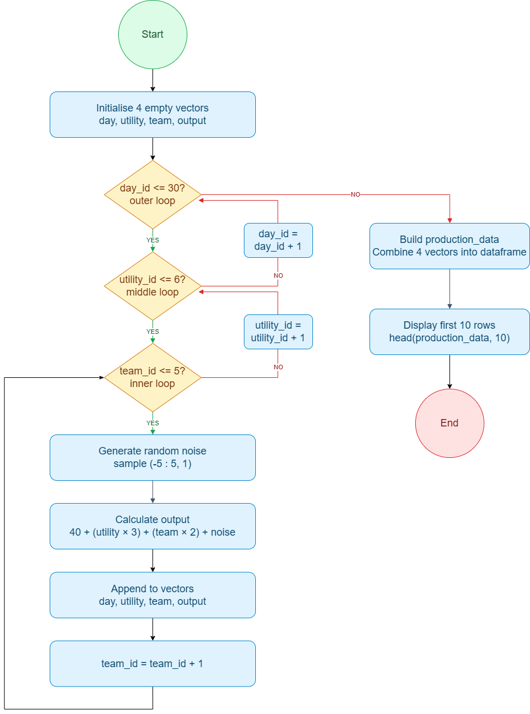

Figure 1: Generate Production Data Flowchart

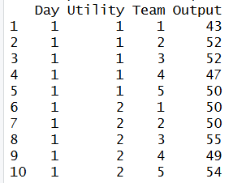

Figure 2: First 10 rows of production_data output

Testing & Verification:
I tested the dataset by checking it contained the expected 900 rows. I also verified the formula: for Day 1, Utility 1, Team 1, the base output without noise is 40+(1×3)+(1×2) = 45, so with noise between -5 and +5, the output should fall between 40 and 50. My dataframe shows 43 for this row, which fits, and I checked a few other rows the same way with the same result.

Task B: Total Production per Utility

In Task B I needed to find the total output for each of the 6 utilities across all 30 days and all 5 teams.
I started by creating two empty vectors to store the utility number and its total output. Then I used two loops, the outer loop goes through each utility one by one and the inner loop goes through every single row in production_data.
For each row I checked if it belonged to the current utility. If it did I added its output to a running total. Once all 900 rows were checked the utility number and its total were saved. This repeated for all 6 utilities.
After the loops finished, I combined the two vectors into a dataframe called Utility_totals with two columns: Utility and TotalOutput.

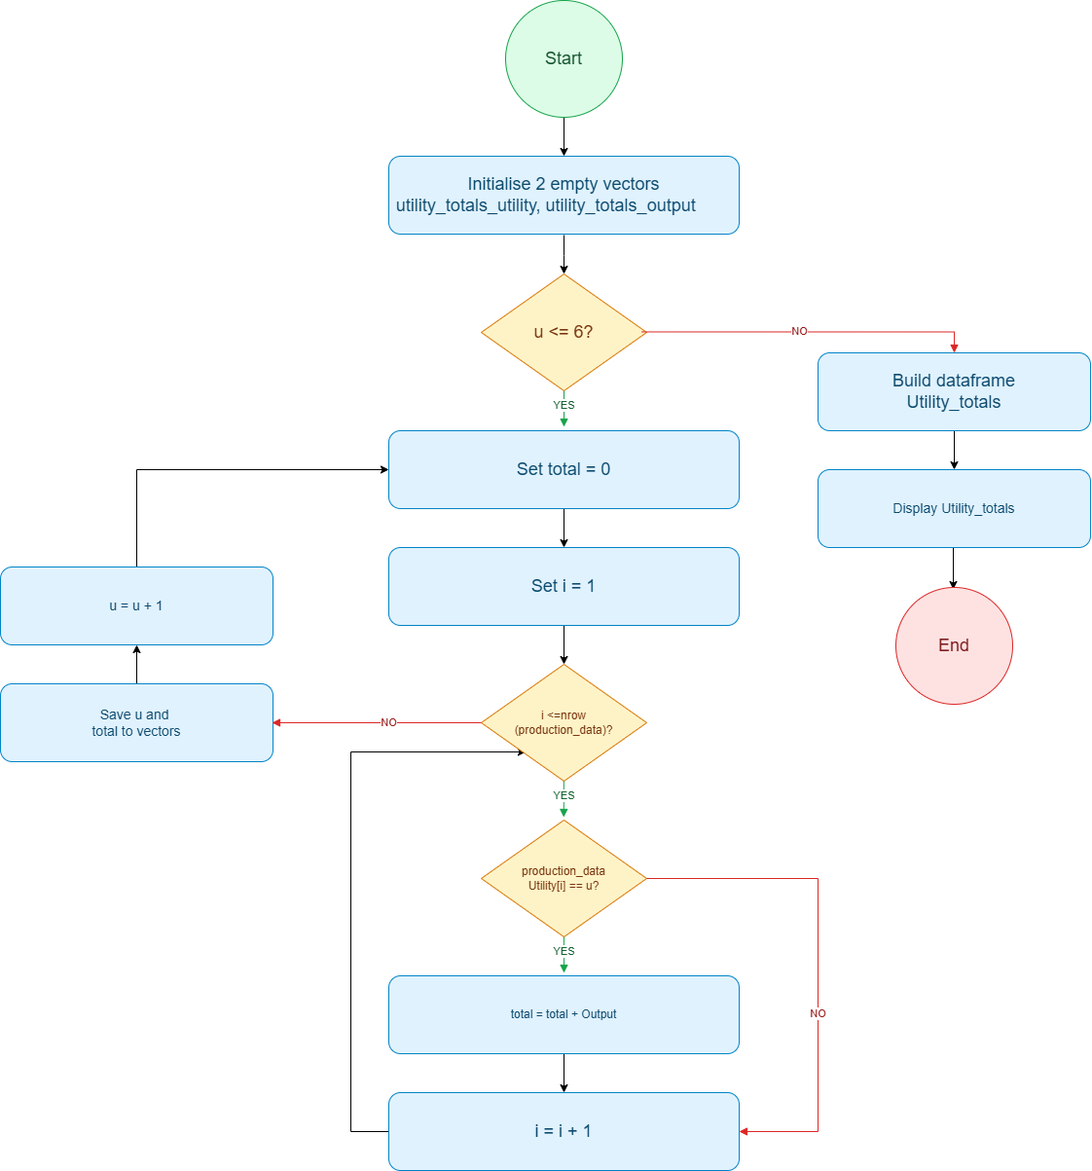

Figure 3: Total Production per Utility Flowchart

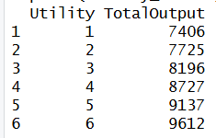

Figure 4: Utility_totals output

Testing & Verification:
I tested Utility 1's total manually. Each row ranges from 40 to 58 depending on team and noise, so the total across 150 records should fall between 6000 to 8700, near an expected 7350. My dataframe showed 7406, close to expected and within range. Totals also increased with utility number, as expected since higher utility IDs produce larger base outputs.

Task C: Detect Production Anomalies

Task C was the most complex task, requiring me to check every team's output, on every day, for every utility, and flagging anomalies more than 10% from the daily average.
I created five empty vectors for the anomalies dataframe's columns, then used two outer loops, one for each day, one for each utility.
For each day-utility combination, I first summed the 5 team outputs to get a daily total, then divided by 5 for the daily average. I then looped through the production_data again, this time checking each team's deviation, and flagged it TRUE if the deviation exceeded 10% of the average, otherwise FALSE.

Source Code:

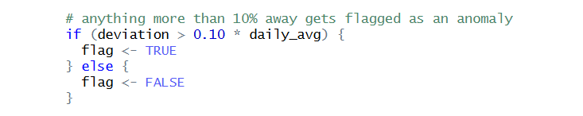

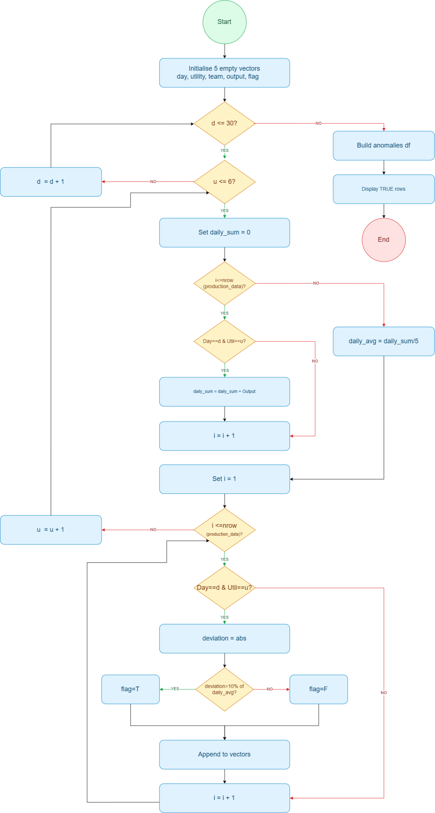

Figure 5: Detect Production Anomalies Flowchart

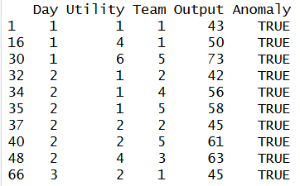

Figure 6: First 10 anomalies output

Testing & Verification:
I tested the anomaly detection using a real flagged record: Day 1, Utility 1, Team 1, output 43. The other four teams that day had outputs 52, 52, 47, and 50, giving a daily average of 48.8. Team 1's deviation of 5.8 exceeds 10% of 48.8 (4.88), confirming the TRUE flag was correct.

Task D: Identify Peak Productivity Days

In Task D I needed to find which day had the highest total output for each of the 6 utilities.
I created three empty vectors to store the utility number, the best day and the highest output. Then I used three loops, the outer loop goes through each utility, the middle loop goes through each of the 30 days, and the inner loop goes through all the rows in production_data to add up the outputs for that day and utility.
For each day I compared the total output against the current best. If it was higher I updated the best day and best output. This way by the time all 30 days were checked I had the peak day for that utility saved.
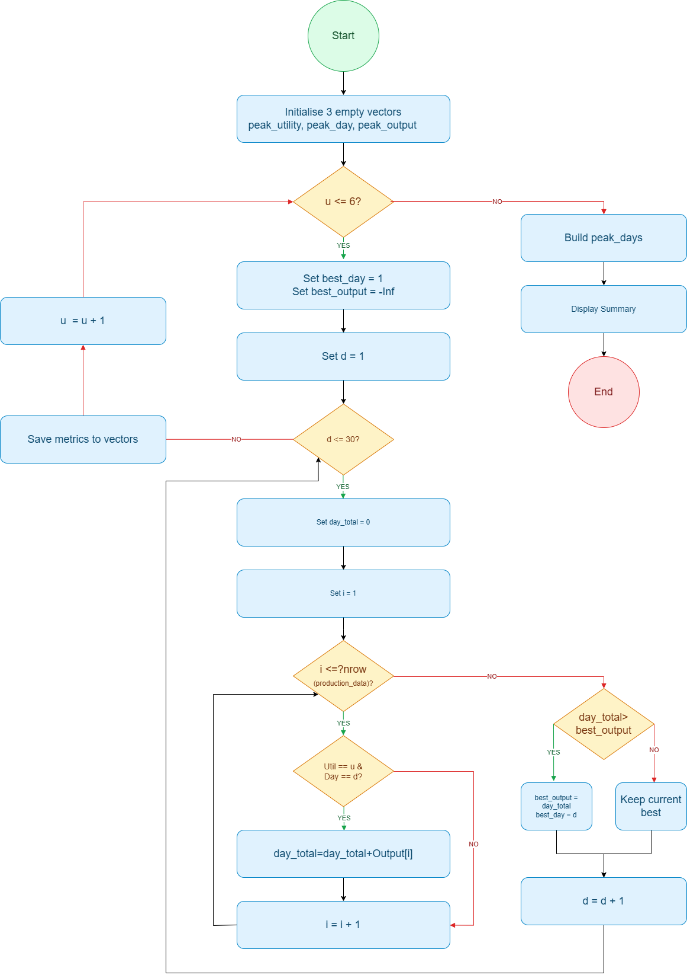

Figure 7: Identify Peak Productivity Days Flowchart

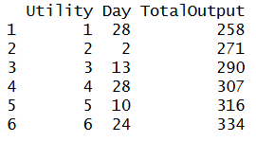

Figure 8: peak_days output

Testing & Verification:
I tested the peak day result for Utility 1. Its 5 teams have a combined base output of 245, so with noise of ±5 per team, a day's total should fall between 220–270. My dataframe shows Day 28 with a total of 258, within range and the highest of the 30 days. I checked the same logic for the other utilities, and their peak totals matched too.

Task E: Calculate Efficiency Score

Task E was the simplest task. I just needed to add a new column called EfficiencyScore to the existing production_data dataframe.
I created one empty vector to store the scores. Then I used a single loop that went through every row in production_data. For each row I divided the output by the sum of the utility and team numbers using the formula from the assignment. Each score was saved to the vector and after the loop finished, I added the whole vector as a new column to production_data.

Source Code:
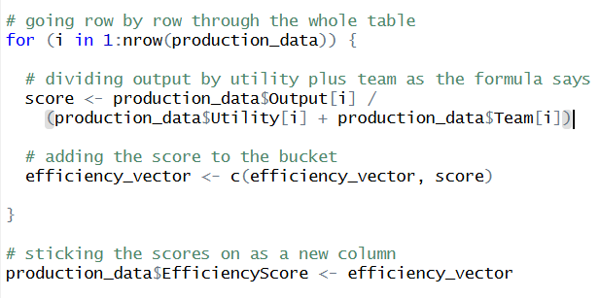
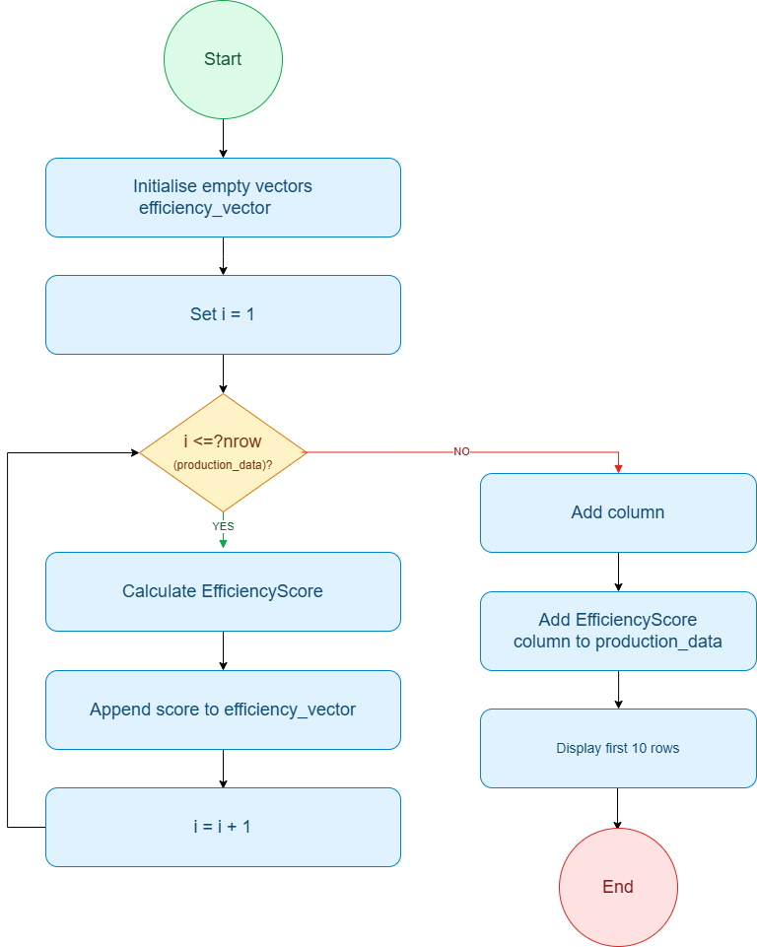

Figure 9: Calculate Efficiency Score Flowchart

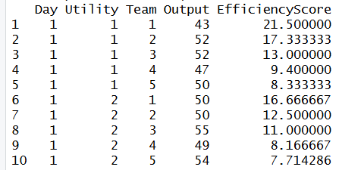

Figure 10: First 10 rows with EfficiencyScore output

Testing & Verification:
I tested the efficiency score by manually calculating one row's value and comparing it with the dataframe. Row 1 has Output = 43, Utility = 1, Team = 1, so the expected score is 43 / (1+1) = 21.5, which matched exactly what was shown in the dataframe.

Reflection

Coming into this assignment I had almost no experience with R. I had used Python briefly before, but R felt completely different, even for basic things like creating vectors and using the assignment operator. The first evening I spent just getting RStudio set up and understanding why <- is used instead of = which sounds small, but it slowed me down at the start.
Task A was where I spent the most time initially. Writing three nested loops was something I had never done before, and I kept getting confused about which variable belonged to which loop. I made a mistake early on that caused the values in my data frame to look wrong, and it took some time using print statements to work out where in the loops it was going wrong.
Task C was genuinely the hardest part for me. The challenge was not just writing the loop but understanding that I needed to make two separate passes through the data, first to calculate the daily average, then to compare each team against it. My first attempt tried to do both in one loop which gave wrong results. Realising I needed to separate the two steps took time and a few failed attempts before it clicked.
Throughout the assignment I used a generative AI tool as a learning aid. For example, when I was stuck on Task C I asked it to explain what a two-pass approach means rather than asking it to write the code for me. It explained the concept and I then wrote the solution myself. I made sure I understood every line before moving on rather than copying anything directly.
If I did this again, I would sketch the loop logic on paper before touching the keyboard. Several times I jumped into coding before fully thinking through the structure which cost me time fixing mistakes that better planning would have avoided. I would also test each task immediately after writing it rather than waiting until the end.

References

Anthropic (2025) Claude. Available at: https://claude.ai/
diagrams.net (2025) Flowchart and Diagram Tool. Available at: https://app.diagrams.net/
Google (2025) Gemini. Available at: https://gemini.google.com/
OpenAI (2025) ChatGPT. Available at: https://chat.openai.com/
RStudio (2025) RStudio Desktop. Available at: https://posit.co/products/open-source/rstudio/
Simplilearn (2025) R Programming for Beginners. YouTube. Available at: https://youtube.com/playlist?list=PLjgj6kdf_snYBkIsWQYcYtUZiDpam7ygg
W3Schools (2025) R Tutorial. Available at: https://www.w3schools.com/r/

