
Module Name: Professional Career Development

Module Code: BMBS4005

Student Name: Patricia Horvathova

Student Number: 2537018

Lecturer: Miss Christine Joyce

Deadline: Monday 26th October 2026 23.59 PM

AI Acknowledgement

I confirm that I have not presented any AI-generated text as my own work. I confirm that I have retained copies of drafts, notes, and resources used before and after the use of AI tools.

Contents
Element 1: Career Sector Investigation 3
1.1 My Chosen Sector or Business Area 3
1.2 Sector / Business Area Research 3
1.3 Skills, Qualities and Attributes Valued by Employers 3
1.4 Current Trends Affecting the Sector 3
1.5 Personal Career Fit 4
Element 2: Skills Audit and Professional Development Plan 5
2.1 Personal SWOT Analysis 5
2.2 Emotional Intelligence and Professional Behaviour 5
2.3 Applying Theories or Models 5
2.4 SMART Development Goal 6
Element 3: Recruitment Application Pack 7
3.1 Selected Job Role 7
3.2 Tailored Curriculum Vitae (CV) 7
3.3 Cover Letter 8
3.4 LinkedIn Profile 8
3.5 Application Rationale 8
Reference List 8

.

Element 1: Career Sector Investigation
Target length: 500 words
Choose either a graduate career sector that interests you or a business area that you would like to establish.

1.1 My Chosen Sector or Business Area
I chose the digital marketing sector because it mixes creativity, data and technology, which are things I enjoy and want to do in my future career. Digital marketing has lots of different starting points for graduates, like content, social media and analytics, so there are many ways to get into it. Also, this area is growing a lot because organisations now focus more on online engagement and want results they can measure.
1.2 Sector / Business Area Research
Digital marketing involves promoting products and services through online channels such as social media, websites, email and mobile apps. It is used by organisations of every size, from large marketing agencies to teams in retail, finance, hospitality and tech. Common jobs include digital marketing assistants, social media managers and content creators.
1.3 Skills, Qualities and Attributes Valued by Employers
Data analytics and reporting are highly valued skills in the digital marketing sector because they enable organisations to make informed, evidence-based decisions. By analysing data from marketing campaigns, businesses can identify customer preferences, measure performance and determine which strategies are most effective. This helps organisations allocate resources efficiently, improve customer targeting and maximise return on investment. Strong analytical skills also allow marketers to identify trends, respond quickly to market changes and continuously improve campaign performance. As a result, employers seek candidates who can interpret data accurately and communicate findings clearly to support business growth and competitiveness.

1.4 Current Trends Affecting the Sector
One of the most significant trends affecting the digital marketing sector is the increasing use of artificial intelligence (AI). AI is helping businesses create content, analyse customer behaviour, automate marketing campaigns and improve customer service through chatbots. This allows organisations to work more efficiently, reduce costs and deliver more personalised experiences to customers.
Another important trend is the growth of short-form video content on platforms such as TikTok, Instagram Reels and YouTube Shorts. Consumers increasingly prefer engaging video content, which means marketers must create creative and interactive campaigns to capture attention quickly.
In addition, data-driven marketing is becoming more important as businesses rely on analytics to measure campaign performance and understand customer preferences. As a result, employers are looking for marketing professionals with strong digital, analytical and technical skills. These trends are changing the way organisations promote their products and services and are creating new opportunities for graduates entering the industry

1.5 Personal Career Fit
The digital marketing sector is a good fit for me because it combines several areas that I am interested in, including technology, creativity and data analysis. I enjoy learning how businesses use digital tools to connect with customers and promote their products online. Through my studies, I have developed skills in research, Microsoft Office applications and data handling, which are all useful in digital marketing.
What attracts me most to this sector is the variety of career opportunities available. I am particularly interested in areas such as social media marketing, content creation and digital analytics because they involve both creative thinking and problem-solving. I also like the fact that digital marketing is a fast-changing industry where new trends and technologies are constantly emerging.
My current strengths include being organised, willing to learn and comfortable using digital technologies. However, I would like to develop more advanced skills in areas such as SEO, Google Analytics, digital advertising and AI-powered marketing tools. Gaining practical experience through internships, online courses or industry projects would also help me build my confidence and improve my employability. Overall, I believe digital marketing matches my interests and career goals, and it is a sector where I can continue to learn and grow professionally

Element 2: Skills Audit and Professional Development Plan
2.1 Personal SWOT Analysis
STRENGTHS  • Time management  • Communication  • Problem solving | WEAKNESSES / AREAS FOR DEVELOPMENT  • Confidence  • Public speaking  •
OPPORTUNITIES  • Improve employability  • Gain practical experience  • Build professional networks | THREATS / CHALLENGES  • Time  • Confidence  • Hoping to pass Level 4 CertHE in business skills
My SWOT analysis helped me identify my key strengths and areas for development. My main strengths are time management, communication and problem-solving. These skills help me balance my studies and other responsibilities, work effectively with others and find solutions to challenges. They are important for my future career because employers value individuals who can stay organised, communicate clearly and adapt to different situations.
My main areas for development are confidence and public speaking. Although I can communicate well in small groups, I find presenting to larger audiences more challenging. Improving these skills will help me perform better in interviews, presentations and future leadership roles.
The opportunities available to me include improving my employability, gaining practical experience and building professional networks through LinkedIn. These opportunities can help me develop new skills and prepare for future employment.
The main challenges I face are managing my time, building confidence and successfully completing my Level 4 CertHE in Business Skills. Overcoming these challenges will help me become more resilient and professionally prepared.
This reflection links to Goleman's Emotional Intelligence Theory (1995), particularly self-awareness, as it has helped me recognise both my strengths and weaknesses. It also relates to Gibbs' Reflective Cycle (1988), which encourages continuous reflection and improvement.
Overall, my SWOT analysis has given me a better understanding of my professional strengths and development needs. By improving my confidence and public speaking skills while continuing to build on my existing strengths, I can increase my employability and achieve my future career goals.

2.2 Emotional Intelligence and Professional Behaviour
I believe I manage my emotions well when facing deadlines, assignments and group work. I try to stay calm under pressure and focus on finding solutions to problems rather than becoming stressed. This helps me work effectively and maintain positive relationships with others.
My communication skills allow me to work well in teams and contribute to group discussions. I listen to other people's opinions, share ideas respectfully and support team members when needed. I always aim to behave professionally by being reliable, respectful and organised.
One area I need to improve is confidence, particularly when speaking in front of larger groups. Developing my public speaking skills will help me become more effective in presentations, interviews and future leadership roles.
This reflection links to Goleman's Emotional Intelligence Theory (1995) through self-awareness and self-management. It also relates to Gibbs' Reflective Cycle (1988), which encourages learning through reflection and continuous improvement.
Overall, I demonstrate professional behaviour through effective communication, teamwork and reliability, while continuing to develop my confidence and public speaking skills.

2.3 Applying Theories or Models
Two theories that support my reflection are Gibbs' Reflective Cycle (1988) and Goleman's Emotional Intelligence Theory (1995).
Gibbs' Reflective Cycle helps individuals learn from their experiences and identify areas for improvement. By reflecting on my studies and group work, I have recognised that my strengths are time management, communication and problem-solving, while confidence and public speaking are areas I need to develop.
Goleman's Emotional Intelligence Theory focuses on self-awareness and self-management. This has helped me understand how my confidence affects my performance and how staying calm under pressure helps me work effectively with others.
Both theories have helped me understand my strengths and development needs, allowing me to improve my professional skills and employability.

2.4 SMART Development Goal
Specific | I will improve my academic writing skills by learning how to structure assignments more effectively and write in a clear and professional style
Measurable | I will complete at least one academic writing task each week and use feedback from my lecturer.
Achievable | I can achieve this through my studies by attending classes, using university learning resources and regularly practicing academic writing.
Relevant | Academic writing skills will improve my assignments and prepare me for a career in digital marketing.
Time-bound | I aim to improve my academic writing skills by the end of the current term.

Element 3: Recruitment Application Pack

3.1 Selected Job Role
Job Title | Warehouse team leader
Organisation | GXO Logistics
Location | Bristol
Where the vacancy was found | Indeed
Job Role URL | Team leader

3.2 Tailored Curriculum Vitae (CV)

Patricia Horvathova
📍 Cardiff, Wales
📞 07868 XXX XXX
✉️ Patricia.Horvathova@email.com
Personal Profile
Motivated and reliable individual with strong organisational, communication and IT skills. Experienced in fast-paced environments, managing workloads efficiently to meet targets. Confident using Microsoft Excel, Word and Outlook, with a proactive approach to problem-solving and team support. Currently developing leadership and management skills through education and work experience, with a strong interest in progressing into a Warehouse Team Leader role within logistics and supply chain operations.

Key Skills
- Team leadership and motivation
- Communication and interpersonal skills
- Warehouse operations awareness
- Performance monitoring
- Microsoft Excel, Word and Outlook
- Workload planning and prioritisation
- Health and Safety compliance
- Problem-solving and decision-making
- Attention to detail
- Ability to work under pressure
- Time management
- Team collaboration

Education
University of Wales Trinity Saint David
Business Studies / Business Management
Expected Completion: 2027
Relevant modules:
- Data Analysis
- Business Operations
- Professional Communication
- Digital Technologies
- Project Management
Work Experience
Warehouse Operative
ABC Distribution Ltd, Cardiff
October 2026 – Present
- Picked, packed and prepared customer orders for dispatch.
- Worked towards daily productivity and accuracy targets.
- Assisted with stock checks and inventory management.
- Followed health and safety procedures at all times.
- Supported new team members during busy periods.
- Communicated effectively with colleagues and supervisors to ensure smooth operations.
Retail Assistant
FreshMart Supermarket, Cardiff
September 2022 – May 2024
- Provided excellent customer service in a fast-paced retail environment.
- Replenished stock and maintained organised displays.
- Handled cash and card transactions accurately.
- Helped train new employees on store procedures.
- Worked as part of a team to meet sales and customer service goals.
- Managed responsibilities efficiently during busy periods

Relevant Achievements
- Developed strong Excel and reporting skills through academic projects.
- Successfully balanced studies with work responsibilities.
- Improved organisational and time management skills through coursework and group projects.
- Consistently demonstrated a positive attitude and willingness to learn new systems and processes.

Additional Information
- Available for permanent night shifts.
- Flexible and adaptable to changing operational requirements.
- Full UK Driving Licence
- Eligible to work in the UK.
3.3 Cover Letter
Patricia Horvathova
Cardiff, Wales
07868 XXX XXX
Patricia.Horvathova@email.com
Hiring Manager
GXO Logistics
Avonmouth, Bristol BS10
25 October 2026
Dear Hiring Manager,
I am writing to apply for the Warehouse Team Leader - Nights position at GXO Logistics, which I found advertised on Indeed. As a Business Management student at the University of Wales Trinity Saint David, I am interested in developing a long-term career in logistics and supply chain management. This role particularly appeals to me because it combines leadership, teamwork and operational performance within a fast-paced environment.
Through my experience as a Warehouse Operative, I have gained practical knowledge of warehouse operations, including order picking, packing, stock management and inventory control. I have worked towards daily productivity and accuracy targets while ensuring that health and safety procedures were followed at all times. I understand the importance of efficiency, organisation and teamwork in achieving operational goals and delivering a high-quality service. Supporting colleagues during busy periods has also helped me develop leadership potential and strengthened my ability to work effectively within a team.
My previous experience as a Retail Assistant enabled me to develop excellent communication and customer service skills. In this role, I managed multiple responsibilities, assisted with training new employees and worked collaboratively with colleagues to meet performance targets. These experiences improved my ability to motivate others, solve problems and remain productive in busy working environments, all of which are valuable qualities for a Team Leader position.
Alongside my work experience, my Business Management studies have further developed my analytical and organisational abilities. Modules such as Data Analysis, Business Operations and Project Management have strengthened my problem-solving skills and understanding of how organisations achieve efficiency and continuous improvement. I am also confident in using Microsoft Excel, Word and Outlook, which are important skills highlighted in the job description.
I consider myself a reliable, hardworking and motivated individual with a positive attitude and a willingness to learn. I am keen to continue developing my leadership skills and believe that GXO Logistics would provide an excellent environment in which to grow professionally. I am confident that my skills, experience and commitment would allow me to make a positive contribution to your team.
Thank you for taking the time to consider my application. I would welcome the opportunity to discuss my suitability for the role at an interview and look forward to hearing from you.
Yours sincerely,
Patricia Horvathova

3.4 LinkedIn Profile

LinkedIn Profile URL | https://www.linkedin.com/in/patricia-horvathova-883119407
Professional Headline | Business Management Student at the University of Wales Trinity Saint David
Evidence / Screenshot

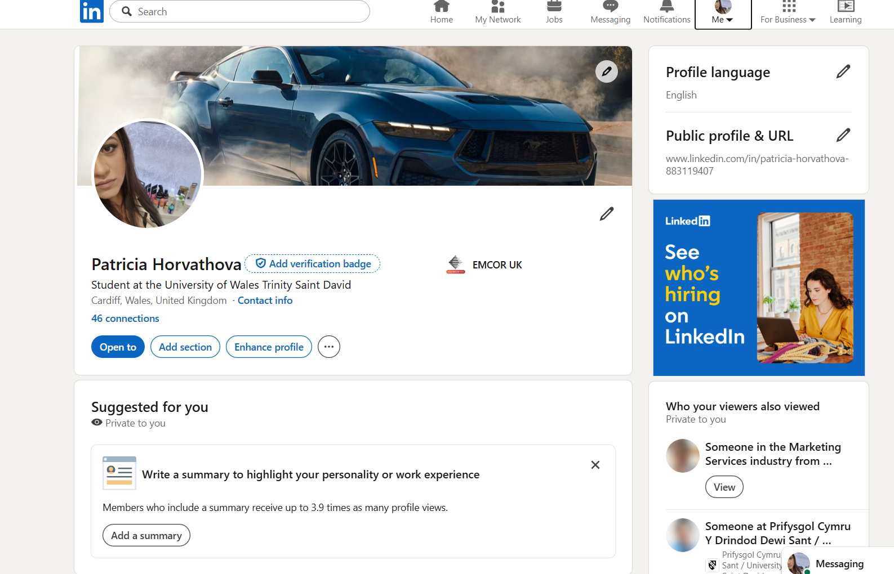
3.5 Application Rationale
I tailored my application specifically to the requirements of the Warehouse Team Leader - Nights role at GXO Logistics. After reviewing the job description, I identified the key requirements as leadership, communication, workload management, attention to detail, IT skills, health and safety awareness and the ability to work effectively in a fast-paced warehouse environment. These requirements influenced how I presented my skills, experience and achievements across my CV, cover letter and LinkedIn profile.
In my CV, I highlighted my experience as a Warehouse Operative and Retail Assistant because these roles demonstrate my ability to work under pressure, meet targets and contribute to team success. I included examples of order picking, stock management, customer service and supporting colleagues during busy periods. I also emphasised my Microsoft Excel, Word and Outlook skills because the job advert specifically mentioned these as important requirements. My personal profile was tailored to show my interest in logistics and supply chain operations, while my key skills section focused on leadership, organisation and teamwork.
In my cover letter, I directly linked my experience and education to the responsibilities outlined in the job description. I explained how my warehouse experience helped me develop operational knowledge, while my retail experience strengthened my communication and interpersonal skills. I also highlighted my Business Management studies, particularly modules such as Data Analysis, Business Operations and Project Management, to demonstrate my ability to support performance monitoring and continuous improvement.
My LinkedIn profile was updated to create a professional online presence that supports my application. I added a professional headline, updated my education information and included relevant skills that match the role. This ensures consistency between my CV, cover letter and online profile.
Overall, I prioritised the requirements most important to GXO Logistics and ensured that every part of my application demonstrated my suitability for the role and my commitment to developing a successful career in logistics and supply chain management.

Reference List1
Aloulou, W. et al. (2024) ‘Dreaming digital or chasing new real pathways? Unveiling the determinants shaping Saudi youth’s digital entrepreneurial intention’, International Journal of Entrepreneurial Behaviour & Research, 30(2/3), pp. 709–734. Available at: https://doi.org/10.1108/IJEBR-10-2022-0942.
Bhawika, G.W. et al. (2023) Proceedings of the 3rd International Conference on Business and Engineering Management (IConBEM 2022). 1st ed. Dordrecht: Atlantis Press Zeger Karssen.
Cao, Q., Geng, X. and Zhang, J. (2022) ‘Impact of channel structure on a manufacturer’s bundling decision with an application to digital goods’, Production and Operations Management, 31(4), pp. 1679–1697. Available at: https://doi.org/10.1111/poms.13638.
Gamble, E., Linehan, C. and Heavin, C. (2023) ‘Establishing Requirements for Technology to Support Clinical Trial Retention: Systematic Scoping Review and Analysis Using Self-determination Theory’, Journal of Medical Internet Research, 25(1), p. e38159. Available at: https://doi.org/10.2196/38159.
Gibbs, G. (1988) Learning by Doing: A Guide to Teaching and Learning Methods. Oxford: Oxford Polytechnic.
Goleman, D. (1995) Emotional Intelligence: Why It Can Matter More Than IQ. New York: Bantam Books.
Hadi, S. (2026) Proceedings of the 1st International Conference on Business, Economic, and Social Sustainability (ICOBES 2025). 1st ed. Dordrecht: Atlantis Press Zeger Karssen.
Hagopian, L.P. (2020) ‘The consecutive controlled case series: Design, data-analytics, and reporting methods supporting the study of generality’, Journal of Applied Behavior Analysis, 53(2), pp. 596–619. Available at: https://doi.org/10.1002/jaba.691.
Hurley, J. and Linsley, P. (eds.) (2026) Emotional Intelligence for Health and Social Care Practice. Abingdon: Routledge. Available at: https://doi.org/10.4324/9781003673309.
Mahmoud, M.V., Fattahi, M. and Saeidabadi, R.U. (2024) ‘Developing a Green Digital Marketing Model in the Business-to-Business Sector’, Journal of Green Development Management Studies, 3(2), pp. 117–134. Available at: https://doi.org/10.22077/jgdms.2024.7406.1102.
Madecraft et al. (2021) Conducting a SWOT Analysis. Carpenteria, CA: LinkedIn Learning. Available at: https://www.linkedin.com/learning/conducting-a-swot-analysis.
Palmucci, D.N., Prima, C.D. and Magrelli, V. (2025) ‘Digital Marketing Strategies to Meet Digital Consumers’ Behavior in the New Era: Challenges, Path, and Interventions to Navigate the Technological and Social Turbulence’, Economic and Business Review, 27(4), pp. 250–262. Available at: https://doi.org/10.15458/2335-4216.1364.
Quesenberry, K.A. (2025) Social Media Strategy: Marketing, Advertising, and Public Relations in the Consumer Revolution. 4th ed. Lanham: Rowman & Littlefield.
Santos, J.D. (2021) Management and Marketing for Improved Competitiveness and Performance in the Healthcare Sector. Edited by J.D. Santos and I.V. Pereira. Hershey, PA: IGI Global. Available at: https://doi.org/10.4018/978-1-7998-7263-4.
Saunders, E. and LinkedIn Learning (2022) SQL: Data Reporting and Analysis. Carpenteria, CA: LinkedIn Learning. Available at: https://www.linkedin.com/learning/sql-data-reporting-and-analysis-18082247.
Wang, W. (2026) ‘Digital Agricultural Marketing Adoption in Developed Chinese Regions: An Extended Technology Acceptance Model Study on Farmers’ Intentions’, SAGE Open, 16(3). Available at: https://doi.org/10.1177/21582440261485052.

