

Student name: Sharon McGrane
Student ID: 2533624

Module name: Introduction to Health and Social Care
Module code: LCHS4003
Lecturer name: Sam Parker

Content page

Element 1 …………………………………………………………….. page

References 7
Community Disability Services 8
Introduction 8
Historical Origins 8
Current Functioning of Community Disability Service 9
Significance in Enhancing Quality of Life 9
Conclusion 10
References: 11

The London Ambulance Service NHS

Sharon McGrane
Introduction to Health and Social Care
2533624@student.uw.tsd.ac.uk

intriIINT

Introduction
The health and social care system provides free, tax-funded services based on fairness, universal access, and personalised care (NHS England, 2023). Healthcare is overseen by NHS England, while social care is delivered by local authorities to support independence and wellbeing in the community. Although separate, both sectors work together to provide holistic support that meets clinical and social needs.
A vital part of this system is the London Ambulance Service NHS Trust (LAS), the busiest ambulance service in the UK. Serving over nine million people across Greater London, the LAS operates 24/7, providing emergency care via 999, urgent care, and clinical advice through NHS 111. Its role extends beyond transporting patients to hospital; it also provides hear-and-treat and see-and-treat models, which help to manage patients safely at home and reduce pressure on emergency departments.
The LAS is particularly relevant to community disability support, the focus of this assignment. Individuals with physical, learning, or sensory disabilities often have more complex health needs and more frequent contact with ambulance and community services. For these patients, effective care depends on the core values of the NHS Constitution, including person-centred care, dignity, respect, effective communication, equality, and inclusion.
This assignment will explore the community disability support available in Greater London and how health and social care professionals work in partnership. It will examine the historical development of disability support, moving from institutional models to community-based care that promotes independence. It will also discuss the current legal framework that underpins practice, specifically the Care Act 2014, which places wellbeing and prevention at the heart of social care, and the Equality Act 2010, which provides legal protection against discrimination.
Finally, it will consider the practical roles of professionals involved in supporting people with disabilities in the community, including paramedics, GPs, district nurses, occupational therapists, and social workers. By exploring the link between emergency services and community support, this assignment will demonstrate how the wider system works together to promote safety, independence, and quality of life for vulnerable people.

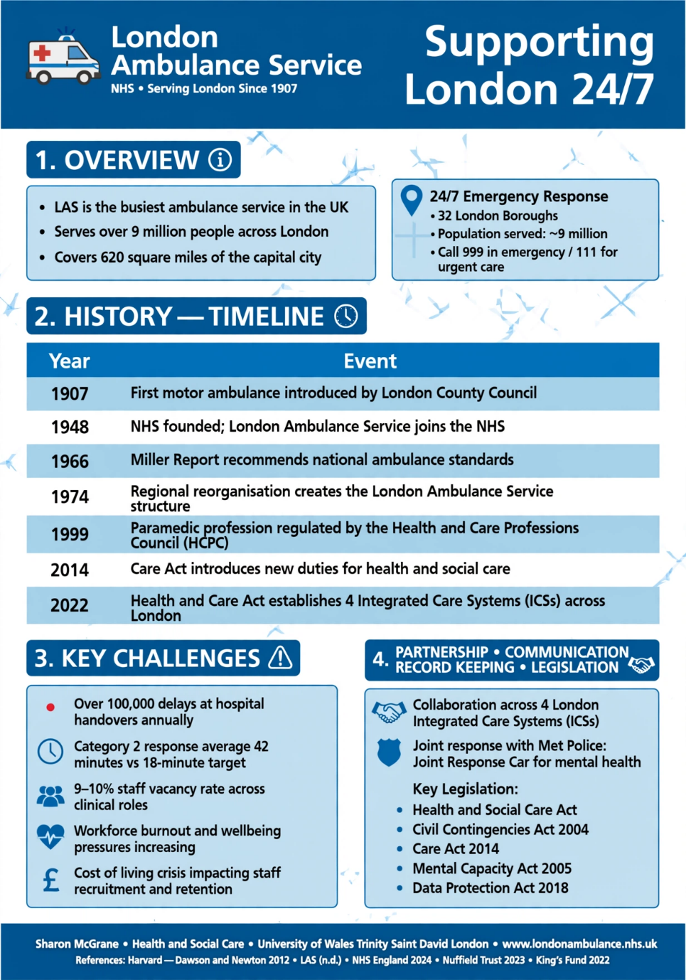
References:
Gibson, R. (1983) The London Ambulance Service: It’s History and Development. London: London Ambulance Service.
London Ambulance Service NHS Trust (n.d.) Who we are and what we do. Available at londonambulance.nhs.uk. Accessed 15 July 20206).Available at: https://www.londonambulance.nhs.uk/talking-with-us/freedom-of-information/classes-of-information/who-we-are-and-what-we-do/ (Accessed: 17July 2026).
Newton, A, (2012). History of the London Ambulance Service. London: Historical Publications.
NHS England (2024) Ambulance Quality Indicators and Clinical Outcomes. Available at: https://www.england.nhs.uk/statistics/statistical-work-areas/ambulance-quality-indicators/ (Accessed: 13 July 2026).
Nuffield Trust (2023) Ambulance Handover Delays and Hospital Pressures. Available at: https://www.nuffieldtrust.org.uk (Accessed: 13 July 2026).
The King’s Fund (2022) The Health and Care Act 2022: What It Means for Integrated Care Systems. Available at: https://www.kingsfund.org.uk (Accessed: 13 July 2026).

Element 2

Community Disability Services

Introduction
Community disability services are essential for enabling adults and children with physical, sensory, and learning disabilities, as well as those with autism, to live independently and with dignity in their own communities by promoting inclusion, personalisation, and person-centred support rather than institutional care (Glasby, 2014). Commissioned by local authorities and delivered through partnerships among the NHS, councils, and private and voluntary providers, these services are a key part of adult social care in the UK (Glasby, 2014). This essay examines the historical development, current operation, and significance of these services in improving the lives of people with disabilities.

Historical Origins
Historically, disabled people in the UK were often segregated in large institutions, reflecting a medical model that treated disability as a problem to be managed rather than a social issue. (Barnes and Mercer, 2010). This approach changed significantly in the late twentieth century, as the disability rights movement gained momentum. The social model of disability, as described by Barnes and Mercer (2010), holds that people are disabled by societal barriers rather than by their impairments. This conceptual shift laid the groundwork for rights-based reforms and community integration.
The publication of "Valuing People" (Department of Health, 2001) marked a turning point in policy for people with learning disabilities. The strategy emphasised independence, choice, and the importance of supporting individuals in their communities rather than in long-stay hospitals. The Care Act 2014 further advanced these principles by making local authorities legally responsible for promoting well-being, preventing needs from escalating, and supporting independent living (Great Britain, Care Act 2014).

Current Functioning of Community Disability Service
Today, community disability services operate within a framework that prioritises personalisation, partnership working, and legal protection. Local authorities assess the needs of disabled people and, in collaboration with health services and voluntary organisations, develop care and support plans (Glasby, 2014). Services are delivered through models such as supported living and domiciliary care, enabling individuals to remain at home with tailored support. Other key services include day opportunities that promote skills development and employment, respite care for family carers, and direct payments or personal budgets that allow disabled people to employ their own personal assistants and exercise greater choice and control over their support (Department of Health, 2001).
The Care Act 2014 has been instrumental in shaping current practice, requiring councils to promote well-being, prevent or delay the development of care needs, and protect individual rights (Great Britain, Care Act 2014). Partnership working is now central, with health and social care professionals, local authorities, and voluntary organisations collaborating to deliver holistic, person-centred care (Glasby, 2014).

Significance in Enhancing Quality of Life
Community disability services are significant because they uphold human rights and enhance well-being across physical, psychological, and social domains. By enabling disabled people to live in their own homes and communities, these services promote independence, inclusion, and dignity, which are key principles of person-centred care (Department of Health, 2001). Research shows that supported living arrangements and personal budgets can improve life satisfaction, autonomy, and control compared with traditional institutional models (Glasby, 2014).
These services also address health inequalities. Mencap (2023) notes that disabled people continue to experience higher rates of health issues and have reduced access to mainstream healthcare. Community-based support helps reduce social isolation by providing opportunities for education, employment, leisure, and relationships, and by supporting family carers to prevent crises and unnecessary hospital admissions.

Conclusion
In summary, community disability services in the UK have evolved from systems of institutionalisation and segregation to models grounded in rights, personalisation, and inclusion. Landmark policies such as "Valuing People" and the Care Act 2014 have driven this transformation, supported by the social model of disability and partnership working. Despite ongoing funding and workforce challenges, these services remain vital to promoting independence, dignity, and quality of life, ensuring that disabled people are not only included in the community but also active citizens.

References:

Care Act 2014, c. 23. Available at: https://www.legislation.gov.uk/ukpga/2014/23/contents [Accessed 15 July 2026].
Department of Health and Social Care (2014) Care and support statutory guidance. London: DHSC.
Equality Act 2010, c.15. Available at: https://www.legislation.gov.uk/ukpga/2010/15/contents (Accessed: 15 of July 2026).
Health and Care Act 2022, c.31. Available at: legislation.gov.uk. (Accessed on 15 July 2020).
London Ambulance Service NHS Trust (2024) Our services and 999/111 care. Available at: londonambulance.nhs.uk (Accessed: 15 July 2026) www.londonambulance.nhs.uk (Accessed: 15 July 2026) d (2023).
NHS England (2023). The NHS Constitution for England. London: NHS England
NHS England (2024) Integrated Care Systems overview. London: NHS England.

