

Assessment Component 2
Individual Report

Student name: Eleonora Krupic
Student ID: 2008937

Module name: Psychology for Health and Social Care
Module code: (BMHP4003_LON)
Lecturer name: Bianca Sanfilippo
Word count: 1645

Contents
1. Introduction 3
2. Erikson’s Psychosocial Theory 3
3. The impact of Erikson’s Psychosocial Theory on the Role of Health Care Practitioners in Supporting the Wellbeing of Individuals in Health or Social Care Settings 7
4. Reflection: How I will apply Erikson’s Psychosocial Theory in my own practice 8
5. Conclusion 8
6.References 8

1. Introduction
This report presents Erickson's Theory of Psychosocial Development and its relevance and application in healthcare practice. It covers the age scale from infants to the old age in separate chapters.

2. Erikson’s Psychosocial Theory
The theory of psychosocial development was devised by Eric Erickson from reinterpretations of psychosexual phases developed by Sigmund Freud. Eric Erickson's theory of identity development contains essential assumptions about human development from birth to adulthood and Freud's theory is based on the fact that the management of human behavior is based on an unconscious motive and a primitive biological process. Erickson does not deny Freud's thesis about the importance of the first five years of life in the development of personal but abandons the idea that development ends with puberty (Chery, 2019).
It is assumed Erickson's theory is more complete. Man's development does not stop with puberty. It continues through adulthood and old age. In an older man, it is true, there is a collapse and weakening of the body and physical ability. But wisdom is often evolving. This means that development also exists in that age. This is one of the reasons why we have decided to explain Erickson’s theory of development.
He identified eight phases of Psychosocial Developmental stages (as opposed to Freud's five) If a person through each of these stages and resolves the corresponding crisis, he or she develops the full potential and maturity of his or her personality and character.

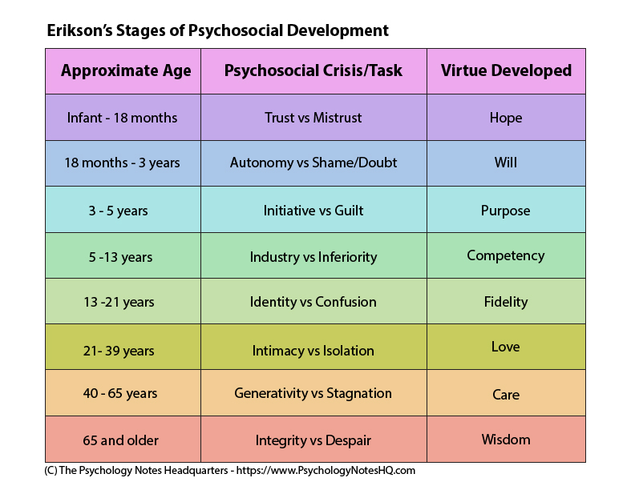
Erickson's theory attaches much greater importance to the role of the environment and highlighted the social aspects of each of them in four main aspects: PIES (Physical, Intellectual, Emotional, Social).
The stages differ from each other, and are hierarchically organized to follow one another in an unchanging order. If in each of the new phases of life a person has attained an ability that corresponds to that vital moment, that person will experience the sense of mastery that Erickson marks as the ego of strength (McLeod, 2018).
2.1 ‘Trust vs mistrust’ - Infant (0-1.5)
Infant (0-1.5) years is the first stage of psychosocial development - Trust and Mistrust. Physical side changes after birth and primary reflexes disappear by the middle of the first year of life and are replaced by the so-called. secondary reflexes, among which supportive reactions are especially important for the development of the function of walking and catching.
Milestone Developmental showed rapid physical, motor, changes in normal Childhood Development, especially in the first phase of infancy. From raising baby head for a moment, through playing with fingers and putting them in your mouth, then sitting briefly, crawling, standing with support, walking alone... (Developmental Milestones for All Ages | Milestone Tracking, 2020).
The consciousness of an adult is at the root of a child’s innate desire to seek intimacy from the first day of life that will provide him with protection and security. That is indicates that the baby has a predisposition to attach to the figure that provides protection - the mother (or caregivers). This specific, unique relationship that develops between the baby and the mother is called the relationship of closeness arises from the development of the mechanism of emotional attachment to protective figures (McLeod, 2018). Thus, the first relationship of attachment is established with the mother, and it brings comfort, security, contentment and trust. This has an impact on a person's later social and affective behavior. The absence or loss of such a connection and relationship causes intense anxiety (Cherry, 2019).
2.2 Autonomy vs Shame and Doubt (1.5 to 3)
It is a period when a child learns independent activities and autonomy and becomes aware of the world around him and the prohibitions and restrictions. The child should develop self-control, in parallel with the development of speech, imagination and movement.
Success and Failure
Negative resolution of this crisis leads to impulsivity the development of insecurity, anxiety, shame. Parents should praise the child's successes, so that the child feels pride and the experience that his opinion and emotions are accepted. A child who has been bullied or ridiculed will not develop a sense that he is capable of doing something successfully on his own. When a child has a sense of skill and control over things, he or she develops self-confidence and a sense of autonomy that allows to explore him or her virtue of will.
2.3 Initiative vs Guilt (3-5)
According to Erickson, it is also called the "age of the game", a period in which power increases of the child over the environment, but at the same time his responsibility grows
Success and Failure
As a result of development at this stage, the child becomes more goal-oriented. Parents' actions and behavior are of great importance in the emergence of the initiative or guilt.
2.4 Industry vs Inferiority (5-12)
At this stage, school children are compared to other children, and become aware of their qualities, but also their weaknesses.

Success and Failure
Parents and teachers play an important role here because they need to encourage the development of competences in the child (feeling that he is competent), because if this is not done, it leads to inferiority, discouragement and a sense of inferiority.

2.5 Identity vs. Role Confusion (12-18)
Erickson paid special attention to adolescence in his work, marking achievement identity is one of the most important development goals. Many people at that stage experiment by trying different identities. This period is characterized by large and turbulent emotional reactions, and experimentation in personal appearance and behavior.

Success and Failure
People who are unsuccessful at this stage develop role confusion and enter adulthood without a firm feelings of who they are or what they think is the meaning of their lives.

2.6 Intimacy vs. Isolation (21-39)
This phase occurs after puberty and is characteristic for young adulthood. Then the main task is to form close and quality relationships with other people.

Success and Failure
If this developmental crisis is not resolved positively, feelings of loneliness and emotional emptiness develop. There is a fear of intimacy and attachment. Success in this stage will lead to the virtue of love.

2.7 Generativity vs. Stagnation (40-65)
The main tasks of this phase are forming and reflecting marriage, expanding the family, and taking care of the household, family, career and raising children.

Success and Failure
By failing to find a way to contribute, we become stagnant and feel unproductive. Success in this stage will lead to the virtue of care.

2.8 Ego Integrity vs. Despair 65+
The primary task of this phase is to deal with old age, to understand its purpose. The professional career is over, the retirement period is coming, and people need to find new interests for themselves.

Success and Failure
People who are satisfied with their life choices and decisions have no great remorse and successfully face what follows in old age. On the other hand, people who are dissatisfied with their life decisions or have not successfully resolved previous developmental crises will not find a sense of fulfillment and meaning in old age. Then the experience that they "missed life" may come.

3. The impact of Erikson’s Psychosocial Theory on the Role of Health Care Practitioners in Supporting the Wellbeing of Individuals in Health or Social Care Settings

According to Erickson, identity is socially mediated: it is built through social relations and environment. Crises are periods of great vulnerability, but also of increased potential for development. Social institution, health care, can help an individual cope with a crisis more easily. Either to help the parents, or the caregiver to resolve those crises.

To understand one's personality, individual needs to know the ways in which he or she has overcome important developmental crises. Thus, health workers have a greater approach and ways of solving the care plan and providing life support at every age.

One of the most important skills that healthcare professionals should demonstrate is empathy (Moudatsou et al, 2020). The relationship between the medical staff and the patient is a relationship in which the social care with an empathic approach assesses the individual needs. Through an empathic approach, he or she receives the necessary information and the possibility of choice in problem solving, treatment or rehabilitation. Healthcare professionals can provide the right intervention, such as counselling, cognitive behaviour therapy, etc.

One advantage of Erickson's theory is that people can reflect on different phases through their own experiences. However, the theory does not provide a universal method for resolving crises. For this reason, it is very important that social workers empathize and communicate with clients in order to get to know the personality and ways of solving it psychosocial crises in the development of the individual. For Erickson, each individual is different.

4. Reflection: How I will apply Erikson’s Psychosocial Theory in my own practice
In the field of child and adult protection, with the knowledge of Erickson's Psychosocial Theory, I would apply my communication skills and empathy to solve problems or challenges and provide interventions as well as to support health and well-being of the specific person. I strongly believe empathy leads to self-disclosure which may be crucial. Also, communication covers active listening as well as asking the right questions. These two terms are the ones which I want to keep in mind while applying knowledge from Erickson's psychological Theory.

5. Conclusion
Coming to the end, this report has focused on Erikson's Psychological Theory. Each stage and its main points have been described. Then, this work has also aimed at the impact of this theory on health care practitioners. At the end, a self-reflection has been implemented.
All in all, it is crucial to focus on important developmental needs of each stage as it can be the stage of building strong life relationships or self-esteem, for example. For people working in health care services, two terms are necessary and so empathy and communication leading to uncovering client's issues.

6.References
Cherry, K., 2018. Understanding Erikson's Stages of Psychosocial Development. [online] Verywell Mind. Available at: <https://www.verywellmind.com/erik-eriksons-stages-of-psychosocial-development-2795740> [Accessed 7 August 2021].
Cherry, K., 2019. How Do Erikson's and Freud's Theories Compare?. [online] Verywell Mind. Available at: <https://www.verywellmind.com/freud-and-erikson-compared-2795959> [Accessed 7 August 2021].
Cherry, K., 2021. Understanding Erikson's Stages of Psychosocial Development. [online] Verywell Mind. Available at: <https://www.verywellmind.com/erik-eriksons-stages-of-psychosocial-development-2795740> [Accessed 17 August 2021].
Healthline. 2020. Erikson Stages of Psychosocial Development in Plain Language. [online] Available at: <https://www.healthline.com/health/parenting/erikson-stages#6-relationships> [Accessed 17 August 2021].
Lewis, R., 2020. Erikson Stages of Psychosocial Development in Plain Language. [online] Healthline. Available at: <https://www.healthline.com/health/parenting/erikson-stages> [Accessed 17 August 2021].
McLeod, D., 2018. [online] Simplypsychology.org. Available at: <https://www.simplypsychology.org/Erik-Erikson.html> [Accessed 7 August 2021].
Pathways.org. 2020. Developmental Milestones for All Ages | Milestone Tracking. [online] Available at: <https://pathways.org/all-ages/milestones/> [Accessed 25 July 2021].
The Psychology Notes Headquarters. 2021. Erik Erikson's Stages of Psychosocial Development - The Psychology Notes Headquarters. [online] Available at: <https://www.psychologynoteshq.com/erikson-stages/> [Accessed 7 August 2021].

