
problem solving and decision making
BMSW4004

LECTURER’S NAME: DR. Faizu Edu
Student Name: Carmen mariana cheta
Student ID: 2123761

Table of Contents
Summary 2
Introduction 2
The importance of problem-solving skills 2
Background of the organization 2
The workplace problem 2
Analysing Information 3
Root cause analysis (RCA) 3
Applying Situational Analysis Models 4
SWOT Analysis 4
Range of Alternative Solutions 4
Solution 1 4
Solution 2 4
Solution 3 5
Evaluation of Alternative Solutions 5
Implementing The Solution 6
Communicating Plan with Stakeholders 6

Summary
In this report I am going to discuss the importance of problem-solving skills in the workplace. I am going to apply recognised problem-solving tools and techniques to identify and propose solutions to a problem from my workplace. I will discuss and evaluate each possible solution to make sure that the outcome of the final decision is the best for everyone involved.

Introduction

The importance of problem-solving skills
The importance of problem-solving skills in the workplace is significant in any industry and organization. A problem is an undesirable situation that prevents people from accomplishing their objectives. There are six stages to effective problem-solving. To be able to solve problems effectively you need to 1) Identify and define the problem 2) Specify the cause, reasons, and effects 3) Identify possible solutions 4) Evaluate, and select the best option, 5) Plan the action, and 6) Apply the chosen solution (moodle.uwtsd.ac.uk, n.d.). There are several essential skills needed to solve problems successfully and to effectively identify the root of the problems. In stage one of problem-solving observational skills are very important. Also, analytical skills will help in determining the root cause and accurately assess the situation, negotiation skills to show conviction, creative thinking to come up with solutions, teamwork, and leadership skills to implement solutions, and once the solution is implemented to evaluate the results you will need critical thinking and attention (Ansary, 2019).

Background of the organization
I have been working as an office administrator in the financial industry for the last four years. The company is specialized in credit cards, preventing fraud, and making sure that all costumers transactions and transfers are done in the safest way possible. The company is very much focused on the customer service and customer satisfaction aspect. My role was to do all the administrative tasks in the office including taking inbound calls and resolve costumer issues, replying to emails, organising the incoming and outgoing post and others as necessary. The working environment is a very fast paced one as there are a lot a phone calls, I needed to take amongst doing all the other tasks, constant complaints from the costumer made the job very stressful. The shifts were eight hours a day, five days per week, no weekends. One of the reasons that made me stay there for so long is because there was no weekend work, and the location is literally 7 minutes of walk from my house.

The workplace problem
When Covid-19 pandemic started we were all sent home. Equipment was given to each of us so we can work from home. That was good for us, but the managers weren’t too happy about it as they felt they don’t have the same control over us, and they were very glad to see us back in the office once it was safe to do so. When we went back in the office there was a lot of changes. A lot of employees didn’t turn up because of sickness and some of them ended up resigning, we were very short staff and busier than ever.
The shortage of staff caused a lot of chaos around the office, nothing was the way it used to be. The management couldn’t handle the demands of employees and they struggled a lot in hiring new people and make them stay, so instead they insisted in making us work 12 hours a day without caring about our wellbeing. The job became very stressful, we got a lot of complaints, we were struggling in completing our tasks and everyone felt as if they did more than others causing several arguments amongst us. There were a lot of missed phone calls, unread and missed emails, running out of office supplies, responding to emails, problems with the outgoing mails and costumers’ data entry problems. All these issues led to our dissatisfaction. We felt as if nobody cared about us that we were been treated as if we were robots, the stress level of our job was very high and we were working very long hours, and I felt that after all we are going trough at work we weren’t being paid enough, the salary was nowhere near the competition salaries.
The impact across the organization was terrible being a customer service focused business no matter how much we tried we couldn’t deliver a good service to customers therefore the customers satisfaction was poor making them leave bad reviews online about the company and many of them left choosing the competition.

Analysing Information

Root cause analysis (RCA)
To analyse the possible causes to the complex problem I am going to make use of a Fish Bone diagram to identify the root causes causing the complex problem.
The fishbone diagram, also known as the Ishikawa diagram, is a cause-and-effect chart that assists managers in identifying the causes of problems, variations, defects, or failures (Pearson, 2017).
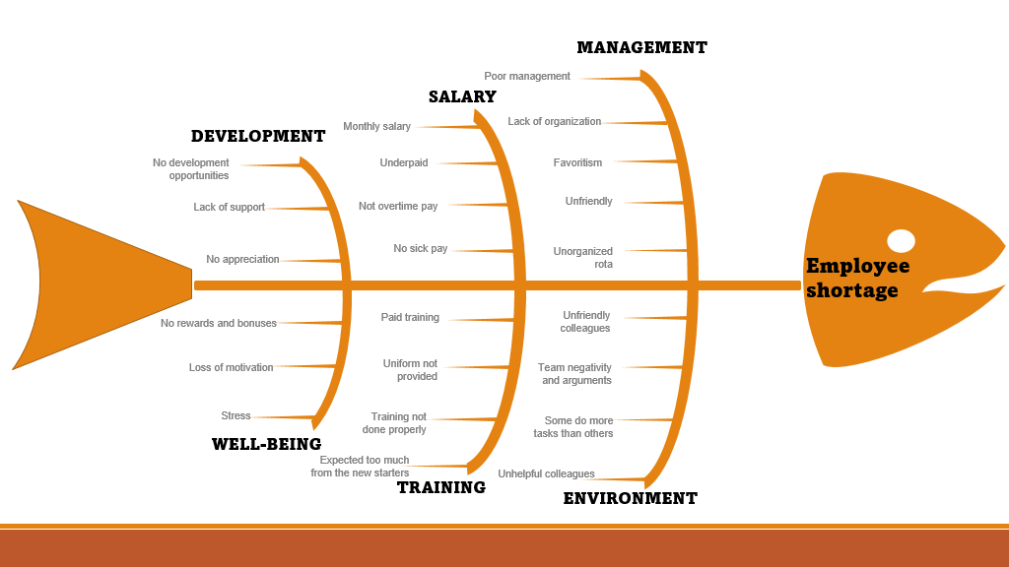
(Created by: The student)

Applying Situational Analysis Models

SWOT Analysis
To identify my organization’s Strengths, Weaknesses, opportunities, and Treats, I am going to make use of a SWOT analysis to help me asses my organization position prior to planning a range of solutions to the complex problem. SWOT analysis is a method of analysing strengths, weaknesses, opportunities, and threats. Many experts apply this framework to an entire organization to determine whether current operations are sustainable over time, but it can also be applied to individual departments and projects to determine profitability. increase. The Strengths and Weaknesses section identifies internal components that affect the company, such as intellectual property, locations, and people. Opportunities and threats focus on external factors such as raw material costs and consumer buying habits (Indeed Career Guide, n.d.).

Range of Alternative Solutions
The employers need to find effective solutions in order to keep the employees happy, satisfied, motivated, productive, and committed.

Solution 1
Increasing salary
By increasing the salary and pay a competitive hourly wadge the employees can feel motivated and committed to work.

Solution 2
Overtime paid for unsociable hours
Nobody wants to work unsociable hours, especially when you don’t get any extra rewords for doing it, so by paying extra for the unsociable hours the employees will be more motivated to stay and do any overtime.

Solution 3
Prioritize employee’s Health and Wellbeing
It is very important to feel that your managers care about your well-being so creating a supportive relationship between employer- employee and listen to employees needs can be a very good strategy to improve employee satisfaction.

Evaluation of Alternative Solutions
After I have identified some alternative solutions to what seems to cause the complex problem in my workplace, I am going to evaluate these suggested alternative solutions to help me select the appropriate one. To do this I am going to discuss the pros and cons of each solution against the complex problem and select the most appropriate one.
Increasing Salary-
Advantages
- If the salary levels are higher than the competitors, the employees are more likely to stay, lower turnover reduces hiring costs, and fewer new hires are trained.
- High-paying employees can increase employee happiness and boost employee morale
- Recruitment becomes easier as employees' perception of the employer's brand increases.
Disadvantages:
- Rising wages are also associated with an increased wage tax burden for employers.
- The new staff will be paid the same as the old employees and this can cause frustration
Overtime pays for unsociable hours
Advantages
- Employers can get more work done.
- Overtime pay contributes to a company's financial health and business profits.
- Employees are motivated to work harder to earn more overtime pay.
Disadvantages
- Employees can become overworked and burn out.
- Overtime can be expensive for employers and can violate employment laws.
Prioritize employee’s health and well-being
Advantages
- Better employee engagement
- Higher performance and productivity
- Reduced sickness absence
Disadvantages
- Cost money

Implementing The Solution
To discuss the implementation plan I am going to make use of Gannt Chart where I set the tasks with clear milestones and deliverables.
As the complex problem in the organization is the shortage of staff, I have identified some solutions which are going to be implemented as set bellow in the Gannt Chart which will help in the hiring process and also in making the employees stay.
Task | Activity | Predecessor | Duration
Task 1 | Book a meeting with managers | 5 | 1
Task 1 | Talk with managers | 3 | 1
Task 2 | Tell managers the problems | 1 | 1
Task 3 | Suggest solutions | 4 | 2
Task 4 | Talk with the HR team | 4 | 2
Task 5 | Increase salary by 10% | 2 | 4
Task 6 | Overtime pay increase by 15% | 4 | 4
Task 7 | Focus on employee wellbeing | 3 | 2
Task 8 | Offer a good work environment | 4 | 4
Task 9 | Offer more benefits | 1 | 3
Task10 | Hire more people | 8 | 5
Task 11 | Offer free training | 4 | 3
Task 12 | Complete management training | 7 | 6

Communicating Plan with Stakeholders
There are some requirements when it comes to stakeholders’ communication. Transparency, communication, and accuracy are the key factors in communicating effectively with stakeholders. Learning how to communicate with your stakeholders through stakeholder engagement is one of the most effective ways to help you learn more about your stakeholders and uncover their needs. This improves overall relationships and helps shape project goals and objectives.
A communication plan description is a document that outlines the topic (what, when, how) information will be shared with stakeholders at key intervals. An effective plan includes
• What do you need to do to motivate them?
• How should the message be designed to achieve the desired result?
• What are the most effective channels for spreading your message?
• Who do you need to communicate with?
Email and Newsletter, Email Automation, Online/Virtual Presentations, Project Summary Report, Group Video Call- These are 5 channels on how to communicate with stakeholders effectively.

LIST OF STAKEHOLDERS
Amir- CEO Director Sahra- Shareholder John- Shareholder
Sofia- Secretary Dave- CEO Director

Influence/Power and Interest Matrix
Meet their Needs  Engage and consult  Increase/ Maintain level of interest  Aim is to move them to the right  Could be a risk to your idea | Key Player  Manage closely  Involved in projects and decision  Engage on a regular basis and work to maintain the relationship
Low Priority  Monitor  Communicate generally to keep updated  Aim to move to the right | Keep Informed  Make use of interest trough involvement  Consult on their area of interest  Can be supporter/Ambassador

The Power Interest Matrix is ​​important because it shows the tools and cards used to influence project stakeholders. This helps project managers identify stakeholders to focus on and take necessary actions (KnowledgeHut, 2022BC)

Stakeholder Engagement Plan
STAKEHOLDER COMMUNICATION PLAN
Stakeholder | POWER/INTERESTS | KEY INTEREST & ISSUES | COMMUNICATION  VEHICLE | FREQUANCY
Amir | Key player | Project overview | Meeting, face to face | Monthly
Sofia | Key Player | Recording projects | Phone | Daily
Sahra | Low priority | Introducing the new project | email | Weekly
Dave | Meet their needs | Decision making | Project summary report | Monthly
John | Keep informed | Agreeing to the new project | Group Video call | Weekly

Monitoring and Review Techniques
This is very important in any industry especially after implementing new changes.
Monitoring is an ongoing process of regularly collecting and analyzing relevant information to ensure that what is planned is being done. This is usually continuous, but a series of information may occur periodically. B. Collected Quarterly.
Reviewing is when you look at the results of an evaluation and decide if changes are necessary. Monitoring information may also lead to a review of small areas of your work, but a full review can only occur after your effectiveness has been properly assessed. Can be done at the end of a long-term project (scvo.scot, n.d.).
Project monitoring methods include project documentation, formal surveys, interviews, direct observation, focus group discussions, and mapping. The Project Assessment and Review Technique (PERT) organizes, plans, and coordinates all events on a network diagram.
After the changes in my organization take place I suggest doing a survey where employees anonymously can share their opinions and give feedback on the changes that occur within the organization. Also monitoring the new staff and see if the these new changes will make them be more committed to work and see if they have interest in staying longer in working for our company.
Furthermore I believe that a group meeting should take place once a month between the managers and employees just to discuss the outcome of the implemented solutions and what else could it be done in order to improve employee satisfaction as well as delivering an excellent service at the workplace.

Conclusion
In conclusion, I believe that problem solving skills are very important in every career aspect as well as in day-to-day life. Problem solving skills helps you become more creative at work and develops your decision-making skills as well as your leadership skills which are so much required these days by any employer. These skills will make you stand out in front of the managers and will hep you improve your career goals.

References

- Ansary, A.S. (2019). 15 Importance of Problem Solving Skills in the Workplace. [online] CareerCliff. Available at: https://www.careercliff.com/importance-of-problem-solving-skills-in-the-workplace/#:~:text=15%20importance%20of%20problem-solving%20skills%20in%20the%20workplace [Accessed 1 Jan. 2023].
- Indeed Career Guide. (n.d.). How To Do the SWOT Analysis for Your Company: Steps and Tips. [online] Available at: https://www.indeed.com/career-advice/career-development/how-to-do-a-swot-analysis.
- KnowledgeHut (2022BC). Power Interest Grid: How to Use, Benefits, Examples. [online] www.knowledgehut.com. Available at: https://www.knowledgehut.com/blog/project-management/power-interest-grid [Accessed 2 Jan. 2023].
- moodle.uwtsd.ac.uk. (n.d.). UWTSD Moodle 2021/22: Log in to the site. [online] Available at: https://moodle.uwtsd.ac.uk/course/view.php?id=7090.
- Pearson, S. (2017). Definition – What is a Fishbone... [online] Tallyfy. Available at: https://tallyfy.com/definition-fishbone-diagram/.
- scvo.scot. (n.d.). Monitoring, evaluation & review – SCVO. [online] Available at: https://scvo.scot/support/running-your-organisation/business-planning/monitoring-evaluation-review.

Appendix

Appendix A- Problem solving and decision-making Role Play

