Week nine session one tutorial and case Answers
Question one
Using interest rate parity formula to find (predict) what the exchange rate will be in one years time.
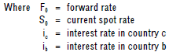
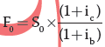

Using interest rate parity, the Canadian dollar is the numerator and the Kuwaiti dinar is the denominator.
So the expected future exchange rate dollar/dinar is given by:
F_{o} = 5.4670 x (1 + 0.14)
(1 + 0.09)
F_{o} = 5.4670 *1.14/1.09 = 5.7178
F_{o} = C$/dinar 5.7178
This prediction is subject to great inaccuracy, but note that the company could 'lock into' this exchange rate, working a money market hedge by borrowing today in dinars at 9%, converting the cash to dollars at spot and repaying any 14% dollar debt. When the dinar cash is received from the customer, the dinar loan is repaid.
Question two
Using the purchasing parity formula to find the expected spot exchange rate at the end of the year
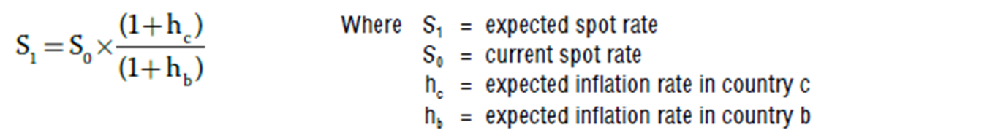

S1 = 8 x (1 + 0.05)
(1 + 0.08)
S1 = Kr/£ 7.78
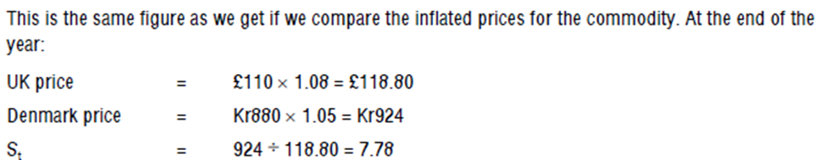
Question three
(a) According to the International Fisher Effect (IFE) interest rate differentials between any two countries provide an unbiased predictor of future changes in the spot rate of exchange.
If interest rates are 6% in the UK, and 8.5% in the USA the expected annual change in spot exchange rates is:

The expected exchange rate in two years time is $1.5240 (1.02358)² = $1.5967/£
The non-executive director has based her estimate on the International Fisher Effect, and has correctly calculated the expected change in exchange rates.
However, this does NOT mean that the exchange rate in two years time will be $l.5967/$ Reasons for this rate:
(i) The interest rate differential may change during the next two years
(ii) Even if the interest differential remains constant the IFE is an unbiased, not accurate, predictor of future exchange rates.
(iii) Exchange rates may not be in equilibrium at the current time. The IFE predicts movements from an equilibrium position.
(iv) Factors other than interest rates influence exchange rates, including government intervention in foreign exchange markets.

(b) The most likely reason for the differences in the forecasts of the banks is that they have based their forecasts on different economic assumptions and/or used different types of forecasting model.

Different assumptions about inflation rates, interest rates, unemployment levels, balance of payments, economic growth, which political party will be in power etc. will lead to wide variations in forecasts.

Forecasts may be based on purchasing power parity, IFE or other elements of the four way equivalence model, on macro-economic factors such as flow of funds and the balance of payments, on charting exchange rate trends in order to spot patterns of future exchange rate movements, on econometric modelling, or a combination of such methods. Each of these forecasting methods is likely to produce different results.

