Programming in c
Software Development ACCA4017

Iwan Jones
1803154

Table of Contents
Exercise 1 (Higher Or Lower) 2
Overview 2
Development stages & Problems 2
Exercise 2(Treasure Hunt) 10
Overview 10
Development stages & Problems 10
Bibliography 19
Appendix 20
Exercise 1 Code List : 20
Exercise 2 Code List : 20

Programming Report – Introduction
The report has been written by Iwan Jones. The writer has written this report on two exercises that he has been asked to complete. The game he had to complete for exercise one was a version of a high or lower game. In exercise 2 Iwan had to code a game that was a variant of treasure hunt. In the report below you will find information of all problems he faced in the process of coding these games from the easiest one he found to the most challenging, he will provide evidence of these problems and their solutions. He will show some images of the stages he went through of the design of the games and he will talk about said images and finally and description of the tests that he conducted to complete

Exercise 1 (Higher or Lower)

Overview
In exercise 1, the game that has been coded by Iwan is a variation of a Higher or Lower game. This game is a two player game. In the game that Iwan has coded, player 1 is the player that inputs 10 values for the second player to guess with. Once the first player has taken their turn and inputted all 10 values, player 2 then take their turn. Player 2 is show a value that player 1 has entered and they have to guess if they think that the next value will be greater than the next value or whether the value will be less that the next value. If player two makes any wrong guesses the game ends and player 1 wins. However, if player two gets all the guesses correct then player two will then win.

Development stages & Problems
Before Iwan started coding the game he sat down and thought through the game and wrote down the way he was going to work through the exercises. Iwan started at the welcome messages he would use to welcome both players to the game all the way down to each individual statement he would use for the higher or lower part of the game. The screenshot below shows the code welcome message code Iwan planned on using compared to the code that he used in his game. To begin with, Iwan wrote down the code that he was planning to use for the welcome message to the game. You can see this in the screenshot below.
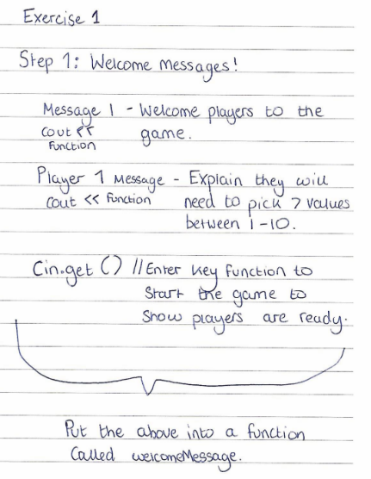
Iwan planned on putting his welcome message into a function. He would do this by using a ‘cout’ function to print out the message he wanted on screen while putting all this code into the message function which can be seen in the screenshot below. He also created a function for player one to explain the range of value. Finally, he used a ‘cin.get’ function for the players to show they were read to start the game by pressing enter. In coding this part of the game Iwan did not face any issues nor did he have to change what he had planned out. The screenshot below are of the code itself and as you can see it is the same as Iwan planned out as previously stated.
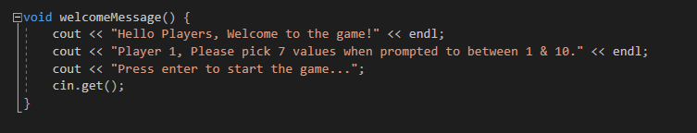
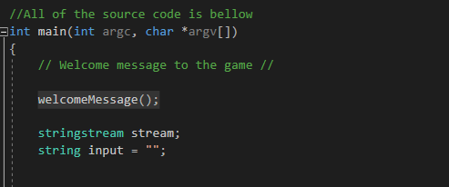

Iwan then tested this function to test that it works in the way it is supposed to. The test he ran was very simple. He compiled and ran the code that he had and then waiting to see if the output was as it was supposed to be. He expected that when he ran the code he would get the messages that he had written in the “welcomeMessage” function and once all of the messages had been printed out he would be asked to press enter to continue. As you can see from the following screenshot below, the expected output was indeed the output Iwan was expecting so this test was a pass.
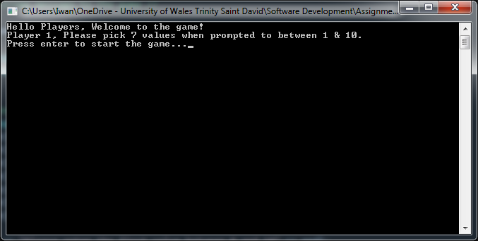

The screenshot below is the writers plan for the next part of the game. This is the section of the game where player 1 will input the values he wishes to use and this data will then be stored and used later in the game for player 2’s guesses. Iwan decided to use an array. He has created an array which is seven values in size. This then has enough values to store each of the guesses. He had planned to use “getline(cin, value[“ ”])” to prompt player 1 to enter value and each value will have its data stored in said array allowing this data to be used later in the game. The use of the system(“cls”) or system(“clear”) is to hide player 1’s guesses so that player 2 is unable to see what he had entered.
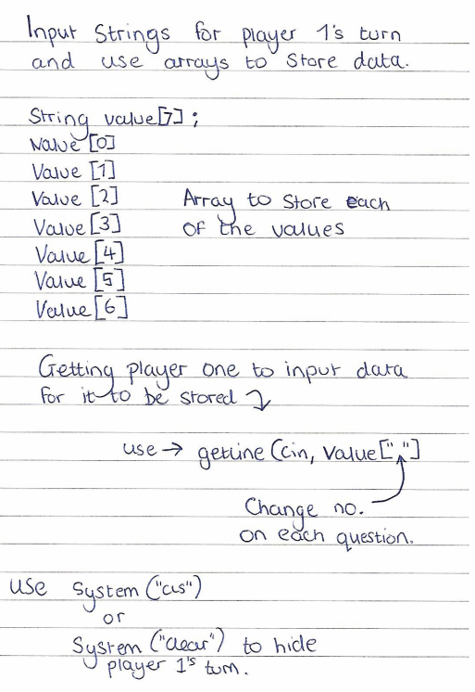
Below you will be able to see the code that Iwan that inputted into his game and as he didn’t come across any errors here the code in the game stayed unchanged from the code that he had planned. Iwan carried out tests on this particular function of his game to check he had no issues. Once again, he compiled his work and ran the code. He expected to see the player 1 being prompted to enter each values as stated and to have all the previous code cleared off screen once all the value had be inputted. For the purpose of this test, Iwan then added some extra code to check this function was working that will not be part of the game. He used the “cout” function while calling on each individual to check the data was being stored correctly. The test can be seen in screenshot two.

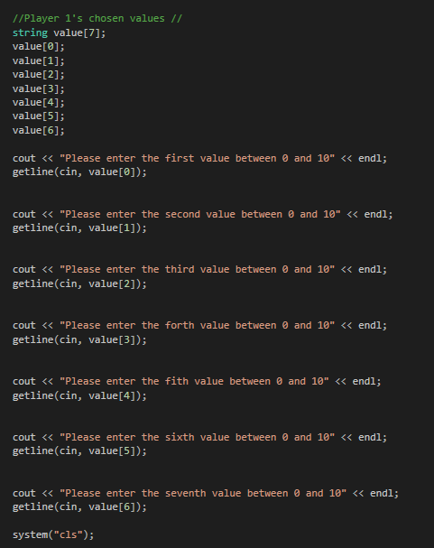

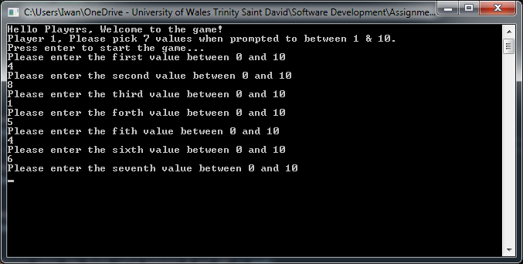
The screenshot below is of the test code that Iwan added and the output screen. As you can see the numbers Iwan added for the test were 1,2,3,4,5,6,7 and the array printed all seven of these number out to show that the array work’s and the data is indeed stored once it had been inputted by player 1.

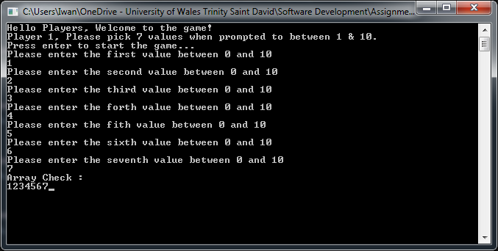

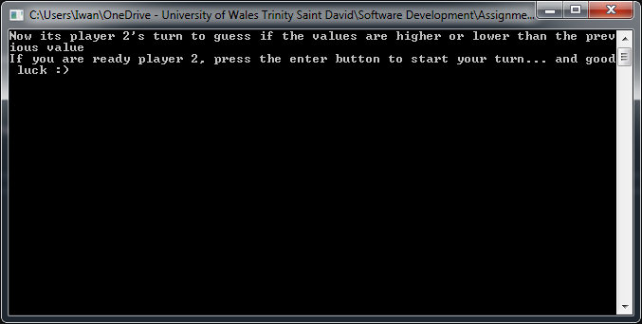
As seen in the screenshot above the system(‘cls’) clear all of player 1’s turn to make sure that player 2 cannot see the numbers that player 1 has chosen.

As you can see above the test was a success and the expected output is what the source code did indeed show. This meant that player 1’s turn was now completed and there had been no issues up to this point. However, player 2 posed more of an issues. First of all Iwan created a function for a player 2 display message which will be shown once player 1’s turn has be cleared off the screen. This was tested by checking the output of the function by running the game. The result was as expected a and the message was outputted just as the welcome message was. The screenshot below shows the output for this test.

As part of player 2’s turn Iwan would be calling upon the already coded and working array. Iwan decided to split each turn up into separate code, as seen below question 1 would have its own section of code as would each and every turn up until question 7. First of all Iwan created a guess variable which would store player 2’s guess of either ‘h’ or ‘l’ to allow the if statement to use this variable to run and to output the correct data. Iwan then decided to use an ‘if statement’. Player 2 would have to use the ‘h’ key or the ‘l’ key to make his guess, ‘h’ being used for higher and ‘l’ being used for lower. For player 2 to guess, Iwan created another variable called “guess”. This would allow him to compare the players higher or lower guess to the array, using player 2’s input of the ‘h’ key or the ‘l’ key in and if statement to the provide the output for the player to see if he was indeed correct and allow him to move onto the next value or whether their guess was wrong and that meant the end of the game and player 1 to win. To print out whether player 1 and won or whether player 2 and won Iwan used the ‘cout’ function within the if statement to show who won. The screenshot below shows Iwan initial design for the if statements.

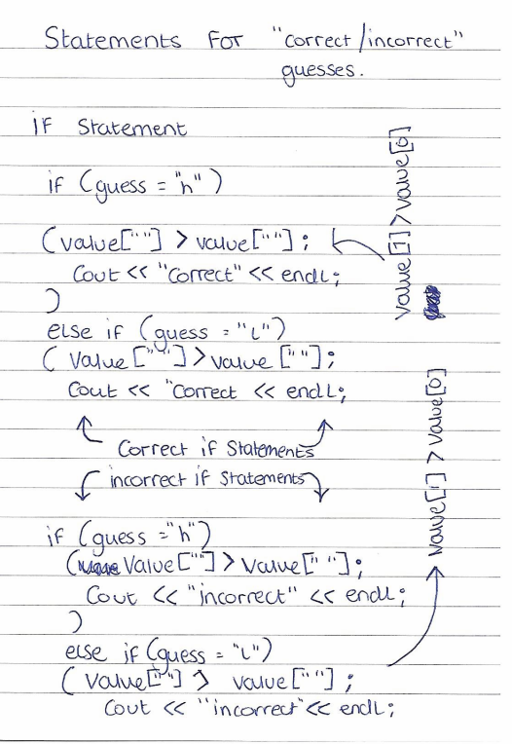
Once Iwan implemented this into his game this is where he started to see his problems starting to occur. When player 2 would have an incorrect guess he would get both an output of correct and incorrect. This can be seen in the screenshot below. The issue was that as there were two if and else statements, both of these statements were being used in each question which mean that player 2’s guess was being put through both if statements and there for caused the output to show each statement.
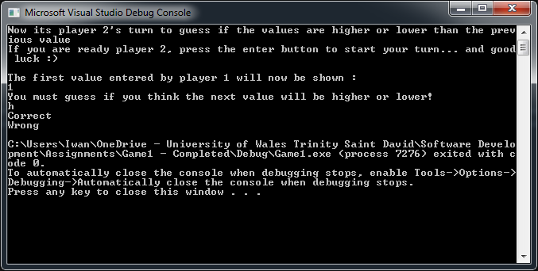
As you can see above the answer should be correct but it also prints out the “wrong” function too. To overcome this problem Iwan carried out some research. The writer carried out this research on a website called “cplusplus.com” [1]. He researched a switch statement which seemed to be the better option and would work the way Iwan intended on using the if statement.

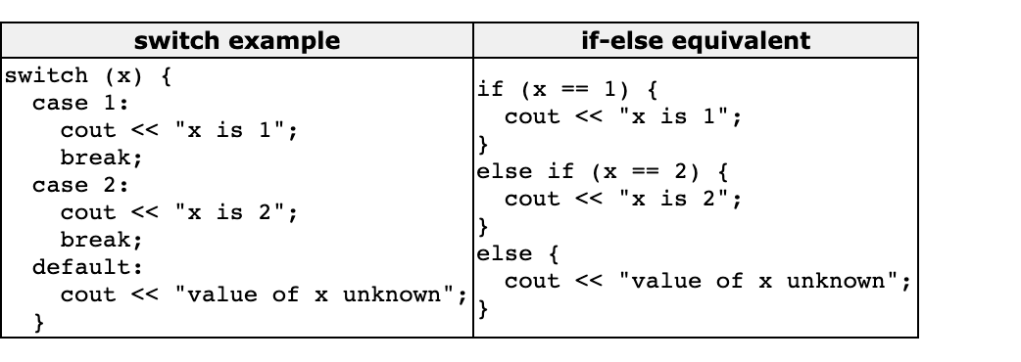
Iwan realised that using a switch statement would allow him to set the case to the letter ‘h’ or to the letter ‘l’. Iwan still kept the guess variable which can be seen in the code below to allow the switch statement for each question to access player 2’s guess. This meant that he could keep the same format as he had used in the if statements previously. The switch statement code can be seen in the screenshot below.
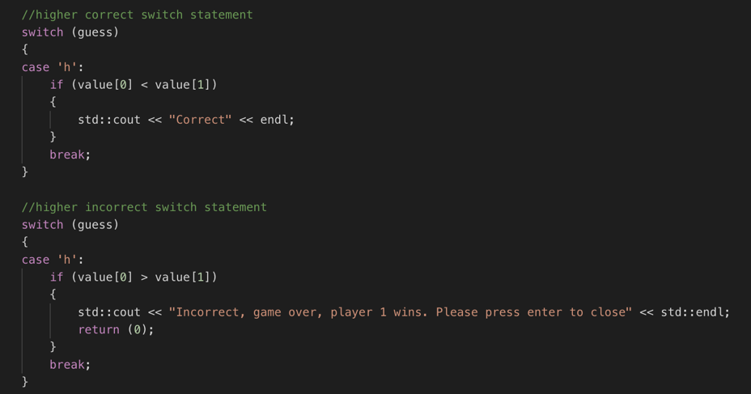
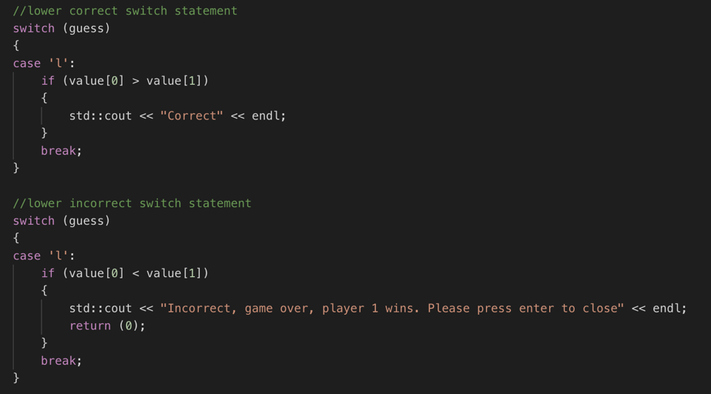
To check that these switch statements worked Iwan had to run the game in its entirety. He entered the value for player 1 and then guess higher and lower. The screenshot below shows the tests that Iwan carried out for this particular test. All the tests passed as the correct statements were shown on each of the input as you can see. Iwan did then test the end game function if player 2 was to get the guess wrong which can be seen in the second screenshot, this meant that the whole of the switch statements worked.

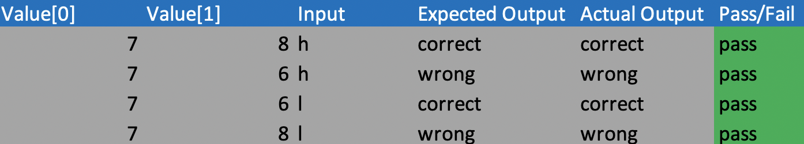
Finally, the screenshot below shows a complete overall test for the whole game which Iwan conducted after he had tested each section of the game to make sure it worked all together, as well as covering the tests that it failed on and was then corrected.
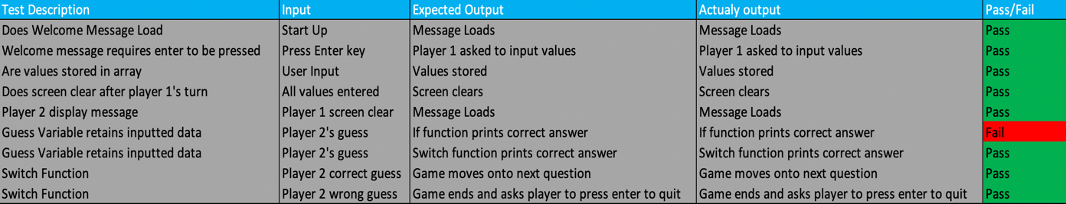

Exercise 2(Treasure Hunt)

Overview
The second exercise that Iwan worked on was essentially a variation of treasure hunt. Player 1 is prompted to select three sets of co-ordinates to hide his treasures. Once player 1 had chosen where to hide his treasures, player 2 will then have to guess the co-ordinates. If their guess is wrong the letter “N” will be printed on the map in the co-ordinates the player chose, however if they guess correctly, the letter “X” will be printed in the co-ordinates on the map. Player 2 has three lives once all three lives are up, the game is over and player 1 wins, however if player 2 guesses all the co-ordinates within three lives then they win.

Development stages & Problems
Iwan looked towards the grid first off. This was a part of the game he knew he would have to research to see how to do this. Iwan read up on this on cplusplus [2]. The screenshot below shows the section of the webpage that Iwan focused on and used to help him with his work. This lead Iwan to then design the grid that he wanted to use and use the code below to help him structure his work.
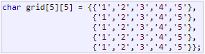
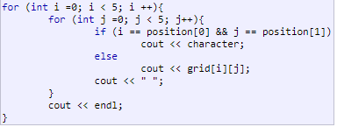
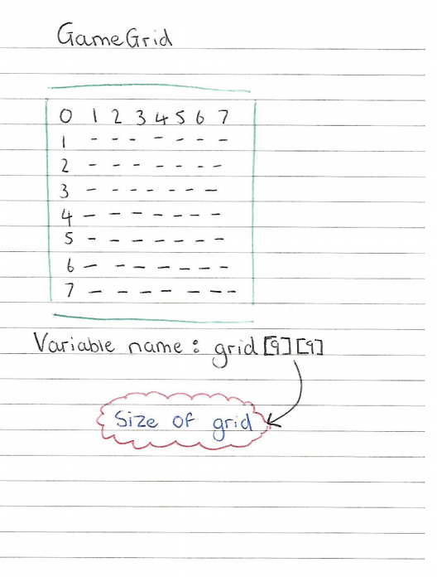

Iwan decided that he was going to play the code that was going to shape the grid inside the main and then create a function to print the grid out which would be located above the main. The writer was going to create the grid as seen above in the hand drawn design. The code that he put in the main was just the design of grid. The function for the grid is what will print the grid out. The screenshots below are of the code that Iwan used to create the grid.
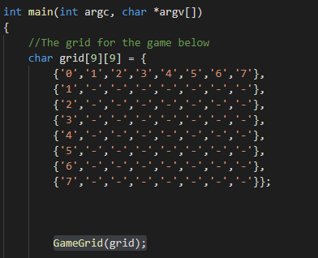
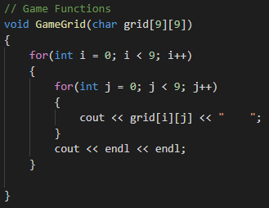
To test that the work that Iwan had done did actually print out the grid and in the design, he wanted. He added code that would call and display the grid. He expected it to look the same as he had designed. This code his highlighted in the first screenshot of the two above, “GameGrid(grid);” and then ran the code to see what the result was. From the screenshot below you can see that the grid displayed correctly. This grid is show the players the grid that they will be playing on.
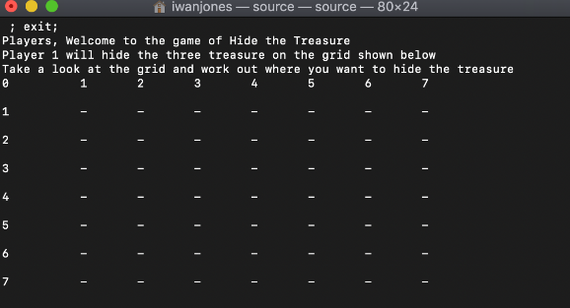
Secondly, Iwan moved onto adding a welcome message to the game, a player 1 ready up and a player 2 ready up to check if the players were ready to play the game. The screenshot below shows the functions that Iwan created to display these messages to the players. He conducted tests to make sure all these functions worked as they should. The messages displayed correctly as they should which can be seen in the second screenshot below. He created player ready up functions to prompt both players to make sure they are ready to play the game. Iwan ran tests to see if both of these functions worked. He ran the game and expected both player 1 and player 2 to be prompted to press enter for the game to continue. Once they had pressed enter the grid should then display. This can be seen be seen in the screenshot, this test passed and worked as it was meant to.
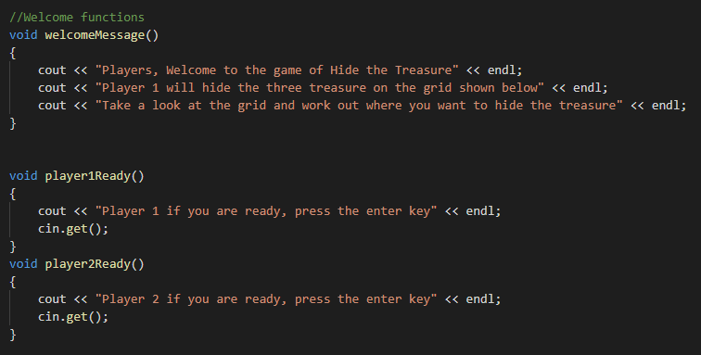
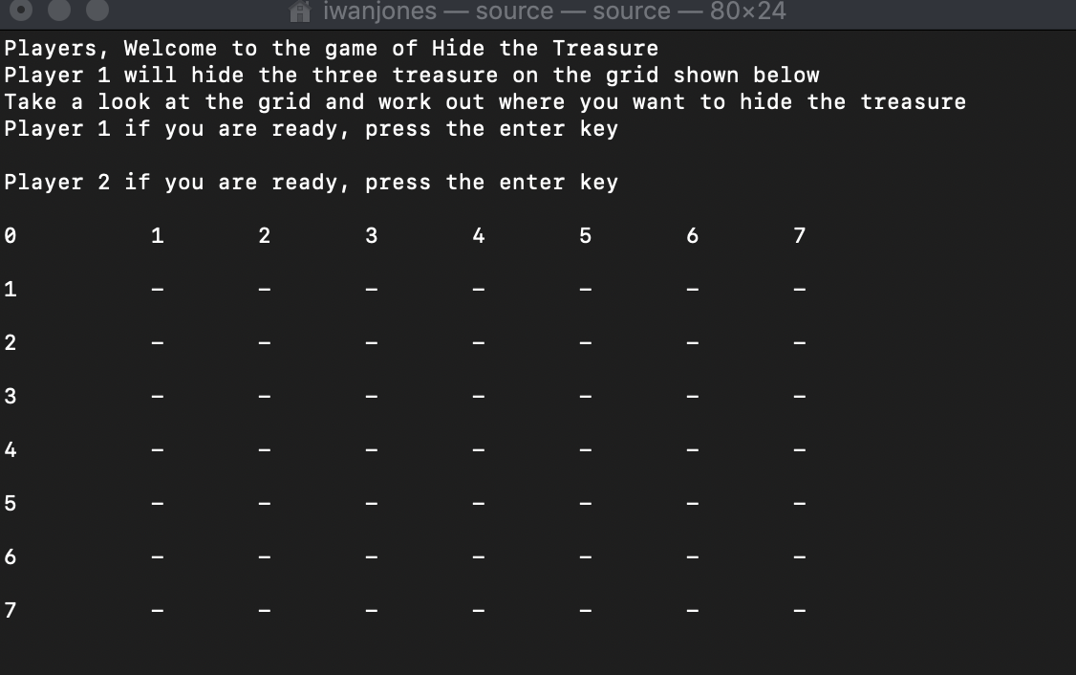

The next stage of the development for Iwan was player 1’s turn where they would be inputting the co-ordinates to hide the treasure. The code in the screenshot below was what Iwan used. Iwan used while loops to limit player 1 to inputting co-ordinates on the grid (numbers 1-7) and if they do there will be prompted to enter new co-ordinates. He then used if statements to make sure the same co-ordinates couldn’t be used more than once. If the player tried to enter the co-ordinates more than once they would be asked to enter new co-ordinates same as if they tried to enter anything other than whole numbers between 1 and 7 then they would be prompted to enter new co-ordinates. To test that this function worked, first Iwan tested to see if he could enter both x and y axis values, then he tested to see if he would be allowed to enter the same co-ordinates more than once and finally he tested to see if he would be prompted to enter new values if he attempted to input a number over 7 or under 1. Finally, he tried entering decimal place numbers and letter to see if it would prompt him to retry entering co-ordinates. All the tests were passed which meant that this piece of code was working as it should.
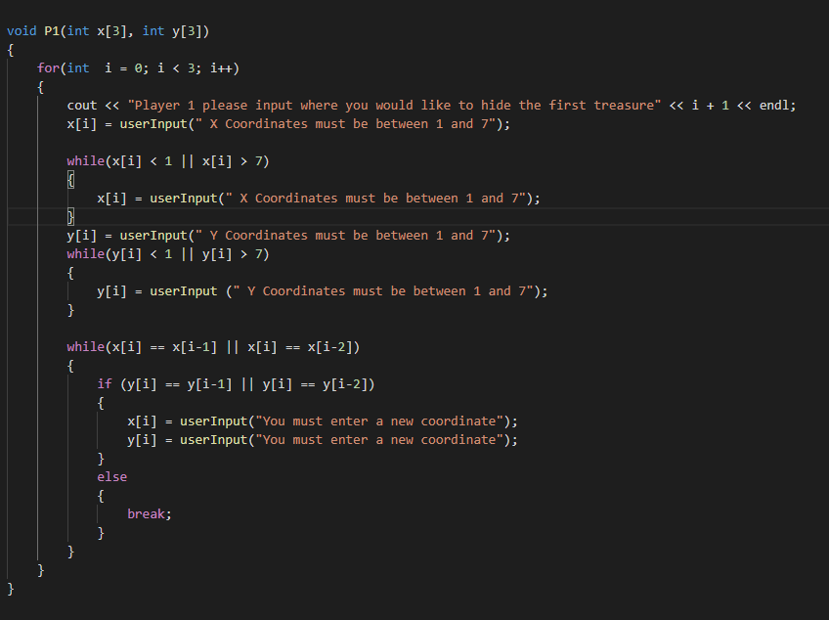
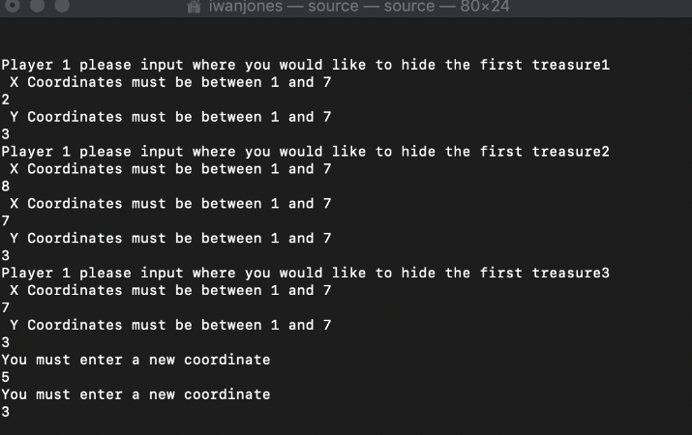
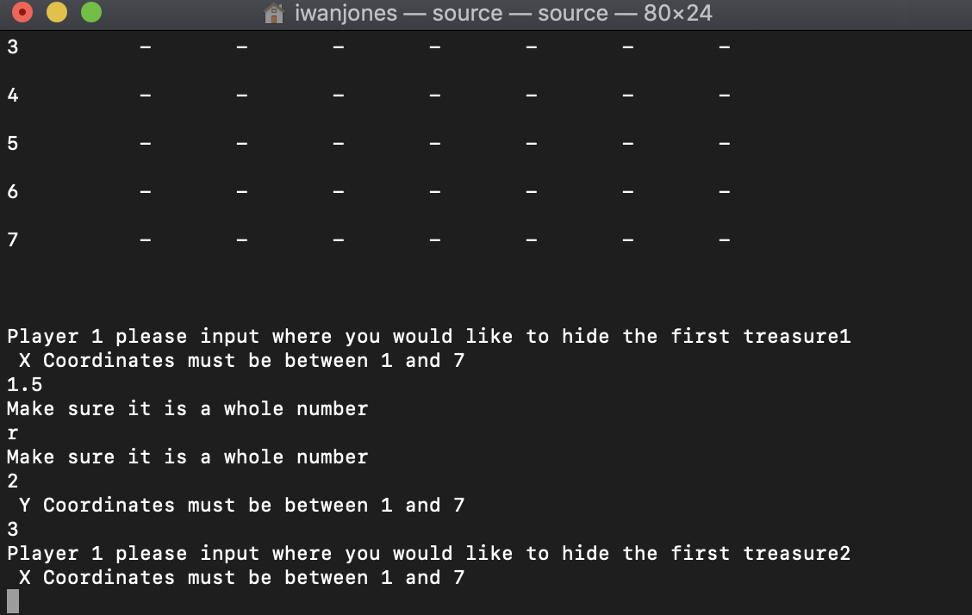

Next Iwan moved onto player 2’s turn. He again created functions for this. In the main he had created two arrays one for the x axis and one for the y axis which is then referred to in the function. He again added while loops to both turns to make sure just like in player 1’s go. There were two parts to this test. The first part was to check that player two could make guesses which can be seen in the second screenshot below, the second part of the test was to ensure the player would be prompted to enter new co-ordinates if the values entered were over 7 or under 1, as well as if they had already been entered before to avoid the player repeating guesses. He also made sure that a decimal number or letter couldn’t be entered by player 2 just as he used in player 1. All these tests were a pass as this can be seen in the screenshot below.
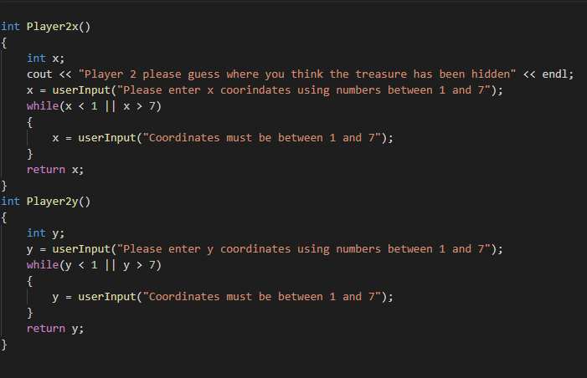

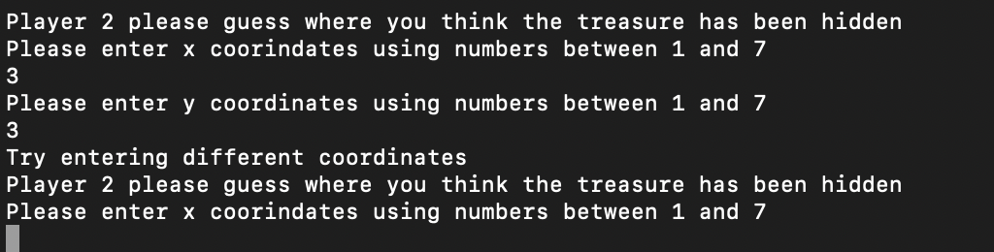
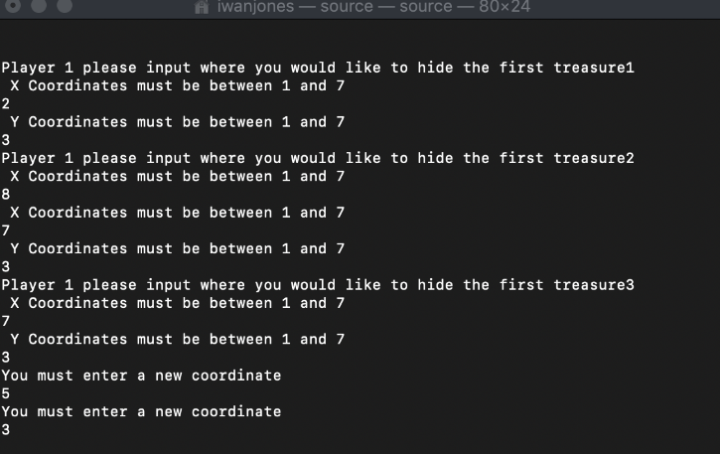
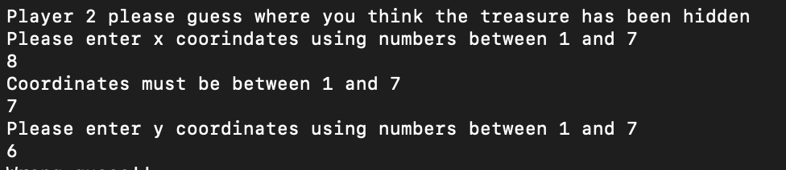
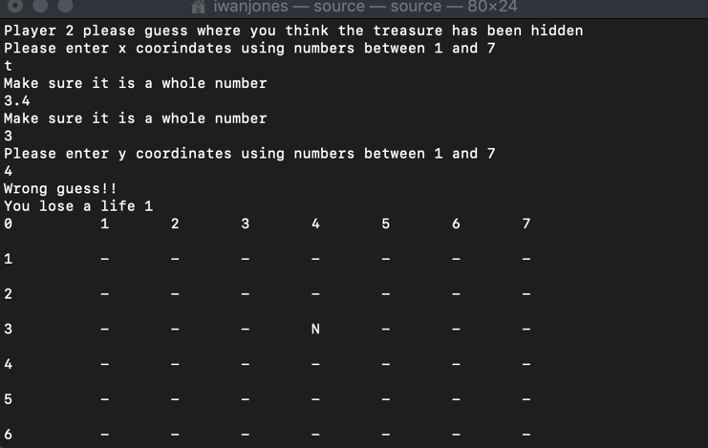

The next and final function that Iwan created was the function for which player would win or not. The function was named pwinner. This function was to work with the amount of lives the player has left. This function will print out the winner and loser of the game. If player 2 loses all three lives then it will print out player 2 loses and player 1 wins. To test this Iwan ran the game and made three wrong guesses to see if the function printed out the winner and loser. All the tests were passed which can be seen in the second screenshot below.
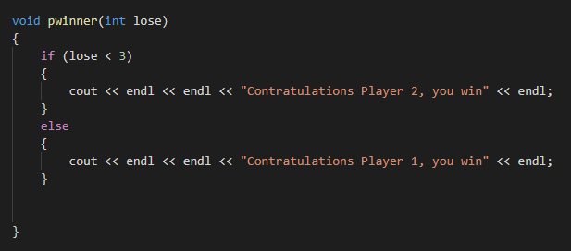
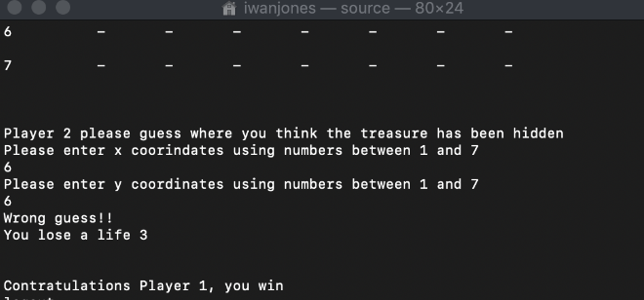
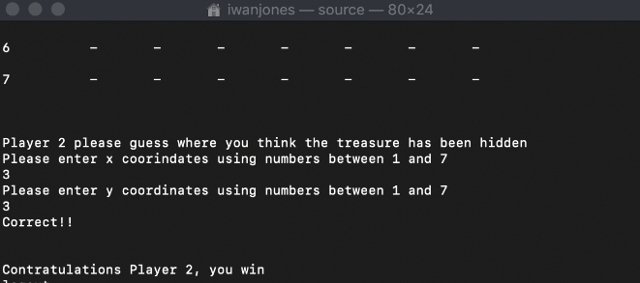

Iwan then moved onto directly coding in the main. He was working on the win and lose function of the game. This would then in turn refer to the pwinner function during the game. First of all the while loop was to print out the letter “X” or the letter “N” on the grid. This is where he moved into an if and else statement. He used this if statement to print the letter “X” in the co-ordinates if the guess from player 2 matches the co-ordinates that player 1 entered. As you can see in the screenshot below, if the x variable and y variable are the same as the xguess variable and the yguess variable then the “X” will be printed. This is where you can see the output of “Correct” then the grid is called upon to display the grid with the “X” in it. The else statement then was simple. Iwan then had to write that if the guess didn’t match up with the x and y array then the if else statement would print out “Wrong” and would print the letter “N” in the grid. However, it also would print out “You lose a life” and you would lose a lift. The way that Iwan created this function was if you lost a lift you game one almost and once you have gain three lives you would lose but to the player you are losing the life. To test that this function works Iwan carried out two tests. The first test was to make sure that if player 2’s guess matched the first co-ordinates that player 1 entered then the while and if statement would print out the word “Correct” and print the letter x in the said co-ordinates. This can be seen in screenshot two which shows that this function works so this test passed.

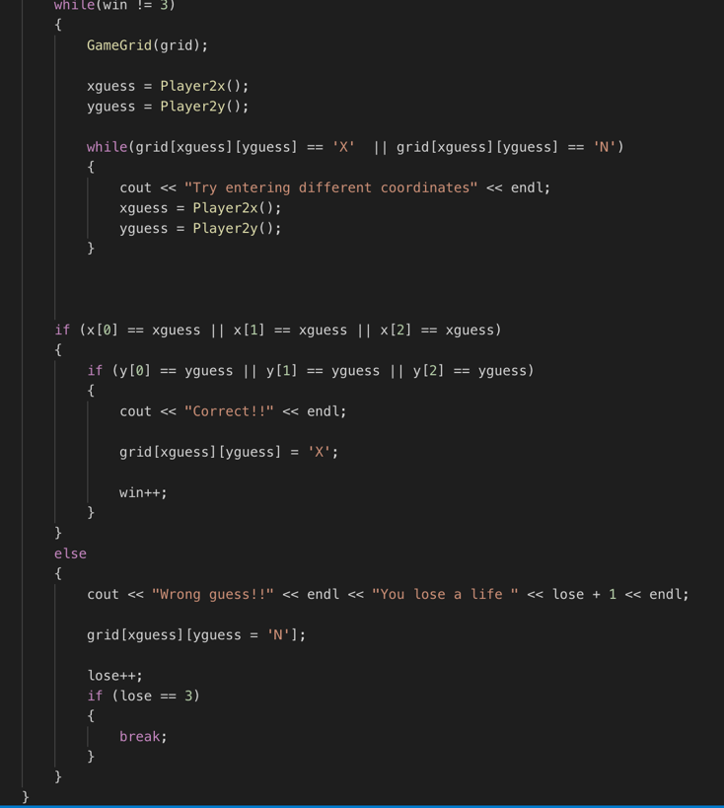

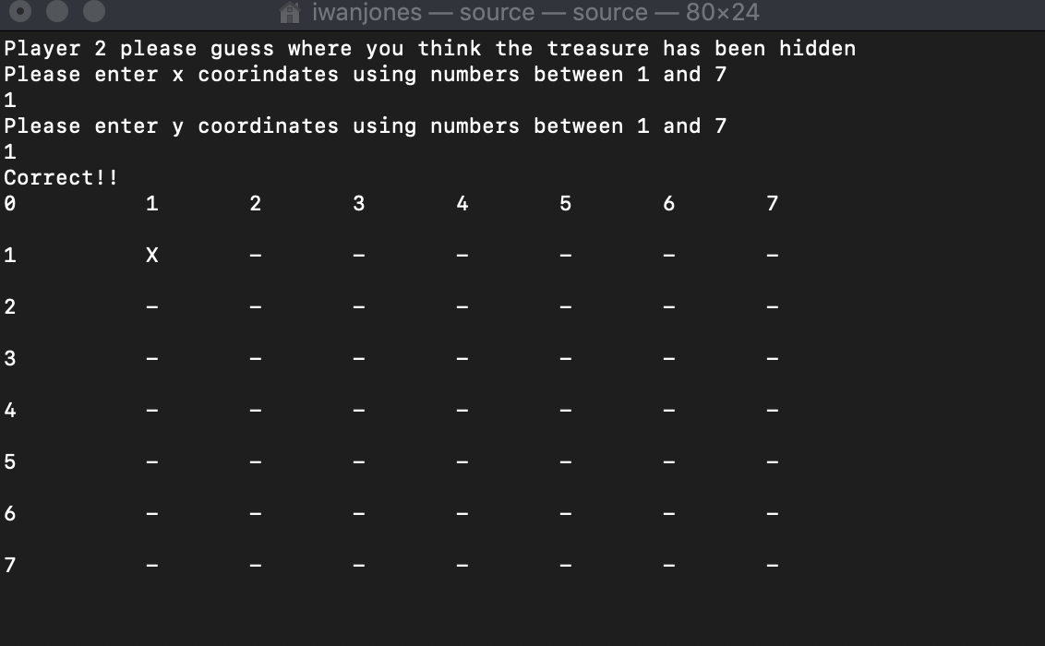

The second test was to see if there would be an “N” printed out on the grid in the co-ordinates that player 2 guesses that was wrong, also to make sure that it says “incorrect” too. The first time that Iwan conducted the tests on this function, it failed. This was due to an error in the code where Iwan had made an error with ‘]’ character. This meant that when the guess was wrong there was no “N” printed. This can be seen below.
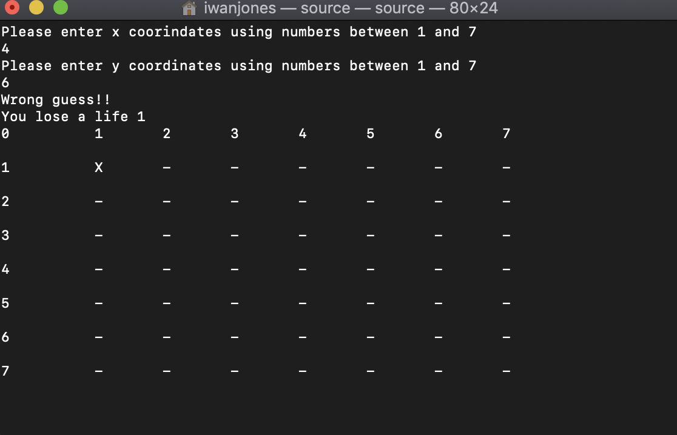
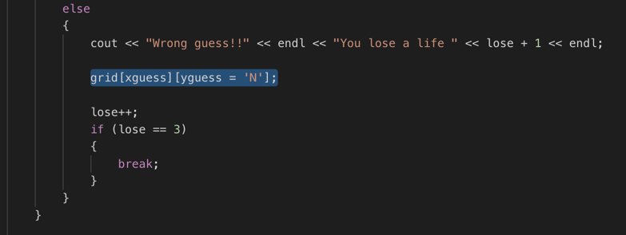

This error wasn’t a big issue, but it needed to be fixed. It wasn’t something that Iwan had to research he just had to comb through his code to find this issue. Once he had fixed this issue, he re tested this part of the function and there were no errors as the “n” printed out in the wrong co-ordinates entered. As you can see below, these screenshots are of the tests on this function and it work correctly. The second screenshot below is the code in the whole while, if and else statement corrected.
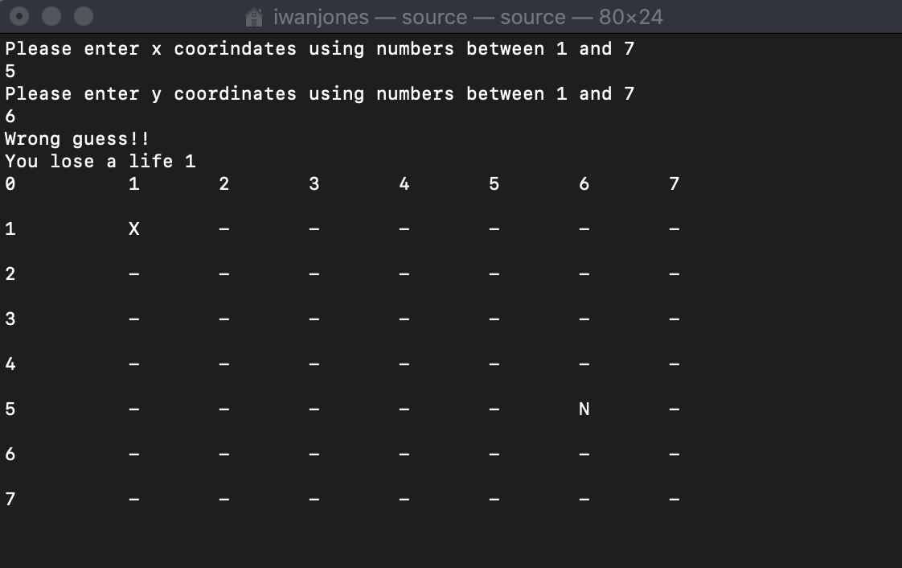
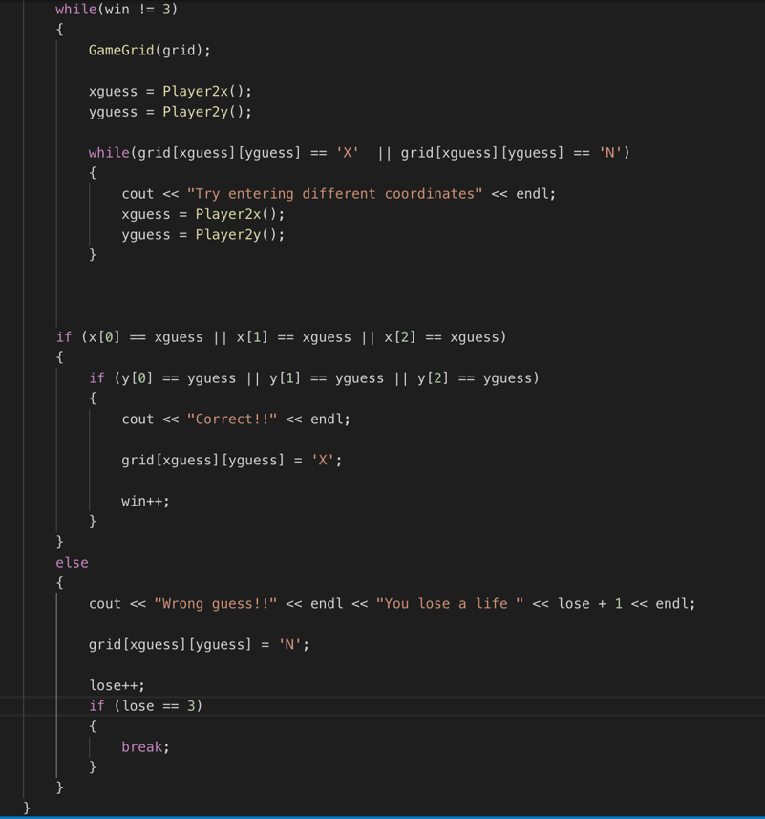

Finally, Iwan put together a complete test plan for exercise 2 to test the game runs all together after he had run tests on each section on their own. This shows the tests that also failed previously as well as the whole game test.

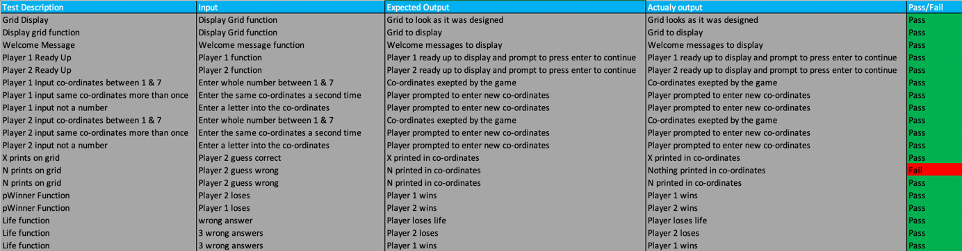

Bibliography

[1] | CPlusPlus, “Statements and flow control,” [Online]. Available: http://www.cplusplus.com/doc/tutorial/control/. [Accessed 2nd April 2019].
[2] | cPlusPlus, “Making a grid,” [Online]. Available: http://www.cplusplus.com/forum/beginner/66127/. [Accessed 03 April 2019].

Appendix

Exercise 1 Code List :

// Higher Or Lower Game //

#include "pch.h"
#include <iostream>
#include <sstream>
#include <string>
#include <stdlib.h>

using namespace std;

void welcomeMessage() {
cout << "Hello Players, Welcome to the game!" << endl;
cout << "Player 1, Please pick 7 values when prompted to between 1 & 10." << endl;
cout << "Press enter to start the game...";
cin.get();
}

void Player2() {
cout << "Now its player 2's turn to guess if the values are higher or lower than the previous value" << endl;
cout << "If you are ready player 2, press the enter button to start your turn... and good luck :) " << endl;
cin.get();
}

//All of the source code is bellow
int main(int argc, char *argv[])
{
// Welcome message to the game //

welcomeMessage();

stringstream stream;
string input = "";

//Player 1's chosen values //
string value[7];
value[0];
value[1];
value[2];
value[3];
value[4];
value[5];
value[6];

cout << "Please enter the first value between 0 and 10" << endl;
getline(cin, value[0]);

cout << "Please enter the second value between 0 and 10" << endl;
getline(cin, value[1]);

cout << "Please enter the third value between 0 and 10" << endl;
getline(cin, value[2]);

cout << "Please enter the forth value between 0 and 10" << endl;
getline(cin, value[3]);

cout << "Please enter the fith value between 0 and 10" << endl;
getline(cin, value[4]);

cout << "Please enter the sixth value between 0 and 10" << endl;
getline(cin, value[5]);

cout << "Please enter the seventh value between 0 and 10" << endl;
getline(cin, value[6]);

system("cls");

//code here to hide the values entered //

char guess;

Player2();

//Q1
cout << "The first value entered by player 1 will now be shown : " << endl;
cout << value[0] << endl;
cout << "You must guess if you think the next value will be higher or lower!" << endl;
cin >> guess;

//higher correct switch statement
switch (guess)
{
case 'h':
if (value[0] < value[1])
{
std::cout << "Correct" << endl;
}
break;
}

//higher incorrect switch statement
switch (guess)
{
case 'h':
if (value[0] > value[1])
{
std::cout << "Incorrect, game over, player 1 wins. Please press enter to close" << std::endl;
return (0);
}
break;
}

//lower correct switch statement
switch (guess)
{
case 'l':
if (value[0] > value[1])
{
std::cout << "Correct" << endl;
}
break;
}

//lower incorrect switch statement
switch (guess)
{
case 'l':
if (value[0] < value[1])
{
std::cout << "Incorrect, game over, player 1 wins. Please press enter to close" << endl;
return (0);
}
break;
}

//Q2
std::cout << "The second value entered by player 1 will now be shown : " << endl;
std::cout << value[1] << endl;
std::cout << "You must guess if you think the next value will be higher or lower!" << endl;
cin >> guess;

//higher correct switch statement
switch (guess)
{
case 'h':
if (value[1] < value[2])
{
std::cout << "Correct" << endl;
}
break;
}

//higher incorrect switch statement
switch (guess)
{
case 'h':
if (value[1] > value[2])
{
std::cout << "Incorrect, game over, player 1 wins. Please press enter to close" << endl;
return (0);
}
break;
}

//lower correct switch statement
switch (guess)
{
case 'l':
if (value[1] > value[2])
{
std::cout << "Correct" << endl;
}
break;
}

//lower incorrect switch statement
switch (guess)
{
case 'l':
if (value[1] < value[2])
{
std::cout << "Incorrect, game over, player 1 wins. Please press enter to close" << endl;
return (0);
}
break;
}

//Q3
std::cout << "The third value entered by player 1 will now be shown : " << endl;
std::cout << value[2] << std::endl;
std::cout << "You must guess if you think the next value will be higher or lower!" << std::endl;
cin >> guess;

//higher correct switch statement
switch (guess)
{
case 'h':
if (value[2] < value[3])
{
std::cout << "Correct" << std::endl;
}
break;
}

//higher incorrect switch statement
switch (guess)
{
case 'h':
if (value[2] > value[3])
{
std::cout << "Incorrect, game over, player 1 wins. Please press enter to close" << std::endl;
return (0);
}
break;
}

//lower correct switch statement
switch (guess)
{
case 'l':
if (value[2] > value[3])
{
std::cout << "Correct" << std::endl;
}
break;
}

//lower incorrect switch statement
switch (guess)
{
case 'l':
if (value[2] < value[3])
{
std::cout << "Incorrect, game over, player 1 wins. Please press enter to close" << std::endl;
return (0);
}
break;
}

//Q4
std::cout << "The third value entered by player 1 will now be shown : " << std::endl;
std::cout << value[3] << std::endl;
std::cout << "You must guess if you think the next value will be higher or lower!" << std::endl;
cin >> guess;

//higher correct switch statement
switch (guess)
{
case 'h':
if (value[3] < value[4])
{
std::cout << "Correct" << std::endl;
}
break;
}

//higher incorrect switch statement
switch (guess)
{
case 'h':
if (value[3] > value[4])
{
std::cout << "Incorrect, game over, player 1 wins. Please press enter to close" << std::endl;
return (0);
}
break;
}

//lower correct switch statement
switch (guess)
{
case 'l':
if (value[3] > value[4])
{
std::cout << "Correct" << std::endl;
}
break;
}

//lower incorrect switch statement
switch (guess)
{
case 'l':
if (value[3] < value[4])
{
std::cout << "Incorrect, game over, player 1 wins. Please press enter to close" << std::endl;
return (0);
}
break;
}

//Q5
std::cout << "The third value entered by player 1 will now be shown : " << std::endl;
std::cout << value[4] << std::endl;
std::cout << "You must guess if you think the next value will be higher or lower!" << std::endl;
cin >> guess;

//higher correct switch statement
switch (guess)
{
case 'h':
if (value[4] < value[5])
{
std::cout << "Correct" << std::endl;
}
break;
}

//higher incorrect switch statement
switch (guess)
{
case 'h':
if (value[4] > value[5])
{
std::cout << "Incorrect, game over, player 1 wins. Please press enter to close" << std::endl;
return (0);
}
break;
}

//lower correct switch statement
switch (guess)
{
case 'l':
if (value[4] > value[5])
{
std::cout << "Correct" << std::endl;
}
break;
}

//lower incorrect switch statement
switch (guess)
{
case 'l':
if (value[4] < value[5])
{
std::cout << "Incorrect, game over, player 1 wins. Please press enter to close" << std::endl;
return (0);
}
break;
}

//Q6
std::cout << "The third value entered by player 1 will now be shown : " << std::endl;
std::cout << value[5] << std::endl;
std::cout << "You must guess if you think the next value will be higher or lower!" << std::endl;
cin >> guess;

//higher correct switch statement
switch (guess)
{
case 'h':
if (value[5] < value[6])
{
std::cout << "Correct, Player 2 wins!!!" << std::endl;
}
break;
}

//higher incorrect switch statement
switch (guess)
{
case 'h':
if (value[5] > value[6])
{
std::cout << "Incorrect, game over, player 1 wins. Please press enter to close" << std::endl;
return (0);
}
break;
}

//lower correct switch statement
switch (guess)
{
case 'l':
if (value[5] > value[6])
{
std::cout << "Correct, Player 2 wins!!!" << std::endl;
}
break;
}

//lower incorrect switch statement
switch (guess)
{
case 'l':
if (value[5] < value[6])
{
std::cout << "Incorrect, game over, player 1 wins. Please press enter to close" << std::endl;
return (0);
}
break;
}

stream.str(input);
stream >> value[7];
stream >> guess;
stream.clear();

return (0);
}

Exercise 2 Code List :

//Hidden Treasures game//

#include "pch.h"
#include <iostream>
#include <sstream>
#include <string>
#include <stdlib.h>

using namespace std;

//Welcome functions
void welcomeMessage()
{
cout << "Players, Welcome to the game of Hide the Treasure" << endl;
cout << "Player 1 will hide the three treasure on the grid shown below" << endl;
cout << "Take a look at the grid and work out where you want to hide the treasure" << endl;
}

void player1Ready()
{
cout << "Player 1 if you are ready, press the enter key" << endl;
cin.get();
}
void player2Ready()
{
cout << "Player 2 if you are ready, press the enter key" << endl;
cin.get();
}

// Game Functions
void GameGrid(char grid[9][9])
{
for (int i = 0; i < 9; i++)
{
for (int j = 0; j < 9; j++)
{
cout << grid[i][j] << " ";
}
cout << endl << endl;
}

}

int userInput(string errormessage)
{
int num;
string input;
stringstream stream;

cout << errormessage << endl;
getline(cin, input);
stream.str(input);

while ((stream >> num && stream.eof()) == false)
{
cout << "Make sure it is a whole number" << endl;
stream.clear();
getline(cin, input);
stream.str(input);
}
return num;
}

void P1(int x[3], int y[3])
{
for (int i = 0; i < 3; i++)
{
cout << "Player 1 please input where you would like to hide the first treasure" << i + 1 << endl;
x[i] = userInput(" X Coordinates must be between 1 and 7");

while (x[i] < 1 || x[i] > 7)
{
x[i] = userInput(" X Coordinates must be between 1 and 7");
}
y[i] = userInput(" Y Coordinates must be between 1 and 7");
while (y[i] < 1 || y[i] > 7)
{
y[i] = userInput(" Y Coordinates must be between 1 and 7");
}

while (x[i] == x[i - 1] || x[i] == x[i - 2])
{
if (y[i] == y[i - 1] || y[i] == y[i - 2])
{
x[i] = userInput("You must enter a new coordinate");
y[i] = userInput("You must enter a new coordinate");
}
else
{
break;
}
}
}
}

int Player2x()
{
int x;
cout << "Player 2 please guess where you think the treasure has been hidden" << endl;
x = userInput("Please enter x coorindates using numbers between 1 and 7");
while (x < 1 || x > 7)
{
x = userInput("Coordinates must be between 1 and 7");
}
return x;
}
int Player2y()
{
int y;
y = userInput("Please enter y coordinates using numbers between 1 and 7");
while (y < 1 || y > 7)
{
y = userInput("Coordinates must be between 1 and 7");
}
return y;
}

void pwinner(int lose)
{
if (lose < 3)
{
cout << endl << endl << "Contratulations Player 2, you win" << endl;
}
else
{
cout << endl << endl << "Contratulations Player 1, you win" << endl;
}

}

int main(int argc, char *argv[])
{
//The grid for the game below
char grid[9][9] = {
{'0','1','2','3','4','5','6','7'},
{'1','-','-','-','-','-','-','-'},
{'2','-','-','-','-','-','-','-'},
{'3','-','-','-','-','-','-','-'},
{'4','-','-','-','-','-','-','-'},
{'5','-','-','-','-','-','-','-'},
{'6','-','-','-','-','-','-','-'},
{'7','-','-','-','-','-','-','-'} };

welcomeMessage();
GameGrid(grid);
cout << "If youre happy to start the game press enter" << endl;
cin.get();
system("cls");
player1Ready();
player2Ready();

int x[3];
int y[3];
int xguess = 0;
int yguess = 0;
int win = 0;
int lose = 0;

GameGrid(grid);

P1(x, y);

system("clear");

while (win != 3)
{
GameGrid(grid);

xguess = Player2x();
yguess = Player2y();

while (grid[xguess][yguess] == 'X' || grid[xguess][yguess] == 'N')
{
cout << "Try entering different coordinates" << endl;
xguess = Player2x();
yguess = Player2y();
}

if (x[0] == xguess || x[1] == xguess || x[2] == xguess)
{
if (y[0] == yguess || y[1] == yguess || y[2] == yguess)
{
cout << "Correct!!" << endl;

grid[xguess][yguess] = 'X';

win++;
}
}
else
{
cout << "Wrong guess!!" << endl << "You lose a life " << lose + 1 << endl;

grid[xguess][yguess] = 'N';

lose++;
if (lose == 3)
{
break;
}
}
}

pwinner(lose);

return 0;
}

