Student Name: Natalyn Dorn
P Number: 2304984
Programme of Study: Surface Pattern & Textiles

Module: ADDA4022/C Ways of Thinking
Tutor: Julia Lockheart

Manifesto:
- Models are constantly shamed for their weight.
- The fashion industry portraits a toxic environment for young girls, where most of the time we see unrealistic body standards.
- Images are usually professionally edited so that the models look unnatural and doll-like just so they can fit the beauty standard.
- Females are objectified and sexualised from a very young age when entering the model world.
- Editing of images became popular due to young girls feeling insecure about themselves and are constantly shamed into the ideal beauty standards.
- Plus-size models are rarely seen on the runway shows.
- Dietary guidelines are so strict, that it affects the mental and wellbeing for each model in the fashion industry.
- Plus-sized models get a negative reputation for their weight, whenever they appear on fashion runways.
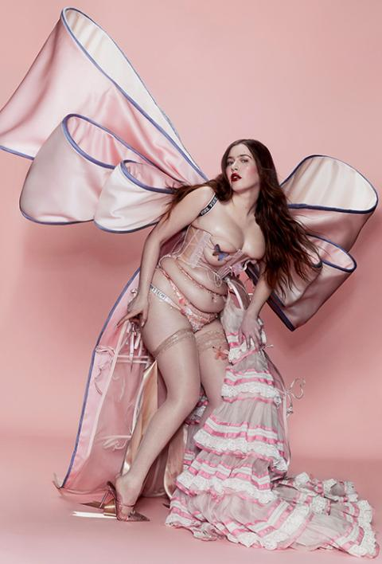
Keywords: Size and Body Diversity
Figure 1: Victoria Secret, Michale Starks in Michale Starks, The Tour’ 23
Size and Body diversity have been major concerns in the fashion industry for years. The constant display of unattainable body standards that we as young girls see on the runways especially the Victoria Secret runway shows, leaves many young girls either insecure, depressed, or empowered by their femineity. Victoria Secret is a perfect example, where lingerie and femineity play a huge part, but being skinny is what makes you beautiful and empowering.
The recent Victoria Secret runway show ‘The Tour’ 23 ‘was introduced as body inclusivity where Victoria Secret tried to bring models of different shapes and sizes. To the runway. This however backfired on the company, with many feelings angry and disappointed.
Models who played part in ‘The Tour’ 23’ were given negative feedback from the audience as they were accused of replacing the original Angels, which “The point of Angels is that not everyone could be an Angel. When I think of Victoria's Secret Angels, I think of a beauty standard that is not achievable. Something that a lot of people aspire to potentially be” (Tipton, 2023).
Elinor discontent towards the brands mission shows that she is correct. Victoria Secret has completely changed its mission and humiliated these women apart from empowering them. Tight corset on a plus-size woman doesn’t make her look as a strong female figure, it makes her look trapped and uncomfortable.
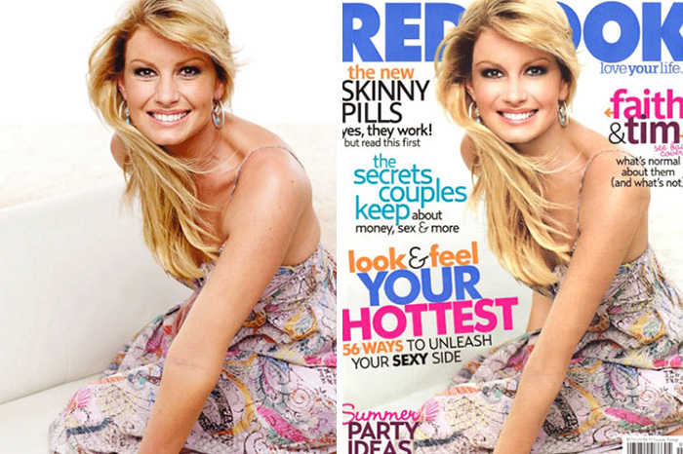
Keywords: Editing of Imagery
Figure 2: The retouched and original shots, Faith Hill, Redbook magazine
The editing of imagery has also become a huge issue in the beauty industry. Many of these fashion brands heavily rely on the use of photoshop to hiding any “imperfections” of models and replacing them into doll-like features.
One of the fashion industry’s photo editor Pascal Dangin, was awarded "the premier retoucher of fashion photographs" New Yorks Magazine, 2008. It’s scary how he “can change someone's character just by doing work on their eyes," Dangin told The New Yorker Magazine. ‘Not only does this distort our reality and perspective of woman but also creates trends for younger audiences, that editing your own images for social media is what grabs attention and likes for Instagram.’( Carey 2010)
Photoshop isn’t supposed to be used as a tool to make woman look doll-like and unrealistic, but as a tool to make the images more vibrant were keeping models natural features and not slimming them to fit the ‘ideal’ is what needs to happen. This will help younger generations understand that changing yourself to fit the norms won’t make you happier.
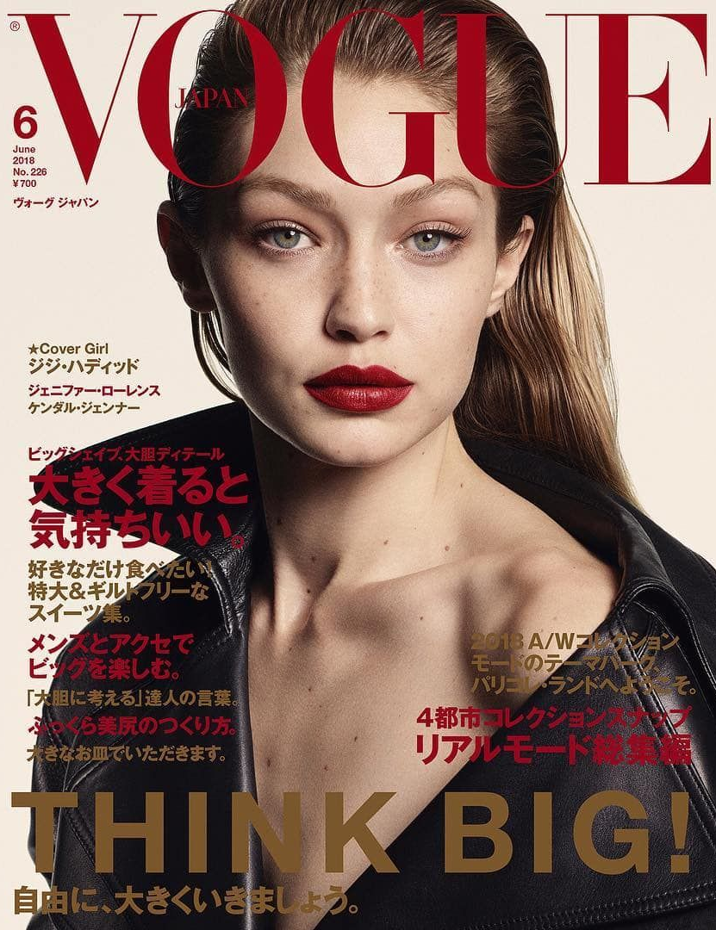
Keywords: Objectifying Females
Figure 2: Vogue, Japan, Photographed by Luigi & Iango, 2018
Fashion magazines such as Vogue and Playboy, almost always “depicts a young woman wearing highly sexual clothing supplemented with racy subtitles.” (Canavan, M. 2022) These models are always told by photographers what to wear and never have any say in their choice of clothes or pose.
Photographers know that sex sales, so targeting the male audience with a sexy woman wearing revealing clothes will gain more attention, then a softer more modest look.
Even Vogue Japan has hopped on the trend with Gigi Hadid, wearing red lipstick, with the leather jacket exposing her neck and shoulder. Surprising for Japan as it’s known as a modest country, but sex sales and objectifying and sexualising woman is what gets the money.

Bibliography:

Tipton, N. (2023) ‘A Woman Says She's Hugely Disappointed In The New Victoria's Secret Runway Show — 'The Angels Were The Epitome Of What Beauty Was' [Website for an Article about Victorias Secret ‘The Tour’23’] Available at: https://www.yourtango.com/entertainment/woman-explains-why-shes-disappointed-new-victorias-secret-fashion-show (Accessed on 7th October, 2023)

Carey, A. (2010) ‘Little Photoshop of horrors.’ [Website for an article about editing of imagery] Available at: https://www.independent.ie/style/beauty/little-photoshop-of-horrors/26650439.html (Accessed on 10th October, 2023)

Canavan, M.(2022)‘Call It What It Is: The Truth Behind the Modelling Industry’ [Website for an article based on objectifying woman] Available at: https://theacademyadvocate.com/13717/opinion/call-it-what-it-is-the-truth-behind-the-modeling-industry/#:~:text=It%20may%20seem%20easy%20to,bulimia%20being%20the%20most%20prominent (Accessed on 12th October, 2023)

Books:
- Constantian, M. B. (2019). Childhood abuse, body shame, and addictive plastic surgery : the face of trauma. Taylor & Francis.
- Warin, Megan. (2009). Abject relations everyday worlds of anorexia. Rutgers University Press.
- Thompson, J. Kevin. (1999). Exacting beauty : theory, assessment, and treatment of body image disturbance. American Psychological Association.

List of Figures:

Figure 1: Victoria Secret, The Tour’ 23, Michaela Stark in custom Michaela Stark, 2023. Accessed: https://vspressroom.com/victorias-secret-the-tour-2023/ (Accessed on 7th October, 2023)
Figure 2: The retouched and original shots, Faith Hill, Redbook magazine. https://www.independent.ie/style/beauty/little-photoshop-of-horrors/26650439.html (Accessed on 10th October, 2023)

Figure 3: Vogue, Japan, Photographed by Luigi & Iango, 2018. https://en.vogue.me/fashion/models/gigi-hadids-fashion-story-told-vogue-covers/ (Accessed 12th October, 2023)

Semiotics Analysis:

Campaign: Dior Hypnotic Poison Fragrance 1998

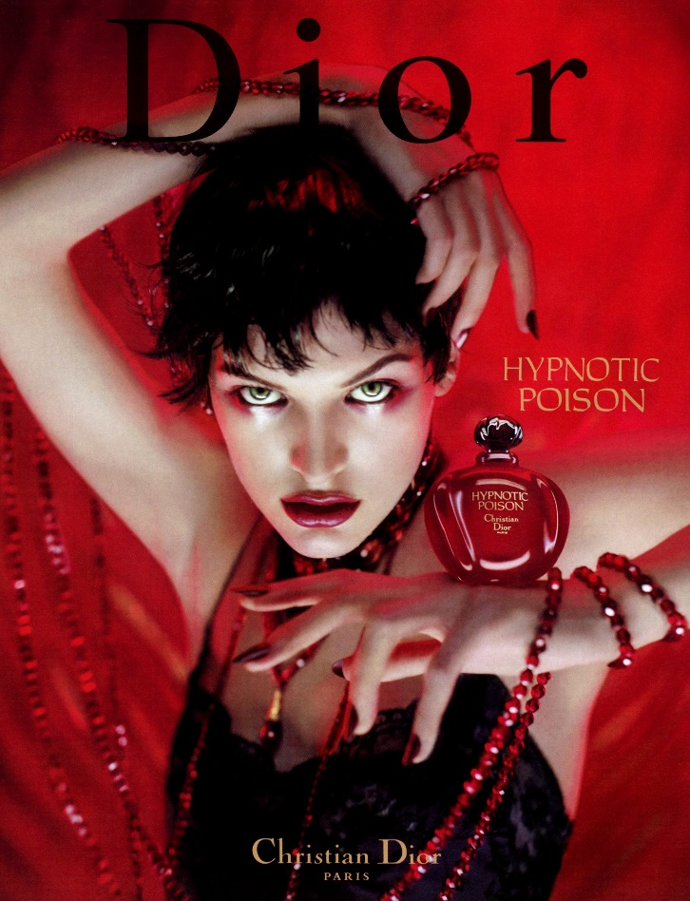
Semiotics is the study of signs and symbols and how they can be interpretated from different views, as we as people all have our own different views and ideas. In today’s generation, advertisement heavily relays on semiotics to convey message and create meaning, which allows brands to sell their products much more efficiently. One example of this is the Dior Hypnotic Poison Perfume Campaign.

Figure 1: Dior Campaign, Hypnotic Poison, Fragrance 1998

In October 1998, the luxury brand Dior released a campaign for their new fragrance ‘Hypnotic Poison’. The campaign focused on making anyone who wore the perfume, draw everyone’s attention to them with such captivating scents: ambary and vanilla-tinged version of Poison, the iconic fragrance of the House of Dior, created in 1985. Its captivating scent reveals a refreshing heart of jasmine enhanced with notes of bitter almond and sensual vanilla.
The Dior Hypnotic poison perfume advertisement utilizes various semiotic elements to communicate this hypnotising fragrance through to its viewers. Using vibrant colours such as red and black, creates this seductive aura that draws you in to further investigate. The colour red can be portrayed in many ways, such as ‘passion, love, sexuality, warmth’ while in the Dior campaign we can almost see this negative twist that red can have: ‘evil, lust, seductiveness’.
With the model’s provocative pose and intense gaze, it almost gives of the idea of the model playing the role of the serpent and the perfume bottle being this forbitten fruit that ‘You must not eat…and you must not touch it, or you will die.’ (Bible Genesis 3) While you’re playing the role of Eve and slowly being tempted to eat this forbitten fruit and try out this Hypnotic poison perfume that the model / serpent is tempting you to try ‘You will surely not die’ (Bible Genesis 3).
Keeping the text in the advertisement minimal but impactful with the use of the world Hypnotic Poison in the perfume’s name immediately strikes this sense of fascination and allure that the perfume holds. Choosing the bottle to symbolise an apple in the advertisement is also significant as we can associate the Hypnotic Poison and apple bottle to Snow White. Imagery of an apple is often associated with health and ‘One apple a day keeps the doctors away’ saying. However, with the addition of the word poison to the mix, we get this fairytale feel of Snow White that Dior might be selling to us. These Symbols work well together to create a fairytale narrative around the perfume, suggesting that it has power to captivate and enchant those who dear to wear it.
Overall, Dior Hypnotic Poison campaign exemplifies the use of semiotics in modern advertising. It showed us that with careful selection of symbols, colours and text we all can be captivated with such strong advertisement which appeals to viewer’s desires and emotions.

Bibliography:
- The Holy Bible. Genesis 3:23. The Fallen.
- Gage, John. (2000). Colour and meaning : art, science and symbolism. Thames & Hudson.
- Mears, A. (2011). Pricing beauty : the making of a fashion model. University of California Press.
- Pallant, C. (Ed.). (2020). Snow White and the seven dwarfs. Bloomsbury Academic.

Dior Perfume (2022) Hypnotic Poison eau de toilette. [website for the purchase of the perfume] https://www.dior.com/en_gb/beauty/products/hypnotic-poison-eau-de-toilette-Y0063401.html (accessed on 24th November 2023)

List of Figures:
Figure 1: Dior Hypnotic Poison Campaign, Fragrance 1998 https://www.scannedfashionworld.com/2019/12/campaign-dior-hypnotic-poison-fragrance.html (accessed on 24th November 2023)

Link the word to the object.
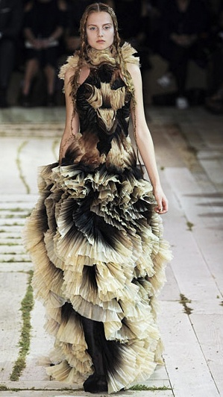
Keyword: Texture
Figure 1: Alexandera McQueen, Ready To Wear Fashion Show, Collection Spring Summer 2011 presented during Paris Fashion Week, runway look #032

In the contemporary context, texture plays a significant role in various fields such as art, design, fashion and technology. With the tools and techniques, we learned over the years, artists and designers can have more freedom to play around with various ideas of textures, creating these amazing outcomes in different artistic fields. We use texture to add depth, visual interest, and tactical qualities. Like in Fashion and textiles, to create texture we would use fabrics including various techniques to make these textures come to life: Embroidery, pleating, printing, sewing. These techniques give the fabric this textured 3D look that most artists and designers love in their work.
The history of texture can be tracked back to ancient times, where it played a significant role in various art forms and crafts. In Egypt, Mesopotamia and Greece texture was used to enhance the look of sculptures, pottery, and architectural structures that we see today. To achieve these looks, artists and craftsman used various techniques including: carving, engraving and modelling adding depth and visual interests to their work.
Alexandera McQueen is an example of this with his abstract runway designs, with ready to wear spring summer 2011 fashion show collection. This was the first collection that was run by Sarah Burton after McQueen’s suicide, ‘where Sarah Burton brought out the feminine and tender qualities to the designs with the garments being softer than previous designs’ (Elizebeth, 2010). This fashion runway was based on silhouettes and texture where we can see these gradient, soft pleats layered all over the model’s runway outfit. Seeing this design almost shows a mixture of past designs of Alexandera McQueen that Sarah Burton included in this runway across all the designs. Spring Summer 2011 was like the beginning and end for the McQueen Brand, where new designs began, and old ones ended, paying a tribute to McQueen’s Legacy.
I feel like texture can be such broad theme to use in a design context, especially as we see texture everyday: from household objects that were manmade to nature based that were naturally created by mother earth herself. All these different outcomes we see in our daily lives has a significant impact on our creative thinking and how we could use texture in our designs, especially when texture can create such unique and dynamic sensory experience for so many people like Textiles Designers which are tactical people, anything with texture is always a win.
Nature itself is a form of texture, representing different shapes and textures, the waves in the ocean mixing with the sea foam perfectly resemble the marble we are so used to seeing. Manmade objects draw from the various aspects of nature, generating ideas and beauty in our modern architecture. The lightning and dessert resemble various marks and textures on our bodies, we as human beings are tied to mother nature through the simple textures on our skin. Stretch marks on our skin resemble the bolts of lightning that light up the sky, the dessert shows all the beautiful imperfections of various specks on our bodies.

Bibliography:
- Sakmar, E. M. (1987). Fashion illustration techniques, workbook 4 : rendering fabrics and textures. North Light Books.
- Lee, Y. (2020). Surface and Apparition: The Immateriality of Modern Surface (1st ed.). Bloomsbury Publishing Plc.
- Bruno, G. (2014). Surface : matters of aesthetics, materiality, and media. University of Chicago Press.

Joanna, E. (2010) Alexander McQueen Spring 2011 | Paris Fashion Week [Website article for the spring summer 2011 fashion show] https://www.fashiongonerogue.com/alexander-mcqueen-spring-2011-paris-fashion-week/ (accessed on 10th December 2023)

List of Figures:
Figure 1: Alexandera McQueen, Ready To Wear Fashion Show, Collection Spring Summer 2011 presented during Paris Fashion Week, runway look #032 https://nowfashion.com/alexander-mcqueen-ready-to-wear-fashion-show-collection-spring-summer-2011-presented-during-paris-fashion-week-runway-look-032/ (accessed 10th December 2023)

