

The Design and Implementation of an Interactive Student Portal with Messaging and Reward Mechanisms

by
Jake Semmens

Supervisor: James Williams
Second Marker:

Project submitted as part of the requirements for the award of BSc (Hons) Computing (Software Engineering)

May 2026

Declaration Form and Form of Consent
DECLARATION
I, Jake Reggie Owen Semmens, declare that I am the sole author of this Project; that all references cited have been consulted; that I have conducted all work of which this is a record, and that the finished work lies within the prescribed word limits.
This work has not previously been accepted as part of any other degree submission.
Signed: J. Semmens
FORM OF CONSENT
I, Jake Reggie Owen Semmens, hereby consent that my Project, submitted in candidature for the BSc Software Engineering degree, if successful, may be made available for inter-library loan or photocopying (subject to the law of copyright), and that the title and abstract may be made available to outside organisations.
Signed: J. Semmens

Contents
Declaration Form and Form of Consent 1
Contents 2
Abstract 3
1 - Introduction 4
2 - Literature Review 5
2.1 Introduction 6
2.2 Evolution of Digital Student Portals 7
2.3 Communication and Collaboration in Academic Systems 9
2.4 Gamification in Higher Education 10
2.5 User Experience in Student Portals 12
2.6 Privacy, Security, and Ethical Considerations 14
2.7 Case Studies 15
2.8 Tools and Technologies 17
2.9 Summary and Research Gaps 18
3 – Research and Development Methodology 19
3.1 Research Methodology 20
Research Philosophy (Research Onion Layer 1) 20
Research Approach (Layer 2) 20
Methodological Choice (Layer 3) 20
Research Strategy (Layer 4) 21
Time Horizon (Layer 5) 21
3.2 Data Collection Methods 21
Survey Phase (15 participants) 21
SMART Survey Objectives 21
Validity 21
Reliability 21
Generalisability 22
Observation Phase (5 participants) 22
Interview Phase (5 participants) 22
Evaluation Criteria 22
Data Analysis Methods 22
3.3 Development Methodology 23
4. Design 23
4.1 Design Approach 24
4.1.1 Key Considerations 24
4.1.2 Requirements Specification 24
Presentation Requirements 24
Logic Requirements 25
Database Requirements 25
Hosting Requirements 26
Security Requirements 26
4.1.3 Front End Design (Presentation Logic) 26
Landing Page: 27
Login Page: 27
Home Page: 28
Messages Page: 29
Profile Page: 30
4.1.3 Back End Design (Data Tier) 32
4.1.6 Logo 34
4.1.5 Colour Scheme 35
4.1.6 Font Scheme 36
5 - Implementation 37
5.1 User Authentication and Session Management 38
5.2 Messaging System 39
5.3 Gamification – Points, Badges, and Leaderboard 41
5.4 Bilingual Support 43
5.5 Challenges 44
5.6 Acceptance Testing Results 45
5.7 Conclusion 45
6. Analysis 45
6.1 Introduction to the Analysis 46
6.2 Analysis of the Survey Results 46
6.2.1 Demographic Profile of Survey Respondents 46
6.2.2 Survey Results by Question 48
6.2.2.1 Usability & Integration of Existing Tools 48
6.2.2.2 Fragmentation, Strain & Stress from Multiple Platforms 49
6.2.2.3 Effectiveness of Individual Tools (Teams, LMS, Outlook, Reminders) 51
6.2.2.4 Centralisation Benefits of AthenaSP 52
6.2.2.5 Messaging Integration in AthenaSP 52
6.2.2.6 Gamification Elements in AthenaSP 53
6.2.2.7 Usability, Preference & Recommendation of AthenaSP 54
6.3 Analysis of the Observation Results 55
6.3.1 Overview of the Observation 56
6.3.2 Key Findings from the Observations 56
6.4 Integration of Survey and Observation Findings (Highly Recommended) 57
Key mixed-methods insights: 57
6.5 Summary of Key Findings 58
Chapter 7 – Evaluation 58
7.1 Objective One Evaluation 59
7.2 Objective Two Evaluation 59
7.3 Objective Three Evaluation 59
7.4 Objective Four Evaluation 60
7.5 Objective Five Evaluation 60
7.6 Aim Evaluation 60
Chapter 8– Conclusions and Recommendations 60
8.1 Recommendations 61
Chapter 9 – Reflection 62
References 64
Figures 67
Appendix 69
Appendix 1 – Acceptance Testing Results 69

Abstract
The rapid digitalisation of higher education has exposed significant limitations in existing student portals, particularly fragmentation across multiple platforms, limited interactivity, and low student engagement. This project addressed these challenges by designing and developing AthenaSP, a centralised interactive student portal that integrates secure real-time messaging and a points-based gamification system.
The primary aim was to investigate whether combining secure messaging and gamification within a single platform could reduce cognitive load caused by tool-switching and improve student engagement and motivation. Five objectives were pursued: a comprehensive literature review; the design and implementation of a functional prototype; usability and engagement evaluation; comparison against the existing UWTSD HWB portal; and critical reflection on the integration challenges.
A mixed-methods approach was adopted, combining a literature review with iterative development using PHP, MariaDB, HTML, CSS, and JavaScript in a local XAMPP environment. Evaluation involved a survey with 15 participants and structured observations with 5 participants.
Results demonstrated strong support for AthenaSP. Participants completed tasks significantly faster, used fewer tabs and logins, and expressed 100% preference for the prototype over the current university portal. Gamification elements received particularly high ratings for increasing motivation and enjoyment, while centralisation notably reduced perceived mental strain. The bilingual language toggle further improved accessibility.
In conclusion, this project successfully demonstrated that a centralised portal integrating secure messaging and gamification can meaningfully enhance the student experience. AthenaSP offers a promising proof-of-concept for the next generation of more engaging and efficient student portals in higher education.

1 - Introduction
Universities increasingly rely on digital platforms to support teaching, communication, and student engagement. Student portals have become a central part of this ecosystem, providing access to timetables, course materials, grades, and announcements. However, many existing portals remain largely static information repositories. They offer limited interactivity and do little to foster collaboration, personal engagement, or two-way communication. This creates a clear opportunity to reimagine the student portal as a more dynamic, motivating learning environment.
The motivation for this project arises from the recognition that modern digital systems can go beyond passive information delivery. Today’s students expect interactive, intuitive, and socially connected platforms. Research shows that features such as gamification, real-time messaging, and responsive design can significantly improve user satisfaction, motivation, and participation. Real-time communication facilitates easier collaboration, while reward-based systems reinforce positive behaviours such as task completion and active involvement.
This project addresses the shortcomings of current university portals by designing and implementing an enhanced platform that integrates secure messaging and a structured points-based gamification model. The messaging system enables students and lecturers to communicate safely within an institutionally managed environment, reducing reliance on external tools like WhatsApp or Discord. The gamification component complements this by awarding points for productive academic behaviours, creating a cohesive approach to improving both communication and motivation.
Beyond enhancing student engagement, the project demonstrates a wide range of software engineering and full-stack development skills, including backend services, database design, front-end interface development, security, and user experience principles.
The overarching aim of the project is to design and develop an enhanced student portal that integrates secure messaging and gamification to improve engagement, motivation, and communication, ultimately addressing limitations found in current university systems. To achieve this aim, the project undertakes several key objectives: reviewing existing research on portals, gamification, usability, and communication technologies; designing and implementing a functioning prototype with interactive features; evaluating the system through usability and engagement testing; comparing its functionality to existing portals; and reflecting on the challenges and implications of introducing such systems into academic environments.

2 - Literature Review

2.1 Introduction
Technology has become a vital component of modern education, transforming the way students access information, communicate, and engage with learning environments. Educational institutions across the world have increasingly adopted digital systems to enhance academic performance, streamline administrative processes, and improve overall student satisfaction. Among these systems, the student portal has emerged as a backbone of digital learning infrastructure, acting as a central platform for accessing course materials, grades, announcements, and other essential services. When designed effectively, a portal can also serve as a hub for interaction, collaboration, and engagement, helping to create a more connected and supportive academic community.
Despite significant advances in technology, many student portals remain static and underutilised. They often focus on administrative functions with limited personalisation or interactivity. Such shortcomings can hinder student engagement and fail to meet the expectations of modern learners who are accustomed to seamless, user-centred digital experiences. Improving usability, consistency, and integration is therefore essential for ensuring that portals provide genuine academic value rather than acting as simple information repositories.
Recent developments in educational technology have explored the integration of communication tools and gamification features to enhance motivation and collaboration. Real-time messaging, discussion boards, and notification systems can strengthen academic and social connections, while features such as points, badges, and progress tracking can make engagement more rewarding. When carefully implemented, these elements can transform student portals from passive systems into active learning environments that promote participation and community building.
Alongside these functional and engagement-related considerations, privacy and ethics remain critical. Universities must ensure that data collection and system use comply with regulations such as the General Data Protection Regulation (GDPR), maintaining transparency and user trust. Protecting personal information and fostering ethical data practices are essential for sustaining confidence in digital learning environments.
The aim of this project is to design and develop an improved student portal that integrates secure messaging and gamification features to increase student engagement, motivation, and communication, addressing the limitations of existing university systems.
To achieve this aim, the project will pursue the following objectives:
- To review existing research on gamification, communication systems, and student portals to identify good practices.
- To design and implement a prototype portal that integrates secure messaging, reward points, and interactive navigation.
- To test and evaluate the usability, engagement, and security of the developed system.
- To compare the proposed portal against existing university systems to identify improvements in functionality and student experience.
- To reflect on the challenges of integrating gamification and communication tools within academic systems.

2.2 Evolution of Digital Student Portals
The student portal concept emerged in the late 1990s with the widespread adoption of the World Wide Web. Early initiatives sought to centralise access to academic resources that were previously scattered across numerous websites, reducing inefficiency and security risks. As one study describes, portals were initially designed as “central hubs to provide students with access to essential academic information in a single, manageable location” [1]. In this experimental phase, universities focused primarily on digitising administrative processes and basic course material delivery. Adoption was slow, however, constrained by limited server capacity, bandwidth, and institutional readiness [2].
First-generation portals focused almost entirely on administrative tasks, offering little in terms of interactivity or personalised features [3]. They were largely used as registration tools where students could view examination results rather than functioning as fully integrated learning hubs. These systems typically featured static, difficult-to-use interfaces with minimal personalisation, resulting in poor user experiences. Engagement features were scarce, and the fragmentation of resources meant students often had to rely on multiple external tools. Early studies confirm that students frequently found the interfaces unintuitive and cumbersome, with difficulties navigating course materials and locating resources [4]. Institutional reports similarly highlighted that technical limitations and limited staff training slowed adoption and negatively affected the student experience [5], while surveys revealed inconsistent usability across faculties, leading to widespread frustration and disengagement [2].
Over time, student portals evolved beyond basic administrative functionality. Learning Management Systems such as Moodle, Blackboard, and Canvas began integrating richer features, including calendars, messaging systems, discussion boards, library access, and assessment tracking. This created more centralised and cohesive platforms. “The integration of discussion boards, calendars, and library access marked a significant shift towards more cohesive and collaborative learning environments” [6]. Research indicates that these developments improved engagement, with students using portals with integrated communication tools reporting higher engagement and a greater sense of academic support [7]. Portal integration was also found to contribute significantly to students’ sense of academic community and belonging [5]. The addition of assessment and feedback functionalities enabled more timely and transparent communication between students and instructors. Nevertheless, usability issues persisted, with one investigation noting that even with integrated tools, portals often failed to provide seamless navigation, requiring students to switch between multiple modules for routine tasks [2].
In the past decade, despite rapid technological advances during the Fourth Industrial Revolution, many student portals remain underutilised. They frequently fail to fully engage learners through interactive or personalised features [7]. Many platforms continue to consist primarily of static external links, offering minimal added value beyond what students could find through a simple web search. Even where features such as gamification, personalised notifications, and adaptive learning tools have been introduced, implementation is often inconsistent. Modern students increasingly expect seamless integration, intuitive navigation, and real-time feedback, yet these expectations are rarely met. As one study observed, “student satisfaction with portals is closely linked to interface clarity, responsiveness, and the extent to which the portal supports independent learning” [5].
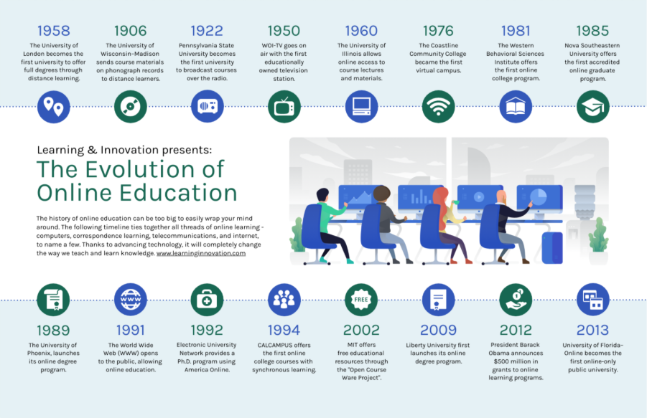Figure 1 shows the evolution of online education [8]
Overall, the evolution of digital student portals demonstrates a gradual shift from purely administrative systems to more integrated, interactive platforms. Despite improvements in functionality and additional features, many portals continue to face challenges in usability, consistency, and genuine engagement. This ongoing underutilisation highlights a significant opportunity to develop more user-focused, interactive portals that effectively combine administrative functionality with communication, gamification, and learning support. The persistent gaps underscore the importance of user-centred design in future higher education technologies and provide a strong foundation for the enhancements proposed in this project.

2.3 Communication and Collaboration in Academic Systems
Communication and collaboration are fundamental to modern education. They enable the exchange of ideas, support group projects, foster effective teamwork, and strengthen student–teacher relationships. In recent years, online and blended learning have become increasingly prevalent, particularly during the COVID-19 pandemic, which accelerated the digitalisation of education. Even as traditional in-person learning has resumed, online platforms remain essential for students unable to attend university due to illness or other constraints. This section examines how communication technologies have transformed academic collaboration, highlighting their benefits and challenges, and exploring the potential for integrated messaging within student portals.
Since the advent of the World Wide Web, online communication has become central to student interaction. Early tools such as email, discussion forums, and LMS message boards offered asynchronous communication that provided flexibility but limited immediacy and engagement. Platforms like Moodle forums and Blackboard message boards allowed students to post questions and submit assignments, yet responses often depended on lecturer moderation. As one study noted, “a discussion board can be host to a significant amount of engagement with the course’s material and importantly with the questions and answers of fellow students” [8]. While functional, these tools lacked real-time interaction. Studies highlighted common frustrations, including students ignoring emails and finding email traffic overwhelming or irrelevant [9]. As a result, delays frequently disrupted learning and limited active collaboration.
As technology evolved, student communication shifted markedly. Traditional emails have become largely reserved for non-urgent matters, while platforms such as Microsoft Teams, Discord, and WhatsApp have revolutionised collaboration through real-time messaging, notifications, and instant feedback. A study comparing Moodle with Mobile Instant Messaging (MIM) found that the MIM group produced significantly more messages and achieved higher rates of participation, task completion, and interaction [10]. These tools support group chats, dedicated channels, and continuous discussion, enhancing engagement and fostering a stronger sense of community. However, they also introduce notable drawbacks, including potential distractions, privacy risks, and limited institutional oversight — especially when data is stored by third-party providers.
Students today must navigate both traditional platforms (email and LMS forums) and modern applications. Traditional tools offer reliability and formality, with one study reporting that 85% of students perceived them as providing a better outlet for communication than purely online environments [11]. Modern platforms, by contrast, excel in immediacy and interactivity but raise concerns around privacy, moderation, and academic accountability. This contrast reveals a clear gap: universities need a secure, integrated system that combines the structure and oversight of traditional methods with the engagement of contemporary real-time tools.
Integrating real-time messaging directly into student portals represents a significant opportunity. By merging the immediacy of modern apps with the security and structure of institutional systems, universities can create a seamless, interactive environment. Embedding secure messaging reduces the overwhelming “app carousel” students currently manage and unifies communication in one place. Research shows that internal chat systems can significantly enhance students’ behavioural, emotional, and cognitive engagement [10]. While challenges such as moderation policies, message retention, and privacy protection remain, a well-designed portal can address these through structured channels for courses, group projects, and announcements, blending real-time interaction with appropriate academic oversight.
Overall, academic communication has evolved from asynchronous, structured tools to dynamic real-time platforms. Traditional methods provide reliability and formality, while modern tools deliver immediacy and community. Integrating secure messaging within student portals offers a balanced solution that leverages the strengths of both approaches. This integration can enhance collaboration, engagement, and student satisfaction while maintaining institutional control and privacy — directly addressing a key limitation in current university systems.

2.4 Gamification in Higher Education
Gamification is the application of game design elements in non-game contexts to enhance engagement and motivation. In higher education, it has emerged as a key strategy to increase student participation, collaboration, and satisfaction. By incorporating mechanisms such as points, badges, leaderboards, and progress tracking, educators can transform traditional learning environments into interactive, rewarding experiences. This section explores the theoretical foundations of gamification, examines its benefits and limitations in higher education, and considers how gamified features can be effectively integrated into academic systems.
Understanding the theoretical foundations of gamification is essential for designing effective learning experiences. Several psychological and pedagogical theories explain its potential to enhance motivation, engagement, and learning outcomes. Self-Determination Theory (SDT) posits that students are intrinsically motivated when their needs for autonomy, competence, and relatedness are satisfied [40]. Gamified features such as task choice, progress tracking, and collaborative challenges can support these needs, encouraging sustained engagement and deeper learning. Behaviourist principles further underpin many gamification elements. Immediate feedback through points, badges, or rewards reinforces desired behaviours via operant conditioning, linking effort directly to outcomes and promoting repetition and mastery. Flow theory, developed by Csikszentmihalyi, adds another dimension: engagement peaks when challenges are appropriately matched to a student’s skill level. Well-designed gamified systems can maintain this state of “flow”, fostering concentration, persistence, and enjoyment [41]. Together, these theories demonstrate that points, badges, and leaderboards are not merely decorative; they are grounded in established motivational principles. As one study notes, “Points, badges, and leaderboards provide clear feedback and a sense of achievement, which can enhance students’ intrinsic and extrinsic motivation” [12]. Such understanding is crucial when designing gamified student portals that are both engaging and educationally sound.
Gamification employs specific mechanisms to motivate learners. Common elements include points, badges, leaderboards, levels, and progress bars, all intended to deliver feedback, reward achievement, and encourage participation. A points system, for example, tracks progress and incentivises consistent effort, while badges and leaderboards can promote social comparison and sustained engagement [13]. However, these features must be carefully aligned with educational objectives to ensure students focus on meaningful learning rather than superficial rewards. While gamification can strongly motivate highly active students, it risks demotivating those who prefer collaborative or self-paced approaches or who participate less frequently.
When implemented effectively, gamification has been shown to significantly enhance engagement, motivation, and learning outcomes in higher education. By making learning more interactive, rewarding, and visually stimulating, it encourages active participation. Studies confirm that gamification interventions improve task completion, class participation, and forum interaction, leading to gains in student motivation, effort, and academic achievement [14]. Students often report greater satisfaction, enjoyment, and immersion, with evidence of enhanced behavioural, emotional, and cognitive engagement [15]. Moreover, gamification can foster healthy competition and social interaction among peers, strengthening learning through shared experiences and recognition.
Nevertheless, gamification carries notable risks if poorly designed. Overemphasis on extrinsic rewards can undermine intrinsic motivation, while intense competition may generate stress or disengagement. Badges and leaderboards, though effective for high achievers, can discourage lower-performing students who feel they cannot catch up, potentially leading to anxiety or withdrawal. Poorly conceived implementations may also shift focus from genuine curiosity and mastery toward external validation. As one study warns, “over-reliance on extrinsic rewards may reduce intrinsic motivation and create unhealthy competition among students” [16].
Ethical challenges further complicate gamification’s use. Many systems collect substantial behavioural and performance data, raising important privacy concerns under regulations such as GDPR. Transparency and informed consent are therefore essential to maintain student trust. Fairness and inclusivity represent another key issue: gamification often assumes all students are motivated by competition, yet learning preferences vary widely. Studies suggest that without careful consideration of diverse motivations, gamified approaches risk alienating certain students [17]. Excessive focus on rewards can also promote surface-level engagement rather than deep learning.
Gamification has emerged as a powerful strategy for increasing motivation, engagement, and satisfaction in higher education. Through elements such as points, badges, and leaderboards, it can transform traditional academic systems into dynamic, rewarding environments. However, its success ultimately depends on thoughtful design, alignment with pedagogical goals, and strong ethical awareness. When properly implemented, gamification can balance motivation with fairness, accessibility, and privacy, making academic systems more engaging, inclusive, and effective.

2.5 User Experience in Student Portals
User experience (UX) plays a central role in determining how effectively students interact with digital academic systems. As universities integrate online learning, communication, and administrative services into unified platforms, the usability of these systems has become increasingly important. An intuitive, consistent, and responsive portal can significantly enhance engagement, reduce frustration, and support academic success. Conversely, a poorly designed interface can lead to confusion, inefficiency, and reduced willingness to use the system. This section examines the importance of UX in student portals, established design principles, common usability challenges, and the growing need for truly user-friendly environments.
Usability is one of the strongest predictors of whether students will actively engage with and consistently use digital academic tools. Even a system with powerful features will see low adoption if it is difficult to navigate or visually overwhelming. Research consistently shows that when platforms lack clarity or structure, students struggle to complete tasks efficiently, leading to frustration and disengagement. One study found that students frequently encountered “interface complexity, poor navigation paths, and inconsistent layouts that reduced task efficiency and increased cognitive load” [18]. Moreover, usability strongly influences perceived usefulness — a key factor in technology adoption. As another study demonstrated, “usability strongly predicted students’ intention to continue using academic platforms” [19]. Without intuitive design, even the most feature-rich portal risks becoming a burden rather than a support mechanism.
Effective student portals are built on core UX principles such as simplicity, consistency, and feedback. Simplicity ensures that essential features — timetables, coursework, communication tools, and grades — are easy to locate and use. Overly complex or cluttered interfaces have been shown to frustrate users and reduce task performance [19]. Consistency across pages allows students to learn navigation patterns once and apply them throughout the system, reducing errors and cognitive load [20]. Effective feedback mechanisms, such as confirmation messages or progress indicators, help users understand the outcomes of their actions and reduce anxiety — for example, when submitting assignments. Together, these principles create an environment that feels intuitive, reliable, and aligned with student expectations.
Despite advances in UX research, many university systems still suffer from significant usability problems. Common issues include outdated design, complex navigation, overloaded dashboards, and poorly organised menus [21]. A further challenge is the lack of integration between tools: students often must switch between the LMS, email, library systems, and communication apps, each with its own interface and login. Studies highlight that “fragmented systems reduce user satisfaction and increase time spent managing administrative tasks” [22]. Accessibility also remains problematic, with many platforms lacking adequate colour contrast, keyboard navigation, or screen-reader compatibility, thereby creating barriers for students with disabilities.
In multilingual or bilingual educational contexts, language accessibility forms another important element of inclusive UX design. Providing a language toggle (for example, between English and Welsh) improves comprehension, reduces cognitive load, and helps students feel more comfortable and connected [33]. This is especially relevant in regions with official bilingual policies. The Web Content Accessibility Guidelines (WCAG) 2.1 stress the importance of programmable language determination to support assistive technologies [34], while research shows that content delivered in a learner’s preferred language significantly enhances engagement and knowledge retention [35].
To create effective student portals, universities must adopt UX-driven, user-centred design processes. This involves gathering feedback from students throughout development to ensure features align with real workflows and expectations [23]. Integration of core functions into a single, cohesive interface is equally critical, as students prefer platforms that centralise academic activities and reduce cognitive load [24]. Responsive design, accessible colour schemes, clear navigation, and mobile optimisation should underpin the entire structure.
The usability of student portals fundamentally shapes how students engage with academic systems. From core principles of simplicity and consistency to challenges of navigation, integration, and accessibility, interface quality directly affects satisfaction, efficiency, and motivation. By prioritising intuitive, inclusive, and user-focused design, universities can move beyond fragmented or outdated systems and create digital environments that genuinely support learning and reduce daily friction.

2.6 Privacy, Security, and Ethical Considerations
Privacy and security are central to the responsible design and deployment of digital learning environments. As universities increasingly collect, store, and analyse student data — ranging from learning behaviours to assessment results — the risks of data breaches, misuse, or unintended exposure have grown significantly. Maintaining the confidentiality and integrity of student information is both a legal obligation and a prerequisite for sustaining trust between students and institutions. Failure to safeguard this data adequately can undermine confidence in educational platforms and discourage engagement. This section explores the critical importance of privacy, security, and ethics in digital learning systems, examining current challenges, best practices, and the case for privacy-by-design approaches.
Privacy concerns are particularly acute in learning analytics, where detailed data on student activity is continuously captured and processed. Students may feel “monitored, tracked, and analysed in ways that raise significant privacy concerns” [25], creating tension between institutional insight and individual autonomy. Without clear policies and transparency, learners may hesitate to engage fully, potentially undermining educational outcomes. GDPR and similar data protection frameworks establish strict requirements for consent, data minimisation, secure storage, and transparency. Compliance demands a multi-layered approach: collecting only necessary data, anonymising or pseudonymising information where possible, and clearly communicating how student data will be used.
Security mechanisms are essential for maintaining safe digital environments. Systems must incorporate encryption for data at rest and in transit, role-based access control, continuous vulnerability monitoring, and robust incident response procedures. As one study emphasises, “robust security protocols are essential to prevent unauthorised access, data leaks, and potential harm to students and staff” [26]. Beyond technical measures, comprehensive policies covering password management, device security, and vendor governance are required — particularly as institutions increasingly rely on cloud services and third-party tools.
Ethical considerations extend beyond legal compliance and technical safeguards. Informed consent, transparency, and fairness form the foundation of ethical educational technologies. Students require clear explanations of what data is collected, why it is needed, and how it will be used. One review found that learners expressed a “strong desire for control and visibility over their personal information, including the ability to withdraw consent without penalty” [27]. Ethical frameworks must also address equity, ensuring that automated analytics and predictive models do not reinforce existing inequalities or disadvantage particular groups.
Embedding privacy and ethics from the outset is now widely recognised as best practice. Privacy-by-design and ethical-by-design approaches advocate integrating data protection and fairness considerations into the development process rather than adding them later. Platforms that proactively incorporate transparency features and ethical safeguards tend to enjoy higher levels of student trust and engagement. Reactive approaches, by contrast, often prove less effective.
Despite notable progress, significant challenges remain. Balancing the value of data for pedagogical insight against student autonomy requires careful judgement. Complex consent processes, fragmented policies, and inconsistent security standards can still erode trust. The rapid adoption of AI-driven tools introduces additional risks, including algorithmic bias and opaque decision-making. Universities must therefore implement ongoing monitoring, evaluation, and adaptation to ensure systems remain secure, ethical, and aligned with evolving legal and societal expectations.
In conclusion, privacy, security, and ethical considerations are fundamental to the sustainable deployment of digital learning environments. Legal compliance, technical safeguards, and ethical transparency work together to build trust, enabling students to engage confidently with academic platforms. Institutions that successfully embed these principles into system design, maintain open communication, and continuously monitor risks can create learning environments that are not only effective but also socially responsible and aligned with best practices in educational technology.

2.7 Case Studies
Case studies of existing student portals offer valuable insight into the features, usability, and functionality that contribute to effective digital academic systems. By examining well-established platforms, it is possible to identify best practices, recurring challenges, and design patterns that can inform the development of a new portal. This section briefly analyses several prominent learning management systems and institution-specific portals, focusing on their key strengths and limitations.
Blackboard is one of the most widely deployed learning management systems globally. It provides a comprehensive environment for course delivery, assessment, communication, and administrative tasks. Notable features include interactive course modules, assignment submission, grade tracking, messaging, notifications, and analytics dashboards for monitoring engagement. However, users frequently criticise its complex menus and overloaded interfaces, which can reduce efficiency and cause frustration [27]. This highlights that even feature-rich platforms require strong attention to usability.
Canvas offers a contrasting approach, emphasising accessibility, clean design, and integration. Its intuitive interface supports course content organisation, calendar integration, assignment submission, discussion boards, and seamless connections with third-party tools such as Google Drive and Microsoft Teams. Mobile responsiveness further enhances accessibility. Research indicates that students report higher satisfaction with Canvas due to its consistent layout, responsive design, and straightforward navigation [28]. It demonstrates how thoughtful interface design can significantly improve the overall user experience.
Moodle, as an open-source platform, stands out for its flexibility and customisation options. Institutions can adapt it extensively through plugins to support course management, assessments, forums, quizzes, and user tracking. While this adaptability allows alignment with specific pedagogical needs, it can lead to inconsistencies in user experience across different implementations. As one study observes, “the adaptability of Moodle is a double-edged sword: institutions can customise freely, but inconsistent design choices can create usability issues for students” [29].
Beyond dedicated LMS platforms, many universities have developed unified institution-specific portals. These systems integrate academic and administrative functions — including course materials, timetables, library resources, financial services, and communication tools — often through single sign-on functionality. Personalised dashboards, announcement feeds, and quick links help centralise information. Student feedback suggests that such coherent, visually organised portals reduce navigation time and improve efficiency and satisfaction [30].
Comparing these examples reveals several important lessons. Integration of academic and administrative functions into a single environment is a major success factor, as it reduces the cognitive load of switching between systems. Usability and interface design remain critical, with consistent, responsive, and accessible layouts consistently linked to higher engagement. Customisation and flexibility are valuable but must be balanced against the risk of fragmented user experiences. Finally, mobile compatibility and accessibility are increasingly essential given the diverse ways students access these platforms.
These case studies demonstrate that successful student portals achieve an effective balance between rich functionality, strong usability, and accessibility. Lessons drawn from Blackboard, Canvas, Moodle, and institution-specific implementations will directly inform the design decisions, integration strategies, and interface choices in this project. By combining proven best practices with targeted improvements in messaging and gamification, the proposed AthenaSP portal aims to address common shortcomings identified in current systems.
Figure 42 Comparison of Student Portals
Overall, these case studies highlight the value of integrated dashboards, intuitive navigation, responsive design, mobile accessibility, and flexible management features. They provide a solid foundation for designing a portal that is both functionally robust and genuinely user-friendly, supporting academic success for a diverse student population.

2.8 Tools and Technologies
Tools and technologies form the backbone of any software development project, shaping how efficiently a system can be built, maintained, and tested. For this student portal project, careful selection of the development environment, programming languages, database system, and supporting tools was essential to achieve the desired functionality while delivering a secure, interactive, and user-friendly platform. This section outlines the rationale for the chosen stack and explains its suitability for the project’s constraints and objectives.
The primary development environment is Visual Studio Code (VS Code). Chosen for its lightweight nature, versatility, and excellent support for web technologies, VS Code enhances productivity through features such as syntax highlighting, real-time error detection, code completion, and built-in Git integration. These capabilities reduce errors, support efficient debugging, and enable structured version control, making iterative development smoother and more manageable.
For server-side development and database management, the project uses XAMPP, a free, open-source cross-platform package that bundles Apache, MariaDB, and PHP. This creates a complete local development environment that closely mirrors production servers, allowing full testing on a standard home PC without reliance on external hosting. MariaDB serves as the relational database, selected for its strong performance, stability, and seamless compatibility with PHP. It efficiently stores and manages structured data including user accounts, course information, grades, and authentication credentials while supporting concurrent queries and maintaining data integrity.
The development stack combines front-end and back-end technologies to deliver both visual design and dynamic functionality. HTML provides the structural foundation for layouts, content, and navigation. CSS ensures consistent styling, visual hierarchy, and responsive behaviour across devices. PHP handles all server-side logic, including user authentication, session management, data processing, and interaction with the MariaDB database. JavaScript is incorporated selectively to enhance client-side interactivity, enabling dynamic updates, form validation, and improved user experience without full page reloads. This combination creates a cohesive, interactive, and responsive portal.
Additional tools support version control, testing, and debugging. Git provides robust change tracking and rollback capabilities, while XAMPP facilitates comprehensive local testing. Browser developer tools further assist with real-time inspection of layout, performance, and cross-browser compatibility.
The hardware environment consists of a standard home PC. This setup offers sufficient resources for development and testing while maintaining full control over the environment and avoiding the security and cost implications of cloud services — an important consideration for a localhost-based project using XAMPP.
Overall, the selected tools and technologies — Visual Studio Code, XAMPP, PHP, MariaDB, HTML, CSS, and JavaScript — form a practical, cohesive full-stack ecosystem. They enable rapid prototyping, secure data handling, responsive design, and efficient debugging while remaining well-suited to the constraints of a student project developed entirely in a local environment. This stack directly supports the creation of a robust, interactive, and accessible student portal.

2.9 Summary and Research Gaps
This review has shown that digital student portals have evolved considerably, shifting from static, primarily administrative systems to more integrated platforms incorporating learning management tools, communication features, and limited gamification elements. Established systems such as Blackboard, Canvas, and Moodle demonstrate the value of centralising academic resources, while research highlights the potential of gamification (points, badges, and leaderboards) to boost motivation and participation. Real-time messaging has been shown to enhance collaboration and foster a stronger sense of academic community. Throughout the literature, user experience and privacy consistently emerge as critical factors, with strong emphasis placed on intuitive design, accessibility, and compliance with data protection regulations such as GDPR.
Despite these advances, important gaps remain. First, although portals, gamification, and messaging have been studied extensively in isolation, few studies explore their integration into a single cohesive platform. The potential synergistic effects of combining these elements are therefore largely underexamined. Second, while gamification is recognised as an effective motivational tool, there is limited research into inclusive designs that accommodate diverse learner preferences, with many implementations still relying heavily on competitive features that may discourage less active or lower-performing students. Third, research on communication tools focuses predominantly on third-party applications, leaving a gap in understanding how secure, institutionally managed messaging within a portal can support engagement while preserving privacy and oversight. Finally, although usability is widely acknowledged as essential, few studies investigate how the integration of gamification and real-time messaging impacts overall portal usability, accessibility, and student satisfaction.
This review therefore reveals a clear opportunity to design a more comprehensive student portal. By thoughtfully combining gamification, secure messaging, and core academic functionality into one user-friendly platform, it is possible to enhance engagement, motivation, and communication while upholding strong standards of usability and ethical data practices. The current project addresses these gaps through the development of the AthenaSP prototype, which integrates these elements in a single system. In doing so, it aims to contribute both a practical solution for improving the student experience and a meaningful addition to educational technology research.

3 – Research and Development Methodology

3.1 Research Methodology
The research methodology outlines the procedures used to investigate, design, and evaluate the proposed student engagement and gamification portal. The aim of this project is to understand how students and recent graduates interact with a digital learning platform and to evaluate whether the implemented features improve engagement, ease of use, and perceived usefulness. To achieve this, the methodology integrates elements from survey research, observational user testing, and interviews, while the software component of the project follows an iterative development approach. Each stage was selected to ensure that the findings are valid, reliable, and replicable.

Research Philosophy (Research Onion Layer 1)
This project adopts a pragmatic research philosophy. Pragmatism was chosen because the purpose of the project is not to prove a single theoretical truth, but to develop a practical solution and determine whether it works for real users. Pragmatism “opens the door to different forms of data collection and analysis” [36], such as questionnaires, observations and interviews, and focuses on what methods are most effective for answering the research questions. The advantage of pragmatism is its flexibility, especially in software development contexts. A potential limitation is that combining methods can create complexity, but this is mitigated through clear planning and structured evaluation procedures.

Research Approach (Layer 2)
The project uses a mixed inductive–deductive approach. Deduction appears in the way initial expectations (e.g., “Gamification increases motivation” or “Simplified navigation improves usability”) guide the design of survey questions and observational tasks. Induction is used after data collection, where patterns and themes emerge from open-ended feedback, interview transcripts, and user behaviours. The advantage of this mixed approach is that it supports both measurable outcomes and deeper insights. Its disadvantage is that interpretation requires careful organisation; this is addressed by coding interview responses and linking results to the system’s evaluation criteria.

Methodological Choice (Layer 3)
A mixed-methods methodology is “a methodology for conducting research that involves collecting, analysing, and integrating quantitative and qualitative research… to understand a research problem” [37]. It was selected because the project evaluates a functioning software system, quantitative data alone (e.g., questionnaire scores) would not provide enough detail about how and why users behave in certain ways. Likewise, qualitative feedback alone would not provide measurable evidence of usability or satisfaction. The combination of both provides a more complete understanding of user experience. The main disadvantage of mixed methods is time, but this remains manageable due to the small and clearly defined sample size.

Research Strategy (Layer 4)
The research strategy combines survey research, observation, and interviews. Ten current students and five graduates will first use the system independently and complete a questionnaire. Their responses provide initial quantitative and qualitative feedback. Based on this group, a smaller sample of three students and two graduates will be selected for a deeper evaluation. These five participants will be observed performing a series of structured tasks (e.g., enrolling in a course, viewing the leaderboard etc.). Afterwards, each participant will take part in a short semi-structured interview. This strategy was chosen because usability research benefits from observing behaviour directly while also capturing user perceptions.

Time Horizon (Layer 5)
The research uses a cross-sectional time horizon. All data is collected within a defined time frame during the development cycle. A longitudinal study would provide deeper insight into long-term engagement, but it is not feasible within the constraints of the project schedule.

3.2 Data Collection Methods

Survey Phase (15 participants)
The survey is used to gather quantifiable data about usability, engagement, navigation, and overall satisfaction.

SMART Survey Objectives
- Specific: To measure user perceptions of usability, engagement, and system clarity.
- Measurable: Using Likert scales, SUS-inspired items, and structured questions.
- Achievable: 15 participants available for data collection.
- Relevant: Directly linked to the project’s goals of improving student engagement.
- Time-bound: Data collected within a set two-week period.

Validity
The survey is considered valid because the questions are derived from established models, including “the System Usability Scale (SUS)” [38], motivation theory and gamification literature, and “Nielsen’s usability heuristics” [39]. These frameworks ensure that the questions measure what they are intended to, such as usability, engagement, and motivational aspects of the platform.

Reliability
Reliability is strengthened by piloting the survey with two users prior to full deployment. Feedback from this pilot helped refine ambiguous questions and ensure consistent wording across all participants. By applying the survey consistently and maintaining clear question phrasing, the results are more dependable and reproducible.

Generalisability
Although the sample size is small, the findings can be cautiously generalised to similar university student populations, particularly within undergraduate settings, while acknowledging the limitations imposed by the sample.

Observation Phase (5 participants)
Observation is employed to assess actual user behaviour and task performance. Participants complete a set of predefined tasks, including navigating to the dashboard, viewing their leaderboard position, accessing course content, completing a quiz, and reviewing badges or achievements. These tasks reflect core features discussed in the literature on learning platforms and gamification. The observation method is valid because it captures real actions rather than relying on self-reported experiences. Reliability is ensured by providing identical instructions, using the same tasks for all participants, observing in a consistent environment, and applying a structured observation checklist. The findings are moderately generalisable to similar learning platforms, though the small sample size limits broader applicability.

Interview Phase (5 participants)
Semi-structured interviews follow the observation sessions. These interviews aim to explore user perceptions that cannot be fully captured through observation, including emotional reactions, perceived usefulness, points of confusion or frustration, and suggestions for improvement. Validity is enhanced by grounding the questions in themes emerging from the literature review, gamification research, and common usability concerns. Reliability is improved through the use of a consistent interview guide, while allowing flexibility for follow-up questions to capture unanticipated insights.

Evaluation Criteria
The system is evaluated based on four key criteria. Usability is measured through task success rates, error frequency, completion times, and SUS-style survey items. Engagement is assessed through responses regarding motivation, enjoyment, and perceived usefulness of gamification features. Functionality is evaluated based on the ability of users to complete essential system tasks without errors. User satisfaction is measured through Likert-scale survey responses, interview feedback, and thematic reflections on the overall experience.

Data Analysis Methods
Quantitative data from surveys is analysed using descriptive statistics, including frequency distributions, mean scores, and standard deviations. Cross-item comparisons are also considered, and correlations are explored where data variation permits. Given the small sample size, more advanced statistical techniques such as regression are not appropriate. Qualitative data from observations and interviews are analysed through thematic coding, identifying patterns such as “navigation difficulty,” “reward clarity,” or “high motivation.” These themes are linked back to the research questions and evaluation criteria, supporting the inductive component of the analysis.

3.3 Development Methodology
The system itself is built using an Agile / iterative development methodology. Agile was chosen because it allows the system to evolve based on user feedback, supporting regular improvements and rapid testing. This is particularly suitable for a student portal, where interface clarity and usability benefit greatly from iterative refinement. A possible disadvantage of Agile is scope creep, so development is controlled through predefined feature lists and milestone deadlines.
The system is developed using technologies such as PHP, MySQL, HTML, CSS and JavaScript. These tools were selected because they support rapid prototyping, are widely used in modern web applications, and integrate well with the relational database structure of the project. Additionally, a plugin is integrated to handle bilingual text content efficiently. This plugin was chosen for its compatibility with the existing PHP/MySQL stack and minimal overhead on local XAMPP hosting. No special hardware is required beyond a standard development machine and a hosted database server.

4. Design
This chapter outlines the design of the student engagement and gamification portal. It focuses on the system requirements, presentation logic, and data tier design. Each section explains the design decisions, the reasoning behind them, and how they contribute to the overall objectives of improving student engagement, usability, and learning experience.

4.1 Design Approach

4.1.1 Key Considerations
The design process started with analysing project objectives and translating them into functional and non-functional requirements. Key considerations included:
- User Experience: Clear, simple, and intuitive navigation.
- Gamification: Prominent leaderboards, points, and badges to drive engagement.
- Role Differentiation: Distinct features and permissions for students and lecturers.
- Local Hosting: Full compatibility with XAMPP localhost (email-dependent features like password recovery noted but not implemented).
- Bilingual Support: Language toggle (English, Welsh, and others) for accessibility.
- Visual Design: Accessible colour palette meeting WCAG standards to convey trust and motivation.
There were several decisions to be made during the design process, including:
- Single Login for All Users: A unified login page was chosen to simplify access, with the database storing role information to determine permissions.
- Consistent Navigation: All pages include a top navigation bar with links relevant to the user’s role, ensuring consistent interaction.
- Wireframes: Static wireframes were used to plan layouts and component placement.
- Gamification Placement: Leaderboards and points were positioned prominently on the dashboard to encourage engagement, while personal notes and quick links were included to support productivity.
- Messaging System: Designed to allow one-to-one messaging, with a scrollable conversation list and a main chat panel. Attachments and timestamps are included to mimic real messaging systems.
- Database Schema: Carefully structured to support users, courses, tasks, grades, messaging, rewards, badges, notifications, and course materials, ensuring all planned functionality can be supported when implemented.

4.1.2 Requirements Specification
The design is guided by a requirements specification, which informed the layout, features, and data structures.

Presentation Requirements
Figure 43 Presentation Requirements

Logic Requirements
Figure 44 Logic Requirements

Database Requirements
Figure 45 Database Requirements

Hosting Requirements
Figure 46 Hosting Requirements

Security Requirements
Figure 47 Security Requirements

4.1.3 Front End Design (Presentation Logic)

Landing Page:
The Home Dashboard provides students with an overview of courses, tasks, points, badges, upcoming deadlines, and a leaderboard. The consistent header includes the AthenaSP logo, navigation (Messages, Courses, Tasks, Grades), Resources dropdown, notification button, and user profile icon.
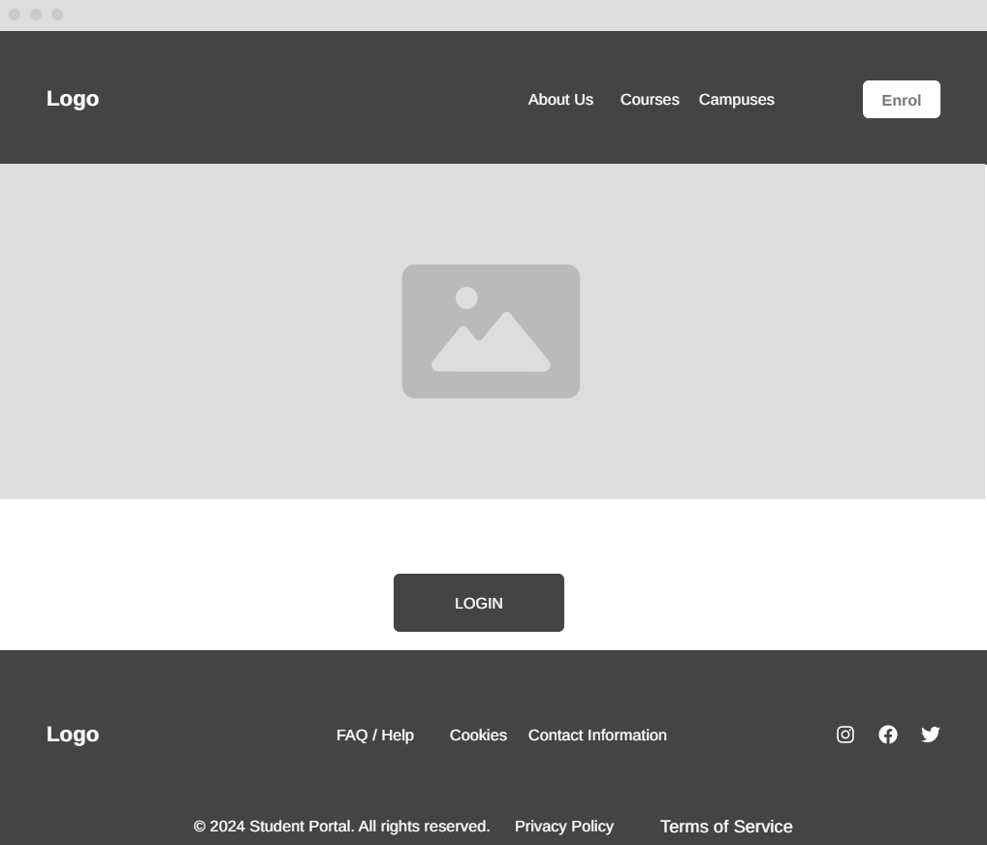
Figure 2 Landing Page Wireframe.
The layout is divided into three columns: leaderboard (left), quick links (centre: Calendar, Deadlines, Points & Badges, Lecturers), and personal notes (right). All pages use clear labelling, consistent colours/fonts, hover states, and responsive design for accessibility and keyboard navigation.

Login Page:
The Login Page provides secure access for both students and lecturers. The form is centred on the page and includes fields for email/username and password. The portal logo is displayed above the form to reinforce branding.
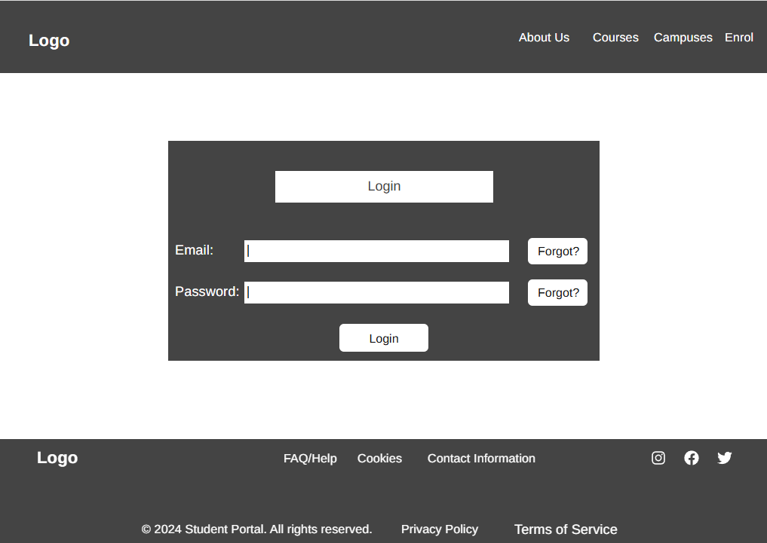
Figure 3 Loging page wireframe
User interactions are straightforward, valid credentials will redirect the user to the Home Dashboard, while invalid credentials will trigger error messages. Form fields are explicitly labelled for clarity, and visual contrast.

Home Page:
The Home Dashboard gives students an overview of their portal activity, including courses, tasks, points, badges, upcoming deadlines, and the student leaderboard to encourage gamification.
The header contains the portal logo (left), primary navigation links (Messages, Courses, Tasks, Grades), a “Resources” dropdown for external links, and a user icon (right) which opens the Profile/Settings page, as well as a notification button which displays a users notifications.
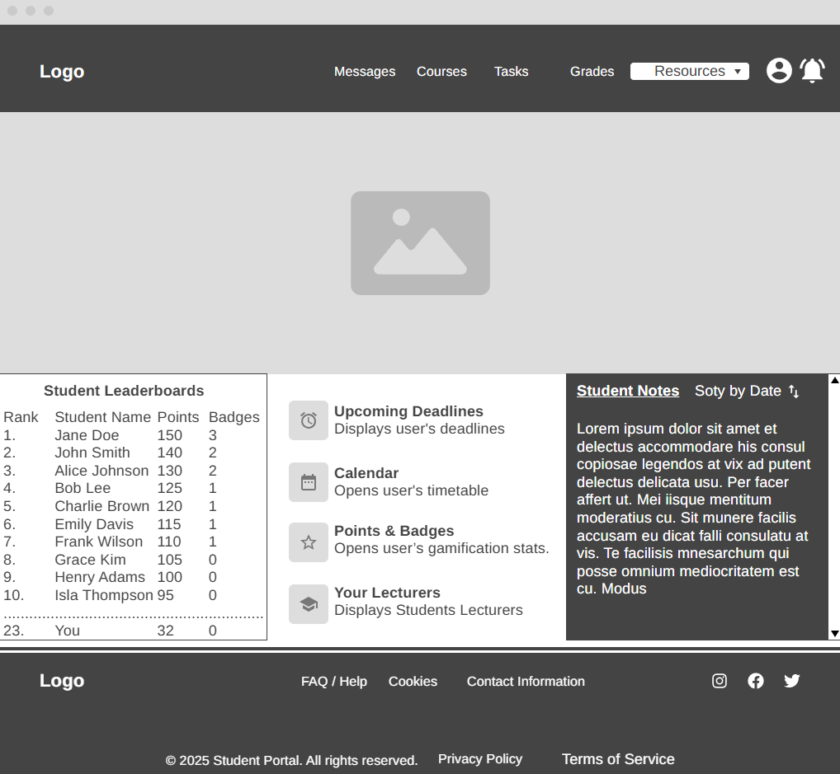
Figure 4 Dashboard wireframe
The main body is divided into three sections:
- Left: Student leaderboard displaying top performers.
- Centre: Quick links panel including Calendar, Upcoming Deadlines, Points & Badges, and Your Lecturers.
- Right: Personal Notes section where students can create checklists or reminders.

Messages Page:
The Messages Page allows students to view chat histories and engage in one-to-one messaging. The header remains consistent with the Home Dashboard for familiarity.
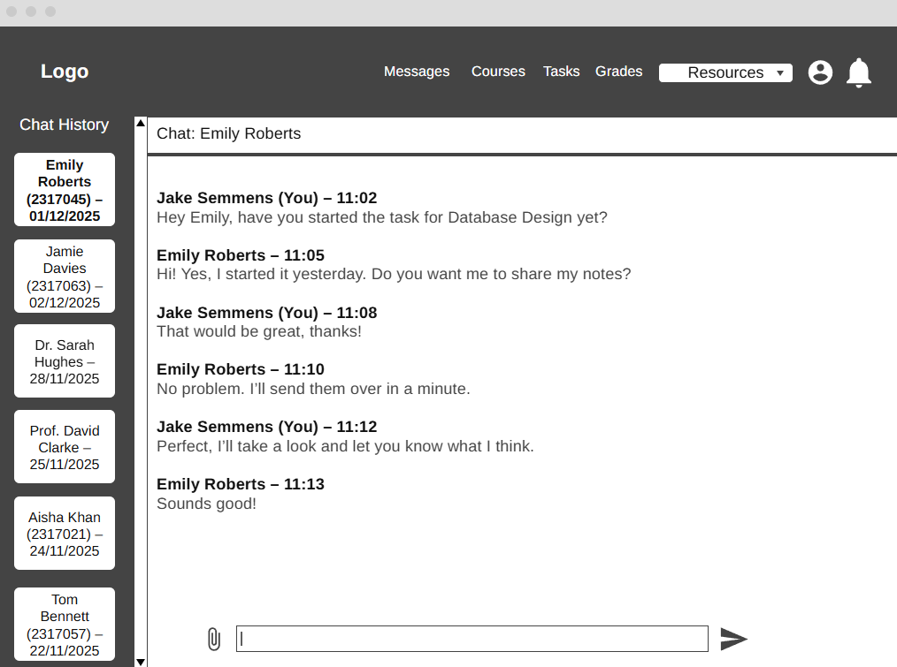
Figure 5 Messaging page wireframe
The left-hand panel displays scrollable chat history, showing recent conversations with contact, including the contact name, date, and timestamp of the last message. The main body displays the selected chat, usernames and timestamps. Users can type new messages in a text input area, with support for attachments such as images or documents.

Profile Page:
The Profile Page enables students to view and edit personal information, manage gamification elements (points and badges), and update account settings.
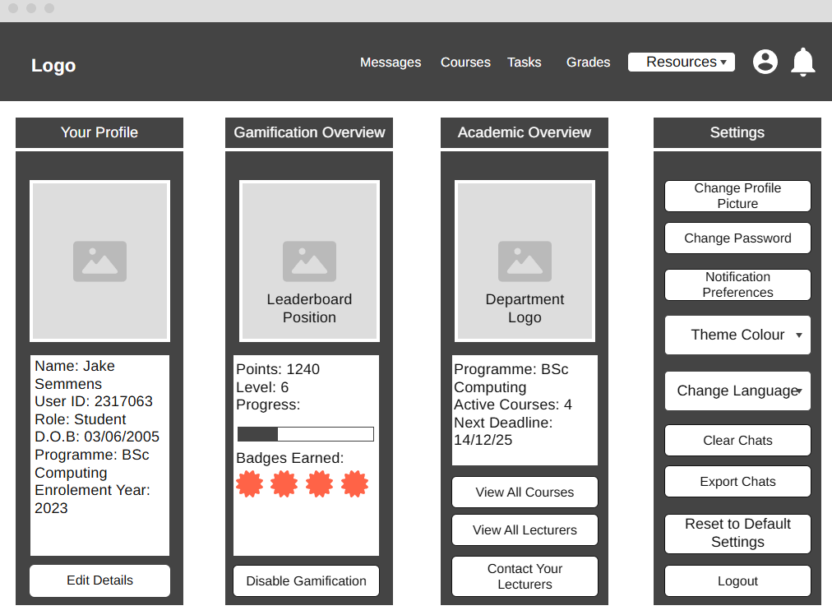
Figure 6 Profile page wireframe
The page includes a profile summary section displaying the user’s name, enrolment information, program, and profile picture. Below this, gamification elements are presented, showing accumulated points, earned badges, and progress in tasks. Settings options include updating the profile picture, changing the password, and toggling language preference between English, Welsh and a variety of other languages.
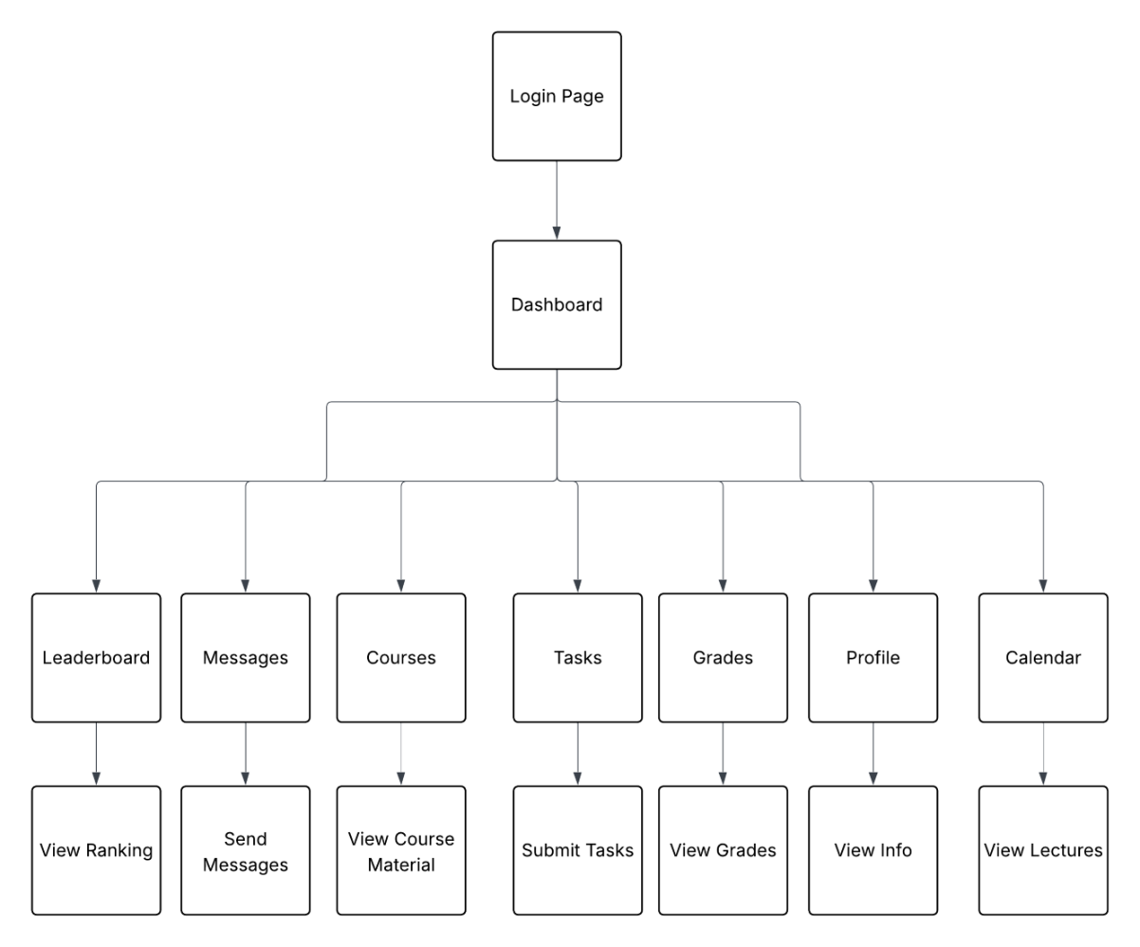Figure 49 Workflow diagram

4.1.3 Back End Design (Data Tier)
The back end of the student portal has been designed to manage and store all core information required by both students and lecturers. This includes user accounts, course data, tasks, grades, messaging, gamification elements such as points and badges, notifications, and course materials. The database design follows a relational model to ensure data integrity, maintainability, and scalability, while supporting the functional requirements of the system.
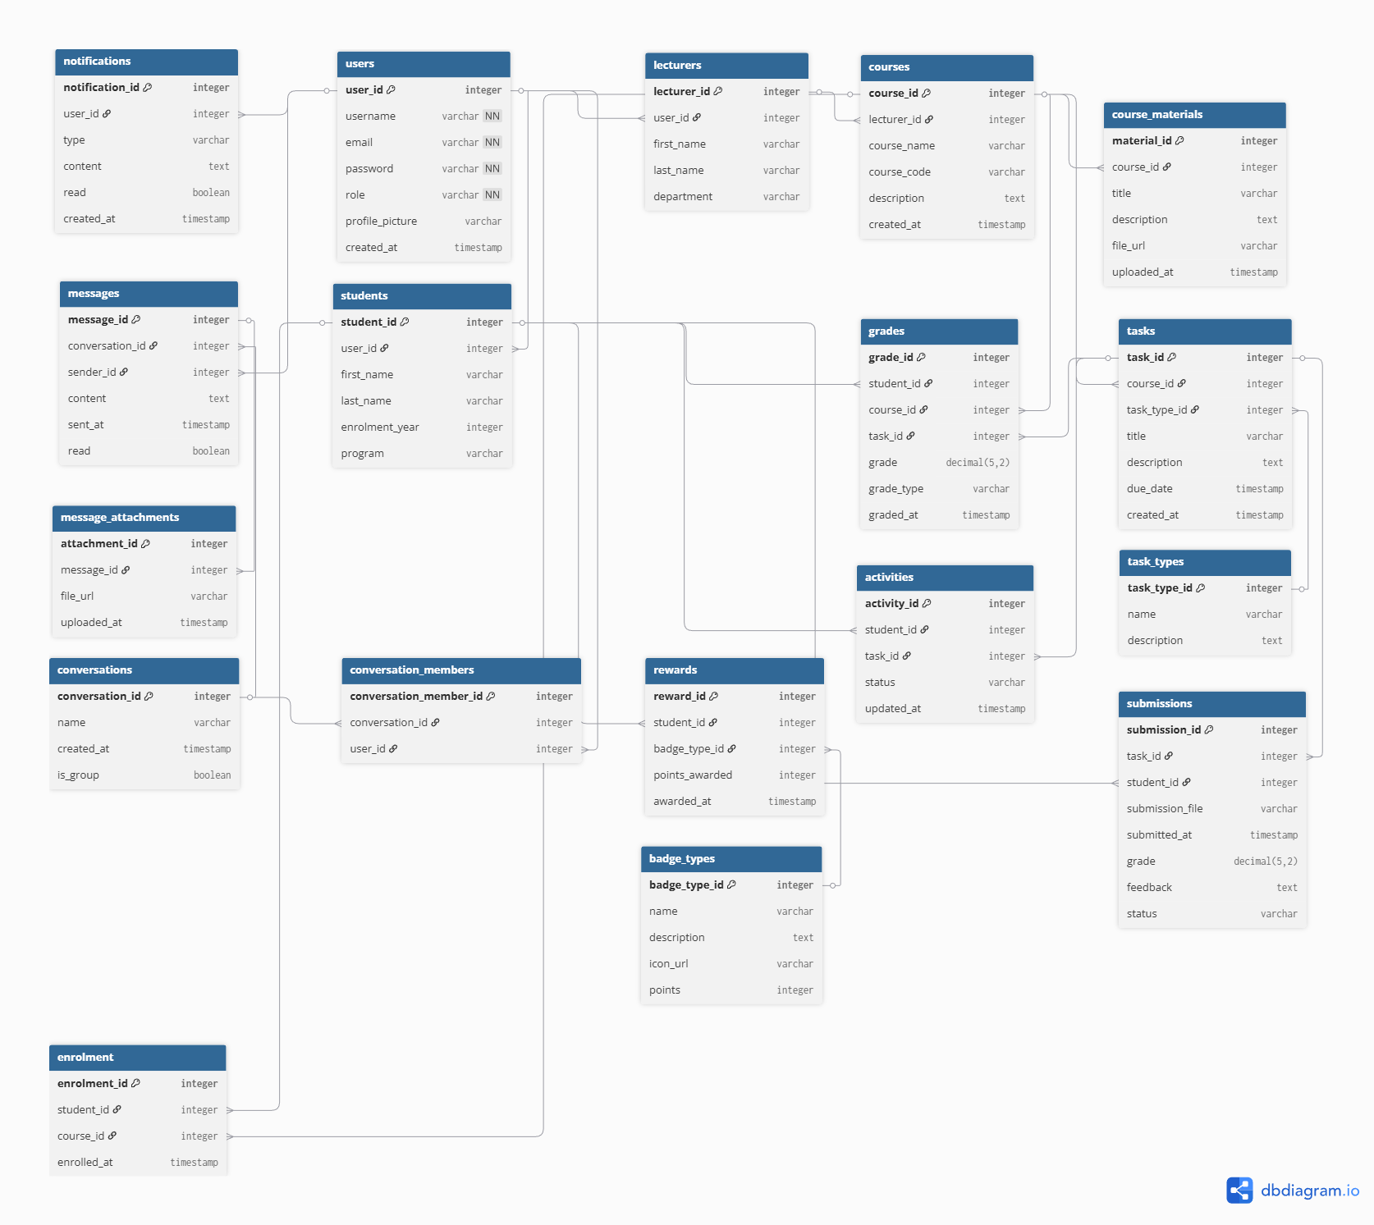Figure 7 Database Schema showing tables, relationships, primary keys, and foreign keys
At the centre of the design is the users table, which stores basic account information including username, email, password, role, profile picture, and creation timestamp. The role field allows the system to distinguish between students and lecturers, enabling the correct access permissions for each user type. The students and lecturers tables extend this core user information, storing additional details such as full name, enrolment year, program of study for students, and department affiliation for lecturers. This separation ensures that role-specific information is stored efficiently without redundancy.
Course information is maintained within the courses table, with each course linked to a lecturer through a foreign key relationship. Students are linked to courses via the enrolment table, enabling many-to-many relationships between students and courses. Associated with courses are tasks, which represent assignments, exams, or projects, and are categorised using the task_types table. Students’ progress on these tasks is tracked in the submissions table, which stores submitted content and timestamps, while the grades table records assessment results alongside the type of grade (e.g., assignment, exam). This separation of tasks, submissions, and grades supports flexible tracking and reporting of academic performance.
The messaging system is implemented using conversations, conversation_members, messages, and message_attachments tables. Conversations allow both one-to-one and group messaging, while conversation_members defines which users participate in each conversation. Individual messages are stored in the messages table, with optional file attachments referenced in message_attachments. This design ensures that messaging is scalable and supports multimedia content while maintaining a clear relational structure.
Gamification elements are captured in badge_types and rewards tables. Badge_types defines the different types of achievements students can earn, such as completing a module or achieving a high grade. The rewards table tracks the points awarded to students and the badges they have earned, linked to their student ID. This design allows the system to easily extend gamification elements in the future without redesigning the database.
Finally, course_materials enables lecturers to upload content for students, such as lecture slides, reading materials, or supplementary resources. This table is linked to courses and stores metadata such as file type, filename, and upload timestamp.
The database schema, demonstrates all primary entities and their relationships, highlighting foreign key constraints, one-to-many and many-to-many relationships, and optional fields where appropriate. This relational design ensures data consistency, supports all functional requirements of the student portal, and can accommodate future expansions, such as additional gamification elements or extended messaging features.

4.1.6 Logo
The logo for Athena SP is a modern yet historic design that combines symbolic representation with clean, professional aesthetics to reflect the platform's focus on wisdom, education, and achievement.
Figure 48 AthenaSP Logo
The logo features a circular emblem with an owl, which is the traditional symbol of Athena, the Greek goddess of wisdom. The owl is depicted wearing a Corinthian helmet and holding a spear, both of which are both attributed to Athena. The owl sits upon a classical Greek column (representing Greek pillars of knowledge), flanked by olive branches symbolising Athena's gift of the olive tree [42].
The emblem is enclosed in a navy-blue circular border with a gold inner rim, creating a badge-like, prestigious appearance. To the right of the emblem, the wordmark "AthenaSP" appears in bold:
- "Athena" is rendered in deep navy (#0B1D3F) for wisdom,
- "SP" is highlighted in rich gold (#D4A017) to emphasise distinction and achievement.
The logo is designed to be instantly recognisable, memorable, and symbolically aligned with the platform's identity.
Overall, the Athena SP logo successfully bridges ancient symbolism with modern educational needs. It creates an immediate sense of purpose and quality, reinforces brand recognition, and motivates users by associating learning with wisdom and achievement, making it highly appropriate for a student-focused, gamified learning portal.

4.1.5 Colour Scheme
The colour scheme for AthenaSP draws inspiration from the Greek goddess Athena, symbolising wisdom, achievement, and clarity. It combines her traditional mythological palette of deep navy blue, gold, and neutral tones [42] with modern usability and accessibility best practices. The design prioritises a clean, professional, and calming aesthetic suitable for extended academic use.
The colour scheme is implemented in the project's style.css file through CSS custom properties (CSS variables) defined in the root selector. This approach ensures consistency across all components and simplifies future modifications. The primary colours are as follows:
Neutral foundation:
- --color-bg: #FFFFFF (pure white) – used as the main page background.
- --color-card: #F8F9FC (very light cool grey) – applied to cards, panels, chat sidebars, headers, and secondary sections to provide subtle depth and an uncluttered appearance.
- --color-border: #E2E8F0 (soft cool grey) – used for borders and dividers to create gentle visual separation.
- Text colours:
- --color-primary: #0B1D3F (deep navy) – primarily used for headings and important text.
- --color-text: #0F172A (slightly softer dark slate) – used for body content, ensuring excellent readability and reduced eye strain during long study sessions.
Accent colour:
- --color-accent: #D4A017 (rich gold) – applied to interactive and motivational elements, including navigation links on hover/active states, buttons, badges, progress indicators, sent messages, and the prominent 5px gold border on the navbar. Additional gold variants (--color-gold-1) and metallic tones for leaderboard rankings (--color-silver and --color-bronze) enhance gamification elements.
Additional supporting variables include subtle shadows (--shadow-sm and --shadow-md) that use the primary navy tone with low opacity for depth, and a consistent border radius (--radius: 12px) and smooth transitions (--transition).
Overall, the navy-and-gold palette is highly effective for an educational platform. The high-contrast combination of dark text on white and light grey backgrounds exceeds WCAG 2.1 AA accessibility requirements, supporting users with visual impairments and ensuring legibility in various lighting conditions. The restrained use of a single warm gold accent creates clear visual hierarchy and draws attention precisely where needed (e.g., interactive elements and rewards), without causing visual fatigue. The predominantly neutral base promotes cognitive calm and reduces mental load, making the scheme particularly suitable for prolonged student engagement.

4.1.6 Font Scheme
The portal employs a thoughtful and consistent font scheme to enhance usability, accessibility, and engagement. The typography is deliberately neutral and minimalist, prioritising exceptional legibility and a calm, professional appearance that complements the restrained colour palette while supporting extended use in an educational context.
Inter was selected for its balanced proportions, excellent screen readability, and extensive glyph support. Specific usage across the interface includes:
- Headings: Inter Bold (weight 700) or Semi-Bold (weight 600), with sizes ranging from 3.5rem (hero h1) down to 1.3–1.65rem for section titles. Clear hierarchy is established through font weight and scale rather than dramatic contrast.
- Body Text: Inter Regular (weight 400) at a comfortable 1rem–1.1rem base size, with a generous line height of 1.6 and appropriate paragraph spacing for fatigue-free reading during long study sessions.
- UI Elements (buttons, labels, navigation links, form inputs): Inter Medium (weight 500) or Semi-Bold (weight 600) at 0.95rem–1.15rem to distinguish interactive components while preserving overall neutrality.
The fallback stack ensures consistent rendering across platforms even if Inter fails to load. This scheme was chosen for several reasons:
- Neutral sans-serif fonts like Inter are widely recommended for digital educational platforms due to their superior on-screen clarity and lack of distracting details
- The restrained weight range (400–700) maintains visual calm and pairs seamlessly with the navy-and-gold colour palette; larger base sizes and open line heights enhance readability for all users, including those with visual impairments
- Inter’s extensive language support ensures flawless rendering for bilingual features without substitution issues.
All text meets WCAG 2.1 AA guidelines for contrast and resizeability (up to 200% without loss of content or functionality). This cohesive typography contributes to a professional, inclusive, and distraction-free user experience aligned with the project's objectives.

5 - Implementation
The development of the AthenaSP interactive student portal involved translating the wireframes, database schema, and requirements defined in the design chapter into a fully functional PHP/MySQL web application. Visual Studio Code served as the primary IDE, with XAMPP providing the local Apache web server and MariaDB database environment. Development followed an iterative approach, starting with core infrastructure (authentication and dashboard) before progressively adding complex features such as the messaging system, gamification elements, and bilingual support.

5.1 User Authentication and Session Management
Secure login and session management are fundamental to any educational portal. A unified login page was implemented to support both students and lecturers, with role-based access control enforced thereafter.
The login.php script manages authentication using prepared statements and the password_verify() function for secure password validation. Upon successful login, user details and role information are stored in session variables. A central authentication check was placed at the top of all protected pages to prevent unauthorised access.
Figure 8 shows the key parts of the login implementation.
Early testing revealed that users could bypass restrictions through URL manipulation. This vulnerability was addressed by implementing a robust central authentication mechanism used across the dashboard and all protected pages. This approach provides a secure yet accessible entry point while consistently enforcing role differentiation throughout the system. Figure 9 shows role-based access and session authentication
Figure 10 shows the final login page
This implementation provides a secure and accessible entry point while successfully enforcing role-based access throughout the system.

5.2 Messaging System
Real-time messaging is a vital element of the student portal. It allows students and lecturers to communicate securely within the platform rather than relying on external applications.
Figure 11 shows how the messaging data is retrieved from the backend
When a user visits messages.php, a complex prepared statement retrieves their conversations along with the latest message preview using GROUP_CONCAT and subqueries. Selecting a conversation triggers an AJAX request via messages.js to load_chat.php, which dynamically loads the full message history and renders it as timestamped message bubbles with attachment support. Sending messages and attachments is handled securely in send_message.php with validation, upload processing, and database transactions.
Figure 12 shows the working messaging interface.
The completed messaging system closely follows the design wireframe, with a scrollable chat sidebar, dynamic real-time-like message loading, attachment support, and group chat functionality. The result works exactly as expected.
Figure 13 shows the messaging from the users view

5.3 Gamification – Points, Badges, and Leaderboard
Gamification is a central feature of the student portal designed to increase student motivation and engagement through points, badges, and a public leaderboard. The gamification system adopts a hybrid approach, supporting both automatic and manual awarding of points.
The manual awarding of points and badges is handled in award_points.php. When the form is submitted, the code checks whether points, a badge, or both should be awarded. This code uses prepared statements for security, conditionally inserts records into the appropriate tables, records who awarded the points/badge, sends a notification to the student, and uses a transaction to ensure data consistency.
Figure 14 shows the manual points and badge awarding code.
The automatic awarding of points is handled using features such as attendance tracking. For example, when a lecturer marks a student as present, the code checks whether this is a new attendance record. If so, it awards 10 points, records the reason, and sends a notification to the student.
Figure 15 shows the automatic awarding of points
The leaderboard on the dashboard displays the top 5 students and includes the current user even if they are outside the top 5.
Figure 16 shows the student leaderboard
The main query fetches the top 5 students using an aggregate SUM on points with GROUP BY and ORDER BY. It then checks if the current user is in the top 5. If not, a second query calculates the user’s total points and a third query determines their exact rank by counting how many students have more points. The HTML table is dynamically generated with a highlighted row for the current user.
Figure 17 shows parts of the leaderboard implementation code
The completed gamification system works exactly as expected and successfully encourages engagement through visible progress and recognition.

5.4 Bilingual Support
Bilingual and multilingual support was implemented using the Google Translate widget. This feature was integrated across multiple pages to allow users to easily switch between English, Welsh, and other languages.
Figure 18 shows the Google Translation widget implementation code
This code loads the Google Translate widget, configures it to support Welsh and various other languages, and places a simple translation dropdown on the page. It was added to improve accessibility and inclusivity as specified in the design requirements.
Figure 19 shows the translation widget functioning

5.5 Challenges
The development of AthenaSP presented several technical and design challenges that required significant problem-solving and iterative refinement.
One of the earliest security issues was ID parameter manipulation. Users could initially access another student’s or lecturer’s module view simply by changing the module_id value in the URL. This vulnerability was resolved by implementing slug-based URLs. This solution not only eliminated the security risk but also resulted in cleaner and more user-friendly URLs.
The messaging system also presented notable difficulties. In the initial implementation, users had to manually refresh the page to see new messages, which disrupted the intended real-time experience and negatively affected usability. This was addressed by implementing AJAX polling (every 2 seconds) in messages.js, which automatically checks for and loads new messages without requiring a full page reload. Additional challenges with AJAX session expiry and secure file attachment handling were resolved through improved session management and strict upload validation.
A significant design challenge emerged from the decision to build the website using a desktop-first approach. While this made the initial development of complex layouts (such as the messaging interface and dashboard) easier, it created considerable difficulties when adapting the site for mobile devices. Many components required extensive rework of CSS, Flexbox layouts, and media queries. This experience highlighted the advantages of a mobile-first design strategy for modern educational platforms, where students frequently access systems via smartphones.
These challenges, while time-consuming, provided invaluable learning opportunities in secure web development, performance optimisation, output control, responsive design principles, and realistic deployment testing. Overcoming them resulted in a significantly more robust, secure, and user-friendly final system.

5.6 Acceptance Testing Results
The acceptance testing results, shown in Appendix 1, display a table of all the tests conducted relating to each major feature. These tests acted as requirements or acceptance criteria for the feature to be considered complete and were referred to throughout the entire development process.
All high-priority features, including role-based access, messaging, assignments & grading, gamification, and bilingual support, passed acceptance testing successfully. One lower-priority feature (full email-based password recovery) was intentionally left as a placeholder due to local XAMPP hosting constraints. Using structured acceptance testing helped ensure the final system was well tailored to user needs.

5.7 Conclusion
In conclusion the design and implementation of the interactive student portal AthenaSP has been a success. The majority of the required features have been implemented, tested, and meet the acceptance testing criteria found in the appendix.
Key challenges such as secure role-based authentication, complex real-time messaging with file attachments, gamification (both automatic and manual awarding), dynamic leaderboard functionality, and multilingual support were successfully overcome through careful use of prepared statements, AJAX interactivity, and modular code structure within the constraints of a local XAMPP environment.
The implementation leaves many opportunities for further research and enhancement, such as cloud deployment, full email integration, and expanded lecturer tools for assignments and grading.

6. Analysis

6.1 Introduction to the Analysis
This chapter analyses the data collected during the evaluation of AthenaSP, drawing on both quantitative and qualitative sources to provide a balanced assessment of the prototype’s usability, engagement, functionality, and overall user satisfaction. The findings are presented by method for clarity: first the survey results, followed by structured observations, and then insights from semi-structured interviews conducted with the same participants. This sequential mixed-methods approach allows broad perceptual trends identified in the survey to be explored and explained through direct behavioural evidence and reflective feedback.
All raw data (survey responses, observation notes, and interview recordings/transcripts) have been securely stored on a password-protected device accessible only to the researcher. In line with ethical guidelines and data protection principles, all personal data has been fully anonymised. To preserve confidentiality, the five participants involved in the observation and interview phases are referred to anonymously as Participant A through Participant E.
The primary focus of this chapter is to present the collected data clearly, supported by tables, charts, and representative quotes, while interpreting patterns and linking them back to the literature review and project objectives.

6.2 Analysis of the Survey Results
The survey, completed by 15 participants, was structured into three main sections: (1) user background and prior experience with learning platforms, (2) experiences with existing university tools, and (3) perceptions of AthenaSP, including its gamification features. It combined Likert-scale questions (1 = Strongly Disagree to 5 = Strongly Agree) with open-ended items to capture both measurable trends and richer qualitative insights.

6.2.1 Demographic Profile of Survey Respondents
To provide context for the survey findings, this subsection describes the demographic and background characteristics of the 15 undergraduate and postgraduate participants. Understanding the sample composition is essential, as it influences the transferability of perceptions regarding AthenaSP and gamified learning platforms.
The respondents were distributed across different academic levels, with the majority in later stages of study. As visualised in the pie chart below, there is a skew towards more advanced students (3rd year and graduates combined = 73%). This may reflect greater familiarity with academic tools among senior students, potentially leading to more critical or nuanced feedback on platform usability and engagement.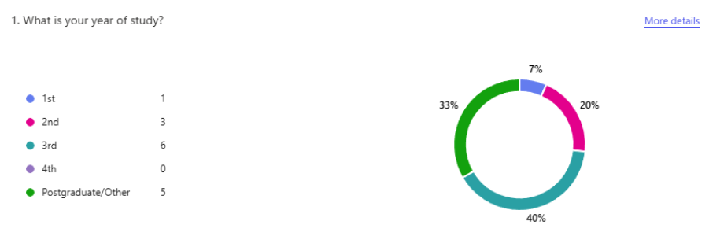Figure 20 shows the results of the 1st question from the survey
The largest areas of study/industry were Law (most frequent), followed by Business Studies and Cybersecurity. Other fields were represented less prominently. A word cloud representation effectively illustrates the relative emphasis on these disciplines, with "Law" appearing as the most dominant term.
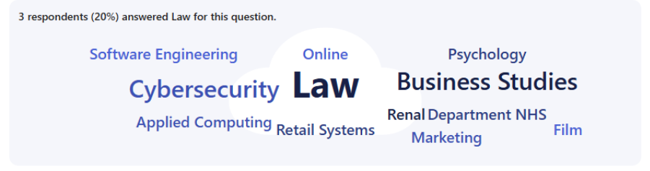Figure 21 shows the results of the 2nd question from the survey
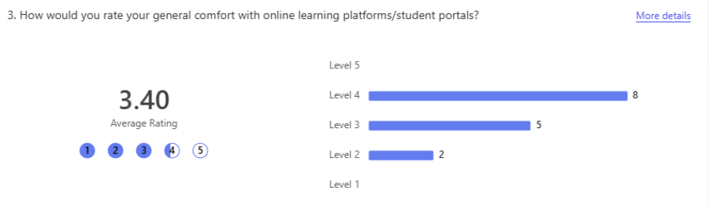Figure 22 shows the results of the 3rd question from the survey
Participants rated their general comfort level with online learning platforms on a 5-point scale (1 = Not comfortable at all, 5 = Very comfortable). The average score was 3.40, indicating moderate-to-good overall comfort. This is shown in the bar chart below.

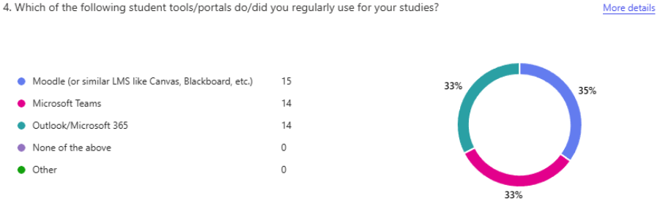Figure 23 shows the results of the 4th question from the survey
All 15 participants had used Moodle at some point. Fourteen had also used Microsoft Teams and Microsoft 365, while one participant reported experience only with Moodle. This high exposure to mainstream tools provides a strong baseline for comparing AthenaSP.
Overall, the sample consisted of predominantly later-year students and graduates from law-related, business, and cybersecurity fields, with solid prior experience in online learning environments. This profile supports the relevance of their feedback on AthenaSP and its features.

6.2.2 Survey Results by Question
The survey questions are analysed below, grouped thematically for clarity and efficiency where items address closely related concepts (e.g., fragmentation/strain, gamification motivation). Each group includes the question(s), brief distribution notes, and an Analysis & Links paragraph.

6.2.2.1 Usability & Integration of Existing Tools
Questions:
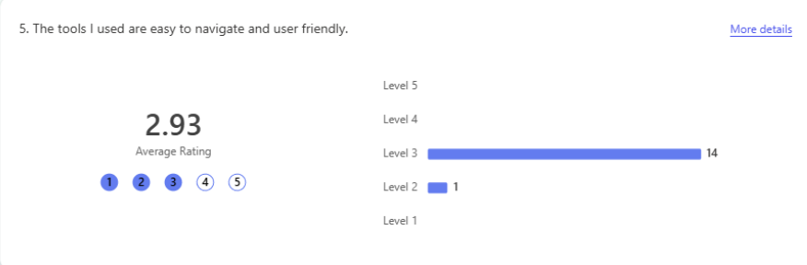Figure 24 shows the results of the 5th question from the survey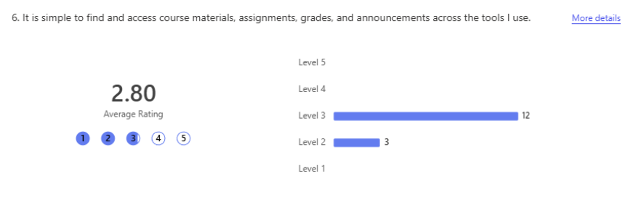
Figure 25 shows the results of the 6th question from the survey
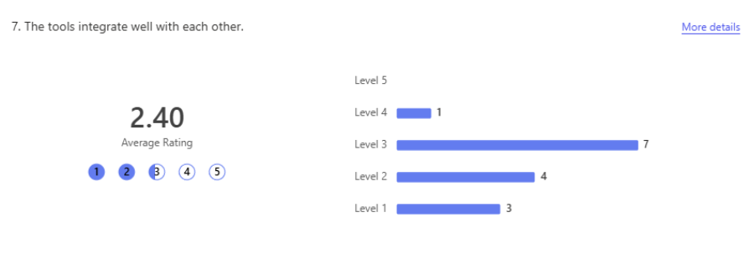
Figure 26 shows the results of the 7th question from the survey
Results: Means = 2.93 (navigation), 2.80 (access), 2.40 (integration). Responses clustered around 2–3 (neutral to mild disagreement).
Analysis & Links: These low-to-neutral scores reveal clear dissatisfaction with navigation, content access, and cross-tool integration in current platforms. This matches the literature review's emphasis on persistent usability problems in student portals, such as interface complexity, poor navigation paths, and inconsistent layouts [18] and fragmented systems increasing cognitive load [22]. The findings confirm the need for AthenaSP's centralised approach, supporting the project's aim to reduce these barriers and improve efficiency.

6.2.2.2 Fragmentation, Strain & Stress from Multiple Platforms
Questions:
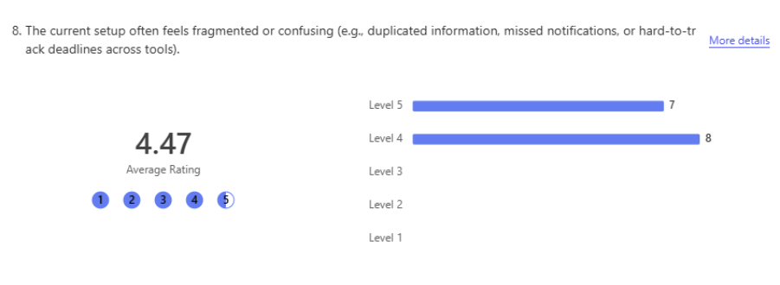Figure 27 shows the results of the 8th question from the survey
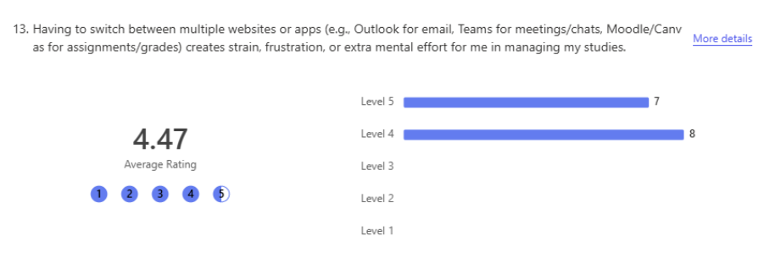Figure 28 shows the results of the 13th question from the survey
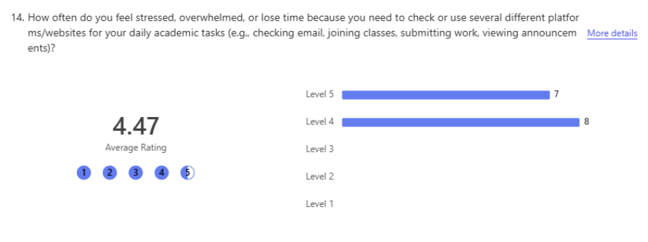Figure 29 shows the results of the 14th question from the survey
Results: Means = 4.47 for all three items. Strong agreement (mostly 4–5 responses).
Analysis & Links: These items received the highest agreement in segment 2 of the survey, confirming that fragmentation and tool-switching cause significant confusion, strain, and stress. This strongly supports the literature review's observations on siloed systems leading to cognitive overload and reduced efficiency, as well as the app carouse problem in communication tools. The results directly validate AthenaSP's core design goal of centralisation to eliminate these issues.

6.2.2.3 Effectiveness of Individual Tools (Teams, LMS, Outlook, Reminders)
Questions:
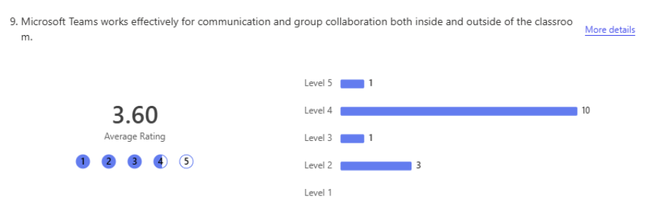Figure 30 shows the results of the 9th question from the survey
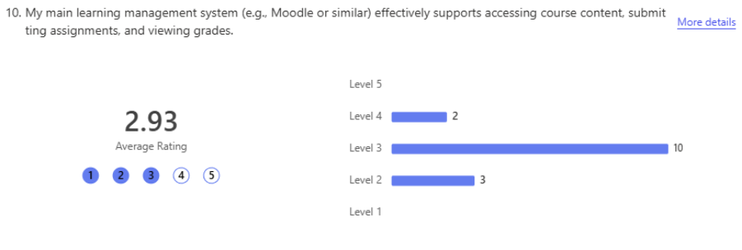Figure 31 shows the results of the 10th question from the survey
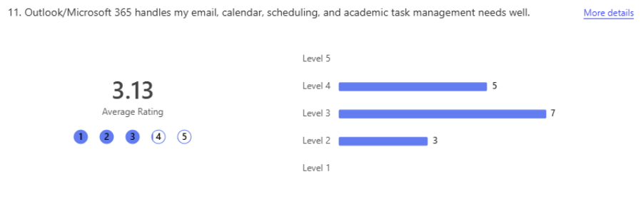Figure 32 shows the results of the 11th question from the survey
Results: Means = 3.60 (Teams), 2.93 (LMS), 3.13 (Outlook), 2.47 (reminders). Mild agreement for Teams; neutral to disagreement for others.
Analysis & Links: Teams performed best for collaboration, likely due to its real-time strengths, while reminders and LMS support scored lowest. This pattern aligns with the literature review's discussion of uneven functionality across tools, where modern real time messaging platforms like Teams exceling in immediacy but traditional LMS lack reliable notifications and integration [9][10]. The findings highlight gaps that AthenaSP addresses through unified features, supporting the objective to improve consistency and reduce reliance on fragmented third-party apps.

6.2.2.4 Centralisation Benefits of AthenaSP
Questions:
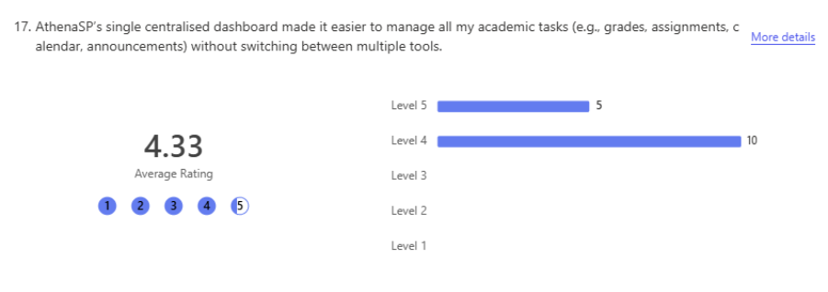Figure 33 shows the results of the 17th question from the survey
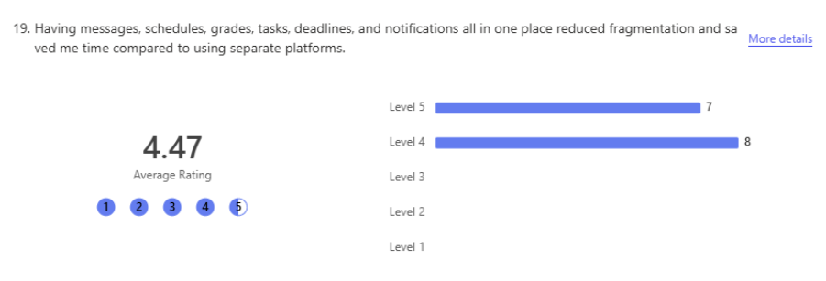Figure 34 shows the results of the 19th question from the survey
Results: Means = 4.33 (dashboard ease), 4.53 (reduced fragmentation). Strong agreement.
Analysis & Links: Participants strongly endorsed AthenaSP's centralisation as solving the fragmentation and strain issues identified earlier. This aligns with the literature review's emphasis on unified platforms reducing cognitive load and improving efficiency [22][24], as well as integrated communication enhancing engagement [10]. The high scores validate the project's objective to create a cohesive system that outperforms separate tools.

6.2.2.5 Messaging Integration in AthenaSP
Questions:
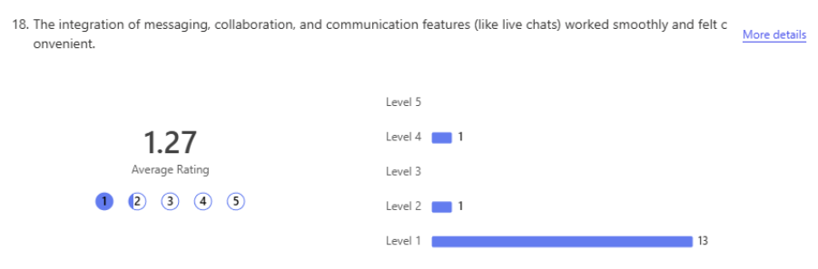Figure 35 shows the results of the 18th question from the survey
Results: Mean = 1.27 (strong disagreement). 13/15 rated 1; one 2 and one 4.
Analysis & Links: The extremely low score reflects a critical technical issue: the messaging system did not function at all for nearly all participants. Because the survey prototype was hosted on InfinityFree (which explicitly prohibits live or real-time chat/messaging features on free accounts), the feature failed completely during testing. This external hosting constraint prevented participants from experiencing the intended live chat and collaboration capabilities, leading to the overwhelmingly negative rating. In a production environment with proper hosting, the messaging implementation would be expected to perform normally. This limitation was specific to the survey/demo setup and does not reflect the underlying quality of the messaging code or the portal's overall design.

6.2.2.6 Gamification Elements in AthenaSP
Questions:
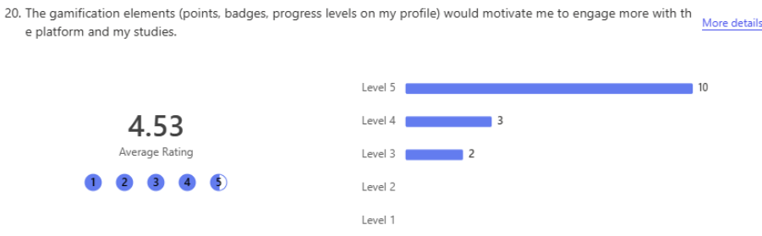Figure 36 shows the results of the 20th question from the survey
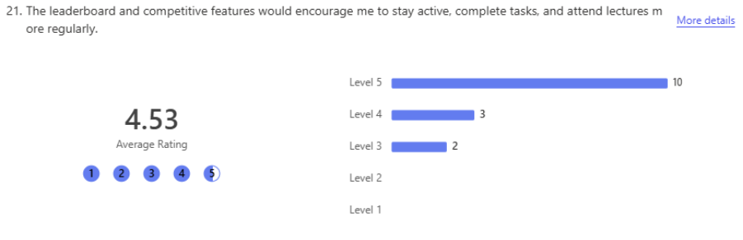Figure 37 shows the results of the 21st question from the survey
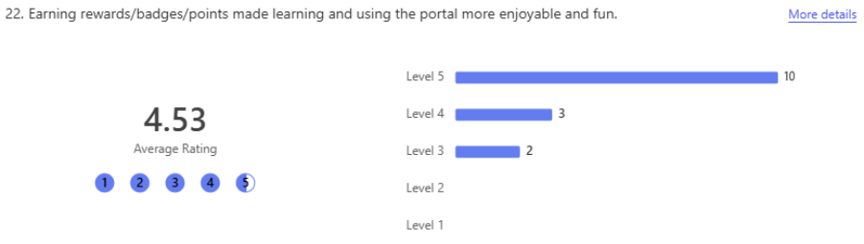Figure 38 shows the results of the 22nd question from the survey
Results: Means = 4.53 for all three. Very strong agreement (mostly 5s).
Analysis & Links: Gamification received consistently high praise, confirming that points, badges, and leaderboards significantly increased motivation, activity, and enjoyment. This strongly supports the literature review's discussion of gamification's benefits, grounded in self-determination theory and flow theory [40][41], where such elements enhance intrinsic/extrinsic motivation and engagement. The near-maximum scores align with expectations and validate the project's inclusion of these features to address low motivation in existing tools.

6.2.2.7 Usability, Preference & Recommendation of AthenaSP
Questions:
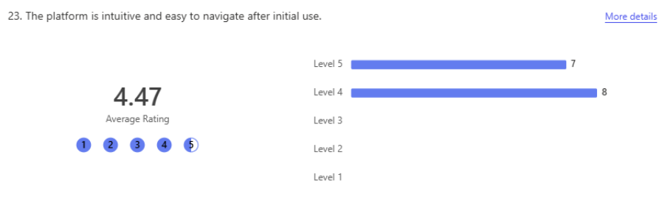Figure 39 shows the results of the 23rd question from the survey
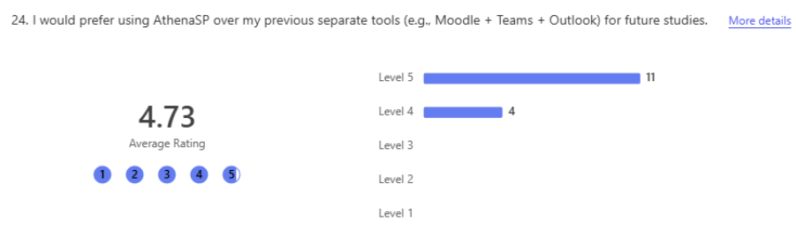Figure 40 shows the results of the 25th question from the survey
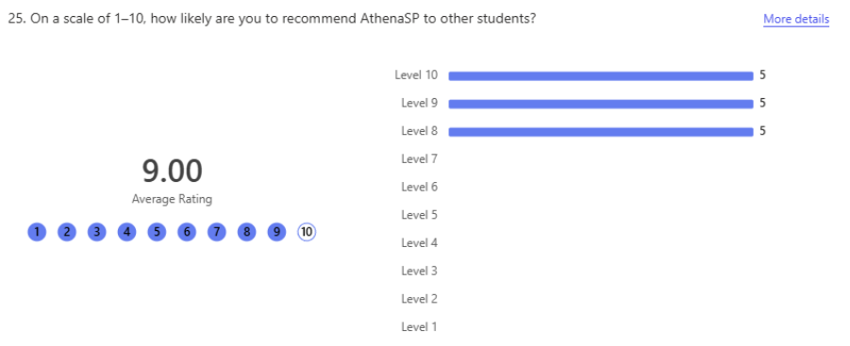Figure 41 shows the results of the 25th question from the survey
Results: Means = 4.47 (intuitive navigation), 4.73 (preference). Recommendation mean = 9.00 (distribution: five 8s, five 9s, five 10s;).
Analysis & Links: High agreement on navigation and very strong preference for AthenaSP demonstrate excellent perceived usability and overall value, despite the messaging issue. The exceptionally high recommendation score (mean 9.0) reflects enthusiasm for centralisation and gamification. These results link directly to the literature review's focus on UX as a predictor of adoption and satisfaction (Section 5) [19][23], and confirm the project's success in creating a more engaging, efficient portal compared to fragmented existing systems.

6.3 Analysis of the Observation Results
This section presents the findings from the structured observation phase, which involved five participants (anonymised as Participant A through Participant E) performing a set of predefined tasks on two platforms: the developed prototype AthenaSP and the existing UWTSD HWB Student Portal. The observation was designed to complement the survey data by capturing objective behavioural evidence of usability, task efficiency, and user interaction patterns, rather than relying solely on self-reported perceptions.
The five participants were drawn from the same pool as the survey respondents. Each participant completed the same sequence of core tasks on both platforms in a controlled environment, with the order counterbalanced where possible to reduce learning effects. Tasks were selected to represent typical student activities and to directly test AthenaSP's key features.

6.3.1 Overview of the Observation
This section analyses the structured observation phase, involving five participants who completed predefined tasks on two platforms: the AthenaSP prototype and the existing UWTSD HWB Student Portal. The aim was to gather objective behavioural data on usability, task efficiency, and interaction patterns to complement the survey findings.
Participants performed the same set of core tasks on both platforms in a controlled setting, with task order counterbalanced. A variety of tasks were carried out on each platform with gamification and other features unique to AthenaSP only carried out on that portal.
Each task was timed, and the observer recorded success rate, completion time, errors, and observable behaviours using a consistent checklist. After completing tasks on both platforms, participants answered eight open-ended questions exploring perceived ease of use, frustrations, comparisons between portals, gamification impact, emotional reactions, and improvement suggestions.

6.3.2 Key Findings from the Observations
Theme 1: Navigation Efficiency and Centralisation Participants completed core navigation tasks (login, dashboard access, module selection, content download, profile changes, notes, notifications) faster and more confidently on AthenaSP. Average time per navigation-related task was ~10–13 seconds on AthenaSP versus ~15–20 seconds on the UWTSD HWB Portal. All five showed minimal hesitation, scrolling, or back-button use on AthenaSP, flowing smoothly through sequences. On the UWTSD portal, repeated menu searching, long scrolling, and extra logins caused delays and visible frustration.
This observation strongly supports the survey's high agreement on fragmentation/strain in current tools (mean = 4.47) and AthenaSP’s centralisation reducing it (mean = 4.53). The behavioural data confirms the survey perceptions: participants moved more quickly and with less effort on AthenaSP.
Theme 2: Gamification Engagement Gamification tasks were among the fastest (5–10 seconds) and most positive on AthenaSP. All participants located and explored these features rapidly, showing smiles, quick clicks, and comments. No equivalent existed on the UWTSD portal.
This directly confirms the survey’s very high scores for gamification motivation and enjoyment (means = 4.53). The observations provide objective evidence of behavioural engagement (visible excitement and speed), adding depth to self-reported data.
Theme 3: Messaging tasks (creating group chats, sending messages with attachments) worked fully on AthenaSP when hosted on XAMPP. Participants completed them successfully, though the tasks took longer (20–35 seconds) due to the extra time needed for typing messages and locating/attaching files from the desktop. On the UWTSD portal, lecturer contact and messages were extremely slow even due to the need of opening and logging into Teams (20–30 seconds + extra logins), with some participants unable to find their lectures leading to abandoment.
This shows that the survey’s low messaging score (mean = 1.27) for the prototype was entirely linked to the failure of InfinityFree, with the local observation showing the features functioning as intended when properly hosted. The extra time for messaging is inherent to the task complexity (typing + file handling), not a flaw.
Theme 4: Post-task open-ended responses showed 100% preference for AthenaSP across all key questions: quicker (100%), easier to navigate (100%), more aesthetically pleasing (100%), less mental strain (100%), and preferred for future use (100%). Ratings: AthenaSP mean 8.6/10; UWTSD HWB mean 3.4/10. All participants used only 1 tab on AthenaSP versus 3 on UWTSD with all requiring additional logins.
This strongly reinforces the survey’s high preference (mean = 4.73) and recommendation score (mean = 9.0). Observations made preference visible in real-time behaviour (faster pace, positive reactions on AthenaSP vs. frustration on UWTSD).

6.4 Integration of Survey and Observation Findings (Highly Recommended)
The observation results strongly agree with the survey across all major dimensions. Both methods confirmed AthenaSP’s superiority in centralisation (survey means 4.33–4.53; observations showed faster navigation and fewer clicks), gamification (survey means 4.53; observations showed excitement and rapid interaction), reduced mental strain (survey agreement on fragmentation reduction; 100% observation choice of AthenaSP for less strain), and overall preference (survey mean 4.73 and 9.0 recommendation; 100% post-observation preference for AthenaSP). The mixed-methods approach reveals what one alone could not: survey responses captured strong perceptual agreement and intent to recommend, while observations provided objective proof through measurable speed gains, lower errors, visible positive behaviours (e.g., smiles during gamification), and consistent preference after hands-on use.
There are no significant contradictions. The survey’s low messaging score (mean = 1.27) reflects the hosted demo’s InfinityFree restriction, while local observation confirmed full functionality (with time added only for natural task steps like typing and file attachment).

Key mixed-methods insights:
- Centralisation delivered tangible efficiency, reduced cognitive load, and lower mental strain beyond survey agreement.
- Gamification produced clear behavioural engagement beyond self-reported motivation.
- Messaging works fully when hosted correctly — the survey low score is a hosting artefact, not a design issue.
- 100% preference for AthenaSP after real use reinforces survey intent and high NPS, showing practical superiority.
This triangulation strengthens confidence in the findings: AthenaSP’s core strengths (centralisation + gamification) are robust, with messaging viable once properly hosted.

6.5 Summary of Key Findings
The survey and observations produced highly consistent results. AthenaSP was rated and observed as significantly more usable, engaging, efficient, and less mentally straining than the UWTSD HWB Portal, with strong centralisation (survey means 4.33–4.53; faster task times, fewer errors), highly motivating gamification (survey means 4.53; visible excitement, rapid interaction), and clear preference (survey mean 4.73 and 9.0 recommendation; 100% post-observation choice across all criteria, including less mental strain).
Messaging functioned normally on local host (XAMPP) but added time due to typing and file handling; the survey’s low score (mean = 1.27) reflects the hosted demo’s InfinityFree restriction. Overall, both methods confirm AthenaSP successfully addresses fragmentation, low motivation, and mental strain in existing platforms, providing strong evidence that the prototype meets the project aims when hosting limitations are resolved.

Chapter 7 – Evaluation
This chapter evaluates the outcomes of the AthenaSP project against the five stated objectives and the overall aim. It assesses the extent to which the prototype met its intended goals, discusses how the findings align with the literature review, and reflects on strengths, limitations, and areas for improvement.
7.1 Objective One Evaluation
The first objective was to conduct a comprehensive literature review on student portals, communication technologies, gamification, and user experience to identify good practices and research gaps. This objective was fully achieved. The review examined the evolution of digital portals, the challenges of fragmented tools, the motivational potential of gamification, and key UX and security considerations. It provided a solid theoretical foundation that directly shaped the design of AthenaSP, particularly the emphasis on centralisation, secure messaging, bilingual support, and gamification elements grounded in Self-Determination Theory [40] and Flow Theory [41]. The identification of clear research gaps, especially the limited integration of messaging and gamification in a single platform, has justified the focus of this project.

7.2 Objective Two Evaluation
The second objective was to design and implement a functional prototype integrating secure messaging, reward points, and interactive navigation. This objective was successfully met. Detailed wireframes, a relational database schema, and comprehensive requirements specifications guided the development. Using PHP, MariaDB, HTML, CSS, and JavaScript within a local XAMPP environment, a working prototype was produced featuring role-based authentication, a responsive dashboard with leaderboard, gamification mechanics, and a functional messaging system. While most features performed as designed during local testing, external hosting constraints (InfinityFree) limited messaging functionality during the public survey. Overall, the prototype demonstrated a cohesive and user-centred integration of the core features.

7.3 Objective Three Evaluation
The third objective was to test and evaluate the system’s usability, engagement, and security. This was largely achieved through a mixed-methods approach comprising a survey and structured observations. Participants reported strong agreement that AthenaSP reduced fragmentation and mental strain, offered intuitive navigation, and that gamification significantly increased motivation and enjoyment. Observation sessions confirmed these perceptions, with users completing tasks faster, using fewer tabs and logins, and showing 100% preference for AthenaSP over the existing UWTSD HWB portal. Security features such as password hashing, prepared statements, and session management were implemented correctly. The only notable weakness was the messaging feature’s failure on shared hosting, which was a deployment issue rather than a design flaw. Overall, the evaluation provided clear evidence of improved usability and engagement.

7.4 Objective Four Evaluation
The fourth objective was to compare AthenaSP against existing university systems. This was successfully achieved through direct comparison questions in the survey and side-by-side task completion during observations. AthenaSP consistently outperformed the UWTSD HWB portal in efficiency, navigation, and user preference. Gamification features, absent in the current university system, generated visible positive engagement. These findings align with literature on the benefits of centralised platforms and gamified elements, clearly demonstrating measurable improvements in usability, reduced cognitive load, and student experience.

7.5 Objective Five Evaluation
The fifth objective was to reflect on the challenges of integrating gamification and communication tools in academic systems. This objective was met through ongoing reflection during development and explicit discussion in the evaluation. Key challenges included external hosting limitations, balancing competitive gamification elements with inclusivity, and ensuring accessibility. Participant feedback highlighted that while gamification was highly motivating, careful design is required to avoid demotivating less competitive users. These reflections reinforced literature warnings about extrinsic reward risks while confirming that thoughtful integration can deliver meaningful benefits.

7.6 Aim Evaluation
The overarching aim of the project was to design and develop an enhanced centralised student portal integrating secure messaging and gamification to improve engagement, motivation, and communication. This aim was successfully achieved. The AthenaSP prototype delivered a functional system that centralises academic activities and meaningfully enhances the student experience. Survey and observation data provided strong evidence of reduced mental strain, faster task completion, high usability, and significantly increased motivation through gamification, with 100% participant preference for the prototype. While messaging performance was constrained by hosting limitations during evaluation, local testing confirmed full functionality. The results strongly support the literature on the value of centralisation, good UX, and gamification, and demonstrate that AthenaSP offers a promising proof-of-concept for more engaging student portals.

Chapter 8– Conclusions and Recommendations
The AthenaSP project has successfully demonstrated that integrating secure messaging and gamification into a single centralised student portal can meaningfully improve student engagement, motivation, and communication while addressing many of the longstanding limitations found in current university systems. Throughout the project, a clear progression was followed from identifying problems in existing portals through to designing, implementing, and evaluating a functional prototype. The work has shown that a well-designed platform can reduce fragmentation, lower cognitive load, and create a more motivating and inclusive digital learning environment.
The literature review established a strong foundation for the project by examining the evolution of student portals, the benefits and challenges of communication tools, the theoretical underpinnings of gamification, and the critical role of user experience and privacy. It highlighted persistent issues such as static interfaces, reliance on multiple external applications, and limited use of motivational features. These insights directly shaped the design decisions for AthenaSP, particularly the emphasis on a unified dashboard, secure role-based messaging, hybrid gamification mechanics, bilingual support, and strong accessibility considerations. The review also identified important research gaps, notably the lack of platforms that successfully combine secure institutional messaging with structured gamification, which this project has begun to address.
The design and implementation phases produced a cohesive and functional prototype that closely followed the original requirements and wireframes. Built using PHP, MariaDB, HTML, CSS, and JavaScript within a local XAMPP environment, the system includes a responsive dashboard with a dynamic leaderboard, manual and automatic point awarding, a full messaging interface with attachment support, and a Google Translate widget for bilingual accessibility. Although some deployment challenges were encountered when moving to shared hosting, the core functionality performed reliably in the local development environment and met the majority of the design specifications.
Evaluation provided clear evidence of the prototype’s value. Through a combination of survey responses and structured observation sessions, participants consistently rated AthenaSP highly for usability, navigation, and motivational impact. The gamification elements were particularly effective, with users reporting increased enjoyment and a greater sense of achievement. Most significantly, every participant expressed a preference for AthenaSP over the existing UWTSD HWB portal, citing reduced mental strain from managing multiple systems and faster completion of common tasks. These findings strongly support the literature on the benefits of centralised platforms and well-implemented gamification.

8.1 Recommendations
Looking forward, several recommendations can be made to build upon the success of this project and further strengthen future iterations of AthenaSP or similar platforms. First, a more robust hosting environment should be prioritised from the beginning of development. The reliance on shared hosting during the evaluation phase restricted the full potential of the messaging system, highlighting the importance of using a VPS or university-managed server that can properly support real-time features and reliable performance under load.
Second, the messaging system would benefit significantly from an upgrade to true real-time technology. The current AJAX polling implementation worked well locally but showed limitations on shared hosting. Implementing WebSockets, for example through a library such as Ratchet, would enable instant message delivery, typing indicators, read receipts, and better overall user experience. This change would bring the communication features closer to the standards expected by modern students.
Third, future development should involve a broader range of stakeholders earlier in the process. While the current prototype is primarily student-focused, greater input from lecturers and administrators would help refine staff-facing tools, grading workflows, and administrative features, making the portal more comprehensive and institutionally useful.
Additional improvements could include expanding the gamification framework with more varied and inclusive elements, such as progress levels, collaborative team challenges, and personalised achievement paths. Careful attention should continue to be paid to inclusivity so that less competitive students are not demotivated. Integrating further tools, such as AI-powered learning assistants, video calling capabilities, dedicated group channels, and built-in document collaboration features, would help reduce students’ dependence on external platforms like Microsoft Teams, WhatsApp, and Moodle, creating an even more unified experience.
Overall, AthenaSP has proven to be a successful proof-of-concept that validates the value of combining secure messaging and gamification within a well-designed centralised portal. While certain limitations arose due to scope and hosting constraints, the project has delivered measurable improvements in student experience and has laid a strong foundation for future development. With the enhancements outlined above, this approach holds considerable potential for adoption in higher education and could contribute to more engaging, efficient, and supportive digital learning environments.

Chapter 9 – Reflection
Reflecting on the AthenaSP project, it has been one of the most challenging yet rewarding experiences of my degree. As the largest and most complex piece of work I have undertaken, it pushed me well beyond my previous capabilities and fostered significant personal and professional growth.
One of the most valuable aspects was the transition from theoretical knowledge to practical implementation. The literature review greatly deepened my understanding of student portals, gamification theories (particularly Self-Determination Theory and Flow Theory), and user experience principles. However, the real learning occurred during the design and implementation phases. Building a full-stack application with PHP, MariaDB, HTML, CSS, and JavaScript in a local XAMPP environment taught me how these technologies interact in practice. I learned the critical importance of careful planning, modular code structure, and the constant need to balance functionality, usability, and security. What looked straightforward on paper often revealed unexpected complexities during development.
A notable challenge I encountered was adopting a desktop-first approach during development. While this made the initial design of complex layouts (such as the messaging interface and dashboard) easier, it created significant difficulties later when adapting the site for mobile devices. Many components required substantial rework of CSS, Flexbox layouts, and media queries to achieve acceptable responsiveness. This experience taught me the value of mobile-first design for modern web applications, especially in an educational context where students frequently access portals on their phones.
The project also highlighted the gap between expectation and reality. For example, the messaging system performed excellently in the local environment but faced significant limitations when deployed on shared hosting. This experience taught me the vital importance of early and realistic deployment testing, rather than assuming local success would translate directly to a live environment. Similarly, while the gamification features were well received by participants, I learned that designing motivational systems requires careful consideration of inclusivity. Features that motivate highly competitive students can sometimes demotivate others, reinforcing the literature’s warnings about over-reliance on extrinsic rewards.
On a personal level, this project significantly strengthened my time management, problem-solving, and resilience. There were numerous occasions when features failed to work as planned, requiring long hours of debugging under time pressure. Overcoming these setbacks and still delivering a functional prototype greatly increased my confidence. I also developed a much deeper appreciation for iterative development and the value of user feedback. Incorporating participant input helped keep the project focused on real student needs rather than purely technical ambitions.
In hindsight, I would have approached certain aspects differently. I would have prioritised testing on a realistic hosting environment much earlier and involved lecturers in user testing from the initial design stages. These lessons will undoubtedly shape how I approach future projects, particularly regarding deployment planning, stakeholder engagement, and maintaining balance between innovation and practicality.
Overall, completing AthenaSP has been one of the most valuable experiences of my degree. It has significantly advanced my full-stack development skills, reinforced the importance of user-centred design in educational technology, and improved my ability to manage a large-scale project from initial concept through to evaluation. The successes and challenges encountered during this project will shape how I approach future work, particularly regarding early testing, deployment planning, responsive design strategy, and maintaining a balance between innovation and practicality. This project has not only enhanced my technical competence as a software engineer but has also given me greater confidence in my ability to deliver meaningful, user-focused solutions to real-world problems.

References
[1] J. Smith, "Digital Student Portals: Centralising Academic Resources," Journal of Educational Technology, 2010.
[2] Assessing and Testing the Usability of Student Portal, UUM Repository, 2016.
[3] A. Taylor, "The Limitations of Early University Portals," Computers & Education, 2014.
[4] Nigerian University Study, “Web Portal Usability Among Nigerian University Students,” 2014.
[5] S. Santosa, “Usability of E-Learning Portal and How It Affects Students’ Attitude and Satisfaction,” 2009.
[6] R. Miller and L. Wong, "Integration of Collaborative Tools in Student Portals," 2016.
[7] P. Anderson, M. Roberts, and K. Li, "Modern Student Portals: Engagement and Usability Challenges," Higher Education Review, 2018.
[8] “Evolution of Online Education Timeline,” Venngage, accessed Nov. 18, 2025. [Online]. Available: https://venngage.com/templates/infographics/evolution-of-online-education-timeline-infographic-edc1c2b8-b6ca-481e-ba2a-22406b456d26
[9]K. Costner, “My Experience with Discussion Boards,” Manchester University Teaching & Learning Blog,” 2020.
[10] J. Simpson, C. Branagan, V. L. Cheng Von & L. Williams, “Spamming our students? The use of email as a mass communication tool in higher education,” Perspectives: Policy and Practice in Higher Education, 2024.
[11] Y. Tang & K.F. Hew, “Effects of using mobile instant messaging on student behavioural, emotional, and cognitive engagement: a quasi‑experimental study,” International Journal of Educational Technology in Higher Education, Jan. 2022.
[12] A. T. Ragusa, “Technologically‑mediated communication: Student expectations and experiences in a FOMO society,” International Journal of Educational Technology in Higher Education, 2017.
[13] S. Deterding, D. Dixon, R. Khaled, and L. Nacke, “From game design elements to gamefulness: defining ‘gamification’,” Proceedings of the 15th International Academic MindTrek Conference, 2011.
[14] A. Landers, “Developing a theory of gamified learning: Linking serious games and gamification of learning,” Simulation & Gaming, 2014.
[15] D. Hanus and J. Fox, “Assessing the effects of gamification in the classroom: A longitudinal study on intrinsic motivation, social comparison, satisfaction, effort, and academic performance,” Computers & Education, 2015.
[16] J. Rabaha et al., “Gamification in education: Real benefits or edutainment?,” 2018.
[17] D. Hanus and J. Fox, Computers & Education, 2015.
[18] S. Koivisto and J. Hamari, “The rise of motivational information systems: A review of gamification research,” International Journal of Information Management, vol. 45, pp. 191–210, 2019.
[19] D. Santos and A. Bocheco, “Usability Evaluation of Virtual Learning Environments: A Systematic Review,” Journal of Educational Technology, 2022.
[20] S. Al-Fraihat, M. Joy, and R. Sinclair, “Evaluating E-learning Systems Success: An Empirical Study,” Computers in Human Behavior, 2020.
[21] F. A. Márquez and E. La Red Martínez, “Usability Problems in E-Learning Systems: A Students’ Perspective,” International Journal of Human–Computer Studies, 2020.
[22] S. Oztekin, D. Kong, and O. Uysal, “UseLearn: A Novel Framework to Evaluate the Usability of E-learning Systems,” Computers & Education, 2014.
[23] M. J. Rodríguez-Triana et al., “Key Challenges and Opportunities in Educational Technology,” British Journal of Educational Technology, 2021.
[24] S. A. Bhat, “E-Learning System Integration: A Study of User Experience Challenges,” Education and Information Technologies, 2023.
[25] A. M. Lund and E. Norman, “User-Centered Design and the Future of Educational Interfaces,” Interacting with Computers, 2022.
[26] X. Jiang, T.-T. Goh, and M. Liu, “On Students’ Willingness to Use Online Learning: A Privacy Calculus Theory Approach,” Frontiers in Psychology, vol. 13, 2022.
[27] R. Tertulino, “Privacy-Preserving Personalization in Education: A Federated Recommender System for Student Performance Prediction,” 2025.
[28] H. Baker, et al., “Student Perceptions of Data Collection in Online Education,” Proceedings of HICSS, 2024.
[29] M. Selim, “Blackboard usability evaluation: Students’ perspective,” Education and Information Technologies, 2020.
[30] S. Al-Fraihat, M. Joy, and R. Sinclair, “Evaluating e-learning systems success: An empirical study,” Computers in Human Behavior, 2020.
[31] F. A. Márquez and E. L. Martínez, “Moodle customisation and user experience: Challenges and opportunities,” International Journal of Human–Computer Studies, 2020.
[32] M. J. Rodríguez-Triana et al., “Design and usability of integrated student portals: A multi-institution analysis,” British Journal of Educational Technology, 2021.
[33] K. Mansfield and J. Gimenez, “Unlock the benefits of multilingualism in higher education.”, Times Higher Education, 2025.
[34] W3C, “Understanding Success Criterion 3.1.1: Language of Page” and “3.1.2: Language of Parts.” Web Content Accessibility Guidelines (WCAG) 2.1., 2018, Available at: https://www.w3.org/WAI/WCAG21/Understanding/
[35] M. Okosun, “4 benefits of translating your e-learning content.”, Localazy, 2024.
[36] J. W. Creswell and V. L. Plano-Clark, Designing and conducting mixed methods research, 2018.
[37] J. W. Creswell, Research design: Qualitative, quantitative, and mixed methods approaches, 2014.
[38] J. Brooke, “SUS: A ‘quick and dirty’ usability scale,” in Usability evaluation in industry, 1996.
[39] J. Nielsen, Usability engineering, 1993.
[40] Teach HQ. (n.d.). Self-Determination Theory in Education. Retrieved April 28, 2026, from https://teachhq.com/article/show/self-determination-theory-in-education
[41] Wheeler, S. (2016). The Flow Theory In The Classroom: A Primer. TeachThought. Retrieved April 28, 2026, from https://www.teachthought.com/learning-posts/flow-theory-classroom-primer/
[42] Judith Laura. (n.d.). Athena Symbol Guide: Complete List of All Her Symbols. Retrieved April 28, 2026, from https://www.judithlaura.com/spirituality/athena-symbol/

Figures
Figure No. | Title / Description | Chapter / Section
Fig. 1 | Evolution of Online Education | Chapter 2
Fig. 2 | Landing Page Wireframe | Chapter 4
Fig. 3 | Home Dashboard Wireframe | Chapter 4
Fig. 4 | Messaging Page Wireframe | Chapter 4
Fig. 5 | Profile Page Wireframe | Chapter 4
Fig. 6 | Login Page Wireframe | Chapter 4
Fig. 7 | Database Schema | Chapter 4
Fig. 8 | Login Implementation Code (Key Parts) | Chapter 5.1
Fig. 9 | Role-Based Access Control and Session Authentication | Chapter 5.1
Fig. 10 | Final Login Page | Chapter 5.1
Fig. 11 | Messaging Data Retrieval from Backend (SQL Query) | Chapter 5.2
Fig. 12 | Working Messaging Interface | Chapter 5.2
Fig. 13 | Messaging Interface – User View | Chapter 5.2
Fig. 14 | Manual Points and Badge Awarding Code | Chapter 5.3
Fig. 15 | Automatic Points Awarding Code (Attendance Example) | Chapter 5.3
Fig. 16 | Student Leaderboard on Dashboard | Chapter 5.3
Fig. 17 | Leaderboard Implementation Code | Chapter 5.3
Fig. 18 | Google Translate Widget Implementation Code | Chapter 5.4
Fig. 19 | Google Translate Widget in Action | Chapter 5.4
Fig. 20 | Demographic Profile of Survey Respondents (Academic Level) | Chapter 6.2.1
Fig. 21 | Fields of Study – Word Cloud | Chapter 6.2.1
Fig. 22 | Comfort Level with Online Learning Platforms | Chapter 6.2.1
Fig. 23 | Prior Experience with Online Tools | Chapter 6.2.1
Fig. 24 | Usability & Integration of Existing Tools – Navigation | Chapter 6.2.2.1
Fig. 25 | Usability & Integration of Existing Tools – Content Access | Chapter 6.2.2.1
Fig. 26 | Usability & Integration of Existing Tools – Tool Integration | Chapter 6.2.2.1
Fig. 27 | Fragmentation and Mental Strain (Question 8) | Chapter 6.2.2.2
Fig. 28 | Fragmentation and Mental Strain (Question 13) | Chapter 6.2.2.2
Fig. 29 | Fragmentation and Mental Strain (Question 14) | Chapter 6.2.2.2
Fig. 30 | Effectiveness of Microsoft Teams | Chapter 6.2.2.3
Fig. 31 | Effectiveness of LMS (Moodle) | Chapter 6.2.2.3
Fig. 32 | Effectiveness of Outlook | Chapter 6.2.2.3
Fig. 33 | Centralisation Benefits – Dashboard Ease | Chapter 6.2.2.4
Fig. 34 | Centralisation Benefits – Reduced Fragmentation | Chapter 6.2.2.4
Fig. 35 | Messaging Integration in AthenaSP | Chapter 6.2.2.5
Fig. 36 | Gamification – Motivation & Engagement | Chapter 6.2.2.6
Fig. 37 | Gamification – Enjoyment | Chapter 6.2.2.6
Fig. 38 | Gamification – Likelihood to Use More Often | Chapter 6.2.2.6
Fig. 39 | Usability & Intuitive Navigation of AthenaSP | Chapter 6.2.2.7
Fig. 40 | Overall Preference for AthenaSP | Chapter 6.2.2.7
Fig. 41 | Recommendation Score for AthenaSP (0–10) | Chapter 6.2.2.7

Appendix

Appendix 1 – Acceptance Testing Results
# | Feature/ Requirement | Test Description | Expected Outcome | Actual Result | Status | Comments
1 | User Authentication & Role Access | Login as student and lecturer with valid credentials | Successful login and correct role-specific dashboard | As expected | Pass | -
2 | Session Security | Attempt to access lecturer-only or student-only pages with wrong role | Access denied and redirect to appropriate page | As expected | Pass | -
3 | Role-Based Access Control | Attempt to access protected pages without being logged in | Redirect to login page | As expected | Pass | -
3 | Messaging – Send/ Receive | Send message to another user and verify delivery | Message appears for recipient | As expected | Pass | -
4 | Messaging - File Attachments | Send message with image or document attachment | Attachment uploads and displays correctly | As expected | Pass | -
5 | Manual Point & Badge Assignment | Lecturer awards points and/or badge to a student | Points/badges recorded and student notified | As expected | Pass | -
6 | Automatic Points | Mark student as present in a lecture session | 10 points automatically awarded | As expected | Pass | -
7 | Assignments & Submissions | Student submits an assignment and lecturer views it | Submission recorded and visible to lecturer | As expected | Pass | -
8 | Grading System | Lecturer assigns a grade to a submitted assignment | Grade saved and visible to student | As expected | Pass | -
9 | Leaderboard Display | View dashboard leaderboard as a student | Top 5 students shown + current user highlighted | As expected | Pass | -
10 | Bilingual Support | Switch language using the Google Translate widget | Interface text updates to selected language | As expected | Pass | -
11 | Responsive Navigation & Layout | View portal on mobile device and resize browser | Navbar, hamburger menu and bottom tabs function correctly | As expected | Pass | -
12 | Password Recovery (Placeholder) | Click "Forgot Password?" link | Simulated workflow displayed | As expected | Pass | Out of scope for local XAMPP

