

Module: BMSW4002
Written for : Dami Pokubo
Written by: Adrian Ulesan
Student ID: 2026789


EFFECTIVE TEAMWORKING FOR TEAM SUCCESS

TABLE OF CONTENTS

INTRODUCTION 1
MAIN BODY 2
BRUCE TUCKMAN MODEL 2
SUSAN WHEELAN MODEL 3
BARRIERS TO EFFECTIVE TEAMWORK 5
BELBIN’S 9 TEAM ROLES 5
CONCLUSION 7
REFERENCES 8

INTRODUCTION

The following report is going to evaluate how students can develop an effective team, to demonstrate the impact effective teamwork can have for team success, to evidentiate the barriers that occur to work efficiently but also types of roles that are needed to create a cohesive and effective team, however, at first, we need to know what a team is. A team is defined as a collection of individuals who execute interdependent activities to achieve a shared goal or mission. (What is a Team? Types of Teams & Processes | ASQ, 2021) There are 3 main types of teams, and these are Process Improvement Teams, Work Group, or Natural-Teams.

We also need to understand the difference between a team and a group in other to fully understand how students can develop an effective and successful team. According to Surbhi (S, 2018), A group or a team idea is adopted via the organization, to accomplish various customer projects. When two or more people categorize it out of social needs or organizations, it is called a group. However, on the other hand, a team is a series of people who are linked together to achieve a common goal.

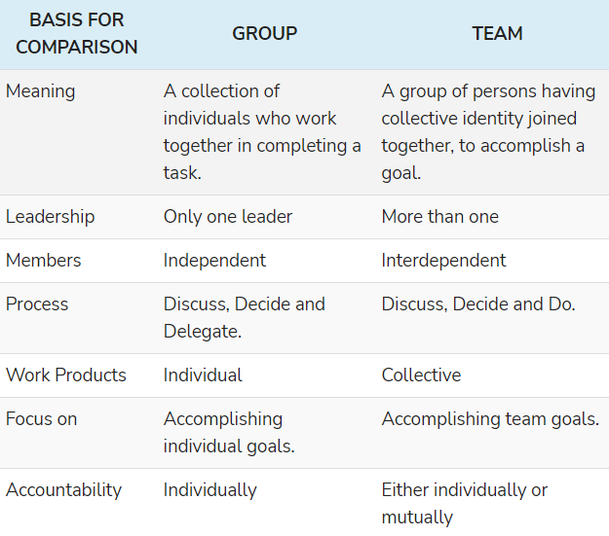

(Table made by Surbhi S, 2018)

MAIN BODY

The next section will be focused on how students can develop an effective team, and also the impact effective teamwork can have on team success. This section will also highlight Tuckman’s model and Wheelan’s method.

Teamwork is defined by Scarnati (2001, p. 5) “as a cooperative process that allows ordinary people to achieve extraordinary results”, team members develop effective, mutual relationships to achieve their common goal, which is the success of the team, despite the barriers they must overcome during the process.

BRUCE TUCKMAN MODEL

To better understand how students can develop an effective team, is to understand Tuckman’s model. Psychologist Bruce Tuckman came up with the memorable phrase "forming, storming, norming, and performing" in his 1965 paper, "Developmental Sequence in Small Groups." [1] It describes the course that groups observe on their way to excessive performance. Later, he delivered the fifth stage, "adjourning" (also recognized as "mourning") to mark the cease of a team's journey.
(Forming, Storming, Norming, and Performing: Tuckman’s Model for Nurturing a Team to High Performance, n.d.)
In the forming stage, students will be unsure about the purpose of the team, how they fit together, and whether they can work well together. They may also start acting anxiously, curiously, or excitedly. However, they felt that they would seek direction from the captain. In the storm phase, students began to challenge the established boundaries.
Conflicts or frictions may also occur between team contributors because their true personalities-and the way they want to work-conflict with different people. If roles and responsibilities are not yet clear, individuals may begin to feel overwhelmed by the workload or frustrated by lack of progress. (Forming, Storming, Norming, and Performing: Tuckman’s Model for Nurturing a Team to High Performance, n.d.)
Gradually, the crew entered the standard phase. People began to resolve their differences, recognized each other’s strengths, and admired the authority of the leader. Now that they know each other better, it will be easier for the team members to ask for help and provide positive feedback. They will share greater dedication to the team's goals and must make appropriate developments for this. (Tuckman’s Model for Nurturing a Team to High Performance, n.d.)
Now that the team is in the mood and they are performing to their full potential; with hard work, the team is very likely to achieve the goals effectively.
"Roles on the team may have become more fluid, with members taking on various roles and responsibilities as needed. Differences among members are appreciated and used to enhance the team's performance." (Judith S, MIT’s HR department)

SUSAN WHEELAN MODEL

Students may also want to use another model to understand how their team is performing and whether they are effective. This is the Wheelan model. Susan Wheelan builds on Tuckman's model and suggests that companies achieve real maturity through cooperation. She claimed that there was a considerable relationship between the length of time the team was together and their behavior patterns. She uses a four-stage model based entirely on the life growth cycle to describe these relationships. (Puscasu, 2021) They are maturity, adulthood, adolescence, and infancy. Wheelan's module is used to evaluate each member's view of what stage they think the team is in.

In the first phase (infancy), team contributors who exhibited characteristics that were proven in infancy (such as dependence, immaturity, and wanting to be wanted) seem to be out. Invest time and energy with these people. Explain what you want, answer questions, provide help, and simulate what you expect them to do. (Puscasu, 2021)

In the second stage (adolescence), you can foresee conflicts about values, challenges to authority, disagreements, and outbursts of struggle. Stay calm and understand that this is no longer personal. Provide various possibilities and time for team members to discuss with each other. Use these conversations to emphasize the common values ​​you expect the team to display. (Puscasu, 2021)

In phase three back off as the team enters younger adulthood. It is preffered that the team attain full maturity and resist becoming too concerned with the team’s decision-making. Act as a facilitator no longer a director and let the team sort out its mistakes. (Puscasu, 2021)

The fourth stage (maturity) is where your team has confidence and trust and can handle even the most difficult responsibilities alone. Give them space and don't interfere but keep them family-like attention and enjoy their achievements. They may also reduce the apron’s rope, but (hopefully) they will still appreciate you and spend your suggestions, rewards, and appreciation. (Puscasu, 2021)

Now that students can build an effective team, they need to know the impact of effective teamwork on team success. Real teamwork takes time to start, because working with people with unique personalities is usually not easy. According to Loop, there are many advantages to having an efficient team. (6 advantages of teamwork-Loop Email Blog, 2021)
Working together facilitates ideas generations and creativity. “There are no new ideas; there are only new ways to recycle old ones ”(Mark Twain, 2020)
Therefore, an important benefit of teamwork is that the whimsical ideas in the team affect creativity. By involving several people, a variety of unique perspectives can produce a wider mix of these ideas. However, the advantages of this teamwork can only be accomplished when properly managed.
Teamwork improves productivity and brings better business results. Working in a team makes people work harder than before. Scientists discovered that team members only encourage each other to improve work efficiency. We should explain: Surrounded by different people, we have experienced the social pressure of operation and delivery-to do things well.

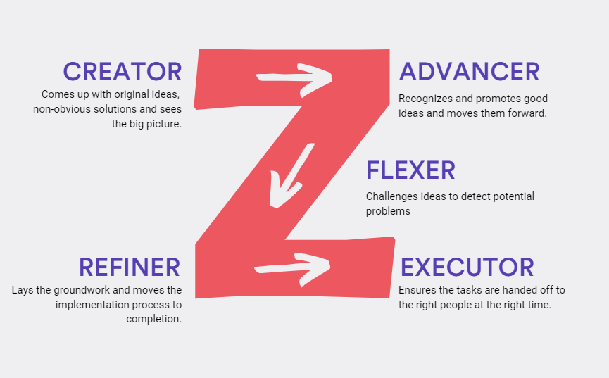

(Email and Puellin, 2019)

Working in teams boosts employee morale and motivation. The advantage of (well managed) teamwork is a more lucrative work environment, which as a result improves company loyalty, worker retention, and lowers turnover – all fantastic matters for any business. (Loop Email blog, 2021)

When we work together, we learn faster. Once you put a group of people together, it will most likely consist of people of different ages, backgrounds, skills, and experience. Although there are certain challenges in closing the gap between these differences, the richness of shared information far exceeds it. This means that humans have uninterrupted learning opportunities-whether professional or personal. (Loop Email blog, 2021)
Teamwork relieves stress. In the long run, due to workload sharing, employees working together will be under less stress. A person dealing with a heavy workload alone may show overwork effortlessly, which should lead to exhaustion. In addition to working long hours, there are also psychological factors at play. If a few people go to dig, many tasks will be easier to deal with-once the work is delegated, all employees find the project easier. (Loop Email blog, 2021)

BARRIERS TO EFFECTIVE TEAMWORK
As compromising as all the above benefits may sound like, it is really difficult to put together a group of people who will make a great team from the very beginning. That is why is about time to evidentiate the barriers that a team must overcome during the process. The best example we can use in this situation is the next due assignment which is a team/group assignment. People who are taking part belong to different age groups, have different backgrounds, skill sets and experience. Here, the failure can interfere from the very beginning if the goal is not properly set and the individuals have not split the tasks and responsibilities equally throughout the team. The goal has to be common, achieving the highest mark in the assignment. Each member should pick to work on the part of the project they are most interested in and not accept responsibilities they do not like as they will just trouble themselves and the other members later on in the process. Another factor that hinders the effectiveness of the team is the lack of discussion and poor communication. During team meetings no member should sit quietly as it is very important that everyone gets to share their opinion and work together to analyze the pros and cons of a situation in order to have the best results. The lack of discipline and punctuality could create dispute among the members as it is a proof of unprofessionalism and a carefree attitude towards the purpose and the outcome of the final decision, in this case the final grade. The group dynamic could also be threatened if ego gets in the way. Most teams have members who are not working for the benefit of the group, thing which harms the process as they can interfere in other people work and lead them into a wrong direction, implementing doubt and insecurity among others. All individuals are being given different responsibilities with a reason, they must work on it at their best capability and make sure that when putting together the final piece everyone is happy and pleased. (Barriers to Effective Team Building, 2021)

BELBIN’S 9 TEAM ROLES
The report will next be looking at the types of roles that are needed to create a cohesive and effective team. In order to do that we will be analyzing Belbin’s 9 team roles which are Resource Investigator, Teamworker and Co-ordinator (the Social roles); Plant, Monitor Evaluator and Specialist (the Thinking roles), and Shaper, Implementer and Completer Finisher (the Action or Task roles). His method is very useful and can be applied right from the beginning, from the forming stage of Tuckman’s method. To efficiently delegate the tasks and responsibilities, people should look first at all the members individually and get to know their strengths and weaknesses as follow (Belbin's Team Roles: How Understanding Team Roles Can Improve Team Performance, 2021):

Resource Investigator - innovative, curious, enthusiastic. They see new opportunities, analyses all the possible options and play the role of negotiator within the team.
- over-optimistic and may loose track and interest if the initial enthusiasm is over.
Team Worker - co-operative, helpful, trustworthy. Aids all the other members and listen carefully to everything they have to say.
- indecisive, not willing to confront other members in case they are wrong.
Co-ordinator - good organizers, mature, confidents. They play the role of a chairman and guides the team towards their objectives.
- can be wrong precepted as being manipulative.
Plant - problem-solver, creative, open minded, usually the person who comes with new ideas and approaches.
- not an efficient communicator.
Monitor Evaluator - strategic, able to see clearly all the options having an accurate judgement.
- unable to motivate and inspire others.
Specialist - having various skills and abilities, maintaining professionalism.
- limited contribution
Shaper - has the ability to overcome challenges.
- if not careful, could offend people’s feelings.
Implementer - good organizer, convert ideas into actions.
- too focused, not opened to other possibilities
Completer Finisher - the quality controller, polishes the outcome and takes it to perfection.
- reluctant to delegate, worries too much. (The Nine Belbin Team Roles, 2021)

CONCLUSION

To summaries, the above report was meant to offer a clear overview on how a team should be organized and the steps that must be followed in order to achieve good results at the end of the project. Starting from Tuckman’s method which clearly explained the stages of a team: forming, storming, norming, and performing and the similarity in concept with Wheelan’s model, followed by an explained content of the obstacles that the team must overcome. After offering solution on how to break the barriers the report has offered some benefits of the team forming and explaining how important it is to correctly delegate responsibilities and identify the right person to do it. Being able to understand all the above concepts is offering the individual the capability to form the best team in order to achieve the set goal.

REFERENCES

- Loop Email blog. 2021. 7 Advantages of Teamwork – Loop Email blog. [online] Available at: <https://www.intheloop.io/blog/advantages-of-teamwork/> [Accessed 22 October 2021].
- Ape. 2021. 8 Best Team Building Methods Series - Wheelan and Locke Methods - Ape. [online] Available at: <http://apepm.co.uk/the-8-best-team-building-methods-wheelan-and-locke/> [Accessed 21 October 2021].
- Managementstudyguide.com. 2021. Barriers to Effective Team Building. [online] Available at: <https://www.managementstudyguide.com/team-building-barriers.htm> [Accessed 22 October 2021].
- Mindtools.com. 2021. Belbin's Team Roles: How Understanding Team Roles Can Improve Team Performance. [online] Available at: <https://www.mindtools.com/pages/article/newLDR_83.htm> [Accessed 24 October 2021].
- Hyper Island. 2021. Creating Effective Teams - The Detailed Curation | Hyper Island. [online] Available at: <https://www.hyperisland.com/blog/creating-effective-teams-the-detailed-curation> [Accessed 21 October 2021].
- The Happy Manager. 2021. Define Teamwork | a teamwork definition that works! - The Happy Manager. [online] Available at: <https://the-happy-manager.com/article/define-teamwork/> [Accessed 21 October 2021].
- Mindtools.com. 2021. Forming, Storming, Norming, and Performing: Tuckman’s Model for Nurturing a Team to High Performance. [online] Available at: <https://www.mindtools.com/pages/article/newLDR_86.htm> [Accessed 21 October 2021].
- performance, C. and workplace, T., 2021. The Importance of Teamwork in the Workplace | BrightHR. [online] Brighthr.com. Available at: <https://www.brighthr.com/articles/culture-and-performance/teamwork/the-importance-of-teamwork-in-the-workplace/> [Accessed 20 October 2021].
- Belbin.com. 2021. The Nine Belbin Team Roles. [online] Available at: <https://www.belbin.com/about/belbin-team-roles> [Accessed 24 October 2021].
- Insidehighered.com. 2021. Tips for improving student teamwork in class (opinion) | Inside Higher Ed. [online] Available at: <https://www.insidehighered.com/advice/2018/04/17/tips-improving-student-teamwork-class-opinion> [Accessed 20 October 2021].

