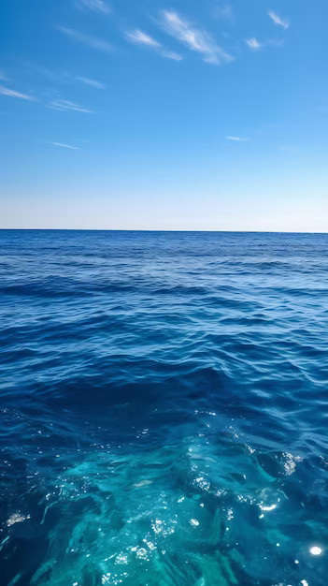

Sailing towards sustainability: a strategic report for royal Caribbean

Nia Moores
2200282
Managing Tourism, Leisure, and Events Organisation
Robyn Griffiths
Word Count – 2170

Table of Contents
Intro 2
Change management 3
Cultural and process enablers 4
Behavioural dynamics in teams 6
Ethical considerations 6
Conclusion 8
Recommendations 8
References 9

Intro
The current business environment throughout Royal Caribbean has multiple factors. (ROYAL CARIBBEAN, 2023) With the increase of global warming the company have had pressure to alter their environmental factors over the last few years. They have had to change their practices and technologies to reduce their footprints and try to stay ahead of the game when it comes to new technology to create a sustainable future. This means innovation throughout the company must be constant in all departments to help the company in years to come. Diversity has always been a known factor when trying to improve a business, so Royal Caribbean having their DEI committee is the start to the adaption of the company. If Royal Caribbean didn’t have their social factors in line this could become very negative to the company, even something as small as not having done research and having background knowledge on suppliers could ruin the business.

Having Multiple factors can lead to implications. Typically, main issues includes finances, spending habits are changing constantly so the business have to be careful with what they are relying on. As having to constantly change to reduce their carbon footprint can be very expensive and may take time over the years to earn back money. Also, the cruise line industry is very competitive, so keeping up with new technology and practices may be difficult within the company.

Change management
It is already known by the company how much Diversity, Equality and inclusion plays into the success of the business. Since the company takes customers around the world on adventures, they want to ensure they have a diverse team with different backgrounds, perspectives, and experiences. (Royal Caribbean, 2022) In 2022, Royal Caribbean set the goals within the company to form an executive diversity council. They however completed this before the end of 2022 ahead of schedule. (Royal Caribbean, 2022) This shows the importance of the council to staff members and to keep the company changing to keep up to people’s needs. Another way the team has made change throughout the years is rewording certain terms, so for example mental illness is now called mental fitness throughout the company. Employees are encouraged to train not only physically but mentally. They get these messages across through their newsletters that ensures employees that their wellbeing is important and cared for. (Royal Caribbean, 2022) The company was awarded the title of 11th healthiest workplaces in America, this has shown that the company has taken a different approach to their staffs health. (Royal Caribbean, 2022)

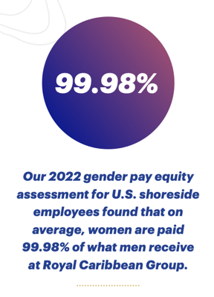
Another form of changes is the gender pay gap; they created a goal for all staff globally to be given fair equal pay including crew onboard the ships. This shows that Royal Caribbean are trying to shorten the gap between men and women. The current statistic for the gender pay gap is 7.7% (White, 2023) while Royal Caribbeans is 0.02%. (Royal Caribbean, 2022)

Cultural insight could be a radical solution for change within the company. The DEI can be used and input into the companies structure rather than just being an aspect of the company. Training could be provided to create a better understanding of diversity amongst the team to make staff more comfortable and completely remove unconscious biases that might be in place.

The company are slowly starting to change their outlook on mental health. This including health services onsite and a lot of resources. (Royal Caribbean, n.d.) I believe that a wellbeing sabbatical could be introduced to the company. As currently there aren’t any offered within the company for any positions. This can help reduce burnout and improve job satisfaction. It has been found that in other companies sabbaticals often keep the businesses reputation up and also avoids costs for recruitment as staff can come back and train in a new position and have a new start in the business to keep things changing. (May 2023, 2023)

Cultural and process enablers
Royal Caribbean have created the slogan ‘the friendliest service at sea’. (Royal Caribbean, n.d.) The company prides themselves with good customer service, employees are always motivated to go above and beyond to meet their passengers needs to create a positive organizational culture. This is done in different forms of training to show consistency throughout their ships. It has seemed to be successful as the business have wan multiple awards throughout the years including the best cruise line overall for 21 years running. (Ltd, 2023)

The companies propelled by the people promises staff to be passionate, innovative, unstoppable, and open the world to employees. (RCG Careers, n.d.) This encourages staff to share their stories and experiences this helps the feeling of belonging to the company and also have a purpose within it. In an industry like cruising, it is very common for turnover to be high during the end of a season this’ll be increased as the company has over 94,000 crew members on board the ships. So, if engagement with staff is strong this could make crew feel like they have a place within the company. This goes hand in hand with the sustainability commitment of the business, as those who feel a connection to the business they’ll want to stand by the missions and Royal Caribbean’s NetZero aim. (Royal Caribbean, 2022)

Large companies hold a great responsibility in their stakeholders, this means to ensure good business transparency and trust is essential when building a relationship between the two. When a business incorporates sustainable principles into their culture this will attract stakeholders of the same nature that can join and help reach the goals set in place by the company but with more knowledge behind them. Royal Caribbean have had their NetZero project in place for decades, so a sense of responsibility from the business is throughout the company. (Group, 2021) This will also help the commitment from the stakeholder with the company as they can feel a sense of pride with the principles as they have helped the company move forward with their purpose.
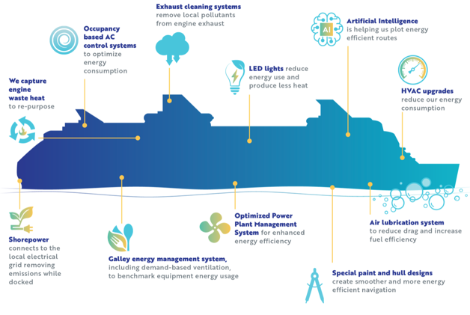
Innovation is something Royal Caribbean has learnt over the years. They have tried to create the most efficient ship possible. They have upgraded their ships over the years and have started to include different things such as engine waste heat is now repurposed, HVAC upgrades reduces energy consumption, and an exhaust cleaning system removes any pollutants from the engine. Royal Caribbean have created an image to show different areas of the ship that are now sustainable. (NetZero, n.d.)
This is a goal to help the company hit the NetZero goal in 2050. The more the business try’s new solutions to tackle the climate issue the closer they are to finding a breakthrough solution that can advance the goals.

Behavioural dynamics in teams
Hierarchy isn’t dead it has just changed its form over the years. It Is important to have some type of hierarchy within a job this is because the power aspect of a job may have been toned down in the current type of workplace, but the boss is still in charge. (Jebb, 1998) It also helps with the organisational structure. Since a good structure doesn’t automatically produce good performance. However, if you have a poor organisational structure good performance doesn’t exist no matter how good the managers among the team may be. So, improving structure will always improve performance throughout a team. (Drucker, 2017)

Royal Caribbean have been encouraging diversity throughout their business. This could be incorporated even more if they have an area where all team members feel valued and respected as this will make staff want to speak their mind and allow for all voices to be shared and heard. This will make better communication and innovation throughout a number of teams as people will be comfortable with working with others no matter their roles.

To help staff further their skills to create more knowledge throughout teams, Royal Caribbean could offer extra development. This can range from soft skills to technical skills that are relevant to the business. Since the company already offer the Royal Caribbean university at the start of someone’s development that provides people with the basic understanding of the ships, the key selling points, and many other skills for working on the ships. (Frequently Asked Questions General Information, 2024)

Ethical considerations
Royal Caribbean are already creating ethical considerations, their newer ships already are attempting to reduce waste pumped into the ocean. The business’s NetZero campaign is the leading front of its improvements. This is reducing the companies carbon footprint, by creating more of their efficient ships to create energy saving techniques on board. This will not only reduce carbon but also give Royal Caribbean a head start in the business for efficient ships.

Social issues found within the cruise industry is that companies lack working alongside the human right laws when it comes to suppliers, however Royal Caribbean are one of the few businesses in the industry that demand evidence of sustainable practice in that matter. It has been seen that Royal Caribbean require ‘all contractors and suppliers to agree to these fair labour principles’. These principles include child labour, health and safety, wages, benefits and more. (Bonilla, 2022)

On the ships there is an AWARE hotline, it is so staff stay aware for everything happening around them and a way for them to speak up regarding harmful activity. If anything, suspicious needs to be reported there is a 24/7 phone number available. It is also able to answer any queries that staff may have without any retaliation from others. It has been found that since this system has come into place, the workspace has become ethical and positive, this leads to a good place to work. (www.rclinvestor.com, 2024)

The cruise industry is a place that is always changing, normally for the better. At the start of 2024 Royal Caribbean brought out their new ship, Icon of the seas. It is a ship full of many firsts and some of the largest activities on the seas. Including the largest waterpark, the largest pool, and a whole neighbourhood just for families. (Royal Caribbean, n.d.) The ship has 3 different sectors when it comes to the environmental aspect of the ship. This is the energy, water, and waste management. The energy management includes new technology like AI-based routes to maximise the efficiency of the ship. It is also a shore power ready ship which means when it has the chance to, you can plug the icon of the seas into the local power grid of wherever it may be in the world. Next is the water management, 93% of the fresh water is created on board through osmosis with plants. Then finally is waste management Icon of the seas has a recycling program that ensures more than 90% of rubbish will never reach a landfill. They also have a waste-to-energy system, this is when different technology takes left over rubbish and turns it into different forms of energy on board the ship. (www.RoyalCaribbeanpresscenter.com, n.d.)

Conclusion
From analysing different strategies that Royal Caribbean are using I have found that the Diversity, Equality, and inclusion within the business is very good and is continuing to improve as the years go along. The business is reaching goals set in place before the deadline as it is shown that the company is determined to get this in place as it creates a more inclusive place for staff to work. The NetZero project is also another aspect of the business that is coming together faster than anticipated. The goal of 2050 is still in reach however the innovations made already in this project shows the importance to Royal Caribbean, this includes the new efficient ships. There are very few companies in the industry that were found to be aware of their social actions. This could lead to the company losing customers and stakeholders, so Royal Caribbean being named as a company who are considering their actions is very positive.

Recommendations
Even though it is obvious that Royal Caribbean are aware of their sustainable practices, I believe there are still a few ways they could improve this throughout their ships. Reducing single-use plastics could be beneficial, they have started this by removing food containers and water bottles so far. (Hyde, 2024) However, I believe if they replace majority of the plastic single use on board with either biodegradables or reusable this would stop the single use plastic waste by the end of 2024 rather than 2025.

Royal Caribbean currently use Sherwood food distributors as their suppliers. (Distributors, 2018) I believe if they used local providers depending on where they are docked in the world. This would not only provide customers with local cuisines that they might have never gotten the chance before, but it would also create business for over 61 countries and give Royal Caribbean a better supplier portfolio. (ETravel, 2024) Since Royal Caribbean are such a large company this could benefit a lot of local businesses and create a better revenue in different countries.

References
Bonilla, M.J. (2022). Research Anthology on Developing Socially Responsible Businesses. Hershey, Pennsylvania (701 E. Chocolate Avenue, Hershey, Pennsylvania, 17033, USA): IGI Global.
Distributors, S.F. (2018). Sherwood Food Distributors Named Royal Caribbean Supplier of the Year. [online] Sherwood Food Distributors. Available at: https://sherwoodfoods.com/sherwood-food-distributors-named-royal-caribbean-supplier-of-the-year/#:~:text=Sherwood%20Food%20Distributors%20Named%20Royal [Accessed 5 May 2024].
Drucker, P.F. (2017). The Theory of the Business (Harvard Business Review Classics). Harvard Business Press.
ETravel (2024). Royal Caribbean Cruises Destination: Check out the Royal Caribbean Cruises Destinations | Cruise Booking. [online] www.cruisebooking.com. Available at: https://www.cruisebooking.com/cruise-lines/royal-caribbean-international/destinations#:~:text=How%20many%20destinations%20does%20Royal [Accessed 5 May 2024].
Frequently Asked Questions General Information. (2024). Available at: https://creative.rccl.com/Sales/Royal/Training/17057239_RCU_FAQs_final.pdf [Accessed 2 May 2024].
Group, R.C. (2021). Royal Caribbean Group Announces ‘Destination Net Zero’ -- Program to Achieve Net Zero Emissions by 2050. [online] www.prnewswire.com. Available at: https://www.prnewswire.com/news-releases/royal-caribbean-group-announces-destination-net-zero--program-to-achieve-net-zero-emissions-by-2050-301411074.html.
Hyde, L. (2024). Royal Caribbean Group Reduces Carbon Intensity by 6.8 per Cent. [online] CruiseandFerry.net. Available at: https://www.cruiseandferry.net/articles/royal-caribbean-group-reduces-carbon-intensity-by-68-per-cent#:~:text=In%202023%2C%20Royal%20Caribbean%20Group%20launched%20phase%20three%20of%20its [Accessed 5 May 2024].
Jebb, F. (1998). UK: Don’t Call Me sir. [online] www.managementtoday.co.uk. Available at: https://www.managementtoday.co.uk/uk-dont-call-sir/article/411582 [Accessed 27 Apr. 2022].
Ltd, J.M.G. (2023). Globe Travel Awards 2023: Winners Revealed. [online] Travel Weekly. Available at: https://travelweekly.co.uk/news/air/globe-travel-awards-2023-winners-revealed [Accessed 29 Apr. 2024].
May 2023, G.P. 10 (2023). Employee sabbaticals: Business Benefits and Tips on Getting the Policy Right. [online] www.peoplemanagement.co.uk. Available at: https://www.peoplemanagement.co.uk/article/1822250/employee-sabbaticals-business-benefits-tips-getting-policy-right#:~:text=Provides%20an%20alternative%20to%20redundancy [Accessed 22 Apr. 2024].
NetZero (n.d.). Sustainability. [online] Royal Caribbean Group. Available at: https://www.royalcaribbeangroup.com/sustainability/.
RCG Careers. (n.d.). Propelled by People. [online] Available at: https://careers.royalcaribbeangroup.com/propelled-by-people/.
Royal Caribbean (n.d.). Award-Winning Guest Service, Friendliest Service | Royal Caribbean Cruises. [online] Royal Service. Available at: https://www.royalcaribbean.com/gbr/en/experience/royal-service.
Royal Caribbean (n.d.). Benefits. [online] RCG Careers. Available at: https://careers.royalcaribbeangroup.com/benefits/#:~:text=We%20offer%20a%20competitive%20total [Accessed 22 Apr. 2024].
ROYAL CARIBBEAN (2023). 5 Ways Royal Caribbean Practices Sustainability | Royal Caribbean Blog. [online] Royal Caribbean Connect. Available at: https://www.royalcaribbean.com/blog/sustainability-at-sea/#:~:text=Royal%20Caribbean%20has%20reduced%20single.
Royal Caribbean (2022). Sustainability. [online] Available at: https://www.royalcaribbeangroup.com/wp-content/uploads/2024/04/RCG_ESG_Report_2022-1.pdf.
Royal Caribbean. (n.d.). Icon of the Seas: The Icon of Vacations. [online] Available at: https://www.royalcaribbean.com/icon-of-the-seas/?&ecid=ps_43700077770155352&country=GBR&gad_source=1&gclid=CjwKCAjw88yxBhBWEiwA7cm6pWvh8O6usEIANsjAursW-Hh-ZwVjD3k6B1okM3XQ6tfctPe8t_cduhoCuggQAvD_BwE&gclsrc=aw.ds [Accessed 2 May 2024].
White, N.J. (2023). Gender Pay Gap in the UK - Office for National Statistics. [online] www.ons.gov.uk. Available at: https://www.ons.gov.uk/employmentandlabourmarket/peopleinwork/earningsandworkinghours/bulletins/genderpaygapintheuk/2023#gender-pay-gap-data.
www.rclinvestor.com. (2024). Aware Compliance & Ethics | RCCL Investors. [online] Available at: https://www.rclinvestor.com/leadership-governance/corp-gov/aware-compliance-ethics/.
www.royalcaribbeanpresscenter.com. (n.d.). Icon of the Seas Environmental Fast Facts | Royal Caribbean Press Centre. [online] Available at: https://www.royalcaribbeanpresscenter.com/infographic/115/icon-of-the-seas-environmental-fast-facts// [Accessed 2 May 2024].

