THE RECOGNITION OF INDIVIDUALITY
As mentioned in Chapter 1, organisations are made up of their individual members. The individual is a central feature of organisational behaviour, whether acting in isolation or as part of a group, in response to expectations of the organisation, or as a result of the influences of the external environment. Where the needs of the individual and the demands of the organisation are incompatible, this can result in frustration and conflict. It is the task of management to integrate the individual and the organisation and to provide a working environment that permits the satisfaction of individual needs as well as the attainment of organisational goals.

Managing relationships at work has always been a key skill, but the speed at which organisations and the external environment are undergoing change places increasing pressure on individuals at work. The effective management of people requires not only an understanding of the individual employees but also recognition of the culture of the
organisation. What is expected and accepted in one organisation may not be the same in another. For instance, creativity and individuality may be encouraged in one business but undermined by bureaucracy in another.

A discussion of individual behaviour in organisations is therefore riddled with complexity and contradictions. Managers are required to be competent at selecting the individuals who will be valuable to the organisation. They need to be observant about the individuals who are performing well and have the potential to develop within the organisation. They also need to be able to value individual difference and be sensitive to contrasting needs. Finally
managers need to know themselves and understand their uniqueness and the impact their personality has on others.

Individual differences and change
Sensitivity to individual needs and differences, especially in terms of their resilience, becomes particularly significant when organisations embark on change initiatives. Even when the change appears to be relatively straightforward, the reality is likely to be messy and complex. When organisations are working through change and when change appears to be externally imposed, the management of people takes on a different dimension in terms of the sensitivity required. In this situation there is an implicit requirement of changes in attitudes and beliefs. Such changes may lead to new mindsets, new attitudes and new perceptions that enable people to cope and adjust to the different world. At these times effective management is vital; managers will be expected to understand the strains that their employees feel during times of change, but at the same time be able to deal with their own stress levels.

HOW DO INDIVIDUALS DIFFER?
Our sense of self is shaped by our inherited characteristics and by influences in our social environment. The process of growing up – such as the impact of our early family life and the country in which we live – has a significant part to play in our identity. Most social scientists would agree that both inherited and environmental factors are important in our development, and it is the way in which these factors interact which is the key to our adult personality.
However, scientists differ with regard to the weight they place on these factors – some believing that our personality is heavily influenced by our inherited characteristics and will never change, others believing the reverse.

But first, what are the differences among individuals? These include:
■ ethnic origin
■ physique
■ gender
■ early family experiences
■ social and cultural factors
■ national culture
■ motivation
■ attitudes
■ personality traits and types
■ intelligence and abilities
■ perception.
Some of these characteristics are shared with others, for example individuals who are from the same ethnic group or who have the same ability levels or who share similar physical attributes such as short-sightedness. But our uniqueness stems from the dynamic ways in which these inherited and environmental factors combine and interact. The ways in which it is possible to differentiate between individuals include an understanding of personality,
the heart of individual differences and the importance and functions of attitudes.. The process
of perception and communications is examined in Chapter 6. All contribute to a greater understanding of self and others.

PERSONALITY
Personality may be viewed as consisting of stable characteristics that explain why a person behaves in a particular way. So, for instance, independence, conscientiousness, agreeableness and self-control would be examples of these personality characteristics. However, it is only when we see/hear/observe a person that we can gain an understanding of their personality. For example, a person who is independent may show that characteristic by displaying a strong sense of self-sufficiency. We would expect him or her to take the initiative and not to depend on other people. Furthermore, if the characteristic is ‘stable’ we can rely on this being a consistent part of the person’s behaviour. We would be surprised if the person one day demonstrated autonomy and initiative and the next withdrew and delayed any decisions. We anticipate that individuals are generally consistent in the way in which they respond to situations.

There are times when we might be surprised by somebody’s behaviour and we may feel they are ‘acting out of character’. Of course this would be known only if we had an understanding of their ‘typical behaviour’ in the first place. Individuals may exaggerate or suppress certain personality traits, for example if they are under stress or influenced by drink/drugs. It is self-evident that managers need to learn the art of ‘reading’ people’s behaviour in order to manage relationships effectively.

NOMOTHETIC AND IDIOGRAPHIC APPROACHES
Broadly speaking, personality studies can be divided into two main approaches, labelled as nomothetic and idiographic.

The nomothetic approach is a measurable and specific perspective that looks at the identification of traits and personality as a collection of characteristics. These characteristics are ones that can be described, identified and measured and therefore can be subjected to observation and tests. This perspective is especially helpful for managers when they are involved in the selection, training and development of individuals. Nomothetic approaches tend to view environmental and social influences as minimal and view personality as consistent, largely inherited and resistant to change. Although they would not diminish the difficulties that measuring personality brings, nomothetic approaches would claim that it is possible to measure and predict the ways in which personality types would behave given certain circumstances.
Table 4.1
Nomothetic researchers closely align themselves to studies that are ‘scientific’ in a positivistic sense. (The term positivism refers to the branch of science that is exclusively based on the objective collection of observable data – data that are beyond question.) Such an approach transfers methods used in natural sciences to the social world. Some psychologists are interested in describing and measuring characteristics and comparing individuals’ scores.
Does this person exhibit more or less than ‘average’ of this particular trait? Being able to predict behaviour is a major aim and outcome of this approach.

The idiographic approach is a holistic and dynamic perspective which insists that managers take into account a ‘whole’ understanding of the individual at work. This may also require going beyond the study of pure psychology to an understanding of the societal context in which the person lives. These are called idiographic approaches and are particularly pertinent in understanding motivation, career development and team relationships.

Idiographic approaches are concerned with understanding the uniqueness of individuals and the development of the self-concept. They regard personality development as a process that is open to change. They regard individuals as responding to the environment and people around them and see the dynamics of the interactions as playing a critical part in shaping personality. The measurement of traits is seen as largely inappropriate in that
one person’s responses may not be comparable to another’s. They suggest that personality assessment is not a valid method of understanding the unique ways in which a person understands and responds to the world. The depth and richness of a person’s personality cannot be revealed in superficial paper-and-pencil questionnaires. Furthermore, the categories defined by psychologists are too narrow in scope and depth.

Theory and the world of work
The application of theory to the world of work is not always easy and some find the process confusing when theory does not match with their experiences. Psychological investigations emphasise the complexity and variety of individual behaviour and insist that simple answers and explanations are generally inadequate. The study of personality provides an excellent example of some of the complexities involved in applying psychological theory in practice.

Consider two individuals who share similar characteristics. They are both 24 years old and have lived in the same area; both have a first-class honours degree in pharmacy and they have identical personality assessment profiles. However, we would still predict differences with regard to their attitude and performance in the workplace. In addition, differences would be predicted in the ways they interact with others. If one of the pharmacists was male and/or African, a further set of assumptions might be made. It is not only the features themselves which identify individuals as being different, it is also their interaction which leads to a unique pattern of behaviour. The complexities of the process pose a number of questions that interest psychologists and evoke different responses (see Tables 4.1 and 4.2).

Figure 4.1 identifies the links between the dynamics of personality and life’s experiences.Figure 4

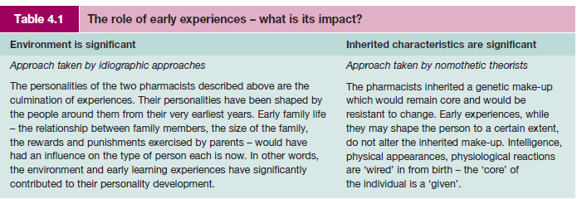

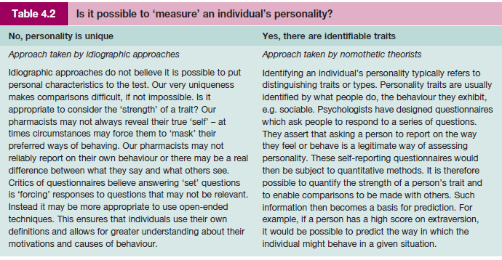
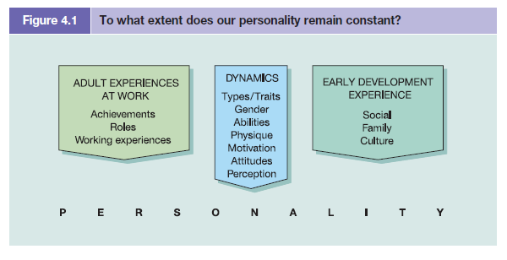
Uniqueness and similarities
Tables 4.1 and 4.2 focus on two major issues of prime importance in the study of personality. First, is personality a constant throughout our lifetime, which remains resistant to change and circumstances? Second, to what extent can we measure and compare individuals on the basis of their personality? This second question assumes that it is possible to distinguish personality characteristics in the first place. Trying to make sense of the nature of personality has resulted in a prolific number of theories, with some psychologists focusing solely on the unique makeup of individuals, others drawing comparisons between individuals or looking for broad similarities in aspirations and goals. Table 4.3 charts these differences as series of ‘levels’. In a work context we tend to be more interested in understanding ‘what’ an individual’s personality is rather than why it is as it is. Furthermore, it is important to understand how various personality characteristics relate to performance at work. The nomothetic approach explores the ‘what’ of personality and the idiographic approach enriches our understanding of ‘why’.

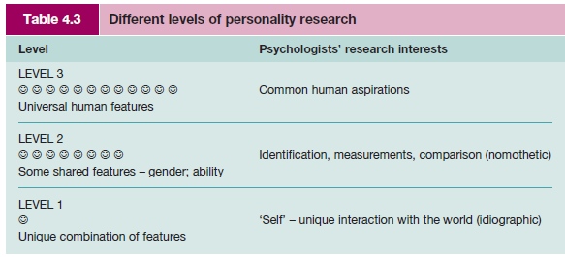

NOMOTHETIC PERSONALITY THEORIES
The big five
The identification of personality traits has been a dominant subject of research in the UK and the USA. There is now a body of evidence which suggests that five dimensions capture distinct differences between people. These clusters of traits (not personality types) are known as the Big Five2 and sometimes expressed in the acronym OCEAN:
■ Openness/closed-mindedness
■ Conscientiousness/heedlessness
■ Extraversion/introversion
■ Agreeableness/hostility
■ Neuroticism/stability
The big five form the basis of standard personality questionnaires that determine positive or negative scores for each dimension. Results from a wide number of studies have shown that these factors can be identified as being significant in measuring the variation between people.3 Of these, conscientiousness has the highest positive link with high levels of job knowledge and performance across a range of occupations.4 However, some researchers are critical of the descriptors used.5 Bentall suggests they are ‘tainted by the investigators’ values’ and continues: ‘I suspect that most people will have a pretty clear idea of where they would like to find themselves on the dimensions of neuroticism, extraversion, openness, agreeableness and conscientiousness.’ He questions the ethical and political
nature of the scales.6 The relationship between personality and work performance is also questioned by Robertson who suggests that the only two of the five dimensions linked consistently with high levels of performance are conscientiousness and emotional stability.7

Despite these reservations, the strength and value of the Big Five model has been extolled in a review by Lord and Rust. They conclude that:

Indeed, the five factor model has become the linchpin that holds personality assessment together, at least within the work context. Without it, how would we generalize with confidence from the validity of one work-based instrument to that of another? Furthermore, the model links the study of assessment instruments within the HR field to research in personality and related areas
carried out within clinical and mainstream psychology fields in which the Big Five have also become dominant.8

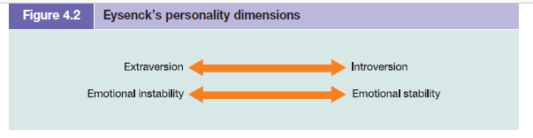

Eysenck
Hans Eysenck believed that personality was largely inherited and that we are born with differing physiological tendencies. He identified two major individual differences – see Figure 4.2. Eysenck’s approach was influenced by the positivistic tradition with his research findings grounded in robust research. His aim was to produce objective evidence of personality differences using large samples of the population.9 The two dimensions define four distinct
personality types:

■ stable extraverts (sanguine) with traits such as being talkative, responsive, easygoing, lively, carefree;
■ unstable extraverts (choleric) with traits such as being impulsive, changeable, excitable, restless;
■ stable introverts (phlegmatic) with traits such as being calm, even-tempered, peaceful, thoughtful;
■ unstable introverts (melancholic) with traits such as being anxious, moody, reserved, pessimistic.

Individuals in Eysenck’s theory could, therefore, be one of four main personality types. The type would lead to a predisposition of traits that would, itself, lead to the likelihood of certain behaviours. For instance, a person typed as an extravert would predictably talk over things with someone to help them think it through, while an introvert would prefer to mull it over before talking about the issue. Eysenck developed an instrument to measure personality type called EPQ (Eysenck’s Personality Questionnaire).
Supporting research evidence
Although Eysenck’s theory appears simplistic, it has an impressive amount of supporting research evidence. His approach has immediate appeal to managers in organisations who are concerned with predicting the future behaviour of their employees, either for selection or promotion. Given the evidence that personality is a useful predictor of behaviour, it is not surprising that the use of psychometric tests has grown substantially over the past decade and that the majority of large companies use occupational tests.10 (Further information about testing is given later in this chapter.)

Cattell
Cattell’s work resembles Eysenck’s in the methods used to study personality. He used quantitative, objective techniques in order to analyse his data and followed traditional scientific procedures in order to understand the basic dimensions of personality.11 He identified two main types of personality traits:
■ surface traits – that seem to cluster together consistently and are observable in behaviour such as assertiveness;
■ source traits – such as self-discipline that can only be inferred and seem to underlie and determine the traits which are likely to ‘surface’ into behaviour.

Unlike Eysenck, Cattell did not ‘type’ individuals but used ‘traits’ as his main personality descriptor. They also differed with regard to the determinants of personality: Eysenck viewed the inherited physiological basis as the main determinant, whereas Cattell was more interested in taking social factors into account when understanding an individual’s personality. Both theorists have contributed to a lively debate about personality structure and its measurement and in doing so have advanced the selection techniques available to managers.12

IDIOGRAPHIC THEORETICAL APPROACHES
Idiographic approaches emphasise the development of the individual and of individuals’ views of themselves – their self-concept. Supporters of idiographic approaches are critical of the nomothetic approach that attempts to categorise individuals on the basis of group data. They argue that the techniques used to collate the group data are questionable and the outcome inappropriate to an understanding of personality. For the idiographic researchers, personality is expressed through the experiences and development of the individual. It cannot be understood outside a social context and has to be studied in the light of individuals’ own perceptions of their world.

Idiographic researchers would always take into account the social circumstances of the person and in particular the relationships with others, family life and social conditions. In early childhood strong personal relationships and unconditional love are essential for later fulfilment and psychological growth. Carl Rogers’ theory claims that personality is embedded within personal relationships. The process of becoming an adult requires the ability to give
and receive unconditional regard – the warmth and respect for the person, who they are, regardless of how they behave.13 The phrase ‘the looking-glass self’ was first discussed by Cooley – by this he meant that we come to know ourselves through our relationship with others and their reactions to us.14
Gurus in idiographic approaches
Erikson
Erik Erikson’s theory is a good example of the idiographic approach. He viewed personality development as continuing throughout life. He was interested in the effect of experiences on the development of the self-concept and how different individuals resolved personal conflicts.15 He recognised the importance of early childhood in establishing certain basic concepts of trust, autonomy and initiative, but also claimed that all stages of life produce different tensions and conflicts.

For Erikson, there are eight distinct stages of life, each of which produces different tensions and conflicts that have to be resolved (see Table 4.4). Successful resolution of these conflicts produces a healthy personality, whereas difficulties in earlier stages may produce problems later on. Erikson’s theory not only makes considerable sense in terms of face validity (i.e. the ‘it feels right’ factor), it also links with other research indicating that managers’ motivations and goals change with age (see Hunt, who identified nine different career/life stages).16

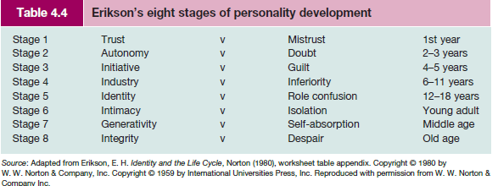

COMPLEMENTARY APPROACHES
Some researchers do not fit easily into either of the two broad approaches of nomothetic or idiographic and have their own theories and models of personality development, for example the work of Carl Jung and the cognitive approach of George Kelly.

Jung
Carl Jung’s theory is of particular significance in that it bridges the psychoanalytic approach (of writers such as Sigmund Freud) with modern approaches of personality test design. His theory identifies life energy as concerned with hopes and goals of the future and not just of the past. Jung describes three levels of personality:

■ a conscious level (daily reality);
■ an unconscious level (contains our unique complexes);
■ a collective unconscious level (store of universal and evolutionary experiences).

Jung identified four universal aspects of everyone’s personality that he referred to as archetypes; for example he claimed we all strive for self-actualisation; have a darker self; have both masculine and feminine qualities; and have a persona – a role we can play.17

The Myers–Briggs Type Indicator® (MBTI®)
Jung is probably best known for his constructs that form the foundation for the MBTI personality indicator. The Myers–Briggs Type Indicator (MBTI) assessment tool was designed by Isabel Briggs Myers and Katherine Briggs who applied the rigours of systematic testing to Jung’s personality functions and attitudes.18 Jung identified differences between individuals in terms of their libidinal energy that could flow outwards to the external world (extravert) or inwards
to their inner world (introvert). Personality differences would also be manifest through differing cognitive functions of thinking, feeling, sensation and intuition. The Myers–Briggs assessment added a further dimension of style of living. The personality types are shown in Figure 4.3.

The MBTI tool has promoted considerable research interest, particularly with regard to the correlation between personality type, occupations and management style – see Table 4.5. The Myers–Briggs assessment asserts that people tend to be attracted to and have the most satisfaction in work that allows them to express and use their psychological type preferences. Such a match enables them to handle their tasks more effectively and generates more energy. Confidence is a likely outcome of this process. The Myers–Briggs instrument is an affirmatory tool
and knowledge gained through using the MBTI assessment can lead to recognition and respect for differences between people and appreciation for the value such differences bring.19

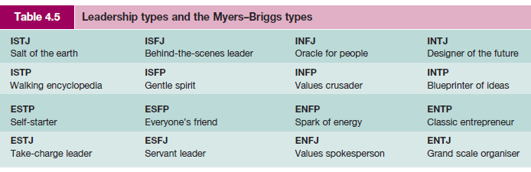

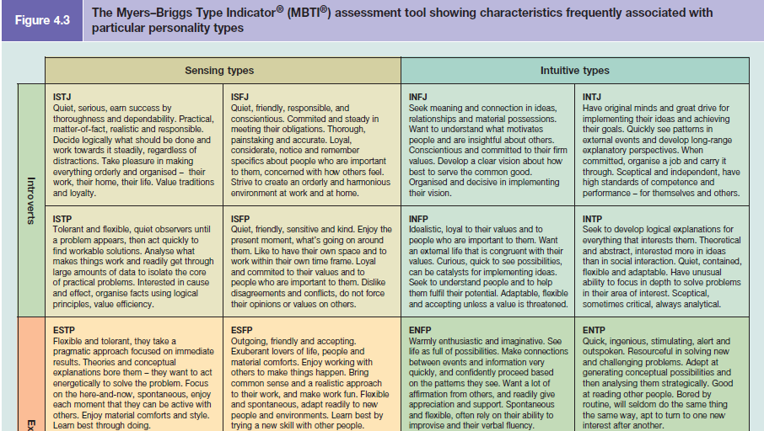
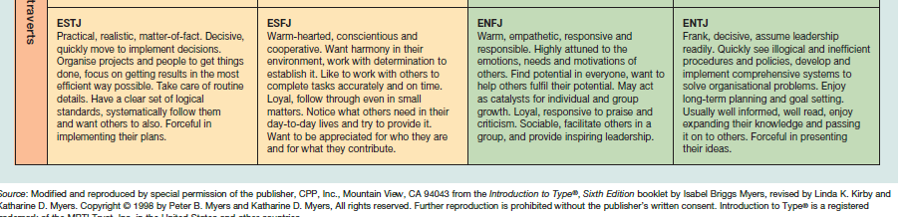

Kelly’s personal construct theory
Kelly’s theory of personal constructs does not just consider personality development; it considers the whole person in terms of their perceptions, attitudes and goals. For Kelly, personality is the individual’s way of construing and experimenting with their world. Kelly was critical of separating the study of personality apart from the ‘whole’ person:

The castrating effect of separating personality off as a mini-psychology in its own right is perhaps best seen in the curiously named study of ‘individual differences’, which in fact turns out to be the study of group sameness. As a result we have focused on the establishment of general dimensions, at some point along which all individuals can be placed, rather than on a study of the dimensions which each individual develops in order to organise his own world.20

For Kelly it was critical to take data from one individual person (idiography) and to employ a technique that could cope with the qualitative nature of the data to be collected. He developed the Repertory Grid that was able to measure an individual’s construct of the world. Kelly was thus able to employ a clear and valid measure within an idiographic approach. This was an important advance in idiographic techniques and the repertory technique has become increasingly important as a research tool. It enables the person to use their own constructions of the world but in such a way that they are comparable and measurable.

APPLICATIONS WITHIN THE WORK ORGANISATION

Recruitment and selection
It would be rare for organisations not to take the personality of a candidate into consideration at a selection interview. For some organisations, personality is a major criterion for selection or rejection. The hospitality industry, for example, is replete with research studies demonstrating the potency of personality.21 So, how do organisations assess a candidate’s personality?

The interview remains the most usual method of selection, but there is an increasing use of objective psychometric measures. Such growth in psychometric testing is significant and a number of studies have demonstrated its growing popularity.22 Concern has been expressed about the use and misuse of psychological instruments and there is a continuing debate within psychological circles with regard to the validity of these measures23 – that is, do they actually measure what they claim to measure? There are controversies and sensitivities surrounding the use of any psychological test, but tests of typical performance are especially problematic in certain circumstances.
As Anastasi has stated:

The construction and use of personality inventories are beset with special difficulties over and above common problems encountered in all psychological testing. The question of faking and malingering is far more acute in personality measurement than in aptitude testing.24

Critics have accused consultants and practitioners of inappropriate use of personality assessments and claim low validity between non-work-related personality assessments and work performance.25 Goss suggests that the use of personality assessments not only is an infringement of the individual’s privacy but also leads to unfortunate organisational consequences, with ‘cloning’ as an outcome. Such techniques can be perceived as a form of social
engineering and an insidious form of organisational control.26 Aware of these problems, the British Psychological Society has produced guidelines and codes of practice for users of psychometric tests. Furthermore, evidence is emerging to show that where personality questionnaires have been specifically designed and related to work characteristics, prediction and validity scores are much higher.27Critical reflection

Personal development and teamworking
Personality questionnaires can be particularly valuable if individuals complete them for their personal development or if they are used within team-building and development programmes. Here, they can initiate discussion about individual differences, the importance of diversity in teamworking and the strengths that each personality type can bring to the working situation. The notion of judgement is therefore out of the equation. Personality questionnaires can thus be a valuable diagnostic tool at the start of a coaching session or as a preliminary to a team-building process – an audit of strengths and weaknesses. At these times a discussion can be held to look at a balanced team with complementary personalities, skills and abilities. This could be followed by group training exercises designed to
develop strengths and balance the weaknesses of the team. An effective team at work should be aware of the division of their strengths and weaknesses.

None of us is perfect; but a group of people, whose strengths and talents complement each other, can be.28

EMOTIONS AT WORK
Until recently workplaces were seen as rational, logical places where emotions were excluded or seen in a negative light. Hochschild’s30 research describes the way in which some jobs require a display of certain emotions, especially those in the service industries, where customer care is inextricably linked with making people feel good. Such work has been labelled as emotional labour and distinguishes between surface acting – displaying emotion without
experiencing it – and deep acting – involving thinking, visualising to induce the emotion in the situation. Briner challenges psychologists to broaden research to throw light on the complexities of emotions in the workplace. He notes that organisations specify the emotions they would like their employees to feel in the mission statements and in more subtle ways in terms of the rewards and career enhancements people receive when they display appropriate emotions. However, he suggests that little is known about the incidence of emotion
at work and the part it plays in work behaviours. The illustration shown in Table 4.6, although simplistic, plots a possible sequence of events and the power of rewards (or not) and psychological well-being (or not).

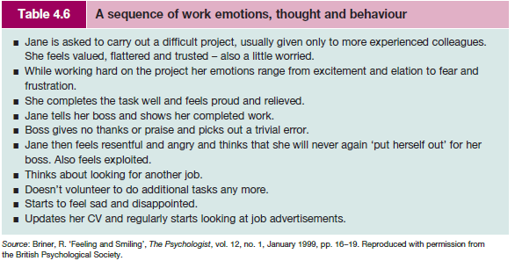

TYPE A AND TYPE B PERSONALITIES
Two polar sets of behaviour that link with personality and health have been identified by medical students Friedman and Rosenman, who identified recurring patterns of personality in patients suffering from premature heart disease.32 Individuals with a Type A personality are excessively competitive and thrive on hard work and long hours. They work under moderate to high levels of stress and exhibit characteristics such as:
Table 4.6
■ a high need for achievement;
■ extreme competitiveness;
■ impatience with obstacles to the completion of tasks;
■ aggressiveness;
■ a tendency to move and speak rapidly;
■ an aversion to idleness;
■ restlessness and urgency about time.

Individuals with a Type B personality are considered to exhibit the opposite characteristics from Type A. They may still have high levels of drive and ambition but are more relaxed, work at a steady pace and do not exhibit a sense of time urgency.

According to Friedman and Rosenman, Type A personalities are far more vulnerable to heart attacks than Type B personalities. Individuals who have a personality classified as Type A are more likely to suffer from heart disease under severe stress than individuals with a Type B personality.33 Research also supports the link between stress and Type A personality.34

Type A people and team performance
Gratton reports on what happens when Type A people, for whom time urgency is crucial, get to work together with less time-urgent people. Type A people are likely to pay a great deal of attention to the passage of time, constantly check the time remaining and see time as their enemy. Typically they will be very efficient in their use of time, and will use deadlines to prioritise tasks and increase their work pace. Type A people have the potential to keep things
moving and active but can have a detrimental impact.35 A study by Waller et al.36 found that where teams were responsible for completing creative tasks, Type A time-urgent people tended to impose strict, linear schedules on members and this reduced the innovative performance of the team.
Critical reflection
ABILITY
Individuals vary with regard to their mental abilities and the extent to which they apply them at work, and different occupations require different skills, competencies and abilities. The ‘happy’ scenario is one where a match occurs between the individual’s abilities and their occupation, but reality suggests that this is not always the case. The extremes include employees bored rigid with a simple task who become careless and make a succession of mistakes, and the employees who have been promoted beyond their capability. The result could be stress either for the individuals unable to cope or for their colleagues who are picking up the debris left behind.

In a similar vein to the studies of personality, different schools of thought have emerged with regard to the study of abilities. Similar debates to the ones that surround the study of personality have also swirled around the research on intelligence.
■ Is intelligence inherited? Is it constant throughout life? Is it dependent upon our life’s experiences, our culture, our education, etc.?
■ What is the nature of intelligence? Can it be measured and how?
Figure
ATTITUDES
There are no limits to the attitudes people hold. Attitudes are learned throughout life and are embodied within our socialisation process. Some attitudes (such as religious beliefs) may be central to us – a core construct – and may be highly resistant to any change, whereas other, more peripheral attitudes may change with new information or personal experiences. Specific events, particularly traumatic ones such as redundancy, may have a dramatic effect
on our attitudes.

So what are attitudes and how can they be distinguished from beliefs and values? Attitudes can be defined as providing a state of ‘readiness’ or tendency to respond in a particular way.51 Beliefs are concerned with what is known about the world; they centre on what ‘is’, on reality as it is understood. Values are concerned with what ‘should’ be and what is desirable.

Gross suggests that ‘to convert a belief into an attitude, a “value” ingredient is needed which, by definition, is to do with an individual’s sense of what is desirable, good, valuable, worthwhile and so on’. Gross has suggested that whereas ‘adults may have thousands of beliefs, they may have only hundreds of attitudes and a few dozen values’.52 Hofstede defines values as a ‘broad tendency to prefer certain states of affairs over others’.53

The functions of attitudes
Katz has suggested that attitudes and motives are interlinked and, depending on an individual’s motives, attitudes can serve four main functions:

■ Knowledge. One of the major functions is to provide a basis for the interpretation and classification of new information. Attitudes provide a knowledge base and a framework within which new information can be placed.
■ Expressive. Attitudes become a means of expression. They enable individuals to indicate
to others the values that they hold and thus to express their self-concept and adopt or internalise the values of a group.
■ Instrumental. Held attitudes maximise rewards and minimise sanctions. Hence, attitudes towards other people (or objects) might be held because of past positive (or negative) experiences. Behaviour or knowledge that has resulted in the satisfaction of needs is thus more likely to result in a favourable attitude.
■ Ego-defensive. Attitudes may be held in order to protect the ego from an undesirable truth or reality.54

Prediction of behaviour
Is it possible to predict behaviour if we know an individual’s attitude? Research suggests the answer is ‘no’ – what we say and what we do may be very different. Such evidence indicates that attitudes can be revealed not only in behaviour but also by the individual’s thoughts (although these may not be revealed in public) and by feelings, the strength of which demonstrates the extent to which the attitude is a core or peripheral construct.

A classic study by La Piere illustrates this point. Visiting American hotels and restaurants with a Chinese couple, La Piere found no sign of prejudiced attitudes in the face-to-face situation, but there were marked racist attitudes in the follow-up attitude survey. He found complete contradictions between public and private attitudes.55

These findings have important implications for the study of attitudes and reveal two important issues for the psychologist and manager.

1 Attitudes cannot be seen; they can only be inferred.
Given that the attitudes employees hold are important for morale and the effectiveness of organisations, it is important that there is confidence in the measurement techniques used to assess the strength of attitudes. As attitudes are inferred, heavy reliance is placed therefore on the accuracy of assessment. Although there are a number of techniques that could be used to measure attitudes, the two most common are direct observation and self-reporting techniques.

All of us observe others and assess attitudes on the basis of communication style (both verbal and non-verbal) and behaviour. This is an example of an informal approach – unsystematic, spontaneous and based on our understanding of social cues. We may be wrong in our judgement. Students who turn up late for classes, slouch on their seat and do not ask questions may still hold very positive attitudes towards the subject. Managers may also be
erroneous in their assumptions and beliefs about their colleagues (both subordinates and superiors). Their beliefs may never have been tested out – merely assumed to be correct. Serious mistakes can be made when dealing with people across different cultures. For instance, eye contact in Western countries is normally associated with confidence, politeness and attentiveness, but in some African countries it may be seen as rude and disrespectful.
Bulgarians nod when they mean ‘no’ and shake their heads when they mean ‘yes’, while the Greeks nod upwards or raise their eyebrows for ‘no’ and shake the head side to side or tilt it to say ‘yes’. A lack of ‘cultural literacy’ can lead to incorrect assumptions, poor relationships and a failure to make useful business connections.56

Organisations that assess their employees’ attitudes by using attitude questionnaires (selfreporting techniques) are attempting systematically to gauge and measure these assumptions. Attitude questionnaires are time-consuming to design and administer. The questions asked, their relevance, style and length are all important variables in the validity of the questionnaire.
So, too, is the honest completion of questionnaires. Making public people’s private attitudes may also have its dangers as expectations of change may be envisaged. If these do not occur, disappointment and low morale may be the result.57

2 Attitudes are often shared within organisations and as such are embodied in the
culture of organisations.
Classic research has shown the influence of the wider community in the formation of orientations towards work. Differences in class/orientation may elicit a range of loyalties and possibly produce opposing perceptions of commitment, loyalty and co-operation. Attitudes are not just individually formed but arise out of interaction with others. They are often ‘locked-in’, often regarded as obvious, mere common sense, and are so much taken for granted that they may be overlooked. Sharing the belief system of others also has affective outcomes. If people feel that they belong and are included, it enables them to feel good about working in an organisation. If, however, people do not feel part of the organisation – if they feel that they do not share the dominant attitudes and beliefs – negative emotional consequences are likely to result.

Researchers of organisational culture suggest that it is the shared perceptions of daily practices that are at the core of organisational cultures.58 ‘The reality of everyday life is taken for granted as reality.’59
Implications of the unquestioning nature of the ‘reality’ of what can or cannot be done can lead to individuals becoming ‘culturally blinkered’. Insitutionalised attitudes result. Major problems arise when these attitudes are formed on the basis of stereotypes and prejudice, as was evidenced in the Stephen Lawrence Inquiry into the murder of a black teenager stabbed to death in London in April 1993:

Unwitting racism can arise because of lack of understanding, ignorance or mistaken beliefs. It can arise from well intentioned but patronising words or actions. It can arise from unfamiliarity with the behaviour or cultural traditions of people or families from minority ethnic communities. It can arise from racist stereotyping of black people as potential criminals or troublemakers. Often this arises out of uncritical self-understanding born out of an inflexible police ethos of the ‘traditional’ way of doing things. Furthermore such attitudes can thrive in a tightly knit community, so that there can be a
collective failure to detect and to outlaw this breed of racism. The police canteen can too easily be its breeding ground.60

Attitudes are not just created within organisations. Attitudes inherent within wider society are reinforced or reshaped by the organisation.

Employee attitude surveys
Attitude surveys or questionnaires are used by many organisations as a way of attempting to gauge the attitudinal climate of the organisation and monitor the views of members of staff.
The Chartered Management Institute defines an employee attitude survey as:
A planned procedure which enables an organisation to obtain the opinions of its employees on a particular issue or on the organisation itself, so as to take account of them in the planning process or make changes beneficial to the organisation and individuals alike.
Table 4.7
Surveys can encourage employee involvement, allow management to be more aware of employees’ opinions, and provide effective communications or a sounding board. However, surveys require significant time and costs to administer and evaluate, and may generate suspicion from staff about ‘hidden agendas’ of the survey. The frequency should be no more than every 18 months and it is important to report results of the survey and plans of action to all employees.61
The usual method of measurement is by adopting a five-point ‘Likert scale’ (as in the example shown in Table 4.7) that reflects the comparative strength of the attitude.62

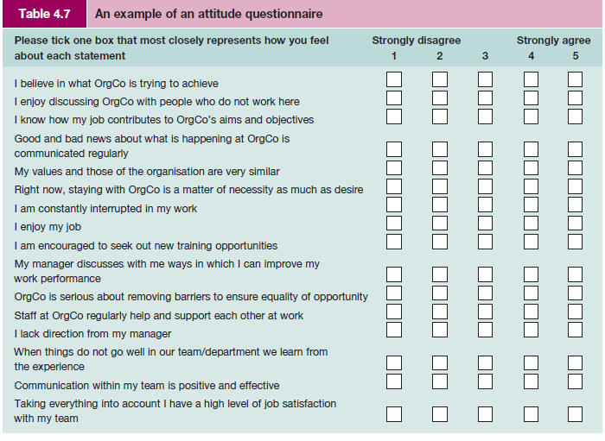
ATTITUDE CHANGE
The permanency of attitudes clearly has implications for attitudinal change. At the beginning of the previous section it was pointed out that whereas peripheral attitudes may easily change with new information or experiences, central attitudes tied into other cognitive systems may be much more difficult to shift.

Theories on attitude change stress the importance of balance and consistency in our psyche. Heider, for example, suggests that not only would we find it uncomfortable to hold two conflicting attitudes, but to do so would motivate us to change one of the attitudes in order to reach a balanced state.63

Cognitive dissonance is the term given to the discomfort felt when we act in a way that is inconsistent with our true beliefs. It suggests that we are motivated to reduce its impact.64 The process of attitude change is dependent on a number of key factors, the most important being:

■ why an attitude is held in the first place;
■ why it should change;
■ what the benefits are and to whom;
■ what the outcomes are if it does not change.
Considerable research has demonstrated the importance of the following variables in a
programme of attitude change:
■ the persuader’s characteristics;
■ presentation of issues;
■ audience characteristics;
■ group influences;
■ outcome of attitude change (reward or punishment).
The last decade has produced tumultuous change for employees and their managers. It would be rare indeed to find an organisation that has not experienced some degree of change in structure, product, processes, philosophy, culture or ownership. The way in which these changes are implemented can have a dramatic impact on the attitudes of staff.
Critical reflection
TESTING AND ASSESSMENT
Much has been written about the value of selection tests and questionnaires and they are subject to a number of criticisms. It should be noted that the word ‘test’ is often taken to refer to measures of intelligence, achievement and developed abilities, and aptitude for particular tasks. Measures of interests, social attitudes, emotional stability or traits of personality are usually referred to as questionnaires or profiles, or similar. Answers are regarded as common or uncommon, typical or untypical, rather than right or wrong, good or bad. The word ‘test’
is therefore usually avoided in such measures, as in, for example, the Cattell 16PF Questionnaire.

The early tests of intelligence have evolved into a large psychological business. Most people will have taken a psychometric test of one kind or another by the time they are an adult in employment. Tests may be administered at school or college, or as part of the selection assessment process at work. The use of tests is widespread and growing. They are perceived to be useful as an objective discriminating tool, but they are not without controversies and
sensitivities.

Tests are divided broadly by the British Psychological Society into the following:
1 Tests of typical performance. These assess an individual’s typical responses to given situations. Answers are not right or wrong but identify choices, preferences and strength of feelings. Personality assessments and interest inventories are examples of such tests.
2 Tests of maximum performance. These assess an individual’s ability to perform effectively under standard conditions. Performance on these tests, which include ability and aptitude tests, can be judged as right or wrong. Ability tests come in many different forms and may test a general intellectual functioning or a specific ability (such as verbal reasoning, numerical reasoning, etc.).

Alice Heim (cited in Anastasia) developed a series of general ability tests – AH series – which is widely used to assess general ability. These test three key areas: verbal, numerical and diagrammatical reasoning. For example, an individual would be asked questions similar to the following:

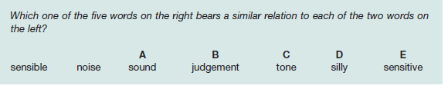

Modern Occupational Skills Tests are an example of specific ability tests and measure a range of clerical and administrative skills: verbal checking, technical checking, numerical estimation, etc. They claim to be an aid in the selection of administrative staff. Their tests are short and can be used singly or together as a battery of tests. The individual would be asked questions similar to the following:

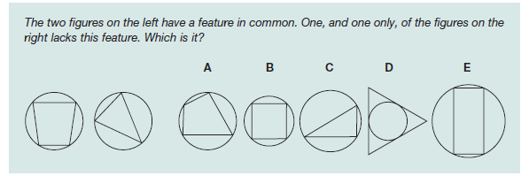
Some tests are designed to be given individually whereas others are suitable for administering within a group situation. However, there are certain minimum features and standards of conditions that distinguish psychological tests from other forms of informal assessments; tests are essentially ‘an objective and standardised measure of a sample of behaviour’.65

Features of psychometric tests
Psychometric tests have certain standard features:
1 Tests will comprise a standard task or a set of questions with a standard means of obtaining the score.
2 A technical manual will explain what the test is measuring, how it was constructed, and the procedures for administering, scoring and interpreting the test.
3 Details of the test’s validity (whether the test measures what it claims to measure) and reliability (the test’s ability to measure consistently) will also be shown in the manual along with the inferences that can be drawn from the data.

For a test to be considered as a psychological instrument it must be objective, standardised, reliable, valid and discriminating (but not discriminatory). The selection and choice of the test should be based on a number of other key features such as its acceptability, practicality,
time, costs and perceived and actual added value.

DIVERSITY MANAGEMENT
The concept of diversity
An integral and essential feature of individual differences is the concept of diversity. We have seen from the discussion above that people are not homogeneous. Diversity focuses on the multiplicity of differences among people – on the variety of people as heterogeneous groupings. Individual differences are the basis of diversity.

For Kandola and Fullerton, diversity is defined as follows:
The basic concept of managing diversity accepts that the workforce consists of a diverse population of people. The diversity consists of visible and non-visible differences which will include sex, age, background, race, disability, personality and workstyle. It is founded on the premise that harnessing these differences will create a productive environment in which everybody feels valued, where their talents are being fully utilised, and in which organisational goals are met.68

Individual differences and diversity have long been recognised as important for effective team performance but in recent years greater attention has been given to the management of diversity. Reasons for this include:

■ demographic changes in the workforce;
■ wider customer base;
■ equal employment opportunities legislation;
■ a shortage of higher-level skills;
■ programmes of affirmative action and positive discrimination;
■ increasing number of women and part-time workers entering the workforce;
■ changing social attitudes;
■ a more global environment and increasing internationalisation.

However, valuing differences is easier said than done. It means relating and working with people who hold different perspectives and views, bringing different qualities to the workplace, having different aspirations and having different customs and traditions. Differences are challenging; they question people’s views, perceptions and attitudes and require individuals to see things from a different frame of reference. Managing diversity does not mean that managers champion their own values and try to shift other people’s values to conform and match their own!

The Chartered Management Institute provides the following description of diversity:
The concept of diversity encompasses any sort of difference between individuals. These could be differences in ethnic origin, age, gender, disability, family status, education, social or cultural background, personality or attitudes – in fact, anything which may affect workplace relationships and achievements. The management of diversity involves the implementation of strategies through which a network of varied individuals are integrated into a dynamic workforce.69

In addition to the above it is possible to identify a number of ‘secondary’ learned characteristics that a person acquires and modifies throughout life and over which the individual has relatively more influence. These include:
■ religious beliefs
■ sexual orientation
■ work experience
■ personal style
■ income
■ geographical location.

From equal opportunities to managing diversity
Equal opportunities relates to legislation intended to outlaw discrimination. The government is committed to protect individuals at work against discrimination in employment on the basis of gender, disability, race, religion, sexual orientation or age. Encouraging a diverse workforce is high on the government’s agenda and the reluctant employer is having their hand forced by statutory obligations. Although diversity in the workplace relates to treating everyone equally, it complements and further develops initiatives on equal opportunities.
Future demographic patterns present new challenges for managers.

Diversity management goes beyond what is required by legislation designed to promote equal opportunities and prevent discrimination. It comprises an approach which recognises and values differences and aims to make positive use of the unique talents and perspectives within the workforce. The focus is on individuals rather than minority groups.70

Among those who believe that equal opportunities policies and training, though important, are not by themselves enough to secure the positive value of individual contributions is Guirdham. Only where an organisation has fully embraced diversity, trained its staff accordingly and inculcated its principles in every way will the barriers to good work communications between subgroups be lowered.

THE BUSINESS CASE FOR DIVERSITY
As businesses become increasingly global it is even more important for managers to have a sound understanding of diverse countries and workforces. According to ACAS, the business case for diversity – that a more diverse employee base will attract a more diverse customer base and increase sales, improve performance etc. – is a well-argued one.72 Organisations that embrace difference and diversity as opposed to those which are merely compliant will, it is claimed, succeed in a fiercely competitive climate. For example, as J. M. Barry Gibson, (then) Chief Executive of Littlewoods, has stated:

The fact is that if we effectively exclude women, ethnic minorities and disabled people we are fishing in a smaller pool for the best possible talent. As a service organisation, we ought to reflect the style, taste and opinions of our consumers, who of course represent sexes, all colours and creeds, all ages and disabilities. The main point is that cultural diversity will strengthen the quality of the company and will make us much more outward-looking.73

A joint report from the CBI and TUC, supported by the Equality and Human Rights Commission, suggests that promoting diversity in the workplace and employing people solely on the basis of their ability can bring many real business benefits. These include:
■ increasing employee satisfaction, which helps attract new staff and retain those already there, reduces recruitment costs, and can increase productivity;
■ understanding better how the company’s diverse customers think and what drives their spending habits, or how they access markets they have not previously been able to tap into so effectively;
■ finding enough workers to fill skills gaps in areas with tight labour markets, where there are not enough ‘obvious candidates’ for the vacancies they have.

The report also makes clear that diversity can be improved through positive action – such as encouraging applications from types of people who have not in the past applied for jobs, additional training, providing support networks or adapting work practices – but not positive discrimination.74

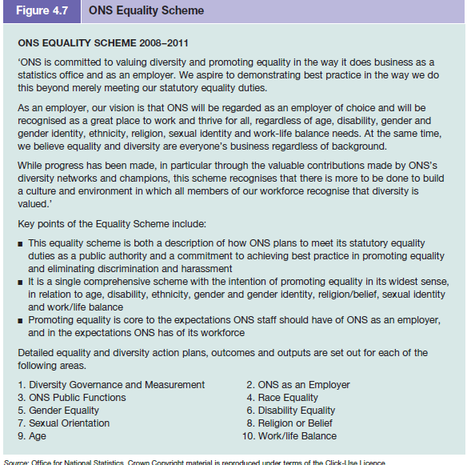

Diversity and management recruitment
The Institute for Employment Studies, in conjunction with the Chartered Management Institute, emphasises the importance of diversity as a strategic priority for retaining and developing key people in an organisation. They draw attention to the different career ambitions of managers from under-represented groups and state that, if organisations want management talent at the top, recruitment approaches must recognise that managers from
different ethnic groups are attracted by different benefits. For example, compared with other ethnic groups, black managers were more likely to cite good progression opportunities; Asian managers more likely to cite working for a good employer; managers from mixed background to cite challenging work; white managers and black managers more likely to mention better work/life balance.77

Diversity action plans
Management of diversity requires an effective action checklist and plan. As an example, The Office for National Statistics (ONS) has produced a comprehensive and detailed Equality Scheme 2008–2011 which includes reference to ONS as an employer; equality impact assessments; and governance, monitoring, reporting and reviewing. This is shown as Figure 4.7.
Figure 4.

DIVERSITY TRAINING
More than ever, effective organisational performance demands an understanding of, and response to, diversity. This necessitates a work climate that respects individual differences and treats all members of staff with dignity and mutual respect. Diversity training will not be effective unless there is active support from the top and it is recognised as a company-wide initiative and part of the core value of the organisation.
Organisations need to manage diversity in a manner that benefits the well-being of all members of staff. Training should involve:

■ increasing the awareness and value of diversity;
■ education in understanding the culture and values of members of a diverse workforce;
■ the ability to communicate effectively with all members of staff – and also customers and
suppliers;
■ developing the skills of effective diversity management;
■ addressing biases, prejudices and stereotypes.

Business in the Community (BITC) is one of the agencies that help businesses to embrace a culture of inclusiveness by helping them to look at the competitive case for diversity. Current activities focus on labour market discrimination, religious beliefs, sexual orientation, and general diversity and equality.79 As another example, ACAS draws attention to managing disability and to the importance of line managers’ contribution to organisational
culture and managing performance. Training managers in effective people management skills and developing a culture of inclusion are crucial.80 Attention to top management is also required. Arkin suggests that in company headquarters the chances are that the people will be overwhelmingly white, male, able-bodied and of a certain age. There is little joinedup thinking between activities under the diversity agenda and the nurturing of top talent.81

The effective management of diversity will also entail a review of organisational processes and the execution of work. For example, not everyone

■ shares the same work ethic or seeks the same goals and objectives;
■ responds in the same way to working in a bureaucratic structure;
■ works better in a self-managed group or with a more participative style of management;
■ will fit the same psychometric profile;
■ is motivated in the same way; or
■ reacts the same way to different forms of control.

Diversity management requires time and effort and may well have a high financial cost. There is a general feeling that badly managed initiatives do more harm than good. Managing diversity requires a company-wide philosophy and commitment, a change to organisational culture and supportive systems of management and training.

Diversity and stereotyping
Diversity also challenges many traditional stereotypes. Stereotyping infers that people within a particular perceived category are assumed to share the same traits or characteristics. Stereotypes are a means of making simplified judgements of other people instead of coping with a range of individual stimuli. Stereotyping attributes to all individuals the characteristics or tendencies of the categorisation as a whole. An important feature of
managing diversity is an awareness of, and training in, overcoming inaccurate stereotyped perceptions and attributions. A greater understanding of cultural differences in non-verbal communications and body language will help improve interpersonal relationships.

Managers’ attitudes, values and beliefs
If they are to be successful in managing diversity, managers need to have greater reserves of emotional intelligence (discussed earlier in this chapter). In turn this suggests that managers need to have an awareness of, and be able to get in touch with, their own attitudes, values and beliefs – what they are and where they come from. Clements and Jones recognise that the process can be uncomfortable:

A model of good diversity training will recognize that when people engage in an exploration of their attitudes, values, beliefs and prejudices, this may be an uncomfortable process. Some will find out things about themselves that will cause them emotional pain, and often the tension in learners will relate to how they should respond.83

TOP PERFORMING ORGANISATIONS
An increasing number of public and private organisations appear to recognise the business case for diversity. The government department for Business, Enterprise and Regulatory Reform (BERR), created on the disbanding of the Department of Trade and Industry, is among top public sector performers. In the private sector, Lloyds TSB has been praised for its approach.

BERR diversity statement
‘Promoting Equality, Valuing Diversity’
The BERR Operating Committee and Management Board agreed the Department’s revised diversity strategy in September 2008. This is the second diversity strategy and builds on the success of the earlier 2006–8 strategy. The 2008–11 strategy reflects the cross-government diversity and equality priorities set by the Cabinet Office and aims to tackle those issues
identified as key by staff and stakeholders.

Proposed actions are based on a number of key themes and pressure points for the Department that needed to be addressed in relation to:

■ representation of women, ethnic minorities and disabled staff in senior levels
■ changing behaviour to create an inclusive culture
■ building on strong leadership and accountability for diversity
■ talent management – bringing in and bringing on people from different backgrounds
■ mainstreaming diversity and equality considerations in management, operations and in policy development.84

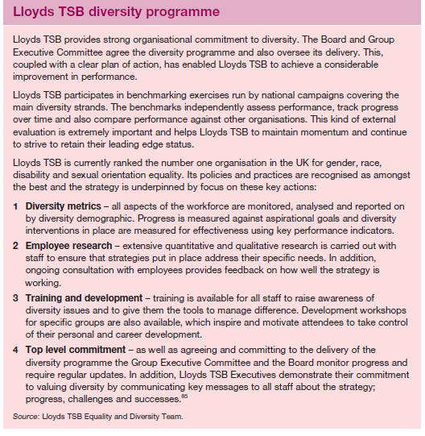

Individuality and groups
Social interaction is a natural feature of human behaviour and group working is a major feature of organisational life. Strong and cohesive groups can have beneficial effects for the organisation but there are potential disadvantages. There is arguably a potential conflict with workforce diversity because of the need to consider staff both as individuals and also as members of a group. The greater the compatibility of its members and the more homogeneous
the group, the greater the danger of the group developing its own subculture. Members may display a critical attitude towards people outside the group or members of other groups. Encouraging individuality and at the same time expecting group co-operation and teamwork are potential triggers for tension.
Concern for moral and social issues
A major concern with the increasing attention to diversity is that too much attention is given to the advantages for business rather than to broader moral or social issues and the ethical arguments for equality of treatment.

In arguing the case for combining heterogeneity and homogeneity, Nordström and Ridderstråle suggest that although quite often people talk favourably about diversity since it supposedly promotes a better atmosphere and equality, the typical manager is persuaded to change the mix of people at the company for economic reasons. ‘The competitive reality is that organisations that are bogged down in issues of race, gender, age, sexual preferences,
look and so on, will slip deeper down in the mire.’89

Kirton and Greene believe that the ‘business case’ should be broadened to include wider issues of social justice and social responsibility.90 Liff and Cameron argue that organisational culture needs to shift radically to win the ‘hearts and minds rather than just achieve reluctant compliance’. In their article, which uses women as their illustration, they assert that there are real dangers in conventional equality measures. Focusing on women as having special
problems requiring special treatment results in resentment and defensive attitudes from managers. They believe that one of the first essential stages to enact change is to consider the organisational culture and the way in which it could move to an equality culture.91

However, Lucas points out that:

One of the key messages the experts want to get across is that paying attention to diversity isn’t just a moral obligation, it’s a business imperative. Workers in organisations where diversity is valued generally feel more engaged with their employer and are more likely to stay on board. The organisation will build a reputation as an ‘enlightened’ employer, and will be able to attract the best people at a time when talent is at a premium. The business can also draw on the expertise of its diverse workforce to create new and improved products and services which will help them get ahead in competitive, global markets.92
DIVERSITY, GENDER AND ORGANISATIONS
One of the most significant and important aspects of managing diversity is that of gender equality, and the participation of men and women in the workforce.93 One of our initial perceptions and classifications of another individual is usually the identification of their gender.

■ How does this perception affect our behaviour?
■ What difference does it make if our work group is predominantly male or female?
■ Do women and men have different experiences at work?
■ If organisations are rational and neutral institutions – why should gender make a difference?
■ Does it matter that many classic theories have been based on research carried out on men, by male researchers?
■ What has been the influence of diversity policies on work behaviour and on the position of women in organisations?

Emotions, politics and gender
Emotions and politics surround the issue of gender. Alvesson and Due Billing suggest that some people may be over-sensitive to gender and interpret any negative comment as if it is symbolic of an act of discrimination. Likewise under-sensitivity may also occur and organisations may remain gender blind to everyday instances of bias and distortion. Although not easy, achieving the right balance (neither overwhelming nor rejecting the pervasiveness of gender) is an important skill in managing men and women at work.94

Contradictions and confusion
Gender research is replete with contradictions and confusions. Although there is a body of evidence to confirm the position, status and (lack of ) power of women in organisations – aspects that can be measured and quantified – such clarity is blurred when it comes to understanding the subjective and qualitative aspects of working life. It is not helpful to view all men or all women as homogeneous groups. There may be as many differences within each gender as between the two genders. Social class, race and age will affect attitudes, beliefs and values and may impinge upon different understandings of gender. Although earlier organisational research could be criticised as having been conducted by men largely investigating male behaviour, so too much of the research on women has been dominated by white middle-class women assuming their values are those that should be upheld.

Perhaps the most positive approach to take is for an organisation to acknowledge the changing working pattern of all employees and to consider the best working practices for managing a diverse workforce as a whole. This should not be done mechanically but by analysis of the organisation and its workforce. Organisations need to analyse, consciously debate and question their unwritten assumptions and expectations in order to reveal prejudices inherent in the culture of their organisations. Analysis of the way in which culture is expressed in all its trivial detail would lead to an understanding of perceptions and attitudes. Until a full analysis is completed it remains doubtful whether more egalitarian practices will develop.

IBM – united by diversity
When IBM decided men and women should be paid equally for doing the same job, and should have equal responsibilities and career opportunities, it made headline news. Not surprisingly – it was in 1935. This early recognition of the importance of an inclusive workplace laid the foundation for today’s focus on diversity, where every employee is encouraged to perform at their best,
and where different opinions are both welcomed and appreciated. IBM Corporation95
Critical reflection

Notes and references
1 We wish gratefully to acknowledge Linda Carter, the
original author of this chapter and the joint author in the
eighth edition of this text.
2 McCrae, R. R. and Costa, P. T. ‘More Reasons to Adopt the
Five-Factor Model’, American Psychologist, vol. 44, no. 2,
1989, pp. 451–2.
3 Bayne, R. ‘The Big Five versus the Myers-Briggs’, The
Psychologist, January 1994, pp. 14–17.
4 Barrick, M. R. and Mount, M. K. ‘The Big Five Personality
Dimensions and Job Performance: A Meta-Analysis’,
Personnel Psychology, Spring 1991, pp. 1–26.
5 Mount, M. K., Barrick, M. R. and Strauss, J. P. ‘Validity of
Observer Ratings of the Big Five Personality Factors’,
Journal of Applied Psychology, April 1994, p. 272.
6 Bentall, R. P. ‘Personality Traits May Be Alive, They May
Even Be Well, But Are They Really Useful?’, The Psychologist,
July 1993, p. 307.
7 Robertson, I. ‘Undue Diligence’, People Management,
no. 22, November 2001, pp. 42–3.
8 Lord, W. and Rust, J. ‘The Big Five Revisited: Where Are We
Now? A Brief Review of the Relevance of the Big Five for
Occupational Assessment’, Selection and Development
Review, vol. 19, no. 4, August 2003, pp. 15–18.
9 Eysenck, H. J. Eysenck on Extraversion, Crosby Lockwood
Staples (1973).
10 Mabey, B. ‘The Majority of Large Companies Use
Occupational Tests’, Guidance and Assessment Review, vol. 5,
no. 3, 1989.
11 Personality tests have been debated by: Bartram, D.
‘Addressing the Abuse of Personality Tests’, Personnel
Management, April 1991, pp. 34–9; and Fletcher, C.
‘Personality Tests: The Great Debate’, Personnel
Management, September 1991, pp. 38–42.
12 Howarth, E. ‘A Source of Independent Variation:
Convergence and Divergence in the Work of Cattell and
Eysenck’, in Dreger, R. M. (ed.) Multivariate Personality
Research, Claiton (1972).
13 Rogers, C. A Way of Being, Houghton Mifflin (1980).
14 Cooley, C. ‘The Social Self ’, in Parsons, T., Shils, E.,
Naegele, K. D. and Pitts, J. R. (eds) Theories of Society,
The Free Press, New York (1965).
15 Erikson, E. H. Identity and the Life Cycle, Norton (1980).
16 Hunt, J. W. Managing People at Work: A Manager’s Guide to
Behaviour in Organisations, third edition, McGraw-Hill
(1992).
17 Jung, C. G. Analytical Psychology: Its Theory and Practice,
Routledge and Kegan Paul (1968). See also Jacobi, J.
Psychology of C. G. Jung, seventh edition, Routledge and
Kegan Paul (1968).
18 Myers, I. B. Introduction to Type, sixth edition, Consulting
Psychologists Press (1998); and Myers, K. D. and
Kirby, L. K. Introduction to Type Dynamics and Development,
second edition, Consulting Psychologists Press (2000).
19 Hirsh, S. K. and Kise, J. Introduction to Type and Coaching:
A Dynamic Guide for Individual Development, Consulting
Psychologists Press (1994).
20 Kelly’s theory as described by Bannister, D. and Fansella,
F., in Inquiring Mind: The Theory of Personal Constructs,
Penguin (1971), pp. 50–1.
21 Stone, G. ‘Personality and Effective Hospitality
Management’, paper presented at the International
Association of Hotel Management Schools Symposium,
Leeds Polytechnic, Autumn 1988; and Worsfold, P. A.
‘Personality Profile of the Hotel Manager’, International
Journal of Hospitality Management, vol. 8, no. 1, 1989,
pp. 55–62.
22 Bartram, D. ‘Addressing the Abuse of Psychological Tests’,
Personnel Management, April 1991, pp. 34–9; Newell, S.
and Shackleton, V. ‘Management Selection: A Comparative
Survey of Methods Used in Top British and French
Companies’, Journal of Occupational Psychology, vol. 64,
1991, p. 23.
23 Kline, P. ‘The Big Five and Beyond’, conference paper
given at the British Psychological Society Occupational
Psychology Conference, University of Warwick, January
1995.
24 Anastasi, A. Psychological Testing, Macmillan (1988),
p. 560.
25 Blinkhorn, S. and Johnson, C. ‘The Insignificance of
Personality Testing’, Nature, 348, 1990, pp. 671–2.
26 Goss, D. Principles of Human Resource Management,
Routledge (1994).
27 Gibbons, P., Baron, H., Nyfield, G. and Robertson, I.
‘The Managerial Performance and Competences’,
conference paper given at the British Psychological
Society Occupational Psychology Conference, University
of Warwick, January 1995.
28 Platt, S. with Piepe, R. and Smythe, J. ‘Teams’: A Game to
Develop Group Skills, Gower (1988).
29 Gray, M. J. ‘Personality and Performance’, Selection and
Development Review, vol. 19, no. 1, February 2003, p. 4.
30 Hochschild, A. R. The Managed Heart: Commercialization of
Human Feeling, University of California Press (1983).
31 Cooper, C. ‘Papering Over the Cracks: Individual Strategies
or Organizational Intervention in Dealing with Stress at
Work’, conference paper given at the British Psychological
Society Occupational Psychology conference, University of
Warwick, January 1995.
32 Friedman, M. and Rosenman, R. Type A Behavior and Your
Heart, Knopf (1974).
33 Rosenmann, R., Friedman, F. and Straus, R. ‘A Predictive
Study of CHD’, Journal of the American Medical Association,
vol. 89, 1964, pp. 15–22; and Warr, P. and Wall, T. Work
and Well Being, Penguin (1975).
34 See, for example, Jex, S. M., Adams, G. A., Elacqua, T. C.
and Bachrach, D. G. ‘Type “A” as a Moderator of Stressors
and Job Complexity: A Comparison of Achievement
Strivings and Impatience-Irritability’, Journal of Applied
Psychology, vol. 32, no. 5, 2002, pp. 977–96.
35 Gratton, L., Hot Spots, Financial Times Prentice Hall
(2007).
36 Ibid., p. 83.
37 Howe, M. J. A. ‘Can IQ Change?’, The Psychologist, February
1998, pp. 69–72.
38 Spearman, C. The Abilities of Man, Macmillan (1927).
39 Vernon, P. E. The Structure of Human Abilities, Methuen and
Co. (1950).
40 Thurstone, L. L. ‘Primary Mental Abilities’, Psychometric
Monographs, no. 1, 1938.
41 Guilford, J. P. ‘ Three Faces of Intellect’, American
Psychologist, vol. 14, pp. 469–79.
42 Gardner, H. Frames of Mind, second edition, Fontana
(1993).
43 Goleman, D. Emotional Intelligence, Bloomsbury (1996),
p. 34.
44 Goleman, D. Working with Emotional Intelligence, Bantam
Books, New York (1998).
45 Boyatzis, R., Goleman, D. and Hay/McBer, Emotional
Competence Inventory Feedback Report, Hay Group (1999).
46 ‘Management Futures: The World in 2018’, Chartered
Management Institute, March 2008.
47 Landale, A. ‘Must Have EQ’, Manager: The British Journal
of Administrative Management, February/March 2007,
pp. 24–5.
48 Ibid.
49 Garrett, A. ‘Crash Course in Raising Emotional
Intelligence’, Management Today, August 2005, p. 16.
50 Dann, J. ‘Managing Your Emotions’, Professional Manager,
vol. 17, no. 4, July 2008, pp. 32–4.
51 Ribeaux, P. and Poppleton, S. E. Psychology and Work,
Macmillan (1978).
52 Gross, R. D. Psychology: The Science of Mind and Behaviour,
Edward Arnold (1987).
53 Hofstede, G. Culture’s Consequences: International Differences
in Work-Related Values, Sage (1980).
54 Katz, D. ‘The Functional Approach to the Study of
Attitudes’, Public Opinion Quarterly, issue 21, 1960,
pp. 163–204.
55 La Piere, R. T. ‘Attitudes versus Action’, Social Forces,
issue 13, 1934, pp. 230–7.
56 Gidoomal, R., Mahtani, D. and Porter, D. The British and
How to Deal With Them, Middlesex University Press (2001).
57 Sykes, A. J. M. ‘The Effect of a Supervisory Training Course
in Changing Supervisors’ Perceptions and Expectations
of the Role of Management’, Human Relations, 15, 1962,
pp. 227–43.
58 Hofstede, G., Nevijan, B., Dhayu, D. D. and Sanders, G.
‘Measuring Organisational Cultures: A Qualitative and
Quantitative Study across 20 Cases’, Administrative Science
Quarterly, vol. 35, 1990, pp. 286–316.
59 Berger, P. L. and Luckmann, T. The Social Construction of
Reality, Penguin (1966), p. 37.
60 MacPherson, Sir William The Stephen Lawrence Inquiry,
The Stationery Office, February 1999, Section 6.17.
61 ‘Undertaking Employee Attitude Surveys’ Checklist 078,
Chartered Management Institute, February 2007.
62 Likert, R. ‘A Technique for the Measurement of Attitudes’,
Archives of Psychology, vol. 22, no. 1, 1932, pp. 1–55.
63 Heider, F. ‘Attitudes and Cognitive Organization’, Journal
of Psychology, vol. 21, 1946, pp. 107–12.
64 Festinger, L. A. A Theory of Cognitive Dissonance, Row,
Peterson and Co. (1957); reissued by Stanford University
Press and Tavistock Publications (1962).
65 Anastasia, A. Psychological Testing, Macmillan Publishing
(1988), p. 23.
66 Barrett, R. S. ‘Guide to Using Psychological Tests’, in
Fleishman, E. A. (ed.) Studies in Personnel and Industrial
Psychology, revised edition, Dorsey Press (1967), p. 58.
67 See, for example, Furnham, A. The Psychology of Behaviour
at Work, Psychology Press (1997); and Wilson, C. ‘Tough
Choices’, Manager: The British Journal of Administrative
Management, May/June 1999, pp. 10–12.
68 Kandola, R. and Fullerton, J. Managing the Mosaic Diversity
in Action, IPD (1994), p. 19.
69 ‘Implementing a Diversity Management Programme’
Checklist 152, Chartered Management Institute, January
2008.
70 Ibid.
71 Guirdham, M. Interactive Behaviour at Work, third edition,
Financial Times Prentice Hall (2002), p. 67.
72 ‘Back to Basics: Acas’ Experience of Equality and Diversity
in the Workplace’, ACAS Policy Discussion Paper no. 5,
November 2006.
73 ‘Littlewoods: Increasing Diversity, Increasing Profits’, Equal
Opportunities Review, no. 81, September/October 1998,
pp. 20–7.
74 ‘Talent not Tokenism: The Business Benefits of Workforce
Diversity’, CBI and TUC, June 2008.
75 Hill, L. A. ‘Leadership as Collective Genius’, in Chowdhury,
S. (ed.) Management 21C, Financial Times Prentice Hall
(2000), p. 53.
76 ‘Managing Diversity: Linking Theory and Practice to
Business Performance’, CIPD, May 2005.
77 ‘Management Recruitment: Understanding Routes to
Greater Diversity’, Chartered Management Institute,
June 2008.
78 From http://hiltonworldwide.hilton.com (accessed
1 March 2006).
79 Information on BITC can be found at
http://www.bitc.org.uk.
80 ACAS ‘Managing Diversity’, Employment Relations Matters,
issue 3, Spring 2005.
CHAPTER 4 INDIVIDUAL DIFFERENCES AND DIVERSITY
169
PART 2 THE INDIVIDUAL
170
81 Arkin, A. ‘Hidden Talents’ People Management, vol. 11,
no. 14, 14 July 2005, p. 26.
82 Khan, S. P.U.S.H. for Success, Vermilion (2006), p. 230.
83 Clements, P. and Jones, J. The Diversity Training Handbook,
Kogan Page (2002), p. 45.
84 www.berr.gov.uk (accessed 3 March 2009).
85 Information kindly provided by Lloyds TSB Equality and
Diversity Team.
86 Francesco, A. M. and Gold, B. A. International
Organizational Behavior, Prentice Hall (1998), p. 236.
87 ‘Back to Basics: Acas Experience of Equality and Diversity
in the Workplace’, ACAS Policy Discussion Paper no. 5,
November 2006.
88 ‘Implementing a Diversity Management Programme’
Checklist 152, Chartered Management Institute, January
2008.
89 Nordström, K. and Ridderstråle, J., ‘Funky Inc.,’ in Crainer,
S. and Dearlove, D. (eds), Financial Times Handbook of
Management, second edition, Financial Times Prentice
Hall (2001), p. 63.
90 Kirton, G. and Greene, A.-M. The Dynamics of Managing
Diversity, Butterworth Heinemann (2000).
91 Liff, S. and Cameron, I. ‘Changing Equality Cultures
to Move Beyond Women’s Problems’, Gender, Work
and Organization, vol. 4, no. 1, January 1997, pp. 35–46.
92 Lucas, E. ‘Making Inclusivity a Reality’, Professional
Manager, vol. 16, no. 4, July 2007, pp. 32–5.
93 See, for example, ‘What’s Keeping Women out of the Top
Jobs?’, Social Agenda, The European Commission, no. 16,
February 2008, pp. 7–10.
94 Alvesson, M. and Due Billing, Y. Understanding Gender and
Organization, Sage (1997).
95 IBM in the UK 2005, IBM Corporation, 2005, p. 41.
96 From the B&Q website: www.diy.com/diy/jsp/
bq/templates/content_lookup.jsp?content=/
aboutbandq/2004/company_information/
history_brief.jsp&menu=aboutbandq.
97 Talk at Portsmouth University Business School by CEO
Euan Sutherland, 9 July 2009.
98 B&Q ‘Is Age a Barrier to Employment? Equality +
Diversity: Achieving a Balanced Workforce’, http://www.
diy.com/diy/jsp/aboutbandq/2004/social_responsibility/
pdfs/age_policy.pdf (accessed 28 July 2009).
99 Warr, P. and Pennington, J. Views about Age Discrimination
and Older Workers, Institute of Personnel Management
(1993).
100 Stoney, C. and Roberts, M. ‘The Case for the Older
Worker at Tesco: An Examination of Attitudes,
Assumptions and Attributes’, Carleton University
School of Public Policy and Administration Working
Paper no. 53, 2003.
101 B&Q op. cit.
102 The Employers Forum on Age can be found at
www.efa.org.uk.
103 B&Q Statement of Social Responsibility, www.diy.com
(accessed 28 July 2009).
104 Talk at Portsmouth University Business School by CEO
Euan Sutherland, 9 July 2009.
105 Gallup Great Workplace Award, http://www.gallup.com/
consulting/ (accessed 28 July 2009).

