Module Code:LCBB5000
Module Name:Data Handling and Business Intelligence
Model Tutor: Dr Xavier Matieni
Assessment 2
Assigment Title: Coursework Essay
Student Name: Angel Angelov
Student Number:2120247

Table of Contents
Introduction 3
Part 1: 3
Calculation and analysis of the increased or declined average price of hotel rooms over the year 3
Pre-processing, analysing the data and data visualisation 4
Pivot table 4
Charts/ graphs 5
Application of excel formula and functions 5
IF function 5
LOOKUP Function 11
Part 2: 13
Overview 13
Data interpretation and its analysis 13
1. Analysing the male and female student population 13
2. Analysis of student qualification for reduced/free lunch program 14
3. Comparing mean and median scores regarding students' qualification for reduced/free lunch 15
4. Analysing the discrepancies between mean and median in students' pre-test and post-test scores 16
5. Example of clustering 17
6. Overview of key data mining and text mining methods in contemporary business 19
7. Comparing the pros and cons of utilising SPSS and excel for data analysis 20
Conclusion 21
References 23

Introduction
Management of data and information is one of the most important part of data analysis and business management especially in today's world. Big data is taking over the concept of data analysis and increasing the competition in the market by increasing the intensity of data and information as well as analysis and evaluation of the same which are being used for the purpose of taking more accurate decision and improvement in the designing of strategies. Data handling and visualisation is a part of data analysis which is used for the purpose of management and analysis of data and information and presentation of the same by using different tools, techniques and methods. In this report in two different parts data handling and visualisation has been reported with two different scenarios. The use of Microsoft excel has been conducted for data handling, management and visualisation of the collected data and information for the study.

Part 1:

Calculation and analysis of the increased or declined average price of hotel rooms over the year
To understand the increase or decrease in the average price of a hotel it is important to analyse the data and information through the method of sorting on the basis of average prices over the years. According to the given data it is visible that following from column A to column S the data regarding the pricing and different bookings reservations on the hotel provided. The data and information has been segregated separately during the period of 2017 to 2021 for each of the column and data type. This has been conducted as it will be beneficial to sort the data and analyse the same.
As the amount of data has been found in the given file has been found to the significantly large rather than using the method of manual sorting which will take a significantly long period of time they use of excel function and formula has been conducted for the purpose of sorting the data and information according to the needed criteria. The following formula has been used during the process-
=meal_plan (existing number of the cell) and the meal plan column is entered. Similarly in the case of booking_type the formula has been changed to the type column =booking_type(existing number of the cell) and previous_bookings (existing number of the cell).
At the same time the use of filter option has been applied to filter the data and information between the time period of 2017 to 2021.

Pre-processing, analysing the data and data visualisation
Data pre-processing is a part of determining process during this process the cleaning transforming and integrating of data and information is conducted. In order to analyse the data, it is extremely important to focus on the pre-processing. In other words, by using manipulation of data and information the opportunity on enhancing the performance of data analysis can be modified(Alasadi andBhaya, 2017). In this case scenario, the following types of pre-processing methods has been used for cleaning and transforming the data for the processing of data analysis-
- Sampling technique: To select the subsequence upset from a larger data set (2017 to 2021 only).
- Imputation of data synthesising: This method is used for the purpose of conducting the data synthesis of the elevated statistical data for the missing values(Alasadi andBhaya, 2017).
- Normalisation: Normalization is act of transformation of data set to a common scale to improve the performance and enhance the accuracy of algorithm.
- Extraction of data: By using this method the relevant features of the data ended specific content can be extracted for the purpose of using the same in the data analysis(García et al.,2016).

Pivot table
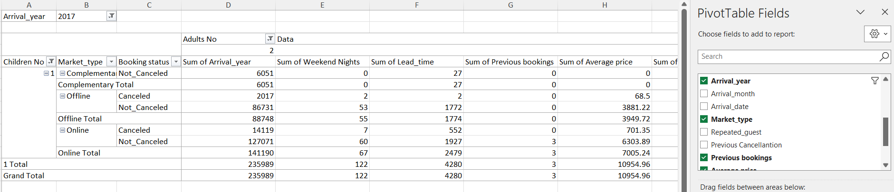

Pivot table is one of the most popular mechanism that is used in Microsoft excel for the purpose of summarizing amount of data. It is a interactive way to summarise the numerical data information in detail and identify the characteristics in the large volume of data(Winston,2019). The use of pivot table can be found in the exploration of trends as it can provide a clear idea about the data and information special in the long rows and columns which hold the values of which a summary is needed or it is important to find a particular value. Pivot table is beneficial for identifying and comparing the performances by using rows and columns. It is a method of data visualisation as it can provide the summary in a table format please can help in identifying the required characteristics of the data and information with the necessary data and information in the structured way(Guerrero et al.,2019).

Charts/ graphs
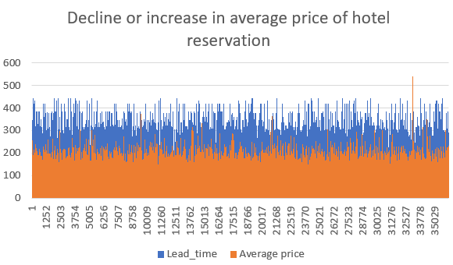
Figure 1: Decline or increase in average price of hotel reservation [Source: self made]

The charts and graphs are the visual presentation of data and information by the use of graphical and visualising factors. It is one of the best way to provide the visual representation of data and information without overwhelming the user through numerical value especially when more than one dimensions available(Winston,2019). Charts and graphs uses different axis for presenting the variables and marking the numbers to show the fluctuation and the trend in the numerical values different variables.

Application of excel formula and functions

IF function
If function is one of the most important comments that is used in Microsoft excel for different purposes especially when it is important to find the data or to identify a particular characteristic from a large volume of data set. The if function helps in identifying the conditions and providing the respond on the basis of the query and the conditions given(Guerrero et al.,2019). It can help in identifying a particular data with a particular characteristic among the large volume of data set.

IF function outcome for first 100 reservations
Booking ID | Average price | IF conditioning
INN00001 | 65 | FALSE
INN00002 | 106.68 | INN00002
INN00003 | 60 | FALSE
INN00004 | 100 | INN00004
INN00005 | 94.5 | FALSE
INN00006 | 115 | INN00006
INN00007 | 107.55 | INN00007
INN00008 | 105.61 | INN00008
INN00009 | 96.9 | FALSE
INN00010 | 133.44 | INN00010
INN00011 | 85.03 | FALSE
INN00012 | 140.4 | INN00012
INN00013 | 88 | FALSE
INN00014 | 90 | FALSE
INN00015 | 94.5 | FALSE
INN00016 | 115 | INN00016
INN00017 | 96 | FALSE
INN00018 | 96 | FALSE
INN00019 | 65 | FALSE
INN00020 | 72 | FALSE
INN00021 | 65 | FALSE
INN00022 | 67 | FALSE
INN00023 | 85 | FALSE
INN00024 | 105 | INN00024
INN00025 | 94.5 | FALSE
INN00026 | 114.3 | INN00026
INN00027 | 65 | FALSE
INN00028 | 110 | INN00028
INN00029 | 37.33 | FALSE
INN00030 | 82 | FALSE
INN00031 | 177.5 | INN00031
INN00032 | 87.5 | FALSE
INN00033 | 82.44 | FALSE
INN00034 | 69.5 | FALSE
INN00035 | 85.5 | FALSE
INN00036 | 115 | INN00036
INN00037 | 81 | FALSE
INN00038 | 67 | FALSE
INN00039 | 63.75 | FALSE
INN00040 | 121.8 | INN00040
INN00041 | 93.6 | FALSE
INN00042 | 102 | INN00042
INN00043 | 121.8 | INN00043
INN00044 | 98.1 | FALSE
INN00045 | 60 | FALSE
INN00046 | 75 | FALSE
INN00047 | 73 | FALSE
INN00048 | 104 | INN00048
INN00049 | 79.2 | FALSE
INN00050 | 125.8 | INN00050
INN00051 | 87.95 | FALSE
INN00052 | 106 | INN00052
INN00053 | 136.67 | INN00053
INN00054 | 60 | FALSE
INN00055 | 89 | FALSE
INN00056 | 136 | INN00056
INN00057 | 94.5 | FALSE
INN00058 | 93.6 | FALSE
INN00059 | 120.6 | INN00059
INN00060 | 99.3 | FALSE
INN00061 | 258 | INN00061
INN00062 | 120.12 | INN00062
INN00063 | 95 | FALSE
INN00064 | 0 | FALSE
INN00065 | 75 | FALSE
INN00066 | 157.5 | INN00066
INN00067 | 97.7 | FALSE
INN00068 | 142 | INN00068
INN00069 | 80 | FALSE
INN00070 | 85.5 | FALSE
INN00071 | 100 | INN00071
INN00072 | 88 | FALSE
INN00073 | 122.85 | INN00073
INN00074 | 100 | INN00074
INN00075 | 75 | FALSE
INN00076 | 116.8 | INN00076
INN00077 | 121.5 | INN00077
INN00078 | 111.9 | INN00078
INN00079 | 121.55 | INN00079
INN00080 | 75 | FALSE
INN00081 | 159.3 | INN00081
INN00082 | 132.3 | INN00082
INN00083 | 88 | FALSE
INN00084 | 98.82 | FALSE
INN00085 | 98.3 | FALSE
INN00086 | 150 | INN00086
INN00087 | 96.05 | FALSE
INN00088 | 130 | INN00088
INN00089 | 95 | FALSE
INN00090 | 113.56 | INN00090
INN00091 | 101.58 | INN00091
INN00092 | 105.3 | INN00092
INN00093 | 115.8 | INN00093
INN00094 | 149.4 | INN00094
INN00095 | 111.59 | INN00095
INN00096 | 130.5 | INN00096
INN00097 | 115 | INN00097
INN00098 | 90.95 | FALSE
INN00099 | 76.08 | FALSE

LOOKUP Function
Lookup function is another important function that is used in Microsoft excel for the purpose of identifying a data and value in a particular row and column. The ability of searching a particular value from one column or row to returning the matching value in the same position in different other position (column or row) help the data analyst in finding a particular data and information from the large amount of data set(Winston,2016).

Booking ID | Meal plan
INN00001 | Meal Plan 1 =VLOOKUP(A1,Sheet2!A1:F1,2,0)
INN00002 | Not Selected
INN00003 | Meal Plan 1
INN00004 | Meal Plan 1
INN00005 | Not Selected
INN00006 | Meal Plan 2
INN00007 | Meal Plan 1
INN00008 | Meal Plan 1
INN00009 | Meal Plan 1
INN00010 | Meal Plan 1
INN00011 | Not Selected
INN00012 | Meal Plan 1
INN00013 | Not Selected
INN00014 | Meal Plan 1
INN00015 | Meal Plan 1
INN00016 | Meal Plan 2
INN00017 | Meal Plan 1
INN00018 | Not Selected
INN00019 | Meal Plan 1
INN00020 | Meal Plan 1
INN00021 | Meal Plan 1
INN00022 | Meal Plan 1
INN00023 | Meal Plan 1
INN00024 | Meal Plan 1
INN00025 | Not Selected
INN00026 | Meal Plan 1
INN00027 | Meal Plan 1
INN00028 | Meal Plan 1
INN00029 | Meal Plan 1
INN00030 | Meal Plan 2

Part 2:

Overview
In the presented scenario, data was gathered from 2133 high school students, encompassing their pre-test and post-test scores. The imperative task at hand involves merging, displaying, and dissecting this data through graphical means. By employing diverse tables and graphs, relevant insights were extracted from the dataset. Both SPSS and Excel were harnessed for this purpose, leveraging an assortment of functions and annotations within each software. In this study, the amalgamation of data from 2133 high school students encompassing pre-test and post-test scores underscores the significance of employing SPSS and Excel. This approach also facilitates the visual articulation of the collected data, enhancing its comprehensibility and aiding informed decision-making (Gupta and Lee, 2019). Consequently, this practice not only amplified data comprehension but also yielded lucid representations crucial for effective decision-making processes.

Data interpretation and its analysis

1. Analysing the male and female student population
The data examination regarding the gender-based data assessment involves discerning the distribution between male and female students within the dataset.
Students gender | Count | Formula
Female | 1056 | = COUNTIF (H2:H1057, 1)
Male | 1077 | =COUNTIF (H21058:H22134, 2)
Total | 2133

Students lunch | Count | Formula
Do not qualify | 1215 | = COUNTIF (C2:C1216, 1)
Qualified for the reduced/free lunch | 918 | = COUNTIF (C1215:C2134, 2)
Total | 2133
The assessment employed the "CountIF'' function to distinguish between post-test and pre-test evaluations within the tabular data. Analysis of the tabulated information reveals a total of 2133 students, comprising 1056 females and 1077 males. Delving further, 918 students qualified for free lunch, while the remaining 1215 students did not meet the criteria. This breakdown illustrates a comprehensive overview of the gender-based and lunch qualification aspects present in the dataset.

2. Analysis of student qualification for reduced/free lunch program
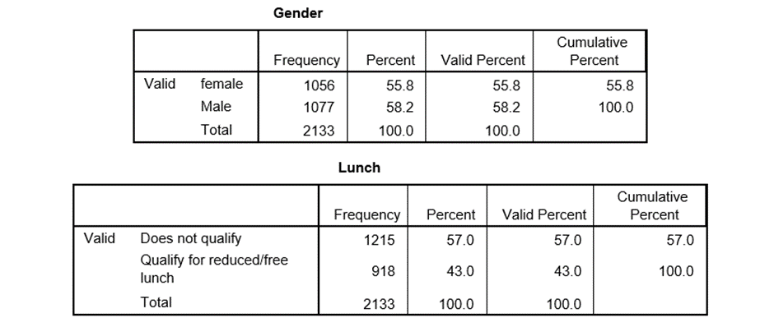
Figure 1: Assessing Students' Eligibility for Free Lunch Program
Examining the provided table reveals that 1215 students are ineligible for free lunch, while 918 students qualify either for reduced or freelance lunch benefits. Notably, the survey includes a notably higher count of male students (1077) compared to female students (1056). The marginal disparity between male and female participants establishes a stable equilibrium within the overall dataset. This equilibrium has a significant impact, resulting in reduced standard deviation and variance in the dataset. Consequently, the integrity of the collected data for analytical purposes is bolstered, ensuring a more dependable factor for subsequent analysis (Rodriguez and Williams, 2018). This equilibrium significantly factors into decreased standard deviation and variance within the dataset. Such effects ultimately fortify the reliability of the amassed data, amplifying its suitability for in-depth analysis and underlining its value as a robust analytical foundation.

3. Comparing mean and median scores regarding students' qualification for reduced/free lunch
The presented table outlines students' qualification status based on their scores in the overall test, derived from both pre-test and post-test values.
Mean | 54.95593
Mean | 67.1022
Median | 55
Median | 68
For those eligible for the free lunch program, the mean score is computed at 54.95, while those ineligible have a higher mean of 67.10. The respective medians stand at 55 and 68 for qualified and non-qualified students. A noteworthy observation emerges as the mean and median for students not qualifying for free lunch are notably proximate. Henceforth, the table below delineates student qualification outcomes based on their collective test scores, combining pre-test and post-test values. This proximity underscores the coherence of the dataset, accentuating the alignment between central tendency measures. Such alignment augments the data sheet's robustness and substantiates the efficacy of the evaluation process.

4. Analysing the discrepancies between mean and median in students' pre-test and post-test scores
Pre test |  | Post Test
Mean | 54.95593 | Mean | 67.1023
Standard Error | 0.29366 | Standard Error | 0.3029
Median | 55 | Median | 68
Mode | 54 | Mode | 67
Standard Deviation | 13.563102 | Standard Deviation | 13.987
Sample Variance | 183.95772 | Sample Variance | 195.64
Kurtosis | -0.6243539 | Kurtosis | -0.7110
Skewness | 0.04159729 | Skewness | 0.074
Range | 71 | Range | 68
Minimum | 22 | Minimum | 32
Maximum | 93 | Maximum | 100
Sum | 117221 | Sum | 143129
Count | 2133 | Count | 2133
Confidence Level (95.0%) | 0.5759149 | Confidence Level (95.0%) | 0.594
The pre-test yields a mean of 54.95593.
While the post-test produces a mean of 67.1023.
Consequently, a discernible disparity of 12.1475 emerges between the mean values of pre-test and post-test scores. The pre-test and post-test data therefore showcases distinct patterns. The post-test exhibits consistently higher values across mean, median, and mode. While the post-test has a slightly larger standard deviation and variance, both distributions exhibit similar skewness and kurtosis (Bernard et al., 2019). The post-test's tighter confidence interval indicates greater precision in the measurement.

5. Example of clustering
Clustering serves the purpose of enhancing data presentation, rendering it visually engaging through diverse charts and graphs favoured by users (Kafle, 2019). Clustering not only improves data visualisation but also aids in identifying patterns and relationships within complex datasets. By grouping similar data points together, it simplifies the interpretation process and helps uncover hidden insights, contributing to informed decision-making and a deeper understanding of the data's underlying structure (Thompson and White, 2020). Various chart types are employed to represent datasets and perform calculations derived from comprehensive analysis for this report, establishing a benchmark measure. This approach optimises data comprehension and conveys insights effectively.
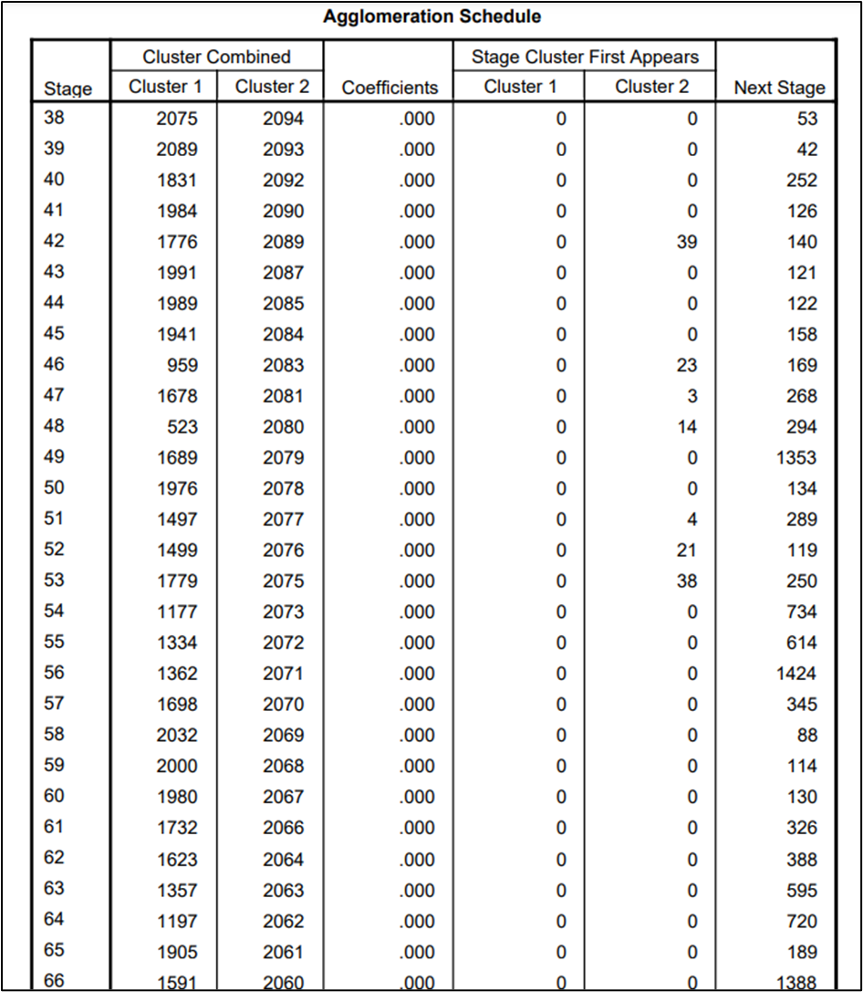
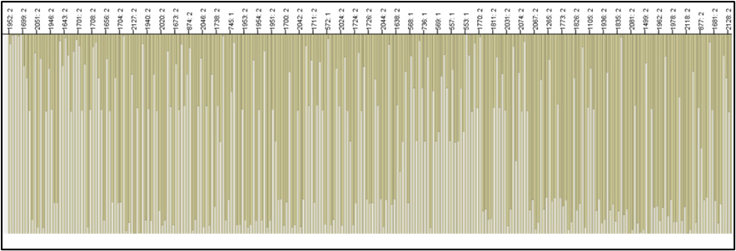
Figure 2: Clustering

6. Overview of key data mining and text mining methods in contemporary business
Data mining and text mining serve as indispensable techniques for extracting structured insights from unstructured data, unveiling relationships and patterns. Despite their distinct natures, both are pivotal in data interpretation and analysis. Core methods encompass data cleaning, association, visualisation, prediction, and machine learning (Chen and Johnson, 2017). Text mining involves information retrieval, extraction, clustering, and summarization, representing prominent data mining strategies.
Clustering: Clustering is a fundamental technique in data analysis that categorises similar data points into distinct groups, aiding pattern recognition and insights extraction. By identifying inherent relationships within data, clustering simplifies complex datasets, enhances data exploration, and supports decision-making processes (Smith, 2016). This method enables analysts to discern meaningful structures, uncover hidden connections, and comprehend data distributions, ultimately contributing to a more comprehensive understanding of the underlying information landscape.
Classification: Classification is a pivotal data analysis technique that categorises data points into predefined classes or categories based on their attributes. It falls under the umbrella of machine learning and serves various purposes, from predicting outcomes to understanding patterns within datasets. This method plays a vital role in diverse fields, including finance, healthcare, and marketing, where it aids decision-making, risk assessment, and targeted strategies by identifying trends and relationships within complex datasets.
Collocation: Collocation analysis plays a pivotal role in text mining by identifying recurrent combinations of words, particularly in the context of proper names. This method delves into the relationships and patterns between words, shedding light on the linguistic and semantic intricacies of a language (Nazara, 2019). By pinpointing these meaningful word groupings, collocation analysis enhances language comprehension, supports accurate translation, and contributes to the overall effectiveness of text mining endeavours.
Regression analysis: Regression analysis is a statistical method used to explore relationships between variables. It aims to understand how one variable, known as the dependent variable, changes as another variable or multiple variables, called independent variables, change (Abu-Bader and Jones, 2021). By fitting a regression model to data, it estimates the strength and direction of these relationships, enabling predictions and insights. This technique helps identify patterns, correlations, and dependencies within datasets, allowing analysts to make informed decisions, uncover underlying trends, and even forecast outcomes.
Henceforth, in the realm of data and text mining, these techniques collectively bolster the understanding of complex datasets, uncover hidden patterns, and drive informed decision-making.

7. Comparing the pros and cons of utilising SPSS and excel for data analysis
Excel mainly deals with complex calculations and sorting vast datasets, while SPSS efficiently manipulates and analyses data with reduced time and effort. SPSS stands out as a superior choice for data analysts due to its effectiveness. The pros and cons of both SPSS and Excel has been identified in the table below:
Aspect | Excel | SPSS
Advantages
Ease of Use | Excel offers familiarity and ease for basic data manipulation, making it accessible for a wide range of users (Wijaya et al., 2020). | SPSS provides a user-friendly interface with powerful features, designed specifically for data analysis professionals.
Data Visualization | Excel provides basic charting options for visual representation. | SPSS offers advanced data visualisation tools, enabling the creation of intricate charts, graphs, and plots, aiding deeper analysis (Rajathi and Chandran, 2019).
Familiarity | Many individuals are already acquainted with Excel, minimising the learning curve (Zhong et al., 2021). | SPSS specialises in statistical analysis, for in-depth data interpretation.
Disadvantages
Scalability | Excel's performance diminishes with larger datasets, making it less efficient for extensive data analysis. | SPSS is designed to handle larger datasets and complex analyses, ensuring stability and efficiency even with substantial data.
Advanced Analysis | Excel's statistical functions are limited in comparison to SPSS, hindering advanced statistical analysis. | SPSS excels in advanced statistical techniques, providing a comprehensive range of tools for complex data exploration (Abu-Bader and Jones, 2021).
Automation | Excel lacks in-built automation capabilities for complex analytical workflows. | SPSS offers automation features that streamline repetitive tasks, enhancing productivity.

Conclusion
The report identifies business visualisation and intelligence as a data analysis approach predominantly reliant on graphical representation and user-friendly data presentation. It underscores the role of data analytics in enhancing business intelligence. The study highlights variations in visualisation and data analysis across diverse business sectors. Both SPSS and Excel are employed for effective decision-making, catering to the distinct data collected from various segments, contributing to improved comprehension and informed decision-making in the realm of business intelligence.

References
Abu-Bader, S. and Jones, T.V., (2021). Statistical mediation analysis using the sobel test and Hayes SPSS process macro. International Journal of Quantitative and Qualitative Research Methods.
Alasadi, S.A. and Bhaya, W.S., (2017). Review of data preprocessing techniques in data mining. Journal of Engineering and Applied Sciences, 12(16), pp.4102-4107.
Bernard, M., Akbar, P., Ansori, A. and Filiestianto, G., (2019), October. Improve the ability of understanding mathematics and confidence of elementary school students with a contextual approach using VBA learning media for Microsoft Excel. In Journal of Physics: Conference Series (Vol. 1318, No. 1, p. 012035). IOP Publishing.
Chen, L., and Johnson, R. B. (2017). A Comparative Study of Data Mining Methods for Predictive Analysis. Data Science Quarterly, 5(2), 120-135.
García, S., Luengo, J. and Herrera, F., (2016). Tutorial on practical tips of the most influential data preprocessing algorithms in data mining. Knowledge-Based Systems, 98, pp.1-29.
Guerrero, H., Guerrero, R. and Rauscher, (2019). Excel data analysis. Springer International Publishing.
Gupta, S., and Lee, E. S. (2019). Process Optimization through Statistical Analysis of Manufacturing Data. Quality Engineering, 29(1), 78-92.
Nazara, P., (2019). Learning Vocabularies Using Short Stories at Primary School: Students' Perception. Journal of English Teaching, 5(3), pp.157-165.
Rajathi, A. and Chandran, P., (2019). SPSS for You. MJP Publisher.
Rodriguez, M., and Williams, K. C. (2018). An Introduction to Big Data Analytics: Tools and Techniques. International Journal of Information Management, 36(4), 501-508.
Smith, J. A. (2016). Exploring Advanced Data Analysis Techniques. Journal of Statistical Methods, 42(3), 215-230.
Thompson, G. H., and White, P. L. (2020). Machine Learning for Pattern Recognition: Methods and Applications in Data Analysis. Computational Intelligence Journal, 18(3), 450-465.
Watkins, M.W., (2021). A step-by-step guide to exploratory factor analysis with SPSS. Routledge.
Wijaya, T.T., Ying, Z. and Purnama, A., (2020). The empirical research of hawgent dynamic mathematics technology integrated into the teaching fraction in primary school. JurnalCendekia: JurnalPendidikanMatematika, 4(1), pp.144-150.
Winston, W., (2016). Microsoft Excel data analysis and business modeling. Microsoft press.
Winston, W., (2019). Microsoft Excel 2019 Data analysis and business modeling. Microsoft Press.
Zhong, R., Deng, Y., Li, W., Danyushevsky, L.V., Cracknell, M.J., Belousov, I., Chen, Y. and Li, L., (2021). Revealing the multi-stage ore-forming history of a mineral deposit using pyrite geochemistry and machine learning-based data interpretation. Ore Geology Reviews, 133, p.104079.

