Component 2 plan de development

https://youtu.be/di-gOyEEldg

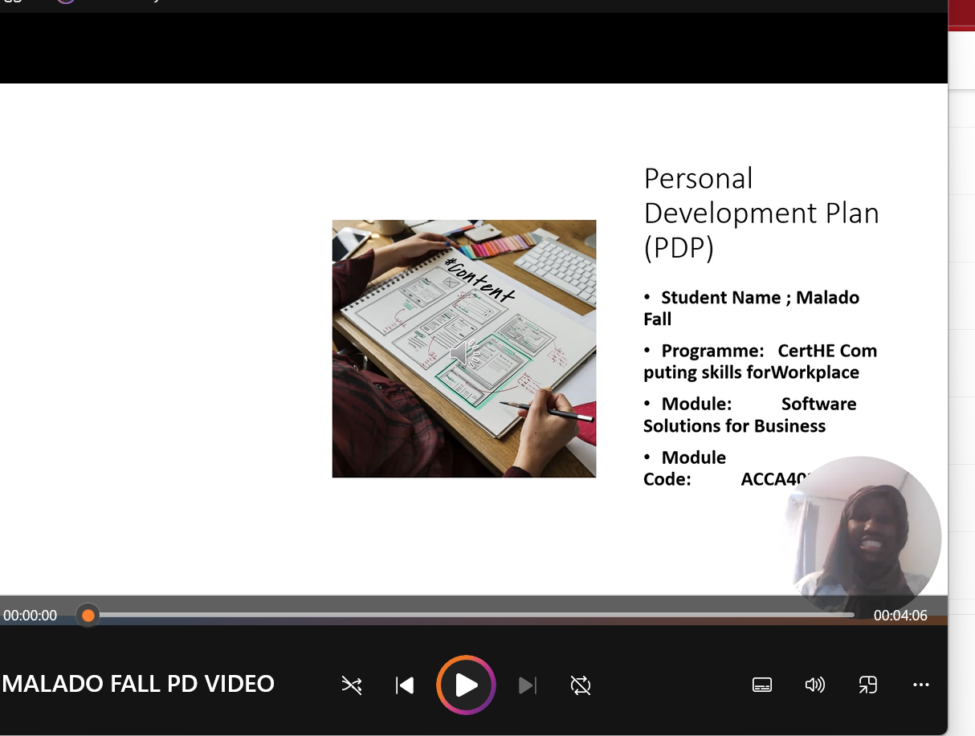


Table of contente
Component 2 plan de development 1
Task 1 – Self-evaluation.Task 2 – PDP.component 2 final presentation MF.pptx 3
Task 3 – Unit 4 topic summary. * A screenshot of the task answer from either e.g. word, online source, PowerPoint or video presentation. 5
Task 4 – Video presentation. 6
component 2 final presentation MF.pptx 7

Task 1 – Self-evaluation.
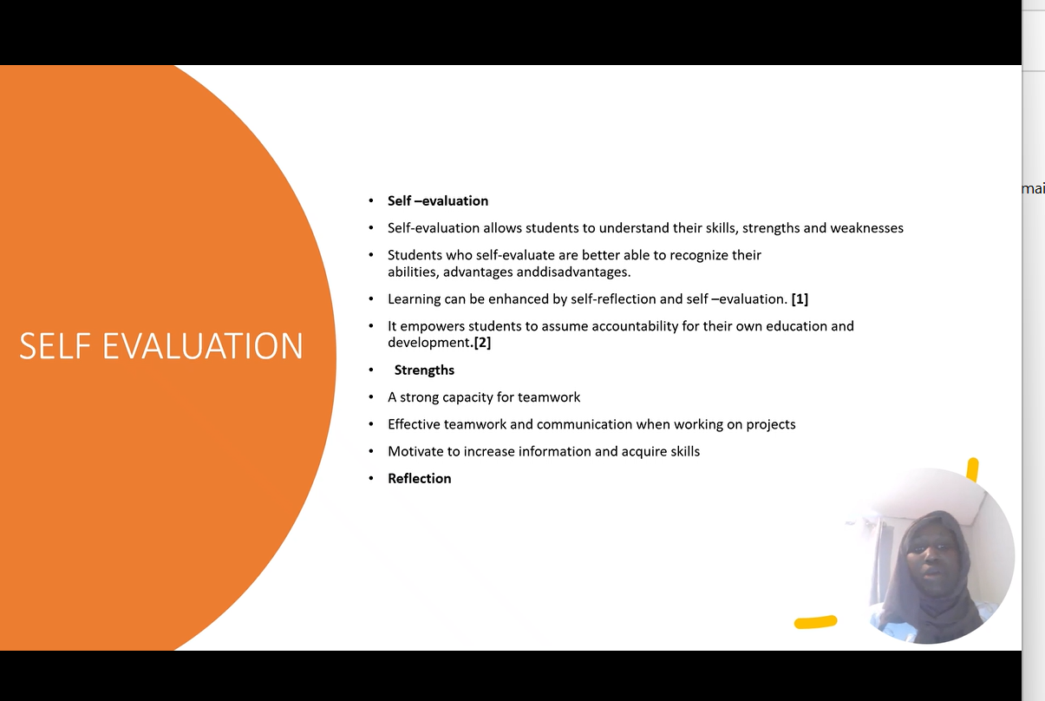

Task 2 – PDP.
component 2 final presentation MF.pptx
https://youtu.be/di-gOyEEldg

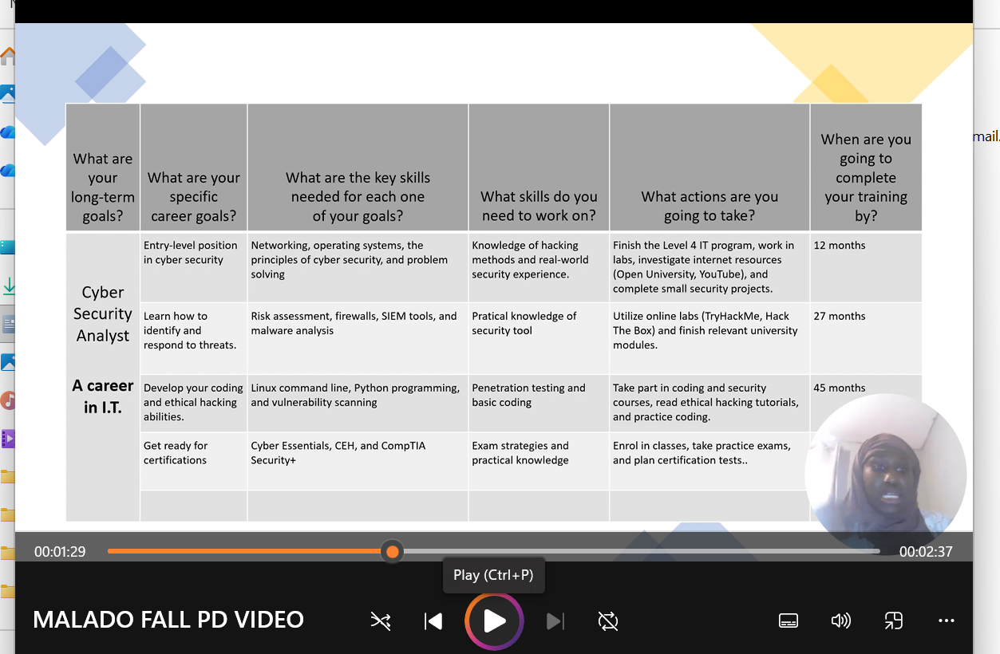

Task 3 – Unit 4 topic summary.
* A screenshot of the task answer from either e.g. word, online source, PowerPoint or video presentation.

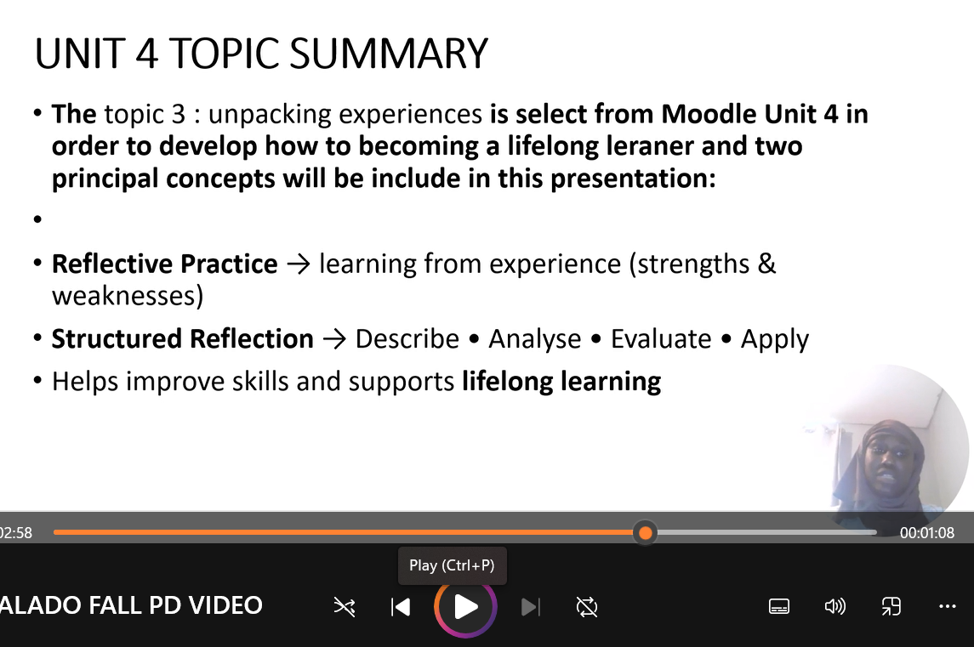

Task 4 – Video presentation.

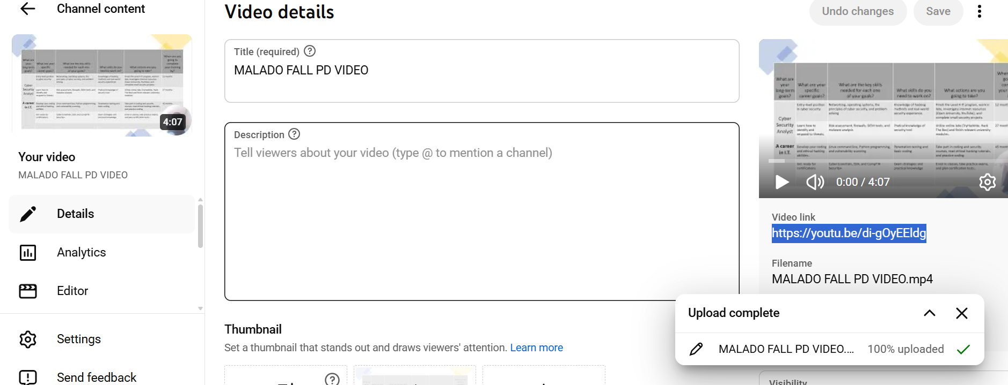

- A single screenshot of the Video in it’s cloud platform (e.g. YouTube).
- A link to view/download the Presentation (e.g. PowerPoint file) from it’s cloud storage (e.g. OneDrive, google drive).

component 2 final presentation MF.pptx
https://youtu.be/di-gOyEEldg

Conclusion

References

