DS 1 Template
Oprescu Georgiana Iuliana
ID number - 2539623

Photo 1
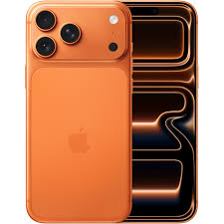
Here's a screenshot of my phone's home screen — it's got all the apps I use daily, like WhatsApp, Gmail, and Google Maps.

Photo 2
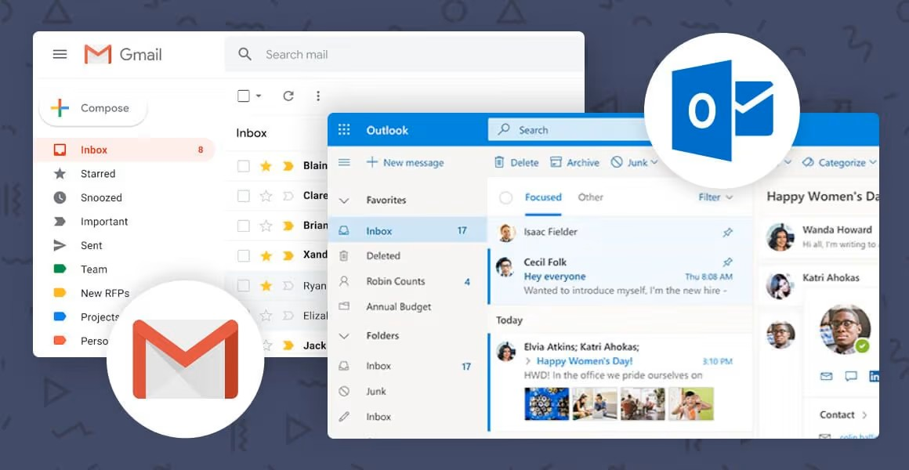
This is a screenshot of my email inbox — I use it to stay in touch with my university, employers, and other important contacts.

Photo 3
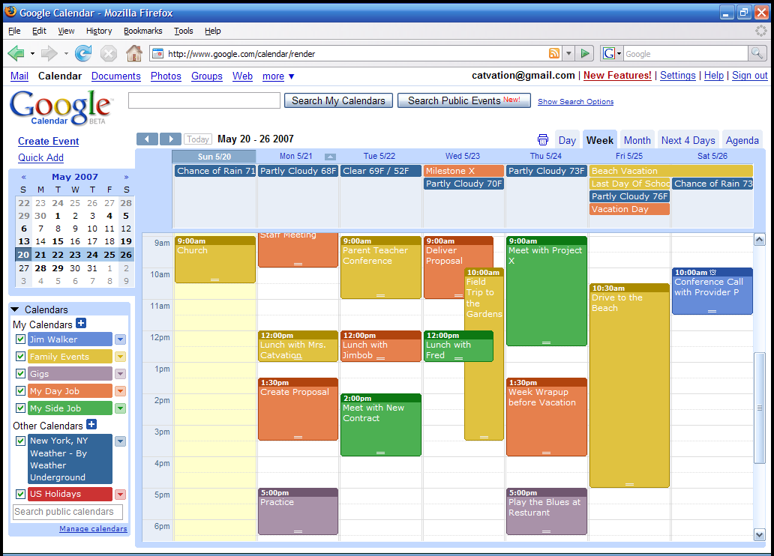
This is a screenshot of my digital calendar — I use it to keep track of my work shifts, university deadlines, and appointments.

Photo 4

Here's what I'm usually listening to or watching in my downtime — just my go-to apps for chilling out.

Photo 5
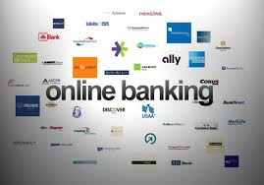
Here's my banking app. I use it for the usual stuff — checking my balance, paying bills, keeping my money sorted.

Photo 6
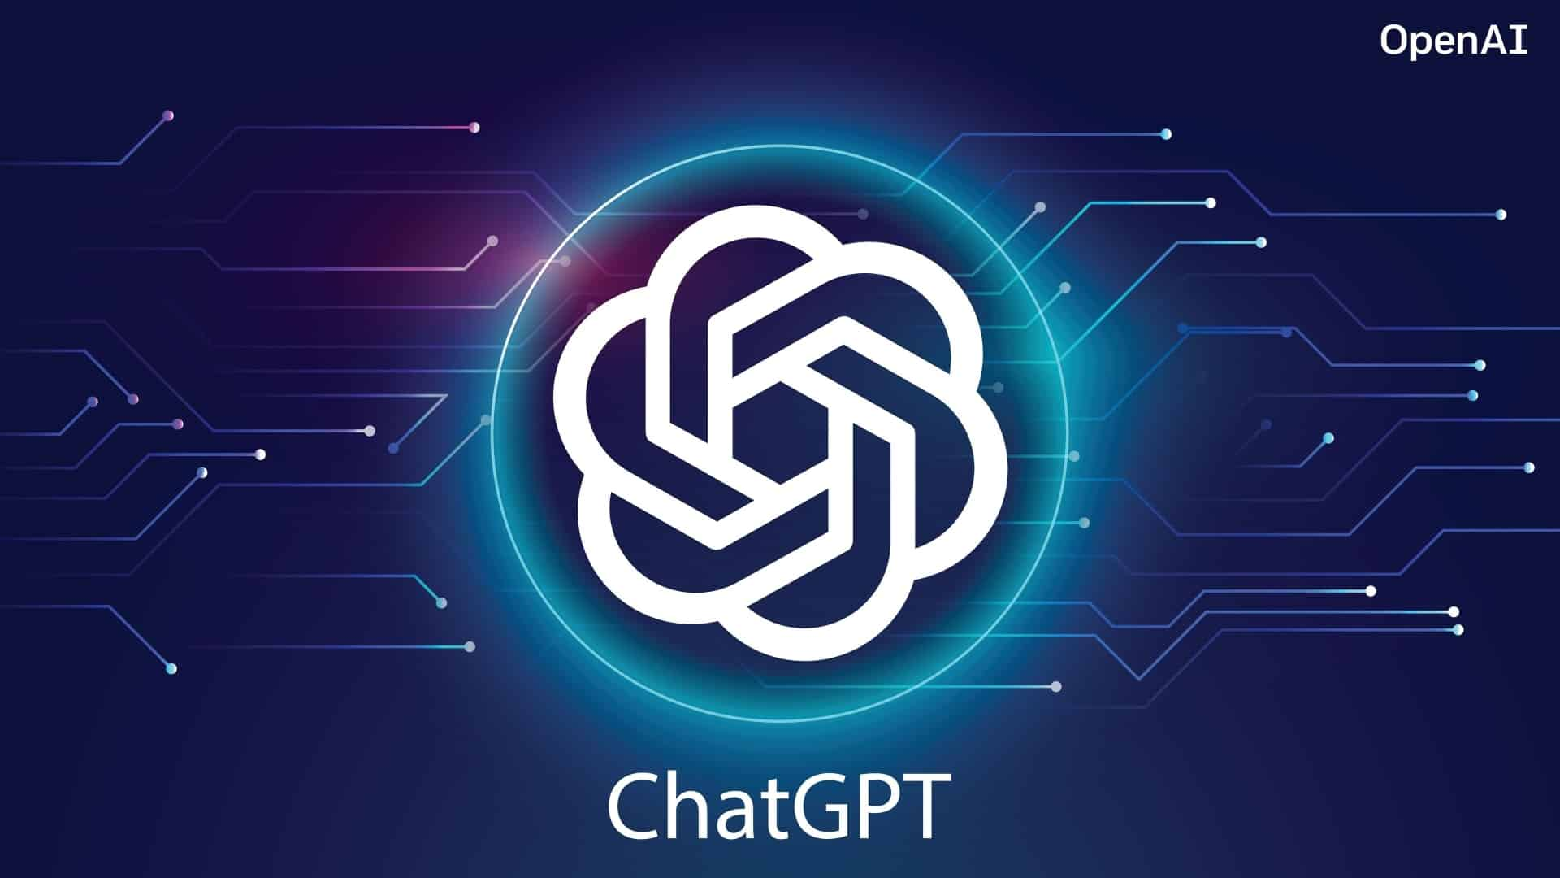
This screenshot displays ChatGPT (or my university portal), which I utilize to support my studies, complete academic assignments, and develop new skills.

Digital stuff is basically woven into my everyday life at this point. I use it to study, keep in touch with friends and family, and stay on top of my work schedule. My go-to tools are Word, Chrome, ChatGPT, Gmail, and WhatsApp. I'm pretty comfortable using tech for assignments and looking things up, but spreadsheets, databases, and making proper presentations? Still a work in progress. Honestly, I get a bit nervous messing up when I'm trying new software. I'm hoping this module helps me feel more confident overall — digital skills are going to matter a lot for university sand my career down the line.

