Contents

Personal Development Plan – Pages 2 – 3

Reflective Practice – Page 4

Part 3 – Page 5 – 7

References – Page 8 – 10

Personal Development Plan

No | Improvement and Development Goals | Success Criteria  (How I will know when I have made this change) | The actions I will take to achieve the goal | Timelines | What will help me to achieve this? | Achievements  (3 monthly review)
1 | To complete my Early Years Degree and eventually complete a master’s degree in social care and use my strength in safeguarding to become a Social Worker. | I will know when I have made this change, when I have successfully completed all degrees needed and obtained employment in a local authority’s children’s services. | I will need to complete the following to achieve this goal:  - Early Years Degree  - Obtain employment as a childcare support worker within a children’s services department.  - Master’s in social care. | 4 years | Managing my time to successfully complete Early Years Degree and continuing to expand on my knowledge in Safeguarding will help to achieve this.
2 | To walk the dogs on a regular basis to ensure that they are getting the exercise that they need and to support my own mental wellbeing | I will be able to identify this to have been succeeded when the dogs are getting out more regularly and are less reactive in the house and when I am able to identify an improvement in my own mental wellbeing. | The following actions will need to be completed to achieve this goal:  - Speak to Aneurin about whether he wants to join me on the walks.  - Ensure that I can carry treats and water.  - Look at when the walks can be fitted into weekly schedule. | 1 week | Encouragement from family members, maintaining a weekly routine to ensure that everything is covered and self-motivation.
3 | Redecorating the house to reflect the achievements of this year and making the home my own. | This change will be apparent when the rooms planned to be redecorated are all painted, wallpapered and feel fresh. | This goal will be achieved by:  - Buying decorating materials e.g. paint, wallpaper, gloss, paint brushes and rollers.  - Prepare the rooms that are going to be decorated by stripping wallpaper, sanding down walls and filling in any holes.  - Ask for family support in moving furniture | 8 weeks | Having the support of my partner to help me to get the rooms prepared and completed.  Also, completing the rooms one by one on a weekly basis will hopefully limit the disruption.
4. | To Complete Circle of Security Training to provide families which I work with the opportunity to complete this work on a one-to-one basis rather than a group | I will have completed the week’s training course that is required to be certified in delivering this course | I will need to identify to my team lead that this training is required and await to be invited into the training | 6 months | Support from team lead in being allocated a place on the training.

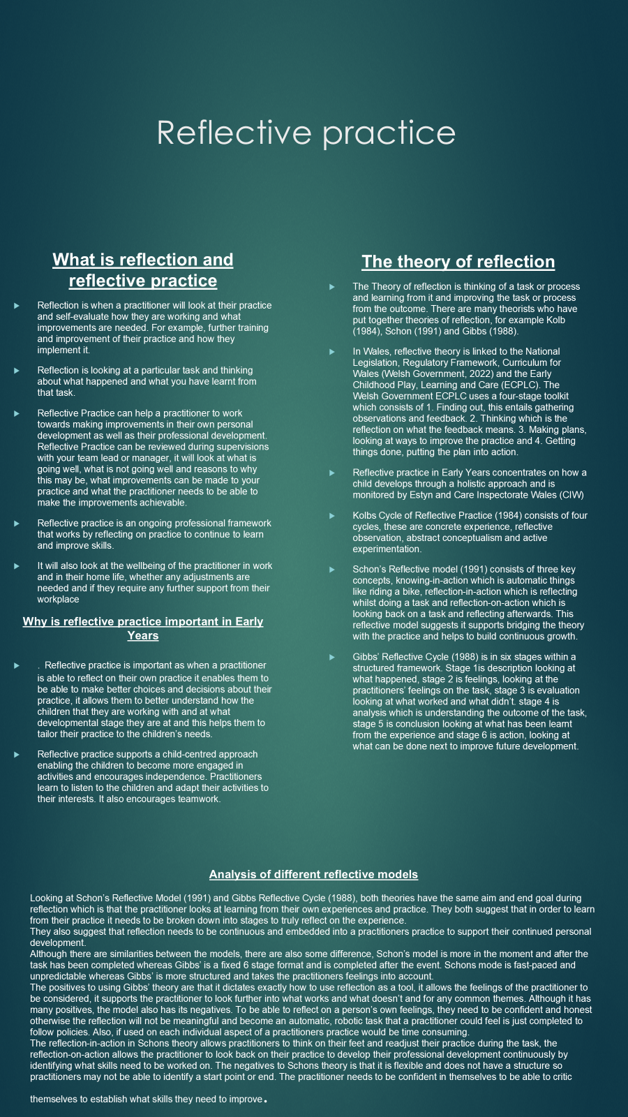

Part 3
Recognise and analyse the significance of different aspects of professional practice and why these are important in meeting the individual and inclusive needs of children.

What is professional practice?

Professional practice is the knowledge and skills that a person has that entails them to do their role successfully. It is the qualifications they have in their specialized roles, the ability to be honest, empathetic and accountable in their practice and actions. The practitioner needs to have the ability to meet the specific industry’s expectations and have a commitment towards professional development.
In Early Years, professional practice consists of having a knowledge of Child Development, the use of reflective practice, multi-agency working, safeguarding and continued professional development ethos.

What is a professional?

A professional is a person who is qualified to be employed in a specific job role. For example, Social Worker, Early Years Family Support Worker, Mental Health Practitioner, these all require a professional to have diplomas or degrees. A professional person has the ability to meet the needs of their job role and employer, and is required to be reliable, respectful, accountable and honest.

Why is communication and relationships important to professional practice and meeting the needs of children?

Communication is important to professional practice to ensure that multi-agency work is effective and that the information being communicated is understood. Communicating amongst other professionals, for example Social Workers, can ensure that the correct and relevant information is recorded, acted on appropriately and it also builds multi-agency working.
From an Early Years point of view, communication is important to develop children’s learning, their emotional wellbeing and it can build positive relationships with parents and carers.
Communication is the forefront of building relationships within an Early Years team and a wider professional collaboration. Multiagency working and effective communication ensure that children are safeguarded, the environments that they are accessing are inclusive and have the ability to meet a child’s individual needs.
Building relationships in a Early Years role with other practitioners, as well as parents and children ensure that all children’s individual developmental needs are met. Having the ability to build a trusting relationship with others allows for consistent interventions from families and professionals supporting the best outcome for the child.
Relationships built with the child support their emotional regulation and attachment (Bowlby, 1997) supports their brain development, social skills and self-esteem.

Why is having in-depth knowledge and understanding important to professional practice, including aspects of safeguarding?

Having in-depth knowledge and understanding is important to professional practice as it makes sure that the practice is safe and accurate. In-depth knowledge ensures that the professional has an ability to make correct decisions in their practice and gives them the understanding of theories that enables them to make thir decision, for example Maslow’s Hierarchy of Needs (Maslow,1943) which is embedded within the Curriculum of Wales supporting children’s physiological needs by providing free school meals, safety and security by using restorative practice, love and belonging by being inclusive, self esteem by empowering children and self-actualisation by encouraging curiosity and independence.

In Early Years, having an in-depth knowledge and understanding in safeguarding children and adults is a vital and essential part of their professional practice. By having this knowledge it enables practitioners to recognize the signs of abuse early like changes in a child’s behaviour or injuries that cannot be explained by the caregiver. Knowing their setting or organisations safeguarding policy and procedures allows the practitioner to report concerns to their local authorities children’s services

Why is partnership and multi-agency working important to professional practice

Multi-agency working is important in professional practice as it enables all professionals who are working with a particular family fully understand the reasons and needs of that family and what support is being provided or can be provided to improve their outcomes. All professionals involved provide a particular skill in which they are able to support. For example, Social worker to protect against harm, Ealry Years to provide family support, Health Visitor for the childrens health needs.
By having a good understanding and providing multi-agency working with effective sharing of information provides the right level of support for families in need. Early intervention, such as Flying Start can help support children and their families to improve their situations and enable the child “to get a better start in life”.
Multi-agency working provides further support that a singular practitioner may not be able to provide and is stated in the Social Services and Well-being (Wales) Act 2014, Wales Safeguarding procedures (2019/2021) and Working Together to Safeguard People legislations and guidance.

How does the observation and planning cycle inform professional practice and ensure practitioners are meeting the needs of children.

The Observation, Assessment and Planning Cycle (OAP) if framework within the Curriculum of Wales that focuses on providing a Child-centred Approach. Practitioners use Observation to watch the children they support and learn about the children’s development and interests. Assessments are provided to put together what has been observed by the practitioners to understand the childrens learning and development which will then lead on to their Planning which will identify a Child-centred Approach and areas of learning that need approvement.
This framework supports professional practice by ensuring that environments are inclusive, it encourages team work, multi-agency working and reflective practice. The OAP framework ensures that practitioners are meeting the needs of the children by observing a child’s individual progress and inputting targeted support if needed for example, early language support, COMit. Like Schon’s(1991) Reflective model and using reflection-in-action a practitioner is able to respond to a child’s learning in the moment.

How do the principles of the UNCRC inform professional practice and Why is this important.

In Wales, the principles of the UNCRC inform professional practice by being implemented in the law “Rights of Children and Young Persons (Wales) Measure 2011.
The United Nations Convention on the Rights of the Child (UNCRC) has four main core principles which are non-discrimination meaning that all aspects of the UNCRC applies to any child regardless of race, religion etc. Best Interests of the Child, Right to life, survival and development and Right to be heard.
In Wales, the UNCRC is covered and put into practice through Children’s Right Approach and is known as “The Right Way”. It ensures that the UNCRC is applied in organisations policies and training. It ensures that the best interests of the child are accounted for and that their voice is heard, that they are given the opportunity to develop healthy sustainable lives and ensure equality for all.
The UNCRC is important from a Early Years perspective as it supports Early intervention and helps children to get the best start in life, which is the ethos of Flying Start. It ensures that practices put the children’s well-being as a priority and that it is in their best interests (Article 3). It gives children the opportunities for play supporting their development which implements their Right to Play (Article 31). Sufficient training teaches practitioners to learn the varied ways that children can communicate their feelings and needs, for example, body language and supports their Right to be Heard (Article 12). Finally, as practitioners have a duty of care to all children, their practice need to ensure that the children have the opportunities to grow, learn and be healthy which supports Survival and Development (Article 6).

References

Children’s Commissioner for Wales. (n.d.). A Children’s Rights Approach in Wales. [online] Available at: https://www.childcomwales.org.uk/resources/the-right-way-a-childrens-rights-approach/a-childrens-rights-approach-in-wales/ [Accessed 21 Oct. 2026].

childrensrightswales.org.uk. (n.d.). About children’s rights | UNCRC guiding principles. [online] Available at: https://childrensrightswales.org.uk/uncrc-principles.aspx [Accessed 21 Oct. 2026].

National Society for the Prevention of Cruelty to Children (2021). Attachment and child development. [online] NSPCC Learning. Available at: https://learning.nspcc.org.uk/child-health-development/attachment-early-years [Accessed 20 Oct. 2026].

NSPCC (2025). Multi-agency working and information sharing: Expert insights | NSPCC learning. [online] NSPCC Learning. Available at: https://learning.nspcc.org.uk/research-resources/expert-insights/multi-agency-working-information-sharing [Accessed 20 Oct. 2026].

Toole, L. (2023). The Importance of Reflective Practice in Early Years. [online] Showcase Training Ltd. Available at: https://showcasetraining.co.uk/2023/12/06/the-importance-of-reflective-practice-in-early-years/ [Accessed 8 Oct. 2026].

Twinkl.co.uk. (2024). [online] Available at: https://www.twinkl.co.uk/blog/reflective-practice-for-early-years-apprentices-and-students-pviblogapprentice [Accessed 8 Oct. 2026].

University of Hull (2024). Reflective writing: Kolb. [online] libguides.hull.ac.uk. Available at: https://libguides.hull.ac.uk/reflectivewriting/kolb [Accessed 8 Oct. 2026].

Wales Safeguarding Procedures (2023). Safeguarding Wales. [online] www.safeguarding.wales. Available at: https://www.safeguarding.wales/en/ [Accessed 20 Oct. 2026].

Welsh Government (2022). Curriculum for Wales. [online] hwb.gov.wales. Available at: https://hwb.gov.wales/curriculum-for-wales [Accessed 12 Oct. 2026].

Welsh Government (2025). National multi-agency practice framework for children’s services [HTML] | gov.wales. [online] GOV.WALES. Available at: https://www.gov.wales/national-multi-agency-practice-framework-childrens-services-html [Accessed 20 Oct. 2026].

www.healthandcarelearning.wales. (n.d.). Unit 003 - professional practice as an early years and childcare worker. [online] Available at: https://www.healthandcarelearning.wales/resources/unit-003-professional-practice-as-an-early-years-and-childcare-worker/ [Accessed 13 Oct. 2026].

Zalipour, A. (2019). Reflective Practice. Reflective Practice, 14(6), pp.ebi-ebi.

