LCBB4000
Academic Skills

Academic Report

Topic: Managing conflicts in workplace teams

Student Name- Silvia

Table of Contents
Introduction 1
Managing conflicts in workplace teams 2
Understanding conflicts in workplace teams 2
Different types of Conflicts in the workplace: 2
Managing the conflicts: 4
Conclusion 6
References 7

Introduction
A team is formed for achieving a central goal for any organisation. The goal could be short-term or long-term. But working in a team, sometimes the teammates face problems. The problems could be substantive or emotional or any other. The conflict in a team could be very lethal for maintaining the current workflow. It's practically hard to prevent conflict amongst members of a group who come from diverse backgrounds or have distinct personalities. As a result, it is critical to respond quickly to the management in order to resolve the issue. A manager should work for it as soon as the conflict arises. In this essay, the types of conflict and the techniques will be discussed (Fooks et al, 2022)

Managing conflicts in workplace teams

Understanding conflicts in workplace teams
Conflicts are all about collision with individual or group of people based on disagreement within an issue. A manager should constantly be prepared to deal with any issues that might jeopardise the overall aim. The management should take action to fix the issue based on the kind of problem. The manager may either assist the staff in developing good relationships or enrol in a dispute resolution course himself. It is critical to care after the teams or workers and avoid any potential disputes in order to reach the organization's end objective or sustain the existing flow of success (Adu et al, 2018).
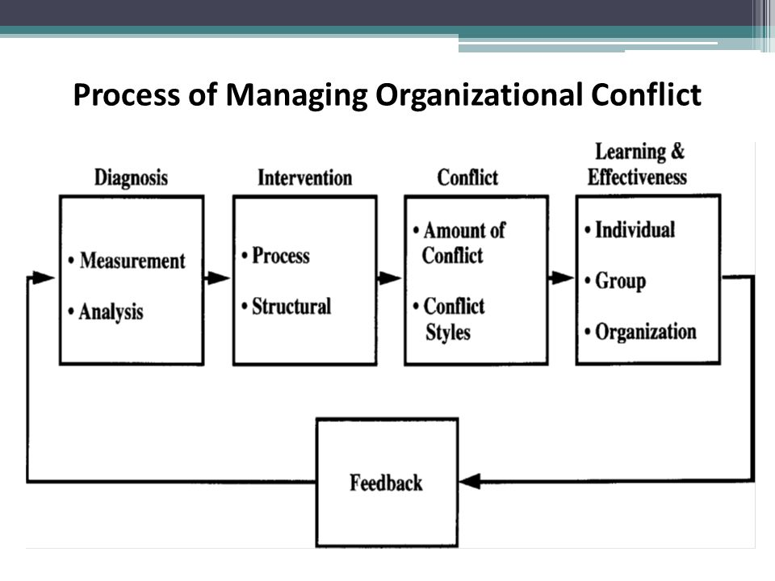
Figure: leadership conflict (Rezvani et al, 2019

Different types of Conflicts in the workplace:
We all are different from one another. It is pretty much natural to arise a clash between people having different motivations, processes, and goals. Some examples of conflicts are given below:
Task-based conflicts: This type of problem arrives when a team member doesn’t complete his part of the work. For example, if a team member doesn’t give his report to accountants then the accountant could not finish the final report. Ninja Corporation faced this type of problem. And, that was production department was questioning how certain work projects should be completed (Liu et al, 2019).
Experiencing creative difference: to improve professional skills while working in a team, creativeness is an excellent opportunity. But strong creativeness could be a cause of envisioning for others. A famous TV series had been in this type of problem. The production team faced creative differences with Joe Smith and then he left the cast of “Murder on Cliché Street” (Titov et al, 2018).
Leadership conflict: every leader has his leadership and reacts differently from others’ leadership styles. In an organisation, different manager’s manger their department with their leadership style, so, the sales department and production department could be in leadership conflict over inventory policy (Freire et al, 2020).
Workstyle conflict: BHP (Brake HorsePower) is a production and maintenance workforce. Under the different leaders or managers, there are different work styles. Some of the employees of BHP were on a new project. The previous manager was friendly and with a positive vibe to working. But the work style conflict happened when a new manager arrived. The new manager was very strict to work, hardworking, and rewarded for good performance (Gashi et al, 2020).
Discrimination: In this area most organisations faces difficulties. Nike Incorporation was accused in 2019 due to employment discrimination. They were charged that they were not paying enough to the women employees (Fernández-Salinero et al, 2020).
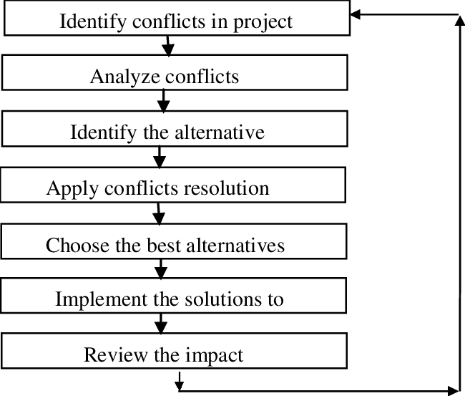
Figure: Conflict (Fernández-Salinero et al, 2020)
There are more types of conflict arrives in working place. The reason for these conflicts could be differences, misunderstanding, deficiency, status, clarification, etc. (Titov et al, 2018). Any sort of disagreement should be resolved by the manager, leader, or authority in terms of the organization's fundamental aim. Managers should communicate with everyone, listen attentively, build and maintain a suitable strategy, and resolve issues as soon as possible (Raykova et al, 2019).

Managing the conflicts:
A manager should always be ready to manage all the problems that could affect the central goal. According to the types of the problem, the manager should take action to solve it. Any organisation forms a team to accomplish a primary aim. The objective might be short- or long-term. However, while working in a group, issues might arise. The issues might be structural, emotional, or psychological in nature. Strong creativity, on the other hand, may be a source of inspiration for others. This was an issue with a well-known TV show. Joe Smith departed the cast of "Murder on Cliché Street" due to creative issues with the production crew (Titov et al, 2018).
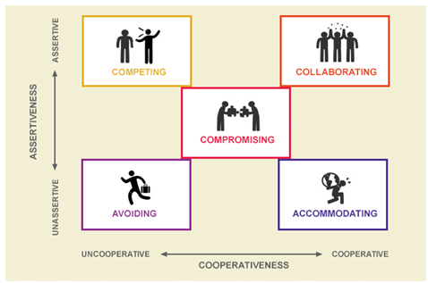
Figure: managing conflicts (Raykova et al, 2019)
Different actions based on different problems are given below:
Task-based conflicts: A manager should delegate the tasks effectively. The manager should communicate with all team members and delegate responsibility and accountability. In Ninja Corporation, the production manager and the control manager mutually solved the problem by going back to the previous decision. The production manager understood the problem and backed down on his decision (Nachlieli et al, 2021).
Experiencing creative difference: to solve this kind of problem, a manager could reframe the opposite creative mind-set. Again, consult both parties and motivate them to compromise where is necessary. And show where to highlight the most promising aspect from each other perspective (Rezvani et al, 2019).
Leadership conflict: to solve this type of conflict the leaders or managers should emphasize mutual respect and think about the central goal of the organisation. Both of the leaders should be more aware of their leadership style and interacting style with others (Freire et al, 2020).
Workstyle conflict: the new manager should be more flexible towards the employee and to prevent this kind of conflict he should be more understanding with mutual respect. The authority should not change the manager within a running project. The manager should use a particular work style for the rest of the group mates. And the group member or employee should collaborate with the guideline (Abbasi et al, 2018).
Discrimination: The manager should motivate all of the members to be open-minded, accepting, and understanding. The federal judge solved the issue by accusing Nice Incorporation and force to adverse employment actions as to salary and promotional potential (Foran et al, 2019). The prior manager was pleasant to work with and had a good attitude. However, when a new manager was hired, a work style clash arose. The new boss was quite tough at work, very industrious, and praised excellent performance (Gashi et al, 2020).
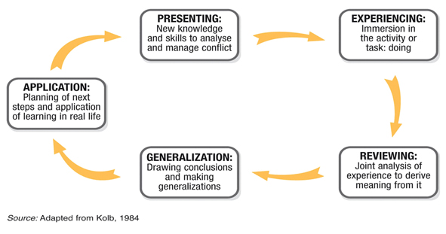
Figure: discrimination conflict solve (Fernández-Salinero et al, 2020)
The manager or leader or the authority should be solved any type of conflict in terms of the central goal of the organisation. In the workplace, there are a variety of issues that might arise. Every single one of us is unique. It's only normal for conflict to emerge between individuals who have different motives, procedures, and objectives. Managers should be communicating with all, listen carefully, develop and maintain a proper plan, etc. and solve these conflicts immediately (Raykova et al, 2021). Different managers in a company handle their departments according to their leadership styles. As a result, there might be a leadership disagreement between the sales and manufacturing departments over inventory policies (Freire et al, 2020).
Conclusion:
It is nearly impossible to avoid conflict among group members with different backgrounds or personalities. So, it is important to react immediately to the manager to solve it. The manager can help the employees to build a strong relationship or do a conflict management course him. To achieve the final goal or maintain the current flow of success of an organisation, it is important to look after the teams or employees and prevent any probable conflicts. Conflict in a team may be fatal to keeping the existing process going. As soon as a problem emerges, a manager should strive to resolve it. The sorts of conflict and the methods will be described in this article (Fooks et al, 2022).

References
Adu, G.A., 2018. Managing conflict within enterprises of multi-cultural dimensions.
Fernández-Salinero, S. and Topa, G., 2020. Intergroup discrimination as a predictor of conflict within the same organisation. the role of organisational identity. European Journal of Investigation in Health, Psychology and Education, 10(1), pp.1-9.
Fooks, Gary Jonas, and Charlotte Godziewski. An Analysis of Submissions to a Consultation on a Draft WHO Tool"." International Journal of Health Policy & Management 11, no. 2 (2022).
Foran, M.P., 2019. Discrimination as an individual wrong. Oxford Journal of Legal Studies, 39(4), pp.901-929.
Freire, C. and Bettencourt, C., 2020. Impact of ethical leadership on job satisfaction: the mediating effect of work–family conflict. Leadership & Organisation Development Journal.
Gashi, M., 2020. Problem-Solving Style and Conflict Management Among School Superintendents (Doctoral dissertation, Fordham University). Raihan
Liu, Y. and Hu, L.Y., 2019. Research on management strategy of coordination behavior of taskconflicts in in-service thermal power unit operation based on big data modeling. Thermal Science, 23(5 Part A), pp.2703-2711.
Nachlieli, T. and Heyd-Metzuyanim, E., 2021. Commognitive conflicts as a learning mechanism towards explorative pedagogical discourse. Journal of Mathematics Teacher Education, pp.1-23.
Raykova, E. and Semerdjieva, M., 2019. METHODS FOR MANAGING ORGANISATIONAL CONFLICTS IN HOSPITAL. KNOWLEDGE-International Journal, 34(1), pp.99-105.
Rezvani, A., Barrett, R. and Khosravi, P., 2019. Investigating the relationships among team emotional intelligence, trust, conflict and team performance. Team Performance Management: An International Journal.
Titov, E., Virovere, A. and Kuimet, K., 2018. Conflict in Organisation: Indicator for Organisational Values. Organisational conflict, pp.19-36.

