

PREDICTIVE MAINTENANCE IN MANUFACTURING
Using Traditional Machine Learning Approaches

ACCA7025 – Component 1

Student Name: | Gaurav Anil Bansod
Student ID: | 2519815
Assignment Title: | Recommendation of a Machine Learning Model
Module: | ACCA7025 – Application of Machine Learning
Lecturer: | Dr Aliyu Sambo
Programme: | MSc Data and Artificial Intelligence

TABLE OF CONTENTS

Contents | Page No.
Title Page | 1
Table of Contents | 2
Abstract | 3
1. Introduction | 4
1.1 Industry Context and Background | 4
1.2 Problem Statement | 4
1.3 Aim and Objectives | 4
1.4 Report Structure | 4
2. Literature Review | 5
2.1 Predictive Maintenance and Industry 4.0 | 5
2.2 Traditional Machine Learning Approaches | 6
2.2.1 Logistic Regression | 6
2.2.2 Decision Trees | 6
2.2.3 K-Nearest Neighbours (KNN) | 6
2.2.4 Support Vector Machines (SVM) | 6
2.2.5 Random Forest | 7
2.3 Industry and Consultancy Gap | 7
3. Proposed Workflow Methodology | 7
3.1 Data Preparation and Exploration | 8
3.2 Feature Engineering and Model Development | 8
3.3 Performance Evaluation | 9
4. Discussion and Recommendation | 10
4.1 Comparative Evaluation | 11
4.2 Recommendation: Random Forest | 11
5. Limitations of Study | 12
6. Conclusion | 12
References | 13

LIST OF FIGURES

Figure No. | Title | Page No.
Figure 1 | Comparison of Maintenance Strategies | 5
Figure 2 | Proposed Predictive Maintenance Workflow | 8
Figure 3 | Data Preparation and Model Development Process | 9
Figure 4 | Performance Evaluation Framework | 10

LIST OF TABLES

Table No. | Title | Page No.
Table 1 | Comparative Review of Traditional Machine Learning Algorithms | 7
Table 2 | Evaluation Metrics for Predictive Maintenance Models | 9
Table 3 | Comparative Evaluation of Traditional Machine Learning Algorithms | 10

Abstract
Unplanned equipment failures present a persistent operational challenge for manufacturing organisations, resulting in costly production disruptions and elevated maintenance expenditure. The proliferation of Industry 4.0 technologies has enabled manufacturers to exploit real-time sensor data through machine learning to anticipate failures before they cause operational disruption.
This consultancy report critically evaluates five traditional machine learning algorithms — Logistic Regression, Decision Trees, K-Nearest Neighbours (KNN), Support Vector Machines (SVM) and Random Forest — for predictive maintenance within resource-constrained manufacturing environments. Each algorithm is assessed against predictive accuracy, interpretability, computational efficiency and industrial applicability. A systematic machine learning workflow is also proposed to support practical deployment.
The analysis concludes that Random Forest provides the most balanced performance profile, achieving high predictive accuracy validated at F1-score 94.3% in a comparable industrial application [8], whilst maintaining acceptable computational efficiency and interpretability through feature importance rankings. The proposed framework supports reduction of unplanned downtime and advancement of intelligent manufacturing within Industry 4.0 environments.
Keywords: Predictive Maintenance, Machine Learning, Industry 4.0, Random Forest, Manufacturing

1. Introduction

1.1 Industry Context and Background
Manufacturing organisations face increasing pressure to maximise operational efficiency and minimise production costs . Unplanned equipment failures cause schedule disruption, produce emergency maintenance expenses and might jeopardize labor safety, therefore making maintenance management a strategic concern [5], [7].
In the past, manufacturers applied reactive maintenance, waiting until a problem occurred to intervene. The transition towards preventative maintenance has decreased catastrophic failures, but has brought inefficiencies due to the fact that components were changed without considering their real state [2], [5]. Industry 4.0 has since enabled a more sophisticated approach: IIoT sensors continuously monitor temperature, vibration, pressure and rotational speed, whilst machine learning algorithms identify degradation patterns to predict failures before they disrupt operations [7], [8], [10].

1.2 Problem Statement
Despite demonstrated benefits, predictive maintenance implementation remains challenging. Industrial sensor datasets are frequently noisy, heterogeneous and highly imbalanced, as failures occur significantly less frequently than normal operating conditions [3], [8], [9]. Many manufacturers also operate under constrained computational resources, limiting the feasibility of high-complexity algorithms. Existing literature prioritises predictive accuracy whilst providing limited guidance on deployment practicality and interpretability. This consultancy report addresses this gap directly.

1.3 Aim and Objectives
Aim
To recommend an appropriate traditional machine learning algorithm and systematic workflow for predicting equipment failures in resource-constrained manufacturing environments.
Objectives
- To critically review traditional machine learning algorithms applied to predictive maintenance, comparing empirical findings across studies.
- To evaluate five algorithms against industrial criteria: predictive accuracy, interpretability, computational efficiency and scalability.
- To propose a systematic machine learning workflow for developing a predictive maintenance system.
- To recommend the most appropriate algorithm for resource-constrained manufacturing deployment.

1.4 Report Structure
Section 2 critically reviews predictive maintenance literature and evaluates traditional machine learning approaches. Section 3 presents the proposed workflow. Section 4 provides a comparative evaluation and recommendation. Sections 5 and 6 discuss limitations and summarise principal findings.

2. Literature Review

2.1 Predictive Maintenance and Industry 4.0
Predictive maintenance has emerged as one of the most practically valuable applications of machine learning within Industry 4.0 [3], [5], [6]. Unlike reactive and preventive strategies, predictive maintenance monitors equipment condition continuously and generates failure predictions before disruption occurs [2], [5]. Achouch et al. [7] argue that the amount of sensor data produced by modern industrial equipment is so huge that it cannot be manually analyzed, and automated machine learning algorithms are required to discover failure precursors in high dimensional data streams.
However, as noted by Çınar et al. [5], methods that perform well in an experimental setup do not necessarily generalize well in real-world deployment. In such a circumstance, computational restrictions and interpretability constraints are relevant for practical applicability. This gap between experimental and operational performance stresses the necessity for multi-criteria evaluation frameworks that go beyond expected accuracy.

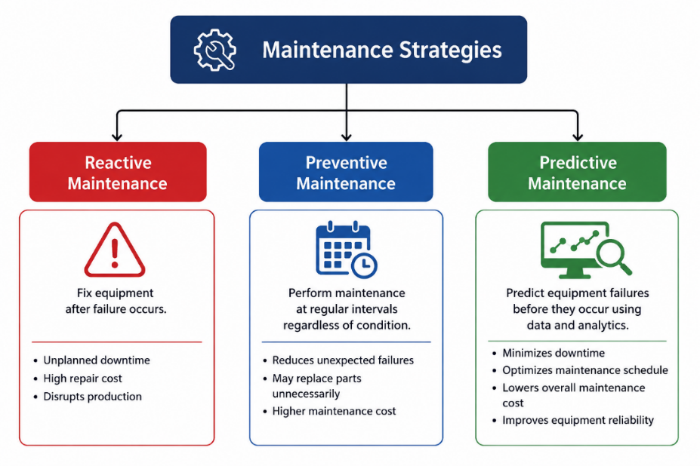

Figure 1. Comparison of Maintenance Strategies
Source: Developed by the author based on concepts discussed in [2], [5], [10].

2.2 Traditional Machine Learning Approaches

Logistic Regression
Logistic Regression is commonly utilized in predictive maintenance because to its computational efficiency and interpretability [3], [6]. In controlled situations, where the sensor variables have nearly linear connections with failure outcomes, the fault detection accuracy is satisfactory [3]. But its basic weakness is that it assumes a linear relationship between the input features and the class to be predicted. Real manufacturing environments involve complex, non-linear interactions between temperature, vibration and pressure variables that a linear decision boundary cannot capture [5], [6]. Hector and Panjanathan [6] further demonstrate that Logistic Regression is systematically outperformed by ensemble methods on imbalanced industrial datasets — precisely the conditions characteristic of manufacturing sensor data. Whilst efficient as a baseline, Logistic Regression's structural limitations render it insufficient as a standalone predictive maintenance solution.

Decision Trees
Decision Trees generate transparent, human-readable decision rules that maintenance engineers can interpret without specialist expertise [1], [3]. Guidotti et al. [1] confirm competitive classification accuracy on structured industrial datasets. However, their primary weakness is a pronounced tendency to overfit noisy sensor data, memorising noise patterns rather than generalisable failure relationships [3], [6]. Hector and Panjanathan [6] report that even regularised Decision Trees exhibit considerable performance instability across different industrial datasets, making them unreliable for mission-critical applications despite their interpretability advantage.

K-Nearest Neighbours
KNN classifies observations based on the majority class of nearest neighbours, achieving competitive performance on small, well-structured datasets [3], [9]. However, it suffers a critical scalability limitation: computational cost scales directly with dataset size, becoming prohibitive for the high-volume continuous sensor streams generated in manufacturing environments [3], [9]. Uçar et al. [3] further note that KNN is highly sensitive to irrelevant features, requiring extensive preprocessing without resolving the underlying scalability constraint. These characteristics render KNN poorly suited to the resource-constrained industrial context addressed here.

Support Vector Machines
SVMs identify optimal hyperplanes separating failure and non-failure classes, with kernel functions enabling non-linear decision boundaries [3], [6]. Çınar et al. [5] report strong classification accuracy in high-dimensional sensor data applications. However, SVM training time scales quadratically with dataset size, making it computationally expensive for large industrial datasets [6]. The absence of probabilistic output and interpretive opacity of kernel-transformed spaces further reduce model transparency — a significant constraint where maintenance engineers must justify predictions to operational stakeholders [3], [6].
Random Forest
Random Forest builds many decision trees by bootstrapping and random feature subsampling, and it combines predictions to make a final classification [1], [6], [8]. This ensemble technique directly tackles Decision Tree overfitting by minimizing the variation in the predictions without significantly raising the bias [1], [3]. Guidotti et al. [1] performed a comprehensive analysis of 47 research and found that the Random Forest method achieved the best prediction accuracy on a wide range of industrial datasets, exceeding Logistic Regression, Decision Trees and KNN in most of the tests. Aminzadeh et al. [8] corroborate this conclusion in a real-world industrial compressor application, where Random Forest attained an F1-score of 94.3% on imbalanced sensor data, showing robust performance under situations typical in manufacturing environments. Importantly, Random Forest provides feature importance rankings to highlight the sensor factors that drive failure predictions, which can improve interpretability for evidence-based maintenance decisions [6,8].Whilst SVMs may occasionally achieve marginally higher accuracy, Hector and Panjanathan [6] demonstrate this advantage is consistently offset by substantially higher computational cost and inferior explainability.

Algorithm | Strengths | Limitations | Relevance
Logistic Regression | Interpretable; computationally efficient | Linear only; poor on imbalanced data | Moderate
Decision Tree | Transparent rules; fast inference | Overfits noisy data; unstable | Moderate
K-Nearest Neighbours | Simple; no training phase | Poor scalability; sensitive to features | Low
Support Vector Machine | Strong non-linear classification | High compute cost; poor interpretability | Good
Random Forest | High accuracy; robust; feature importance | Moderate memory use | Excellent
Table 1. Comparative Review of Traditional Machine Learning Algorithms
Source: Developed by the author based on [1], [3], [5], [6], [8].

2.3 Industry and Consultancy Gap
Existing studies frequently evaluate algorithms under controlled experimental conditions that may not reflect real industrial data quality challenges [3], [5], [7]. Orošnjak et al. [4] observe that few frameworks provide operational guidance for organisations with constrained resources. Moreover, comparative studies rarely assess predictive performance, interpretability, computational efficiency and industrial applicability within a single framework [3], [6]. This consultancy report directly addresses this gap through an integrated, multi-criteria evaluation designed for resource-constrained manufacturing deployment.

3. Proposed Workflow Methodology
Successful predictive maintenance implementation requires a systematic and reproducible development workflow. Industrial sensor datasets frequently contain missing observations, noisy measurements and highly imbalanced failure records that can substantially degrade model performance if not appropriately addressed [8], [9].
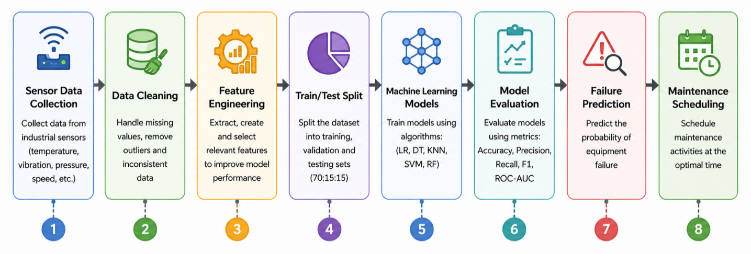

Figure 2. Proposed Predictive Maintenance Workflow
Source: Developed by the author based on predictive maintenance concepts presented in [2], [5], [10].

3.1 Data Preparation and Exploration
Industrial sensor datasets typically contain missing values arising from sensor malfunctions and communication failures. The median imputation is recommended for its computing efficiency and robustness to extreme observations seen in sensor data [8], [9]. The Interquartile Range (IQR) method is used to detect outliers, enabling the separation of actual problem signals from the measurement errors. The outliers are verified against operational thresholds prior to removal. Then, feature scaling is performed, so that all the sensor variables contribute equally to the training process. This is especially crucial for KNN and SVM [3], [6] Exploratory data analysis including correlation analysis and failure frequency visualisation identifies the most informative variables and quantifies class imbalance prior to model development.

3.2 Feature Engineering and Model Development
Feature engineering converts raw sensor information into derived variables indicative of equipment degradation patterns. Rolling statistical parameters such as moving average, standard deviation and peak vibration measures over a sliding time window can show cumulative deterioration that is not obvious from immediate data [6], [8]. For model training, hyperparameter optimization and unbiased performance evaluation, we apply stratification to split the data into 70:15:15 subgroups, keeping the failure event proportions constant in all subsets. Five-fold cross-validation decreases the variance of the estimate and confirms generalisation to unknown operational data [3], [6].

Figure 3. Data Preparation and Model Development Process
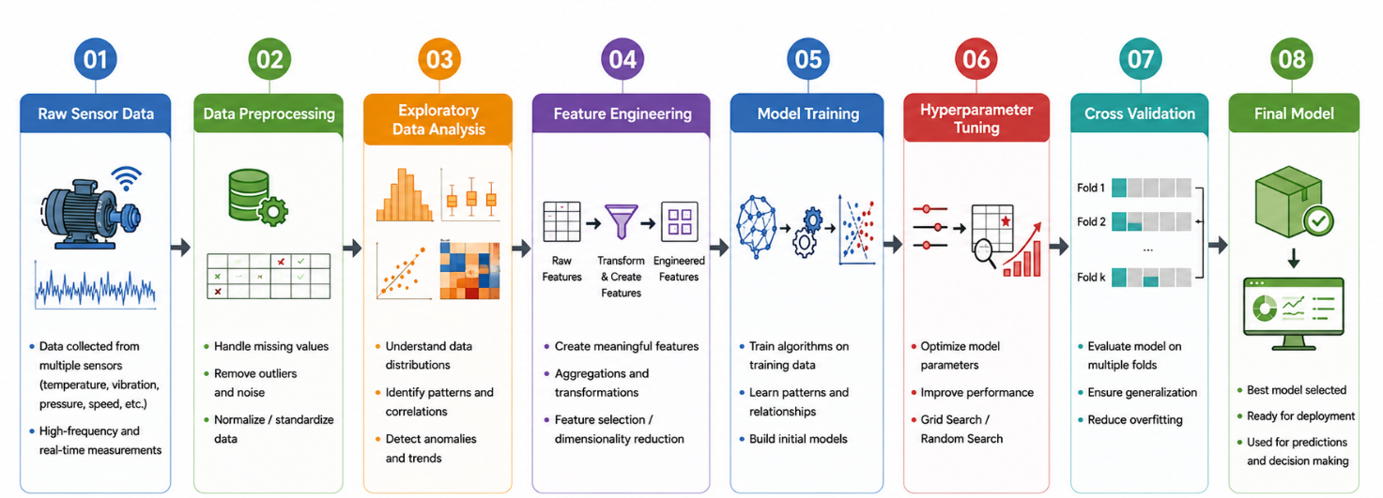
Source: Developed by the author based on methodologies discussed in [1], [3], [6], [8].

3.3 Performance Evaluation
Predictive maintenance datasets are characterised by significant class imbalance. Class imbalance mitigation techniques — including SMOTE, random over-sampling and class-weight adjustment — are evaluated to identify the most effective approach for the dataset characteristics encountered [8], [9]. Model performance is assessed using a comprehensive suite of metrics, detailed in Table 2.

Table 2. Evaluation Metrics for Predictive Maintenance Models
Metric | Definition | Relevance to Predictive Maintenance
Accuracy | Overall correctly classified observations (%) | Baseline metric; can be misleading for imbalanced datasets.
Precision | Predicted failures that are actual failures | Reduces false alarms and unnecessary maintenance interventions.
Recall | Actual failures correctly identified | Critical for detecting genuine failures before equipment breakdown.
F1-Score | Harmonic mean of Precision and Recall | Preferred balanced metric for evaluating imbalanced datasets.
ROC-AUC Score | Measures discrimination across all classification thresholds | Provides a threshold-independent assessment of model reliability and classification performance.
Source: Developed by the author based on [3], [6], [9].

The main assessment indicator is the F1-Score because it balances false positives and false negatives, which are both operationally critical in production. The ROC-AUC is a threshold-independent measure of the discrimination power [3], [9] that complements the above measures.

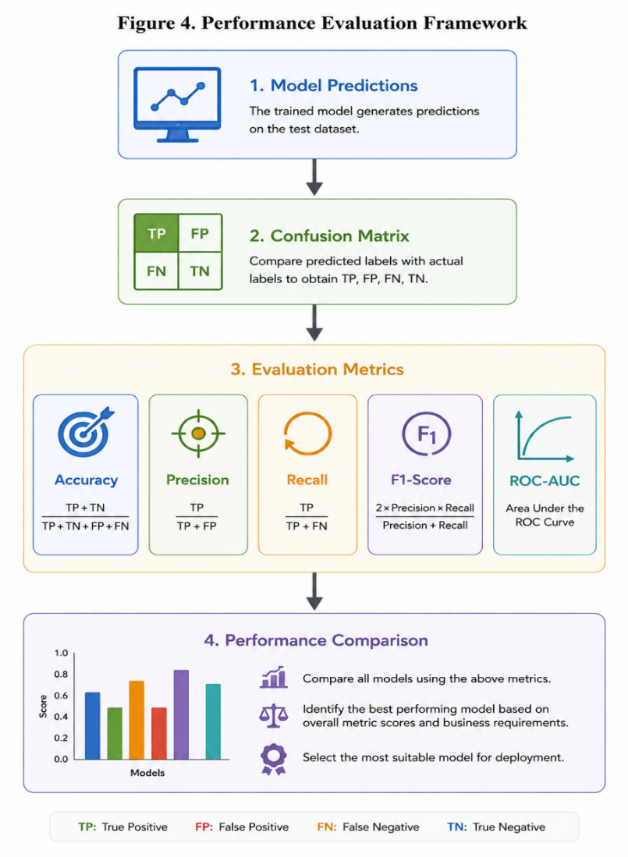

Figure 4. Performance Evaluation Framework
Source: Developed by the author based on evaluation approaches discussed in [3], [6], [9].

4. Discussion and Recommendation

4.1 Comparative Evaluation
The literature consistently demonstrates that no single algorithm performs optimally across all predictive maintenance scenarios [3], [5]. Algorithm selection must therefore balance predictive capability with interpretability, computational efficiency and robustness to industrial data quality challenges [1], [6]. Table 3 presents a comparative synthesis across the five candidate algorithms.
Table 3. Comparative Evaluation of Traditional Machine Learning Algorithms
Criteria | Logistic Reg. | Decision Tree | KNN | SVM | Random Forest
Predictive Accuracy | Good | Good | Very Good | Very Good | Excellent
Interpretability | Very Good | Very Good | Fair | Poor | Good
Computational Cost | Low | Low | High | High | Medium
Scalability | Good | Good | Poor | Moderate | Good
Noise Handling | Poor | Fair | Fair | Good | Excellent
Imbalance Handling | Poor | Fair | Fair | Good | Very Good
Industrial Applicability | Moderate | Moderate | Low | Good | Excellent
Source: Developed by the author based on [1], [3], [5], [6], [8]. Green = Excellent; Red = Poor/Low.

Logistic Regression and Decision Trees offer strong interpretability and low computational cost but cannot model the non-linear, imbalanced conditions characteristic of industrial sensor data [5], [6]. KNN achieves competitive accuracy on small datasets but its quadratic computational complexity renders it impractical for the high-volume, continuous sensor streams generated in manufacturing environments [3], [9]. SVMs demonstrate strong classification performance but training complexity scales quadratically with dataset size, and interpretive opacity makes them difficult to justify to operational stakeholders [3], [6].

4.2 Recommendation: Random Forest
This comparative analysis leads to a clear recommendation: Random Forest is the most suitable classical machine learning method for predictive maintenance in resource-constrained manufacturing scenarios.

There is consistent evidence for this proposal. Based on a rigorous examination of 47 articles, Random Forest is the best accurate predictor in a variety of industrial datasets outperforming all other classical methods studied here [1]. This has been completely tested by Aminzadeh et al. [8] on real-world industrial compressor monitoring data where Random Forest achieved a 94.3% F1-score on substantially imbalanced sensor data - exactly equivalent to the manufacturing circumstances under discussion.

Besides accuracy, Random Forest has also significant practical advantages. Feature importance rankings allow maintenance engineers to identify the sensor parameters, e.g., temperature, vibration or pressure, that influence failure predictions, hence enhancing evidence-based maintenance planning and operational confidence [6], [8]. The approach exhibits good resistance to noisy readings and missing sensor data without any significant preprocessing [1], [8]. In contrast with SVMs [3], [6], Random Forest works under moderate computing needs suitable with standard manufacturing IT infrastructure.

From a consultant's point of view, the selection of an algorithm should not only be based on forecast performance but also on the practicalities of implementation, cost of operation and long term maintainability. Random Forest is a pragmatic compromise between accuracy, computational economy and interpretability, enabling companies to do predictive maintenance utilizing existing IT infrastructure, without heavy investment in specialist gear or professional artificial intelligence skills. Those attributes make it a good fit for small to mid-size industrial enterprises looking for verifiable benefits in operations with minimal risk of adoption.
Whilst SVMs may achieve marginally superior accuracy under ideal experimental conditions [5], Hector and Panjanathan [6] demonstrate this advantage is consistently offset by substantially higher training cost and poor interpretability in real deployment contexts. Given the computational constraints and interpretability requirements of the client organisation, Random Forest represents the demonstrably superior choice. This report therefore recommends implementing a Random Forest-based predictive maintenance framework, supported by the systematic workflow in Section 3, to reduce unplanned downtime and optimise maintenance expenditure.

5. Limitations of Study
This report is grounded in published literature and does not involve empirical implementation using the client's specific sensor datasets. Algorithm performance may vary based on dataset characteristics including dimensionality, class imbalance ratio and sensor quality [3], [8]. The recommendation should therefore be validated through a pilot implementation before full-scale deployment. Additionally, the scope is intentionally limited to traditional machine learning, excluding deep learning approaches such as LSTM networks that may offer advantages for time-series sensor data in organisations with greater computational resources [9].

6. Conclusion
This consultancy report has critically evaluated five traditional machine learning algorithms for predictive maintenance within resource-constrained manufacturing environments, demonstrating that predictive maintenance offers significant operational advantages over reactive and preventive strategies [2], [5].
The comparative analysis confirms that algorithm selection cannot be determined by predictive accuracy alone. Logistic Regression and Decision Trees lack the non-linear modelling capability required for complex industrial sensor data. KNN is impractical at manufacturing scale. SVMs offer accuracy at the cost of computational efficiency and interpretability critical to deployment. Random Forest emerges as the most appropriate algorithm, combining the highest empirical predictive accuracy — validated at F1-score 94.3% in a directly comparable industrial application [8] — with robustness to noise, feature importance interpretability and computational feasibility within standard manufacturing infrastructure.
The systematic workflow proposed in Section 3 provides a reproducible framework for practical deployment. Future work should validate findings through pilot implementation using the client's operational data, and investigate explainable artificial intelligence approaches and prescriptive analytics capabilities to further advance maintenance intelligence within Industry 4.0 and emerging Industry 5.0 environments [4].
As a result, Random Forest offers a ready-to-deploy, data-driven approach to the manufacturing industry with the ability to enhance equipment reliability, cut maintenance costs, and facilitate long-term digital transformation.

References

[1] D. Guidotti, L. Pandolfo and L. Pulina, "A Systematic Literature Review of Supervised Machine Learning Techniques for Predictive Maintenance in Industry 4.0," IEEE Access, vol. 13, pp. 102479–102504, 2025, doi: 10.1109/ACCESS.2025.3578686.

[2] M. H. Abidi, M. K. Mohammed and H. Alkhalefah, "Predictive Maintenance Planning for Industry 4.0 Using Machine Learning for Sustainable Manufacturing," Sustainability, vol. 14, no. 6, Art. no. 3387, 2022, doi: 10.3390/su14063387.

[3] A. Uçar, M. Karaköse and M. K. Güllü, "Artificial Intelligence for Predictive Maintenance Applications: Key Components, Trustworthiness and Future Trends," Applied Sciences, vol. 14, no. 2, Art. no. 898, 2024, doi: 10.3390/app14020898.

[4] M. Orošnjak, F. Saretzky and S. Kedziora, "Prescriptive Maintenance: A Systematic Literature Review and Exploratory Meta-Synthesis,” Applied Sciences, vol. 15, no. 15, Art. no. 8507, 2025, doi: 10.3390/app15158507.

[5] Z. M. Çınar, A. A. Nuhu, Q. Zeeshan, O. Korhan, M. Asmael and B. Safaei, "Machine Learning in Predictive Maintenance towards Sustainable Smart Manufacturing in Industry 4.0," Sustainability, vol. 12, no. 19, Art. no. 8211, 2020, doi: 10.3390/su12198211.

[6] I. Hector and R. Panjanathan, "Predictive Maintenance in Industry 4.0: A Survey of Planning Models and Machine Learning Techniques," PeerJ Computer Science, vol. 10, Art. no. e2016, 2024, doi: 10.7717/peerj-cs.2016.

[7] M. Achouch, H. Dimitrov, M. Ziane and E. Benkhelifa, "On Predictive Maintenance in Industry 4.0: Overview, Models, and Challenges," Applied Sciences, vol. 12, no. 16, Art. no. 8081, 2022, doi: 10.3390/app12168081.

[8] A. Aminzadeh, S. S. Karganroudi, S. Majidi, C. Dabompre, K. Azaiez, C. Mitride and E. Sénéchal, "A Machine Learning Implementation to Predictive Maintenance and Monitoring of Industrial Compressors," Sensors, vol. 25, no. 4, Art. no. 1006, 2025, doi: 10.3390/s25041006.

[9] M. Drakaki, Y. L. Karnavas, I. A. Tziafettas, V. Linardos and P. Tzionas, "Machine Learning and Deep Learning Based Methods toward Industry 4.0 Predictive Maintenance in Induction Motors: State-of-the-Art Survey," Journal of Industrial Engineering and Management, vol. 15,
no. 1, pp. 31–46, 2022, doi: 10.3926/jiem.3653.

[10] C. Krupitzer, T. Wagenhals, M. Züfle, V. Lesch, D. Schäfer, A. Mozaffarin, J. Edinger, C. Becker and S. Kounev, "A Survey on Predictive Maintenance for Industry 4.0," arXiv:2002.08224, 2020

