LEVEL 6 ASSESSMENT SPECIFICATION

Student name: | Jordan Thomas | Student ID number: | 1906033
Programme: | Outdoor Adventure Education BA
Module: | Landscape & Sustainable Recreation
Module code: | BMOE6003 | Contribution to Overall Module Assessment (%): | 50%
Lecturer: | Anthony Burns | Internal Verifier: | Roisin Mullins
Assignment Title: | Reflective Fieldwork Journal | Word count (or equivalent): | 2,500 words
Submission deadline: | 29th April 2022 | Return date of provisional marks & written feedback: | 27th May 2022
Submission method: | All written assessments, where practical and possible, must be submitted via Turnitin unless otherwise instructed by the Lecturer. (Please DO NOT put this assessment specification into Turnitin or it will match many similarities with other students’ submissions.)  Alternative submission method (if applicable):  Late submission of the assessment will result in a late penalty mark. Penalties for late submission: Up to one week late, maximum mark of 40%. Over one week late, 0%. Only the Extenuating Circumstances Panel may approve a change to submission dates.
Academic honesty / referencing: | Academic honesty is required. In the main body of your submission you must give credit to authors on whose research and ideas your work is based. Append to your submission a reference list that indicates the books, articles, etc. that you have used, cited or quoted in order to complete this assessment.

Introduction
In this essay I will be discussing two excursions to landscapes here in the United Kingdom. These excursions were to Dinefwr park in the south of Wales and to Lundy island in the Bristol Channel. The discussions will be centred around the character, quality, use, access and designations attached to the land in order to reach educated conclusions on potential future uses for the landscape.

Dinefwr Park
Dinefwr park is made up by a “Historic Newton House surrounded by a National Nature Reserve and 18th century landscape Deer Park” (National Trust, 2022a). In early 2022 an excursion to dinefwr was undertaken. The excursion here started in the car park and headed east toward the castle woods. The tour then continued through castle woods and north up to the Mill Pond. Once passed the Mill Pond the tour continued into the deer park and out the other side, finishing with a tour of Newton House (National Trust, 2021).
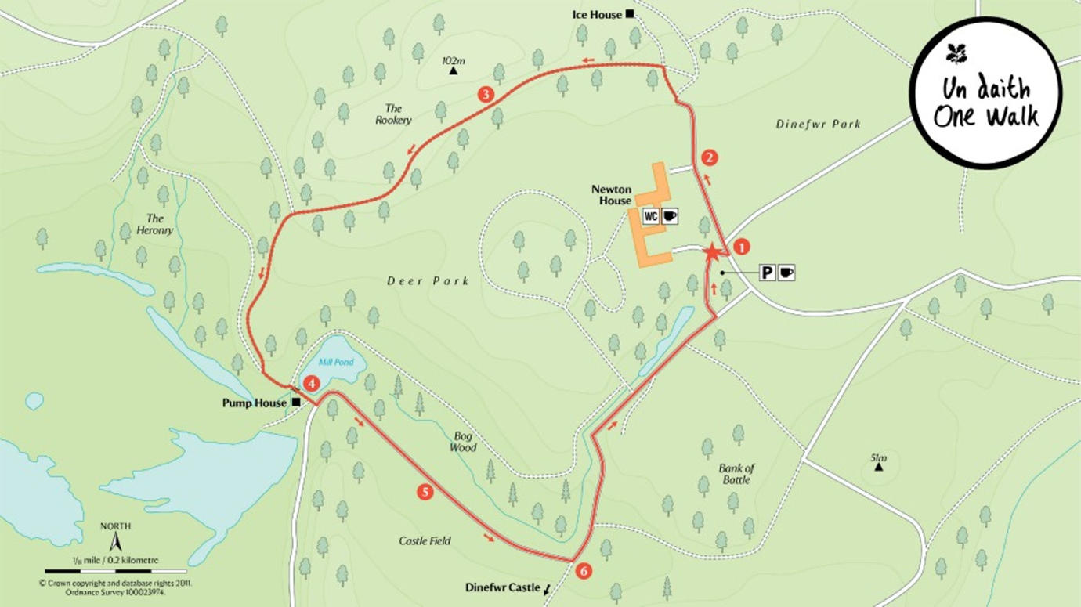
(National Trust, 2022c)

Landscape Character;
Dinefwr parks’ landscape ranges from its “flower-rich meadows” to its “dense ancient woodland” (National Trust, 2022b). Wynford Vaughan Thomas once said “If you take a handful of the soil of Dinefwr and squeeze it in your hand, the juice that will flow from your hands is the essence of Wales” (National Trust, 2022b). The grounds are varied in their landscape which provided the imagination and curiosity plenty of occupation.

Landscape Quality;
In the various woodlands within the park there are more than 300 trees that are over 400 years old (First Nature, 2022). Some of these are oak and are estimated to be over 700 years old (First Nature, 2022) These provide the perfect home for wildlife such as deer and birds. In fact, all three of the native British woodpeckers live within the park grounds (First Nature, 2022).
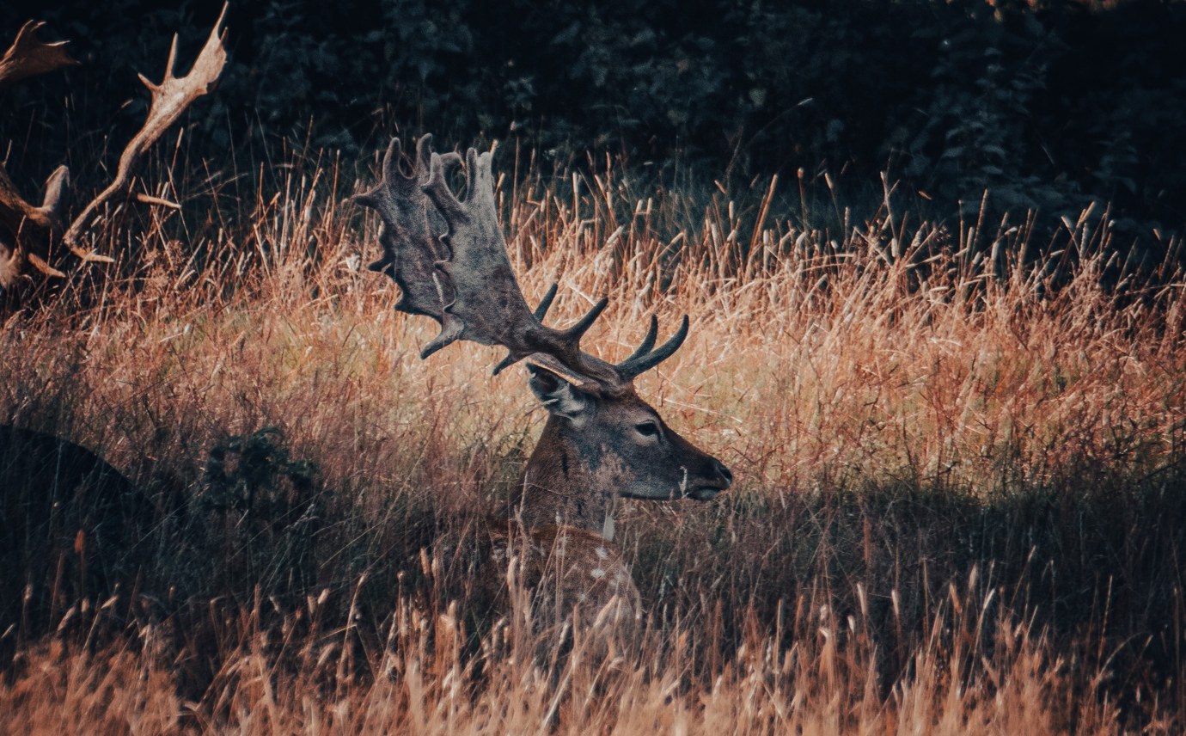
(Thomas, 2021)
Designations;
Dinefwr park is protected as a parkland National Nature Reserve (NNR) by the National Trust (National Trust, 2022b). It is in-fact the first NNR in Wales (Visit Wales, 2022). Within the park is Dinefwr Castle. The castle is managed by CADW and owned by Wildlife Trust (National Trust, 2022b). Cadw is the Welsh Government’s historic environment service with the mission of “caring for historic places” to “inspiring current and future generations”. The area is also a Sight of Special Scientific Interest (SSSI) (Visit Wales, 2022).

In 2001 a fifty year strategy was introduced in wales called “Woodland for Wales” (Welsh government (2018). This Welsh Government policy document acknowledged that: “Woodlands and trees make a positive contribution to the special landscape character of Wales and to sites of heritage and cultural importance”. Woodlands for Wales “concerns all the woodlands that exist in Wales”, and is “irrespective of size, location or ownership” (Welsh government, 2018). This means that the woodlands on Dinefwr grounds fall under this strategy. The aims of this strategy are to “provide real social and community benefits, both locally and nationally”, to “support thriving woodland-based industries” and to “contribute to a better quality environment throughout Wales” (Welsh government, 2018). The strategy lays out policies that effect Dinefwr park directly such as “There is a strong presumption against the permanent removal of woodland except for the restoration of high priority open habitats” (Welsh government, 2018). Policies such as this help to protect Welsh woodland whilst also protecting the open habitats such as the deer park. The most important aim is to create new woodland to help ensure “existing heritage sites are protected from damage and the integrity of historic landscapes is preserved” (Welsh government, 2018)

Use;
Historical use:
Two forts are evidence of a dominant Roman presence at dinefwr (National Trust, 2022b). Lord Rhys was a powerful lord who held court at Dinefwr and influenced decisions in Wales (National Trust, 2022b). Newton House, at the centre of Dinefwr, was a family home for over three hundred years to the descendants of Lord Rhys (National Trust, 2022b).

Current use:
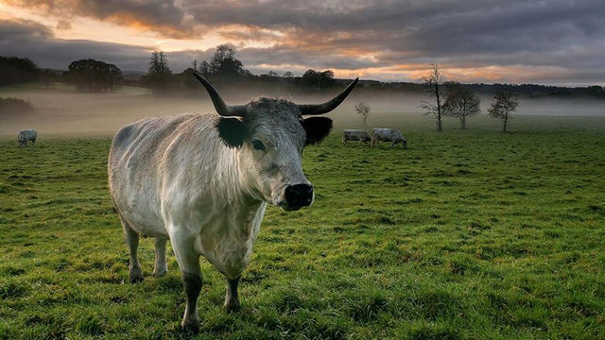
A survey in 2012 showed that 77% of CADW site visitors were from outside of Wales. This unfortunately highlights the lack of interest from the local population. Currently Dinefwr is used for multiple reasons. The most obvious reason is to protect and conserve an important part of Welsh history. This is then facilitated and payed for partly by its second use and that is as a tourist attraction. Most of the modern infrastructure (Paths, tea room, car park, road and gates) are aimed at facilitating visitors to the park. Dynefwr is also used to rear Welsh white cattle which existed far before the Romans occupied the area (First Nature, 2022).
(National Trust, 2022d)
Access;
The access to the landscape is via one long road that starts in the centre of the village. The village is quite far from any major towns or cities which would make it difficult to access if you can not drive. There are two buses that go from Carmarthen and passed the entrance to the property (Bustimes.org, 2022). Hopwever, if you live further afield than Carmarthen this would become significantly more difficult. The accessibility infrastructure on the site is very good. The foot paths through the landscape were very well maintained and easy to follow. There is one “special walk which easily accommodates wheelchair users and people with prams and pushchairs” (First Nature, 2022). There was however evidence of “Desire lines” which indicates the paths are not as easy to follow as first indicated. A desire line is “an unplanned route or path that is used by pedestrians in preference to or in the absence of a designated alternative” (Merriam Webster, 2022). The presence of desire lines hints at the possibility that there is room for improvements in the pedestrian infrastructure on the site.

Future Potential;
A 2020 audit by the National Trust found that “commemorations of people connected with the slave trade rarely have any accompanying interpretation to address matters of contention” (Welsh government, 2022). There is a positive strand however, demonstrated by commemorations to anti-slavery activists across Wales. “We plan to build on this work to make sure that we reflect and celebrate our shared history more holistically” and to “eliminate discrimination and barriers in all aspects of Cadw’s work” (Welsh government, 2022). These plans show Cadws interest in informing the public of the controversial side of the history of their landscapes. This will also be informed by the “Senedd’s Culture, Welsh Language and Communities Committee inquiry” (Welsh government, 2022).

On our tour of Dynefwr park the guide pointed out a number of issues with keeping people on the paths. People seem to create their own desire lines and walk off into random parts of the park and disturb the wildlife. Carl Myhill states “focusing on desire lines” means you can “successfully adapt” elements (actual paths in this case) to what the user really wants. He states “Perhaps these positive adaptions in design, aligned with human natural purpose, will lead to their greater success”. Perhaps a more sustainable approach to keep people on the paths in Dinefwr is to build upon the actual desire lines and remove the old paths. This may ensure less environmental damage if everyone sticks to the most efficient and desirable path. This will help the current recreational use of the park become more sustainable.

Problems with changing the landscape;
Some of the rooms of Newton House have been updated or converted, for example the tea room. Conversion of all or parts of Newton House to alternative uses could “endanger the historic integrity and reduce the association between the family and the area that has been in place since the 15th century” (Norman, 2022). For this reason this approach to development is not entirely sustainable. Although the National Trust has altered farming practices on the property and commits to monitor grazing licences there remains the potential for “unsympathetic use” (Norman, 2022). In light of this it is important that future developments are considered for their long term sustainability and how they fit in with the historic practices of the area.

Lundy Island
Lundy island is an inshore site that covers a rectangular area of thirty one square kilometres (Department for Environment Food and Rural Affairs, 2013 p.1) . Situated nineteen kilometres off the North Devon coast, Lundy is the largest island in the Bristol Channel (Department for Environment Food and Rural Affairs, 2013 p.1). Lundy island has been “inhabited for at least 3,000 years” (The Landmark Trust, 2022c). However since 1969 Lundy has been owned by the National Trust and managed by the Landmark Trust (The Landmark Trust, 2022a). The two charities have been collaborating to restore and protect Lundy and its flourishing wildlife (The Landmark Trust, 2022a).

Landscape Character;
When we arrived at Lundy the particular character that has made people fall in love with the island was immediately evident. The Landmark trust states:

“The particular character of Lundy derives from its varied terrain; on the west side, exposed to the Atlantic, there are high and rugged cliffs, on the east, sheltered from the prevailing wind, the coastline is gentler with grassy slopes, trees and many types of wild flowers” (The Landmark Trust, 2022b)

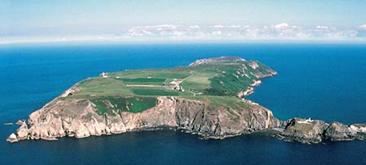
Lundy was once an unsustainable and financially draining landscape. However according to Peter Pearce, former Landmark Director from 1995 to 2012 “Lundy no longer causes the financial palpitations for Landmark that it used to, and has become a model of sustainability” (The Landmark Trust, 2022b)
(The Landmark Trust, 2022b)
Landscape Quality;
Lundy is a “flat-topped island” with a “volcanic past” (Devon County Council, 2022). The island is formed primarily of “Tertiary granite, with Devonian slates revealed along the south-east peninsula” (Devon County Council, 2022).
The west coast is particularly notable for its “spectacular cliffs reaching over 100 meters” and its “absence of tree cover”(Devon County Council, 2022). The east coast of the island is more protected from the elements and is characterised by its “vegetated slopes and secluded rocky coves” (Devon County Council, 2022). This side of the island has “valued wetland habitats” with “oak and sycamore” providing character to the land (Devon County Council, 2022).

The terrestrial landscape is not the only landscape of interest at Lundy. The seabed landscape varies considerably also. With “steeply sloping, vertical and overhanging underwater cliffs all present within the site” (Department for Environment Food and Rural Affairs, 2013 p.1) the seabed is a landscape of its own. The combination of these physical conditions makes the area a “biodiversity hotspot” (Department for Environment Food and Rural Affairs, 2013 p.1). Reefs, sandbanks, sea caves and grey seals are already protected as features within the area (Department for Environment Food and Rural Affairs, 2013 p.1). In addition to this the Marine Conservation Zone offers “additional protection for Spiny lobster that was not previously protected” (Department for Environment Food and Rural Affairs, 2013 p.2).
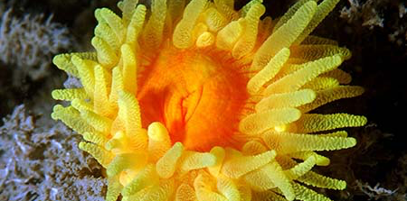
(The Landmark Trust, 2022b)

Designations;
In 1986, the voluntary Marine Nature Reserve became Britain’s first statutory Marine Nature Reserve. In 2010, following the Marine and Coastal Access Act 2009, the area was designated as the UK’s first Marine Conservation Zone (MCZ) (Department for Environment Food and Rural Affairs, 2013 p.1). Marine Conservation Zones help to “protect the diverse species and habitats in the “blue belt” around the English Coast” (Natural England, 2019). The marine area around Lundy has long been recognised for its ecological importance and as such was established as England’s first Marine Nature Reserve (MNR) in 1986. The entire Island is within a North Devon Biosphere Reserve which is a UNESCO strategy to “inspire a positive future by connecting people and nature today” (Winter, 2022). Most of the non-farmland on the island is also designated as a Site of Special Scientific Interest (SSSI) (Devon County Council, 2022). The coasts and surrounding seas of the island are also designated as Special Areas of Conservation (SAC) for their “outstanding offshore reef system” (Devon County Council, 2022). The sea around Lundy is protected by the “Inshore Fisheries and Conservation Authorities” (Department for Environment Food and Rural Affairs, 2013 p.4). The IFCA regulate commercial fisheries and recreational fishing activities such as sea angling around the island. This is then enforced by the Marine Management Authorisation (MMO) (Department for Environment Food and Rural Affairs, 2013 p.4). Department for Transport (DfT) is then responsible for shipping, harbours, ship pollution and offshore safety around the island (Department for Environment Food and Rural Affairs, 2013 p.4)

Use;
Historical use:
Some Stone Age tools found on the island suggest a developed farming community once lived there (The Landmark Trust, 2022c). In 1150 the island was controlled by the De Mariscos who refused to surrender the Island to the King at the time. The De Mariscos used the island as a base for piratical raids on passing shipping and the North Devon coast (The Landmark Trust, 2022c). In 1840 the then owner mr Heaven had financial trouble and his attempt to sell the Island had no takers. This forced him to make Lundy the family’s permanent home (The Landmark Trust, 2022c). In the 1920s it started to become popular with tourists and during the summers it was visited at least twice weekly by excursion steamers providing a landing fee income to the island (The Landmark Trust, 2022c).

Modern use:
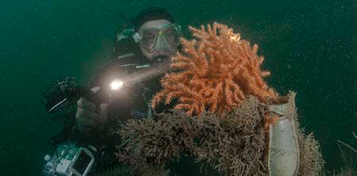
Currently Lundy islands main use is conservation. The conservation of the sea life around the island being a top priority. It is however open to visitors to the island who travel there for multiple reasons such as bird watching, diving, walking, fishing and climbing (The Landmark Trust, 2022d). There are some activities that are solely unique to the island such as the Lundy letterboxes and the Lundy warden led events (The Landmark Trust, 2022d).
(The Landmark Trust, 2022d)

Access;
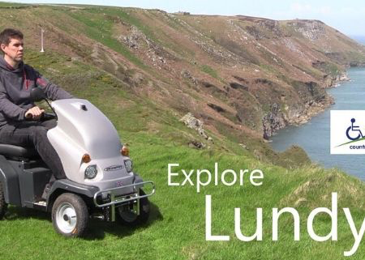
The Landing Bay provides a “sheltered anchorage for yachts and other small craft” with an easily accessible slipway. For those with their own planes or helicopters the island has a small grassy airfield adjacent to the Old Light. The island also has a helipad on the edge of the village. To use either of these advance permission is required. Once on the island there are facilities available for disabled people unable to access the island due to disabilities. Working closely with Countryside Mobility to improve access to Lundy. Lundy has acquired two 'Tramper' 4 x 4 scooters that will help people with disabilities to access the island.
(The Landmark Trust, 2022b)

Future Potential;
Lundy was the first Marine Conservation Zone to be created in the United Kingdom. This set the standard for MCZ’s and became a beacon of conservation. The definition of conservation is “preservation, protection, or restoration of the natural environment and of wildlife” (Oxford Languages, 2022). At this point in time Lundy is doing very well at preserving and protecting the wildlife on and around its coasts. For this reason there is little change in this area that is needed. Over the pandemic Lundy did struggle with “financial hardship in wake of the Coronavirus pandemic” (The Landmark Trust, 2022e). In light of this, a potential suggestion would be to diversify the sources of income to the island to ensure resilience in times of financial hardship.

The greens and blues of Lundy island could be a perfect back drop for Outdoor Mental Health Interventions and Outdoor Therapy. The Institute for Outdoor Learning (2020) state that interacting with an outdoor environment with lots of greens and blues “shapes our behaviour – sometimes adversely affecting aspects of our mental health”. The IOL also believe that “healthy outdoor environments and interacting with them will lead to positive changes in our mental health.” (Institute for Outdoor Learning, 2020). Using Lundy as the location for an outdoor therapy intervention will not only ensure the landscape remain unchanged but could also open opportunities for more charitable funding.

Conclusion
Both land scapes are beacons to sustainability and conservation. It is however evident that a lot of required work cannot be carried out due to the over complication and cross jurisdictions of different organisations. This is particularly evident at Dinefwr park where Cadw run a site within Wildlife Trust property, who run their site within the National Trust estate (Norman, 2022). There may be a benefit to streamlining these organisations into one to better improve cooperation and boost the creation of sustainable recreation infrastructure.

(2701)

References
Bustimes.org (2022) 280 - Carmarthen - Llandovery via Nantgaredig, Llandeilo. Available at: https://bustimes.org/services/280-carmarthen-llandovery-via-nantgaredig-llande-2 (Accessed: 20th April 2022)

Department for Environment Food and Rural Affairs (2013) Lundy Marine Conservation Zone. Available at: http://publications.naturalengland.org.uk/publication/6740830576443392?category=1721481 (Accessed: 20th April 2022)

Devon County Council (2022) Lundy. Available at: https://www.devon.gov.uk/planning/planning-policies/landscape/devon-character-areas/torridge-area/lundy/ (Accessed: 20th April 2022

First Nature (2022) Dinefwr National Nature Reserve, Llandeilo, Carmarthenshire, South Wales. Available at: https://www.first-nature.com/waleswildlife/sw-nnr-dinefwr.php (Accessed: 23rd April 2022)

Institute for Outdoor Learning (2020) Outdoor Mental Health Interventions & Outdoor Therapy: A Statement of Good Practice. 1.3 edn. Available at: https://www.outdoor-learning.org/Good-Practice/Good-Practice/Statements-of-Good-Practice (Accessed: 25th April 2022)

Merriam Webster (2022) Desire Line. Available at: https://www.merriam-webster.com/dictionary/desire%20line (Accessed: 21st April 2022)

National Trust (2022a) Dinefwr. Available at: https://www.nationaltrust.org.uk/dinefwr (Accessed: 19th April 2022)

National Trust (2022b) Dinefwr: Overview. Available at: https://www.nationaltrust.org.uk/dinefwr#Overview (Accessed: 19th April 2022)

National Trust (2022c) ‘Capability’ Brown walk. Available at: https://www.nationaltrust.org.uk/dinefwr/trails/capability-brown-walk-carmarthenshire (Accessed: 24th April 2022 )

National Trust (2022d) White Park Cattle at Dinefwr. Available at: https://www.nationaltrust.org.uk/dinefwr/features/a-living-link-to-our-distant-past (Accessed: 23rd April 2022)

National Trust (2021) Dinefwr: Map. Available at: https://nt.global.ssl.fastly.net/documents/maps/1431730017392-dinefwr.pdf (Accessed: 20th April 2022 )

Natural England (2019) Marine conservation zone designations in England. Available at: https://www.gov.uk/government/collections/marine-conservation-zone-designations-in-england (Accessed: 20th April 2022)

Norman T (2022) Llandeilo History: Dinefwr Park. Available at: https://www.llandeilo.org/nt_vulnerability.php (Accessed: 21st April 2022 )

The Landmark Trust (2022a) Lundy. Available at: https://www.landmarktrust.org.uk/lundyisland/ (Accessed: 19th April 2022 )

The Landmark Trust (2022b) Discover Lundy. Available at: https://www.landmarktrust.org.uk/lundyisland/discovering-lundy/ (Accessed: 19th April 2022 )

The Landmark Trust (2022c) History. Available at: https://www.landmarktrust.org.uk/lundyisland/discovering-lundy/history/ (Accessed: 22nd April 2022)

The Landmark Trust (2022d) Activities and things to do. Available at: https://www.landmarktrust.org.uk/lundyisland/discovering-lundy/activities/ (Accessed: 22nd April 2022)

The Landmark Trust (2022e) Future of Lundy Island secure. Available at: https://www.landmarktrust.org.uk/lundyisland/support-us/lundyappeal/ (Accessed: 23rd April 2022)

Thomas, J. (2021) Deer at Dynefwr Park [photograph]. 23rd August 2021. Authors personal collection

Visit Wales (2022) Dinefwr Park. Available at: https://www.visitwales.com/attraction/country-park/dinefwr-park-2137471 (Accessed: 24th April 2022)

Welsh Government (2022) Cadw Annual Report. Available at: https://cadw.gov.wales/sites/default/files/2022-02/Cadw%20Annual%20Report%20-%20April-2020-March-2021.pdf (Accessed: 23rd April 2022)

Welsh Government (2018) Woodlands for Wales: The Welsh Government’s Strategy for Woodlands and Trees. Available at: https://gov.wales/sites/default/files/publications/2018-06/woodlands-for-wales-strategy_0.pdf (Accessed: 23rd April 2022)

Winter, M. (2022) ‘The Biosphere Reserve Strategy 2014-2024’, biosphere North Devon. Available at: https://www.northdevonbiosphere.org.uk/what-we-do.html (Accessed: 21st April 2022 )

