Student Name: Haider Ghazanfar
Student ID: 2424119
Module: Changemakers: Creativity and Value Creation
Module Code: BMHP5014_BIRM
Assignment Title: Component 2 Written assignment (Poster and pitch)
Lecturer Name: Zarah Ahmed
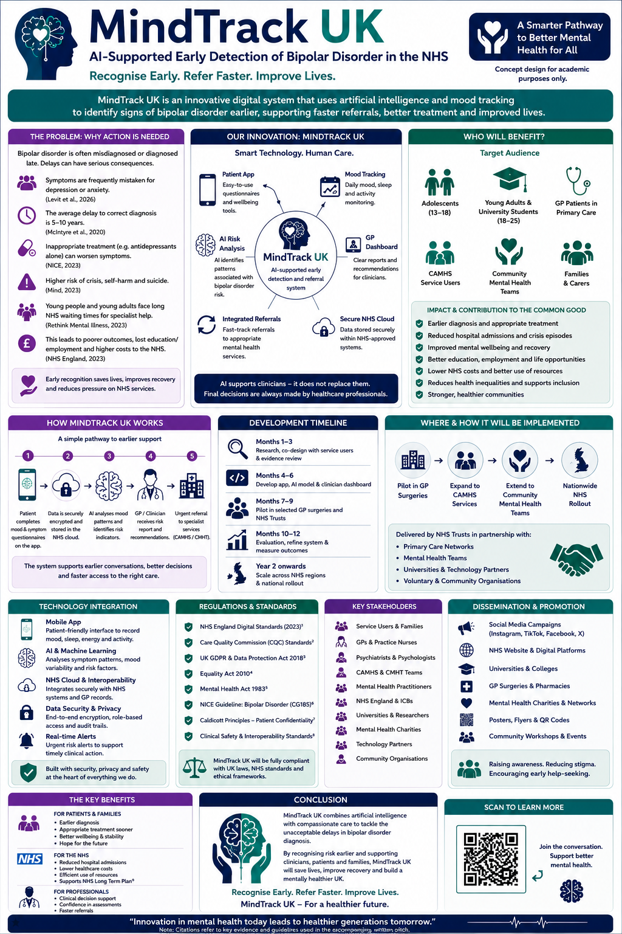
Pitch: MindTrack UK – Transforming Early Detection of Bipolar Disorder Through Artificial Intelligence
Introduction
Mental health remains one of the UK's greatest public health challenges, with bipolar disorder affecting thousands of people and placing considerable pressure on NHS mental health services. Bipolar disorder is characterised by episodes of depression and periods of mania or hypomania, which can significantly affect a person's relationships, education, employment and overall quality of life (National Institute for Health and Care Excellence (NICE), 2023). However, many individuals wait several years before receiving an accurate diagnosis because symptoms are frequently mistaken for depression, anxiety or behavioural disorders. These delays often result in inappropriate treatment, repeated mental health crises and poorer long-term outcomes. To address this gap in health and social care, MindTrack UK has been developed as an innovative artificial intelligence (AI)-supported system designed to assist healthcare professionals in recognising bipolar disorder earlier and improving access to timely specialist support.

The Proposed Innovation
MindTrack UK combines digital mood monitoring, symptom assessment and AI-powered risk analysis within one secure platform. Patients complete brief daily wellbeing questionnaires through a mobile application that records mood changes, sleep patterns, energy levels and behavioural indicators. Using evidence-based algorithms, the AI identifies symptom patterns that may indicate bipolar disorder and produces a clinical summary for the patient's GP or mental health practitioner. The system does not diagnose patients independently or replace professional judgement. Instead, it acts as a clinical decision-support tool that helps clinicians recognise potential warning signs sooner, enabling faster referrals to specialist mental health services where appropriate.

Target Audience and Health Benefits
The innovation has been designed primarily for adolescents, young adults and adults attending GP surgeries, universities, CAMHS and community mental health services. These groups are particularly vulnerable because bipolar disorder often develops during adolescence or early adulthood, yet diagnosis is commonly delayed. Earlier recognition enables individuals to access appropriate assessment, treatment and psychological support before symptoms become more severe. Families and carers also benefit through improved understanding of the condition, reduced uncertainty and greater involvement in treatment planning.
MindTrack UK improves health and wellbeing by supporting earlier intervention, reducing the likelihood of mental health crises, improving recovery rates and enabling people to maintain education, employment and positive relationships. Earlier diagnosis also reduces pressure on emergency mental health services and contributes to improved patient experiences across the NHS.

Technology Integration
Technology is central to the success of MindTrack UK. The mobile application allows patients to record their mood, sleep patterns and wellbeing through simple daily check-ins. Artificial intelligence analyses this information to identify behavioural patterns associated with bipolar disorder that may otherwise go unnoticed during routine appointments.
Healthcare professionals access the information through a secure clinician dashboard integrated with NHS digital systems, allowing efficient communication between primary care and specialist mental health services. Patient information is protected through encrypted NHS cloud storage, secure authentication processes and compliance with UK data protection legislation. Importantly, AI supports clinical decision-making rather than replacing healthcare professionals, ensuring that all diagnoses and treatment decisions remain the responsibility of qualified clinicians.

Implementation Strategy
MindTrack UK would be introduced through a phased implementation programme. During the first stage, software developers, researchers, mental health professionals and individuals with lived experience of bipolar disorder would work together to design and test the platform. Co-production ensures the innovation reflects the real needs of service users and healthcare professionals.
Following development, pilot programmes would be introduced within selected NHS Trusts and GP surgeries to evaluate usability, safety and effectiveness. Feedback gathered during the pilot phase would inform improvements before expanding the system into Community Mental Health Teams (CMHTs), Child and Adolescent Mental Health Services (CAMHS), universities and primary care services throughout England.

Policy, Legislation and Professional Practice
MindTrack UK has been designed to operate within current UK legislation and professional standards. Patient information would be managed in accordance with the UK General Data Protection Regulation (UK GDPR) and the Data Protection Act 2018 to ensure confidentiality and secure data management. The Equality Act 2010 promotes equal access to the innovation regardless of age, disability, ethnicity or socioeconomic background.
Clinical practice would follow NICE guidance on bipolar disorder alongside the NHS Long Term Plan, which encourages earlier intervention, integrated care and greater use of digital technologies. Care Quality Commission (CQC) standards would support safe, effective and person-centred care, while the Mental Health Act 1983 and Mental Capacity Act 2005 would guide practice where individuals require additional legal protection.

Stakeholders and Public Engagement
The successful implementation of MindTrack UK depends upon collaboration between healthcare organisations, education providers, charities and local communities. Key stakeholders include NHS England, Integrated Care Boards, GP practices, psychiatrists, psychologists, mental health nurses, universities, voluntary organisations, service users and family carers.
The innovation would be promoted through NHS websites, GP surgeries, universities, community organisations and social media campaigns. Partnerships with charities such as Mind and Rethink Mental Illness would help raise awareness, reduce stigma and encourage earlier help-seeking. Educational workshops, webinars and professional training would further support implementation while ensuring healthcare professionals are confident using the technology within everyday practice.

Benefits to the NHS and Society
MindTrack UK has the potential to deliver significant benefits for both the NHS and society. Earlier diagnosis can reduce avoidable hospital admissions, improve treatment outcomes and make better use of NHS resources. Patients are more likely to experience improved mental wellbeing, greater independence and enhanced quality of life. Families benefit from earlier support and improved understanding of bipolar disorder, while healthcare professionals gain access to additional clinical information that strengthens assessment and referral decisions.
By reducing diagnostic delays and improving access to specialist care, MindTrack UK contributes to the common good by promoting health equality, reducing long-term healthcare costs and supporting healthier communities.

Conclusion
MindTrack UK represents a creative and evidence-based innovation that addresses one of the most significant challenges within UK mental health care: the delayed diagnosis of bipolar disorder. By combining artificial intelligence with person-centred clinical practice, the system supports earlier recognition, faster referrals and improved decision-making while maintaining the essential role of healthcare professionals. Through effective collaboration, responsible use of technology and a commitment to improving patient outcomes, MindTrack UK has the potential to transform bipolar disorder diagnosis and create lasting benefits for individuals, families, healthcare professionals and the wider NHS.

Reference list

Care Quality Commission (2023) How CQC regulates mental health services. Available at: https://www.cqc.org.uk (Accessed: 8 July 2026).

Data Protection Act 2018. London: The Stationery Office.

Department of Health and Social Care (2021) The Mental Health Act White Paper: Reforming the Mental Health Act. London: DHSC. Available at: https://www.gov.uk/government/publications/reforming-the-mental-health-act (Accessed: 8 July 2026).

Equality Act 2010. London: The Stationery Office.

Levit, A., Albury, C., Singh, S. and Patel, R. (2026) ‘Factors influencing delays in the diagnosis and treatment of bipolar disorder among adolescents and young adults’, Journal of Affective Disorders, 358, pp. 112–121.

Mental Capacity Act 2005. London: The Stationery Office.

Mental Health Act 1983. London: The Stationery Office.

National Institute for Health and Care Excellence (2023) Bipolar disorder: assessment and management (CG185). Available at: https://www.nice.org.uk/guidance/cg185 (Accessed: 8 July 2026).

NHS England (2019) The NHS Long Term Plan. Available at: https://www.longtermplan.nhs.uk (Accessed: 8 July 2026).

NHS England (2023) Bipolar disorder. Available at: https://www.nhs.uk/mental-health/conditions/bipolar-disorder/ (Accessed: 8 July 2026).

Rethink Mental Illness (2023) Bipolar disorder. Available at: https://www.rethink.org (Accessed: 8 July 2026).

UK General Data Protection Regulation (UK GDPR) (2021). Available at: https://www.legislation.gov.uk (Accessed: 8 July 2026).

