

Student Name: Roman Ziga
Student Number: 1913284
Module Title: Digital Skills and Research Methods
Assignment Title: Digital Skills and Research Methods
Module Lecturer’s Name: Modak Koushik

_______________________________________________________
University of Wales

Digital Skills and Research Methods:
A study on the impact of Virtual Learning Environment

Contents
Abstract 5
Introduction 6
Acknowledgment 7
Aim and Objectives of the research 8
Literature Review 9
Research Methodology 12
Research Questions 13
Data Analysis& Findings 14
Conclusion 24
Bibliography 25

Figure 1 VLE platform is effective than attending class physically? 16
Figure 2 What are challenges of VLE? 17
Figure 3 Why does it easier to learn anything on VLE? 18
Figure 4Do you think VLE have positive impact on learning? 19
Figure 5 How does it possible to increase the user of VLE? 20
Figure 6 Are the teachers comfortable to use VLE platform? 21
Figure 7 What are the reasons students preferring to use VLE? 22
Figure 8 How teachers’ activities can be monitored in VLE? 23

Abstract
In learning system, it is more fruitful to realize if the practical training is provided. That is why educational process has introduced by promoting the practical application. The system of learning requires several aspects and gives emphasis on the information of communicating technological issues that create reflection of the teaching & learning procedures mostly. The excellence of the learning can be developed by introducing virtual learning environment easily. Despite having several benefits, there are some shortcomings in VLE. The authority of several universities, colleges select the VLE for the students because it is preferable to them. VLE can adjust the educational period easily. That is why it is more popular to the students.
With updated and effective materials for study any student can learn the lesson without any difficulty. When the aim is to deliver the lesson in a simple way then the concept of Virtual Learning becomes more effective with proper utilization. There are students who can not learn easily from online source because they are not adapted to this platform as to why it is very important to encourage those students or learners so they get used to this. For VLE Moodle is commonly used by many where many learners can easily get access. Moodle is known as modular object-oriented dynamic learning environment.

Introduction
Virtual learning environment (VLE) is a web-based platform where technology is mainly used to accelerate the way of learning with the resources that can easily be accessed via online. Assessment, course outlines and structures can easily be updated in this platform. Apart from this it is effective and many really appreciate to use because they can use it in their convenient time. (Fire Fly Learning, 2020) VLE ensures designed space to teach and let the learners learn at ease. Those who have a laptop or personal computer and access to internet can avail the VLE platform comfortably. Mapping required elements to be used for academic curriculum is mainly considered for Virtual Learning Environment. Tracking the students’ and teachers’ activity, ensuring the use of web link externally via online. Both student and teacher need to have VLE ID to get the access. There are many software like WebCT, blackboard, future learn etc. (Liaw, 2008)

Acknowledgment

I am highly grateful to the academic teachers and students who helped a lot by providing relevant information to complete this research. Several researches were done regarding VLE which contributed a lot to accomplish this paper easily.
It is my great privilege and I am thankful to the University of Wales Trinity Saint David London as they have given the very nice opportunity do this research on VLE.

Aim and Objectives of the research
Research Aim
This paper aimed to find out the impacts of Virtual Learning Environment.
Research objectives
- To know why Virtual Learning Environment is important.
- To find out alternate ways of Virtual Learning.
- To know the overall impact on performance of students due to use of VLE platform.
- To identify the effective resource and materials required for strategy making in VLE.
- To find out the attitudes of student and teachers towards VLE.

Literature Review

Several researches were conducted to identify the reason of not understanding the lesson delivered for the students. The outcome of the research assists to realize the exact problem. The students must complete several study materials within a specific academic period. Most of the time the students are not able to perform the project work or term paper properly for different reasons such as de-motivated in studies, time shortage to realize etc. That is why; the technology of web-based multimedia has been introduced to reduce the problem of learning. Virtual learning environment can organize a suitable learning system for the students. The students can perform better by using VLE and it is fruitful to learn as well as time management of the study material. (Aldosari, 2013)
For developing the virtual learning environment, it is essential to introduce a suitable process to conduct. The process of VLE makes sure of maintaining enough properties, estimation, management & supervising tools. The entire requirements are crucial to run VLE successfully. The educational system is changing rapidly day by day. The usage of digital technology is also growing fast. The students can easily promote their capability or efficiency by using the technological support in learning section. (Harding, 2018)

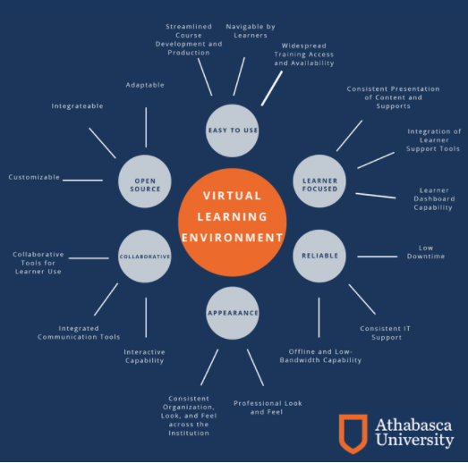
(Athabasca University, 2020)

To promote the efficiency in working sector, employment sector requires more capable workforce. By maintaining VLE the efficiency can be achievable. So, online training through the VLE is more acceptable to develop the skill in learning section. There are several options like cloud-based learning management system, infrastructural models design etc. The acceptance of VLE technology mostly depends on the attitude and experience of teacher and students. Technical skills, high motivation and positive attitudes are important for the successful implementation of VLE. (Lennon, 2003)
Moodle based learning management system is very popular and it brings many benefits for the users. Brandan Hall Group conducted a research on using LMS where 44% companies give priority to user friendly interface. Reporting, tracking, assessment, ease of use and content management are the most notable advantages of Moodle based LMS. (Hurix, 2020)
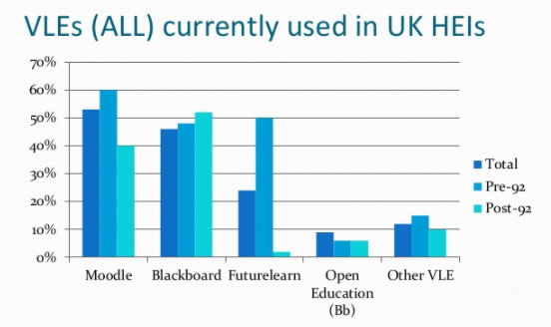

Several surveys conducted on University of York on VLE platform and there was reflection of consideration success for using VLE. (York , 2020) Most of the respondents shared that they got benefitted by using several class lectures, notes, videos, quiz assessment, electronic submissions for reports etc. Apart from this UCISA Technology Enhanced Learning Survey also confirmed the use of VLE platform exceedingly increased. (Alhogail, 2011)
After completing the study, students were feeling free to use VLE in learning system. Finally, it can be said that, students and teachers are more comfortable to use VLE system as learning platform.

Research Methodology

Research design and method
This research is conducted by using quantitative method with the help of secondary sources where previous research done on VLE. To gather the data easily, convenience method for sampling is used here.
Sources of data
Primary and secondary sources are considered.
Tools of data collection
Questionnaire method is applied to collect primary data.
Data analysis
Microsoft office excel, graphical presentations are used for data analysis.
Sample size
120 respondents are considered for this research.

Ethical consideration
It is ensured not to disclose, or misuse of any information collected from respondents.

Research Questions
- VLE platform is effective than attending class physically?
- Agree
- Disagree
- What are challenges of VLE?
- Can not use who lacks technical knowledge
- Can ignore the lesson
- Problem for practical class
- Why does it easier to learn anything on VLE?
- Effective materials are used
- Considered more practical examples
- Students can study at their suitable time
- Do you think VLE have positive impact on learning?
- Yes
- No
- How does it possible to increase the user of VLE?
- By motivation
- By giving some training on technology use
- Are the teachers comfortable to use VLE platform?
- Yes
- No
- What are the reasons students preferring to use VLE?
- Resourceful platform
- Can get free access from home
- How teachers’ activities can be monitored in VLE?
- By evaluating the lectures and teaching materials stored in the platform
- By taking students feedback from online survey

Data Analysis& Findings
The conducted research gives emphasis on the impact of VLE mostly. For collecting primary data, google form in online questionnaire is utilized considering 100 respondents. On the other hand, many researches are available in online to make the assessment.

 | Agree | Disagree
VLE platform is effective than attending class physically? | 100 | 20
 | Can not use who lacks technical knowledge | Can ignore the lesson | Problem for practical class
What are challenges of VLE? | 20 | 40 | 60
 | Effective materials are used | Considered more practical examples | Students can study at their suitable time
Why does it easier to learn anything on VLE? | 50 | 30 | 40
 | Yes | No
Do you think VLE have positive impact on learning? | 105 | 15
 | By motivation | By giving some training on technology use
How does it possible to increase the user of VLE? | 100 | 20
 | Yes | No
Are the teachers comfortable to use VLE platform? | 90 | 30
 | Resourceful platform | Can get free access from home
What are the reasons students preferring to use VLE? | 95 | 25
 | By evaluating the lectures and teaching materials stored in the platform | By taking students feedback from online survey
How teachers’ activities can be monitored in VLE? | 100 | 20

Question-1
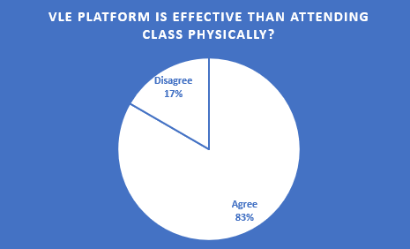
Figure 1 VLE platform is effective than attending class physically?

The above illustration, it is revealed that 83% of the respondents agreed on the effectiveness of VLE platform than attending class physically. A few of respondents that is 17% disagreed on the topic. Overall feature shows the more effectiveness of VLE than attending class physically.

Question-2
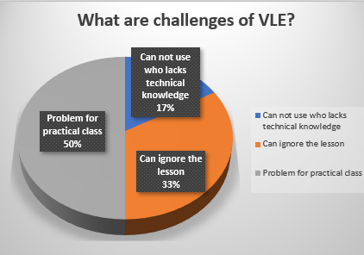
Figure 2 What are challenges of VLE?
There are several challenges of VLE has to face. In VLE, only 17% respondents are not able to use VLE technology. Another problem of taking practical classes that shows 50% of overall problem. 33% of respondents can ignore the classes in VLE. The above challenges impact the learning process of VLE.

Question-3
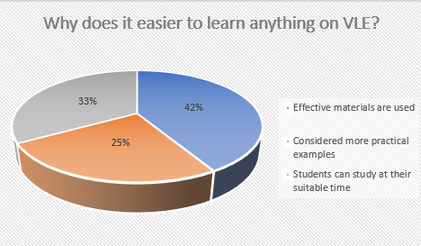
Figure 3 Why does it easier to learn anything on VLE?

The overall chart shows the easiness of learning anything on VLE. At first, 42% respondents think it is easier for effective material utilization, 25% shows for the consideration of practical examples and finally 33% responses are given for appropriate time management of the students.

Question-4
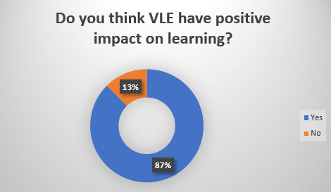
Figure 4Do you think VLE have positive impact on learning?
VLE can create positive impact in learning as almost 87% shared accordingly whereas only 13% of responses are negative. So, it is clear that VLE can impact learning positively.

Question-5

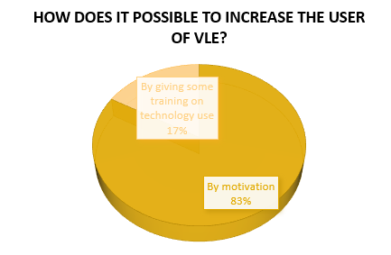
Figure 5 How does it possible to increase the user of VLE?
From the above pie chart we can see that almost 83% respondents shared user rate can be increased when there is more motivation available. On the other hand, 17% respondents think it is important to give technology related training for those we are not able to use computer or VLE platform. This will improve the user percentages.

Question-6
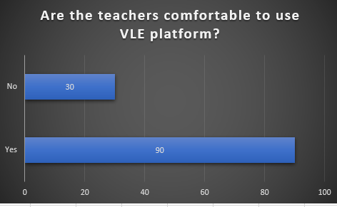
Figure 6 Are the teachers comfortable to use VLE platform?

We can see that almost 90 feedbacks came from teachers out of 120 feedback where they shared that they are very comfortable to use VLE as a learning and teaching platform. On the other hand, 30 respondents are not comfortable to use this platform.
So, it is obvious that most of the teachers are using this VLE as a comfortable platform.

Question-7

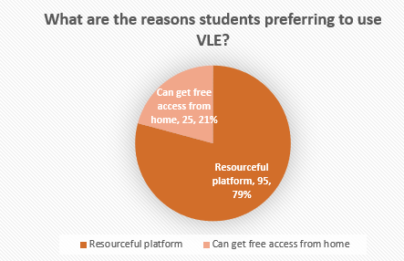
Figure 7 What are the reasons students preferring to use VLE?

Students were asked for the reasons of using VLE and 79% shared they find this as very resourceful platform so they prefer to use it. On the other hand, 21% shared they can easily get access from home or anywhere so they give high preference using it.

Question-8
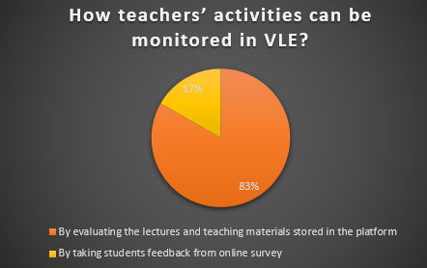
Figure 8 How teachers’ activities can be monitored in VLE?

Almost 83% respondents think the lectures and other materials already used in VLE can be analyzed for teachers’ evaluation. If these materials are effective then it can easily be identified. If these are not effective then further initiative can be taken. 17% respondents also think student can participate by giving feedback in online survey that can help to identify the performance of teachers.

Conclusion
In VLE, the motivational aspect is highly measured topic for the students. Basically, learning system is greatly impacted by the VLE. By using the digital technology based learning the students feel more interest in learning and get sufficient time. The virtual learning environment creates a remarkable performance to learn easily.

Bibliography
Aldosari, H. &. M. M., 2013. The Bandwagon Effect in the Adoption of E-Learning Systems in Language Learning-An Appraisal. GSTF Journal on Computing, 2(4), pp. 61-81.
Alhogail, A. &. M. A., 2011. Implementing a virtual learning environment (VLE) in a higher education institution: A change management approach. Journal of Theoretical and Applied Information Technology, Volume 31, pp. 42-52.
Athabasca University, 2020. Athabasca University. [Online]
Available at: http://opvpa.athabascau.ca/learning-framework/environment.php
[Accessed 31 8 2020].
Fire Fly Learning, 2020. Fire Fly Learning. [Online]
Available at: https://fireflylearning.com/what-is-a-virtual-learning-environment-vle
[Accessed 31 8 2020].
Harding, N., 2018. The Digital Turn: staff perceptions of the virtual learning environment and the implications for educational developers. Irish Journal of Technology Enhanced Learning, Volume 3, pp. 45-52.
Hurix, 2020. Hurix. [Online]
Available at: https://hurix.com/benefits-moodle-based-learning-management-system/
[Accessed 31 8 2020].
Lennon, J. &. M. H., 2003. Why it is difficult to introduce e-learning into schools and some new solutions.. Journal of Unviversal Computer Science, 9(10), pp. 1244-1257.
Liaw, S., 2008. Investigating Students' perceived satisfaction, behavioral intention, and effectiveness of elearning: A case study of the Blackboard system. Computers & Education, Volume 5, pp. 864-873.
York , 2020. York. [Online]
Available at: https://www.york.ac.uk/it-services/information-systems/staff/general/
[Accessed 31 8 2020].

