

University of Wales Trinity Saint David School of Engineering
Pipe Climber Competiton Task 2
Reza Shafie-Pour Motlagh
Joe Lockyear
Hussein Yahye
Tim Stanbury
Table of Contents
1 Concept #1: TIM STANBURY 2
2 Concept #2: YAYHE HUSSEIN 3
3 Concept #3: JOE LOCKYEAR 4
4 Final Design: REZA SHAFIE-POUR MOTLAGH 5

Concept Design #1
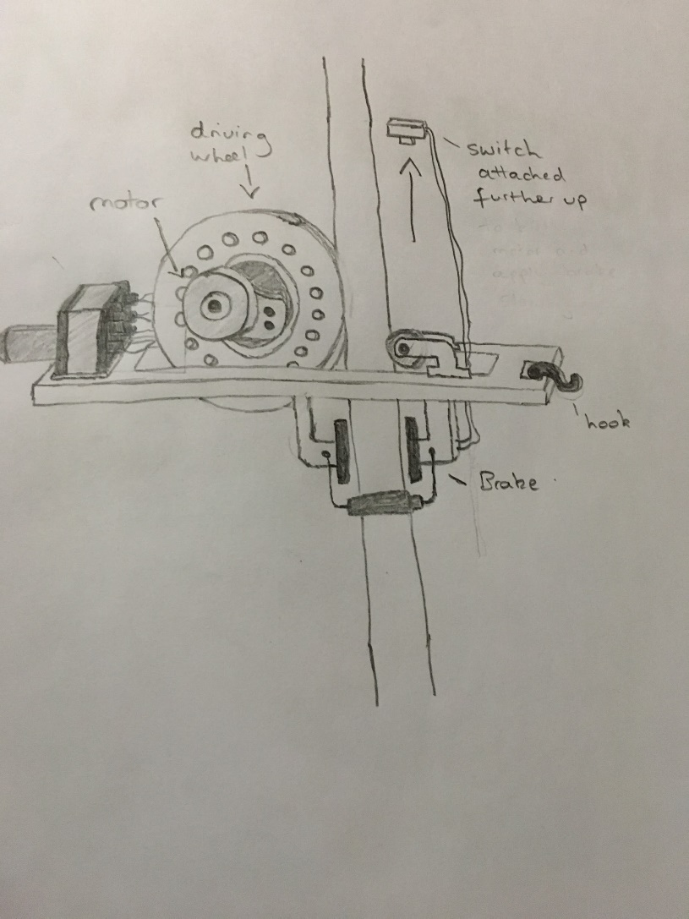
The aim of this task was to come up with a concept design which could potentially be used as an external pipe crawler, therefore being able to climb up and down a fixed pipe. This concept design has several parts which all have individual roles to play.
The driving wheel - the driving wheel used in this design is used to generate the upwards movement of the pipe crawler up the pipe. It does this using friction to grip on to the pipe allowing for the pipe crawler to climb up it, this area of friction will also be in a small indentation in the wheel which allows it to slightly wrap itself around the pipe. The driving wheel will most likely be used in the final design to create the upward movement of the crawler.
The supporting wheel - the supporting wheel is important as it allows for stability. Similarly to the driving wheel it will have an indentation all the way around allowing for it to sit nicely around the pipe. This wheel will allow the pipe crawler to move up and down without having too much play, due to the wheel being very loosely fitted. Some sort of supporting wheel will most likely be used in the final design as it allows for stability as the crawler moves up and down.
The motor - The main power generation in this design comes from an electric motor which turns the driving wheel. This motor will only be used for the climbing of the pipe and will be powered by a small power bank attached to the pipe crawler. A motor will almost certainly be used in the final design as it allows for a cheap way of creating the power required to climb the pipe.
The hook - The purpose of the hook is too assist with the performing of the chain lifting task. The chain can simply be attached to the hook and therefore moves up and down with the pipe crawler. Some sort of hook may potentially be used in the final design to carry the chain, however it could also be attached another way in the final design.
The brake - The purpose of the brake is to allow the crawler to come to a stop smoothly and without any damage. The idea of this concept design is to use a device similar to a bicycles brakes, whereby pressure is applied causing the brakes to be applied. This pressure would ideally be applied halfway down the descent of the crawler to hopefully dampen the fall, but hopefully not reduce the travel time by much. The main area of concern here is how this brake would be created or bought, because if it was a bicycle brake used it would have to have pressure applied so cause the braking action. Therefore due to this it is unlikely that this sort of brake would be used, however using friction to slow down the falling pipe crawler will be taken into consideration.
The switch - The switch was added to this concept design to allow for the killing of the motor when it reaches the top of the pipe, therefore allowing it to fall. Ideally it would then fall and be stopped by the brake which was also applied by hitting the switch, however it is unlikely that this would work. The idea of a switch however cutting the power of the motor could be useful for the final design as it allows for the downward movement which is required, however it is unlikely that this switch will also link to the braking system.

Conclusion on this concept design
This concept design has several parts which will possibly be used in the final design, for example the driving wheel, motor, and some sort of supporting wheel. Therefore this design does have some positive aspects to it. The idea of having a kill switch which is activated when the crawler reaches the top of the design could be key for allowing the downwards travel of the crawler.
The main sticking point of this concept design and the main reason why it is not suitable for the final design in due to the brake design, as it would be far to complex and requires external force for it to be applied. This is not possible as the design has to be self contained, therefore has to brake on its own. It would also potentially prove more costly to use this sort of brake as it would most likely have to be a bicycle brake which are usually around £15, which uses up a fair bit of the budget.

Concept Design #2
In this task we where asked to complete a concept designs, final design and evaluation. During the design process we all presented concept ideas and this report will be about my concept idea and why we did not continue further with it? And I will also be going through the advantages and disadvantages. That was that the pipe was suppose act as a stressed member as when the wheel turned the grip of the tyres would climb up the pipe but the fact that the design used the pipe as a stressed member
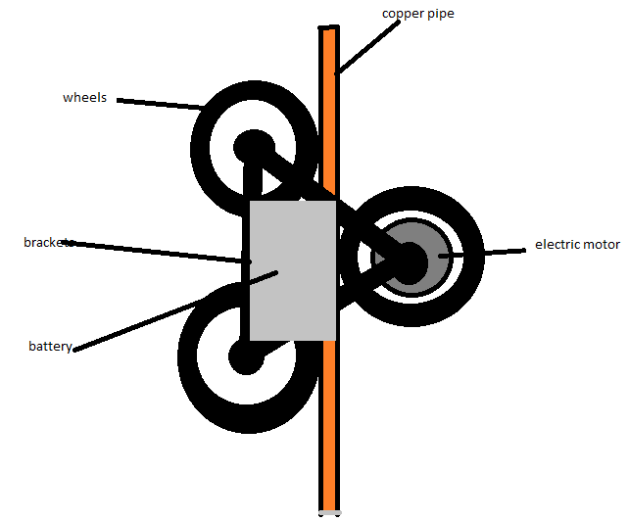

Figure 1: concept design
Design Explanation
Fig 1 is a concept design that I presented to the group. The way this concept is supposed to work is that the copper pipe acts as a stressed member against the three wheels, one wheel on one side the other two being on the other side and one bracket has a width of 3.75mm and the length is just large enough to hold a nut and bolt in place. you can move the bracket sideways, so they can be tightened depending on the size of the pipe. I decided to mount the motor to the right side of the pipe attached to the wheel, so it can balance out because on the other side the battery will be mounted to the bracket the joins the two wheels on the left. The materials of the brackets are plastic the wheels are rubber and plastic because these are light weight materials that are is to get a hold of.
Advantage
The design is simple so that it means a lot of other things will be made easier like build process, it uses simple components that are cheap and easy components that are easy to get a hold of and assemble. It was also designed to be light weight because the bracket will be mad out of plastic and the wheels was supposed to be from rubber and plastic RC car wheels. The placement of the components utilises the space that will otherwise have been wasted for example placement of the battery and the motor.
Disadvantage
After I had presented the design to our group I then realised there was a problem with my design that I had missed and that was that the pipe was suppose act as a stressed member as when the wheel turned the grip of the tyres would climb up the pipe but the fact that the design used the pipe as a stressed member it would rely on the fact that it would need to be tighten and the tightening design was flawed because that would need the bracket to be longer and it would need to much fidgeting to get the right tightens so it can move. The plastic may not be strong enough to support the torque of the electric motor because it is a RC motor with a large battery when it is turned on it might break the other tooth of the sprocket or it might slip.
Decision
I then made the choice to not continue with the design concept because the flaws mentioned above could have been fixed but the when other member presented their design some had flaws but ultimately we all had a similar design and we decided as a group to focus on the design with least or none amount of flaws and as a group we did our best find problems know so we don’t have problems later on in the process for example during the build process we find out that our device does not work as intended.
Conclusion
In conclusion this concept had parts that where good, but the fact is that it required further development and the fact was that we all had similar designs, so I made a choose not to continue further with this design.
Evaluation
In my opinion I feel like that I achieved my goal of presenting a design concept because even though it had a few issues, it was supposed to be a concept design and as we know concepts are not always perfect. The fact that my designed only showed basic concept and I feel like that attributed to the fact that it was not used as the final design.

Concept Design #3
This design proposal is a potentially adjustable system and consists of a few key aspects that should enable the platform to climb the pipe.
This system relies on two wheels placed either side of the platform, these wheels can be tailored for purpose dependent on what’s available. One that is available is RC Car wheels. There is potential to use off road rc car wheels as they are small enough for the pipe of 150mm and can soak up the forces pushing it against the pipe.
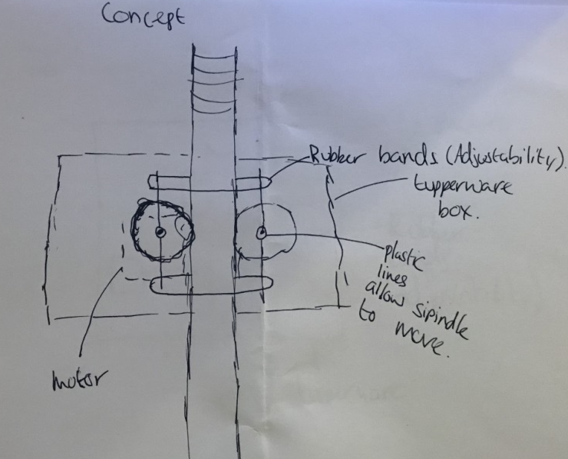
To do this there will be two plastic or metal rods with a hole half way along its length to allow the axles from the electric motors to spin freely. These rods on either side allow elastic bands to be wrapped across to be able to adjust the force of the tyres onto the pipe. This is a very cheap and easy way of adding enough friction to the system to lift the weight of the chain of 0.36kg
Figure one shows how the system will look from a side view. With the rubber bands above and below the wheels to keep the system balanced. The whole system can easily be placed into a Tupperware box which helps keep the cost down. Then the Tupperware box can be filled with expanding foam to help with the impact of it dropping to the floor from the height of the pipe.
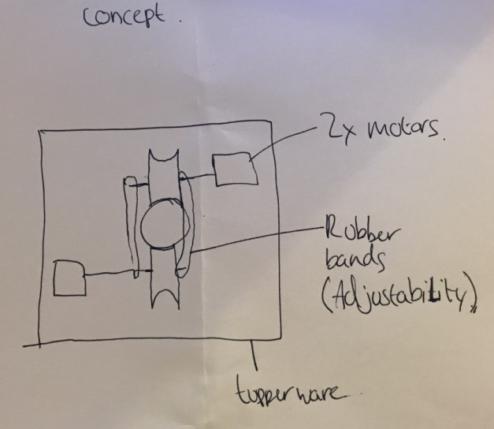
Figure 2 shows the system from the top view. The two motors driving both the wheels are accommodating the necessity of the wheels spinning in different directions. A hole can be placed in the bottom of the Tupperware box to allow more room for the wheels.
The chain used in the competition as specified in the design brief is a typical 3mm steel welded chain. These chains on average weigh 0.16kg/m. Considering the system has to lift two meters of chain which will equate to 0.32kg it is essential to have a secure enough base for a screw hook. This can be achieved from a small bit of wood reinforcement on the inside of the tupperware box.
Small motors are easily obtainable with prices ranging, potentially we could have the 3500rpm-9000rpm 12V-32V motor available on ebay. To enable this the batteries would be far too large for the application. Instead smaller 3V brushless motors are needed. These can run up to 13000rpm but will not have as much torque. Based on a wheel size of 5 cm and motor that constantly works at 9000rpm up the pipe it should be able to accomplish the 2m copper pipe in 0.17 Seconds and would complete 400 rotations over the 2m long pipe.
One of the potential negatives of this system can be found from keeping the balance between the rubber bands either side of the wheels. With these rods being pretty specific it is likely they will need to be made in house. This adds a lot more planning on a manufacturing level and could eat into a lot of time although accomplishable.
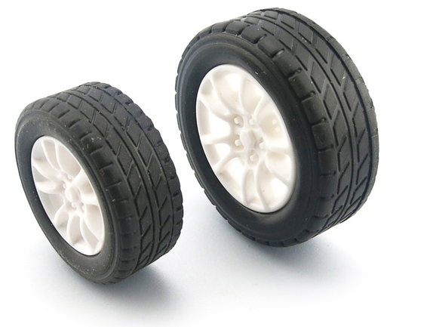
Another worry from this system is being able to keep the wheels on the copper pipe without sliding off. This is something that will need testing. As concave rubber wheels at the diameter of the pipe are difficult to get. Instead, rc car off road wheels as seen in figure 3 are compromise. They should be able to deal with the force of the rubber bands pushing them against the pipe but keeping them on the pipe may be more difficult.
There is also a need for a way of getting the pipe crawler to stop at the top and come back down. This has provided a challenge in which could be solved by having a switch that cuts all power and the pipe crawler will free fall to the floor. This seems to most people the fastest way to get down the pipe but could cause damage to the system allowing only for a certain amount of runs. Its possible to get the pipe crawler down faster by a switch that changes the direction of the motors in order to give extra driving force down the pipe not just gravity.
Considering there is potential for damage to the system it is imperative that something is done to help mitigate damage. This could be done in this system by filling the container with expanding foam and gluing some good quality sponges to the bottom. Not pretty but we aren’t aiming for aesthetics and should work well.

Final Design
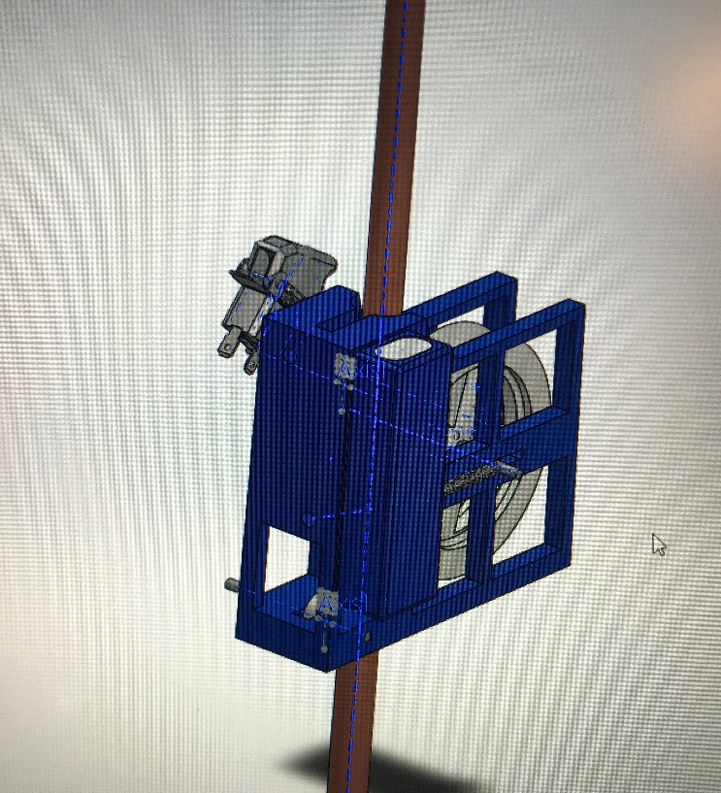
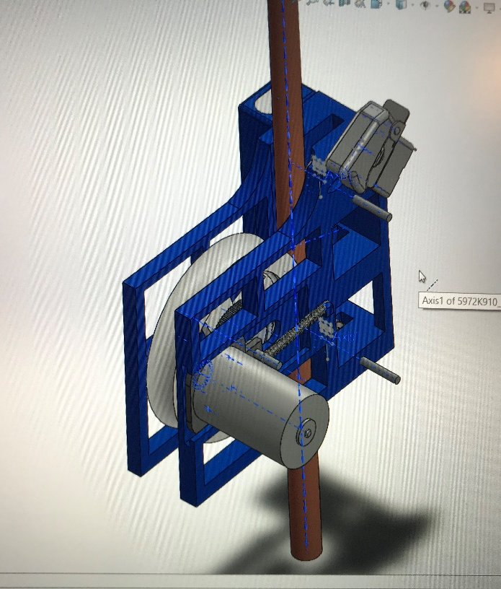
Design Specification:

The design specification for this competition is reasonably simple: make a small machine climb a 15mm diameter pipe as fast as possible, all within the 25-pound budget limit. However, it isn’t that simple, as you have to balance weight, power, money, strength, and performance repeatability together all at the same time. Some factors that are going to be taken into account are: coefficient of friction for the traction wheel against the pipe, linear speed, torque multiplication, and repeatability of performance. This final design is comprised of surprisingly few components, the main of which is the body, or chassis, of the climber. I have designed many mounting points, structural supports, and self-adjusting capabilities into it. The chassis will be 3D printed out of cheap but strong and flexible PLA (Poly Lactic Acid), as a member of our group personally owns two 3D printers. The entire frame, motor mounting plate, and traction wheel only weigh 176 grams combined. With a full spool of PLA costing £18, and there being 350 meters of filament on a spool; And the 176 grams equating to 89 meters needed for the three components we are printing, it will only cost £4.58. With the idea of lightness in mind, as much material was removed as possibly from the chassis, while retaining specific designs and structures to keep rigidity high. However, if the chassis flexes when printed, two or three screws applying a slight spreading force between the two flanks will be more than enough to bring the level of rigidity up to what would be needed. The motor has a no load free speed of 23000rpm, and we expect it to run at about 15000rpm under load. There is a 20 tooth spur gear on the motor, and a 80 tooth gear on the traction wheel, both made from metal so there is no chance of slippage or stripping. This gives a 4.0:1 speed reduction ration, and a torque multiplication factor of 4. Meaning, the RS-540SH-627 motor we will be using, because it is £3.73 and provides good torque, will have its torque increase mechanically from 316 g/cm to 1264 g/cm, and from our calculations this should be enough torque to climb to the top with the chain attached. To counter the traction wheel, i.e. the other side of the pipe, we will have two skateboard bearings that provide very low rolling resistance, while costing £2 for a set of two. The traction wheel and the two bearings are riding on three 4mm rods, which for a pack of 4 is priced at £1.15. To control and power the motor there is a simple SPST (single position single throw) switch, with a “missile cover” . This will allow us to flip it on, let it run to the top, and when contact is made with the top the cover will flip down and turn the motor off. The descension will be done by gravity, and with the weight of the whole assembly, the weight of the chain, and the relative lack of rolling resistance, should be swift however it wont be as fast as possible. The fastest way would be to utilize gravity by designing a mechanism that releases the traction wheel from the pipe allowing it to essentially fall. This would complicate the design and add significant weight as well as adding a possible failure point leading to inconsistency. A 7.4 volt, 1650 mAh, battery will be used allowing for multiple uses in between charges, and plenty of consistent linear power as compared to NiCad batteries.
Possible Design Challenges:
There are one or two possible challenges that could come up when the design is physically built. The main one is the possibility of the motor not producing enough torque to lift the entire weight of the chain. If this happens, depending on budget left, we will look into ta more powerful motor, or if the money is tight, possibly increasing the gear ration to mechanically multiply torque. Whether that is decreasing the spur gear, or increasing the crown gear circumferences, that is a decision that will be made once it is built and tested. The second potential area for improvement would be the descent, it could be too slow to be competitive. Spinning the motor in reverse just using gravity might be slow, inconsistent, and unpredictable, even with no current going through the system. If this happens we will look into a dual position dual throw switch, which will drive the motor the opposite direction when the switch is flipped at the top. Another solution would be the use of gravity, by allowing it to fall with no resistance besides that of air. To keep tension on the traction wheel, a full “floating” mounting system will be used by allowing the axle to slide freely in slots designed into the chassis. Two extension springs are used to apply the tension.



