Bill of materials and processes.

Frame:

Ghost bike: Ghost FR AMR 8.7 Aluminium, injection mould

Cane Creek Helm 170 mm. steel coil, injection mould

Cane Creek DB Coil CS 165 mm. Steel coil. injection mould

Syntace Megaforce2 Dia. 31.8 mm. Aluminium , titanium, injection mould

Syntace Vector 780 mm Rise 20 mm Dia. 31.8 mm. carbon, injection mould

SRAM X01 Eagle 12-S. Forged aluminium, stainless steel, titanium. injection mould

SRAM GX Eagle. aluminium , steel, stainless steel. injection mould

Truvativ Descendant 7K Eagle X-Sync 34T. aluminium, injection mould

SRAM XG 1275 10-50. Stainless steel, injection mould

SRAM Code RSC 4/4 Piston 200 / 180 mm Disc. Forged Aluminium phenolic plastic. forged

Rock Shox Reverb Stealth 31.6 mm. 7050 forged alloy. forged

SDG Fly Mountain. Nylon base, kevlar, cro-mo. sewn, vac formed

FRHG0057 (pin) aluminium. injection mould

16012 (bearings) stainless steel. injection mould

Maxxis Minion DHF 3C MaxxTerra Exo 27.5x2.5 (front). dual compound rubber with exo protection. injection mould

Maxxis Minion DHR II Exo 27.5x2.4(rear) dual compound rubber with exo protection. injection mould

Syntace M Wheelset 33 mm 15x110 mm aluminium. injection mould

Syntace M Wheelset 33 mm 12x148 mm SRAM XD aluminium. Injection mould

Engine:

Iron, aluminium. Injection mould, screwed together and bolted.

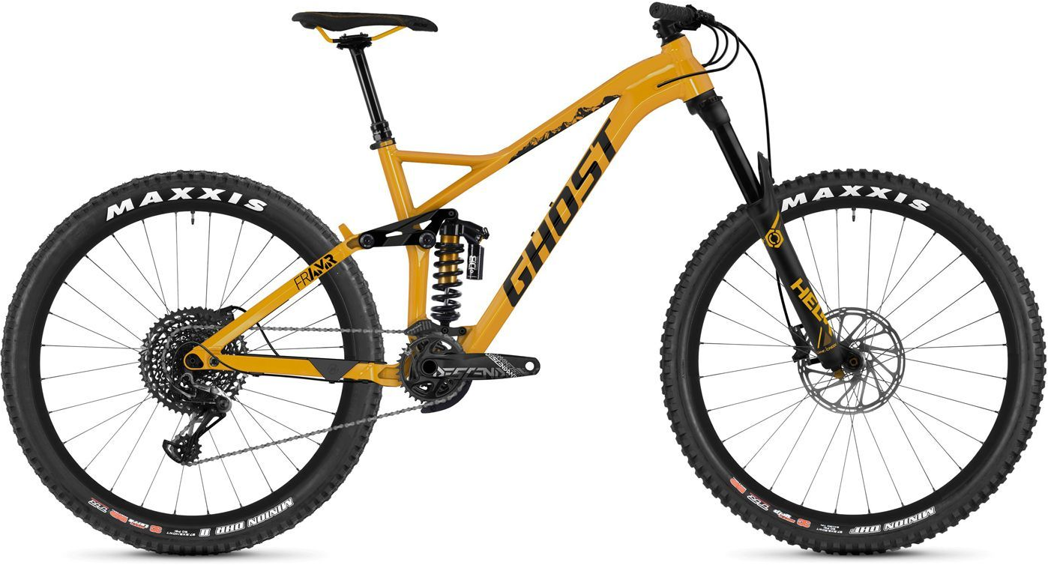
I tried to position the engine so it wouldn’t get in the way of the suspension, but also but not too high so doesn’t get in way of rider when standing on pedals for technical parts of track.
The advantage of using a moped engine is that all the controls are on the handle bars and none are operated by the feet, making it a lot easier to put onto this frame.
The suspension would have to be stiffened to allow for the extra weight from the engine.
The cross bar would have to be removed to put engine on but more bars go around the engine rather the single original crossbar.
Part and its purpose
The bike frame is designed for medium to high skilled mountain bikers, and is ready to use on complex, hard and slightly more downhill orientated tracks and courses. It's not for a high-end market but for a more medium to high price range for the trail biker who wants to upgrade but not spend excessive amounts, unaffordable to your average mountain biker. It's made of aluminium meaning it's not too heavy whilst still being light, affordable and strong. It has dual suspension allowing it to excel on downhill tracks and deal with most obstacles and terrain capably. It has mounting point for a bottle holder, pump or other accessory on inside of frame.
“The Helm is built around 35mm stanchions, with travel adjustment from 140 to 170mm, so is aimed solidly at trail and enduro bikes.” (Hayward, 2018) .

Typical use and work environment
A mountain bike proficient in downhill tracks, which is more affordable. Would primarily be used by a bit more experienced user (with a slightly lower budget), on single track trails in mountains with extreme terrain including jumps and other complex obstacles, for the thrill and excitement. It would need to be able to run well in wet, dry, cold and warm environments meaning it can be used in most environments the user wants and whenever meaning you do not having to wait for dry weather to go out biking. It's also considered quite fashionable in a younger market, where they would be used more often on roads. They also could be used on BMX and skate parks with much harder surfaces, including steep jumps.

New work conditions
I want it to be a lightweight endurance bike that can still perform on complex tracks. It should have a good range so can complete a multitude of tracks, before needing to be refilled, so can be used on a day trip without hassle. Mustn't be too expensive and aimed at a lower price range to other motocross bikes. This is to allow for a large target audience and be a more accessible and viable alternative to traditional motocross bikes. If it were made to be used on road as well it would have to comply with road emissions laws. It could also be made for a certain class of bike race, allowing it to compete in specific races and events. Thus making the bike more prestigious and so be more wanted by the customer audience. Another way to make the bike more desirable is by having a cool and fashionable aesthetic, I would like to keep the mountain bicycle appearance, it also explains to do this in the brief, rather than making it look more like a proper endurance cross motorbike.

Design considerations
The factors affecting my decision are primarily the weight, size and power. It needs to be able to have the torque and power to get over hard terrain. It's very important taking the size of the engine in to account because it needs to fit within the frame whilst not getting in the way of any of parts like the forks or handlebars. It can't be too heavy otherwise it'll be really hard to balance and control having a lighter engine would make the handling much better. I could also use an electric motor to minimise impact on the environment. I want the engine/motor I choose to be affordable, to fit the conditions i've set myself. I want to choose a reliable source of power so it doesn't break easily but also will last a long time and won't be constantly needing to be fixed, because that could make it expensive to run, and I want the running costs to be low, and I want to keep to a lower end more affordable market.

New part design
The weight, power and size of the engine are the major factors involved with my choice, this is why I picked the Yamaha’s jog rr 50cc moped engine, which is a horizontal minarelli engine that's water cooled. The factors making this engine stand out over others are; water cooled, 2 stroke and self mixer. 2 stroke means it’s more powerful and more responsive, however is less fuel efficient as compared to 4 stroke. Self mixer means you don't need to mix the oil yourself manually, instead it has an oil tank which automatically puts the optimum amount into the engine. I chose the water cooled version because it has noticeably improved acceleration compared to aircooled, however meaning its 2kg heavier. The fuel tank for this engine is 5l, which I might change depending on how the engine fits onto the frame. This engine also is very affordable and should keep the same target audience (experienced used wanting a new endurance bike but not wanting to spend too much). Using this 2 stroke engine means it shouldn't be too heavy and cumbersome and is also small so should fit on the bike brafe comfortably with minimal adjustments. A common problem to occur in this engine is for the spark plugs to become loose and fall out, to remedy this flaw I would equip it with better ht leads. To protect and secure the engine I put extra aluminium bars around the engine, making sure I keep aesthetic of mountain bike not motorbike, I would also put aluminium panels over vital and weaker parts of the engine to protect them. These bars could easily be welded onto the frame, and the aluminium panels could be bolted or riveted onto the frame.

New manufacturing method employed for production of this new part
To incorporate this engine into the frame of this bike I plan to remove the crossbar then reweld more tubing around the engine, to keep the same aesthetic of mountain bike not changing it to look more like a motorbike. Also having these bars around the engine make it secure and add protection. I would make sure the fuel and oil tank do have small aluminum panels to protect them from falls and flying rocks. I would bolt on these protection panels so they can easily be taken off when needed to refill or fix them

Suitability and advantages of new part and manufacturing process
The advantages of the decisions I've made and the changes I've made to this design are a fast and responsive engine that's light and cheap, however it doesn't have as much power and torque as other off-road motorbikes so won't be able to cope with some of the obstacles other bikes may be able to deal with, although it'd be much cheaper still very fast off road on on slightly less extreme terrain as well as being considerably light. Some disadvantages of using this engine is that it burns oil, unlike a lot of engines, making it not the most environmentally friendly decision. This also means it needs to be filled up on oil increasing running costs. It also creates a lot more sound pollution than a normal bicycle, to reduce the sound pollution damage done I could have used an electric motor. However using a electric motor would necessitate having a battery, and having a battery capable of decent range would mean the battery would have to be quite large this would add considerable amounts of weight, as batteries are very heavy for their size. Welding extra bars on would add on considerable amounts of weight, but it is a necessity to hold and protect engine, more weight reduces the power to weight ratio and so reducing speed “The logic behind his move was that a lighter bike will have faster acceleration, lower rolling resistance and requires less energy cost when climbing” (Burke, n.d.) . Using aluminium bars is advantageous because it makes assembly much easier as it can be welded, so not using complex assembly processes as well as being quick to do.

Cost justification
Using a water cooled, horizontal minarelli engine meaning the engine is very affordable, not as cheap as the air cooled version, however this engine has much more power which is needed for the off road tracks it's designed for. The bike frame I chose isn't too expensive but it's still a good bike and light, it's also made of aluminium making it strong enough for the engine to be mounted, without worries and meaning it's not too hard to weld onto.

Bibliography.

Burke, E. R. (2019). The Effect of Weight on Speed. Available at: https://www.active.com/cycling/articles/the-effect-of-weight-on-speed ( accessed 17.04.2019)

Hayward, D. (2018) This Cane Creek Helm Fork Is Dead Brilliant, But Is It Only For Experts?. Available at https://singletrackworld.com/2018/01/review-cane-creek-helm-fork/ (accessed 23.03.2019)

Ultimate Specs. (2015). Yamaha Jog RR Specs. Available at: https://www.ultimatespecs.com/motorcycles-specs/adly/yamaha-jog-rr-2010 ( accessed 23.04.2019)

