Appendix 1 (observation sheet)
Engagement | Child | Child | Child
Level 1 - Low

Level 2 – Low-Moderate
Level 3 – Moderate

Level 4 – Moderate-High
Level 5 - High

Appendix 2 (adapted engagement scale)

Engagement | Signals
Level 1 – Low | - Child = Passive, distracted, lack of interest  - Shows no enthusiasm towards task  - Struggles to give feedback (E.G. – Not picking up pupil mistakes or noticing what has been done well)  - Struggles to receive feedback from others and apply to own work to rectify mistakes
Level 2 – Low-Moderate | - Child = Often distracted  - Shows little enthusiasm  - Some difficulty giving feedback (E.G. Lacks confidence/ability to notice mistakes or what has been done well)  - Some difficulty in receiving feedback from others and applying to own work to rectify mistakes
Level 3 – Moderate | - Child = Distracted on occasions – not always focused  - Shows enthusiasm on occasions  - Makes attempts to give feedback (E.G notices some mistakes and able to see some positives)  - Makes attempts to understand feedback and apply feedback to own work to rectify some mistakes
Level 4 – Moderate-High | - Child = Not often distracted  - Shows enthusiasm throughout  - Gives some appropriate feedback  - Able to receive and understand feedback  - Able to apply feedback to own work, rectifies most mistakes
Level 5 - High | - Child = Not distracted, remains focused  - Shows a huge degree of enthusiasm throughout  - Gives appropriate feedback  - Ability to apply feedback to own work effectively by rectifying all mistakes

Appendix 3 (focus group questions)
Interview Questions

General Opening Questions:
- Did you enjoy the lesson? Why?
Focused Questions:
- How did you feel assessing someone else’s work?
- How did you feel about someone else assessing your work?
- Do you think knowing that someone else would be assessing your work made a difference to how you worked? How?
- Did you find the feedback from someone else assessing your work helpful? Did it help you improve your work or not?
- Would you like to assess each other’s work more often?
- How did you feel about giving and receiving feedback mid-way through the lesson? Did it help you with the rest of your work?
- How did you feel about using this sheet to give feedback?
- Could you think of any other ways to give feedback if we did this again?
- Would you like to receive feedback from your classmates more often or would you like it to be always from your teacher?

Appendix 4 (Lesson Study 1 lesson plan)

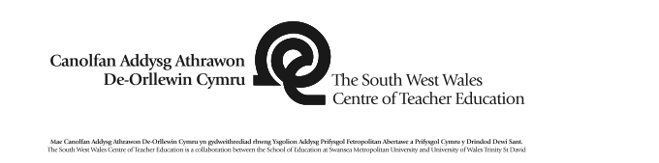 |  |  |  |  |  |  |  |  |  |  | 1B

Session Plan – Key Stage 2
Name of trainee: |  |  |  |  |  | Session ref: |  |  | 11-12:30
Personal target(s) in relation to QTS: |  |  |  | 3.1 To demonstrate clear awareness that learning objectives focus on what children will learn rather than what they will do.
Year group: | 4/5 |  | No. of learners: |  | 30 |  | ALN: | 1 EAL, 1 ALN
Additional Adults:
Learning objective(s):  To use their plan to create a piece of creative writing as though they are either Mr or Mrs Twit after visiting Cardiff Bay. |  |  |  |  |  |  | Success criteria:  To write from a characters’ point of view, include some places in Cardiff Bay with correct punctuation, some adjectives and/or verbs.  To write from a characters’ point of view, include more places in Cardiff Bay with correct punctuation, adjectives and verbs with some imagination.  To write from a characters’ point of view, include many places in Cardiff Bay, including a range of adjectives and verbs, demonstrating imagination.
Links to previous learning: Using their plan to write this piece of creative writing from a character’s point of view.
Curriculum coverage (range, skills)
Writing, Organising ideas and information; Meaning, purposes, readers
Year 3
use the characteristic features of simple continuous and non-continuous texts in their writing, using imagination where appropriate
Year 4
use the characteristic features of an increasing range of continuous and non-continuous texts in their writing, using imagination where appropriate
Year 5
use the characteristic features of a range of continuous and non-continuous texts in their writing, beginning to adapt their style to engage the reader, using imagination where appropriate
Year 6
use the characteristic features of a range of continuous and non-continuous texts creatively in their writing, adapting their style to engage the reader, using imagination where appropriate

Literacy(LNF)  Year 3  write for different purposes and readers choosing words for variety and interest  Year 4  adapt what they write to the purpose and reader, choosing words appropriately, e.g. descriptive and persuasive language  Year 5  write with a clear purpose, showing consideration for the reader, e.g. by choosing appropriate vocabulary and presentational devices  Year 6  adapt writing style to suit the reader and purpose, e.g. formal style for unknown reader, simple style for younger readers |  |  |  |  |  | Numeracy (LNF)
DCF |  |  | Thinking  Write for a range of authentic audiences, real or imagined, e.g. peers, younger learners, teachers, family members, historical and fictional characters. |  |  | ESDGC |  |  |  | YCC
Key vocabulary(English/Welsh):
Writing in the first person. Adjectives, verbs, Cardiff Bay and places to visit there.

Time | Session activities, organisation and management | Key questions & Assessment for Learning opportunities
 | Introduction  - Ask the whole class to re-cap on what we planned yesterday (plan).  - Ensure all of the class refer back to their plan (feedback on the plan has been given) this and yesterday’s session will remind them of the success criteria.  - Introduce the class to peer assessment, explain how half way through the session we will be swapping work with partners and providing oral feedback. Introduce ‘what went well’, remind them of what teachers usually put on their work ‘EBI’ (even better if). Remind them that they will need to do enough work by the half way point for their partner to assess.  - Explain at the end of the session they will ‘become teachers’ and fill in a feedback sheet for their partner (show sheet).  - Remind that if they want to be ‘flyers’ they need to include the majority of places we discussed in yesterday’s session in Cardiff Bay. |  | Key questions:  What did we do yesterday?  What places might you visit in Cardiff Bay?  What do you think The Twits might think of these places?  What person do we need to write in?  What is peer assessment?  What sort of feedback can we give to each other?  Why do we give feedback?  Oral peer feedback and assessment  Written sheets of peer assessment
 | Main activities
- To use their plan to begin writing from a character’s point of view (Mr or Mrs Twit).
- Refer pupils who claim to finish early to the board where there will be a list of places in Cardiff Bay and ask if they’ve referred to them all.
- Encourage independence (dictionaries and thesauruses always available) refer them back to their plans.
- Remind of first person vocabulary ‘I thought’… ‘I went’…

- Half way through the session, stop the class.
- Swap books with partner, give them time to read each other’s work, remind them of the sort of feedback to provide ‘what went well’, ‘even better if’.
- Once they have provided feedback to one another, ask some pupils to share the sort of feedback they gave and received from one another.
- Encourage pupils to consider the feedback they’ve received for the last half of the session.
 | Plenary
- Swap work with partner for the last 10-15 minutes of the session.
- Take time to read through their work and fill in the feedback sheets that include ‘What Went Well’, ‘Even Better If’ and a ‘Target’.
- Announce the 3 pupils that will be included in the focus group (ensure that they are still willing to do so).

Appendix 5 (Lesson Study 1- focus pupils work and the peer feedback they received)
Child A

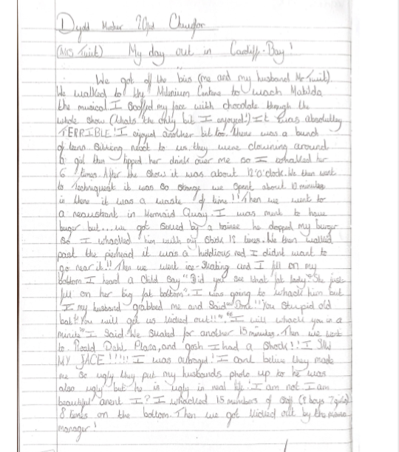

Child A (peer feedback)
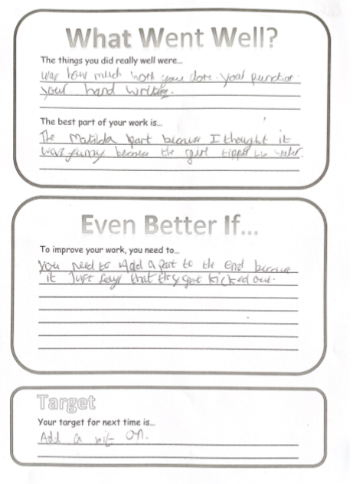

Child B

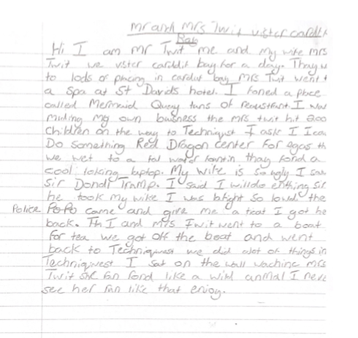

Child B (peer feedback)

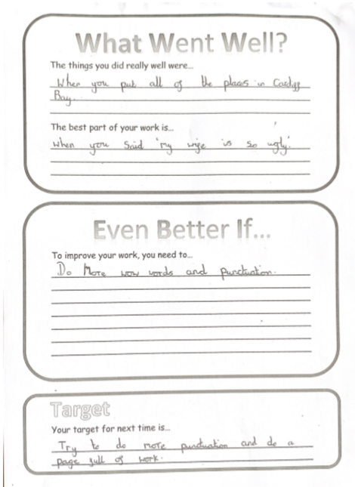

Child C

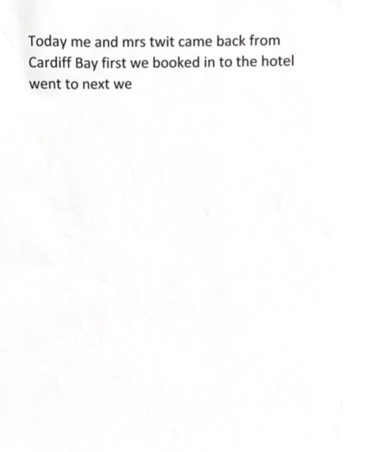

Child C (peer feedback)

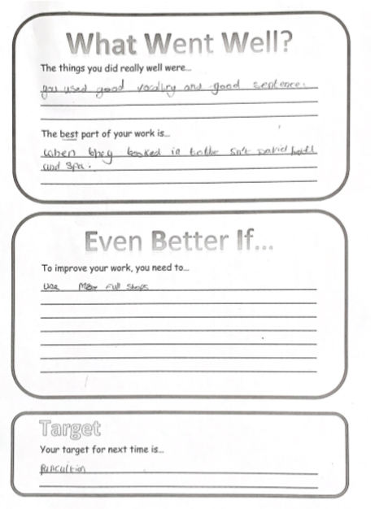

Appendix 6 (observation notes, Lesson Study 1)
Engagement | Child A – High Engagement | Child B – Middle Engagement | Child C – Low Engagement
Level 1 - Low |  |  | Showing little to no focus on task – rarely looking at or typing on laptop – looking around & chatting 11.35am.
Level 2 – Low-Moderate |  | Showing distraction – not on task – head on desk 11.20am  Coming to end of lesson – 12.10pm – said he needs wet tissue for bruise on leg – holding tissue over leg and not doing any work. Does get back on task by 12.13pm Back off task again 12.15pm – not doing a lot of writing. Chatting to others across room. | Did not start task as instructed – spent long time fussing. Encouraged to use laptop to get him writing (legibility of handwriting an issue). 11.10-20am.  Off task – playing with a chatterbox with person sitting next to him – 11.35am.  Written around 2 sentences in 15 minutes.11.40am  Largely distracted and off task 12.10pm  Encouraged to get back on task at 12.11pm – does as instructed for very short time, back chatting when teacher turns back  Largely distracted and de-motivated 12.15pm
Level 3 – Moderate | Drifting off task now and then 11.30am  She recognised her partner needed more WOW Words -  Partner said her work was excellent and all she needs to do is finish it – nothing missing – maybe add more places. 12pm  After given instructions to finish work ready for written assessment by peer – does some chatting but eventually gets back on task. 12.05pm | Shows a little enthusiasm on idea of becoming ‘teacher’ – verbal and written feedback 11.10am  Some distraction – following teacher around asking for spellings 11.35am.  Written one small paragraph (Around 3-4 sentences) 11.40am  11.47am – written 1 more sentence.  His partner said he needed to explain things more  but said his work was good because he included lots of details about characters  He said his partners was good – said it was funny, but to improve – she could have added some more detail and descriptive elements to her work. 12pm  Slipping off task by – showing levels of distraction 12.10pm  12.16pm – shows little motivation to finish work despite being told they have 3 minutes to finish what they are doing before peer assesses their work | Introduction of laptop to write piece boosts engagement – on task for some time 11.20-11.30am  Said his partners was good – said he found it difficult to read her writing.  His partner said he needs better punctuation. 12pm  After given instructions to finish work ready for written assessment by peer – aims to get on task but accidentally pulls battery out of laptop and loses work due to being distracted 12:05pm  Needed support with providing feedback for his partner. 12.35pm
Level 4 – Moderate-High | Written one paragraph (Around 6-7 sentences) 11.40am  Using classroom resources to support her work. 11.45am  Added around 3 more sentences to work and referring to classroom resources to support her writing. 11.47am | Discussing ideas he’s written about with peers to gain opinion – showing care for what he writes. 11.47am  Finishing sentence with some urgency to swap work. 11.55am  After given instructions to finish work ready for written assessment by peer – gets straight back on task. 12:05pm | Did swap work as soon as instructed and making conscious effort to read partners work 11.55am
Level 5 - High | On task instantly 11.10am  Showed enthusiasm towards idea 11.10am  Helping others get on task by assisting them with spelling 11.35am  Swapped books instantly to peer assess – 11.55am  Been on task since 12.05pm – head down, pen down, writing a lot.

Appendix 7 (Lesson Study 1- focus group)

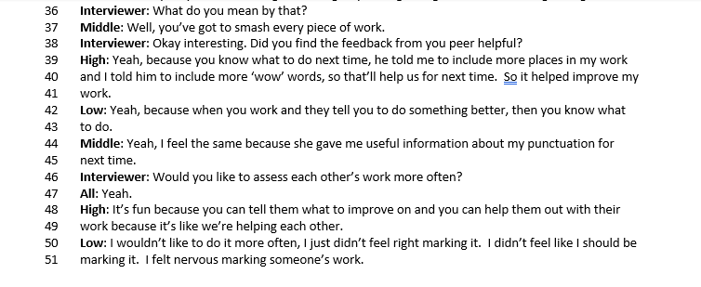
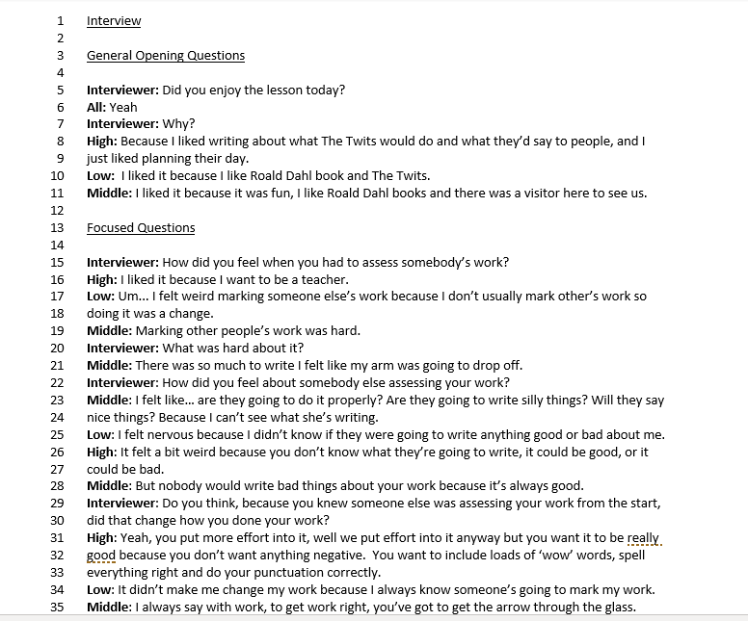

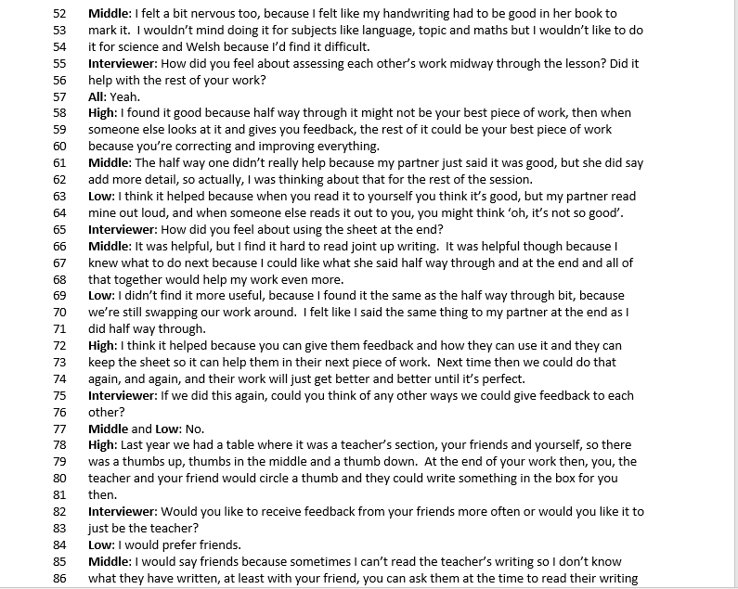
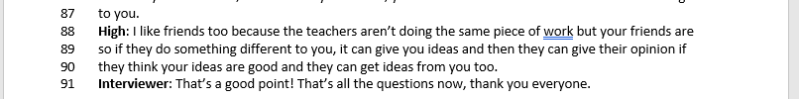

Appendix 8 (ARC reflections Lesson Study 1
Self reflection

Model Beirniad Wedi Adfyfyrio (BWA)

Assisted Reflective Conclusions (ARC) Model
Dyddiad/Date: 20/02/19
Digwyddiad critigol (Ffocws)/Critical incident (focus): Lesson Study: Action Research -AfL – Peer Assessment

Profiad/ Experience

Teimladau/  Feelings  Beth yw eich teimladau ynghylch y profiad?  “What are your feelings regarding the experience?” | I felt happy with the response of the majority of the class towards this work, since they have been enjoying the work on The Twits and on Cardiff Bay, combining the two did add some excitement and many produced some good work.  However, the class as a whole was generally loud, and many were relying upon myself to ask many questions, which they usually are rather good at being independent. The level of noise could be due to a visitor being in the class and the amount of questions could be due to the fact that they knew they had to peer assess during this lesson, a strategy they have not done before. The questions could reflect some anxiousness of a peer reading and assessing their work.
Cofio a Deall/  Remember and Understand  Allwch chi restru’r agweddau ar y profiad dysgu a aeth yn dda?  “Can you list the aspects of the learning experience that went well?”  Pa elfennau o’r profiad dysgi oedd yn siomedig?  “What were the elements of the learning experience that were disappointing?” | The class are usually enthusiastic about most creative writing work and this was no different, especially as it combined both The Twits and Cardiff Bay.  The majority of the class responded with interest to the fact that they would be peer assessing each other’s work. Telling the class that they would ‘become teachers’ at the end of the session sparked enthusiasm and excitement in most children.  However, it was disappointing to learn from my research partner (who was observing) that one of the focus pupils chosen as a ‘low engagement’ pupil, was not enthused by the idea of ‘becoming a teacher’ at the end of the session. Since this pupil is often producing very minimal and poor standard of work due to a lack of engagement, I initially thought that with him knowing his peer would assess his work, he would apply himself more. This was not the case even with a laptop to work on since his handwriting is poor and prompts from myself to concentrate on his work.  It was disappointing to learn from my research partner that the middle ability focus pupil also lacked enthusiasm towards the idea of peer assessing.  However, it must be considered that the whole class do not peer assess or self-assess in regular classroom life, therefore this concept may have been daunting.
Gwerthuso a dadansoddi/  Evaluate and analyse  Beth fyddwch chi’n cadw’r un fath i sicrhau dysgu ac addysgu effeithiol yn y dyfodol?  “What will you keep the same to ensure effective teaching and learning in the future?”  Beth oedd achos yr elfen siomedig bwysicaf?  “What was the cause of the most important disappointing element?” | Upon reflection, considering the middle ability pupil’s situation, as the pupil has dyslexia, it may have been extremely daunting to him to have a peer assess his work. This also may have been escalated as the class do not sit in groups based on ability, therefore the pupil who was peer assessing his work would be classed as a pupil of middle to high ability. However, in the focus group at the end of the session, this pupil did confirm that he would like to peer assess more often in class.  As research partners, we decided it was a good idea for the class to know from the beginning that they would be peer assessing each other’s work. As a whole, and from reflecting upon the focus group, this did spark motivation in pupils, even those who looked worried at the beginning.  The strategy for the next lesson study will be kept the same: peers giving oral feedback half way through the lesson and then a feedback sheet at the end of the lesson will be filled by peers to assess each other’s work. My research partner and I agreed that the strategy should remain as similar as possible since the differences between the classes are enough. Class 1 do not peer or self-assess in class and are sat in mixed ability groups, whereas Class 2 peer and self-assess regularly and are sat in groups based on ability.  Much of the disappointment in today’s session could be a reflection of a new strategy being introduced and the feelings of worry that come with that. However, although the low ability pupil did not produce enough work for effective peer assessment, it gives a diverse range to be able to compare the effectiveness of peer assessment on different pupils’ abilities and therefore, for research purposes, is still useful.
Casgliadau a chamau gweithredu/  Conclusions and actions  Beth yw eich atebion posibl i’r materiaon siomedig a nodwyd?  “What are your possible solutions to the disappointing issues identified?”  Beth ydych yn mynd i’w wneud nesaf?  “What will you do next?” | The effectiveness of peer assessment would increase with practice and understanding of the strategy. Therefore, if a classroom wants to make peer assessment a regular occurrence, it must be introduced slowly and regularly to produce effective feedback.  The next step is to observe in my research partner’s school, although all strategies will remain the same, the differences may be substantial since the context of both classrooms are very different.
Y profiad newydd / Transformed experience

Research partner’s reflection

Model Beirniad Wedi Adfyfyrio (BWA)

Assisted Reflective Conclusions (ARC) Model
Dyddiad/Date: 20/02/2019
Digwyddiad critigol (Ffocws)/Critical incident (focus): Lesson Study: Action Research – AfL – Peer Assessment

Profiad/ Experience

Teimladau/  Feelings  Beth yw eich teimladau ynghylch y profiad?  “What are your feelings regarding the experience?” | It was an enjoyable experience visiting another Yr Athrofa partnership school. My research partner and I were looking forward to testing the peer assessment strategy in a classroom that rarely used self or peer assessment as a form of formative assessment.  The children responded well to having an additional adult in class, and I felt positive throughout the session. I felt that the implementation of peer assessment worked well within the lesson. The children generally responded well to the strategy.
Cofio a Deall/  Remember and Understand  Allwch chi restru’r agweddau ar y profiad dysgu a aeth yn dda?  “Can you list the aspects of the learning experience that went well?”  Pa elfennau o’r profiad dysgi oedd yn siomedig?  “What were the elements of the learning experience that were disappointing?” | The writing task was based on a recent trip to Cardiff Bay and so the children had plenty of inspiration to assist their writing. This helped them to engage with the task.  Explaining to the children beforehand that they would be peer assessing each other’s work did spark some interest amongst the class and the phrase ‘you are going to become teachers’ worked well in building interest and engagement for some children.  Many of the children were able to give each other oral feedback.  When the focus pupils shared their oral feedback, it was clear that this was somewhat of a difficult task for the child who had been selected to represent low engagement. He remained distracted throughout and showed few moments during which he was truly engaged.  The child chosen to represent middle ability was largely de-motivated during the session and did not respond to idea of peer assessment with any engagement or enthusiasm. However, it is important to bear in mind this was a new concept for the children in this class and therefore would take some time to implement properly.
Gwerthuso a dadansoddi/  Evaluate and analyse  Beth fyddwch chi’n cadw’r un fath i sicrhau dysgu ac addysgu effeithiol yn y dyfodol?  “What will you keep the same to ensure effective teaching and learning in the future?”  Beth oedd achos yr elfen siomedig bwysicaf?  “What was the cause of the most important disappointing element?” | Upon reflection, we decided that explaining to the children beforehand that they would be peer assessing each other’s work would be a good idea. We saw that overall, the response to this was a boost in motivation in some ways.  Furthermore, we decided to keep the strategy the same -  Peers giving each other oral feedback half way through the lesson and then feedback at the end of the lesson in a written format with sentence starters included. This worked well in that it helped children re-focus half way through using the oral feedback and then gave them discussion time at the end to look at the feedback alongside their work.  It is difficult to pinpoint a direct cause. I think that the main cause of the disappointment in this case was the children’s lack of familiarity with peer assessment. For some children, particularly those of lower engagement levels, it was a concept that did not really excite them. It is possible this is linked to self-esteem and worry over the work being produced.
Casgliadau a chamau gweithredu/  Conclusions and actions  Beth yw eich atebion posibl i’r materiaon siomedig a nodwyd?  “What are your possible solutions to the disappointing issues identified?”  Beth ydych yn mynd i’w wneud nesaf?  “What will you do next?” | For peer assessment to have its full effect in this classroom would entail the class teacher slowly integrating peer assessment over a number of weeks, while coaching and guiding the children using modeling strategies on how to give constructive feedback. Formative assessment when placed into the hands of the children has to be introduced with some delicacy and care.  Next, I will teach the lesson to my class tomorrow. My class regularly self assess and often peer assess to. We decided during reflection that we would not change the way we carried out the research, based on the differences in our classes. With the only issues arising due to the lack of familiarity with the AfL strategy, we will keep the research session the same for tomorrows session.
Y profiad newydd / Transformed experience

Appendix 9 (Lesson Study 2 lesson plan)

 |  |  |  |  |  |  |  |  |  |  |  | 1B

Session Plan – Key Stage 2
Name of trainee: Hannah Evans |  |  |  |  |  |  | Session ref: |  |  | 2 – 11-12pm
Personal target(s) in relation to QTS: |  |  |  | S2.5 They know how to use ICT effectively, both to teach their subject and to support their wider professional role.
Year group: | 4,5&6 |  | No. of learners: |  | 25 | ALN:  L.S-EAL  I.R-Dyslexia  Bwrdd Coch – Low engagement  J.E-IEP  H.D-IEP  Adjective word mats for Coch and Gwyrdd  Myst Exile images on table  Myst Exile adjective sheets for all tables
Additional Adults: |  |  | 1 – C.M with Bwrdd Coch
Learning objective(s):  ‘To write an introduction of a descriptive story.’ |  |  |  |  |  |  |  | Success criteria:  * Use of punctuation throughout (Full stops, commas, exclamation marks)  ** Written from your perspective (I saw, I felt)  ** Include powerful adjectives in all sentences  *** Written in past tense (I saw, It was, I began)  **** Use of senses (What you can see, smell, taste, hear, feel)  ***** Use of ellipses and brackets
Links to previous learning:
Links to literacy scheme – using game Myst Exile as writing inspiration. Also links to literacy work on story writing.

Curriculum coverage (range, skills)

Literacy(LNF)  Strand: Writing  Elements: Organising ideas and information  Aspects: Meaning, purposes, readers  Year 4: use the characteristic features of an increasing range of continuous and non-continuous texts in their writing, using imagination where appropriate v  Year 5: use the characteristic features of  a range of continuous and non-continuous texts in their writing, beginning to adapt their style to engage the reader, using imagination where appropriate  Year 6: use the characteristic features of a range of continuous and non-continuous texts creatively in their writing, adapting their style to engage the reader, using imagination where appropriate  Elements: Writing accurately  Aspects: SPAGH  Year 4: begin to craft their writing using the standard forms of English, e.g. nouns, pronouns, adjectives, adverbs, prepositions, connectives and verb tense  Year 5: craft their writing by using  the standard forms of English, e.g. nouns, pronouns, adjectives, adverbs, prepositions, connectives and verb tenses  Year 6: craft their writing by using  the standard forms of English, e.g. nouns, pronouns, adjectives, adverbs, prepositions, connectives and verb tenses |  |  |  |  |  |  | Numeracy (LNF)
DCF |  |  | Thinking  PLAN:  Activating prior skills, knowledge and understanding  Identify gaps and begin to build on existing skills, knowledge and understanding required for the task  DEVELOP:  Identify gaps and begin to build on existing skills, knowledge and understanding required for the task  Develop and begin to combine a variety of imaginative ideas, possibilities and alternatives, including those of others.  REFLECT:  Begin to evaluate outcomes against success criteria. |  |  |  | ESDGC |  |  |  | YCC
Key vocabulary(English/Welsh):
Adjectives
Myst
Suspense

Time | Session activities, organisation and management | Key questions & Assessment for Learning opportunities
 | Introduction  SLIDE ONE:  INTRODUCE LO:  WRITE L.O & DATE IN BOOKS  Activity One:  SLIDE TWO:  Warm up game -  Picture from Myst game on whiteboard  Write three adjectives that fit the scene on three sticky notes – be creative, the aim is not to have the same as other people.  Sticky note snap game! |  | Post it snap – will demonstrate children’s ability to think of powerful adjectives on the spot  Key questioning:  What is the aim of the introduction?  Give me an example…  What key things should we try and include? Give me an example…  What is a…  Show my example – getting their feedback – demonstrates understanding
Oral peer feedback

Peer assessment sheets

Traffic light work
Main activities:
Okay so today, we are going to write the introduction of a descriptive story all about our very own little adventure.
Before starting:
Remind them that half way through they will be swapping books with a partner and giving oral feedback on their work and that at the end they will be peer assessing each other’s work.
Activity Two:
Jumanji situation:
Have you all seen Jumanji? – Discussion of Jumanji – show trailer/clip
https://www.youtube.com/watch?v=2QKg5SZ_35I
I want you to imagine that you were playing Myst Exile with two friends at home – when suddenly you press a button on the game and you are sucked inside of the games console with your friends and away from your normal life and dropped into the game!
What is our aim in the introduction?
(To set the scene, to create intensity and build up!)
What are some of the key things we should try and include in the introduction?
Adjectives, use of senses, punctuation for effect)…
Activity Three:
Show my example – ask them what they can see etc
PowerPoint - Some ideas for your introduction:
Describe the journey as you were sucked in
What the landing was liked as you were dropped into the game
What the surrounding area looked like –Senses (See, smell, hear, touch, taste)
How you felt
Who you saw
Other tables: Writing in books
Gwyrdd & Coch – Ipads - Popplet
Bant a chi!
Activity FOUR: Peer assessment oral feedback
After 20 minutes of writing – swap with the person sitting next to you – read through their work. Find what they are doing well and what they could be doing better.

Plenary
Final activity:
10 minutes
Swap with someone on the table
Peer assessment sheets
WWW, EBI, Target

Traffic light your work

Child D

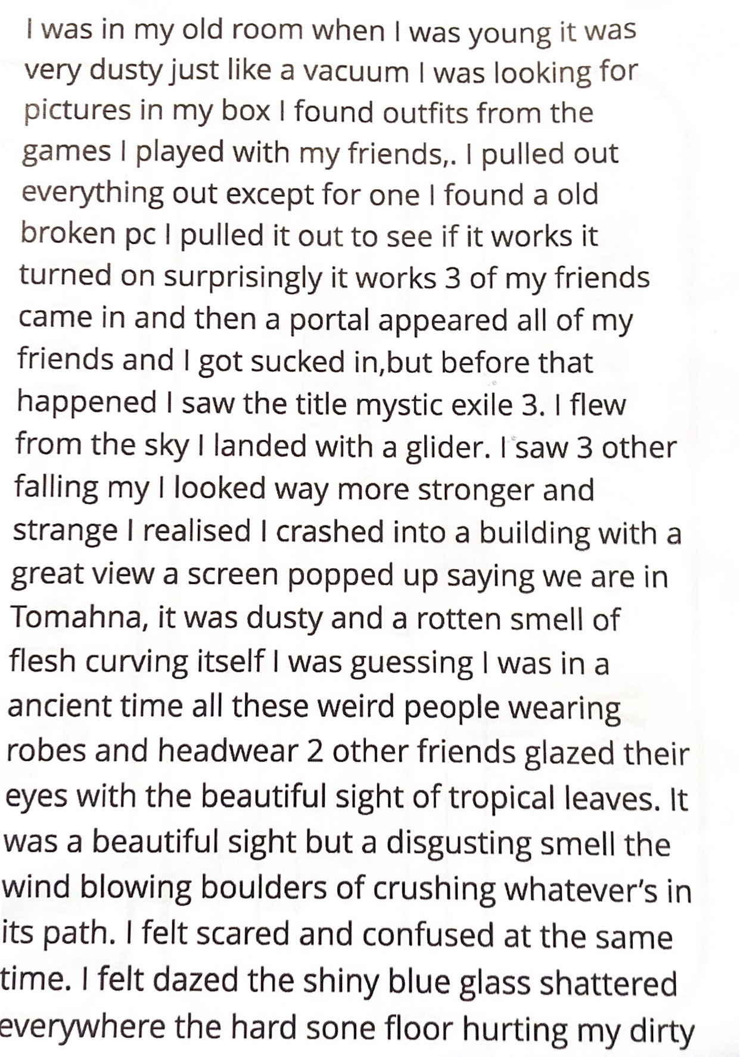

Appendix 10 (Lesson Study 1- focus pupils work and the peer feedback they received)
Child D (peer feedback)

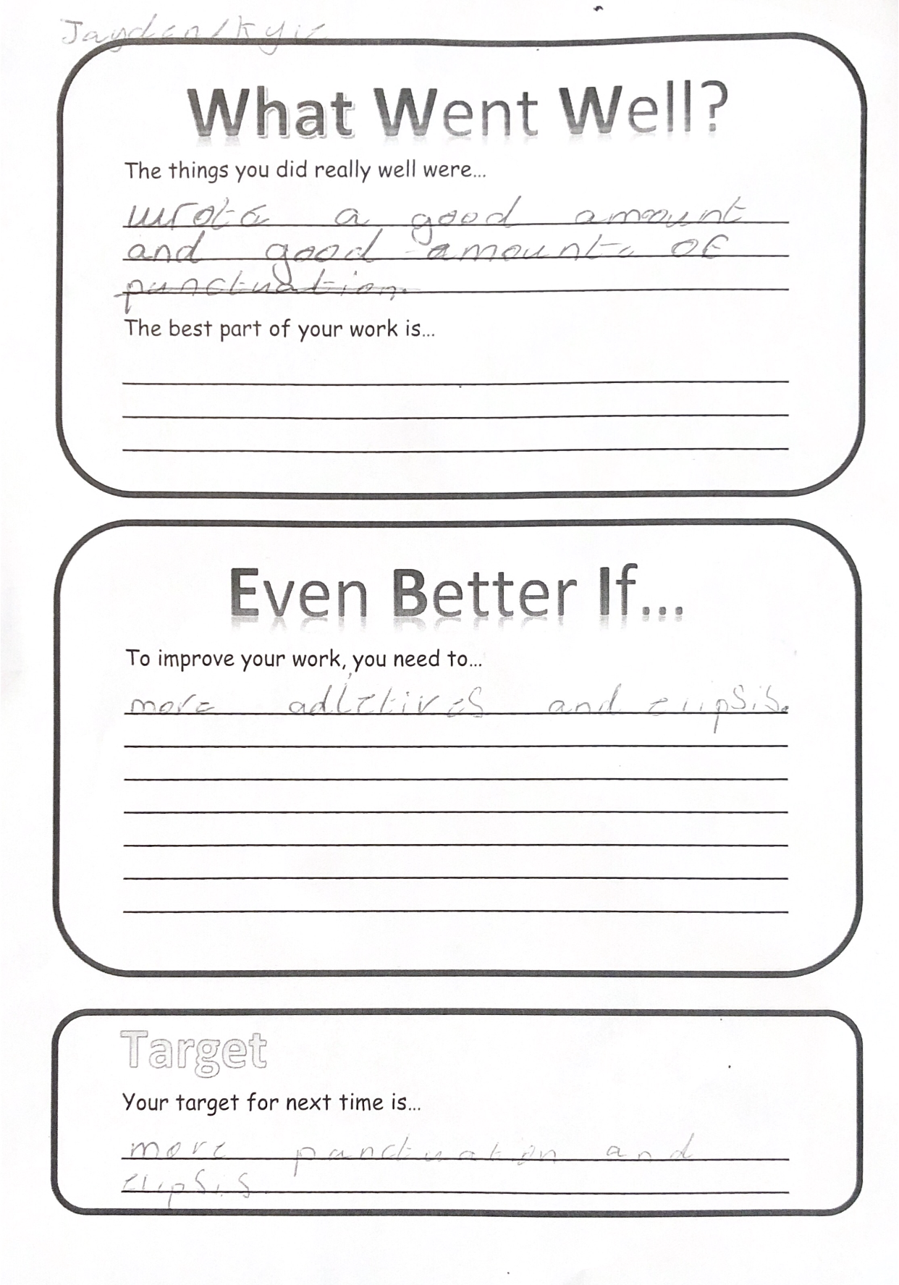

Child E

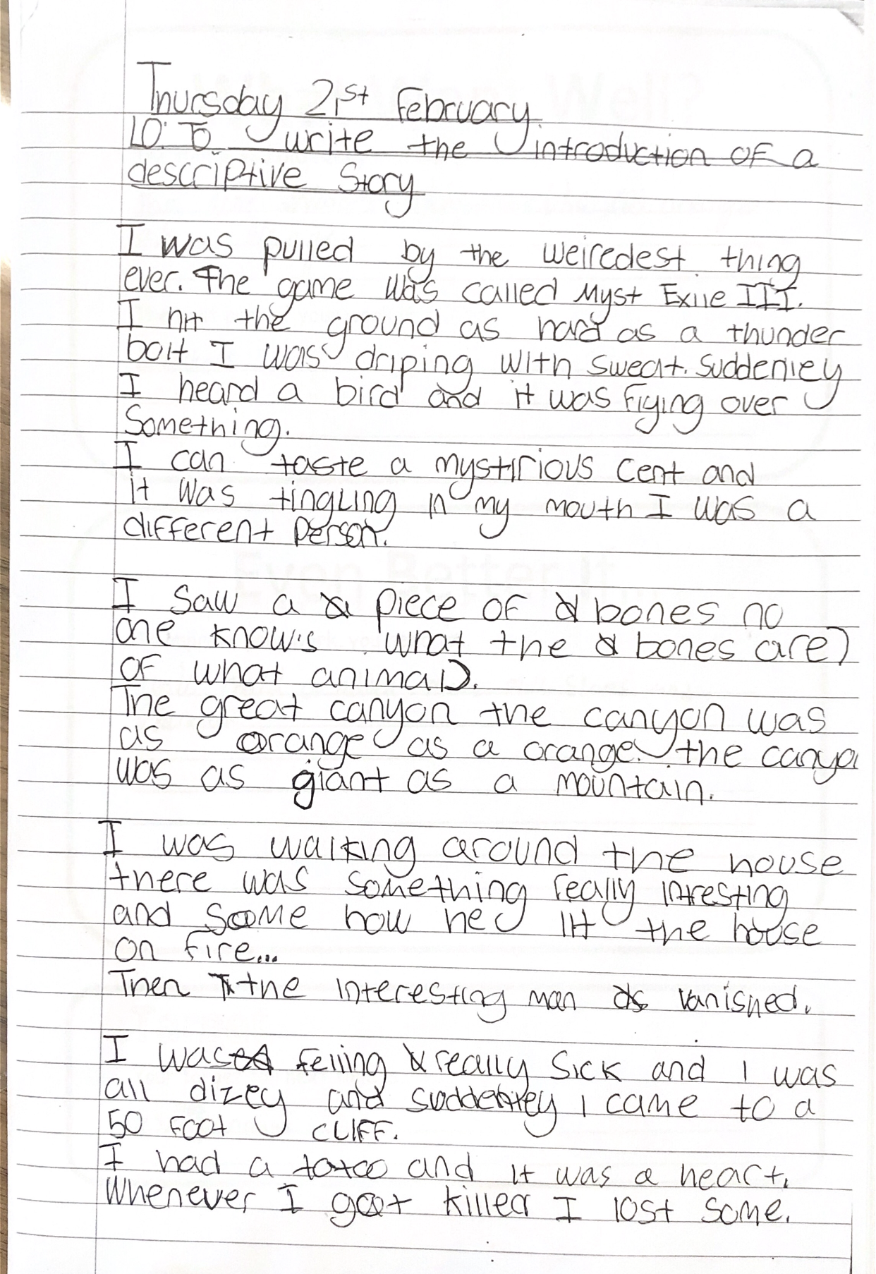

Child E (peer feedback)

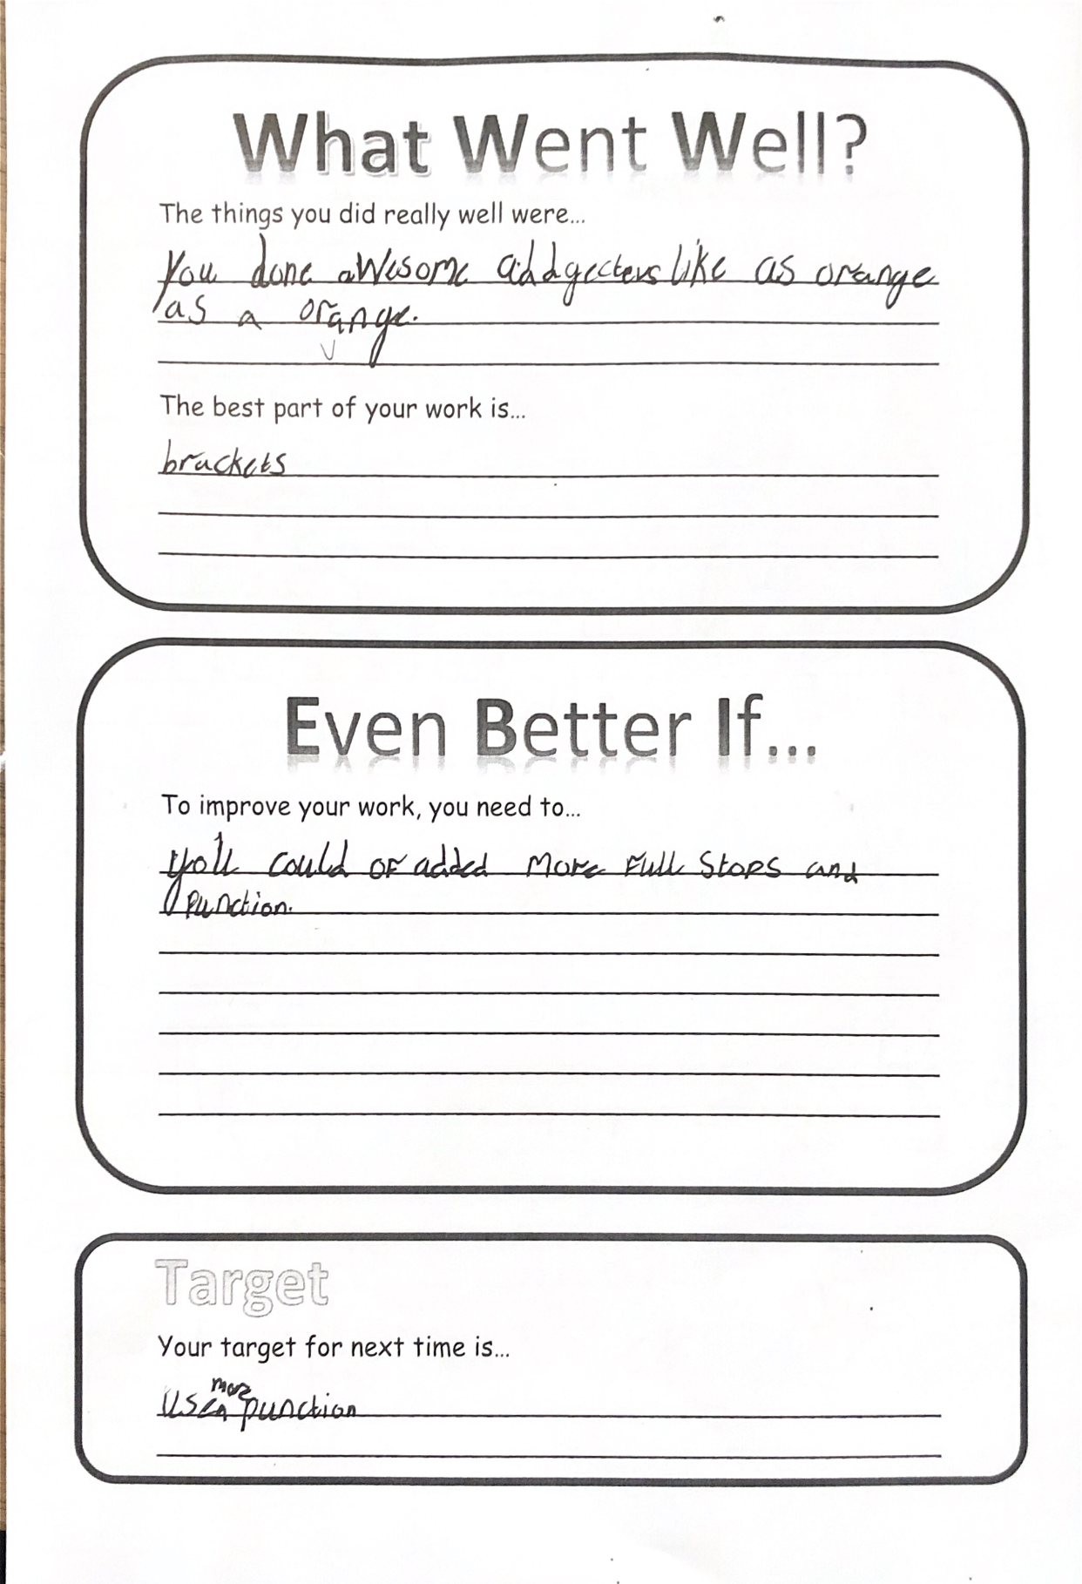

Child F

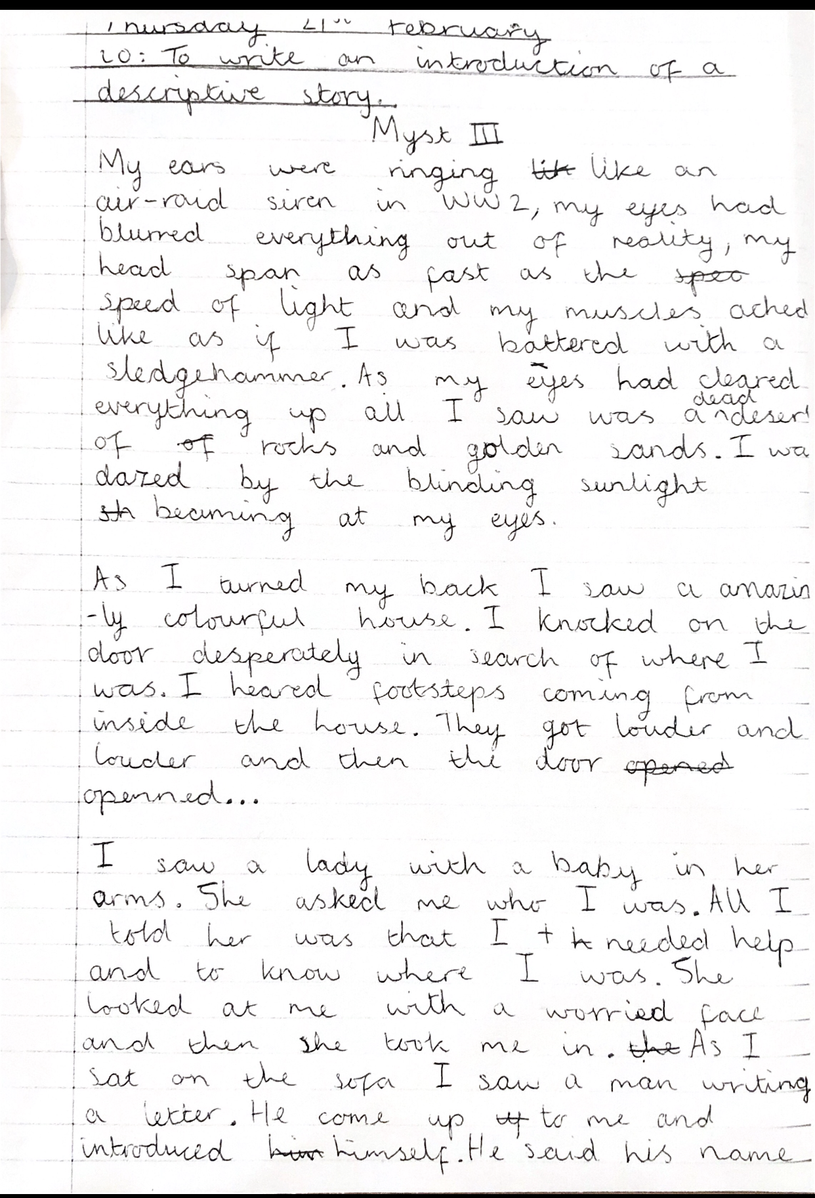

Child F (peer feedback)

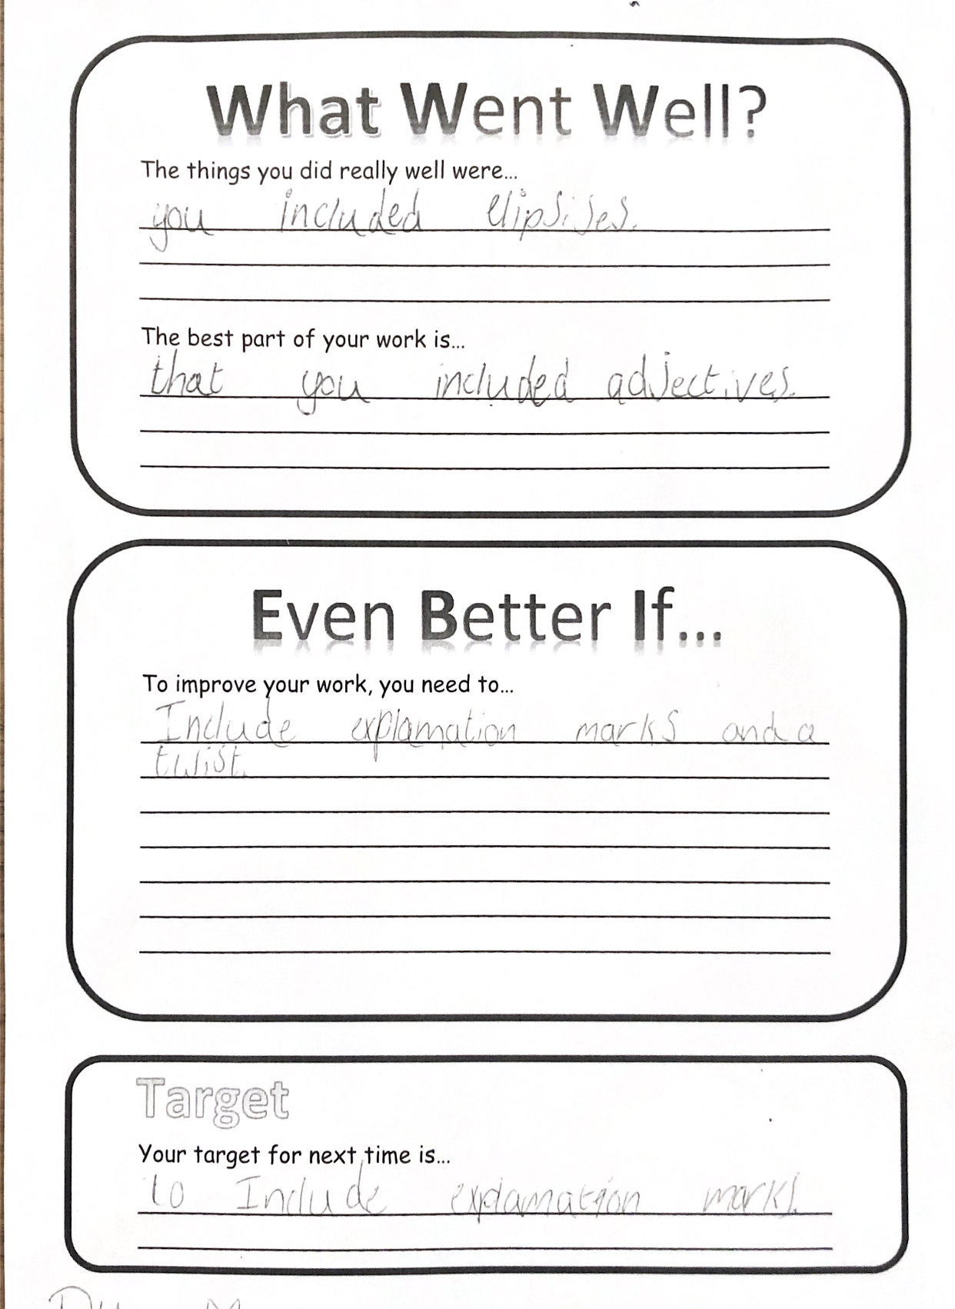

Appendix 11 (observation notes, Lesson Study 2)

Engagement | Child D – Low engagement | Child E – Middle engagement | Child F – High engagement
Level 1 - Low | Given book but playing with pen instead of opening book and writing date and LO as instructed 10:55  Wrote on the first sheet about his own work, not his peers, teacher had to re-explain the task to him and gave him another sheet 11:56  Following the teacher asking what he’s supposed to do with the sheet even though she has explained multiple times to the whole class 12:00
Level 2 – Low-Moderate | Last pupil to collect iPad – walks very slowly, leaning against all the furniture he passes 11:13  Written one word 11:17  Sighed when miss suggested they were going to ‘become teachers’ 11:40  Talking to his partner whilst the teacher is explaining the peer assessment forms 11:50  Talking to his partner instead of reading his partners work 11:52  Didn’t save his work when he was told to do so before the peer assessment, had to be reminded right at the end of the lesson 11:59 | Spoke when others were sharing- reminded about respect 11:36  Continues to write when Miss has instructed them to swap work and talking to the other group 11:52  Looking at his partners sheet and then looking at his own, comparing what his friend said about him before he writes his own 11:54 | Doesn’t seem interested to get sticky notes as instructed 11:02
Level 3 – Moderate | Doesn’t put hand up to say he’s finished writing on sticky notes but involves himself in the group game 11:04  Asked miss a question – she suggests he asks a friend, when the teacher walks away he gives his iPad to someone else 11:18  Talking to his friend now and then, however goes back to his iPad and reads out loud to himself 11:21 | Chatting and laughing with partner after being asked to go back to work 11:41-11:43  Looking around for a bit, whispering to friend until I was walking around behind him, looked at me and started writing 11:45  Watching another pupil talking to the teacher, turned around from his work 11:46 | Prompted to say to use paragraphs for his partner 11:38  Still chatting and laughing with partner after being told to go back to do work 11:40-11:43
Level 4 – Moderate-High | Starts writing date and LO 10:58  Saying his ideas out loud to himself 11:18  Written 3 sentences 11:21 | Answers question for someone else after Miss asked if there were anymore people who ‘snapped’ 11:06  Gets up to ask miss a question related to the work, sits back down, discusses with friend and starts writing 11:26
Level 5 - High | Closes book to show he’s written date and LO 10:59  Opens book back up when told the class needs to underline 10:59  Looked for sticky notes after miss said 11:03  Answers question about the film Jumanji 11:06  Helps friend with spelling 11:22  Written approximately 8 lines on the iPad, has been doing his work consistently, looking up now and then to read out loud to himself 11:31  Read straight away but questions his friend about his work 11:33  Used some describing words – said adjectives when prompted – gives examples, to do better - punctuation 11:36  Agrees that his ways forward are a good idea 11:37  Praised for his concentration, reminded to add paragraphs, reassured her that he was going to add them 11:42  Hasn’t been distracted by the pupils next to him who are talking, when he’s talking he’s reading his work out loud to himself 11:49 | Writing in book straight away as soon as instructed 10:55  Finished writing date and LO when teacher expects 10:58  Knows EBI 11:01  Looked for sticky notes after miss said 11:03  Puts hand up to as instructed to say he’s finished written on sticky notes 11:04  Eager to share his ideas with the class 11:11  Written 3 lines straight away 11:17  Written over half a page 11:30  Partner said he used good adjectives, but include more and he agreed 11:39  About his partner- he has good adjectives, gave an example, is it an adjective? Was more of a simile. For his partner to improve – add more full stops 11:39 | Writing in book straight away as soon as instructed 10:55  Closes book to show he’s written date and LO 10:59  Puts hand up as instructed to say he’s finished written on sticky notes 11:04  Answers question – lots of adjectives for Miss’ example 11:10  Opens book and starts writing straight away 11:15  Written 3 lines straight away 11:17  Has barely lifted his head from his book, has been writing the whole time, looks up now and then as though he’s thinking written half a page 11:27  Written over half a page 11:30  Reads straight away 11:33  About his partner - “He used lots of good adjectives”, examples – shining, mystical 11:38  Almost written a full page 11:45  Hand up straight away when Miss has hers up to show he has listened to her 11:49  Straight on task, swapped and read work, started filling in the sheet 11:51

Appendix 12 (Lesson Study 2 focus group)

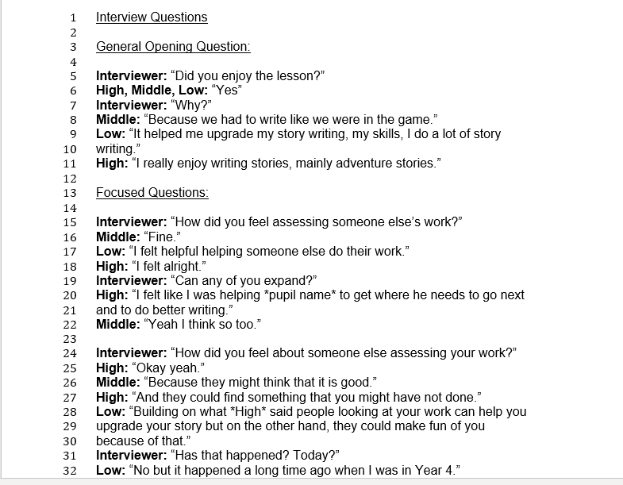
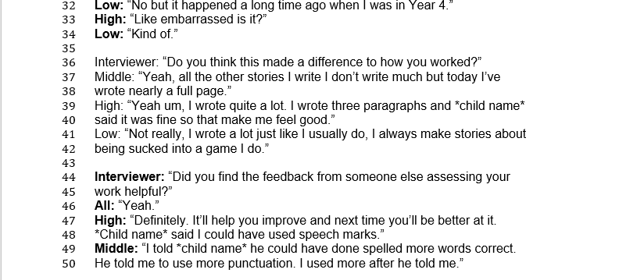
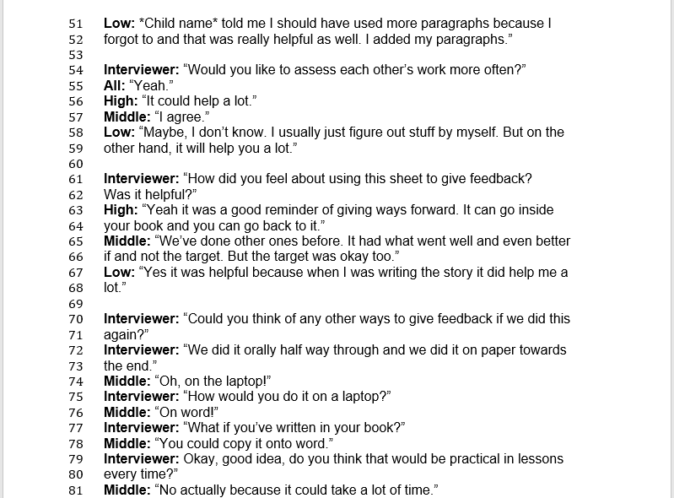
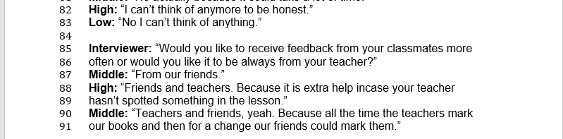

Appendix 13 (ARC reflection Lesson Study 2)
Research partner’s self reflection

Model Beirniad Wedi Adfyfyrio (BWA)

Assisted Reflective Conclusions (ARC) Model
Dyddiad/Date: 21/02/2019
Digwyddiad critigol (Ffocws)/Critical incident (focus): Lesson Study: Action Research – AfL – Peer Assessment

Profiad/ Experience

Teimladau/  Feelings  Beth yw eich teimladau ynghylch y profiad?  “What are your feelings regarding the experience?” | I felt extremely positive following this session. The children responded very well to the peer assessment strategies, and demonstrated the impact it could have on children’s engagement with their own work.  The lesson itself went well, the children were on task throughout and produced some really interesting and high quality work.  The children also responded well to having an additional adult in class and did not allow her presence to become a distraction.
Cofio a Deall/  Remember and Understand  Allwch chi restru’r agweddau ar y profiad dysgu a aeth yn dda?  “Can you list the aspects of the learning experience that went well?”  Pa elfennau o’r profiad dysgi oedd yn siomedig?  “What were the elements of the learning experience that were disappointing?” | The writing task excited the children and captured their motivation. It was based on a computer game they had been using as writing inspiration. We imagined that we had been sucked into the game (A Jumanji like situation).  Explaining to the children that we would be peer assessing each other’s work during the session received a good response. The children were motivated and looked forward to ‘becoming teachers’.  However, I did notice that one of the focus pupils chosen for the observation being completed by my partner, who represented low engagement, did not look to excited about the idea. This did worry me, but during the lesson he got on well with the task and produced some interesting feedback for his partner and took on the feedback his partner gave to him.
Gwerthuso a dadansoddi/  Evaluate and analyse  Beth fyddwch chi’n cadw’r un fath i sicrhau dysgu ac addysgu effeithiol yn y dyfodol?  “What will you keep the same to ensure effective teaching and learning in the future?”  Beth oedd achos yr elfen siomedig bwysicaf?  “What was the cause of the most important disappointing element?” | The use of peer assessment appeared to be very helpful for the children in the class. I think that having them sat in ability based groups helped to reduce the anxiety around such a task. Especially since they are a mixed class of three year groups (4, 5 and 6). I think that overtime, once the children had used peer assessment more, testing it out in mixed ability groups could also yield some wonderful results. I think this would be particularly beneficial for the lower ability children and children with lower engagement levels. I believe it would provide a motivation boost and help them stay engaged with their work. Furthermore, exposure to work produced by higher ability children could eventually assist in improving the quality of their own work.  Upon discussion with this child in the focus group interview, I discovered that he had a bad experience with peer assessment in year 4. He told me that another child had ‘made fun’ of his work and expressed that this was somewhat embarrassing. I think that this highlights the importance of modeling how to give constructive feedback and the due care and diligence that needs to be applied when implementing such strategies in the classroom.
Casgliadau a chamau gweithredu/  Conclusions and actions  Beth yw eich atebion posibl i’r materiaon siomedig a nodwyd?  “What are your possible solutions to the disappointing issues identified?”  Beth ydych yn mynd i’w wneud nesaf?  “What will you do next?” | I think that regular use of peer assessment strategies that have been well implemented would help this child overcome the worries he had of somebody else looking at his work and mocking it. Modeling would be needed in order to demonstrate to children how to give feedback, focusing on the quality aspects of a piece of work as well as giving a peer ways to improve their work.  Next, I will analyse the data collected over the past two days in order to complete my action research project.
Y profiad newydd / Transformed experience

My reflection as a research partner

Model Beirniad Wedi Adfyfyrio (BWA)

Assisted Reflective Conclusions (ARC) Model
Dyddiad/Date: 21/09/19
Digwyddiad critigol (Ffocws)/Critical incident (focus): Lesson Study: Action Research – AfL – Peer Assessment

Profiad/ Experience

Teimladau/  Feelings  Beth yw eich teimladau ynghylch y profiad?  “What are your feelings regarding the experience?” | It was very interesting to visit my research partner’s placement school. I was very interested to see the difference in the knowledge and understanding of peer assessment in a class that regularly engage with the strategy. It was useful to see how it could work if it is implemented regularly.  The class are clearly very used to having an additional adult in the class and they were not distracted by my presence at all. It was enjoyable to see an interesting creative writing session and the way the pupils responded with familiarity to the strategy of peer assessment. The whole class engaged with the strategy with ease.
Cofio a Deall/  Remember and Understand  Allwch chi restru’r agweddau ar y profiad dysgu a aeth yn dda?  “Can you list the aspects of the learning experience that went well?”  Pa elfennau o’r profiad dysgi oedd yn siomedig?  “What were the elements of the learning experience that were disappointing?” | The creative writing task sparked the class’ interest as they were familiar and clearly enthused by the computer game that had inspired the task.  Introducing the peer assessment task in the same way as the previous lesson study session of the pupils ‘becoming teachers’ worked well with the majority of the class reacting excitedly about this.  One target pupil of the low ability did not look very enthused or motivated by the idea of ‘becoming a teacher’, similarly to the previous lesson study session, therefore it may be a lack of confidence in their work.  However, the low ability target pupil responded to the work with interest and was engaged for the majority of the task and produced useful feedback for his partner and considered the feedback he received.
Gwerthuso a dadansoddi/  Evaluate and analyse  Beth fyddwch chi’n cadw’r un fath i sicrhau dysgu ac addysgu effeithiol yn y dyfodol?  “What will you keep the same to ensure effective teaching and learning in the future?”  Beth oedd achos yr elfen siomedig bwysicaf?  “What was the cause of the most important disappointing element?” | Having observed the class during giving and receiving feedback about their work, it came naturally to the pupils, clearly demonstrating their familiarity with the concept.  The pupils were grouped based on ability and this was useful as no pupil had to read their work to their peer as they were all of similar abilities, they produced a similar amount and standard of work.  The focus pupil of a lower ability shared during the focus group that he had previously had an unpleasant experience with peer assessment in the past, this may have triggered the initial look of anxiousness on his face when the teacher said they will ‘become teachers’ in this session. However, I believe the class environment and the practice of giving constructive feedback which would include sharing many positive elements of each other’s work, eased the pupils worry as he got into the task.
Casgliadau a chamau gweithredu/  Conclusions and actions  Beth yw eich atebion posibl i’r materiaon siomedig a nodwyd?  “What are your possible solutions to the disappointing issues identified?”  Beth ydych yn mynd i’w wneud nesaf?  “What will you do next?” | Creating a positive classroom environment towards peer assessment has clearly been effective within this class and reflects that with practice, pupils can produce useful peer feedback in a respectful environment.  The next steps will be to analyse the data from the two lesson study sessions to produce the action research project.
Y profiad newydd / Transformed experience

