Part 1
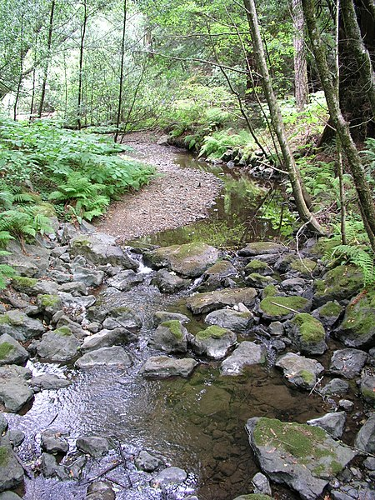

(Source: Wikimedia Commons, 2021)

Part 2
The photograph above displays an outdoor environment that is full of cross-curricular learning opportunities for young children. For this task, I will be focusing on supporting children within Progression Step 1 of the Curriculum for Wales (age range 3-5 years) to develop an understanding of ‘Science and Technology’ and ‘Mathematics and Numeracy’ – two out of the six Areas of Learning and Experience within the Curriculum for Wales (Welsh Government, 2020a).
Nature provides numerous ways for young children to explore, play and investigate, making learning fun and exciting for them. When children walk through the woodland and paddle in the stream, they are introduced to numerous mathematical and scientific concepts without necessarily being aware of it. Through observation alone, they will experience colours, shapes, matter, forces of movement and other living creatures to name a few examples.
Learning can occur both with or without adult intervention; however, when an adult is aware of when they should and should not intervene in a child’s play and acts accordingly, it can enhance the over-all learning experience for the child (Rymanowicz, 2015). One example of how an adult can promote a child’s learning is to provide them with appropriate resources.
Fishing Nets
Magnifying Glass
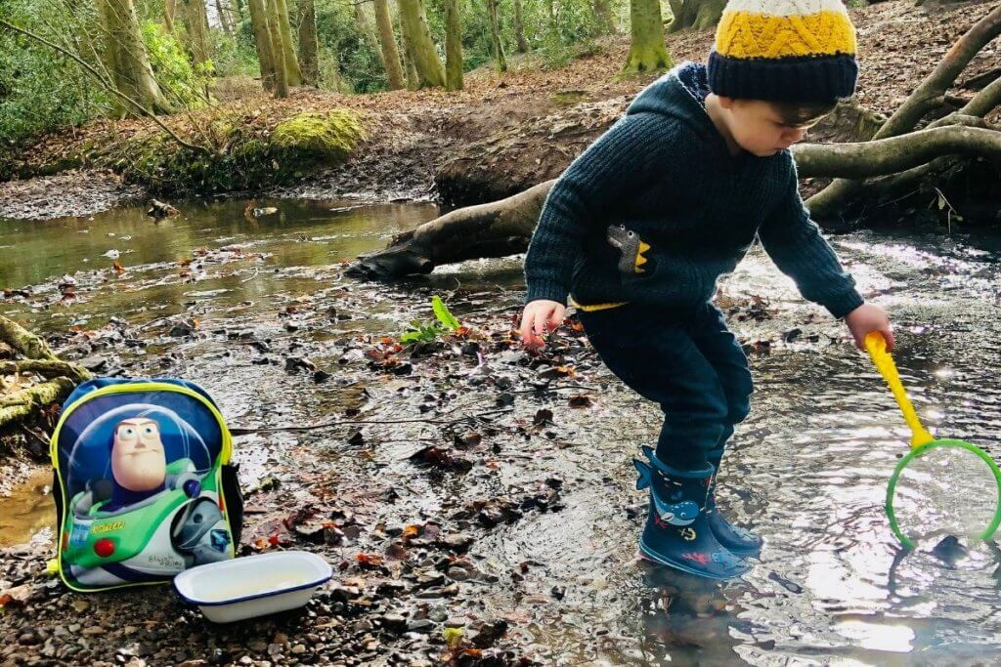
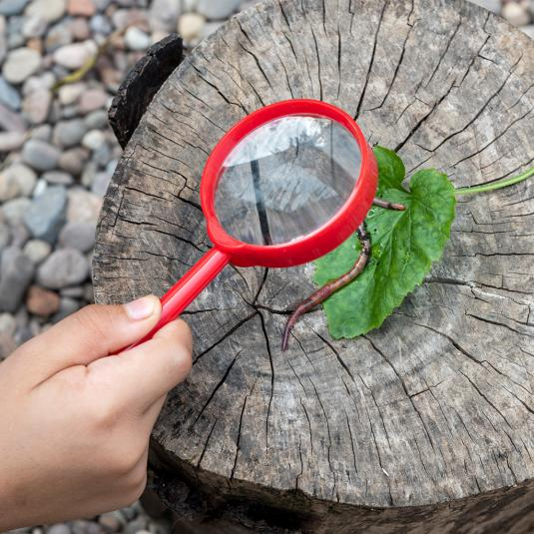
(Source: Rex London, 2022) (Source: Have Fun Outdoors, 2020)

A magnifying glass is a fun tool for children’s play and education as it promotes investigation. Children can literally zoom in on what they find, creating excitement to share and communicate their discoveries with peers and practitioners. When interest and excitement is observed, practitioners can take this opportunity to build on the child’s existing knowledge and understanding.
A fishing net also promotes investigation and observation in a similar way to a magnifying glass, drawing attention and focus to whatever a child may have caught in their net. Another similarity is that both a magnifying glass and a fishing net promotes hand-eye coordination and the development of fine motor skills. It’s also a great way of exploring other living creatures and for investigating the varying properties of matter as described within Progression Step 1 of the Curriculum for Wales (Welsh Government, 2020b).

Below are two examples of the type of conversation that could occur to promote children’s learning:

Example 1: A child with a magnifying glass makes an observation.

Child: “Wow! This leaf has got lots of holes!”
Practitioner: “Hmm… do you think it could have been a hungry caterpillar, like the one in the story we read?”
Child: “Maybe.”
Practitioner: “I think it could be. Do you remember what happens to the caterpillar after he eats lots and lots of food?”
Child shrugs shoulders.
Practitioner: “He turns into a beautiful butterfly!”
Child: “I’ve seen a butterfly in the sky!”
Practitioner: “That’s awesome! Was it green like the hungry caterpillar?”
Child: “No, it was like snow!”
Practitioner: “Do you mean it was it a white like snow?”
Child: “Yes, it was white!”

The shared interest from the practitioner and correct timing of questions has allowed the child to communicate what they are observing, helping them to start making sense of the world around them, including life cycles and the identification and comparison of colours.

Example 2: Children are using their fishing nets in the shallow stream.

Practitioner: “What have you found? Can I see?”
Child A: “Look! I’ve got stones in my net!”
Practitioner: “That’s great! Do they feel soft?”
Child A: “No, they are hard and shiny!”
Child B: “I haven’t got stones; I’ve got mud in mine.”
Practitioner: “That’s good work! Is the mud hard like the stones?”
Child B: “No, it is soft and yucky! And it’s dripping back in the water!”
Child A: “My stones aren’t doing that.”
Practitioner: “No they aren’t. Do you know why that is?”
*Child A and Child B both shake their heads. *
Practitioner: “Well, it’s because the mud isn’t as solid or thick as the
stones. Try to catch water in your nets and see what happens!”

Encouraging children to experiment in the outdoors allows them to naturally experience the varying textures and properties of matter on a first-hand basis, making it a more valuable and memorable experience for their learning and education.

Games that encourage exploration and experimentation:
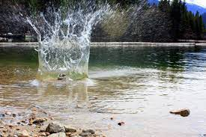
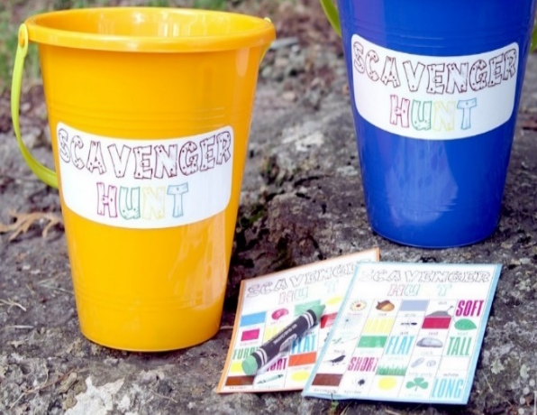
Sink or Float?
Scavenger Hunt

(Source: Donald, 2020) (Source: Rinder, 2011)

Providing children with the instruction and resources to participate in a scavenger hunt game will also help to develop their understanding of matter and the way in which it behaves. In addition to this, it can promote identification of colours, shapes and numbers. Within the descriptions of learning for Mathematics and Numeracy, Progression Step 1 learners should be encouraged to “investigate, collect and record data found within their environment” (Welsh Government, 2020c, Descriptions of learning - Hwb (gov.wales)). Careful and appropriate planning of a scavenger hunt can interlink these specific scientific and mathematical outcomes. To illustrate this point, a practitioner could prepare scavenger hunt cards in advance that will include images of the objects for children to find, and those objects could be of varying textures. Adding a number and a description next to each image such as ‘two wet leaves’ or ‘four wooden sticks’ would provide clear instruction, encourage investigation and collection of data, and would promote children’s understanding of how matter “defines our universe” (Welsh Government, 2020b, Descriptions of learning - Hwb (gov.wales)). To further enhance learning, the practitioner could discuss the objects at the end of the game and ask the children if they think each object would float or sink in the river, before encouraging them to find out for themselves:

Practitioner: “Well done boys and girls! I’m impressed with what you’ve all collected! Shall we take a closer look? You can use your magnifying glasses if you want to.”
Practitioner pulls out a stone from a bucket and encourages the children to pass it along so that everyone can take a closer look.
Practitioner: “What can you tell me about this stone? What shape is it?”
Child A: “It’s round.”
Practitioner: “Yes, it is! Was it heavy or light to pick up?”
Child B: “It was a little bit heavy.”
Practitioner: “Okay. Now, let’s take a look at the next object.”
A stick is pulled out from the bucket and is passed along the children.
Practitioner: “What’s different about the stick?”
Child A: “It’s brown and it’s not very bumpy!”
Practitioner: “Fantastic! So, the stone is grey and the stick is brown, which means they are different in colour. It’s also less bumpy which means it’s smoother. But is it heavier than the stone?”
Child A and Child B: “No!”
Practitioner: “Correct, it’s lighter. Would you like to see what happens when we throw the stone and the stick into the river?”
Child A: “Can I throw the stone?”
Child B: “Can I throw the stick?”
Practitioner: “Everyone can have a turn if they would like to. Do you think the heavier stone will float on top of the water? Or will it sink to the bottom? And what about the lighter stick? Let’s find out!”

Pre-planned tick-list sheets could also be offered to the children to record their findings, which would contribute to the beginning of their understanding of data representation. Children will be able to observe for themselves that heavier objects sink and lighter objects float, introducing them to the idea that it is the density of each object that determines its outcome within the water. Therefore, children will begin to understand that there is a direct link between the properties of materials and the way in which it behaves. Furthermore, it allows children to have fun as they learn!

Part 4
The value and significance of providing young children with outdoor learning experiences has become increasingly acknowledged and accepted within the early years sector (Welsh Government, 2014, p.3; Bilton and Waters, 2016, p.3). In fact, being outdoors is a principle of the child-centred pedagogy embedded throughout the curriculum for funded non-maintained nursery settings (Welsh Government, 2022), and is promoted within the Areas of Learning and Experience of the Curriculum for Wales (Welsh Government, 2020a).
Froebel emphasised the importance of children engaging with nature, hence the reason for the garden being the essence of Froebelian early years settings. In fact, Froebel was responsible for creating the first ever kindergarten. He recognised that engagement in the natural world offered unique opportunities for children’s learning that could not be achieved indoors. The outdoors provides space, freedom for the whole body and opportunities for adventure, risk and challenge (Tovey, 2013; Froebel Trust, 2022).
However, for outdoor learning to be effective, educators are required to plan and prepare outdoor learning activities with as much thought and consideration as they do when preparing lessons inside the classroom (White, 2014; First Discoveries, 2022). According to White (2014), children have a special connection with the outdoors, making it their domain. As a result, adults should not take on the role of a ‘teacher’ during this time. Bento and Dias (2017) appear to agree, claiming that children are both the learners and teachers when they are in the outdoors.
It cannot be denied that outdoor play is predominately child-led; however, the role of the adult is still an important and essential one that impacts on the over-all learning experience and well-being of the child. In fact, the role of the adult requires great judgement and flexibility. For example, it can vary from being a care giver, communicator, observer, collaborator, and facilitator to name a few – all whilst modelling techniques, skills, strategies, and positive interactions (Rose and Rogers, 2012; Keith, 2018; Amin, 2022; First Discoveries, 2022).
When it comes to Science and Mathematics, it can be argued that there is no difference between the two. Indeed, both subjects rely on evidence, lead to ongoing research, and are used to make sense of the natural world; for instance, calculus was used to work out forces of movement (Berkeley, 2022). However, Malmskog (2017) argues against this, stating that the purpose of science is to find an understanding of phenomena, and although this is supported by evidence, it cannot always prove a theory. She states that mathematics, on the other hand, uses logic and is based on fact. Whilst both perspectives are valid, one cannot ignore that both subjects are greatly interlinked, and adults should take this into consideration when planning outdoor learning activities.
Carson (1956, quoted in White, 2014, p.1) states that “a child’s world is fresh and new and beautiful, full of wonder and excitement.” When immersed in the natural world, children can learn about the growth of plants and creatures, see the beauty of nature and begin to understand life cycles (Tovey, 2013). To build on or to captivate a child’s natural curiosity about their world can help to achieve optimal learning experiences for the child (Shah et al., 2018).
Through careful observation, adults can identify children’s individual interests and find out what they are most curious about. Observation enables them to recognise when it is most appropriate to prompt, support and encourage children if there is requirement to do so. (Rymanowicz, 2015; Welsh Government, 2022). In other words, observation enables the practitioner to ‘scaffold’ children’s learning and play. Vygotsky (1978) believed that scaffolding is most efficient in an individual’s Zone of Proximal Development (ZPD), where a more knowledgeable other can support the individual to achieve further knowledge and skills that they had not yet required on their own (Zurek, Torquati and Acar, 2013).
According to the REPEY Report (Siraj-Blatchford et al., 2002), settings with practitioners who participated in sustained shared thinking were more likely to actively search for ways in which they could scaffold children’s thinking. Similarly, the EPPE Project (Sylva, K., 2004) also identified that the most successful settings encouraged sustained shared thinking in their practice.
Sustained shared thinking is an active and creative process that happens when two or more individuals work together. It’s different to the traditional role of a teacher in the sense that teachers usually present information for children to absorb. Instead, it involves a two-way exchange of information, enabling the practitioner to also learn from the child. Sustained shared thinking is achieved when both parties contribute to thinking so that they can solve an issue, make sense of a concept, and further develop or extend a narrative (Brodie, 2014). In other words, sustained shared thinking is the “meeting of minds,” and can occur within a group or when working on a one-to-one basis (Learning Journals, 2021). Keith (2018, p.77) highlights the importance of sustained shared thinking when developing children’s mathematical learning in the outdoors, and states that the “value of the quality of interaction, alongside meaningful contexts of learning, is one that has to be shared with parents and carers.”
Children develop an understanding of science and mathematics through experimenting and playing with ideas (Sargent, 2015; Mechler, 2015). Piaget (1964) recognised that the most effective way for children to learn is through experience and hands-on activities. Their creative, logical and critical thinking skills develop when participating in active social experiences during early childhood – the outdoor environment facilitates this as children can really delve into the natural world and begin to make sense of it (Tovey, 2013; Sargent, 2015).
The outdoors offers certain opportunities for children’s learning that cannot be achieved indoors; one reason being that the range of resources are more restricted indoors by size and space (Keith, 2018). Take for example a mud kitchen – it is not practical for indoor use due to its size and the mess that it creates. However, it offers great benefits for children’s scientific and mathematical development (Ranson, 2017; Harrison, 2019). The Faculty of Mathematics for Cambridge University (2022) point out that mud kitchen activities offer the perfect opportunity to explore size, weight, capacity, position and distance. Scientific concepts are also explored – children will be able to witness the change that occurs through combining, mixing and transferring materials (Ranson, 2017).
It is during such activities that the role of the adult becomes highly significant, as they can facilitate children’s learning in numerous ways. For example, adults can introduce loose parts into play. Materials and experiences that are open-ended encourage problem solving and are child-led, inviting creativity, imagination and curiosity (Penn State Extension, no date). During a mud kitchen activity, adults can provide access to pots, pans, measuring equipment, a water supply and so on (The Faculty of Mathematics for Cambridge University, 2022). However, it is also the adult’s responsibility to help create meaning to those loose parts.
According to White (2011), a key aspect of an adult’s role is to enter a child’s world, scaffold play and encourage sustained shared thinking. Encouraging sustain shared thinking for mathematical and scientific concepts can include modelling good language and prompting children to extend their thinking. Using open-ended questions during play such as “what do you think will happen if we mix the mud with water?” will encourage experimentation and thoughtfulness. It could also mean providing running commentary on your own thoughts and actions. For example, “I’ve just poured water into the bucket of mud and now it’s heavier to carry!” Doing so provides a structure that children can copy (Brodie, 2014).
Another important aspect of outdoor learning is the health benefits that come with it. Physical activity increases within an outdoor environment, which inevitably tackles the issue of childhood obesity, and promotes mental health and well-being (Allen and Balfour, 2014; World Health Organisation, 2022; CDC, 2022). In addition, natural materials such as mud, dirt and soil contain a bacterium which boosts children’s immune system and increases the serotonin level in the brain (Harrison, 2019; Franco and Robson, 2022). Therefore, the outside environment promotes positive physical and mental health whilst also promoting the understanding of mathematics and science. For example, when children climb, it introduces the concept of height, gravity and balance, and swinging on a rope provides experience of energy, forces, speed and distance (Tovey, 2013).
Of course, there will be risks to young children when participating in outdoor physical activity and during their play and exploration in nature. However, challenge and risk-taking are fundamental necessities for their progression and development (Shonkoff and Fisher, 2013; OAEP, 2018). Positive outcomes for children taking risks include increased self-confidence, independence, the ability to self-regulate and problem-solve (Bright Horizons, 2020).
Piaget (1964) believed that children learn through play, and therefore their environment should encourage further cognitive and language development (Hamid, 2018). An environment without any risks does not stimulate children, and bored children can easily begin to display unacceptable behaviour. This can potentially lead to children engaging in risk-taking behaviour which could be dangerous to them and to their peers (City & Guilds, 2019). Early years practitioners have a duty to keep children safe, and therefore are responsible for encouraging healthy risk-taking behaviour. This can be achieved by conducting risk-assessments in advance and analysing if the benefit of an activity is worth the risk (OAEP, 2018; Bright Horizons, 2020). Take for example a child climbing a tree – the benefits include the development of gross motor skills, balance, and other mathematical and scientific concepts stated above. The risk, however, is that a child could fall an injure themselves. Adults can minimise the risk by ensuring adequate supervision, appropriate clothing and by setting clear boundaries such as not to climb beyond a certain point (Nursery World, 2018).
All of this points to the conclusion that adults play a vital role in developing children’s mathematical and scientific development in the outdoors. Despite outdoor play predominately being child-led, the adult’s role is much greater than just supervising the play. It is their duty to model appropriate behaviour, language, and enthusiasm, whilst developing ways to optimise children’s learning experiences through scaffolding and sustained shared thinking. The adult is required to consider challenges and risks that may not arise within an indoor environment. However, it cannot be denied that the natural environment provides holistic opportunities for the learning, health, and well-being of children.

References
Allen, J. and Balfour, R. (2014) Natural solutions for tackling health inequalities. London: UCL Institute of Health Equity. Available at: natural-solutions-to-tackling-health-inequalities.pdf (food4families.org.uk) (Accessed: 17 December 2022).
Amin, R. (2022) ‘Children’s Health – The importance to recognise and value the learning experiences that children have when engaging in play’, Pentagon Play [blog]. Available at: The Role of the Adult in Supporting Children's Play | Pentagon Play (Accessed: 16 December 2022).
Bento, G. and Dios, G. (2017) ‘The importance of outdoor play for young children’s healthy development’, Porto Biomedical Journal, 2(5), pp.157-160. Available at: The importance of outdoor play for young children's healthy development - ScienceDirect (Accessed: 15 December 2022).
Berkely (2022) Understanding Science. The Science Checklist Applied: Mathematics. Available at: The science checklist applied: Mathematics - Understanding Science (berkeley.edu) (Accessed: 15 December 2022).
Bilton, H. and Waters, J. (2016) ‘Why Take Young Children Outside? A Critical Consideration of the Professed Aims of Outdoor Learning in the Early Years by Teachers from England and Wales’, Social Sciences, 6(1), pp.1-16. Available at: Why Take Young Children Outside? A Critical Consideration of the Professed Aims for Outdoor Learning in the Early Years by Teachers from England and Wales (uwtsd.ac.uk) (Accessed: 15 December 2022).
Bright Horizons (2020) Risk Taking in Early Childhood: When is it appropriate? Available at: Bright Horizons | Risk Taking in Early Childhood: When Is It Appropriate? | Bright Horizons® (Accessed: 17 December 2022).
Brodie, K. (2014) Sustained Shared Thinking in the Early Years. Oxon: Routledge.
CDC (2022) Benefits of Physical Activity. Available at: Benefits of Physical Activity | Physical Activity | CDC (Accessed: 17 December 2022).
Donald, M. (2020) ‘Indoor and Outdoor Scavenger Hunt {FREE Printables}’, The Scrap Shoppe blog [blog]. Available at: Indoor & Outdoor Scavenger Hunt {FREE Printables} - The Scrap Shoppe (thescrapshoppeblog.com) (Accessed: 11 December 2022).
First Discoveries (2022) Defining the Outdoor Classroom. Wesco. Available at: Defining-the-Outdoor-Classroom.pdf (firstdiscoverers.co.uk) (Accessed: 15 December 2022).
Franco, A. and Robson, D. (2022) ‘How mud boosts your immune system’, BBC Future. Available at: How mud boosts your immune system - BBC Future (Accessed: 17 December 2022).
Froebel Trust (2022) The Power of Play. Available at: Froebel Trust | The power of play (Accessed: 17 December 2022).
Hamid, K. (2018) ‘The Psychological Theories Behind Learning through Play’, Pentagon Play. Available at: Psychology Behind Learning Through Play | Pentagon Play (Accessed: 17 December 2022).
Harrison, A. (2019) ‘Science Experiments for Mud Kitchens’, Discovering Days [blog]. Available at: Science Experiments For Mud Kitchens - Discovering Days (Accessed: 17 December 2022).
Have Fun Outdoors (2020) Forest School | What is it? Benefits and Activities Involved in Forest School Learning. Available at: Forest Schools, What are Forest Schools? | Have Fun Outdoors (Accessed: 11 December 2022).
Keith, L. (2018) Developing Young Children’s Mathematical Learning Outdoors. Oxon: Routledge.
Learning Journals (2021) What does Sustained Shared Thinking Mean in EYFS? Available at: What Does Sustained Shared Thinking Mean in EYFS? (learningjournals.co.uk) (Accessed: 15 December 2022).
Malmskog, B. (2017) ‘Math is Like Science, Only with Proof’, AMS Blogs [blog]. Available at: Math is Like Science, Only with Proof | (ams.org) (Accessed: 15 December 2022).
Mechler, H. (2015) ‘Applying Math and Science Concepts in Preschool Classrooms’, Texas Childcare Quarterly, 39(2). Available at: fall15_math-science.pdf (childcarequarterly.com) (Accessed: 17 December 2022).
Nursery World (2018) Enabling Environments: Risk – Be safe. Available at: Enabling Environments: Risk - Be safe | Nursery World (Accessed: 17 December 2022).
Outdoor Education Advisory Panel (2018) High Quality Outdoor Learning for Wales. Available at: English (edufocus.co.uk) (Accessed: 17 December 2022).
Penn State Extension (no date) Loose Parts: What does this mean? Available at: Loose parts: What does this mean? — Better Kid Care — Penn State Extension (psu.edu) (Accessed: 17 December 2022).
Ranson, A. (2017) ‘The Benefits of Mud Kitchens!’, The imagination tree [blog]. Available at: The Benefits of Mud Kitchens! - The Imagination Tree (Accessed: 17 December 2022).
Rex London (2022) Gifts of random kindness. Available at: ﻿Wonders Of Nature Magnifying Glass | ﻿Rex London (Accessed: 9 December 2022).
Rinder, K. (2011) ‘Rockity Rock Rock’, North Cascades Institute [blog]. Available at: Rockity Rock Rock — North Cascades Institute (ncascades.org) (Accessed: 14 December 2022).
Rose, J. and Rogers, S. (2012) The role of the adult in early years settings. Berkshire: McGraw Hill Education.
Rymanowicz, K. (2015) ‘The Power of Play – Part 5: Adult roles in child’s play’, Michigan State University. Available at: The power of play – Part 5: Adult roles in child’s play - MSU Extension (Accessed: 9 December 2022).
Sargent, M. (2015) Developing Early Maths Skills Outdoors. London: Practical Preschool Books.
Shah, P. et al. (2018) ‘Early childhood curiosity and kindergarten reading and math academic achievement’, Paediatric research, 84(3), pp.380-386. Available at: Early Childhood Curiosity and Kindergarten Reading and Math Academic Achievement - PMC (nih.gov) (Accessed: 16 December 2022).
Siraj-Blatchford, I. et al. (2002) ‘Researching Effective Pedagogy in the Early Years (REPEY)’ DfES Research Report 365, HMSO. London: Queen’s Printer.
Shonkoff, J. and Fisher, P. (2013) ‘Rethinking evidence-based practice and two-generation programs to create the future of early childhood policy’, Development and Psychopathology, 25(4pt2), pp.1635-1653. Available at: Rethinking evidence-based practice and two-generation programs to create the future of early childhood policy - PMC (nih.gov) (Accessed: 17 December 2022).
Sylva, K. et al. (2004) ‘The effective provision of pre-school education (EPPE) project technical paper 12: The final report-effective pre-school education’, Institute of Education. Available at: OUTLINE OF PURPOSES OF EARLY ANALYSIS OF EPPE RECEPTION DATA (ucl.ac.uk) (Accessed: 16 December 2022).
Tovey, H. (2013) Bringing the Froebel approach to your early years practice. London: Routledge.
University of Cambridge Faculty of Mathematics (2022) Mud Kitchen. Available at: Mud Kitchen (maths.org) (Accessed: 16 December 2022).
Welsh Government (2014) Further Steps Outdoors Guidance. Available at: WG21428 Building a Brighter Future: Early Years and Childcare Plan Progress report 2013-14 (gov.wales) (Accessed: 15 December 2022).
Welsh Government (2020a) Curriculum for Wales. Available at: Curriculum for Wales - Hwb (gov.wales) (Accesssed: 7 December 2022).
Welsh Government (2020b) Area of Learning and Experience: Science and Technology. Available at: Descriptions of learning - Hwb (gov.wales) (Accessed: 7 December 2022).
Welsh Government (2020c) Area of Learning and Experience: Mathematics and Numeracy. Available at: Descriptions of learning - Hwb (gov.wales) (Accessed: 11 December 2022).
Welsh Government (2022) A curriculum for funded non-maintained nursery settings. Available at: A curriculum for funded non-maintained nursery settings (gov.wales) (Accessed 15 December 2022).
Wikimedia Commons (2021) File: Stream in the redwoods.jpg. Available at: File:Stream in the redwoods.jpg - Wikimedia Commons (Accessed: 7 December 2022).
White, J. (2011) Outdoor Provision in the Early Years. London: Sage Publications Ltd.
White, J. (2014) Playing and Learning Outdoors: Making Provision for High Quality Experiences in the Outdoor Environment with Children 3-7. 2nd edn. Oxon: Routledge.
World Health Organisation (2022) Physical Activity. Available at: Physical activity (who.int) (Accessed: 17 December 2022).
Zurek, A., Torquati, J. and Acar, I. (2013) ‘Scaffolding as a Tool for Environmental Education in Early Childhood’, North American Association for Environmental Education, 2(1), p.27. Available at: EJ1108033.pdf (ed.gov) (Accessed: 16 December 2022).

