Name / Enw
Student number / Rhif myfyiwr
E-portfolio report
ADRODDIAD E-BORTFFOLIO
Learning in the Digital Era / Dysgu yn yr Oes Digidol – BMPL4007/BMPS4009
Table of Contents
Task 1 – Written summary / Tasg 1 - Crynodeb Ysgrifenedig 2
Task 2 – Mind map / Tasg 2 – Map meddwl 5
Task 3 – Presentation / Tasg 3 - Cyflwyniad 9
Task 4 – Reflection / Tasg 4 - Myfyrdod 11
Task 5 - PDP/ Tasg 5……………………………………………………………………………………………………………………………
Reference list / Rhestr Cyfeirnodi 14

Task 1 – Written summary / Tasg 1 - Crynodeb Ysgrifenedig

Preparing For Higher Education
Preparation for higher education is a daunting task for many students across the world. However, with good preparation and planning the task can be made much easier. Biggest new challenge you will face
Is to manage your time” organizing your social and academic activities. (Donna, 2017)
Below are some suggestions which could be useful.
- Timetable planner and all necessary tools for study
- Finding a good quiet place to study
- Spending 10-15 minutes of your time preparing your notes.
- Checking your university e mail every day.
- Using your time wisely.
- Set yourself realistic targets.

Digital skills
Almost everything we do is completed on computers, therefore having digital skills are essential to higher education.
Below are a few essential tasks you are required to learn in this digital era.
1. be able to create basic word documents
2. using power point for visual presentation
3.manage your email
4.joining teams meeting
5.learnig how to navigate internet
in recent years there has been much research by academics on digital learning and its importance in today’s world and how it effects our everyday lives. No industry will be left
untouched by the Digital transformation that’s taking place. (Bernard, 2022)
Evidence shows from national and international studies that lack of preparation for higher education is a major factor for non-completion of courses (Murtagh, 2012). Therefore, it is verry important for pr-entry students to take preparation for higher education seriously, it could be the difference between a confident student and a confused student.
Digital learning in higher education has been growing amazingly fast, even institutions are
Struggling with the pace of the implementations, learning and teaching are made much easier by providing many with online lectures and excess to vast information and resources.
In a fast-moving world where technology has become intertwined with our daily lives, digital tools have enormous advantages to both teachers and students. (Christina, 2023)

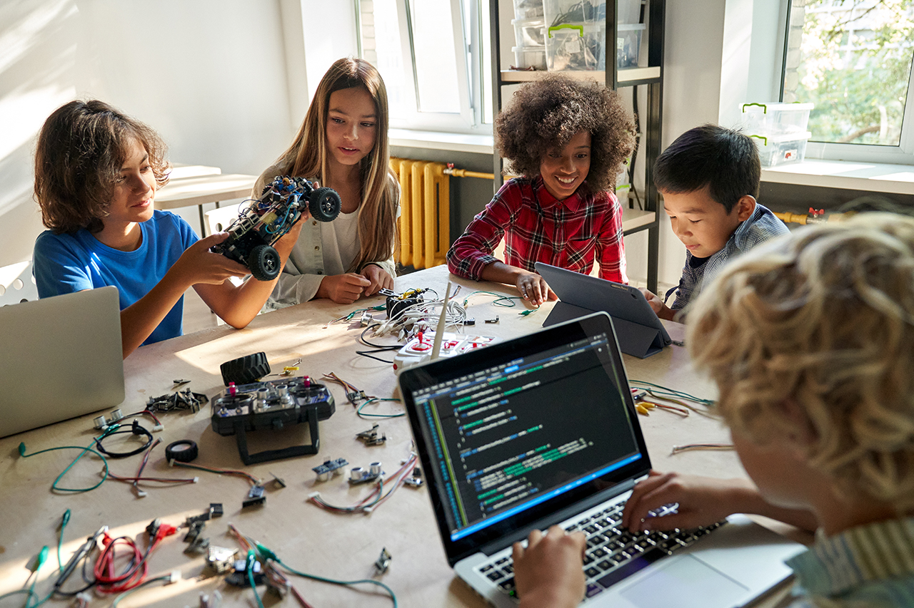
[image from google]

Task 2 – Mind map / Tasg 2 – Map meddwl

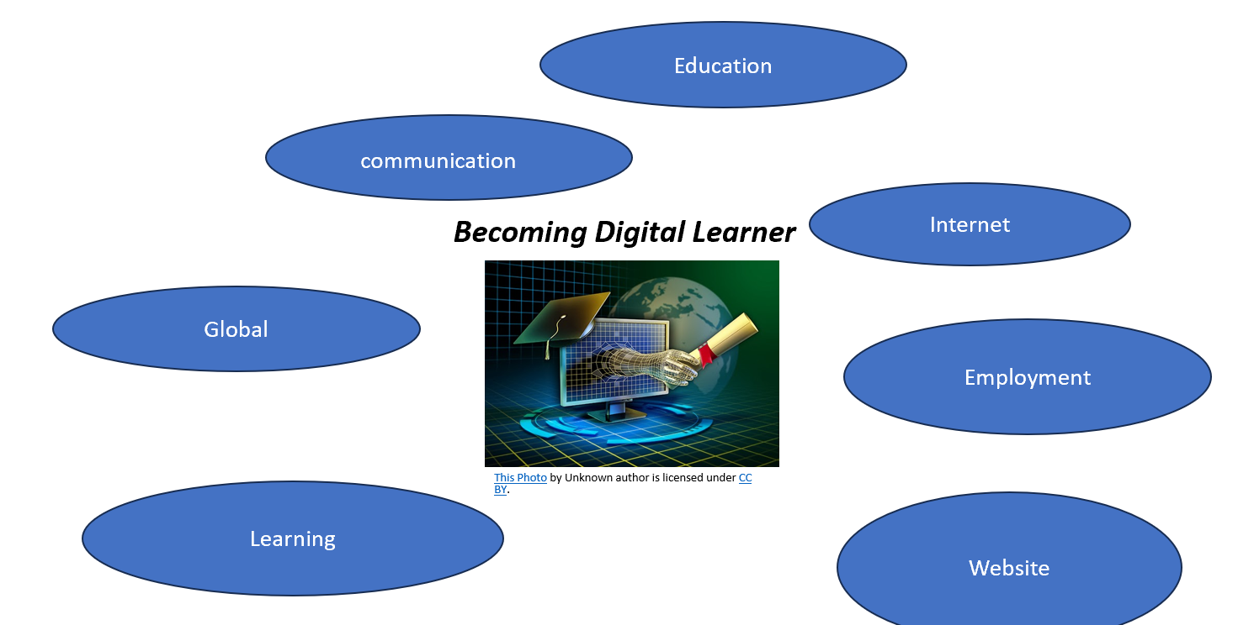

Becoming a Digital Learner.

- Becoming a digital learner is very important these day’s as we are using different digital tool’s to improve efficiency in our work place or our Educational institution .My digital mind maps illustrate few of the Important tool’s that I think is relevant to my chosen discipline Law.
- 1.Internet
- Internet enable to go online .
- 2.Education
- Online education has access to remote learning and access to online library .
- 3.Communication
- Interactive communication online helps develop your digital skill’s .
- 4.Global
- Having a global community at your finger tip’s to help and advise.
- 5.Learning
- Learning in digital era has become very common these day’s, it is great way to access Education from rural area where people previously was unable to gain access
- to education.
- 6.Website
- You will have access to many thousands of website for research and learning.
- 7.Employment
- You will have access to International Job Markets.
- As we are in this Internet era we are learning using many different resources online , for instant we are using online library for gaining information, we are communicating and doing Business globally .
- My chosen discipline Law & Legal Practice requires digital skill’s for conducting everyday tasks ie,
- Excess to large amount of legal information online.
- Writing will's, research material’s.

Task 3 – Presentation / Tasg 3 - Cyflwyniad
Please follow this link to view my presentation: / Dilynwch y cyswllt isod i wylio fy nghyflwyniad
My Personal Identity
Hi my name is Gulam Zilani Latif, I live in Swansea mid Glamorgan. I moved to wales in the 90’s, I started my Takeaway food business in 1996, its situated in llangennech llanelli. I am self employed
Chef, I’ve been running my business with my wife for almost 28 years. This business has provided me
With great wealth of experience in hospitality industry, my duty involves doing several roles
i.e. shopping, cooking, cleaning, and managing staff.
I believe I am a team player; I have a good sense of responsibility and managerial skills for any team work. What makes me a good team player is I am always listening to my staff for any suggestion
Which will make our workplace more enjoyable and productive. I believe these sets of skills and knowledge will help me in the future in my chosen field law. Here is link to my youtube video.https://youtu.be/R2jZN6TL3mA

Task 4 – Reflection / Tasg 4 - Myfyrdod

Lately I've been thinking about going back to higher education, last winter as I was watching TV there was a programme on higher education this was a very interesting programme because it was about adults entering education at later stage of their life and this has appealed to me so I started to wonder if I should enter higher education, so I started to do some research on higher education for adults. My first concern was will I be able to manage my family, work and study at same time. I was able to find many courses to study in my local university, where they helped me choose a online blended
Course . I was always interested in law but I left collage with little or no qualification, with this in mind I wasn’t too sure if I would be able to study at higher education, so I contacted my university which welcomed me to a open day and later offered a written and communication test to complete which I managed to pass. I was incredibly happy after almost three decades of absent from formal education I have decided to study at university.
Soon after the confirmation of my place, I stared to panic, how will I manage my work and my study at the same time. How will I get into the rhythm of studying online, as I have very little knowledge of computing, I will need to do most of my assignments online and also studying learning, doing research,
All this was very overwhelming, but soon all positive thinking helped me to overcome this fear. I looked online for more information on how to prepare
Myself for Higher Education, most of the information helped me become more confident and started to use Gibbs reflection tools to guide me on this beautiful journey to Higher Education.
Finding all or most of the information is online, as digitalisation has become the norm for this generation. Last month was my start
to my online learning, the law and legal Practice course which I am studying has 6 modules, for the past 3 weeks we have been studying Learning in Digital era and homicide. first few lessons were very difficult to process as I was very nervous, I think most of the students was in same situation as me.
Slowly I stared to enjoy every lecture, I do have many weaknesses which I am trying to overcome, as time passes by, I am sure I will become more confident in studying in this digital world, this is my biggest challenge so far in my life and I am determined to finish this course and go on to the next level.
I am finding law very interesting subject I hope to become a lawyer someday, it will be dream come true for me .

Task 5– Personal Development Plan

Student Name |  | Student Number |  | Module |  | Code
 |  |  |  | Learning in the Digital Era |  | BMPL4007  BMPS4009
What goals do I want to achieve? | How will I measure my progress? |  | What resources or support will I need? |  | How is the objective relevant to my personal aspirations? | What is the timeframe for the achievement of my goals?
Specific | Measurable |  | Achievable |  | Relevant | Timebound
- Organisational skills  - Read more academic studies  - Communication skills | - Set specific goals, track task completion and seek feedback.  - Track number of studies read within a given timeframe e.g 1 per day each week. Also evaluate comprehension and retention of key concepts within studies.  - Assess active listening, clarity and feedback reception. |  | -Planners, organised calendar and daily routine.  -Access to online libraries and published academic sources  -Reflection on feedback |  | - Improving my organisational skills can help me break down my goals into actionable steps, increasing the likelihood that I achieve my personal and professional goals.  - Engaging with academic sources can encourage me to think more critically and view things from a different perspective.  - Improving my communication skills will ensure I can coherently discuss important topics and pieces of information. | -Complete assignments in advance (1week beforehand)  - Weekly milestone to read an academic source (7per week/ 1 per day)  - Use feedback given on work to rewrite and improve pieces of work.

Reference list / Rhestr Cyfeirnodi

