Elena Todorova (2124115)
NEAL HADDON
report
Psychology for Health and Social Care BMHP_4003BIRM

CONTENT PAGE:

- Introduction
- Social Identity Theory
- Theory of Planned Behavior
- Frustration Aggression Hypothesis
- Conclusion
- Reference list

1.INTRODUCTION
Following report is produced to aid YOT in understanding the possible cause of the behaviour displayed in the case study. To achieve that there will be used psychological theories to develop understanding of the case and to enable us to create suitable support plan. Discussed will be some useful theories such as:
- Social Identity Theory
- Theory of Planed Behaviour
- Frustration Aggression Hypothesis
In the report will be discussed some literature that supports the points made within the report. On the other hand, the report will summarise the important theories and propose developed support plan.
1.a) What is social identity? Why it is important?
Henry Tajfel came up with the social identity theory in 1979. As mentioned by Dr. Saul McLeon, (2019) Social identity is a person’s sense of who they are based on their group membership(s). Social identity helps person to identify them self as part of a group or as individual and in what circumstances that happens. We all at some point see ourselves as part of a group that we may have some similarities with, this is normal. On the other hand, social identity tries to determine at what circumstances may this happen, we can see ourselves as individual or as part of group. In the case of Gareth, it seems he may have low self-esteem and feels better as been part of a group- however, not realising the impact on him may be negative. When people feel part of a group, they feel better and feel worthy. Humans are inherently social beings. Indeed, there is social psychological perspective that we have a fundamental, evolutionary-based need for interpersonal relationship. (Baumeister & Leary, 1995). Gareth see his friends as his in group, the one group that he sees he belong to. However, his friends or his in group have bad influence on him. He as well sees his YOT as his out group and he finds it hard to fit in and to find common interest. When belonging to a group people have better self-esteem and as well, this impacts their behaviour. As it shows in the case Gareth got into bad influenced company and this led him in trouble. However, when not in contact with them and surrounded by positive support he was doing well. On the other hand, his social identity and self-esteem supposedly are a bit lower as he may find it hard to fit in college and he associates with bad friends, Until he did not get involved again with old habits and harmful influence. Whenever person is feeling as part of any group their behaviour is dictated or in another words is influenced by the group. As in group people behave different then they would do usually. It may be difficult to integrate in new group and gain new habits, but when person is determined and supported through this transition its possible. Many people find it hard and slip back in to known bad behaviour as it seems easier than to integrate new things. It is crucial to know that our self-esteem and the way we see ourselves can be changed by our group belonging.
2.Theory of Planed Behaviour.
There are 3 factors that can influence planned behaviour.
Attitude- Is what we think about it
Subjective norm-What others think about it.
Perceived Behavioural Control- Feeling capable of doing something.
As mentioned by (Elizabeth Brookes, 2021) The theory of planned behaviour (TPB) a cognitive theory by Ajzen (1985) that proposes that an individual’s decision to engage in a specific behaviour can be predicated by their intention to engage in that behaviour. As well can be influenced by our thoughts and by what person think of what his in-group friends may think about it. Moreover, all actions and behaviour depend on how much person want to do something, or how much they believe in what they do. On other hand, it could be influenced by our social circle or in-group as people around us can influence our decisions or actions. In the case study is clear that Gareth is in bad company which has influenced him in the wrong path. And he thinks that his friends think what they are doing is good and cool so he will perceive same group behaviour. It is likely that probably that is the only think he think he is good at, and he can do, and this may be gives him self-esteem.
But if he goes regularly to college and build up friendships and do what he is good at as its clear he enjoys automotive repair so maybe this will boost his self-esteem and helps him make friends and build better in group circle which he can socially identify with. It is evident that by help of professionals and YOT he got on his feet and enrol in college to do something he likes and stay away from trouble so it’s important what people we surround ourselves with and how they influence our behaviour and thoughts. It is important that Gareth feels supported and feel that he can do it and get out of the bad group. Feeling supported and believing that can be changed is the key in getting better and been out of the bad group he is in. Positive attitude and keep going and not give up he can succeed and do it.
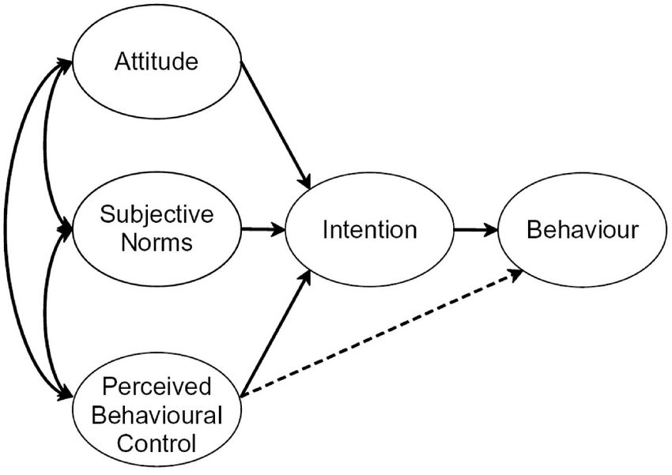
3. Frustration Aggression Hypothesis.
Dollard And Miller (1939) suggested that aggression is always caused by frustration of not been able to reach certain goal. When frustration is building the best way to deal with it is to’’ let out some steam’’ as its not healthy to bottle up. In the case of Gareth its evident he has built frustration up and this leads to him being aggressive towards the youth offender team. There are many reasons that he may be frustrated about, one of them is he may feel patronised been told what to do, he may feel out of place- not fitting in college as it takes time to fit in and make friends and build relationships. On the other hand, maybe he doesn't like that he's not achieving what he wants to achieve. Here is coming in place the perceived behavioural control which shows that maybe Gareth thinking- What are my friends thinking about what I'm doing? The thoughts of them being not supportive or trying to lure him into a wrongdoing again surely can make him be frustrated. He must make a choice between his friend group and between going to college and doing something right for himself as getting on his feet and in right direction. It’s never easy to be able to choose between two things so this may cause him frustration as well. However, when approached by YOT team he let his frustration get the best of him and he became verbally aggressive. As well, this doesn't mean that he's frustrated with them maybe they were on the wrong time at the wrong place. He redirects his frustration towards them may be just the case. There is also the possibility that he may be frustrated with them as he felt patronised, been told what can do or not to do, he may feel like they are always on his case and that may be too much for him. Let’s not forget that Gareth also sees his friends and been good and cool and sees YOT as kind of enemies and may be finding it hard to trust them or to believe they are on his side. On other hand, as mentioned by Anderson and Bushman (2002), there it may be different factors that may cause frustration, such as:
Tiredness
Physical pain
Medication
Arousal
Mood we are in the exact moment
Alcohol/drugs

4. Conclusion.
The case of Gareth is complexed, and it is hard to work out what leads to his behaviour as we may only assume. However, it is evident that he may be able to carry on with his college and succeed in achieving his goals. He could do better for himself stepping on his own feet and getting away of his bad influence friends who clearly are toxic for his success. My recommendations will be as follow.
- Supporting, reassuring and recognition
- Build trust between Gareth and the professionals involved
- Make good new friends in college
- Not making him feel that it’s been judged
- Feel in control of his own life
- Giving opportunities for clean fresh start- may be new place far from bad company
- Finding somebody in common that can talk to him and show him he can do it and turn the page
Some time its hard to do well when you feel unheard or not supported enough. At times may feel that you're not in control, or the whole world is against you- that's why it's necessary he feels supported, lots of reassurance and recognition for his hard work and how hard he's trying to do better. Building trust between Gareth and the professionals is very important, because now he sees them as they are enemies or bossing him around and telling him what to do. Gareth needs to understand that YOT are there for him and they want him to do better, they want to help him and support him through the process. Is very important that he doesn't feel being judged and feels in a control- being able to take a decision of his own life. Giving him maybe opportunity to start somewhere new, somewhere fresh where no one knows him or there is no negative influence that usually gets from his friend. Moreover, may be helpful to find somebody who is done something like him, and they can talk to him, show him that he can turn the page and do better. Show him things can change and he can do good things; so, it's important they have something in common.

REFERENCE LIST

- Ajzen, I. (1991). The theory of planned behaviour, Organizational Behaviour and Human Decision Processes, 50(2), 179-211
- https://www.simplypsychology.org/social-identity-theory.html
- https://www.simplypsychology.org/theory-of-planned-behavior.html
- https://moodle.uwtsd.ac.uk/mod/resource/view.php?id=302328&redirect=1
- Carlson, N.R. (1990) Psychology: the science of behaviour. 3rd ed. London: Boston, (Mass.); Allyn and Bacon.
- Maio, G.R. (2009) The psychology of attitudes and attitude change [electronic resource]. London: Los Angeles, [Calif.]; SAGE.
- Copy to clipboard
- Berkowitz, L. (1989) ‘Frustration-Aggression Hypothesis: Examination and Reformulation’, Psychological bulletin, 106(1), pp. 59–73. Available at: https://doi.org/10.1037/0033-2909.106.1.59.
- ‘Frustration–aggression hypothesis’ (2015) A Dictionary of Psychology. 4th edn. Oxford University Press.
- Lewis, W.A. and Bucher, A.M., 1992. Anger, catharsis, the reformulated frustration-aggression hypothesis, and health consequences. Psychotherapy: Theory, research, practice, training, 29(3), p.385.

