
Cloud-Based Web Services
Gemma Melanie Dunlop (1801285)
BSc Computing (Web Development)
Friday, 07 May 2021

CONTENTS
I. CLOUD COMPUTING 1
A. What is Cloud Computing 1
B. Cost of Cloud Computing 4
I. Why automate shutting down VMs? 5
II. How does distributing the load and caching help? 5
III. Database Cost Reduction 6
C. Scalability 7
D. Reliability 8
E. Disadvantages 9
II. DOCKER AND NODE.JS 10
A. Containerisation Vs Virtualisation 11
B. Docker and Containers 12
III. EVALUTION OF THE DEVELOPMENT PROCESS OF PRODUCING NODE.JS APPLICATIONS RUN IN DOCKER 15
A. Docker 15
B. Node.js 20
I. Nodewebserver 22
II. Nodewebservice 23
C. Starting the Web Service 25
D. Result 26
REFERENCES 28

TABLE OF FIGURES
Figure 1: Typical Cloud Computing Environment. 2
Figure 2: Service Value Nets, Perform as a Service and Infrastructure as a Service. 3
Figure 3: SaaS, PaaS, IaaS models. 4
Figure 4: On Demand Azure vs AWS Pricing - Windows OS (October 2020). 5
Figure 5: Load Balancing. 6
Figure 6: VMs vs Containers. 12
Figure 7: Docker and Containers. 13
Figure 8: Docker Architecture. 14
Figure 9: Dockerfile example. 16

CLOUD COMPUTING

What is Cloud Computing
Cloud storage is an on-demand, self-service Internet platform that allows users to access computing services from anywhere at any time. It is a modern way of delivering computing services rather than a new technology [1].
Cloud computing is network-based computing and:
- is an advancement on utility computing
- has developed due to the growth of high-capacity networks, low-cost servers and storage devices, as well as the widespread acceptance of hardware virtualization, service-oriented architecture, and autonomic and utility computing, known as a platform. Most cloud servers since 2017 run a Linux-based operating system.
- involves using the internet to communicate and transport for the purpose of providing software, hardware, and network services [2].
The Cloud Application Programming Interface (Cloud API) facilitates the development of applications and services for cloud hardware, apps, and platforms provisioning. Administrators may use server APIs to incorporate databases and other workloads into the cloud [3].
However, in comparison to traditional computing, this concept offers three tangible benefits: vast computing services on demand, no up-front investment by consumers, and paying for use on a short-term basis as required [4].
Cloud computing refers to a method of delivering web services. A combination of virtualization technologies, processors, disc storage, broadband Internet connectivity, and affordable, and efficient servers enable Cloud Computing to be a viable and effective model.
Cloud computing is built on the idea of virtualisation. and most cloud-based operations revolve around this technology. Virtualisation techniques are used in Cloud Computing to transform network services into virtual guest machines [5]. These virtual machines typically live in the hosting area on some networked physical servers. It is possible to move around virtual guest machines, removing the direct hardware dependence of traditional machines.
Since hardware dependence is no longer a concern, the guest device can be protected from hardware failures and automatically switched to another usable piece of hardware.
Figure 1 depicts a traditional cloud computing system with automatic provisioning, sophisticated virtualization technology, and virtual machines hosted on physical servers that provide Cloud application services directly to customers.
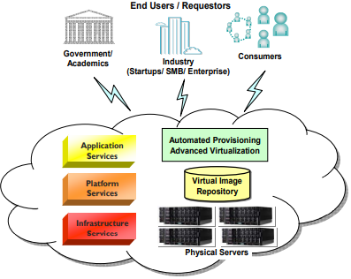
Figure 1: Typical Cloud Computing Environment.
The key benefit of cloud computing is that users do not have to pay for infrastructure installation and maintenance as customers pay subscription fees based on how much computing capacity and other networking services are needed. Furthermore, a business would no longer need to be concerned with software fixes, download, email servers, anti-viruses, backups, database servers, or the physical and logical protection of files. The cloud architecture is shown in Figure 2.
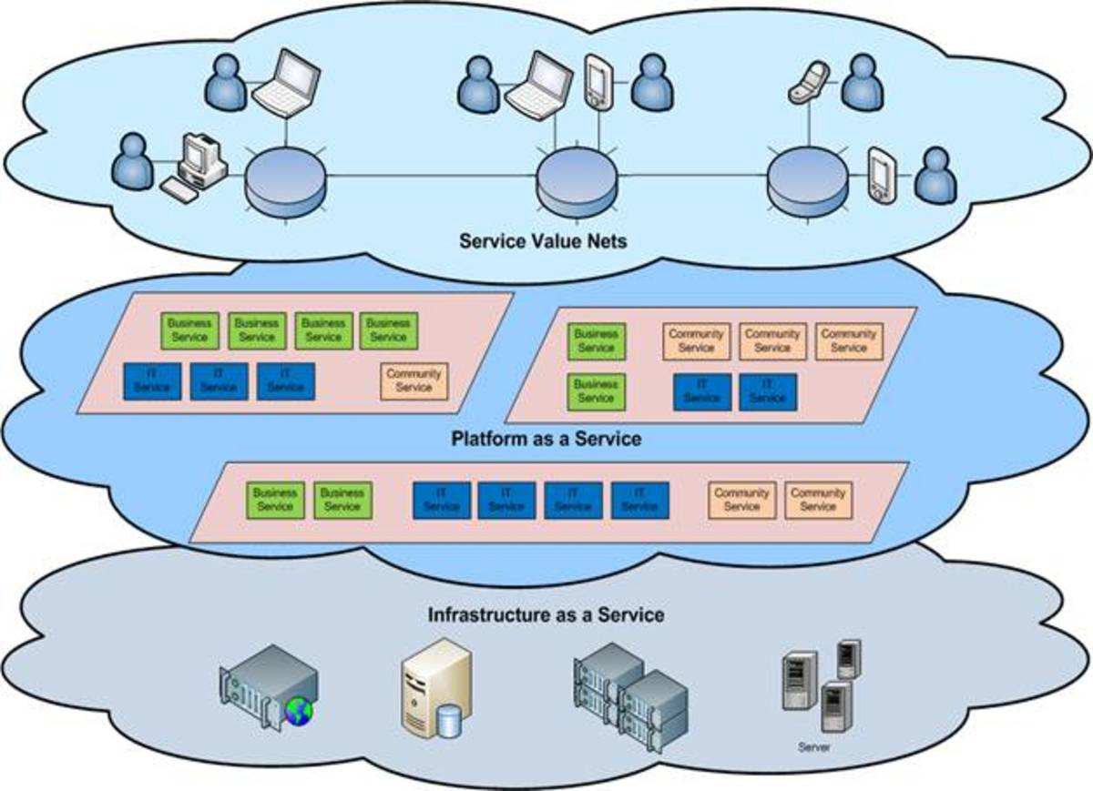[6]
Figure 2: Service Value Nets, Perform as a Service and Infrastructure as a Service.
Cloud computing has three service layers [7]:
- Infrastructure-as-a-service (IaaS), in which servers and applications are entirely outsourced and paid depending on resource use. IaaS, which includes the virtual and physical infrastructure used to create the cloud, is the layer that involves cloud storage. For example Amazon Web Services (AWS), Rackspace, Magento ! and Google Compute Engine.
- Platform-as-a-service (PaaS) in which the service provider allows the use of various applications such as AWS Elastic Beanstalk, Force.com and Windows Azure.
- Software-as-a-service (SaaS), which does not need user of installation of software and can be accessed over the internet. Amazon, Google Apps, Dropbox and Salesforce are examples of cloud service providers.
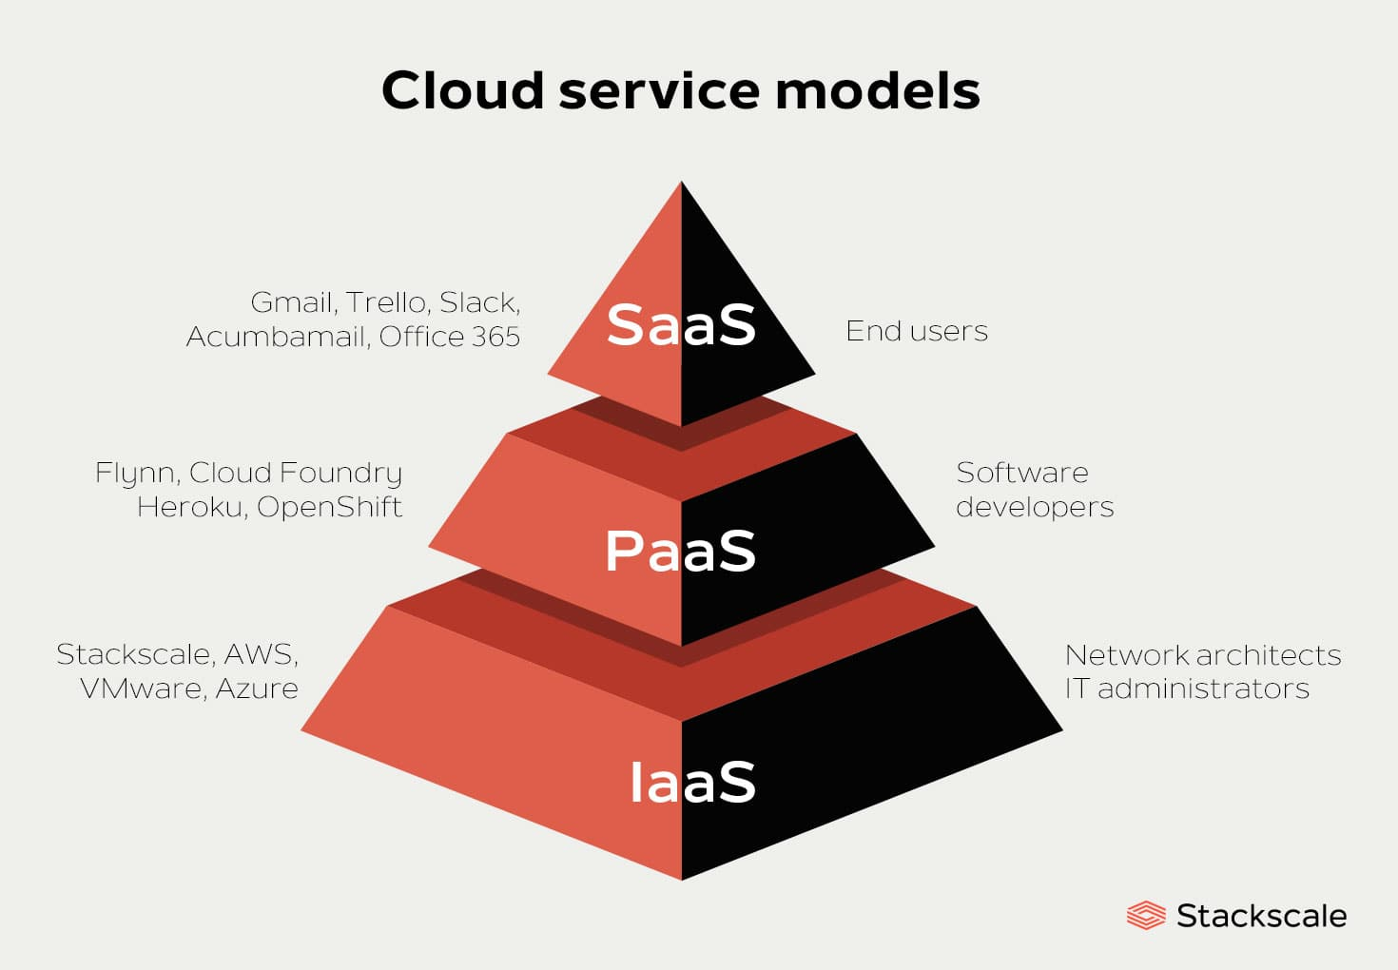[8]
Figure 3: SaaS, PaaS, IaaS models.
Virtualisation technology allows a single computer to run several platforms simultaneously, such as separate copies of Windows operating on the same machine at the same time. It enables a single physical computer to simulate the behaviour of several computers, with the ability to host multiple/heterogeneous operating systems on the same hardware [9].
Virtualization enables servers to consolidate in data centres by relocating various operating systems that may otherwise be underutilised on their host to move to the same physical infrastructure. This allows for a decrease in the number of physical devices and increased exploitation at higher saturation levels, resulting in cost and energy savings [10].

Cost of Cloud Computing
Cloud computing cost implications are a consideration for a business moving to the cloud. The table in Figure 4 shows the most common AWS instance sizes and Azure Virtual Machines (VMs) and contrasts their prices for Windows operating systems with regular SQL. Prices are per hour for AWS instances and Azure VMs of the latest generation.
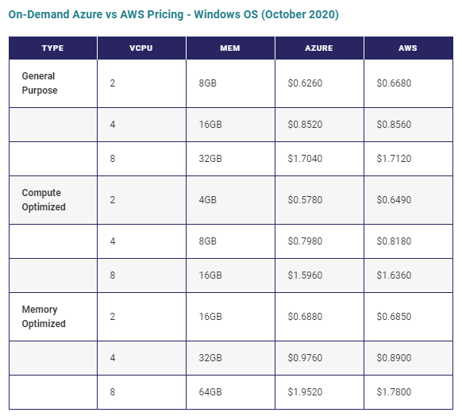
Figure 4: On Demand Azure vs AWS Pricing - Windows OS (October 2020) [11].

Methods of Reducing Costs of Cloud Computing
There are various ways that businesses can reduce cloud computing costs.

Automate shutting down VMs
To save money, automated scheduling after peak hours to switch off services used by non-production workloads (Although this can be done manually, automating the procedure is the most effective method). Switching off idle services during off-hours (such as between 8 p.m. and 8 a.m. on during the week) lowers the net costs—by almost 65 percent, according to some estimates.

Distributing the Load and Caching
A load balancer accomplishes the following tasks:
- Distributes client requests or network demand through several servers in an optimised manner.
- It ensures high availability and reliability by submitting requests only to servers that are online.
- Allows for the addition or removal of servers based on demand.
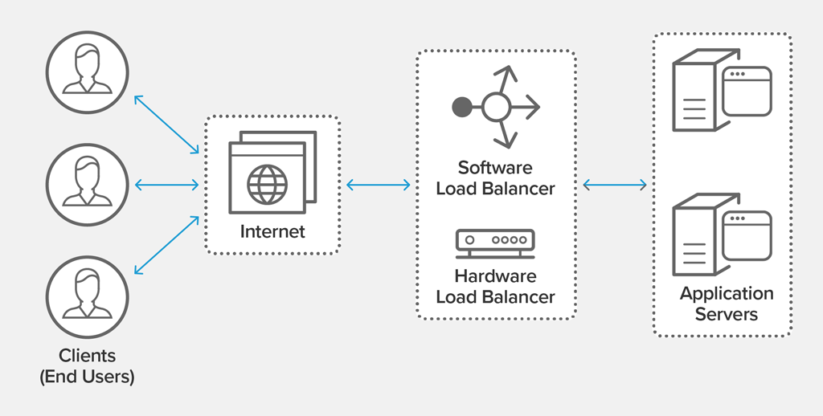
Figure 5: Load Balancing [12].

Database Cost Reduction
Hundreds of thousands of IOPS (input / output transactions per second) can be provided in a single cache instance, theoretically replacing many data base instances, thus reducing overall costs. This is particularly important when the primary database costs per throughput. Pricing savings may be tens of percentage points in these situations [13]. AWS Trusted Advisor can calculate the potential cost savings for the company [14].
Maintaining a direct alignment between IT costs and market success can be challenging. The ownership of internal technology resources will impact on corporate budgets. An IT department may become a significant financial drain on a company, potentially inhibiting responsiveness, profitability, and expansion.
Public cloud providers, like a wholesaler that buys in bulk at cheaper prices, focus their business model on mass-acquisition of IT services, which are then leased to cloud customers. This enables companies to obtain access to powerful technology without having to buy it thus reducing or eliminating upfront IT expenses, including purchasing hardware, software, and ownership costs. The reduction of up-front financial obligations enables businesses to start small and gradually increase IT capital allocation as needed. Furthermore, the decrease in upfront capital costs helps capital to be diverted to key company investments.
For example, an organisation with large batch-centric projects, can complete them as soon as their application software would scale. It costs the same to use 100 servers for one hour as it does to use one server for 100 hours. The "elasticity" of IT, accomplished without the need for substantial initial expenditures to build a large-scale computing system.
Moving to the cloud can lower IT costs and increase automation, flexibility, and performance. However, migrating to the cloud poses financial risks. Businesses benefit from the security of a fixed financial investment when they use on-premises computing and have a good idea of how much money they can spend on computing from month to month. The transition from a fixed cost to a variable cost operating model needs to be considered. While cloud computing can help businesses save money in the long run, attempting to forecast and equate the variable costs of cloud computing to the fixed costs of on-premises computing creates confusion about real cost savings. When using the cloud, there is a risk of increasing costs. A significant benefits of cloud computing is the capacity to scale the services if required as a company just pay for what is used.
Despite how easily many people identify the financial benefits of cloud computing, the real economics can be difficult to quantify and measure.

Scalability
Clouds will rapidly and dynamically distribute IT resources to cloud users, on-demand or through the cloud consumer's direct configuration, by supplying pools of IT resources, as well as resources and technology built to exploit them collectively. This enables cloud users to automatically or manually scale the cloud-based IT capabilities to handle processing fluctuations and peaks. Similarly, as computing demands decline, cloud-based IT services may be released.
Vertical scaling is the method of shifting to a greater instance or an upgrade of resources. For example, a website that is currently operating on an 8-cpu virtual machine and is being redeployed to a 16-cpu virtual machine. Often infrastructure as service platforms have software to make this a simple task that can be completed in minutes or even seconds.
Horizontal scaling is the method of applying more instances to a service, device, or application. For example, a software as a service provider that instals instances when the average number of users per CPU reaches 50 and eliminates instances when the number of users per CPU falls below 40.
Auto scaling is conducted dynamically by use of an API. For example, a bank's settlement mechanism that automatically scales based on the number of trades it is handling.
Side by side scaling is the method of adding instances for various uses on demand. The most famous case is a company that adds implementation and test instances of a service as project requirements dictate.
Global Scaling is the process of scaling a service to operate in many geographical locations. For example, a content distribution network that distributes videos from hundreds of geographically dispersed data centres such that videos are delivered to consumers from a data centre near them [15].

Reliability
Since any type of data centre downtime has a major impact on business continuity for the companies using the services, data centres are configured to run with greater rates of redundancy to ensure availability is sustained. In the event of a device failure, data centres typically have redundant, uninterruptible power sources, cabling, and environmental control subsystems, as well as networking connections and clustered hardware for load balancing.
It is necessary for IT resource to be available and dependable. Outages reduce the amount of time an IT utility will be "open for business" for its clients, reducing its use and revenue-generating capacity. Runtime faults that are not automatically repaired will have a greater effect during peak use hours. Not only is the IT resource unable to respond to customer demands, but its unexpected failure will undermine overall customer confidence. A distinguishing feature of a traditional cloud environment is the inherent capacity to offer robust assistance for reducing or even eliminating outages, as well as increasing stability to reduce the effects of runtime failure conditions.
- An IT resource with improved capacity is available for longer periods of time (for example, 22 hours out of a 24-hour day).
- An IT resource with improved stability can help prevent and rebound from exception situations.
- Cloud vendors commonly provide "resilient" IT services on which they can promise high levels of availability. Cloud environments' modular architecture offers extensive failover protection, increasing stability.
With the total expense of downtime being $300,000/hour, companies cannot afford to be offline. With more redundant and stable operation, the cloud greatly reduces this chance.

Disadvantages
Although cloud computing is unquestionably useful to both individuals and businesses, it is not without drawbacks. Cloud environments often become vulnerable to bots, malware, virtual machines, and attacks by cybercriminals. Experts have concerns with data retention and intellectual property rights in the cloud. The vendor assumes responsibility for the information security of the hosting enterprise. That is essentially why governments and financial companies with confidential data are hesitant to switch their IT data offsite. Cloud services, on the other hand, place a high priority on stability by investing in security-enhancing initiatives and programs. Any company is subject to laws and regulations. Credible cloud services have the highest level of security certification. Furthermore, technological issues (such as network and connectivity outages) are thought to be significant threats when moving to the cloud. The internet is needed for cloud configuration. Outage issues are also aggravating while working on important articles online. To mitigate these risks, cloud services typically use multiple servers. Cloud architectures are unquestionably less costly to implement for businesses as there is no need for upfront investment in the own data centre or extra equipment. However, since a company's operations are successful for anything server-based, it is debatable if it is worthwhile to invest in anything different [16].

II. DOCKER AND NODE.JS
Dockers and Containers have revolutionised the use of cloud technology and DevOps techniques in modern software development. The principle of virtualisation has been transformed due to advances in cloud technology, by developing an alternative to hypervisors. By generating an image of the application, Docker can be used to build, deploy, and run any application in any environment.
Any software development process necessitates the installation of an End-to-End stack, which includes resources such as a web server, database, messaging framework, and an orchestration mechanism such as Kubernetes. The developer must ensure that all the components are compatible with the underlying Operating Systems, as well as the service libraries and dependencies being compatible with the Operating System. Developers prefer different operating systems and an application developed in one environment may not function in another.
Dockers enable all the services to run on the same VM and OS but in separate containers each with its own libraries and dependencies thus reducing the overhead due to virtualisation.
Containers are a lighter, more agile way of dealing with virtualization. Rather than launching a whole virtual machine, a container assembles everything necessary to run a small piece of software. Containers are self-contained environments. They may have their own processes or services, as well as their own networking interfaces, but they all use the same Operating System kernel. The container contains all the code, as well as its dependencies and even the operating system itself. Consequently, programmes will run virtually anywhere—on a personal computer, in a conventional IT infrastructure, as well as in the cloud.
Containers make use of an operating system (OS) virtualization strategy. Simply put, they use OS features to separate processes and monitor their access to CPUs, memory, and desk space [17].
Kubernetes is a container management system for docker containers or other containers. Kubernetes orchestrates, manages, and establishes a contact channel between these containers.

Containerisation Vs Virtualisation
Virtualisation enables multiple operating systems to be run on the hardware of a single physical server, while containerisation allows multiple programmes to be installed on a single virtual machine or server that runs the same operating system.
Virtualisation is the concept of running a virtual instance of a computer device in a layer abstracted from the real hardware. Most specifically, it refers to running several operating systems on a computer machine at the same time. The applications running on top of the virtualised machine may appear to be on their own dedicated machine, with the operating system, libraries, and other programmes specific to the guest virtualised system and unconnected to the host operating system that sits underneath it [18].
This overhead causes a higher use of the underlying infrastructure whilst consuming more storage space because each VM is large and usually measured in gigabytes (GB). Consequently, these machines typically take longer to boot because they use the whole operating system to boot [19].
Dockers are installed on the operating system in the case of containerisation, and because the containers provide the necessary resources such as Node.js and MongoDB, or even another OS running on top of Docker there is no requirement to have a separate virtual machine for every component. Containers are a functional computing unit where its own programme code, libraries and dependencies are bundled.
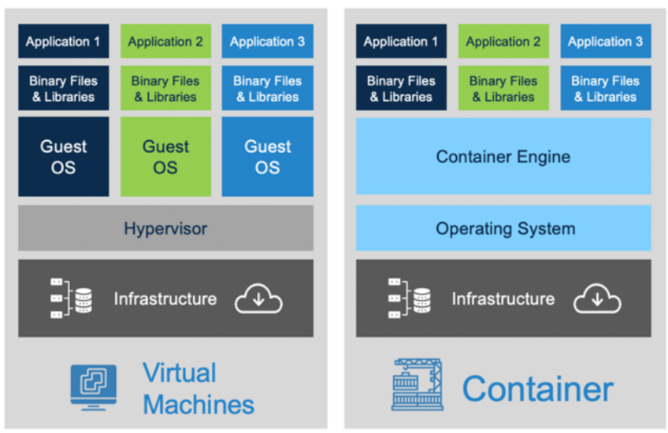[19]
Figure 6: VMs vs Containers.
Docker Desktop vastly improves memory consumption by using the dynamic memory allocation function of WSL 2. This means that Docker Desktop only uses the CPU and memory power that it needs, allowing CPU and memory-intensive activities like container construction to run even faster [20].

Docker and Containers
Docker is a series of platform as a service (PaaS) product that distribute applications in containers using OS-level virtualization [21]. Containers are separate from each other, bundling their own applications, libraries, and configuration files, and communicating with one another via well-defined channels [22]. Containers consume fewer resources than virtual machines because they all share the facilities of a single OS kernel [23].
There are two rates of the service: free and premium. Docker Engine is the programme that runs the containers [23].
Docker has been incorporated into open-source projects such as OpenStack, Chef, Puppet, Vagrant, and MCollective, and various open source projects, including Redis, Memcached, PostgreSQL, and Ruby, have been dockerised by the community. Jay Lyman, a senior analyst for enterprise software at 451 Research, told Linux.com. "Docker is a tool that can package an application and its dependencies in a virtual container that can run on any Linux server". This contributes to the application's stability and portability, allowing it to run in the public cloud, and in a private cloud [24].
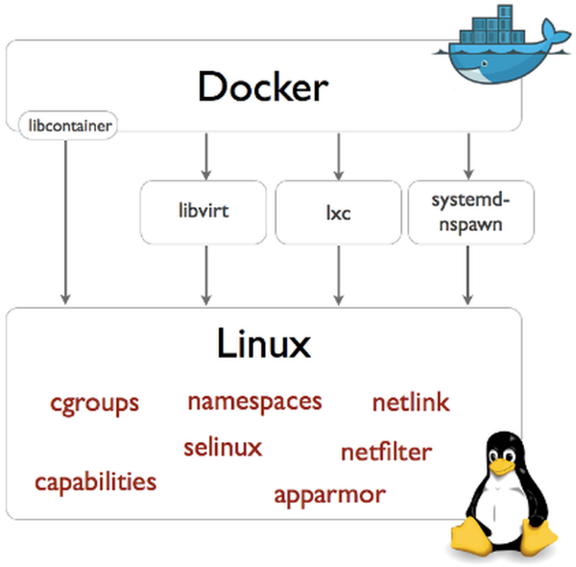[25]
Docker 0.9: Introducing Execution Drivers and Libcontainer. In: Docker Blog [online]. 2014 [accessed 2014-11-15]. Available from:
http://blog.docker.io/2014/03/docker-0-9-introducing-execution-drivers-and-libcontainer/
Figure 7: Docker and Containers.
Docker and containers are a modern way of running apps that is changing the way software is developed and delivered. The Docker architecture is shown in Figure 8.

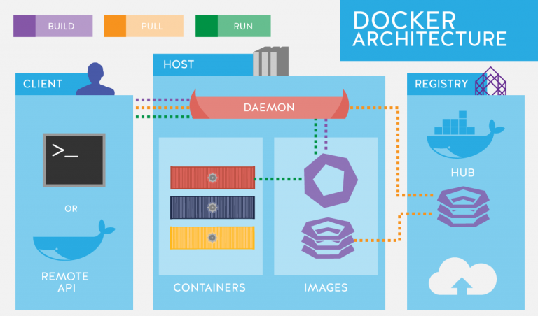[27]
Figure 8: Docker Architecture.
Previously there was not a secure, assured way to isolate a process to its own collection of resources until containers became accessible. A correctly operating container has no means of accessing services that were not allocated to it. Two containers running on the same machine, for example, might as well be on two entirely separate machines, thousands of miles apart. They are completely and practically cut off from one another.
Docker simplified container creation by "wrapping" the complexities of the underlying OS system calls required to run them. Docker and the containers it enables have revolutionised the computing industry, and their success as a tool and forum has increased rapidly in the last five years as containers provide massive economies of scale. Systems that formerly required costly, dedicated hardware resources can now share hardware with other systems. Another advantage of containers is that they are self-contained and compact. If a container operates on one host, it can operate on every other if the host has a compatible runtime [26].

EVALUTION OF THE DEVELOPMENT PROCESS OF PRODUCING NODE.JS APPLICATIONS RUN IN DOCKER

Docker
One of the simplest methods for Docker to automatically create images is by the use of a Dockerfile. A Dockerfile is a basic text file that includes all the commands that a user can use to build an image from the command line. A student database website was created using node.js and docker. The Dockerfile is displayed in Figure 9.
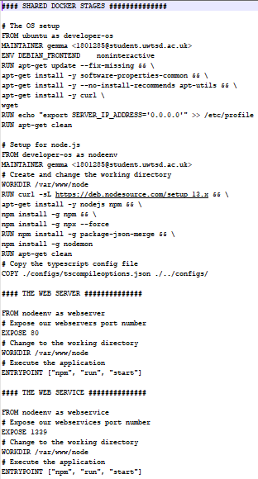
Figure 9: Dockerfile example.

The use of a "dockerignore" file stops local modules and other unnecessary files from being transferred into the Docker image, as well as the risk of overwriting modules already installed in the database. When using Docker Compose, the local (and empty) node modules folder will overwrite the container node modules folder. The solution is then to install the node modules in the docker ignore file to inform Docker Compose not to overwrite the node modules directory.
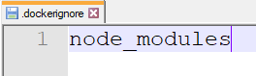
Figure 10: dockerignore file.

Docker Compose is a Docker programme that allows multi-container Docker apps to be defined and run. A YAML package was used to setup the application services using Docker Compose. The docker-compose file attaches a database to the stack and the web resources are specified. The web server runs on an image generated from the current directory's Dockerfile.
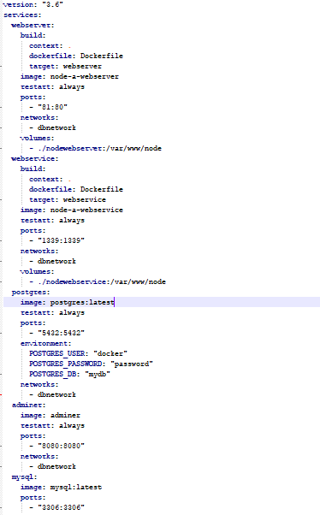
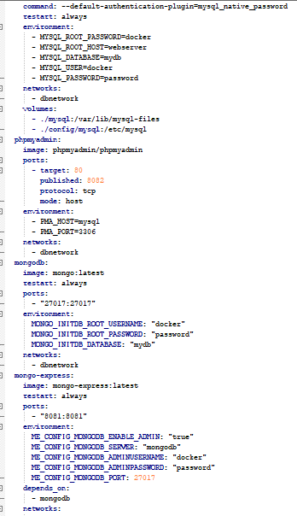
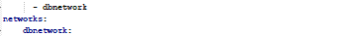
Figure 11: Docker Compose.

In the same folder as the docker files, two folders were made; one to make the web server, and one to make the web service.
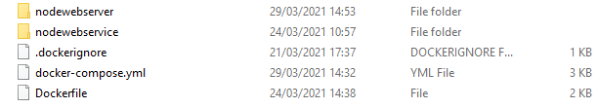
Figure 12: Web server folder structure.

Node.js
A package.json file is created using npm init to store valuable project metadata to help handle Node.js modules based on the project.
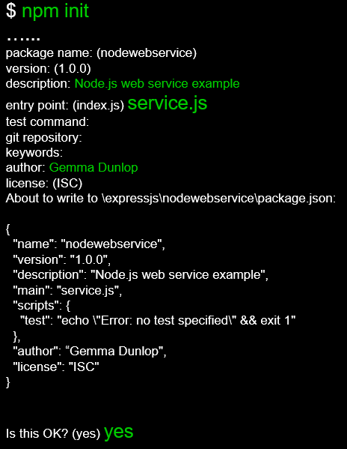
Figure 13: npm init to create package.json.
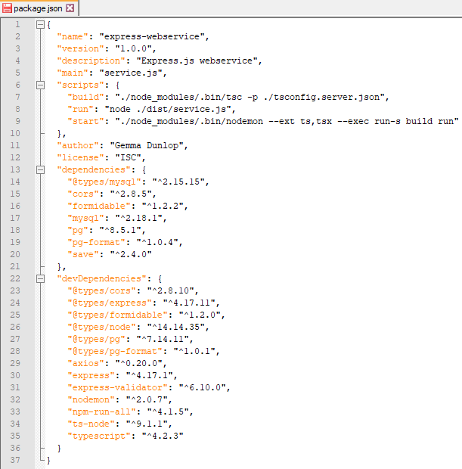
Figure 14: package.json code.
The express.js platform and a Postgresql database were used in the students project. The node_modules installed are displayed in Figure 15.
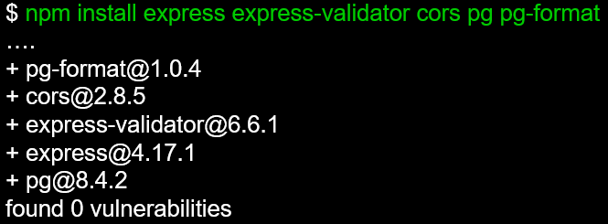
Figure 15: npm install node_module for express, postgresql and cors.

Nodemon and Typescript were used for the project. Node is a run-time environment that enables the development of server-side JavaScript. Due to the complex and weak typed existence of the JavaScript language, writing server-side JavaScript may be difficult when a codebase develops. TypeScript is a typed (optional) superset of JavaScript which can aid in the creation and management of major JavaScript projects. It is similar to JavaScript, but with additional features such as strong static typing, compilation, and object oriented programming. To properly transpile the code with TypeScript @types/node must be installed. Without it typescript will be unable to understand the node modules import.
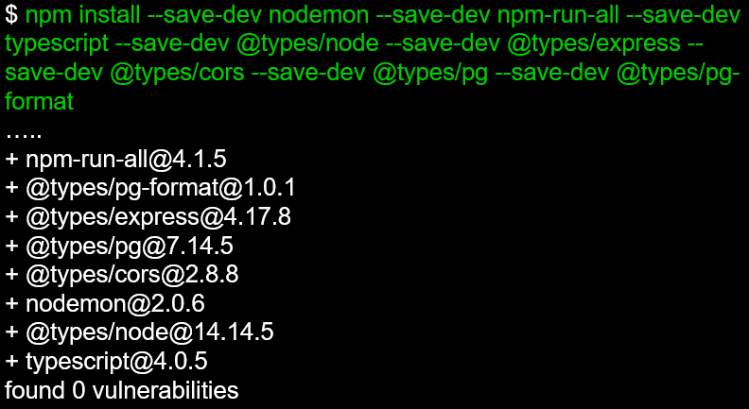
Figure 16: npm install node_modules for nodemon and typescript.

Nodewebserver
A typescript server.ts file was created in the nodewebserver folder that defines the web app using the Express.js framework. It includes an import to Axios which is a well-known JavaScript library that can be used to execute HTTP requests in all browsers and Node.js environments. It is compatible with all current browsers, including Internet Explorer 8 and higher. It is promise-based, which allows one to quickly write async/await code to execute XHR requests.
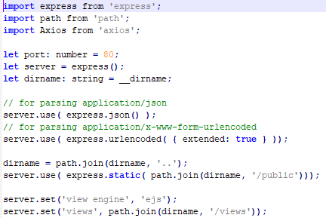
Figure 17: Typescript server.ts file using the express.js framework.

Axios was used to make HTTP requests that can be sent to the web service. The service can be accessed using a container called "webservice". An example POST request is shown in Figure 18.
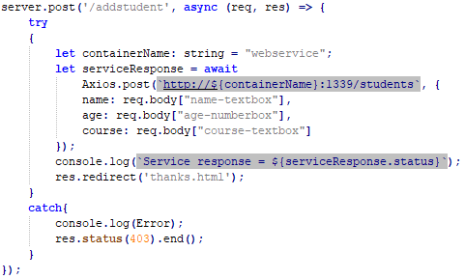
Figure 18: HTTP request for adding a student.

Nodewebservice
A typscript service.ts file was created in the nodewebservice folder. It imports cors which is an acronym that stands for Cross-Origin Resource Sharing. It is a framework for allowing requested web server resources.
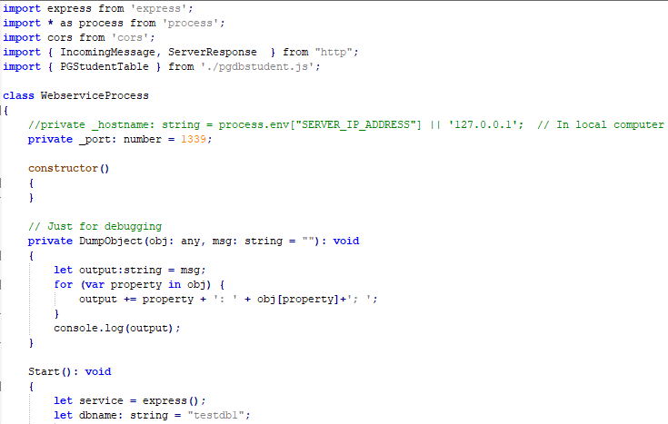
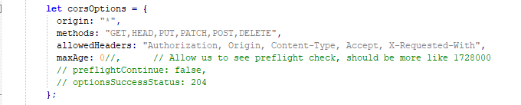

Figure 19: Typescript service.ts file using Express.js.

It imports PGStudents.js which the typescript file version is shown in Figure 20. This connects the web server to the PostgreSQL database and creates interfaces to handle the data in the student table.
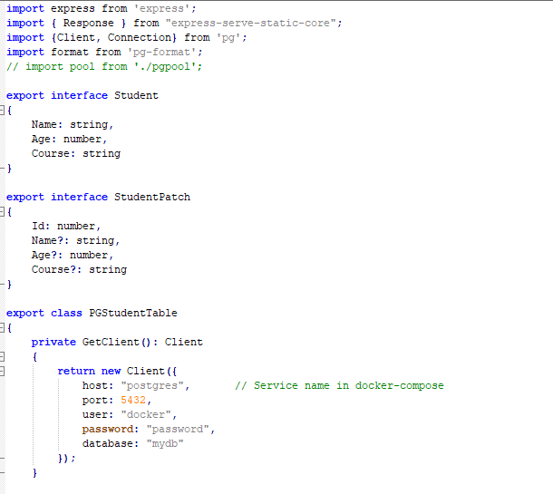
Figure 20: Typescript PGStudents.ts file using Express.js.

Numerous HTTP requests were made like the one in Figure 21 to interact with the student database.
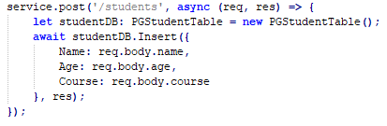
Figure 21: HTTP request to add a student in the PGStudents.ts file.

Starting the Web Service
All the services from the setup can be created and started with a single command – "docker-compose up".
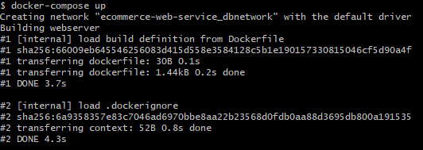
Figure 22: docker-compose up command.
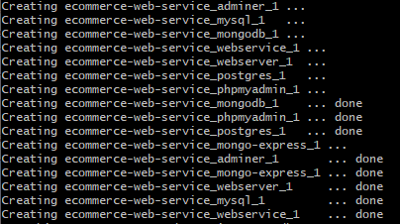
Figure 23: console for creating web service file.

A container is then made which can be viewed in Docker Desktop, as shown in Figure 24.
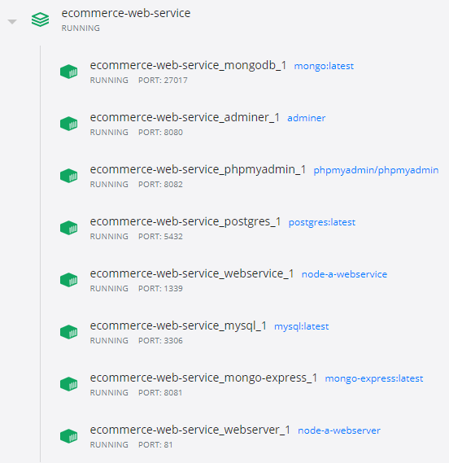
Figure 24: Web service container.

Result
Home Page

Reading all students

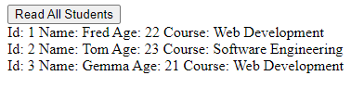
Adding a new student.


Student Updated
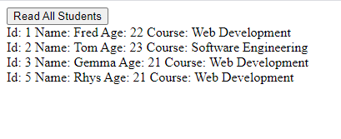

Console response.
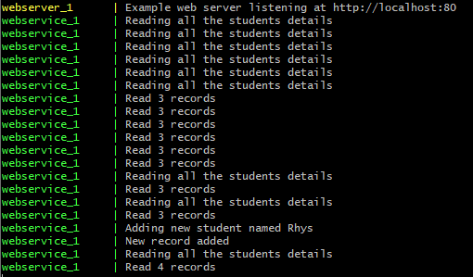

REFERENCES
[1] P. Mell and T. Grance, “The NIST Definition of Cloud Computing - Recommendations of the National Institute of Standards and Technology,” Gaithersburg, MD, Sep. 2011.
[2] “Clash of the clouds; Cloud computing,” The Economist, vol. 393, no. 8658, Oct. 2009, Accessed: May 03, 2021. [Online]. Available: https://search-proquest-com.ezproxy.uwtsd.ac.uk/docview/223974141/fulltext/D7F10024A86041B7PQ/1?accountid=130472.
[3] RapidAPI Staff, “Top Cloud APIs for Developers in 2018,” RapidAPI, Jul. 29, 2020. https://rapidapi.com/blog/cloud-apis/ (accessed May 03, 2021).
[4] M. Armbrust et al., “A view of cloud computing,” Communications of the ACM, vol. 53, no. 4. pp. 50–58, Apr. 01, 2010, doi: 10.1145/1721654.1721672.
[5] “Understanding Full Virtualization, Paravirtualization, and Hardware Assist,” VMware, Mar. 11, 2008. https://www.vmware.com/techpapers/2007/understanding-full-virtualization-paravirtualizat-1008.html (accessed May 03, 2021).
[6] S. Mamun, “Cloud Computing Architecture Explained,” HubPages, May 22, 2013. https://discover.hubpages.com/technology/cloud-computing-architecture (accessed May 03, 2021).
[7] T. Galibus, V. v. Krasnoproshin, R. de Oliveira Albuquerque, and E. Pignaton de Freitas, “Cloud Environment Security Landscape,” in Elements of Cloud Storage Security Concepts, Designs and Obtimized Practices, no. 9783319449616, Springer, 2016, pp. 1–18.
[8] “Main cloud service models: SaaS, PaaS and IaaS,” Cloud Computing, Apr. 14, 2020. https://www.stackscale.com/blog/cloud-service-models/ (accessed May 03, 2021).
[9] M. García-Valls, T. Cucinotta, and C. Lu, “Challenges in real-time virtualization and predictable cloud computing,” Journal of Systems Architecture, vol. 60, no. 9, pp. 726–740, Oct. 2014, doi: 10.1016/j.sysarc.2014.07.004.
[10] I. Odun-Ayo, O. Ajayi, and C. Okereke, “Virtualization in cloud computing: Developments and trends,” in Proceedings - 2017 International Conference on Next Generation Computing and Information Systems, ICNGCIS 2017, Nov. 2018, pp. 35–37, doi: 10.1109/ICNGCIS.2017.10.
[11] “A Look At Azure vs AWS Pricing In 2020-2021,” CloudHealth by VMware, Dec. 13, 2020. https://www.cloudhealthtech.com/blog/azure-vs-aws-pricing (accessed May 03, 2021).
[12] nginx, “What Is Load Balancing? How Load Balancers Work.” https://www.nginx.com/resources/glossary/load-balancing/ (accessed May 03, 2021).
[13] “What is Caching and How it Works,” AWS. https://aws.amazon.com/caching/ (accessed May 03, 2021).
[14] “Amazon Trust Services Repository.” https://www.amazontrust.com/repository/ (accessed May 03, 2021).
[15] J. Spacey, “5 Examples of Cloud Scaling,” Cloud Computing, Mar. 20, 2018. https://simplicable.com/new/cloud-scaling (accessed May 03, 2021).
[16] Z. Mahmood, R. Puttini, and T. Erl, Cloud Computing: Concepts, Technology & Architecture. 2013.
[17] I. C. IBM Cloud Team, “Containers vs. Virtual Machines (VMs): What’s the Difference?,” IBM, Apr. 09, 2021. https://www.ibm.com/cloud/blog/containers-vs-vms (accessed May 03, 2021).
[18] “What is virtualization?,” Opensource.com. https://opensource.com/resources/virtualization (accessed May 03, 2021).
[19] AKF, “What’s the difference between VMs & Containers?,” May 29, 2019. https://akfpartners.com/growth-blog/vms-vs-containers (accessed May 03, 2021).
[20] “Docker Desktop WSL 2 backend,” Docker Documentation. https://docs.docker.com/docker-for-windows/wsl/ (accessed May 03, 2021).
[21] M. O’Gara, “Ben Golub, Who Sold Gluster to Red Hat, Now Running dotCloud,” Jul. 26, 2013. https://web.archive.org/web/20190913100835/http:/maureenogara.sys-con.com/node/2747331 (accessed May 03, 2021).
[22] “Docker frequently asked questions (FAQ),” Docker Documentation. https://docs.docker.com/engine/faq/#what-does-docker-technology-add-to-just-plain-lxc (accessed May 03, 2021).
[23] “What is a Container? | App Containerization,” Docker. https://www.docker.com/resources/what-container (accessed May 03, 2021).
[24] “Docker: A ‘Shipping Container’ for Linux Code,” Linux.com, Aug. 01, 2013. https://web.archive.org/web/20130808043357/http://www.linux.com/news/enterprise/cloud-computing/731454-docker-a-shipping-container-for-linux-code/ (accessed May 03, 2021).
[25] S. Hykes, “Docker 0.9: introducing execution drivers and libcontainer,” Docker Blog, Mar. 10, 2014. https://www.docker.com/blog/docker-0-9-introducing-execution-drivers-and-libcontainer/ (accessed May 03, 2021).
[26] D. Swersky, “What is Docker, and why is it so popular?,” Raygun Blog, Oct. 11, 2018. https://raygun.com/blog/what-is-docker/ (accessed May 03, 2021).
[27] “Hello Docker,” Things Solver. https://thingsolver.com/hello-docker/ (accessed May 03, 2021).

