University of Wales Trinity Saint David

Wales Institute of Science & Art

Materials Testing and Sustainability in Composites for Motorsport & Automotive Industries

Automotive Materials and Sustainability (ACHA6012)
Alfie Morgan
2206510
12/2024
Word Count: 3285


Contents
Introduction 4
Literature Review 5
What is a Composite 5
Yarns/Rovings 5
Woven vs Non-Woven 5
Types of Resin 5
Carbon Fiber 6
Aramid Fibres (Kevlar) 7
Natural Fiber Composites (NFC) 7
Experimental Testing 9
Material Properties 9
Methodology 10
Test Materials 10
Testing Procedure 10
Data Analysis 11
Aluminium 12
Carbon Non-Woven 13
Carbon Woven Bio Resin 14
Carbon Woven Epoxy Resin 15
Kevlar Bio Resin 16
Hemp Non-Woven 17
Flax Non-Woven 18
Flax Woven 19
Analysis 20
Difference to Material Data 20
Maximum Stress Comparison 21
Sustainability Analysis 23
Comparison of Composites 23
Manufacturing Processes 24
Legislation and Policies 25
Carbon Fibre 26
Natural Fibres Composite (NFC) 27
Recommendations 28
References 29
Appendix 31
Average max stress calculations 31

Introduction
The automotive and motorsport sectors are under increasing pressure to reduce their environmental impact whilst maintaining high standards of performance, durability, safety and innovation. Composites have emerged as vital components in achieving these goals due to their exceptional strength-to-weight ratio and adaptable properties. However as sustainability becomes a higher priority in engineering decisions, life cycle impacts and end-of-life solutions of these advanced materials must be investigated.
This report investigates the mechanical properties and sustainability of various materials used in the automotive and motorsport industry. This study aims to evaluate the feasibility of these components as sustainable alternatives to traditional materials. The key areas of analysis are materials’ structural characteristics, environmental impact throughout their lifecycle, compliance with legislation, and potential circular economy integration.
By combining practical testing alongside literature-based analysis, this report provides evidence-based recommendations for material selection for automotive and motorsport applications. The findings will support engineers and manufacturers in making informed decisions that align with both performance and sustainability in a rapidly evolving industry.

Literature Review

What is a Composite
Composites are made by combining two materials with very different properties, usually, one material is a fibre such as carbon fibre and the other a polymer matrix such as epoxy (Hatton, 2019). Fibres carry load along its length, providing strength and stiffness in one direction. However, the fibres become very weak when subjected to compression and/or bending loads, this is where the polymer comes in to improve structural properties as it supports the fibres, allowing them to absorb higher compressive loads.

Yarns/Rovings
A yarn is a number of strands collected into a parallel bundle and twisted, twisting improves handleability and makes processes such as weaving easier, although twisting reduces strength properties. Roving is the same bundling of fibres but without the twisting. Rovings can be chopped into short fibre segments for sheet or bulk moulding compound or for injection moulding (Luthada, 2022).

Woven vs Non-Woven
“The distinct differences between woven and non-woven fabrics are the fibres arrangement at the microstructural level and the type of bonding.” Woven fabrics have an ordered architecture of fibres interlaced to one another, whereas non-woven fabrics have a more random fibre arrangement (Kashani, 2016). Due to lower processing costs and easier recyclability in some cases, non- woven composites have been increasingly used in industry for applications such as fireproofing and thermal insulation. With geometric differences, these different types of composites also have different mechanical properties with woven composites generally having higher stiffness and strength. However, ultimate deformation and absorbed energy in non-woven composites are often higher than their woven counterparts.

Types of Resin
There are two key functions of resin in a composite:
- Bind fibres together to maintain their position/ structure to deliver the composites mechanical properties.
- Corrosion/ temperature resistance and electrical insulation.
Polyester: a thermoset creating a strong, cross linked network structure making it resistant to heat and chemicals, once cured, its properties cannot be changed through re heating or other means. Consists of a polyester solution and a monomer, typically styrene which helps to reduces resins viscosity making it easier to handle. These resins can be modelled without applying pressure and have good chemical resistance. (Excel Composites, 2025)
Epoxy: Another thermoset resin, commonly used in high performance reinforcements such as carbon fibre/ fibreglass, unlike polyester, epoxies use a hardener rather than a catalyst. The hardener cures the epoxy during an additional reaction involving both materials, forming complex 3D structures. It is essential that the correct mix is used to avoid unreacted resin or hardener remaining in the mixture effecting the properties of the composite. Low shrinkage when curing minimizes the risk of internal stresses, it also has high electrical insulation and corrosion resistance (Excel composites, 2025).
Vinyl Ester: combines the best features of polyester and epoxy into one solution, typically stronger than polyesters and more resistant than epoxies this is a hybrid form of polyester strengthened by epoxy. They are also more tolerant to stretching that polyesters, allowing them to absorb impact without damage better reducing the rick of cracking. It also has fewer open sites in its molecular chain making it more water resistant. (Excel Composites, 2025)
Polyurethane: Is a polymer family (group of polymers) characterized by the presence of urethane linkage (De Souza, 2021). An excellent alternative to epoxy for high performance mechanical applications such as springs and bushings thanks to the possibility to use a high fibre volume content delivering high stiffness allowing use of thin wall sections to help save weight.
Additives: Often added into the matrix to offer further benefits such as reducing costs, provide extra properties, or to benefit overall manufacturing process.
Bio- Resins: Are a class of resins derived from renewable, biological sources such as plants or agricultural byproducts. Bio resins can be classed in any of the above resin types such as vegetable oil-based epoxy or bio-based polymers, the use of these resins are on the rise driven by regulation and consumers in the ever-increasing push towards sustainability and reducing carbon footprint.

Carbon Fiber
Commonly used in motorsport for the last 50 years, carbon fibre is 5 times stronger and twice as stiff as steel. With the highest specific stiffness of any fibre commercially available today, making it historically the most popular composite for motorsport applications (Hatton, 2019). It also exhibits high tensile strength and good resistance to corrosion and fatigue, however, is does have relatively low impact strength.
“Carbon fibre can be made from a variety of raw materials which have a high carbon atom content within their chemical compound. These include PAN (polyacryInitrile), pitch or rayon/viscose. The most popular is PAN due to its consistent quality” (Hatton, 2019). Each PAN fibre goes through three stages: oxidation (200°C), Carbonisation (800-1600°C), and Graphitisation (3000°C) forming an isotropic fibre. Each fibre is thinner than a piece of hair, they are combined to form a strand which is then combined into a yarn/ roving.

Aramid Fibres (Kevlar)
Related to nylon with polymer chains that are strongly directed in manufacturing results in an incredibly stiff fibre, additionally having a high tensile strength, low density and extraordinary toughness. The main downside to these fibres is their low compressive strength along the length of the fibre potentially leading to the separation of layers causing delamination under compression. Commonly used for body panels in motorsport due to its low density and strength compared to fiberglass. It is also found in critical components such as timing belts and radiation hoses for reinforcement within the primary material (rubber) as well as being used in performance clutches as a lining to increase durability and performance.

Natural Fiber Composites (NFC)
A more eco friendly alternative, in this study, Flax and Hemp are used for investigation. Theses fibres have low density, high specific properties, are biodegradable, derived from renewable sources, have small carbon footprint, and produce good thermal and acoustical insulation (Luthada, 2022).
Flax is one of the most popular choices in this area which is extracted from the Linum usitatissimum plant. It has the required maturity to provide consistent quality over an extended time period alongside it having the best mechanical properties per unit weight within the natural fibre category. The method of twisting/ weaving has an adverse effect on the composite properties, “different twisting and weaving techniques tailor the mechanical properties of each fabric to its specific application” (Hatton, 2019).
Hemp follows similar advantages to flax that is increasingly used as a reinforcement in composite materials. It is mechanically slightly weaker than flax but exhibits higher specific stiffness than fibreglass and comparable stiffness to carbon fibre while also posing high vibration damping capabilities (Easy Composites, 2025). Typically used in environmental focused applications such as canoes and furniture, its growing influence in the automotive sector sees its use for producing components such as interior Pannels and body panels as seen in the new Porsche 718 GT4 Club sport (Porsche USA, 2025).

Experimental Testing

Material Properties
Table 1- Comparison of Mechanical Properties of Different Composites
Material | Tensile Strength  (Mpa) | Tensile Modulus (Gpa) | Density  (g/cm^3) | Cost (£/kg)
Carbon Non-Woven | 290 | 25 | 1.51 | 29
Carbon Woven | 4120 | 234 | 1.79 | 35
Flax Non-Woven | 44 | 5 | 1.45 | 33
Flax Woven | 58 | 6 | 1.45 | 35
Kevlar | 3000 | 112.4 | 1.44 | 40
Hemp | 46 | 6 | 1.45 | 30
Bio Resin | 60 | 2.64 | 1.12 | 21.5
Epoxy | 70 | 3 | 1.1 | 15
Carbon Woven Bio (50/50 blend) | 2090 | 118.32 | 1.46 | 28
Carbon Woven Epoxy (50/50 blend) | 2095 | 118.5 | 1.45 | 25
Kevlar Bio (50/50 blend) | 1530 | 57.52 | 1.28 | 30.75

Methodology
Testing was conducted to analyse the mechanical performance of relevant composites in the automotive and motorsport industry by conducting tensile tests using the Denison tensile/ compression test machine. Testing was performed under the supervision of technician Mark fall, adhering to health and safety protocol including the appropriate use of PPE.

Test Materials
Materials tested included both natural and synthetic fibre composites alongside a baseline material (aluminium) for comparison. Composites were manufactured using a resin infusion process using either traditional epoxy or bio-resin. Test materials are as follows:
- Baseline: Aluminium
- Twill fibre composites with bio resin: Kevlar, Flax, Carbon
- Twill fibre with epoxy: Carbon
- Non-woven fibre with bio-resin: Flax, Hemp, Carbon
The lay up of each sample followed a consistent methodology for compatibility:
- Twill Materials
  - Flax Twill: 3 layers of 200g/m² (600g total)
  - Carbon Twill: 3 layers of 200g/m² (600g total)
  - Kevlar Twill: 2 layers of 300g/m² (600g total)
- No-Woven Materials
  - Flax/ carbon: 1 layer of 300g/m²
  - Hemp: 3 layers of 100g/m² (300g total)
Multi-layer laminates plies orientated at 45°to each other, simulating realistic fibre laying strategies.

Testing Procedure
Each test piece cut to size and reinforced with mesh grips to ensure proper clamping. Prior to testing, cross-sectional area was measured using digital callipers to enable stress/ strain calculations.
Testing carried out in groups of 4 with each group performing 2 tests per material, conducting 14 test total. Load vs time data was collected directly from Denison machine.

Data Analysis
All data was exported into excel for analysis. Data files include multiple variables, although only load and time were used for analysis due to lack of extensometers. The reported stress, strain and elongation values were disregarded due to known inaccuracies in the test machines built in calculation software.
Extracting stress/ strain characteristics:
- Cross sectional areas and peak load used to calculate UTS
- Strain estimated using displacement over gauge length- Not analysed due to inaccuracy
Analysis conducted across the following areas:
- Aluminium Test vs Data sheet (For Validation)
- Twill vs non-woven
- Bio resin vs epoxy resin
- Fibre type
- Test data vs provided data sheet
High speed tests were also carries out but not analysed due to small and incomplete data set.

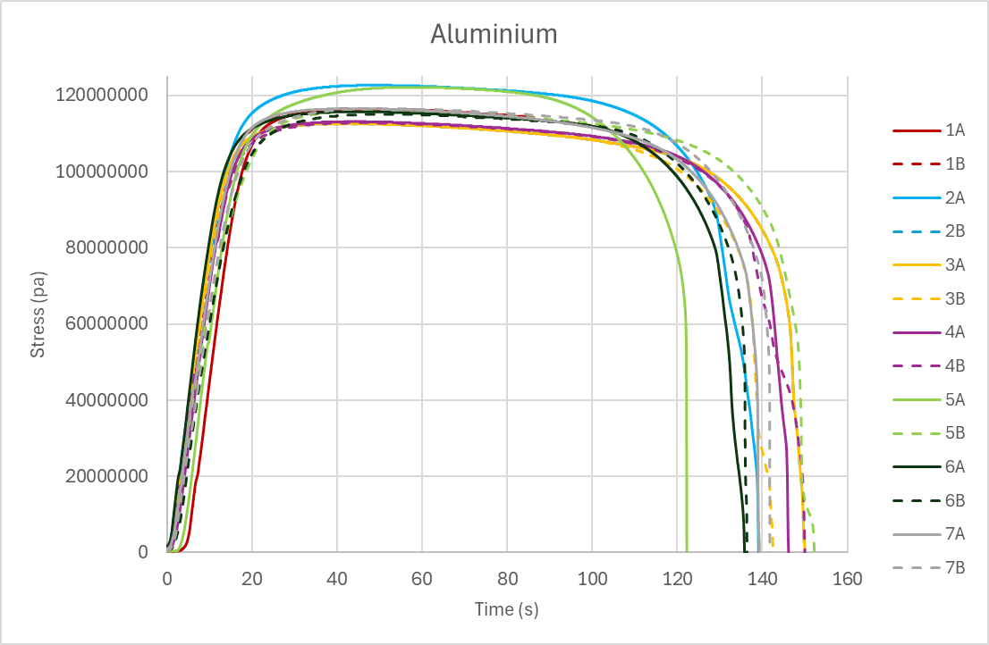
Aluminium
Figure 1- Aluminium Stress vs Time
Overall, collected data for aluminium is fairly consistent with the only slight outliers being run 5A and 2 A with a greater maximum stress than all other runs, experiencing a max stress around 122 Mpa compared to approximately 115 Mpa for all other runs. The discrepancy is not great enough to disregarded values, as the total range of max stress is 10Mpa which is only a difference of 8% from smallest to largest values.

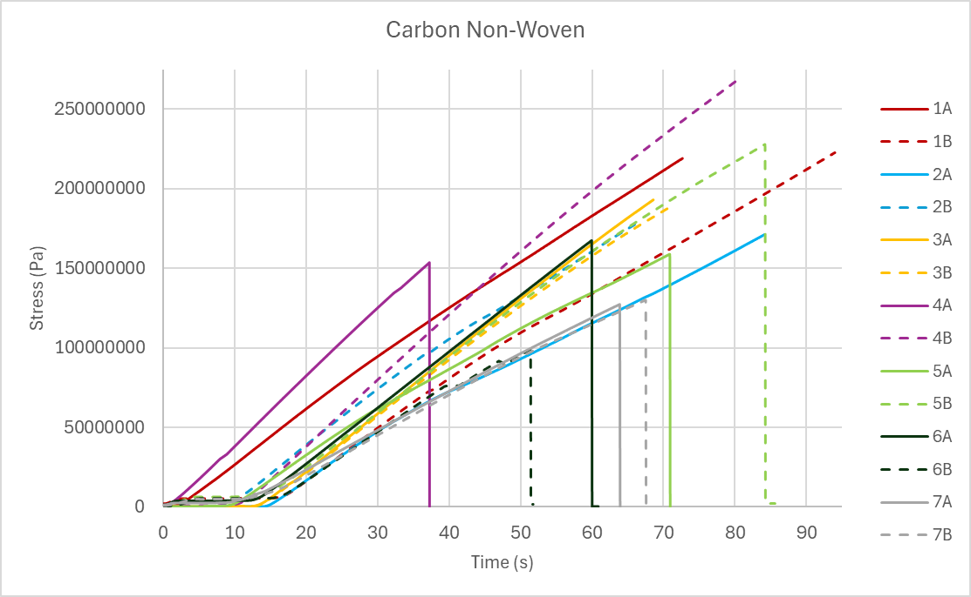
Carbon Non-Woven
Figure 2- Carbon Woven Stress vs Time
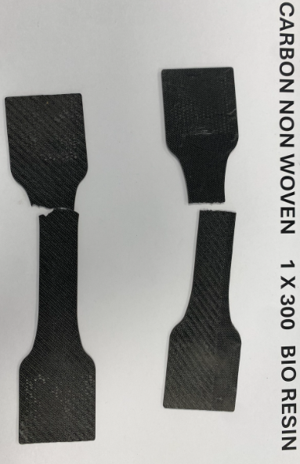
Stress/ Time curves for carbon non- woven see much greater differences between runs. Due to this, runs 4B and 6B have been disregarded for average max stress calculations, these runs experience the smallest stress, 99 Mpa (6B) and largest stress, 269 Mpa (4A) reducing stress range from 170 Mpa (63% difference) to 100 Mpa (44% difference). There is also a large range of time scales at which maximum stress is experiences due to differences in the use of equipment between different groups.
Figure 3- Broken Carbon non-woven sample

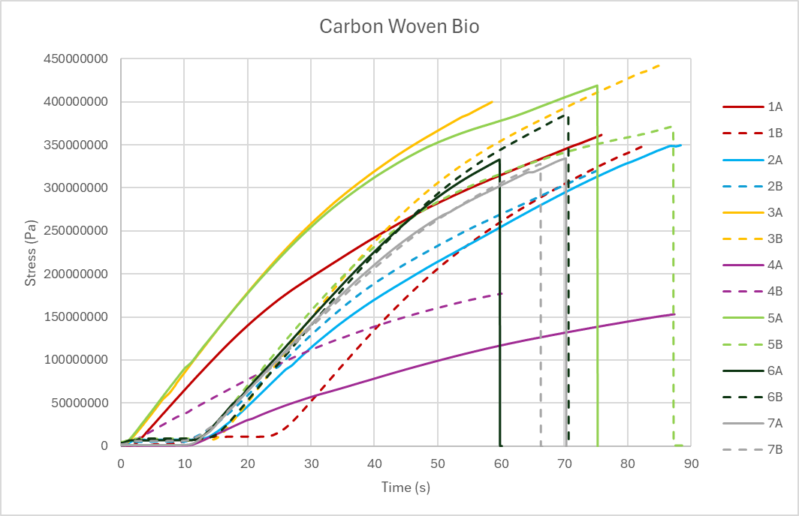
Carbon Woven Bio Resin
Figure 4- Carbon Woven Bio Stress vs Time
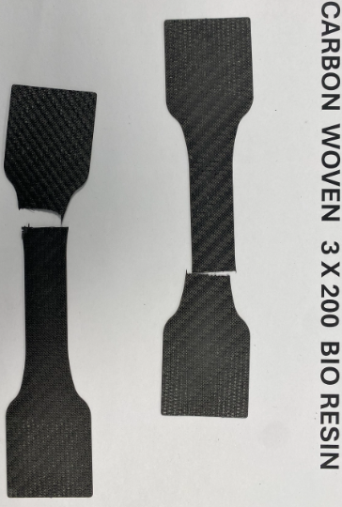
Similarly to non-woven, the woven carbon also experiences large deviations in maximum stress, removing group 4s tests from the runs decreases max stress range from 290.6 Mpa (65.5% difference) to 123.5 Mpa (27.8% difference). Again time scale of runs has a 30s range once again highlighting the differences observed due to different groups running of the tests.
Figure 5-Broken Carbon woven bio resin

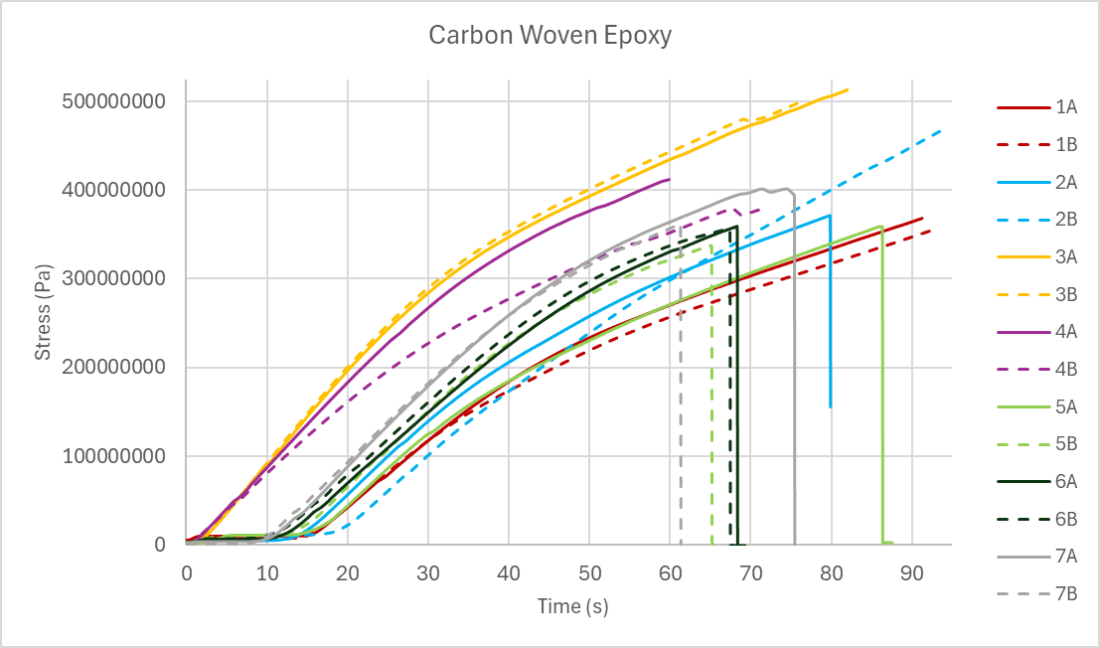
Carbon Woven Epoxy Resin
Figure 6- Carbon Woven Stress vs Time
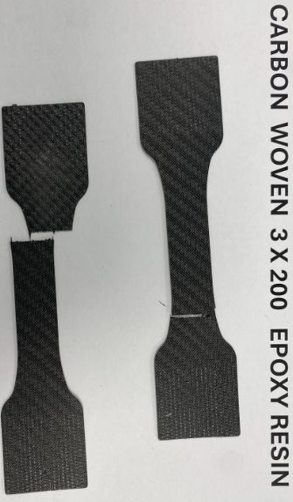
The carbon epoxy woven samples experienced a much more consistent range with no definitive outliers. Maximum stress values range from 356.5 Mpa to 498.3 Mpa (28.4 % diff)
Figure 7- Broken Carbon woven epoxy sample

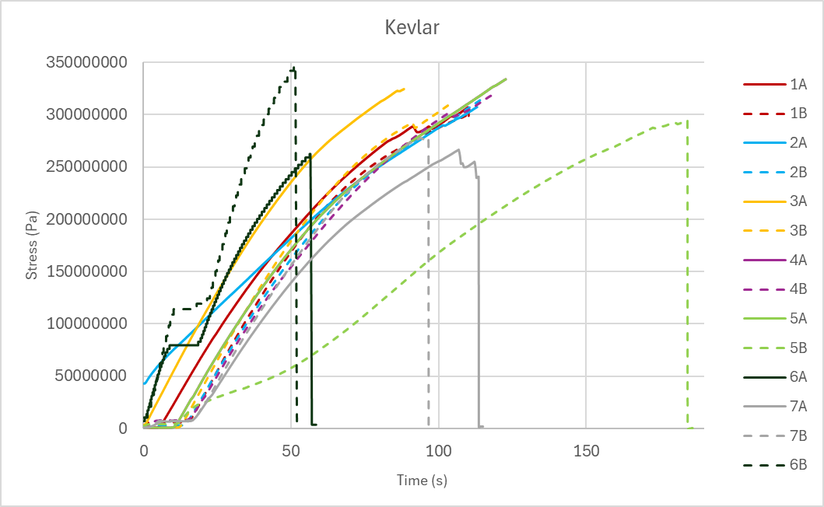
Kevlar Bio Resin
Figure 8-Kevlar Stress vs Time
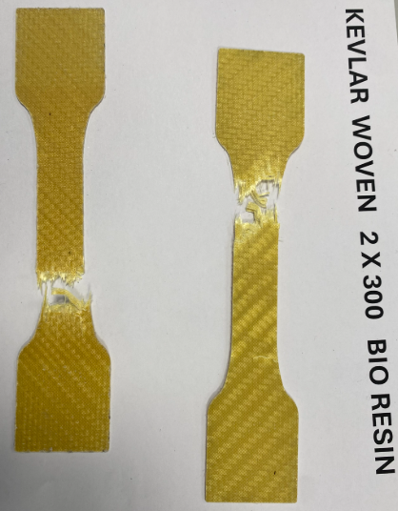
Kevlar sees the greatest range of time scale with a range of over 135s, but stress max stress ranges from 262 Mpa to 347 Mpa resulting in % difference between values of 24.4%, one of the smallest ranges of all composites.
Figure 9- Broken Kevlar Samples

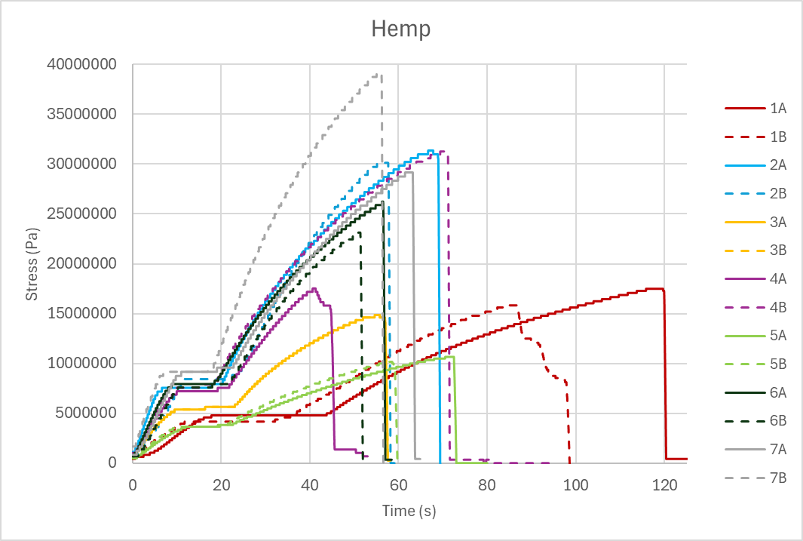
Hemp Non-Woven
Figure 10- Hemp Stress vs Time
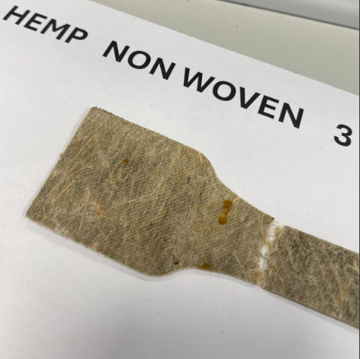
Hemp is definitively the most inconsistent composite in the study, with stresses ranging all the way from 10.2 Mpa to 39.2, although the range here is smaller than some (29Mpa) the percentage difference from the largest to smallest value is 74%, the largest of all composites tested. Therefore, runs 5A, 5B, and 7B are disregarded giving a new stress range of 16 Mpa (52.6% difference).
Figure 11- Broken Hemp sample

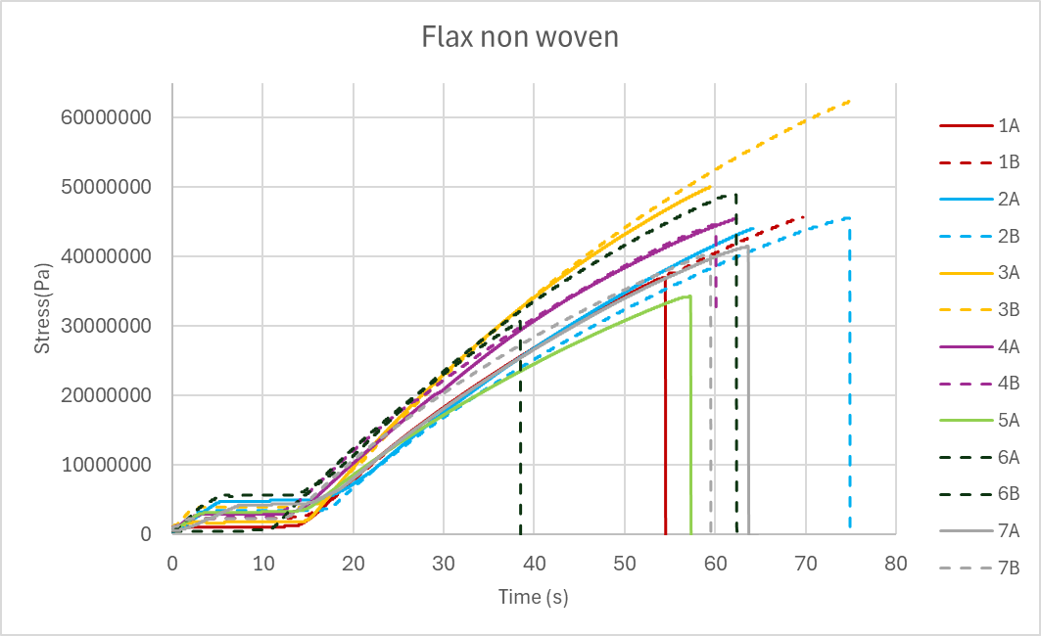
Flax Non-Woven
Figure 12-Flax Non-Woven Stress vs Time
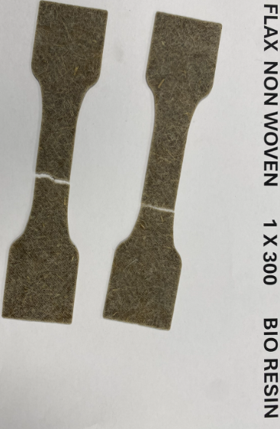
Non-woven Flax exhibits consistent stress/ time curves in comparison to other composites tested, the only correction to be made to this data set is removing run 3B due to a significantly larger max stress compared to all other runs. This gives a max stress range of 19.4 Mpa (38.7% difference).
Figure 13- Broken Flax non-woven samples

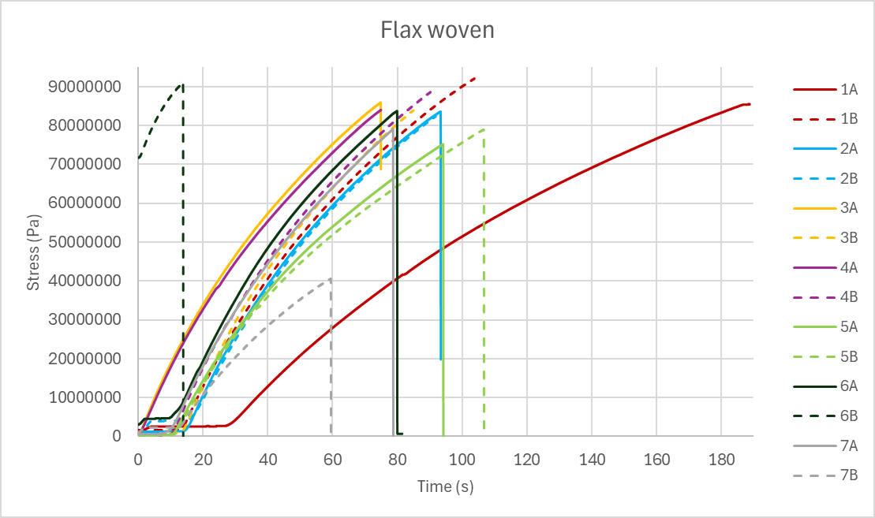
Flax Woven
Figure 14-Flax Woven Stress vs Time
Woven flax has strong correlation of maximum stress with a range of only 16.9 Mpa (18.4% difference), this is the smallest discrepancy between runs when comparing the percent difference from largest to smallest value. There are two major outliers in terms of time scale being run 6B and 1A but as their max stresses are representative, they will remain in the data set.

Analysis

Difference to Material Data
Table 2- Comparison of Test Values vs Data Sheet Values
Composite | Data Sheet Tensile Strength (Mpa) | Recorded Tensile Strength (Mpa) | Percentage increase/ decrease (test value to data sheet value) (100%-Values equal)
Carbon Woven Epoxy (50/50 blend) | 2095 | 396 | 529%
Carbon Woven Bio (50/50 blend) | 2090 | 366.3 | 571%
Carbon Non-Woven | 290 | 178.4 | 162.6%
Kevlar Bio (50/50 blend) | 1530 | 307 | 498%
Flax Woven | 58 | 84.3 | 68.8%
Flax Non-Woven | 44 | 42.4 | 103.8%
Hemp | 46 | 23.1 | 199%
Aluminium | 105-145 | 116.5
First, the accuracy of the Denison machine can be validated comparing aluminium values, the test value sits within the range of “a popular grade of aluminium for general sheet metal” (Aluminium Alloy, no date).
Table 2 presents all tensile stress values from the data sheets compared to the averaged test values (calculations in appendix), differences observed are very inconsistent. Flax non-woven sees very accurate results with only a 3.8% difference between test values, other non-woven composites also experience relatively comparable results but when looking at woven tests, large discrepancies become evident. Material data compared to test value for carbon woven bio has a 471% difference as well as carbon woven epoxy (429%) and Kevlar (398%) These inconsistencies highlighted for woven composites can be due to numerous factors:
- Poor layup quality
- Imperfections in fibres
- Incorrect recording of test data
- No post treatment
Due to the fact large discrepancies are only seen for the woven materials the likely reason for this is due to lay up quality and lack of post treatment.

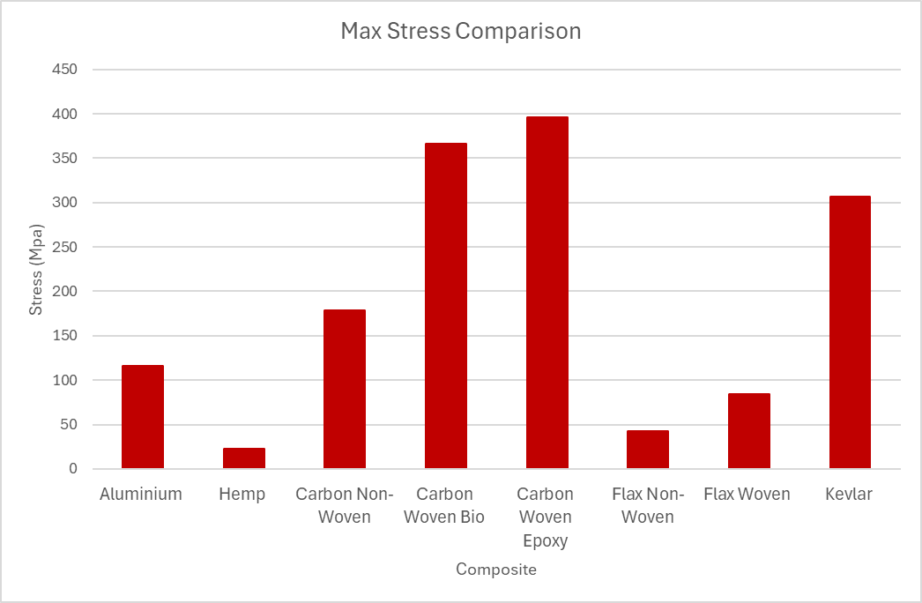
Maximum Stress Comparison
Figure 15- Comparison of Max Stress Values
Figure 15 presents average maximum stresses of all materials, as expected, woven carbon with traditional epoxy can withstand the highest stress, closely followed by woven carbon with bio resin. This highlights the development of biological resins with maximum stresses of 366 Mpa (Bio) and 396Mpa (Traditional) which is only an 8.2% increase in Tensile strength, considering the next strongest option, Kevlar can only withstand 307 Mpa, 16% less than bio carbon woven. Although not as strong, Kevlar would be preferred for components such as body panels due to their exceptional impact resistance, unlike carbon fibre which is extremely brittle (前電小編, 2023).
The lowest performing composites are the natural fibres, specifically hemp and non-woven flax. These composites cannot compete with traditional carbon fibre or Kevlar in terms of its structural properties, but their low density makes them ideal for lightweight non-structural components such as bonnets or interior panels.

Sustainability Analysis

Comparison of Composites
Table 3 compares different values of consumption within the production of each composite, it clearly shows the greater impact of energy usage and carbon footprint for carbon fibre and Kevlar. It is important to highlight water usage, although both flax and hemp have an excellent low carbon footprint and energy usage, its water usage is over 10x that of traditional carbon fibre, additionally, the bio resin carbon and Kevlar has significantly higher water usage than the traditional carbon fibre. This highlights a new issue with using sustainable resources, water shortages are becoming more of a prominent issue in recent years with water storage facilities becoming scarcer and more valuable, potentially increasing future costs considerably if this situation continues to deteriorate. (WWF, 2024)
Table 3- Comparison of Different Sustainability Aspects
Composite | Renewable content | Embodied Energy  (Mj/ Kg) | CO2 (Kg/ Kg) | Water Usage  (l/kg) | Recyclability | Lifecycle impact
Carbon Fibre Epoxy (Lunetto, 2023) (Anon, 2025) (Sakamoto, 2021) (Water footprint, 2024) | Non-Renewable | 247-436 | 30.8-37 | 84-143 | Difficult | High (embodied CO2)
Carbon Fibre Bio-Resin (Anon, 2025) (Cordis, 2019) (Sakamoto, 2021) (Water Footprint, 2024) | Resin Only | 135-348 | +28.06-33.98 | 351-520 | Difficult | Better than std epoxy but still high
Kevlar Bio-Resin (Ansys, 2025) | Resin Only | 245-270 | 12.5-13.7 | 893-987 | Very Difficult | High impact and toxic production
Flax Bio Resin (Ansys, 2025) | Fully Renewable | 10.5-11.6 | 0.42-0.46 | 3000-3300 | Biodegradable | Low
Hemp Bio resin (Ansys, 2025) | Fully Renewable | 9.5-10.5 | 1.52-1.68 | 2400-2600 | Biodegradable | Low

Manufacturing Processes
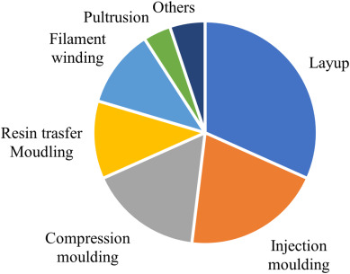
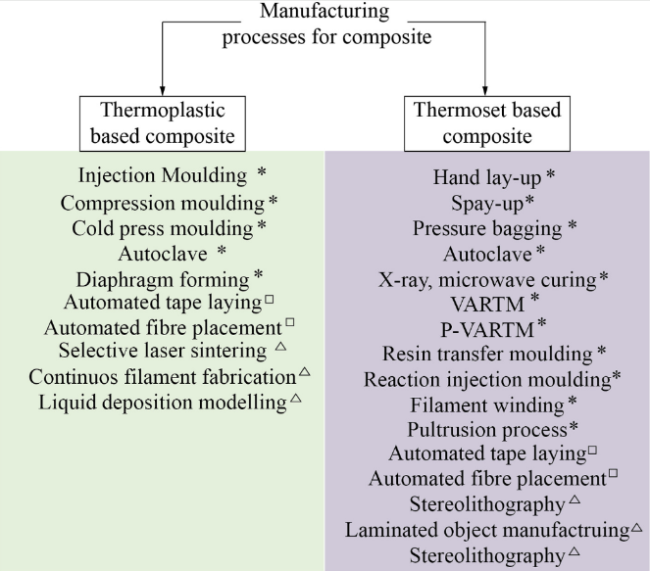
The manufacturing process selection depends on component size and application. Figure 17 presents a summary of different processes used to create composites and groups them into traditional, automated and additive processes. The global market distribution of processes is dominated by layup, injection moulding, compression moulding, and filament winding, shown in figure 16. (Lunetto, 2023)
Figure 16- Distribution of Composite Manufacturing Methods
Figure 17- Different Composite Manufacturing Processes

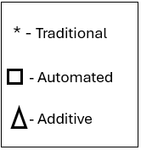

Figure 18- Key for Figure 11
Table 4- Sustainability Aspects of Manufacturing Methods
Manufacturing Type | Energy usage (Mj/Kg) | Carbon Emissions (Kg/Kg)
Compression Moulding (Anon, 2025) | 11-16 | 1.6-0.5
Spray/ Lay-up (Anon, 2025) | 14-18 | 0.7-0.9
Autoclave Moulding (Anon, 2025) | 100-300 | 5-15
Injection Moulding (Hesser, 2016) (Arburg) | 3.39 | 1.83
Filament Winding (Anon, 2025 | 2.7-4 | 0.14-0.2
Table 4 gives an overview of different manufacturing processes specific energy usage and carbon footprint, highlighting the autoclave as the most damaging to the environment by a considerable margin.

Legislation and Policies
The automotive industry creates waste as components are retired or replaced. Although there are no clear estimates, the global automotive composite market is projected to be worth $16.3 billion by 2030, with estimates of 40 million vehicles reaching end of life globally each year, the waste contributed by composites is having a significant effect on global waste. Landfill and Incineration are the most popular choices for waste disposal creating a series of problems for the automotive industry (composite waste, no date).
Policies aim to address the lifecycle impact of composites, from raw material sourcing and production to end of life management. Key areas include promoting sustainable raw materials and enhancing the recyclability/ circularity of composite materials. This is a benefit for NFCs as the push to increase renewability will likely see a soar in NFC development, although as mentioned a new issue arise with NFCs through the substantial use of water in the production, something that will need to be addressed.
F1 teams Mclaren and Mercedes are already working to improve the circularity of their composite production, with Mclaren stating by developing ‘V carbon’ being recycled carbon fibre, there will be a 90% reduction in life cycle emissions, removing 27 tonnes of carbon emissions per tonne of v carbon produced (McLaren, 2023).

Carbon Fibre
The energy consumption of the manufacturing of carbon fibre is unclear to get definitive values, this is primarily due to differences in manufacturing technology, production volume, and plant size (lunette, 2023). There are multiple processes that can be used to produce carbon fibre with some different methods and the energy consumption shown in figure 19, the focus is on thermoset (TS) methods as epoxy is a thermoset. Although useful, this does not give a specific consumption per kg, in paper (Lunetto, 2023) this is specified to be 39-42 MJ/kg for production and 247-436 MJ/Kg for production and assembly, much higher than what is presented in figure 13.
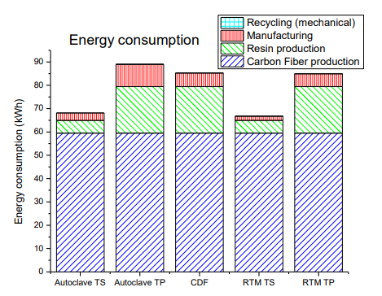
As the energy usage in manufacturing processes is unclear, the production of the material itself will be the focus of sustainability analysis, this identifies an area where further research can be conducted to give a more definitive value of energy usage in production processes.
Figure 19- Energy Consumption of Different Manufacturing Processes for Carbon

Natural Fibres Composite (NFC)
Compared to carbon fibre and Kevlar, the environmental impact of hemp and flax are significantly lower in most stages of production. Key advantages and disadvantages of NFCs are displayed in table 5.
Table 5- Advantages and Disadvantages of NFCs (Desai, 2021)
Advantages | Disadvantages
Low Density- lightweight components | Moisture sensitivity- Can absorb moisture, affecting dimensional stability and mechanical properties
Renewability- Sourced from abundant, natural resources | Thermal Sensitivity- Limiting processing range due to degradation at high temperatures.
Biodegradability- Natural decomposition at end of life | Variability in Properties- Natural variation in properties causing inconsistencies (highlighted in Hemp test results)
Generally lower cost than synthetic fibres | Low durability- Less resistant to the environment than synthetic fibres
Low Abrasiveness- Easier on processing equipment, increasing life cycle, further increasing sustainability

Recommendations
This report highlights the key properties of different composites, ranging from traditional carbon fibre to natural fibre composites with very little carbon footprint. Although the NFCs seem great in principle, their structural properties and durability cannot compare to those of synthetic fibre composites, additionally other issues, primarily water usage arise when using NFCs. A strong alternative that is being heavily invested by multipole F1 teams is the use of recycled carbon fibre, although vast amounts of energy and technological development are required, carbon footprint can be significantly reduced by 90% bringing it closer to the carbon footprint of NFCs. With the development of renewable energies, high energy usage may not be an issue in future, especially when considering the vast reduction in water usage of carbon compared to NFCs which has the possibility to become a more pressing issue than the carbon footprint itself, “at the current consumption rate, this situation will only get worse. By 2025, two-thirds of the world’s population may face water shortages” (WWF, 2024).
This leads to the conclusion of this report, the investment into the development of recycled carbon fibre composites is the most sensible path for the motorsport industry to take, There is currently vast amounts of carbon waste to be put to use and this method is the best way of solving that issue. Additionally, The benefits of NFCs mean they will be a growing area of the composite industry in the near future but the overall effects in the long term will outweigh those of recycled carbon fibre.

References
- Editor, Gemma Hatton.-D. (2019) How are composites used in motorsport?, Racecar Engineering. Available at: https://www.racecar-engineering.com/tech-explained/how-are-composites-used-in-motorsport/.
- ‌Luthada, P. (2022) What are the Terminology, Types, and Formats of Reinforcement Fiber?, Addcomposites. Available at: https://www.addcomposites.com/post/reinforcement-fibers-terminology-types-and-formats.
- ‌Kashani, M.H. and Milani, A.S. (2016) ‘Damage Prediction in Woven and Non-woven Fabric Composites’, Non-woven Fabrics [Preprint]. Available at: https://doi.org/10.5772/61511.
- ‌Resin choice (no date) Exel Composites. Available at: https://exelcomposites.com/guide-to-composites/resin-choices/.
- ‌de Souza, F.M., Kahol, P.K. and Gupta, R.K. (2021) ‘Introduction to Polyurethane Chemistry’, ACS Symposium Series, 1380, pp. 1–24. Available at: https://doi.org/10.1021/bk-2021-1380.ch001.
- ‌100g Non-Woven Hemp Fibre Reinforcement Mat, 480mm Wide - Easy Composites (2025) Easycomposites.co.uk. Available at: https://www.easycomposites.co.uk/100g-non-woven-hemp-fibre-mat.
- ‌Porsche AG: New Porsche 718 Cayman GT4 Clubsport featuring natural-fibre body parts - Porsche USA (no date) Porsche HOME: New Porsche 718 Cayman GT4 Clubsport featuring natural-fibre body parts - Porsche USA. Available at: https://www.porsche.com/usa/aboutporsche/pressreleases/pag/?id=525217&pool=international-de.
- ‌ Aluminium Alloy - Commercial Alloy - 1050A H14 Sheet (no date) www.aalco.co.uk. Available at: https://www.aalco.co.uk/datasheets/Aluminium-Alloy-1050A-H14-Sheet_57.ashx.
- ‌前電小編 (2023) What is Aramid Fiber? Aramid fiber vs Carbon fiber: What’s the difference?, MAEDEN 前電. Available at: https://www.maeden.com/en/post/what-is-aramid-fiber-aramid-fiber-vs-carbon-fiber-what-s-the-difference.
- ‌ Lunetto, V. et al. (2023) ‘Sustainability in the manufacturing of composite materials: A literature review and directions for future research’, Journal of Manufacturing Processes, 85, pp. 858–874. Available at: https://doi.org/10.1016/j.jmapro.2022.12.020. (Figures)
- ‌ Anonyms (2025) ‘Useful numbers for environmental studies ’. Available at: https://www.polybags.co.uk/environmentally-friendly/useful-numbers-for-environmental-studies.pdf.
- ‌ CORDIS, cordis.europa.eu (2019) High Performance, Economical and Sustainable Biocomposite Building Materials, CORDIS | European Commission. Available at: https://cordis.europa.eu/project/id/285689/reporting.
- ‌ Hesser, F. et al. (2016) ‘Injection moulding unit process for LCA: Energy intensity of manufacturing different materials at different scales’, Journal of Reinforced Plastics and Composites, 36(5), pp. 338–346. Available at: https://doi.org/10.1177/0731684416674565.
- ‌ Press release Carbon footprint of injection moulding machines (no date). Available at: https://www.arburg.com/media/daten/other/ARBURG_press_release_CO2_footprint_2022_en_GB.pdf.
- ‌ Kawajiri, K. and Sakamoto, K. (2021) ‘Environmental Impact of Carbon Fibers Fabricated by an Innovative Manufacturing Process on Life Cycle Greenhouse Gas Emissions’, Sustainable Materials and Technologies, 31, p. e00365. Available at: https://doi.org/10.1016/j.susmat.2021.e00365.
- ‌ Desai, G. (2021) What are Natural Fiber Composites? Basics, Applications, and Future Potentials, Addcomposites. Available at: https://www.addcomposites.com/post/what-are-natural-fiber-composites-basics-applications-and-future-potentials.
- ‌ Composite waste: Understanding regulations and finding circular solutions for a growing problem (no date) www.circularise.com. Available at: https://www.circularise.com/blogs/composite-waste-understanding-regulations-and-finding-circular-solutions-for-a-growing-problem.
- ‌ McLaren (2023). McLaren Racing pioneers use of sustainable materials with innovative recycled carbon fibre trial. [online] www.mclaren.com. Available at: https://www.mclaren.com/racing/formula-1/2023/mclaren-racing-pioneers-use-of-sustainable-materials-with-innovative-recycled-carbon-fibre-trial/.
- World Wildlife Fund (no date) Water Scarcity, World Wildlife Fund. Available at: https://www.worldwildlife.org/threats/water-scarcity.

Appendix

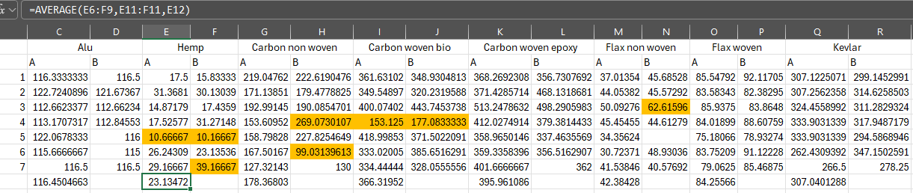
Average max stress calculations

