ACCA6011

Artificial Intelligence & Machine Learning

Author: Jessica Marfell
Student Number: 1809781
Date: 05/01/2022

TABLE OF CONTENTS
1 Task 1 3
1.1 User Guide 5
1.2 Program Listing 8
1.3 Testing 8
2 Task 2 14
3 Task 3 20
4 References 25
5 Appendix 26

Task 1
Task one details the code and steps taken to create and test a Depth First Search (DFS) program. The programme displays a 16 by 16 hospital map where walls, corridors and signs are represented.

A DFS is an algorithm that travels through a graph or data structure to explore each node to ensure all areas are covered. The algorithm starts at the root node and works its way through the structure, once the current node has been visited it will move to the next available node. This process will continue until there are no unmarked nodes on the data structure. The algorithm will then backtrack to ensure there are no unmarked nodes and finally print the path [1].

For the purpose of the assignment the below map has been utilised and loaded into a C++ programme.

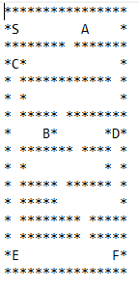

In order to conduct a graph traversal the data points on the map need to be transferred into a graph. In the below example the hospital signs have been transferred into a graph. This algorithm will ensure every vertex of the graph is visited. The depth first search sets out the order to ensure all data points are visited.

The DFS algorithm transverses the information from the graph and stacks them in memory to allow the algorithm to search for the next vertex. It follows three rules [2]-
- Visit the adjacent unvisited vertex. Mark it as visited. Display it and push it in a stack.
- If no adjacent vertex is found, pop up a vertex from the stack.
- Repeat Rule 1 and Rule 2 until the stack is empty.

Putting the theory into practice for the hospital map-

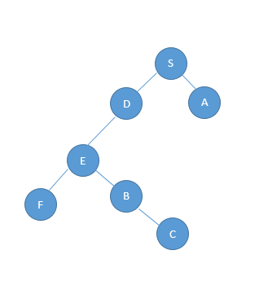

Using the above example ‘S’ is the starting location on the graph. ‘S’ can visit either ‘D’ or ‘A’. For example ‘S’ will visit ‘A’ first. Once ‘A’ has been visited the only vertex option is back to ‘S’. This will remove ‘A’ from the stack and go to ‘D’.

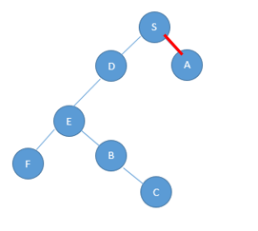

A
S
Stack

Order | S | A

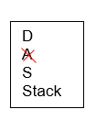

Order | S | A | D

This process will continue until all vertex have been visited and the stack is empty.

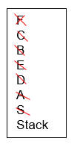
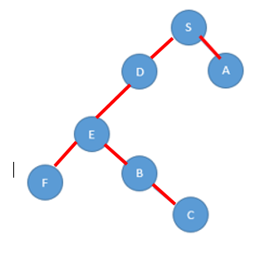

Order | S | A | D | E | B | C | F

To ensure the data structures are coded into the programme the map has been displayed using x and y axis. These axis have been given starting, current and adjacent positions on the map. These positions will change when entering into different while and if loops. For example to move one vector to the right a current.x+1 statement has been used.

To summarise the DFS algorithm searches the data structure and ensures all data nodes are covered. The algorithm has been programmed to continue until the stack is empty with a caveat, that if it reaches an obstacle ‘*’ it will not read it. Four if statements have been created to ensure the DFS looks right, left, up and down. This will continue to loop in this order which does not always display the shortest routes to destinations. For example for the DFS to get to ward sign ‘A’ it has to pass through all other vectors. To enhance this programme a shortest path algorithm may be considered in future developments.

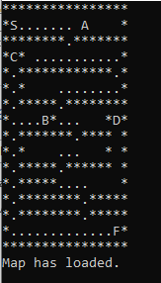

User Guide
A C++ programme has been designed to allow a Depth First Search to be carried out on a 16 by 16 hospital map.

The user has access to a menu to choose the relevant option for them. They are able to select 1 to load the hospital map which is called map.txt, print the map once loaded into the programme, conduct the DFS and end the programme.

The below table details the map with ‘X’ indicating walls, spaces ‘ ‘ being accessible corridors and ‘A’, ‘B’, ‘C’, ‘D’, ‘E’ and ‘F’ representing signs. ‘S’ is displayed as the starting point on the map.
x | x | x | x | x | x | x | x | x | x | x | x | x | x | x | x
X | S |  |  |  |  |  |  |  |  | A |  |  |  |  | x
x | x | x | x | x | x | x | x |  | x | x | x | x | x | x | x
x | C | x |  |  |  |  |  |  |  |  |  |  |  |  | x
x |  | x | x | x | x | x | x | x | x | x | x | x | x |  | x
x |  | x |  |  |  |  |  |  |  |  |  |  |  |  | x
x |  | x | x | x | x | x |  | x | x | x | x | x | x | x | x
x |  |  |  |  | B | x |  |  |  |  |  |  | x | D | x
x |  | x | x | x | x | x | x | x |  | x | x | x | x |  | x
x |  | x |  |  |  |  |  |  |  |  |  |  | x |  | x
x |  | x | x | x | x | x |  | x | x | x | x | x | x |  | x
x |  | x | x | x | x | x |  |  |  |  |  |  |  |  | x
x |  | x | x | x | x | x | x | x | x |  | x | x | x | x | x
x |  | x | x | x | x | x | x | x | x |  | x | x | x | x | x
x | E |  |  |  |  |  |  |  |  |  |  |  |  | F | x
x | x | x | x | x | x | x | x | x | x | x | x | x | x | x | x

The map has been saved in a text file and called map.txt. This text file has been loaded into a C++ programme using a file load function when the user chooses to load the map.

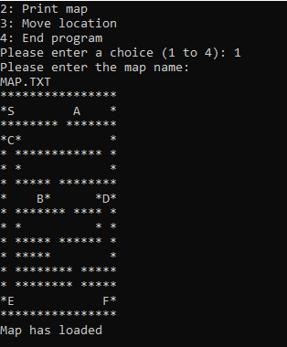

Once the map has been loaded into the programme the user can select option 2 which will print the map.

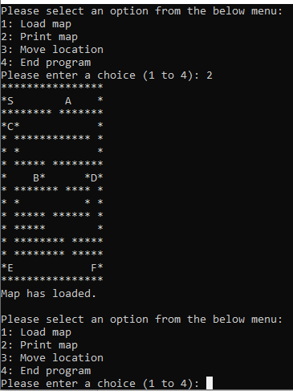

Once loaded the user is able to move location by selecting option 3.
This will ask the user what ward they would like to visit.

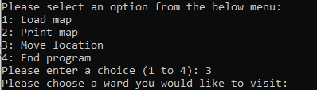

Once the user has selected a hospital ward the DFS will print out the route the user should take to get to the desired ward by identifying the route with ‘.’.
Select ward F-

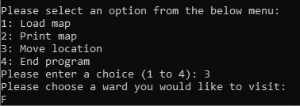

Once the user has collated the information for their desired routes they are able to close the programme by selecting option 4.

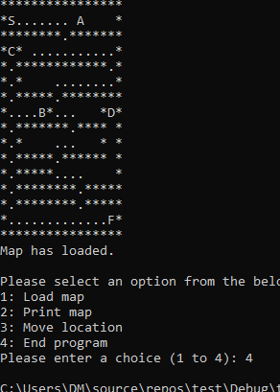

A video recording is available on Microsoft Steam which provides the user with a demonstration on how to use the programme.
Link provided below:
https://www.youtube.com/watch?v=lReML_GDujE&ab_channel=JessWilliams

Program Listing
A C++ program has been created to display a Depth First Search for a 16 by 16 hospital map. A copy of the code has been attached under Appendix A.

Testing
Scenario 1- Open programme and load map.txt file - PASS

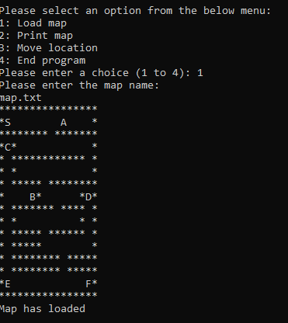

Scenario 2- Open programme and load incorrect file- programme ends- PASS

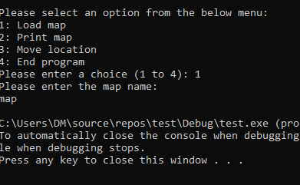

Scenario 3- Load file into programme and select option 2 to print map- PASS

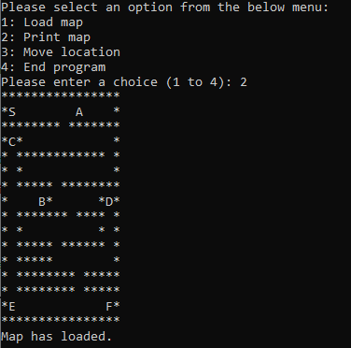

Scenario 4- Select Move Location and enter in a ward sign - DFS should generate and start to search the map leaving a trail of where the algorithm has been.

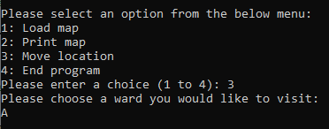

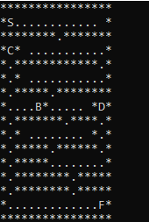

Scenario 4 Passed as the DFS has been initiated however it does not stop the search once the ward sign has been reached.

While loop has been updated to exit the loop if the ward sign has been reached.

Location to A
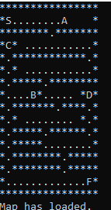

Location to B
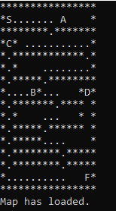

Location to C

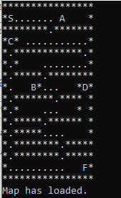

Location to D

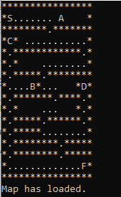

Location to E

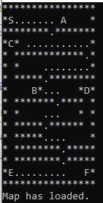

Location to F

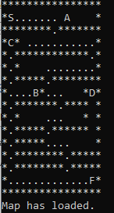

Scenario 5- Ensure valid ward locations are accepted as a valid location- PASS

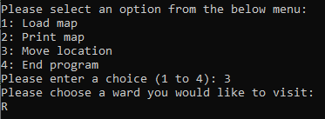

User is unable to move into the while loop and initiate a DFS as a valid position is not given.

Scenario 6- Select option 4 to end the programme- PASS

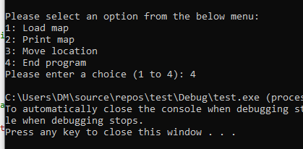

If the user did not have the ability to select the ward they wanted to visit the DFS will search the data structure until all available nodes have been stacked and emptied.

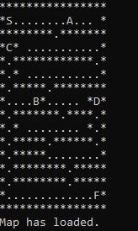

Task 2

Task two explains the k-means algorithm and evaluates the methods used.

K-Means is a clustering algorithm. A cluster is a search for hidden patterns that may exist in data sets. It groups together data that may be disjointed to display information that is similar. Clustering algorithms are applied to pattern recognitions, information retrieval and data analysis [3]. Its aim is to divide the data into clusters from the data parameters to allow the same group to be as similar as possible. K-means is described as one of the simplest and most popular unsupervised machine learning algorithms [4].

To identify underlining patterns k-means will look for a fixed number (k) of clusters in the dataset. The algorithm identifies k number of centroids and allocates every data point to their nearest centroid while keeping the centroids as small as possible [3].

Below is an example of five data points where k=2. This means the data points will be allocated to two centroids.

Data Point | X- Axis | Y-Axis
1 | 5 | 5
2 | 3 | 5
3 | 0 | 3
4 | 2 | 2
5 | 5 | 3

Data point 2 and data point 4 have been selected for this example.

Calculating the centroids using the Euclidean distance equation will identify the closest cluster for the dataset to be assigned to. This equation has been used as it measures the similarities between objects. [5]-

√ ((x1-y1)² + (x2-y2)²

Equation to work out the distance between D1 and D2-

√ (5-3)² + (5-5)²

= 2

Equation to work out the distance between D1 and D4-

√ (5-2)² + (5-2)²

= 4.2

Equation to work out the distance between D3 and D2-

√ (0-3)² + (3-5)²

= √13

= 3.6

Equation to work out the distance between D3 and D4-

√ (0-2)² + (3-2)²

= √5

= 2.2

Equation to work out the distance between D5 and D2-

√ (5-3)² + (3-5)²

= 2.8

Equation to work out the distance between D5 and D4-

√ (5-2)² + (3-2)²

= √10

= 3.2

Data Point | Distance between D2 and other data points | Distance between D4 and other data points | Closest data point- D2 or D4
1 | 2 | 4.2 | D2
3 | 3.6 | 2.2 | D4
5 | 2.8 | 3.2 | D2

Using the Euclidean distance equation, each point has been calculated and allocated to the nearest cluster.
Cluster one has D3 and D4 data points and cluster two has D1, D2 and D5.

Cluster | Mean value of data points along x-axis | Distance between D4 and other data points
D3, D4. | 0+2= 2  2/2  = 1 | D3-2.2 +  D4-0 = 2.2  2.2/2 =  1.1
D1, D2, D5 | 5+3+5  =13  13/3  = 4.33 | D1- 4.2 + D2- 3.2 +D5- 3.2= 10.6  10.6/3  = 3.5

Identifying the clusters allows the new centroids to be calculated. Cluster one is- 1, 1.1 and cluster two is- 4.33, 3.5.

An additional example is provided in Appendix B where data points have been taken from Moodle and calculated to allocate updated class labels for the data points.

The above example displays basic data were k=2 is appropriate. When dealing with more complex data the k-means algorithm may need more analysis as the algorithm does not read the data.

One of the advantages of using k-means is its simple and generally very fast to work with. The algorithm partitions the input datasets into k clusters. These clusters are represented by centroids which are also called cluster centre. It computes the squared distance between the inputs and centroids. It then assigns the inputs to the nearest centroid [3]. K-means allows tighter clusters to be formed and if there are many datasets it works faster than Hierarchical clustering.

Although k-means is widely used, there are some limitations to the algorithm. K-means requires k as an input and doesn’t read and learn from the data. This means there is typically no right answer as it is dependent on the number of clusters. As it uses distance-based measurements it is recommended to standardise the data to work out the mean of zero and a standard deviation of one as it is presumed in most cases the datasets have different units of measurements [6]. Depending on the k-means clustering algorithm, the size of the clustering and density may vary. In the below example taken from Analytics Vidhya, the data set has been clustered to k=3.

Original data point to display different sized clusters where k=3 [7]-

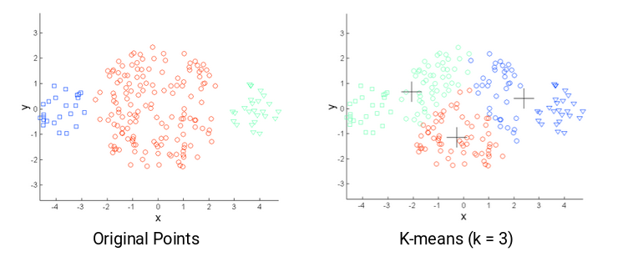

The above data points for k=3 displays a variation of clustering size.

Original data point to display different density of clusters where k=3 [7]-

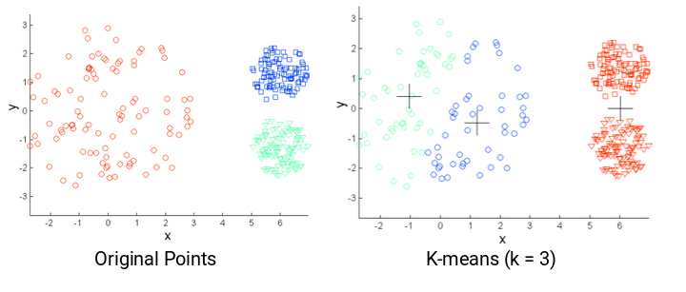
The above example displays the difference in density of the clusters for k=3.

Understanding the data and clusters is crucial. As identified above a limitation of using k-means is the size or density of the clusters being different. To overcome this limitation a higher number of clusters can be used. This may lead to more meaningful data of clusters being identified. To ensure the number of clusters are right for the dataset and identifying what k=’x’ clusters should be, an Elbow curve can be utilised.

To determine the optimum number of clusters an elbow curve can be used to plot a graph to display the metric (y- axis) and clusters (x-axis). The curve will display the decrease in values as the higher number of clusters will diminish the returns past this point. In the example below the number of clusters for K to equal would be advised as 3, meaning, k=3.

Example graph taken from Elbow Method for optimal value of k in K Means [8]-

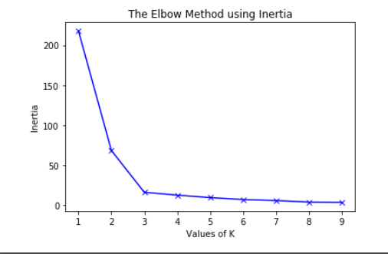

Another approach would be the use of Silhouette analysis. It quantifies the distance between the clusters and has a range of [-1,1]. If the value indicated is +1 this concluded the sample is far away from neighbouring clusters whereas a negative value indicates the samples may have been assigned to the wrong cluster. A value of 0 indicates the sample is close to the decision boundary between two clusters. The number of clusters used to plot the Silhouette graph is dependent on the dataset. Two example graphs taken from Scitkit Learn displays the differences between an example of n_clusters=2 and n_clusters=5 [9].

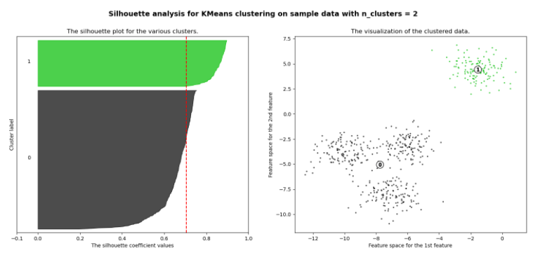

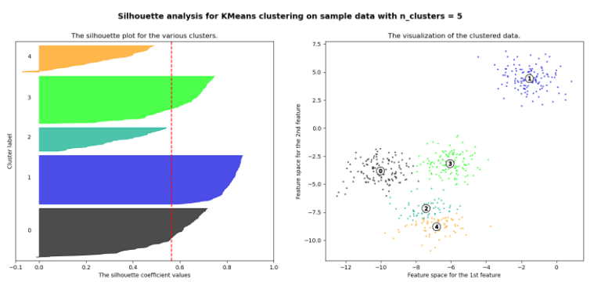

Comparing the two examples above, it displays below average silhouette plots for n_clusters=5 which is bad practice. Whereas n_clusters=2 is displayed above average and display bigger groupings. Using this method, it identifies that k=2 would calculate more meaningful centroids rather than k=5 as some clusters would be below average.

Depending on the complexity and quantity of data for the k-means algorithm, will depend on the best approach to take to work out the optimum k-means calculation. The algorithm can be widely understood but may need additional steps to determine what the optimum clustering equation (k=”x”) should be as this will affect the outcome of the data sets.

Task 3

Task three identifies the data points provided on Moodle and places them into two clusters using the k-means algorithm.

The starting centroid to work out the new clusters using k=2 is calculated below. For the purpose of working out centroids an additional example is provided in Appendix B with full workings out.

Data Points taken from Moodle [7]-

Data Point | X- Axis | Y-Axis
1 | 5 | 5
2 | 0 | 5
3 | 2 | 3
4 | 2 | 2
5 | 5 | 1
6 | 3 | 3
7 | 1 | 4
8 | 5 | 3
9 | 1 | 2
10 | 4 | 2

A graph has been created in excel to display the data points-

Using the starting centroid numbers on Moodle for student id- 1809791 the two new starting centroids to be calculated are-

Centroid | X- Axis | Y-Axis
1 (C1) | 2.12 | 3.41
2 (C2) | 4.25 | 4.61

The Euclidean distance measures the similarities between objects. To work out the distance the below equation is calculated for each data point and starting centroid [5]-

√((x1-y1)² + (x2-y2)²

Equation to work out the distance between D1 and C1-

√(5-2.12)² + (5-3.41)²

= 3.29

Equation to work out the distance between D1 and C2-

√(5-4.25)² + (5-4.61)²

= 0.85

Equation to work out the distance between D2 and C1-

√(0-2.12)² + (5-3.41)²

= 2.65

Equation to work out the distance between D2 and C2-

√(0-4.25)² + (5-4.61)²

= 4.27

Equation to work out the distance between D3 and C1-

√(2-2.12)² + (3-3.41)²

= 0.43

Equation to work out the distance between D3 and C2-

√(2-4.25)² + (3-4.61)²

= 2.77

Equation to work out the distance between D4 and C1-

√(2-2.12)² + (2-3.41)²

= 1.42

Equation to work out the distance between D4 and C2-

√(2-4.25)² + (2-4.61)²

= 3.45

Equation to work out the distance between D5 and C1-

√(5-2.12)² + (1-3.41)²

= 3.76

Equation to work out the distance between D5 and C2-

√(5-4.25)² + (1-4.61)²

= 3.69

Equation to work out the distance between D6 and C1-

√(3-2.12)² + (3-3.41)²

= 0.97

Equation to work out the distance between D6 and C2-

√(3-4.25)² + (3-4.61)²

= 2.04

Equation to work out the distance between D7 and C1-

√(1-2.12)² + (4-3.41)²

= 1.67

Equation to work out the distance between D7 and C2-

√(1-4.25)² + (4-4.61)²

= 3.3

Equation to work out the distance between D8 and C1-

√(5-2.12)² + (3-3.41)²

= 2.9

Equation to work out the distance between D8 and C2-

√(5-4.25)² + (3-4.61)²

= 1.78

Equation to work out the distance between D9 and C1-

√(1-2.12)² + (2-3.41)²

= 1.8

Equation to work out the distance between D9 and C2-

√(1-4.25)² + (2-4.61)²

= 4.17

Equation to work out the distance between D10 and C1-

√(4-2.12)² + (2-3.41)²

= 2.35

Equation to work out the distance between D10 and C2-

√(4-4.25)² + (2-4.61)²

= 2.62

Results are displayed below:

Data Point | Distance between Centroid 1 and other data points | Distance between Centroid 2 and other data points | Closest data point- C1 or C2
1 | 3.29 | 0.85 | C2
2 | 2.65 | 4.27 | C1
3 | 0.43 | 2.77 | C1
4 | 1.42 | 3.45 | C1
5 | 3.76 | 3.69 | C2
6 | 0.97 | 2.04 | C1
7 | 1.67 | 3.3 | C1
8 | 2.9 | 1.78 | C2
9 | 1.8 | 4.17 | C1
10 | 2.35 | 2.62 | C1

Cluster one- D2, D3, D4, D6, D7, D9 and D10
Cluster two- D1, D5 and D8

Cluster | Mean value of data points along x-axis | Distance between D11 and other data points
D2, D3, D4, D6, D7, D9, D10 | 0+ 2+ 2+ 3 +1 + 1+ 4  =13  13/7  = 1.86 | 2.65 + 0.43 + 1.42 + 0.97 + 1.67+ 2.9 + 2.35 = 12.39 /7  = 1.77
D1, D5, D8 | 5 + 5 +5  =15  15/ 3  = 5 | 3.29 + 3.76 + 2.9  9.95 = /3  = 3.32

To conclude the new centroid for cluster one is- 1.86, 1.77 and cluster two is- 5, 3.32

References

[1] | “Depth First Search or DFS for a Graph,” GeeksforGeeks, 30 Nov 2021. [Online]. Available: https://www.geeksforgeeks.org/depth-first-search-or-dfs-for-a-graph/. [Accessed 01 01 2022].
[2] | “Data Structure - Depth First Traversal,” [Online]. Available: https://www.tutorialspoint.com/data_structures_algorithms/depth_first_traversal.htm. [Accessed 01 01 2022].
[3] | K. R. Zˇalik, “An efficient k Means,” 04 04 2008. [Online]. Available: https://pdf.sciencedirectassets.com/271524/1-s2.0-S0167865508X00078/1-s2.0-S0167865508000706/main.pdf?X-Amz-Security-Token=IQoJb3JpZ2luX2VjEHsaCXVzLWVhc3QtMSJIMEYCIQDYeqVsplZuc%2FcTf2ll5W%2F17R%2BghAFlrNR7888K3SFNPQIhAMwnUZXMR7DAOhptpIUbMAgsGgHf0FoFOzSAcG. [Accessed 23 11 2021].
[4] | D. M. J.Garbade, “Understanding K-means Clustering in Machine Learning,” Towards Data Science , 12 09 2018. [Online]. Available: https://towardsdatascience.com/understanding-k-means-clustering-in-machine-learning-6a6e67336aa1. [Accessed 23 11 2021].
[5] | Sunaina, “Steps to calculate centroids in cluster using K-means clustering algorithm,” Tech Target, 18 03 2018. [Online]. Available: https://www.datasciencecentral.com/profiles/blogs/steps-to-calculate-centroids-in-cluster-using-k-means-clustering. [Accessed 17 12 2021].
[6] | I. Dabburi, “K-means Clustering: Algorithm, Applications, Evaluation Methods, and Drawbacks,” Towards Data Science, 17 09 2018. [Online]. Available: https://towardsdatascience.com/k-means-clustering-algorithm-applications-evaluation-methods-and-drawbacks-aa03e644b48a. [Accessed 07 12 2021].
[7] | P. Sharma, “The Most Comprehensive Guide to K-Means Clustering You’ll Ever Need,” Analytics Vidhya, 13 08 2019. [Online]. Available: https://www.analyticsvidhya.com/blog/2019/08/comprehensive-guide-k-means-clustering/. [Accessed 07 12 2021].
[8] | “Elbow Method for optimal value of k in KMeans,” GeeksforGeeks, 09 02 2021. [Online]. Available: https://www.geeksforgeeks.org/elbow-method-for-optimal-value-of-k-in-kmeans/. [Accessed 07 12 2021].
[9] | S. Learn, “Selecting the number of clusters with silhouette analysis on KMeans clustering,” Scikit Learn, [Online]. Available: https://scikit-learn.org/stable/auto_examples/cluster/plot_kmeans_silhouette_analysis.html#sphx-glr-auto-examples-cluster-plot-kmeans-silhouette-analysis-py. [Accessed 07 12 2021].
[10] | “Moodle,” UWTSD, [Online]. Available: https://moodle.uwtsd.ac.uk/course/view.php?id=2533. [Accessed 17 12 2021].

Appendix
Appendix A- Depth First Search Code

#define WIDTH 16// size of map 16 by 16
#define HEIGHT 16
#include <stack>
#include <iostream>
#include <fstream>
#include <string>
using namespace std;
char text[WIDTH * HEIGHT];
int loadFile(string);// loading the hospital map
void printArray(void);// working with 2 dimensional array to print the map
typedef struct
{
int x;
int y;
}
position;
std::stack<position> dfsStack;

int main(void)
{
int x = 0;
char s; // character for user to input chosen sign
int fileLoaded = 0;
position current; //current position
current.x = 0;
current.y = 0;
position startPosition;//start position
position adjPosition;// adjacent position
string fname;

while (x < 4)
{
cout << endl;
cout << "Please select an option from the below menu:" << endl;
cout << "1: Load map" << endl;
cout << "2: Print map" << endl;
cout << "3: Move location " << endl;
cout << "4: End program" << endl;
cout << "Please enter a choice (1 to 4): ";
cin >> x;

if (x == 1)
{
cout << "Please enter the map name:" << endl;
cin >> fname;
if (!loadFile(fname)) exit(0);// if file can't be loaded, the programme will end
fileLoaded = 1;
cout << "Map has loaded" << endl;

}

if (x == 2 && fileLoaded)// if user selects to print map and map can be loaded- map will be displayed
{
printArray();

}

if (x == 3 && fileLoaded) // if user selects to walk through map and map can be loaded- loop will open for user to start walking
{
cout << "Please choose a ward you would like to visit: " << endl;
cin >> s; // saving the ward sign the user selects as char 's'

startPosition.x = 2;
startPosition.y = 1;
dfsStack.push(startPosition); // dfs initialise stack with start position of 1,2 - representing 'S' on hospital map

while (!dfsStack.empty() && (text[WIDTH * current.y + (current.x)] != s))// open while loop when stack is not empty and chosen sign is not selected
{
system("cls");
printArray();// printing the map
current = dfsStack.top(); //top plus pop equals a stack pop operation
dfsStack.pop();

if ((text[WIDTH * current.y + (current.x + 1)] != '*') && (text[WIDTH * current.y + (current.x + 1)] != '.'))// +1 move one location to the right unless the location is a '*' which represents a wall on the map.
{
adjPosition.x = current.x + 1;
adjPosition.y = current.y;
dfsStack.push(adjPosition);
if (text[WIDTH * current.y + (current.x)] != s)// replace locations visited by DFS algorithm unless it is the chosen hospital sign
{
text[WIDTH * current.y + (current.x)] = '.';
}
}

if ((text[WIDTH * current.y + (current.x - 1)] != '*') && (text[WIDTH * current.y + (current.x - 1)] != '.'))// -1 move one location to the left unless the location is a '*'
{
adjPosition.x = current.x - 1;
adjPosition.y = current.y;
dfsStack.push(adjPosition);
if (text[WIDTH * current.y + (current.x)] != s)
{
text[WIDTH * current.y + (current.x)] = '.';
}
}

if ((text[WIDTH * (current.y - 1) + (current.x)] != '*') && (text[WIDTH * (current.y - 1) + (current.x)] != '.')) // move up
{
adjPosition.x = current.x;
adjPosition.y = current.y - 1;
dfsStack.push(adjPosition);
if (text[WIDTH * current.y + (current.x)] != s)
{
text[WIDTH * current.y + (current.x)] = '.';
}
}

if ((text[WIDTH * (current.y + 1) + (current.x)] != '*') && (text[WIDTH * (current.y + 1) + (current.x)] != '.')) // move down
{
adjPosition.x = current.x;
adjPosition.y = current.y + 1;
dfsStack.push(adjPosition);
if (text[WIDTH * current.y + (current.x)] != s)
{
text[WIDTH * current.y + (current.x)] = '.';
}

}

}

}
}
}

int loadFile(string fileName)// loading the map from the text file
{
string line;
ifstream myfile(fileName);
if (myfile.is_open())
{
int count = 0;
while (getline(myfile, line))
{
cout << line << endl;
line.copy(&text[WIDTH * count], WIDTH, 0);
count++;
}
myfile.close();
return 1;
}
else return 0;
}

void printArray(void)// printing the map
{
for (int y = 0; y < HEIGHT; y++)
{
for (int x = 0; x < WIDTH; x++)
{
cout << text[WIDTH * y + x];
}
cout << endl;
}
cout << "Map has loaded." << endl;
}

Appendix B- Example of centroids using two datasets from the information on Moodle.



