DS 1 Template

My Screenshots/Photos
- Please add 4–6 screenshots or photos of your digital life.
- You can use your phone or laptop.
- For each screenshot, write one or two sentences explaining what it shows.

Screenshot/Photo 1
[Insert Photo/Screenshot below]
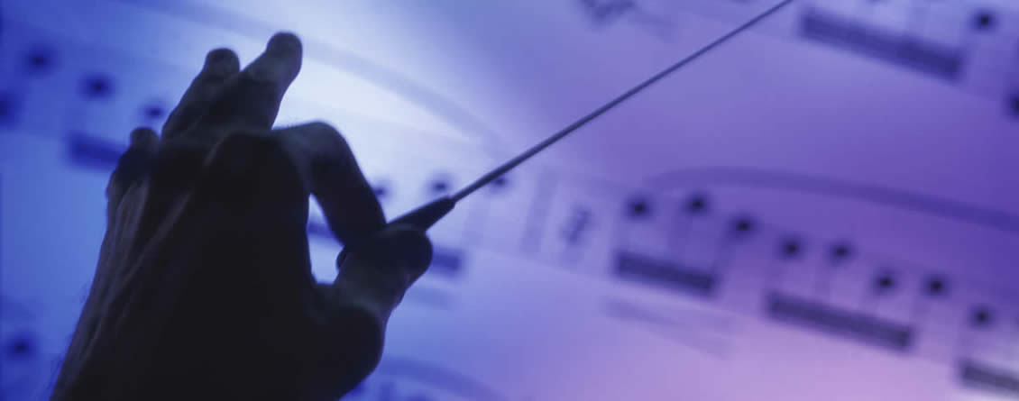
[Write what this shows of your digital life] AI instructed to make a picture that the finger with the string is flying looks like a kite.

Screenshot/Photo 2
[Insert Photo/Screenshot below]

[Write what this shows of your digital life] Linked in is a platform where people make their career, to build their resume, sharing skills between the groups etc. It has learning resources and technology.

Screenshot/Photo 3
[Insert Photo/Screenshot below]

[Write what this shows of your digital life]Microsoft outlook is for sending and receiving email ,manage calendar,organizing work and personal communication platform .

Screenshot/Photo 4
[Insert Photo/Screenshot below]

[Write what this shows of your digital life] Social networking platform where all types of group and communities can share their content, photos and videos to communicate each other.

Screenshot/Photo 5
[Insert Photo/Screenshot below]
 This platform is one search for all jobs available. Very popular AI generate platforms for all types of people .
[Write what this shows of your digital life]

Screenshot/Photo 6
[Insert Photo/Screenshot below]
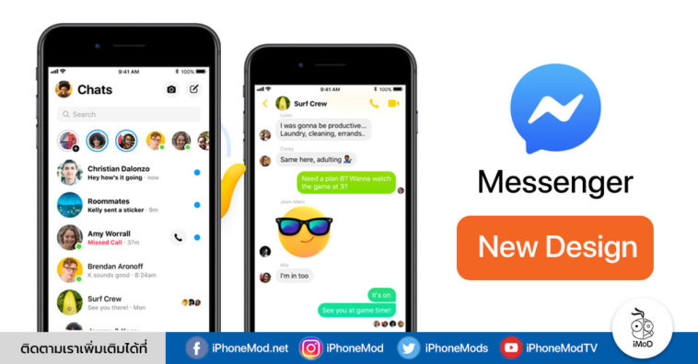
[Write what this shows of your digital life] DAILY USE PLATFORM .

My Short Reflection
- Write 5–8 simple sentences about your digital life.
- You can use the sentence starters below if helpful.
I am using digital tools in every time at my life. Such as mobile, computer and iPad. I feel confident and easiness when using digital equipment. I want to improve my skill to use the AI Technology. I hope this module will help me to fulfil my future goal. Digital skills help us to reach the destination of the digital era. That’s why it is very important for our daily life to get fully confidence and success.

Sentence starters
- I use digital tools to …
- I feel confident when I …
- I want to improve …
- I often use these tools: …
- I sometimes feel nervous about …
- I hope this module will help me …
- Digital skills are important for me because …
You can write more if you want.

Submission Checklist
Before you submit, please check:
​​​ ☒ I added 4–6 screenshots
☒ I wrote short sentences for each screenshot
☒ I wrote my short reflection
☒ My work is my own
☒ My file opens correctly
​​☒ My file opens correctly

