

Student name: FREDERICA OTENG -ANANE
Student ID:2427139

Module name: Introduction to Physioiogy
Module code: BMHP5023
Lecturer name: Shaila Hussain

Assessment: Type 2 Diabetes Management: A Practice Nurse Perspective on Blood Glucose Regulation, Monitoring and Lifestyle Interventions.

Introduction
This report is written from the perspective of a practice nurse in a GP surgery, addressing the increasing prevalence of diabetes among patients. It aims to improve patient understanding of the condition, support engagement with care plans and promote effective blood glucose management.
Diabetes mellitus is a long-term condition where the body cannot regulate blood glucose levels effectively due to problems with insulin production or action. Insulin, produced by the pancreas, allows glucose to enter cells for energy. When insulin is ineffective, glucose builds up in the bloodstream, causing hyperglycaemia and increasing the risk of complications (WHO, 2021). The two main types are Type 1 and Type 2 diabetes. Type 1 is an autoimmune condition where insulin-producing cells are destroyed, resulting in little or no insulin production. Type 2 occurs when cells become resistant to insulin and the pancreas cannot produce enough insulin. It is the most common form of diabetes and is often associated with factors such as excess weight, physical inactivity and age (NHS, 2025). This report focuses on Type 2 diabetes, as it is the condition presented in the case study.

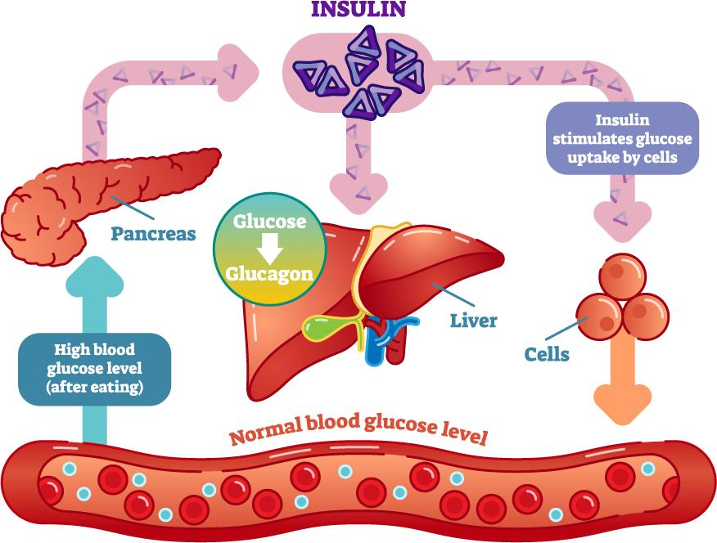
Figure 1. How insulin regulates blood glucose levels. Adapted from World Health Organization (2021).
Risk factors for Type 2 diabetes
The risk factors for Type 2 diabetes can be divided into non-modifiable and modifiable factors. Non-modifiable risk factors include increasing age, a family history of diabetes, and certain ethnic backgrounds. People of South Asian, Black African, Black Caribbean, Chinese and Middle Eastern heritage are at a higher risk of developing Type 2 diabetes, often at a younger age than the general population (Diabetes UK, 2024).
Modifiable risk factors are those that can be changed through lifestyle choices. These include being overweight or obese, particularly carrying excess weight around the abdomen, being physically inactive, eating a diet high in processed foods, saturated fats and added sugars, smoking, and drinking excessive amounts of alcohol. These factors increase insulin resistance, making it more difficult for the body to regulate blood glucose levels (NICE, 2022). Identifying and addressing these risk factors is important because many cases of Type 2 diabetes can be prevented or delayed through healthy lifestyle changes (Diabetes UK, 2024).
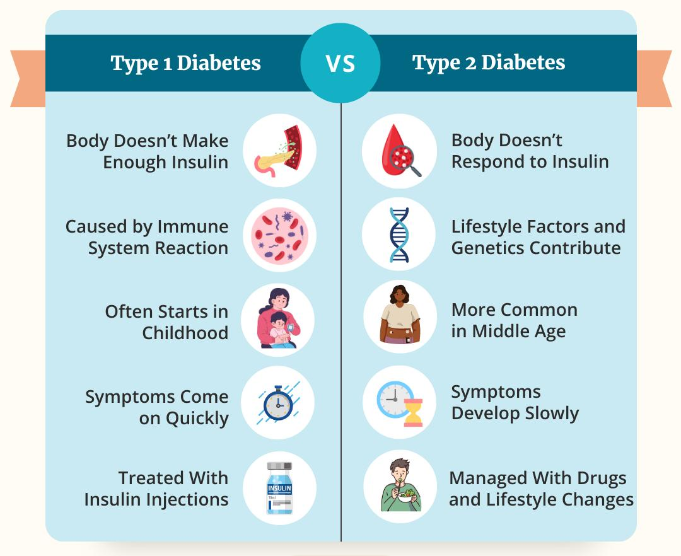
Figure 2. Comparison of Type 1 and Type 2 diabetes. Adapted from Diabetes UK (2024).
Importance of patient education: Patient education is an essential part of diabetes care in a GP surgery because it helps individuals understand their condition and take an active role in managing it. Educating patients about healthy eating, regular physical activity, medication, blood glucose monitoring and recognising symptoms enables them to make informed decisions about their health. This can improve blood glucose control, reduce the risk of complications and improve overall quality of life (NICE, 2022).

Blood Sugar Regulation
Homeostasis is the body's ability to maintain a stable internal environment despite changes inside or outside the body. One important example is regulating blood glucose levels. In healthy adults, fasting blood glucose is usually maintained between 4 and 6 mmol/L. Keeping blood glucose within this range ensures that body cells, particularly the brain, have a constant supply of energy (NHS, 2025).
If blood glucose rises too high (hyperglycaemia), glucose remains in the bloodstream and can damage blood vessels, nerves, kidneys and eyes over time. If blood glucose falls too low (hypoglycaemia), the brain does not receive enough glucose, which may cause dizziness, confusion, sweating or loss of consciousness. The body maintains blood glucose through a negative feedback system, involving the pancreas, liver and the hormones insulin and glucagon.
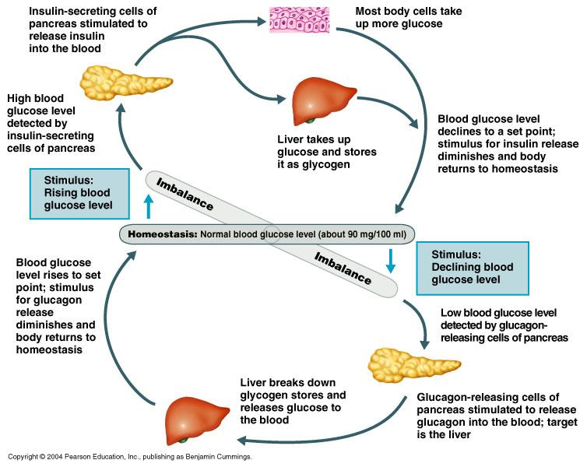
Figure 1. Negative feedback regulation of blood glucose. Adapted from NHS (2025).
After eating, carbohydrates are broken down into glucose, causing blood glucose levels to increase. Specialised beta cells in the pancreas detect this rise and release insulin into the bloodstream. Insulin binds to receptors on muscle and fat cells, allowing GLUT4 transporters to move to the cell surface and transport glucose into the cells, where it is used for energy. The liver also removes excess glucose from the blood and stores it as glycogen for later use. As glucose is taken up by cells and stored, blood glucose levels return to the normal range, completing the negative feedback process (Diabetes UK, 2024).
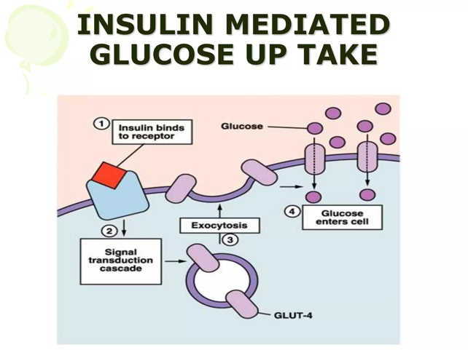
Figure 2. The role of insulin after a meal. Adapted from Diabetes UK (2024).
During fasting, exercise or between meals, blood glucose levels begin to decrease. Alpha cells in the pancreas detect this change and release glucagon. Glucagon signals the liver to break down stored glycogen into glucose (glycogenolysis) and release it into the bloodstream. The liver can also produce new glucose from non-carbohydrate sources through gluconeogenesis. These processes increase blood glucose back to a normal level, helping to maintain homeostasis (NICE, 2022).
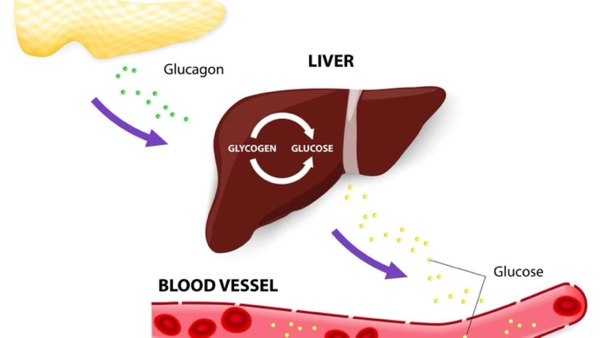
Figure 3. The role of glucagon during fasting. Adapted from NICE (2022).
In Type 2 diabetes, body cells become resistant to insulin, meaning they no longer respond effectively to its signals. As a result, glucose cannot enter the cells efficiently and remains in the bloodstream, causing persistent hyperglycaemia. In the early stages, the pancreas produces more insulin to compensate, but over time the beta cells become less effective and are unable to produce enough insulin. This means the body's normal feedback system can no longer regulate blood glucose effectively. In the case study, this explains why the patient requires ongoing monitoring, lifestyle changes and medication to maintain healthy blood glucose levels and reduce the risk of long-term complications (NICE, 2022; Diabetes UK, 2024).
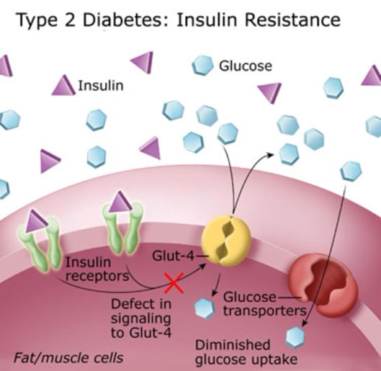
Figure 4. Blood glucose regulation in Type 2 diabetes showing insulin resistance. Adapted from Diabetes UK (2024).

Oxygen and Glucose in Cellular Metabolism
Cellular respiration is the process by which cells use glucose and oxygen to produce energy in the form of adenosine triphosphate (ATP). This process is known as aerobic respiration because it requires oxygen. ATP is the body's main energy source and is needed for essential functions such as muscle contraction, nerve transmission, active transport and cell growth (OpenStax, 2022).
The overall equation for aerobic respiration is:
Glucose + Oxygen → Carbon dioxide + Water + Energy (ATP)
(C₆H₁₂O₆ + 6O₂ → 6CO₂ + 6H₂O + ATP)
Without ATP, cells cannot perform the functions required to keep the body alive.
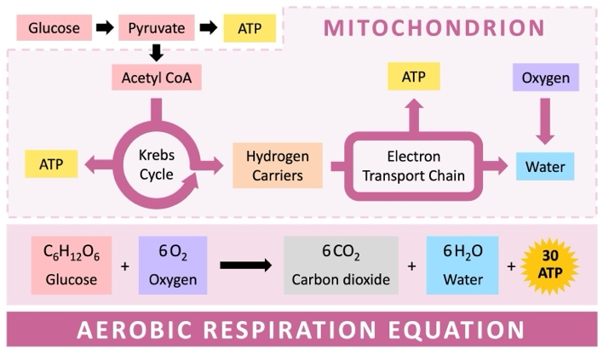
Figure 5. Overview of aerobic respiration. Adapted from OpenStax (2022).
The main stages of aerobic respiration
Aerobic respiration occurs in three main stages. The first stage, glycolysis, takes place in the cytoplasm, where one glucose molecule is broken down into two molecules of pyruvate, producing a small amount of ATP and NADH. The second stage, the Krebs cycle, occurs in the mitochondria. Here, pyruvate is further broken down, releasing carbon dioxide and producing more NADH, FADH₂ and a small amount of ATP. The final stage, oxidative phosphorylation, also takes place in the mitochondria. Oxygen acts as the final electron acceptor in the electron transport chain, allowing large amounts of ATP to be produced. Overall, aerobic respiration generates approximately 30–32 ATP molecules from one molecule of glucose, making it a highly efficient process (Alberts et al., 2022).
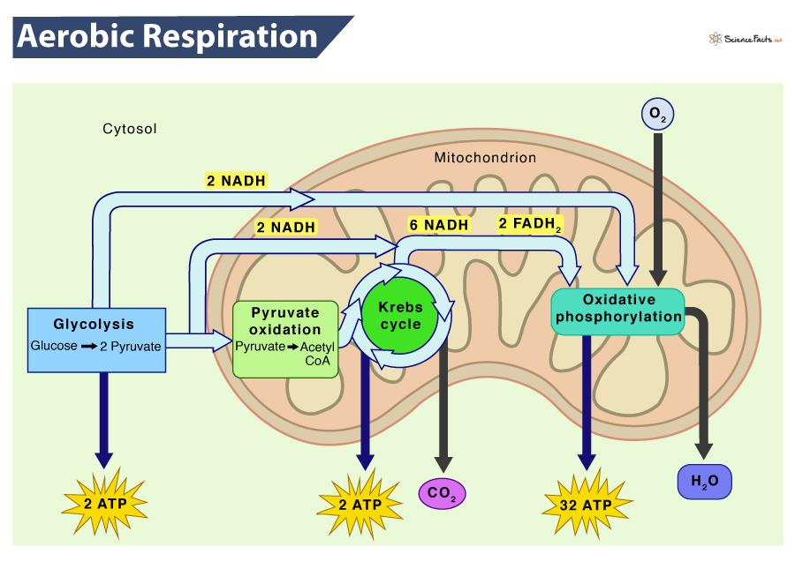
Figure 6. Stages of aerobic respiration within the cell. Adapted from OpenStax (2022).
When oxygen is unavailable, cells switch to anaerobic respiration. Instead of producing carbon dioxide and water, glucose is converted into lactic acid, generating only 2 ATP molecules. This provides a short-term energy supply but is much less efficient than aerobic respiration. Although anaerobic respiration is a normal response during intense exercise, poorly controlled diabetes can affect normal energy metabolism. In people with severe insulin deficiency, particularly those with Type 1 diabetes, the body cannot use glucose effectively and begins breaking down fat for energy. This produces acidic substances called ketones, which can lead to diabetic ketoacidosis (DKA), a serious medical emergency requiring urgent treatment (NICE, 2022). While DKA is less common in Type 2 diabetes, it can occur during severe illness or prolonged uncontrolled hyperglycaemia. Understanding cellular respiration therefore helps explain why maintaining normal blood glucose levels is essential for healthy energy production and reducing the risk of complications.

Recording and Tracking Blood Sugar Levels
Monitoring blood glucose is an important part of managing Type 2 diabetes because it helps both patients and healthcare professionals assess how well treatment is controlling blood glucose levels. One common method is self-monitoring of blood glucose (SMBG), where a small drop of blood from a finger-prick is tested using a blood glucose meter. This provides an immediate blood glucose reading, helping patients understand how food, exercise and medication affect their glucose levels (Diabetes UK, 2024).
Why is consistent tracking important for patient safety and care plan management?
Regular blood glucose monitoring helps patients identify patterns related to diet, physical activity, illness and medication, enabling them to make informed decisions about managing their condition. It also allows healthcare professionals to adjust treatment plans where necessary and reduce the risk of both hyperglycaemia and hypoglycaemia (NICE, 2022). In the case study, regular monitoring supports the patient's individualised care plan by providing accurate information during GP reviews. This helps the healthcare team evaluate treatment effectiveness, encourage self-management and empower the patient to take an active role in controlling their diabetes. Consistent monitoring can improve long-term blood glucose control and reduce the risk of diabetes-related complications.

Evidence-Based Lifestyle Recommendations
Lifestyle changes are a key part of managing Type 2 diabetes because they can improve blood glucose control, increase treatment effectiveness and reduce the risk of long-term complications. Evidence-based interventions focusing on diet, physical activity and smoking cessation should be incorporated into an individualised care plan to support patient-centred diabetes management (NICE, 2022).
Diet has an important role in controlling blood glucose levels in people with Type 2 diabetes. Current guidance recommends a balanced diet that focuses on improving overall nutritional quality rather than following a single restrictive diet (Diabetes UK, 2024). Choosing low glycaemic index (GI) foods, such as wholegrains, vegetables, beans and pulses, can help reduce rapid increases in blood glucose because these foods are digested and absorbed more slowly. Reducing the intake of refined carbohydrates and added sugars, including sugary drinks, sweets and highly processed foods, can help prevent significant blood glucose fluctuations and support weight management. Portion control is also important because the amount of carbohydrate consumed directly affects blood glucose levels. Evidence suggests that a Mediterranean-style diet, which is high in vegetables, fruit, wholegrains, healthy fats such as olive oil, and lean sources of protein, may improve glycaemic control and cardiovascular health in people with Type 2 diabetes (American Diabetes Association, 2024). For the patient in the case study, dietary advice should be personalised and developed collaboratively with healthcare professionals, ensuring recommendations are realistic and achievable.
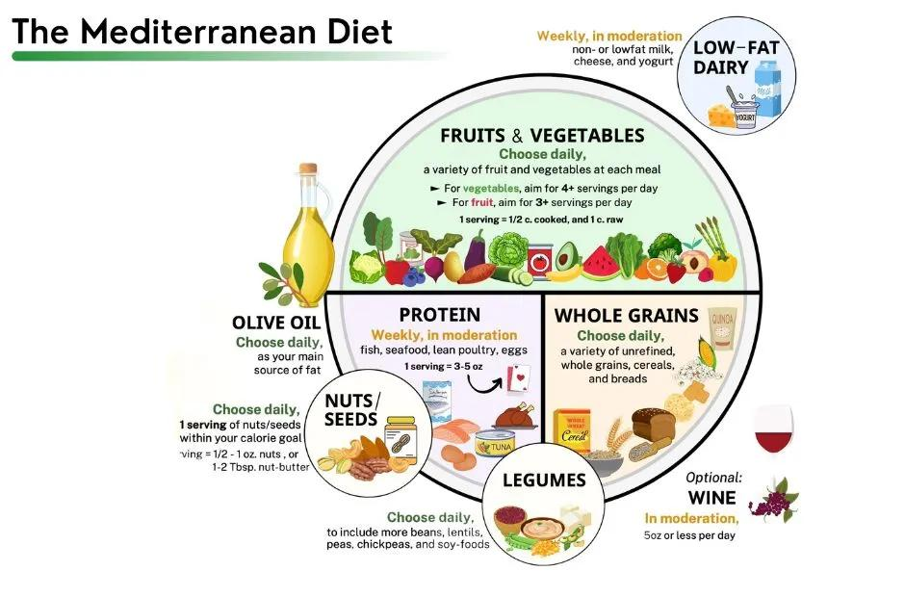
Figure 8. Examples of healthy dietary choices for Type 2 diabetes. Adapted from Diabetes UK (2024).
The role of exercise
Regular physical activity is strongly recommended for people with Type 2 diabetes because it improves insulin sensitivity, allowing glucose to enter cells more effectively and reducing blood glucose levels. Exercise also supports weight management and improves cardiovascular health, which is particularly important because diabetes increases cardiovascular risk. Guidelines recommend that adults aim for at least 150 minutes of moderate-intensity aerobic activity per week, such as brisk walking or cycling, alongside resistance exercise on two or more days per week (NICE, 2022). Aerobic exercise improves cardiovascular fitness, while resistance training increases muscle mass, which can improve glucose uptake. Combining both types of exercise provides the greatest benefit.
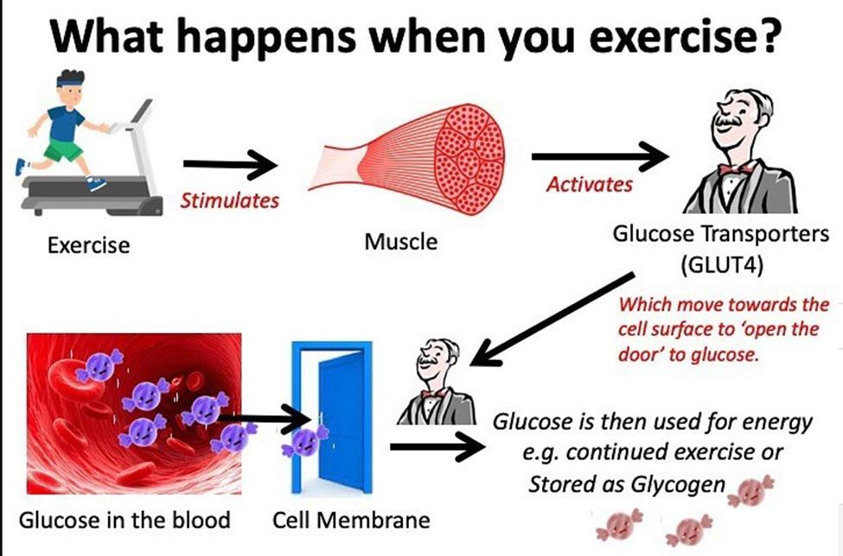
Figure 9. Benefits of physical activity in Type 2 diabetes. Adapted from NICE (2022).
Impact of smoking on diabetes management
Smoking negatively affects diabetes management because nicotine can increase insulin resistance, making it more difficult for the body to control blood glucose levels. Smoking also significantly increases the risk of cardiovascular disease, which is already elevated in people with diabetes (WHO, 2023). As part of a practice nurse role, patients should be offered non-judgemental smoking cessation support, including advice, behavioural support and referral to NHS Stop Smoking Services where appropriate. Supporting smoking cessation can improve overall health outcomes and reduce the risk of diabetes-related complications (NICE, 2022).

Conclusion
This report has highlighted the importance of understanding the physiological processes involved in Type 2 diabetes, including the regulation of blood glucose through the hormone’s insulin and glucagon, and the role of glucose and oxygen in cellular respiration to produce energy. In a healthy individual, these processes work together to maintain homeostasis; however, in Type 2 diabetes, insulin resistance disrupts normal blood glucose control, resulting in persistent hyperglycaemia. Effective management of Type 2 diabetes requires a combination of regular blood glucose monitoring, appropriate medical treatment and positive lifestyle changes. In the case study context, monitoring methods such as blood glucose testing and HbA1c assessments allow healthcare professionals and patients to identify patterns, review treatment effectiveness and make informed decisions about care plans.
Overall, the key message is that Type 2 diabetes can be managed effectively through patient education, self-management and partnership with healthcare professionals. By understanding their condition and making sustainable changes to diet, physical activity and lifestyle behaviours, patients can improve their blood glucose control, reduce the risk of complications and maintain a better quality of life.

Reference List
- Alberts, B., Johnson, A., Lewis, J., Morgan, D., Raff, M., Roberts, K. and Walter, P. (2022) Molecular Biology of the Cell. 7th edn. New York: Garland Science.
- American Diabetes Association (2024) Standards of Care in Diabetes—2024. Available at: https://diabetesjournals.org/care (Accessed: 2 August 2026).
- Diabetes UK (2024) Eating well with diabetes. Available at: https://www.diabetes.org.uk/living-with-diabetes/eating (Accessed: 2 August 2026).
- Diabetes UK (2024) Managing diabetes. Available at: https://www.diabetes.org.uk/about-diabetes (Accessed: 2 August 2026).
- Diabetes UK (2024) Type 2 diabetes. Available at: https://www.diabetes.org.uk/about-diabetes/type-2-diabetes (Accessed: 3 August 2026).
- Higgins, C. (2023) Blood glucose laboratory testing and interpretation. Available at: https://acutecaretesting.org (Accessed: 3 August 2026).
- National Institute for Health and Care Excellence (NICE) (2022) Type 2 diabetes in adults: management (NG28). Available at: https://www.nice.org.uk/guidance/ng28 (Accessed: 3 August 2026).
- NHS (2025) Type 2 diabetes. Available at: https://www.nhs.uk/conditions/type-2-diabetes/ (Accessed: 3 August 2026).
- OpenStax (2022) Biology 2e. Houston, TX: OpenStax. Available at: https://openstax.org/details/books/biology-2e (Accessed: 3 August 2026).
- World Health Organization (WHO) (2021) Diabetes. Available at: https://www.who.int/news-room/fact-sheets/detail/diabetes (Accessed: 3 August 2026).
- World Health Organization (WHO) (2023) Tobacco and diabetes. Available at: https://www.who.int (Accessed: 3 August 2026).

