Strategic Management for SMEs

Rasheda Begum
1814351

Paul Bocij

Contents

Contents
1. Introduction 3
2. The Works Plc Vision and Mission 4
2.1 Porters 5 Forces 5
3. Pestle and SWOT anaylsis 9

1. Introduction

Strategic management is a process that involves the ongoing plans, monitors, and analyses and assesses all the fundamentals in an organisation to meet the goals and needs. For any organisation to be successful strategies to be constantly assessed to meet the requirements and demands of the business (Tucci, 2007).
The industry searches for the growth option in order to develop the business success and business performance strategies need to be in place in order for the business to grow and tackle and issues that arise. The small and medium sized business organisations tend to work on their business success while working for the growth in the competitive business markets (Ray Gehani, 2013).
The chosen company for this task is my current employer The Works PLC. The Works is a medium sized business with 527 stores as of July 2021, around the UK and Ireland. The Works also has its own ecommerce through its online platform, and increase their revenues through Marketplace like Amazon and Ebay.
The Works Plc started in a garage where they were selling extra books at a discounted price, and at that point called Remainders. The Works, best known for selling their discounted books arts and crafts also offers their customers a loyalty card system. The Works have competitors such as Hobbycraft and WHsmiths.
The Works is a perfect company to use as an example where strategic management best demonstrated and the hurdles they came across to be where they are today. The Works is now trading on the stock market and became a PLC in 2018. I have worked with the company for the last 8 years and have seen the changes as it has grown from 1500 employees to 3600+ employees. The works takes the 13th place in the ‘The best company to work for survey’ bringing in a turnover of £180.7m FY21.
The report will demonstrate the understanding of strategic management; discussed in detail by using tools such as Porter’s 5 Forces and SWOT analysis. The report will explain three possible strategic growth options using the tools SAFe.
The report will end with a conclusion to the findings with relevant references attached.

2. The Works Plc Vision and Mission

Creating a mission is an imperative to begin with in the process of strategic planning process.
A competent mission statement defines the fundamentals, purpose and the scope of the business’s operations including products and market terms.
An effective statement helps to appease the customer needs, to produce something that is worthwhile and gain recognition while competing with the competitors.
A mission statement can be the most visible and public component of a strategic plan.
Research shows that there are 8 specific components of mission statements:
- The designated target customer markets.
- The testimony of principal products or services.
- Geographic domain.
- Recognition of core technologies.
- Commitment to survival, growth and profitability.
- Key elements in organisation’s ideology.
- Self-concept.
- Desired public image

A vision explanation depicts what a company wants to attain within the long run, for the most part in a time outline of five to ten a long time or now and then indeed longer. It portrays a vision of what the company will see like within the future and sets a characterized course for the arranging and execution of corporate-level methodologies.
In spite of the fact that researchers have long considered how pioneers communicate vision and values to set up a sense of reason, they have ignored how leaders use these messages to set up a shared sense of reason, which is accomplished when numerous workers have the same understanding of the reason of work (Andrew M, 2017).

The Works mission is to offer customers a unique and enjoyable shopping experience, built on our core principles of value, variety and quality.
The Works business model underpinned by the company’s values:
- We are Crafty - we are creative and agile, we are able to adapt to change and be smart about what we do, with the resources we have. It's what makes us unique.
- We are Caring - We care about each other as one team. We care about our customers, our products and every penny we spend. Caring about the things we do is at the heart of our work ethic.
- We are Can-do - Predicting, reacting, improving and bringing all hands on deck. Whatever the situation, we rise to it because of the Can-do spirit and resilience we all share.

2.1 Porters 5 Forces

The 5 powers of competitive advantage, as sketched out by Porter, endeavour to clarify how firms can accomplish Competitive Advantage within the industry they have a place as well. Whereas this hypothesis is certainly appropriate to a fair degree, it is not free from its restrictions (Anchit G, 2020).
However Professor Micheal E.Porter (2008, 0:50 3.30) points out that the five forces may be useful when competition and profitability is what drives the underlying structure, it fails to understand that the points highlighted do not benefit multi-channel businesses the effect of technology and internet has a significant importance on this model.
Porters 5 forces helps to analyse the organisations place in the current market compared to other organisations. The model aids the organisation to display possible threats (Wright,2021).

Five Forces Analysis ( Porter )

Competitive Rivalry :
- Number of competitors – The Works has two major competiors
Hobbycraft and WHsmiths
- Bringing in majority of our products from China, compromises with the quality of products that are made in the UK.
- Switching costs over which covers closing down stores in areas where sales are decreasing.
- Customer loyalty, this is very important to The Works as they ensure customers get their valued items along with a loyalty scheme that allows them to get further discounts off their purchases.
- Costs of leaving the market – currently The Works has had an increase in their revenues since the pandemic starte, as people wanted to stay occuopied and bought books and jigsaw puzzles along with arts and crafts. Although they closed all their stores during this difficult time the company increased their revenues through their online platform.

Threat of New Entry :
- Time of cost of new entry
- Specialist knowledge of products and customer needs
- Economical challenges – in the pandemic loss from store closure and staff going on furlough, stores being open in areas of poor growth and sales.
- Cost advantages - bringing items from China at a cheaper price, go green in the workplace by recycling more.
- Technology protection – GDPR, PCI are in place to protect customers personal information.
Supplier Power:
- Number of suppliers – The Works’s main supplier comes from China and anything after that are the UK based suppliers.
- Size of Suppliers – this can easily be affected, in the pandemic the company suffered loss as many suppliers were out of stock and we could not fulfil customer orders.
- Uniqueness of service – the companies creativity and low prices makes it difficult for customers to keep away.
- Ability to substitute – The company has many opportunities in the form of new authors and craftsmanship so bringing in alternative items is no big issue.
- Cost of changing – The company is well prepared for changes, as the pandemic hit the economy, the company adapted to changes and got head office from working from home, managed to supply every employer with a laptop and other elemens that were needed to make the transition easy.

Threat of Substitution:
- The performance of substitution
- Cost of change – Underlies the issue of will the change work pro’s and con’s considered.
Buyer Power:
- Number of customer – The company has two platforms of customers, the online customers and the in-store customers both bringing in revenues.
- Size of each order – this matters customer to customer as the company also has B2B customers in the form of schools, councils and other businesses.
- Difference between competitors – In the form of promotions what is The Works offering that competitors are not.
- Price sensitivity – The company offers the best deals in their choice of books, deals like 10 for £10 is a best seller online and in-store.
- The higher bargaining power of the buyers can bring a higher challenge for the company in the competitive markets (Islami et al., 2020).

The five forces analysis reflects the companies mission and vision, it clearly demonstrates the strategy the company is following by adapting to changes when needed, the pandemic made the company move all 550 employees from their head office to working from home. The strategy was to still run the ecommerce side of the business with no further distruptions while the 550 stores remained closed. The company has a clear vison to what is sold and who the target market is with the conscience of their revenues by fair pricing their items with a profit margin.

3. Pestle and SWOT anaylsis

The PESTLE investigation is utilized for commerce assessment purposes and is one of the foremost utilized models within the assessment of the outside commerce environment that's profoundly energetic (Gupta,2013)
The clear assessments of the external and internal environmental factors can indicate the potential threats and opportunities in the market.
PESTLE analysis for The Works is as follows:
Political:
Political choices will affect The Works. With political pressure, the company must regulate abiding these rules, which may be out of control. Impacts on tax increase and Brexit, which had a severe impact on suppliers supplying goods on time. Increase taxes means increase in price while trying to maintain a heathy profit margin without affecting the stakeholders.
Economic:
Economic factors can have an effect on customer buying trends as inflation increases but customers have a decreased disposable income. The Works always keeps their prices into consideration and understand that the strategy to increase revenue is to drive the customers into the store or get the customer to browse on the website, offering promotions and to keep the RRP lower than the competitors. The Works has a loyalty scheme, which allows further discounts for their customers.
Social Factor:
Factors that affect this, the changing customer needs and the way they purchase the goods through their buying decision through their perception all contribute towards the profits and sustainability of the business (Surono et al, 2020).
During the pandemic, customers relied on purchasing through the website, as stores remained closed. Customers that only shopped in store had to use the online store, by creating an account online and placing orders through this avenue. Time and circumstances changes people’s perception and that is why during the pandemic web sales were at its peak during this time.

Technological:
Due to the expansion of technology, the company launched their new e-commerce platform in 2012.
The company then launched their loyalty card scheme in 2013 and in 2016 reached 1 million members for their loyalty scheme.
The company gained more recognition after the launch of their website and selling through marketplace. Using social media platforms like Facebook and Instagram that advertise products and allows customers to share their craft ideas helps build a fan following and creates publicity.
Having the latest phone system GCI and a new updated system Salesforce helps navigate through customers account and orders with ease. With a click of a button, all customer details brought up on the screen.
Legal:
The Works follow regulations when it comes to employment, discrimination and health and safety laws. Procedures followed correctly, training and development given when necessary.
Employees in store and the ones serving at the helpdesk for the online shop all are trained and are compliant to consumer’s data under the GDPR law.

SWOT stands for Strengths, Weaknesses, Opportunities, and Threats. Strengths and weaknesses are inside to your company—things that you just have a few control over and can alter. Cases incorporate who is on your group, your licenses and mental property, and your location. Opportunities and dangers are external—things that are going on outside your company, within the bigger advertise. You will be able take advantage of opportunities and ensure against dangers, but you cannot alter them. Illustrations incorporate competitors, costs of crude materials, and client shopping patterns (Parsons’, 2021).
Research supports SWOT analysis as a tool for planning purposes, research over the last few decades have illustrated that SWOT focusses on analysing the recommended strategic actions within the company (Helms, 2010).

SWOT analysis internal and external

STRENTGHS | WEAKNESSES
Established organisation  Instore and online service  Services offered  Delivery options, click and collect  Minimum wage increase  Loyalty Scheme 1M members  Value for money goods  Adapted to the pandemic diverted all sales through online platform  Multi-channel shopping eg Marketplace Amazon and Ebay. | Pandemic impacted the delivery of instore services  Pandemic disrupted the suppliers supplying  Due to Brexit cost of supplies have gone up  Due to the pandemic closure of stores loss in revenues/ staff on furlough.  Courier company failing to deliver goods on time  Cyber hacking possible
OPPORTUNITY | THREATS
To expand and open new stores  Innovation as technology expands  Bring in new software to make purchasing easier for the consumer  Developing more team leaders and managers  To develop a bigger brand  Increase product range | Suppliers can withhold stock/lack of supplies  Suppliers prices increase  Employee’s retention  Store closure  System failure- customers unable to place orders or make payment  Couriers not delivering within timeframe  Profit/loss and chargebacks  Product quality may not reach customer satisfaction

The PESTLE and SWOT analysis both illustrate that The Works is in a better position; even throughout the pandemic, the business took revenues like never expected. Occupying millions of people during this difficult time. The company used strategic management to allow employees to work from home allowing the business to run smoothly without disrupting sales and making higher profit margins. The gap for opportunities will always be open as time moves on technology will advance to a new product or service that the company will adapt to.

4 STAKEHOLDER ANALYSIS

The company has diverse partners associated to the commerce who have control, interest, and challenges for the commerce (Sakurai et al., 2019). The trade methodology permits the organisation to interface the partners and to attain the commerce objectives. The stakeholder analysis can help the association to assess the desires of the partners.

The Works PLC, have many stakeholders. The mains stakeholders are as below:

The above clarifies the stakeholders of the company. These individuals play a role and have an impact on the performance of the company. The aim is to keep all stakeholders informed of any changes in products, services and overall company policies and procedures that includes performance.
The Works currently support Cancer Research UK and organise many charity events to raise funds including the local community and employees to participate in many local events.

Stakeholder matrix grid

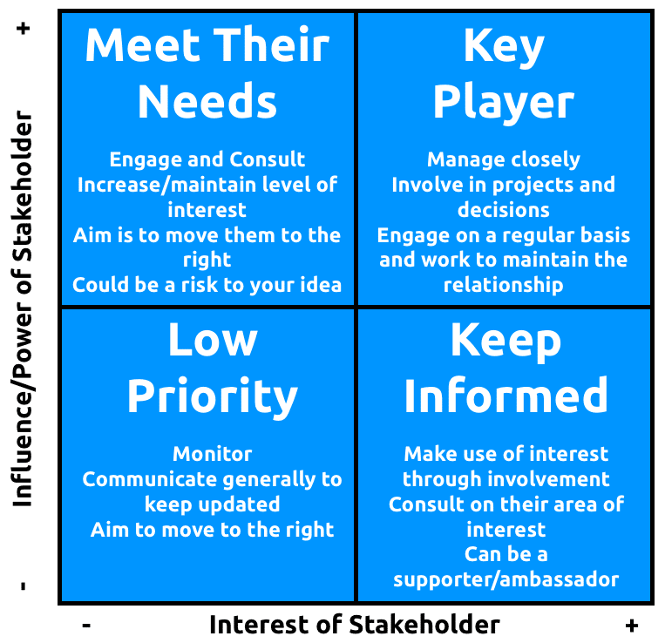

Stakeholder power – grid is a framework that demonstrates the stakeholders and their category of importance in respect to their input into the company. The framework shows stakeholders interest and the impact it has on the business with power and ability (Li et al, .2019).
The company would need to assess the position and power of the stakeholders to be able to make decisions in the business.

5. Strategic growth options

As mentioned earlier, the possible strategic growth for The Works PLC could be to be more flexible with their delivery options and maybe offer same day delivery like Argos offer. This will give the customers more flexibility when shopping. The Works will need to allow their website to be more user friendly especially after the new 3D secure payment option.
They can offer virtual trouble shooting videos for customers to visit when they come across any problems such as payment issues, cannot link loyalty card or any account complications; this will allow customers to resolve the issue themselves and will free any customer service traffic coming through in the form of calls and emails.
Customers should be able to cancel an order online within a designated timeframe to avoid disappointment, currently they will email in or call customer services to cancel the order but this is not always guaranteed especially if the order was placed over the weekend.
The plan to open bigger stores to allow access for disabled customers with wheelchairs, currently this is a problem in many stores and to navigate around them is difficult resulting in many complaints.
The chosen strategy will help the business navigate into a troublesome free zone as customers face many technical issues which results in loss of sales.
The company will need to invest in a more real time software where inventory is live and accurate quantities recorded. Currently customers face out of stock issues when placing orders resulting in refunds and unsatisfactory customers.
The company offers a Click and Collect service allows customers to collect from store next day if the product is available or 3/5 days on a delivery service if the order fulfilled by the warehouse.
The company will benefit in offering a service where stock be transferred between stores or where customers can reserve available stock in stores and then make payment when collecting the item. This service will give the customer more freedom of choice when shopping.
Ansoff Growth Vector:

There are many strategies available for companies to gain the long-term facilities and opportunities. The Ansoff growth vector represents the different types of strategies that are available for the company’s growth.

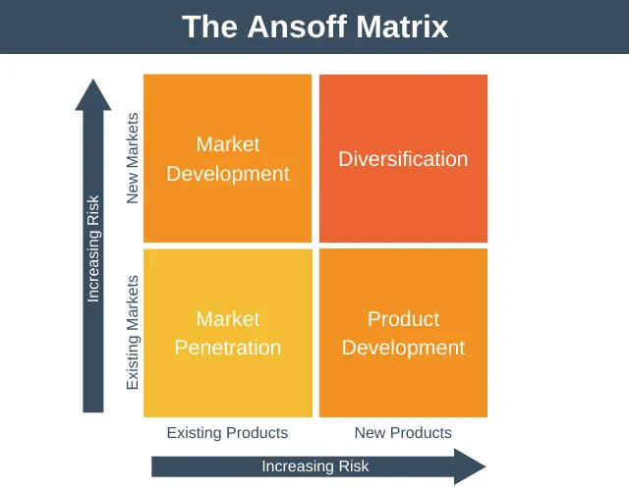

According to this matrix, there are only two essential options available to companies that want to grow: changing what’s sold (product growth) and or changing whom sold to (Market growth).
When both combined into a matrix, the options result in four strategic options, each with a different level of risks and reward.
- Market Penetration Strategy – This is where the company tries to grow the market share of its existing products.
- Market Development Strategy – This is where the company tries to grow by taking its current products to new markets
- Product Development Strategy – This is when the company tries to grow by taking new products to its existing market.
- Diversification Strategy – This is where the company tries to grow by creating new products and taking them to new markets.
The Works believes in bringing in new items but takes them to its existing market, like other retailers The Works tried bringing in electrical products for the home but resulted in low demand for sales. The Works is better known for the items it sells such as books and crafts and therefore its best interest is to stay in that field and bring on new titles for books or new craft items.

6 Recommendations

The company can research on many better options while they continue to bring in new products for the business. The Works has a diversity strategy to grow in the market to target existing and new customers. The company can use social media platforms to promote products and promotions.
To implement the suggested option to have virtual trouble shooting videos for online issues with the website and customers should be able to cancel their own orders, within a period of placing the order.
The IT and web support departments will look at all possible issues that can come across when a customer places an order. Dummy issues investigated thoroughly when creating the trouble shooting videos to ensure no aspect of any foreseen problem not been addressed.
Many issues that arise when placing an order, most commonly address issues, customer’s old address used and they only realise after the order placed. This is when the cancellation feature should be available to customers to avoid disappointment when they call in later and realise the order cannot be cancelled causes further frustration and admin work for the advisor and customer, resulting in call backs.
Investing in the right technology and software that is user friendly and safe for the customers The Works will rely on this to offer customers reliable trouble shooting advice.
The Works understands the needs of the customer and promotes their goods in relation to this. The trend changes and the company is always ready to move with the trend.

7 Competitors

The competitive market can bring in many challenges and to overcome them all is very difficult without investing in the correct manner. Research and development is really important as this will outline all risk factors along with opportunities that can be developed further to gain sustainability and profitability for the company.
The additional cost of the new service that implemented on the website, notified to all stakeholders. Only after a thorough check with all the pros and cons and with the list of benefits to the customer and the company, presented for approval.
The figures will reflect, after collating all information to how many customers are afflicted with the issue and how often the problem arises to be able to implement change with the hope that there are no issues further.
External specialists may be required to implement the extra feature on the website making sure that all cyber security is maintained and the company is not compromising with customer’s details.

8 Conclusion

The Works Plc is a very well established company that is willing to grow bigger and better. They survived the pandemic by using strategies that did not affect the business by making the correct decision at the right time.
The company is placed 13th in the Best Company To Work For Survey 2021. The company is very biased and knows its market very well. The company has allowed to recognise through its values and vision. The loyalty card scheme works extremely well having 1m members to date.
Their target customers are from toddlers to the elderly there is something for everyone at The works.
The business needs to steadily bring in new ideas to the market without disrupting the current customer group.

8. References

Academy of Management https://journals.aom.org/doi/10.5465/ambpp.2014.274
https://corporatefinanceinstitute.com/resources/knowledge/strategy/vision-statement/
https://www.emerald.com/insight/content/doi/10.1108/17554251011064837/full/html
https://expertprogrammanagement.com/2022/01/the-ansoff-matrix/
Goyal, A. (2021). A Critical Analysis of Porter’s 5 Forces Model of Competitive Advantage.
Retrieved from http://doi.one/10.1729/Journal.25126
Gupta, A, 2013. Environmental and pest analysis: An approach to external business environment.
Islami, X., Topuzovska Latkovikj, M., Drakulevski, L. and Borota Popovska, M., 2020. DOES DIFFERENTIATION STRATEGY MODEL MATTER? DESIGNATION OF ORGANIZATIONAL PERFORMANCE USING DIFFERENTIATION STRATEGY INSTRUMENTS – AN EMPIRICAL ANALYSIS. Business: Theory and Practice, 21(1), pp.158- 177.
John A. Pearce, II and Fred David, 1987: Corporate Mission Statements: The Bottom Line. AMP, 1, 109–115, https://doi.org/10.5465/ame.1987.4275821
Li, J., Zhang, F. and Sun, S., 2019. Building Consumer-Oriented CSR Differentiation Strategy. Sustainability, 11(3), p.664.
https://www.liveplan.com/blog/what-is-a-swot-analysis-and-how-to-do-it-right-with-examples/
Ray Gehani, R., 2013. Innovative Strategic Leader Transforming From a Low-Cost Strategy to Product Differentiation Strategy. Journal of technology management & innovation, 8(2), pp.144- 155.
Sakurai, Y., Yuki, Y., Katsuki, R., Yazane, T. and Ishizaki, F., 2019. Quantum-Inspired Weighting Approach to Correlation Diversified Passive Portfolio Strategy. SSRN Electronic Journal,.
Surono, S., Suryanto, T. and Anggraini, E., 2020. Comparing Cost Leadership Strategy with Differentiation Strategy towards Firm Performance on Jakarta Islamic Index. The Winners, 21(1), p.35.
https://www.techtarget.com/searchcio/definition/strategic-management
Wright, G (2020) How to apply Porter’s 5 Forces model to your SME marketing plan

