TATA Steel
Applying Lean Techniques
Analysing and applying lean techniques to the blast furnace coke screen cleaning process.

Williams, Jessica (P149177)


Contents Page

Introduction_________________________________________________________________ pg.1

Types of Waste_______________________________________________________________pg.2

Customers Perspective_________________________________________________________pg.4

Evaluating a leaner coke screen cleaning process____________________________________pg.5

Potential problems with implementing improvement_________________________________pg.7

Conclusion __________________________________________________________________pg.8

Introduction
This assignment will analyse the Coke Screen cleaning process at TATA Steel in the Blast Furnace department. Recommendations to make the task leaner are suggested and this report addresses a number of different issues associated with the process. The types of waste currently occurring are considered, value from a customer’s perspective, evaluating how the process can become leaner and problems implementing leaner improvements. As Patel and Patange (2017, pg. 249) state ‘The goals in implementing the lean manufacturing are lower production costs; increased output and shorter production lead times’. Although lean production is widespread and most businesses seek to apply it, failure of lean techniques will result from a lack of a clear grasp of lean performance and its measures. It is impossible to manage lean without monitoring its results (Durakovic, 2018).
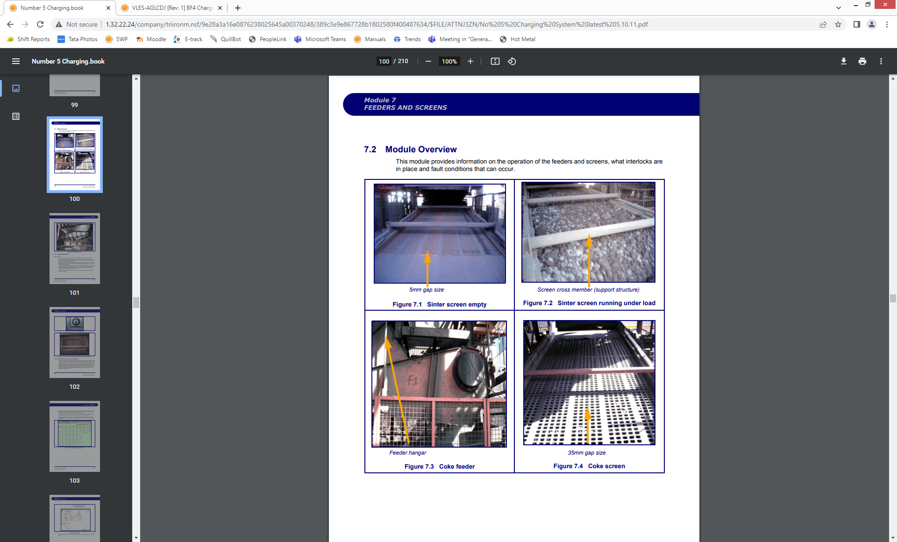
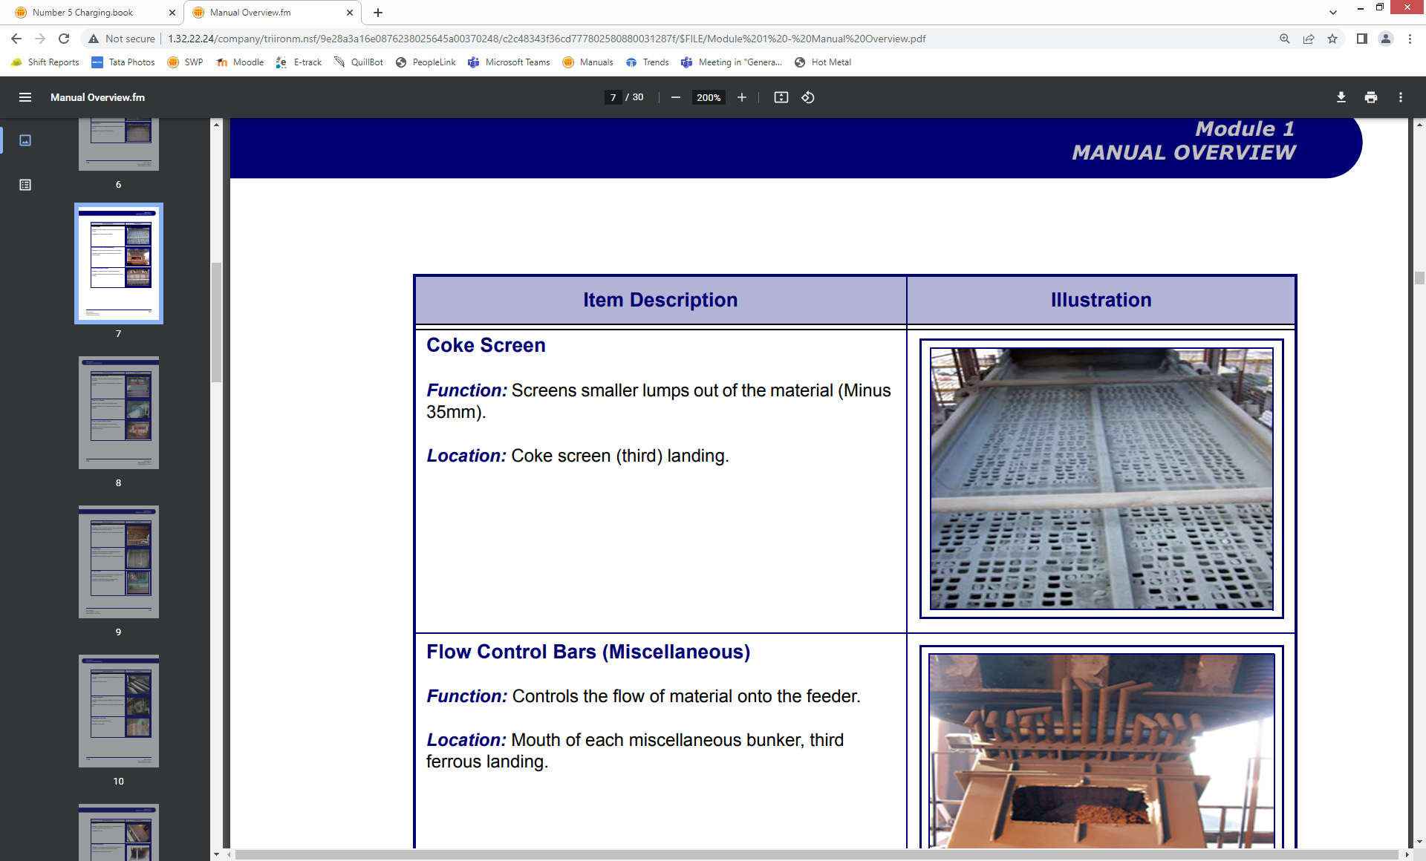
Types of waste currently occurring in Coke Screen cleaning process
Clean Coke Screen
Blocked up Coke Screen
This next section highlights the waste occurring in this process currently.
To keep the coke screening system running well, the screens must be cleaned on a regular basis since the holes become clogged with the finer coke. This should be done in the following manner:
1. Check that the screen and feeder are both electrically isolated.
2. Enter the screen through the gates on the side behind the guards and use a hammer or specially modified object to knock through all the holes until the screen is clear of obstructions.
In this process any coke <35mm will fall through the gap, if these screens are not cleaned regular, coke of all sizes will be discharged into the furnace. As Geerdes, Chaigneau and Lingiardi (2020) state, the specific size of coke is essential for providing structure for gas to ascend, generating heat, reducing gases and providing carbon. The undersize coke would be used in the furnace but as a nut coke.

There are several wastes that can be recognised within the coke screen cleaning process, examples of these are shown below. In the UK, companies had issues implementing lean and those who did implement had a less than 10% success rate according to Leksic, Stefanic and Veza (2020) however, a difficult interpretation of lean is its capacity to overcome the efficiency dilemma, changing a company's focus from resource utilization to flow performance (Fercoq, Lamouri and Carbone, 2016).
Defects- Inefficient screening of coke. The product as stated before needs to be of a certain size, if the coke screens are not cleaned this allows “defected” coke to enter the process. This waste can come from different standards from employees cleaning the screens or damage to the screen that is not picked up on inspection/ irregular maintenance.
Overproduction- In this process overproduction is not as relevant as the other wastes as coke fines are a by-product that can be reused in the process as coke nuts.
Waiting- Employees have to wait for the control room to give them confirmation that they are okay to isolate the screen so it does not hold up production, waiting for other material batches to complete their discharge and for the coke weigh hopper to fill up which can mean standing around idle for some time.
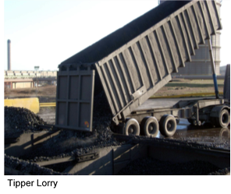
Non-value added processing, transportation and motion- These all link in this process due to the amount of movement in getting the coke to that blast furnaces in the first place. The coke is screened at the coke ovens, then there is potential breakdown when the coke is delivered to the furnaces via tipper trucks, stored in bunkers and screened again. The physical layout of cleaning the coke screens is not ideal as you have to lean over the screen, standing on top of coke spillage, also the coke ovens is 1.5 miles away from the furnaces.
Employees- Knowledge, skills and abilities- The employees who clean the coke screens may not be fully aware of the consequences of not cleaning the screens efficiently, also not all are trained to isolate the screens and feeders which requires electrical engineers to potentially leave a job to isolate.
Energy and Environment- Screening produces a lot of dust which enters the atmosphere, also when screening is not efficient it causes spillage. A lot of resources are used to maintain the screens, using a lot of energy. This links into inventory, there needs to be a balance between stocking spares for the screens and providing inventory when it is needed.
Customers Perspective
Due to the process being analysed in this assignment, the customer in this case is ultimately the blast furnace. Having a stable process is essential to producing the desired crude iron quality that can be processed further along in the supply chain at the BOS plant. Fine material can have a significant negative impact on the condition of the furnace with regards to the internal reduction process, i.e.
the aim is to have a resultant coke with high mechanical strength under the blast furnace conditions. This is to prevent an excessive formation of coke fines during its descent in the blast furnace.
Geerdes, Chaigneau and Lingiardi (2020, pg.55)
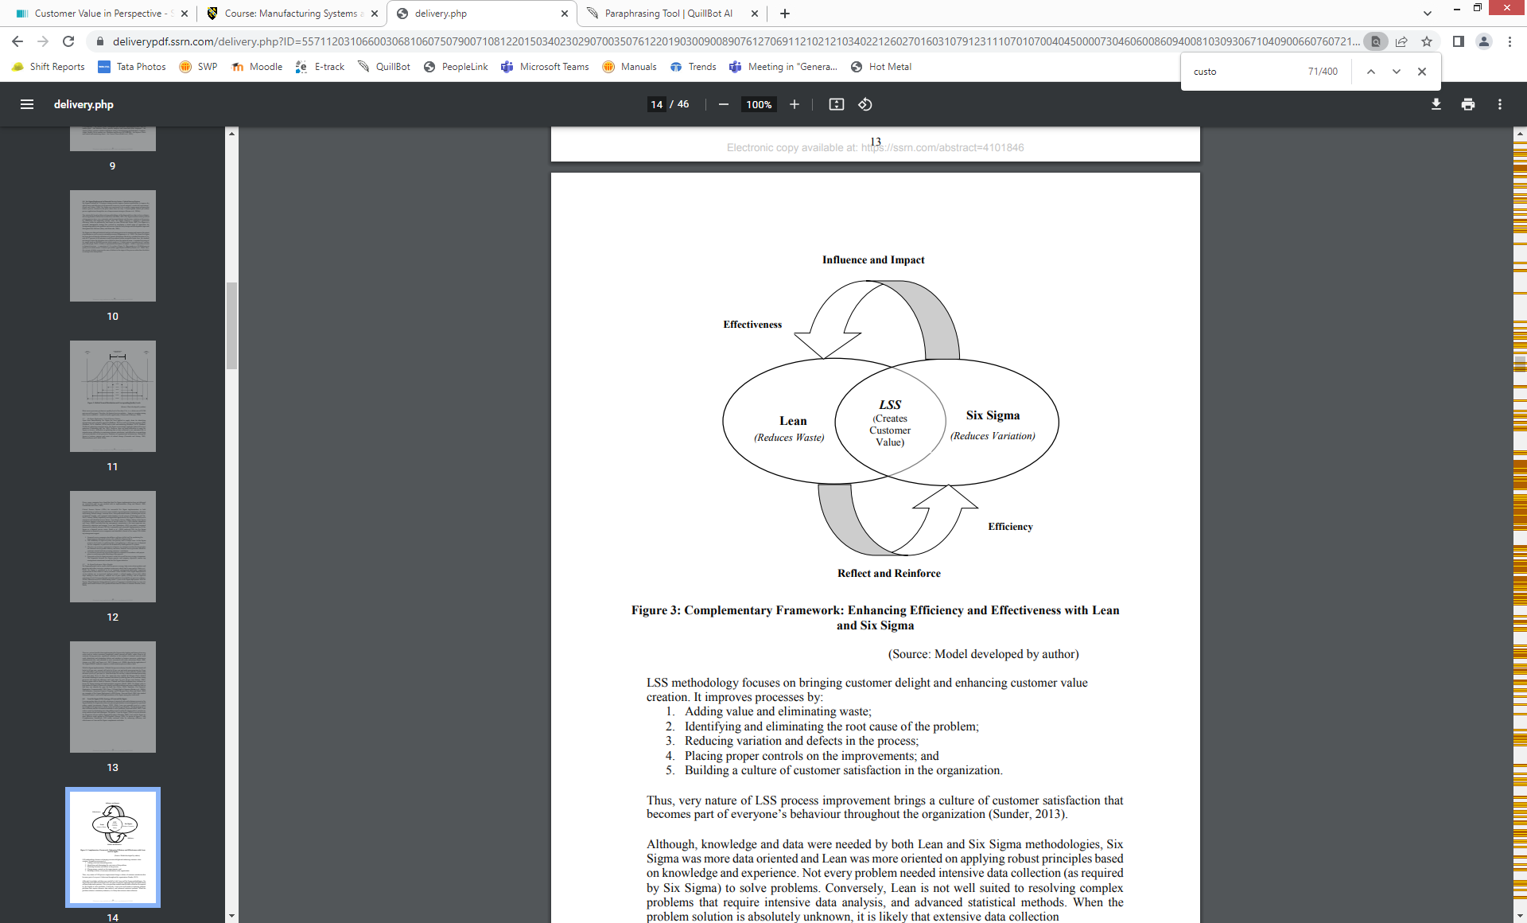
There are also the personnel directly involved in this process such as the operators/service crew who carry out the coke screen cleaning and contractors who carry out cleaning of any spillage out on plant.
(Madhani, 2018, pg.14)
As Hayes and Pisano (1996) state, to thrive in this competitive market, businesses must adopt an operations plan for ongoing improvement, which includes developing the capacity to manage operations at the lowest possible cost, with higher reliability and speed, and with a greater opportunity to modify.
Currently, there are a number of factors that can be considered as valuable and not as valuable to the customer within the coke screen cleaning process. A small number of these are discussed below. Firstly, the current process is a simple system only requiring an emergency stop and lock-off isolation with the method requiring one tool to complete the task. The process can be controlled and monitored throughout the shift with ownership placed on the service crew who carry out the cleaning.
Currently, it does not reduce time on the blast furnace process as the screen must be isolated for the safety of the service crew personnel as they must enter a guarded area (materials are constantly running 24/7 unless the furnace is shut down (when the screen is isolated no material can be processed)- communication with the control room is essential. The current process is not open to change/ adapt to new modern technology due to the financial cost and is only carried out once a shift (12hrs) so more efficient cleaning with only two service crew personnel across two furnaces is not possible. However, overall the value is created from removing fines from the iron making process which as stated above is important for quality.
As lean focuses on shorter lead times, high quality and low cost, it is clear that all of these are not satisfied in this process currently. Low cost is the only factor that is being achieved, however it is important to consider that to satisfy the other two factors more money must be spent.
Evaluating a leaner coke screen cleaning process
To start lean thinking it is important to have a controlled approach if the key principles of lean are to be functional in the new process (Melton, 2005). How does the process work now? What value to we currently get from the process and eliminating the waste. Once the problems within the process have been identified, the process can be re-designed and then the testing and development stage can begin. The coke screen process could be made leaner by focusing on a number of process improvements. The next section of this assignment will evaluate where this process can be made leaner.
- Automation
This would have a number of benefits to the process, for example, tolerances can be set and closely monitored, alerting operators if there is an issue with the cleaning, a machine could be installed to fit into the coke screen mats <35mm coke and push the finer coke through the screening mats. This would remove the need to take the service crew off as job, more efficiently and frequently. Automation would require investment initially but the returns would be seen in the quality of the iron/blast furnace process reliability ( money saved on a stable process). Worker safety would be increased as there would be no need for intervention unless requiring maintenance. However, as Malik and Bilberg (2019) state, automation does not replace the employees work it just adapts it. It may cause new demands such a constant monitoring, when a system is automated employees can become complacent and expect it to work for extended periods of time.
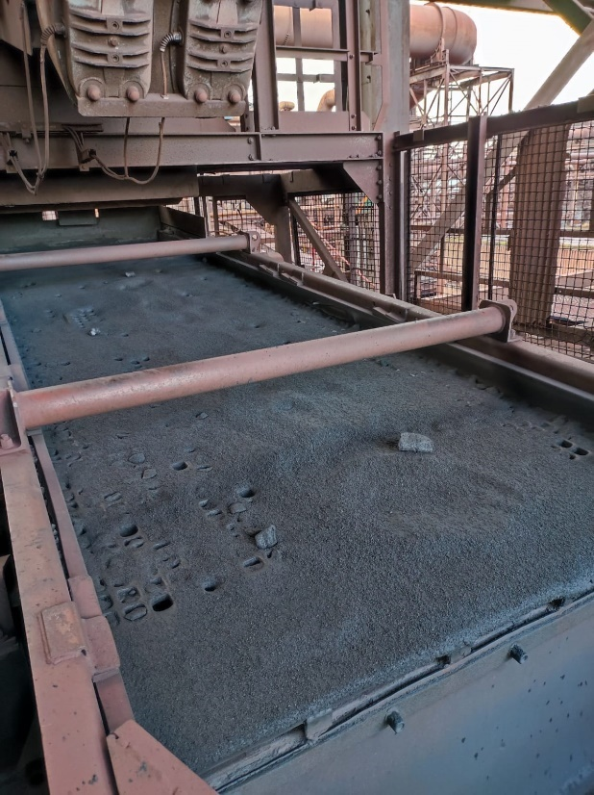
- Waste Reduction
The current process uses up resources (employee time), this would link into having the process automated. The current process is not adapted to the condition of the raw material entering the system for example, if the coke is wet arriving at the furnaces (raining while transporting the material) the coke screens are still only cleaned once per shift but the screens block up more frequent to the point where no screening is occurring. This problem also can overburden the service crew meaning they spend more time/ not having the tools to remove the fines efficiently. The screens also can become defected, spilling coke over the top of the screen potentially causing production delays if it needs to be taken out of batching for a period of time. As processes move towards modern methods, processes should be made simpler for workers, not time consuming and labour intensive.
- Continuous Improvement
This is an essential step in making the process leaner, it helps to focus on continuing to produce as usual but looking for opportunities to cost save and cut time. For example, having the coke screened just before being discharged into the furnace and not twice before getting to the furnaces. For the process to be made leaner it should involve more than just the employees directly involved in the process. For example, different company managers taking the same educational courses as their staff members. However, informally discussing everyday production issues takes up some of their free time, the phrase is "Walk-Observe-Communicate" (WOC). When local adaptation is required, cultural characteristics of the work and how individuals view themselves are crucial. Unions may contribute significantly to the process of improvement, aiding the business in maintaining its profitability (Holtskog, 2013).
Potential problems with implementing improvement
This next section will look at the potential problems that could be experienced while implementing leaner processes referring to the coke screen cleaning process. As discussed below, lack of training, resistance, time, cultural barriers and cost all impact improvement.
One of the biggest barriers is knowledge. A lack of training, understanding of lean and not knowing how to implement lean practices are all factors contributing to unsuccessful implementation. As Kumar and Kumar (2014) state, in most circumstances, having the notion that Lean Manufacturing is just a strategy for increasing supplies to customers by cutting waste is a misunderstanding of Lean Manufacturing that becomes a greater impediment. This is considered a barrier for Lean deployment by focusing on certain tools rather than reaping the overall advantages of Lean Manufacturing adoption. It is important that employees understand how the process of cleaning can affect the blast furnace process and how it is an important step, training on lean concepts can allow employees who are working out on plant and observing processes suggest leaner operations.
Resistance to change and culture can also be problematic when implementing lean. It is critical to incorporate planning, monitoring, and sharing gains, as well as providing essential resources, while designing a lean implementation programme. For example, communication of new process and automating the coke screen cleaning process requires engagement, the coke screens have been cleaned in the same way for years and change would cause resistance, however managerial time needs to be spent to empower employees (Lodgaard et al, 2016). Lean implementation is therefore a technique for altering culture over time, by selectively and gradually implementing lean tools that are situationally relevant for that organisation at the time, followed by additional deployment later when the culture has caught up. It would be best to implement coke screen cleaning automation gradually (only implement one at a time) so any problems can be overcome before changing all screening.
The current process is cheap but the outcome of the process is not producing the quality that the process needs, the process could be carried out more frequently however, there is not enough manning to do so. A big step in making the process lean would be to automate the process however, this would be costly. Not only would spares be needed, training on the new machinery would be required, constant monitoring and strict safety measures. The new process could either be automatic at certain times of the day or a button pressed to stamp down and push the coke fines through the screen mats. An example of some of the costs of screening instrumentation are as follows: a back plate, feed box, screen frame clamping bars and lifting beam would cost the business £117,568.00.
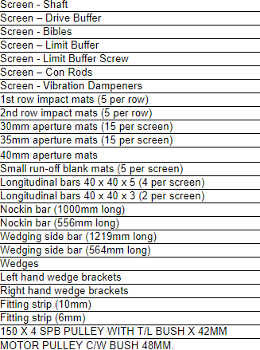
Spares for coke screens include:

Currently, the coke screen mats (30mm apertures) are £144.05 each and there are 15 of these on each coke screen =£2160.75.

Conclusion
To conclude this assignment, the coke screen cleaning process is a simple process that is cost effective to the business, however it can be made leaner in a large steel making business using a small percentage of investment. For further research on this subject a project can be developed on automating this process which would result in a decrease in wait time, higher quality of fuel and stability in the furnace providing stable furnace conditions. Monitoring of the process would still be required however, the risk to the employees’ health would be decreased as intervening with he cleaning process would be minimal unless breakdown of machinery occurred. Overall, creating value from processes can help businesses thrive, benefitting from a tedious task that is essential to blast furnace operations.
References
Durakovic, B., Demir, R., Abat, K. and Emek, C. (2018) ‘Lean Manufacturing: Trends and Implementation Issues’, Periodical of Engineering and Natural Sciences, 6 (1), pp. 130-143.
Fercoq, A., Lamouri, S., Carbone, V. (2016) ‘Lean/Green integration focused on waste reduction techniques’, Journal of Cleaner Production, 137, pp. 567–578.
Geerdes, M., Chaigneau, R. and Lingiardi, O. (2020) Modern Blast Furnace Ironmaking An Introduction. 4th edn. IOS Press: The Netherlands.
Hayes, R.H. and Pisano, G.P. (1996) ‘Manufacturing strategy: at the intersection of two paradigm shifts’, Production and Operations Management, 5( 1), pp. 25-41.
Holtskog, H. (2013) ‘Continuous improvement beyond the lean understanding, Procedia CIRP, 7, pp. 575-579.
Kumar, R., & Kumar, V. (2014) ‘Barriers in implementation of lean manufacturing system in Indian industry: A survey’, Int J of Latest Trends Eng Technol, 4(2), pp.243–251.
Leksic, I., Stefanic, N. and Veza, I. (2020) ‘The impact of using different lean manufacturing tools on waste reduction’, Advances in Production Engineering & Management, 15 (1, March), pp. 81–92.
Lodgaarda, E., Ingvaldsena, J., Gammea, I.& Aschehouga, S. (2016) ‘Barriers to lean implementation: perceptions of top managers, middle managers and workers’, Procedia CIRP, 57, pp. 595-600.
Madhani, P. M. (2018) ‘Lean Six Sigma deployment in BFSI sector: synthesizing and developing customer value creation models’, International Journal of Electronic Customer Relationship Management, 11 (3), pp. 272-314.
Malik, A. and Bilberg, A. (2019) ‚ ‘52nd CIRP Conference on Manufacturing Systems’, Human centered Lean automation in assembly, CIRP 81, pp. 659-664.
Melton, T. (2005) ‘The benefits of lean manufacturing: what lean thinking has to offer the process industries’, Chemical Engineering Research and Design, 83(A6), pp. 662–673.
Patel, J. S., & Patange, G. S. (2017) ‘A Review on Benefits of Implementing Lean Manufacturing’, International Journal of Scientific Research in Science and Technology, 3(1), pp. 249–252.

