

Independent Technical Review — Proposed Explosive Storage Facility, Swansea Waterfront.
51.61818° N, -3.91886° W
Commissioned by: City and County of Swansea Council
Prepared by: Stephen McAngus, University of Wales Trinity Saint David.
1st December 2025
Version 1.0
Executive summary:
This independent technical review evaluates the planning application from BigBang Storage Solutions for five Earth-Covered Storage Houses (ESH) at a proposed site adjacent to Swansea Harbour. The review verifies the applicant’s Net Explosive Quantity (NEQ), examines compatibility segregation, and validates proposed Quantity–Distance (QD) zoning using the IATG QD methodology (IATG 02.20, 02.30, 04.10, 05.20), and proposes rectified Explosive Limit Licence’s (ELL’s)
Report key findings: (1)The NEQ claimed in the application presented by Big Bang Storage Solutions exceeds the storage capacity implied by 1,000 kg per ESH. (2) compatibility grouping as submitted would also significantly increase the number of ESHs or increase the NEQ per ESH and therefore alter the NEQ of the proposed license from Big Bang Storage Solutions. (3) IATG QD maps indicate that existing proposed stand-offs to inhabited / vulnerable buildings and public routes are inadequate for the confirmed NEQ and compatibility combinations. (4) New proposed limit licenses have been proposed in Annex D, where HD 1.1 has been removed from the license as nearby public infrastructure would prohibit the storage of HD1.1 explosives.
Immediate recommendations based off key findings: withhold planning approval until BigBang submits corrected NEQ accounting and revised storage layout demonstrating compliance with IATG QD and compatibility segregation; in addition to supplementary detailed emergency response plan and independent third-party OME verification.

Table of Contents
Table of Figures 1
Table of Tables 1
1. Introduction 2
1.2. Aim of review: 2
1.3. Objectives of review: 3
2. Methodology 3
2.1. Review of Applicant Documentation: 3
2.2. Verification of Stated NEQ and Storage Regime: 3
2.3. Compatibility Assessment Using IATG Mixing Rules: 3
2.4. Quantity-Distance (QD) Assessment and Mapping 4
2.5. Licensing and Regulatory Compliance Modelling 5
2.6. Risk Assessment Approach 5
2.7. Limitations and Uncertainties 5
3. Results & Discussion 6
3.1.Review of proposed plans 6
3.2 NEQ accounting and magazine capacity 6
3.2. Compatibility and aggregation effects 6
3.3. Quantity Distance (QD) analysis and zoning maps 6
3.6 Risk evaluation 7
ALARP Statement: 7
Risk Matrix (Severity vs. Likelihood) 8
4.0. Recommendations 8
4.1 Immediate – requiring urgent ratification prior to the issue of permissions to construct: 8
4.2 Short term – prior to the construction of site. 8
4.3 Medium term / Operational 9
5.0. Conclusions: 9
6.0 Appendices 9
Appendix A – QD Mapping based upon Big Bang storage solutions proposed storage regimes. 9
Appendix B - NEQ and capacity calculation spreadsheets. 9
Appendix C – Safety & risk-reduction questions for BigBang Storage Solutions 10
1. Siting, NEQ and Vulnerable Populations 10
2. RF and Electromagnetic Hazards 10
3. Marine Interface and Mooring Zone 10
4. Storage Configuration and Stacking Limits 10
5. Seawater Exposure and Corrosion 10
6. Transport, Traffic and Public Safety 11
7. Processing Facilities and Life-Cycle Assurance 11
8. Administrative, Welfare and Security Support Buildings 11
9. Security Measures in a High-Crime Urban Area 11
10. Provision of Fire-Fighting Facilities 11
11. Heating Controls and Electrical Safety in ESHs 11
12. Lightning Protection System (LPS) for Explosive Structures 12
Appendix D –proposed Explosive Limit License (ELL) based on the proximity of infrastructure and other building near to the proposed site. 13
Annex E: Additional calculations used to support this report 19
Calculating Inter-magazine distance (IMD) & conversions to coordinates 19
11. References 19

Table of Figures
Figure 1: Displays the compatibility mixing rules as outlined by IATG-01.50 Explosive Hazard Classification System [12]. 5
Figure 2: Displays the quantity distances for Hazard Division 1.1 (mass explosion hazard) based on the proposed quantities to be stored by BigBang Solutions. Red indicates the Vulnerable Building Distance (VBD), Orange denotes the Inhabited Building Distance (IBD), and the yellow line denotes the Public Routes and Transport Distance (PTRD). 12
Figure 3: Displays the quantity distances for Hazard Division 1.2.1 (Projection hazard – severe. e.g. artillery shells) based on the proposed quantities to be stored by BigBang Solutions. Red indicates the Vulnerable Building Distance (VBD), Orange denotes the Inhabited Building Distance (IBD), and the yellow line denotes the Public Transport Routes Distance (PTRD). 12
Figure 4: Displays the quantity distances for Hazard Division 1.2.2 (Projection Hazard - low velocity fragments, small munitions packaged appropriately such as hand grenades) based on the proposed quantities to be stored by BigBang Solutions. Red indicates the Vulnerable Building Distance (VBD), Orange denotes the Inhabited Building Distance (IBD), and the yellow line denotes the Public Routes Transport Distance (PTRD). 13
Figure 5: Displays the quantity distances for Hazard Division 1.3.1(Mass burning Hazard - High heat flux, violent burns) based on the proposed quantities to be stored by BigBang Solutions. Red indicates the Vulnerable Building Distance (VBD), Orange denotes the Inhabited Building Distance (IBD), and the yellow line denotes the Public Routes Transport Distance (PTRD). 13
Figure 6: Figure 5: Displays the quantity distances for Hazard Division 1.3.1(Mass burning Hazard - Low heat flux, less violent burns) based on the proposed quantities to be stored by BigBang Solutions. Red indicates the Vulnerable Building Distance (VBD), Orange denotes the Inhabited Building Distance (IBD), and the yellow line denotes the Public Routes Transport Distance (PTRD). 14
Table of Tables
Table 1: Displays a proposed storage regime that is feasible, but would require the ESH's proposed by BigBang Storage solutions to hold a higher storage licence. 7
Table 2: Displays a more optimised storage regime, which would require the construction of a further three ESH's to maintain compliance throughout the planned storage regime. 8
Table 3: defines a basic and holistic risk assessment based upon the proposed storage 10
Table 4: displays the ESH displacement within the planned PES proposed by Bigband Solutions Ltd, based on Longitudinal displacement mathematics. 24
Table of Equations
Equation 1: displays the IATG 20.20 definition of IMD using the Quantity Distance Scaling law. D = distance required from centre to centre. K = the IATG safety constant based upon the hazard division, and protective measure (in this instance, assumed protective measures of a standard Igloo construction, and worst case HD1.1 Mass explosive hazard. And W = the cube root of the total Net Explosive Quantity (NEQ) of explosives in Kilograms. It was established that an Igloo would be categorised as D3, therefore the K value of 3.6 was used. 6
Equation 2: displays how displacement in meters to degrees longitude at a given latitude was calculated for form Table 4. 24

1. Introduction
Swansea City and County Council have received a planning application that proposes the construction of an Potential Explosive Site (PES) on designated land within its administrative boundary along part of Swansea City’s sea frontage. This proposal was submitted by BigBang Storage Solutions. It specifically seeks permission to erect five Earth-Covered Explosive Storage Houses (ESH) intended for the storage of mixed classes of ammunition and explosive materials. An earther covered ESH is defined by IATG 04.10 as a ‘Igloo’ construction [1].
This type of construction is considered one of the safest means of constructing an ESH, as this type of structure is best designed to reduce the effects of sympathetic detonations between magazines [2] [3] [4]. The proposal also details that each ESH would be constructed without traverses, suggesting that quantity distance is adequate to not require a traverse [5]. The design described as having directional blast effects perpendicular to the expected source of explosion. Suggesting the point of failure for each ESH (i.e. the doors) will be perpendicular to one another, this in turn reduces the risk of sympathetic reactions between magazines in the event of an accidental initiation of the contents of one magazine [6] [7]. The total proposed Net Explosive Quantity (NEQ) for the facility is 7,500 kilograms, distributed across Hazard Divisions (HD) 1.1 to 1.4.
There are significant inherent risks associated with explosive materials and therefore the associated storage of such items. As a result this report shall detail an evaluation to ensure compliance with the International Ammunition Technical Guidelines (IATG). This assessment, will consider the principles that are outlined in IATG 02.20 (Quantity-Distance), IATG 02.30 (Storage of Explosive Substances and Articles), IATG 04.10 (Explosive Facilities – Siting and Design), and IATG 05.20 (Risk Management) [1] [8] [9]. The IATG guidelines are a set of internationally recognised standards that account for the safe storage, handling, and siting of explosive materials, ensuring that potential all hazards to personnel, the public, and infrastructure therefore risks are reduced to As Low As Reasonably Practicable (ALARP) [9].
The proximity of the proposed site to a coastal area and the nearby marina, and a busy city introduces additional public safety and operational considerations. This includes the potential exposure of densely populated areas and also critical infrastructure to Blast overpressure, fragmentation hazard, and other structural damage mechanisms characteristic of explosive events [10] [11]. As such, the review must not only verify the accuracy of the applicant’s proposed safety distances but also evaluate the wider implications for maritime users, transportation networks, and emergency planning. Therefore to demonstrate that the proposed PES can be safely integrated into the nearby surrounding environment adherence to the relevant IATG principles is crucial.

1.2. Aim of review:
The aim of this report is to identify and present the critical safety considerations associated with the construction of a PES located along the Swansea coastline at the following coordinates 51.61818° N, -3.91886° W.

1.3. Objectives of review:
- Critical review of Big Bang’s planning submission, storage schedule, statements on magazine capacity, compatibility codes as submitted, proposed QD distances for vulnerable/inhabited/public traffic routes, marina proximity notes.
- To provide advice and support to Swansea City and County Council advice, and stewardship to ensure critical safety parameters can be achieved between Big Bang Storage Solutions, and the local authorities.

2. Methodology

2.1. Review of Applicant Documentation:
All materials submitted by BigBang Storage Solutions were systematically reviewed, including the proposed site layout, ESH design descriptions, stated Net Explosive Quantity (NEQ) allocations, hazard division breakdowns, and storage regime assumptions. Each document was screened for internal consistency and cross-referenced against IATG requirements.

2.2. Verification of Stated NEQ and Storage Regime:
A simple quantitative verification process was applied to confirm the accuracy of the applicant’s declared NEQ:
- The proposed facility consists of five ESHs, each with a maximum permissible capacity of 1,000 kg, giving a total compliant storage capacity of 5,000 kg.
- The applicant’s stated NEQ of 7,500 kg was cross-checked against the per-magazine limits and total storage capacity.
- This verification confirmed that the planned storage regime exceeds the permissible capacity by 2,500 kg.
- The NEQ allocations were also checked against the declared Hazard Divisions (HD 1.1–1.4) to determine whether the total and per-building NEQ complied with IATG-defined storage constraints.
This stage established that the proposal was not NEQ-compliant under the existing five ESH configuration.

2.3. Compatibility Assessment Using IATG Mixing Rules:
A full compatibility assessment was conducted using the IATG compatibility tables for explosive substances and articles:
- All compatibility codes assigned to the proposed stores were analysed to determine whether mixed storage within the same ESH was permissible.
- Several compatibility codes identified in the submission are subject to non-mixing prohibitions, meaning they cannot be co-stored in the same magazine at any quantity.
- Under IATG rules, these incompatibilities require segregation into separate storage buildings to prevent cross-hazard escalation and violation of compatibility constraints.
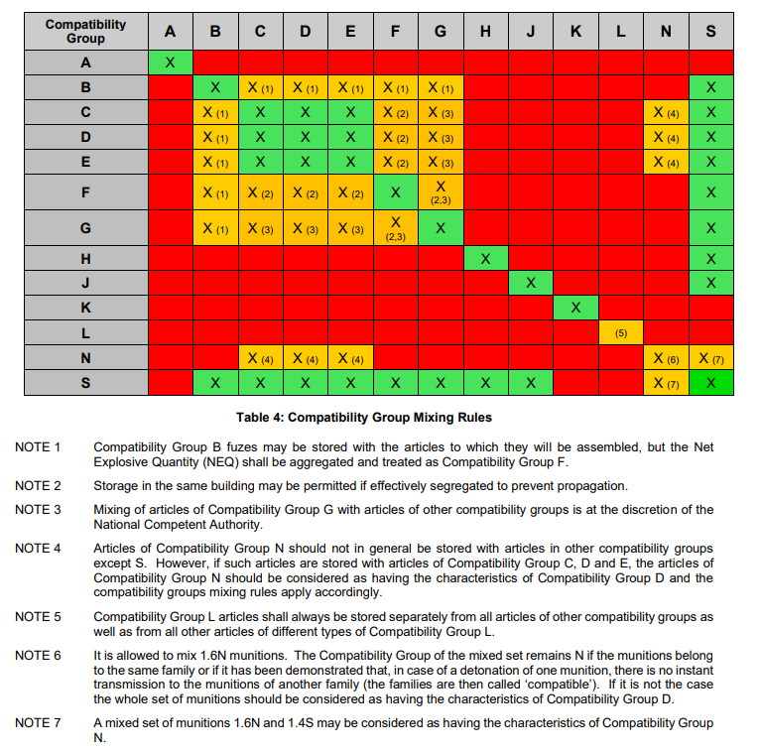
Figure 1: Displays the compatibility mixing rules as outlined by IATG-01.50 Explosive Hazard Classification System [12].
Based on this assessment, it was determined that a minimum of two additional ESHs would be required for the proposed storage configuration to become compatibility compliant.

2.4. Quantity-Distance (QD) Assessment and Mapping
QD distances were established using the official IATG Toolkit mapping utility. The following steps were completed:
- IBD (Inhabited Building Distance), VBD (Vulnerable Building Distance), and PTRD (Public Traffic Route Distance) were generated for the proposed NEQ values.
- QD arcs were modelled for each ESH individually and as combined explosive scenarios representing worst-case propagation conditions.
- Directional blast effects were considered where applicable, particularly in relation to the proposed ESH orientation, which incorporates a designed structural weak side intended to vent blast perpendicular to adjacent magazines.
- Directional blast adjustments were applied using the multipliers and principles specified in IATG 04.10 [1].
- Inter Magazine Distances (IMD) was calculated based on the stated NEQ of each magazine [8].
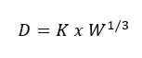
Equation 1: displays the IATG 20.20 definition of IMD using the Quantity Distance Scaling law. D = distance required from centre to centre. K = the IATG safety constant based upon the hazard division, and protective measure (in this instance, assumed protective measures of a standard Igloo construction, and worst case HD1.1 Mass explosive hazard. And W = the cube root of the total Net Explosive Quantity (NEQ) of explosives in Kilograms. It was established that an Igloo would be categorised as D3, therefore the K value of 3.6 was used.

This allowed for a spatial verification of whether the facility, as proposed, satisfied mandatory separation distances.

2.5. Licensing and Regulatory Compliance Modelling
The IATG Licensing Tool was used to assess:
- whether the proposed per-building NEQ (1,000 kg) aligned with licensing limits,
- whether the stated inventory and compatibility group distribution could be licensed within the existing building count,
- and whether the applicant’s proposed operational regime met siting and structural conditions.
The Licensing Tool confirmed that the applicant’s proposed storage configuration cannot be licensed under IATG rules without increasing the number of ESHs and reducing stored NEQ per incompatibility category.

2.6. Risk Assessment Approach
A combined qualitative and quantitative approach was applied in accordance with IATG 05.20 [9]:
- Risks relating to personnel, contractors, the general public, and surrounding infrastructure were evaluated.
- Consideration was given to the proximity of the coast, nearby marina, vessel transit routes, and urban exposure pathways.
- The risk analysis incorporated the effects of potential blast propagation, fire escalation, structural venting, and sympathetic detonation scenarios.
The risk characterisation was benchmarked against ALARP principles.

2.7. Limitations and Uncertainties
The assessment recognises limitations arising from:
- reliance on applicant-supplied data,
- absence of detailed structural drawings for the proposed ESH design,
- assumptions inherent in modelling tools (e.g., directional blast effect multipliers),
- and external variables such as vessel presence in the marina and public traffic volume variability.
These limitations are identified and managed within the bounds of the IATG risk-based framework.

3. Results & Discussion

3.1.Review of proposed plans
Based on the proposed plans submitted by BigBang Solutions to Swansea City Council several key failures have been identified. These failings have a high potential to severely impact the local community’s safety.

3.2 NEQ accounting and magazine capacity
- Present calculation table: claimed NEQ per HD vs. storage capacity 5 × ESH × 1,000 kg each = 5,000 kg total physical capacity.
- State the inconsistency: BigBang aims to store 7,500 kg total NEQ while magazine capacity (5 × 1,000 kg) indicates only 5,000 kg max storage — therefore the NEQ claimed exceeds their proposed built capacity by 2,500 kg.

3.2. Compatibility and aggregation effects
Summary of the compatibility codes breakdown: energetics of differing compatibility groups cannot always be stored with other energetics of a different compatibility group. This is predominantly due to a significant increase in the risk of unintended initiation during storage. When in storage there is a likelihood that a sensitive explosive such as 1.1A or 1.1B may lead to the initiation of more powerful explosives that are less sensitive such as 1.1D. As a result these compatibility groups must be segregated from one another to prevent the chance of united initiation.

Table 1: Displays a proposed storage regime that is feasible, but would require the ESH's proposed by BigBang Storage solutions to hold a higher storage licence.
Table 2: Displays a more optimised storage regime, which would require the construction of a further three ESH's to maintain compliance throughout the planned storage regime.
Whilst the aforementioned provides a mechanism for the storage of explosives on this site, neither of the two methods are ideal. In the first example, there would be the requirement to increase the licence conditions for individual buildings, which whilst possible, is not a recommended route to explore. In addition to this this route jeopardises site in terms of both compliance, and operability. The second option ensures compliance in storage and meets the planned 1000kg per ESH, however this also presents an issue with operability where BigBang solutions would be limited in terms of flexibility of storage and would risk breaching licence conditions.

3.3. Quantity Distance (QD) analysis and zoning maps
- Summary of QD modelling results: state which of BigBang’s declared distances are insufficient when the correct NEQ and compatibility effects are applied.
  - Vulnerable building distance claimed = 300m per ESH. Based on the QD mapping found in Annex A, the nearest Vulnerable Buildings are approx. 100m away from the PES. There is significant overlap, meaning that the storage of HD1.1 is not permissible. This is confirmed by the proposed licence found in Annex C. To store 1.1D the nearest Vulnerable building must be at minimum 430m away from the ESH.
  - Inhabited building claimed = 125m per ESH. Based on the QD mapping aforementioned the nearest potential Inhabited building is a warehouse adjacent to the proposed PES, this would be approximately 100m away from the PES, again limiting the storage of 1.1, 1.2.1, 1.3.1, and 1.3.2. This would limit the site to only store 1.2.2 (small munitions that packaged correctly produce low velocity fragments)
  - Public traffic route claimed: 270 m - Big Bang Storage solutions did not account for the density of traffic along the nearest route. Based on location, it’s estimated that Langdon Road would be classified as a medium density route, expecting 1-10 vehicles per hour. Whereas Fabian way is a major traffic route that connects Swansea City centre to both the extremities of Swansea, and the wider transport routes of Wales, as such this route would be classified as a high density route receiving approximately 10 or more vehicles per hour. In a worst case scenario where both routes are considered a high density route, then the PTRD provided by Bigbang is incorrect and is 240m away from the PES. This however must be confirmed by surveys of the traffic routes.

3.6 Risk evaluation
Mass-Explosion and Public Safety Risk: The presence of HD 1.1 (mass explosion hazard) introduces a significant and intolerable level of risk to the general public due to the potential for instantaneous, catastrophic blast effects. When combined with the proposed storage quantities of HD 1.2, the site continues to pose a substantial explosive fragmentation hazard capable of affecting persons, property, and critical infrastructure at considerable distances. Under the current proposal, these hazard divisions—particularly at the stated limits—create a level of inherent danger that exceeds acceptable thresholds without robust mitigation and verified separation distances.

ALARP Statement:
Based on the current documentation, several key controls (verified Quantity-Distance compliance, compatibility assurance, robust licensing, and emergency planning measures) have not been demonstrated. Consequently, the residual risk cannot be considered ALARP, as further feasible and reasonable precautions are clearly required to attain a tolerable level of safety.

Risk Matrix (Severity vs. Likelihood)
Table 3: defines a basic and holistic risk assessment based upon the proposed storage
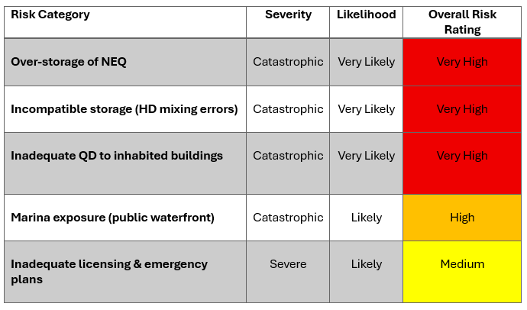

4.0. Recommendations
This report has identified several recommendations to propose to Big Bang Storage Solutions.

4.1 Immediate – requiring urgent ratification prior to the issue of permissions to construct:
- Require corrected NEQ accounting and an updated storage schedule demonstrating magazine capacity matches declared NEQ.
- Require segregation of incompatible sub-divisions per IATG compatibility tables; if segregation not feasible, reduce NEQ to a quantity that is permissible.
- Require resubmission of IATG-compliant QD maps showing combined NEQ and compatibility effects; do not accept claimed distances without verification.
- Require an independent OME expert verification (third-party) of the calculations and magazine designs.

4.2 Short term – prior to the construction of site.
- Revise layout so QD arcs do not encroach on inhabited/vulnerable buildings or public routes; or increase structural protection/earth cover to meet IATG directional provisions with validated calculations.
- Submit a comprehensive emergency response plan addressing marine evacuation, spill/fires, notification to harbour users, and coordination with local emergency services.
- Provide security and transport management plan, this should detail routeing, timing and transport safety.
- Obtain final licences/authorisations showing IATG compliance.

4.3 Medium term / Operational
- Periodic audit and reconciliation of NEQ inventory, with records accessible to the Council/authority.
- Training exercises for emergency services with the site operator that include marine scenarios.
- Operational management planning accounting for harbour transport.

5.0. Conclusions:
There are significant and apparent errors with the proposed licence produced by Big Bang Solutions, not limited to NEQ mismatch, compatibility hazard, insufficient verified QD distances, and marina exposure. The findings of this report conclude the facility should not be approved in its current form. Key areas of concern lay within the scope of proposed storage of HD1.1, and the NEQ proposed of HD1.2.1, where the proposed storage could put untrained persons (members of the public) in significant risk that would not be deemed as low as reasonably practicable.
It would be permissible to store HD, 1.2.2, 1.3.1, and 1.3.2, however the quantity would be many magnitudes lower than what was provided by BigBang Storage solutions.

6.0 Appendices
List appendices and what they contain. Keep the safety questions appendix separate and stand-alone as you requested.
- Appendix A — IATG QD mapping outputs (high-resolution maps, GIS layers, screenshots from IATG tool)
- Appendix B — NEQ and capacity calculation spreadsheets (showing per HD totals, per-magazine allocation, and mismatch calculations)
- Appendix C — Safety & risk-reduction questions for BigBang Storage Solutions (stand-alone) — see full text below
- Appendix D — Licence conditions and information requirements based upon the BigBang Solutions 1000kg/ESH.

Appendix A – QD Mapping based upon Big Bang storage solutions proposed storage regimes.
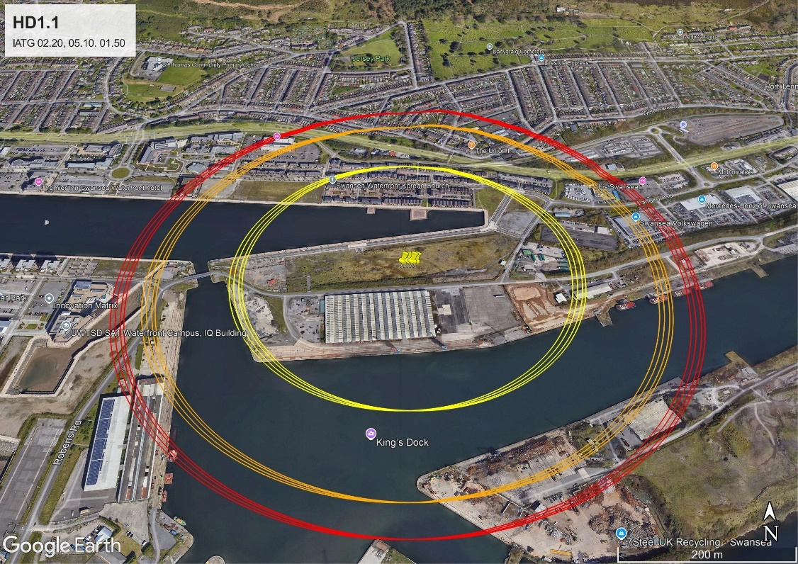
Figure 2: Displays the quantity distances for Hazard Division 1.1 (mass explosion hazard) based on the proposed quantities to be stored by BigBang Solutions. Red indicates the Vulnerable Building Distance (VBD), Orange denotes the Inhabited Building Distance (IBD), and the yellow line denotes the Public Routes and Transport Distance (PTRD).
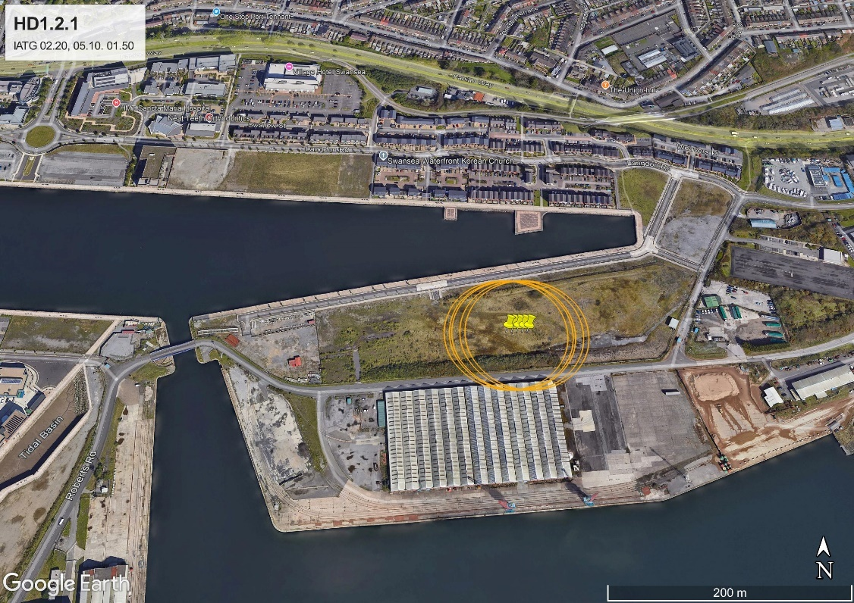
Figure 3: Displays the quantity distances for Hazard Division 1.2.1 (Projection hazard – severe. e.g. artillery shells) based on the proposed quantities to be stored by BigBang Solutions. Red indicates the Vulnerable Building Distance (VBD), Orange denotes the Inhabited Building Distance (IBD), and the yellow line denotes the Public Transport Routes Distance (PTRD).
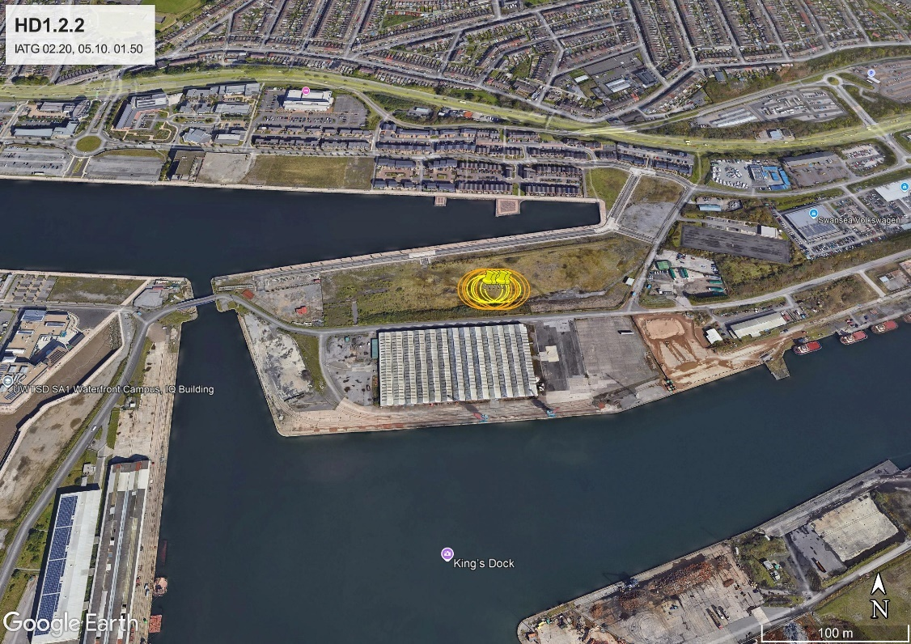
Figure 4: Displays the quantity distances for Hazard Division 1.2.2 (Projection Hazard - low velocity fragments, small munitions packaged appropriately such as hand grenades) based on the proposed quantities to be stored by BigBang Solutions. Red indicates the Vulnerable Building Distance (VBD), Orange denotes the Inhabited Building Distance (IBD), and the yellow line denotes the Public Routes Transport Distance (PTRD).

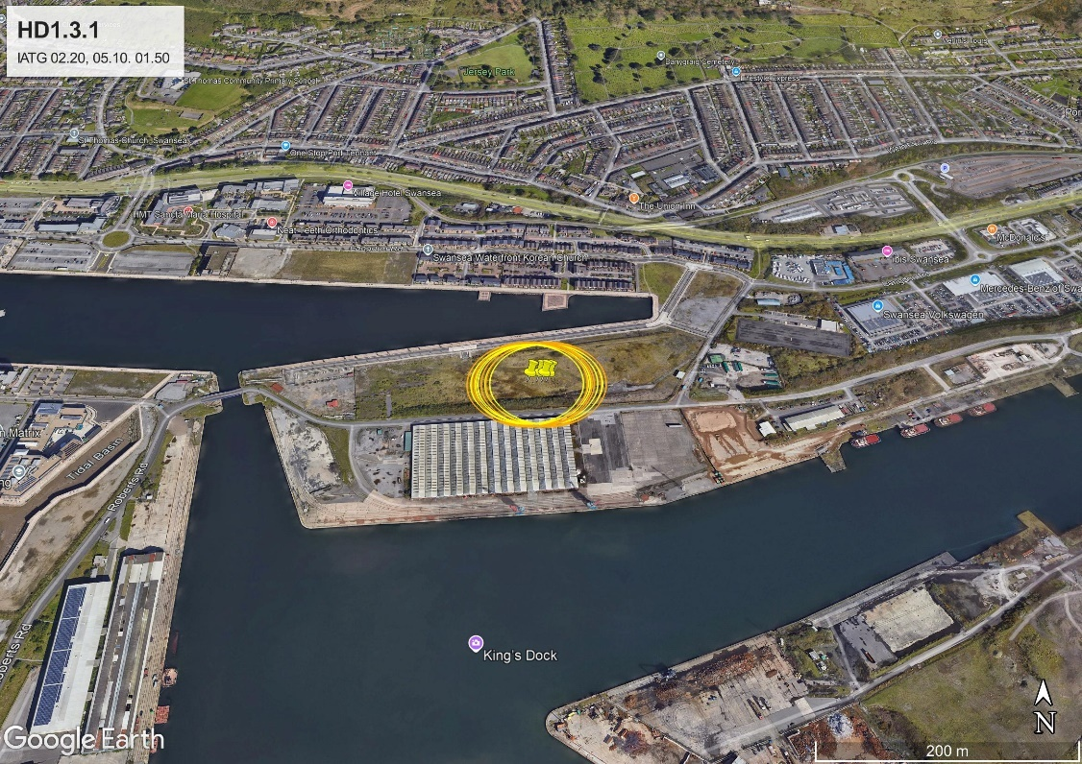
Figure 5: Displays the quantity distances for Hazard Division 1.3.1(Mass burning Hazard - High heat flux, violent burns) based on the proposed quantities to be stored by BigBang Solutions. Red indicates the Vulnerable Building Distance (VBD), Orange denotes the Inhabited Building Distance (IBD), and the yellow line denotes the Public Routes Transport Distance (PTRD).
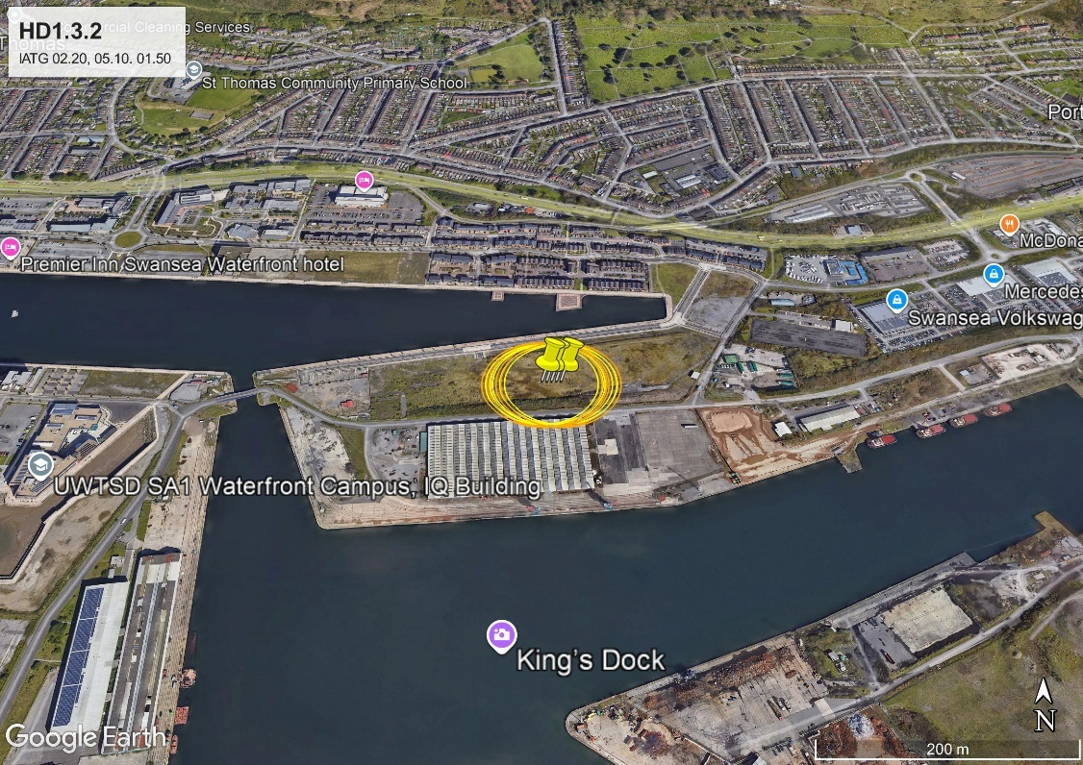
Figure 6: Figure 5: Displays the quantity distances for Hazard Division 1.3.1(Mass burning Hazard - Low heat flux, less violent burns) based on the proposed quantities to be stored by BigBang Solutions. Red indicates the Vulnerable Building Distance (VBD), Orange denotes the Inhabited Building Distance (IBD), and the yellow line denotes the Public Routes Transport Distance (PTRD).

Appendix B - NEQ and capacity calculation spreadsheets.

Appendix C – Safety & risk-reduction questions for BigBang Storage Solutions

1. Siting, NEQ and Vulnerable Populations
HD 1.1 Storage Feasibility at the Proposed Location - Given that QD analysis using IATG 02.20 indicates that residential properties, educational buildings, places of worship, retail premises and manufacturing facilities lie within the Inhabited Building Distance (IBD) for the proposed HD 1.1 NEQ [8], [13] could you explain how you consider HD 1.1 materials to be permissible at this location, and whether you acknowledge that current IBD penetration may preclude HD 1.1 storage unless NEQ is reduced or the site configuration is changed?

2. RF and Electromagnetic Hazards
Radio-Frequency (RF) and HERO Risk Controls - Considering the presence of a telecommunications array approximately 1 km from the proposed facility, and the requirements of IATG 05.60 and HERO guidance regarding susceptibility of certain explosive items to electromagnetic radiation [14], [15], what assessment have you undertaken of RF/HERO risks, and what control measures do you plan to implement to ensure compliance with IATG 05.60?

3. Marine Interface and Mooring Zone
Interaction with Ship Mooring Operations - Since vessels in adjacent mooring areas may be considered exposed sites under IATG 02.20 and 08.10 [8], [16], how do you intend to maintain situational awareness of vessel movements, and what communication arrangements will you put in place with harbour operators to ensure that storage limits or operational activity can be adjusted whenever third-party vessels enter relevant QD arcs?

4. Storage Configuration and Stacking Limits
Stacking of Munitions Within the ESHs - IATG 06.20 and 03.10 place specific limits on stacking heights, pallet formations and clearances for ammunition storage [17], [18], [19]. Could you clarify the maximum stacking heights proposed for each munition nature, and explain how you will ensure compliance with manufacturer limits and IATG stacking rules, particularly where these constraints reduce the effective capacity of an ESH?

5. Seawater Exposure and Corrosion
Prevention of Seawater and Marine Corrosion Hazards - Given the recognised impacts of seawater on explosive substances and munition casings, including sensitivity changes, stability issues, and advanced corrosion [20], [21], what engineering, environmental and procedural safeguards will you plan to implement to prevent seawater ingress, manage humidity, and mitigate corrosion risks affecting both the munitions and the storage infrastructure?

6. Transport, Traffic and Public Safety
Explosive Transport Through High-Traffic Areas in Swansea - Considering Swansea’s high urban traffic volumes and the recognised public-safety challenges associated with road transport of hazardous goods [22], [23], [24], what transport routes, scheduling measures, escort arrangements and Safe Systems of Work do you propose to minimise public exposure and ensure compliance with IATG 08.10 during movements of explosives to and from the site?

7. Processing Facilities and Life-Cycle Assurance
Since IATG 05.20, 07.10 and 07.30 require that processing activities (inspection, conditioning, repair, life-cycle assessment) be conducted in a dedicated APB rather than in storage facilities [9], [25], how do you intend to conduct essential ammunition processing tasks for the munitions stored on site, and can you confirm whether a compliant APB will be added to the facility design or whether these activities will be undertaken off-site?

8. Administrative, Welfare and Security Support Buildings
Office and Administrative Facilities Not Identified in Plans - Given that IATG 06.10, 03.10 and 09.10 require administrative, control and security functions to support safe ammunition storage operations [26], [18], [20], where do you intend to locate office, control, welfare and security administration functions, and do you plan to construct a dedicated building outside all relevant QD arcs?

9. Security Measures in a High-Crime Urban Area
With Swansea’s crime profile higher than the regional average [27], and considering that some ammunition types may be classified as ACTO (Attractive to Criminal or Terrorist Organisations) requiring enhanced protective measures [28] what security measures—physical, procedural and personnel—are planned to prevent theft, diversion or interference with ACTO-classified items stored at the facility?

10. Provision of Fire-Fighting Facilities
In light of IATG 02.50 and UK explosives-response guidance requiring accessible water supplies, hydrants, and fire-fighting routes for emergency services [29], how will you ensure adequate fire-fighting water capacity, hydrant placement, initial fire-fighting equipment and emergency-service access for all magazines and support areas?

11. Heating Controls and Electrical Safety in ESHs
IATG 05.40, guidance require strict control of heating, humidity and electrical equipment to avoid ignition hazards [30]. What heating, ventilation and electrical-control systems do you propose for the ESHs, and how will you ensure they remain within approved environmental limits and hazardous-area classifications?

12. Lightning Protection System (LPS) for Explosive Structures
Given the requirement for lightning protection for explosives facilities under NFPA 780 and defence-sector lightning-safety guidance [31], [32], what form of lightning-protection system will you implement for the ESHs and associated structures, and how will it be designed, tested and maintained over the life of the facility?

Appendix D –proposed Explosive Limit License (ELL) based on the proximity of infrastructure and other building near to the proposed site.
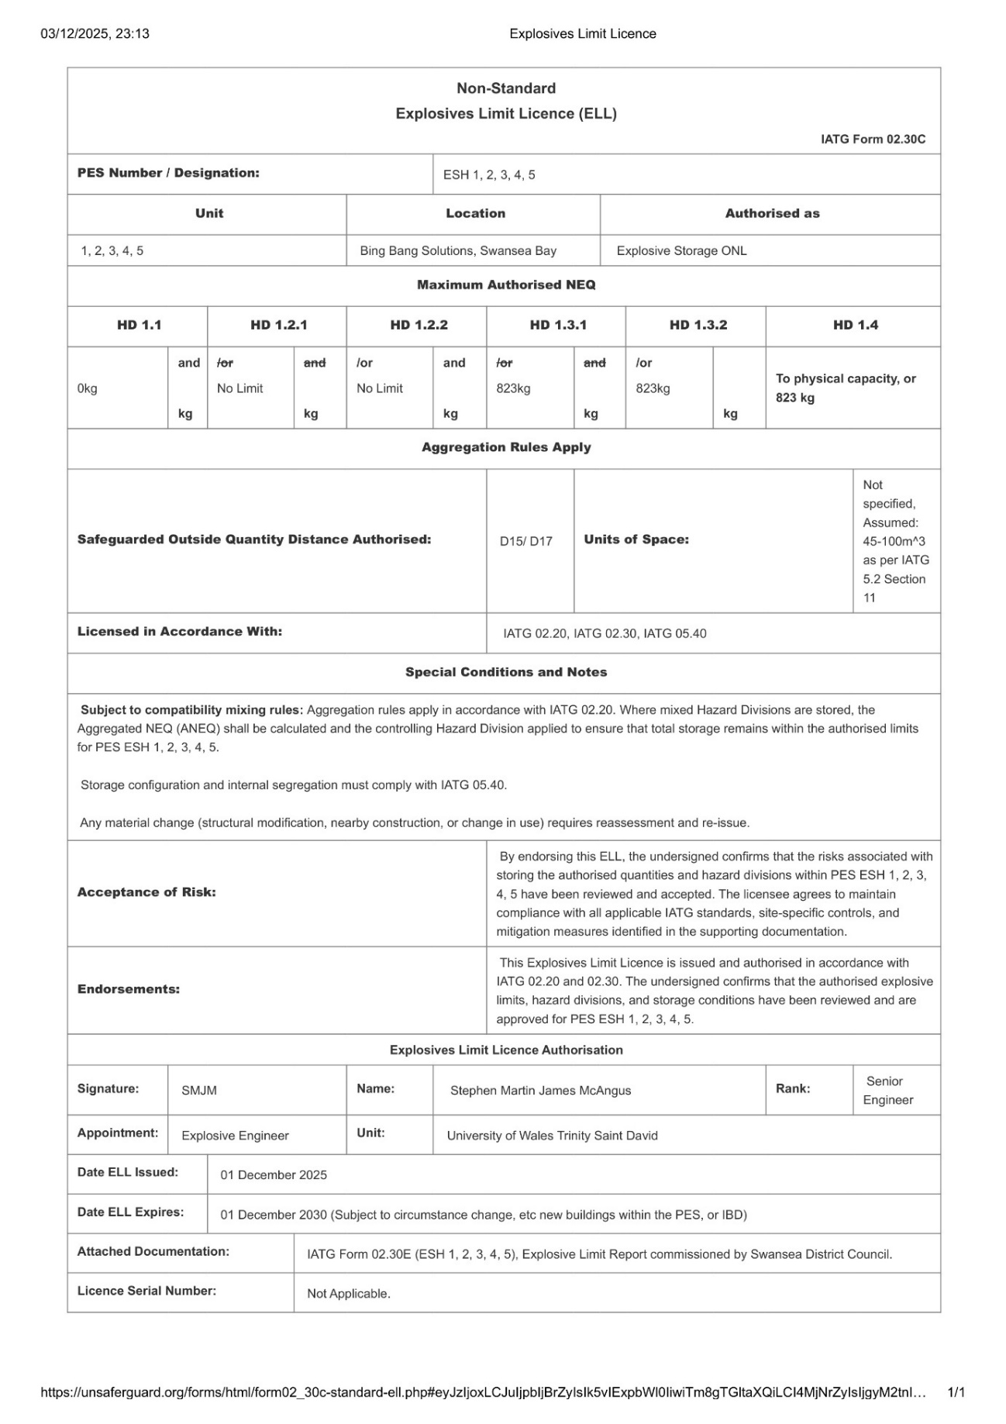
Figure 1: The Explosive Limit License to be distributed between the 5 different Explosive Store Houses.
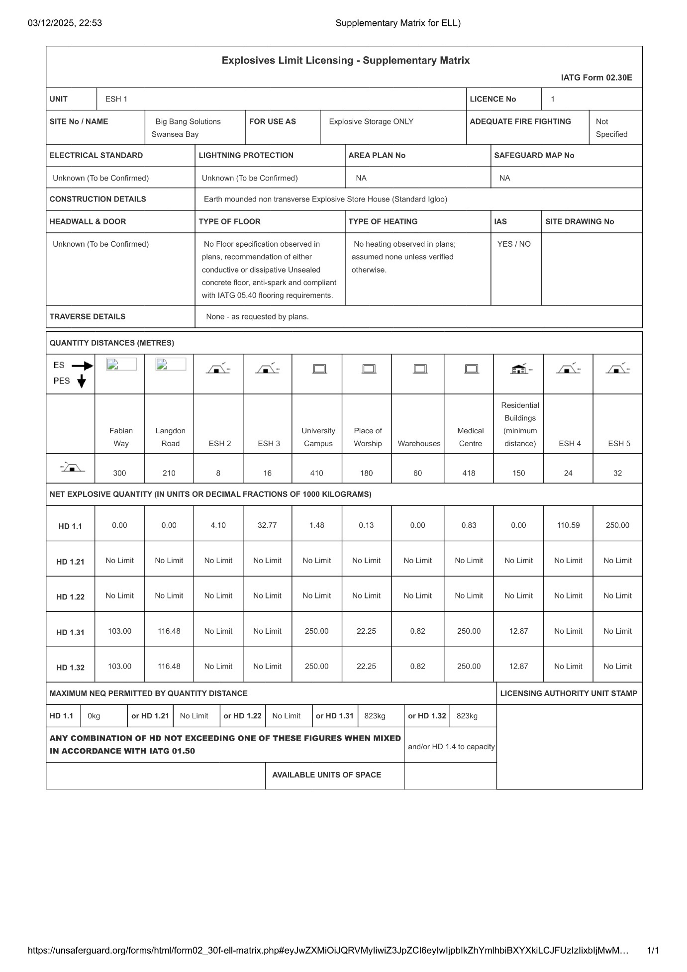
Figure 2: The Supplementary matrix for ESH 1, QD distances were established based on the proximity of civilian population nearby. Therefore D15, and D17 apply to Vulnerable buildings, Inhabited Buildings and Public Routes of Transport respectively.
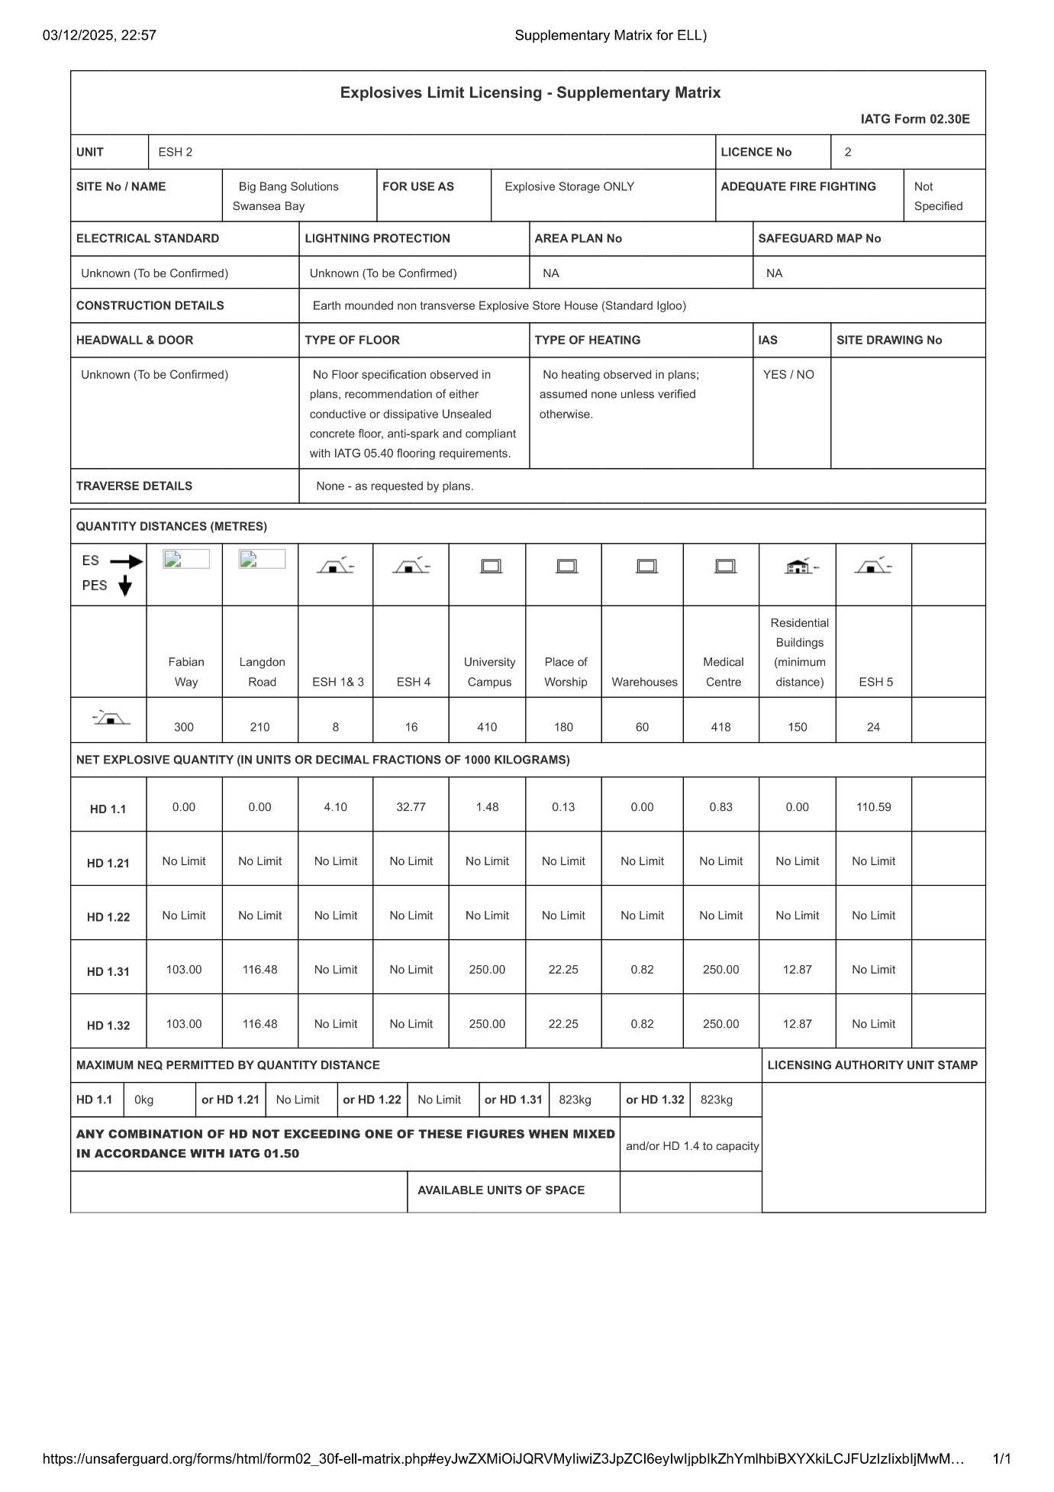
Figure 3: The Supplementary matrix for ESH 2, QD distances were established based on the proximity of civilian population nearby. Therefore D15, and D17 apply to Vulnerable buildings, Inhabited Buildings and Public Routes of Transport.
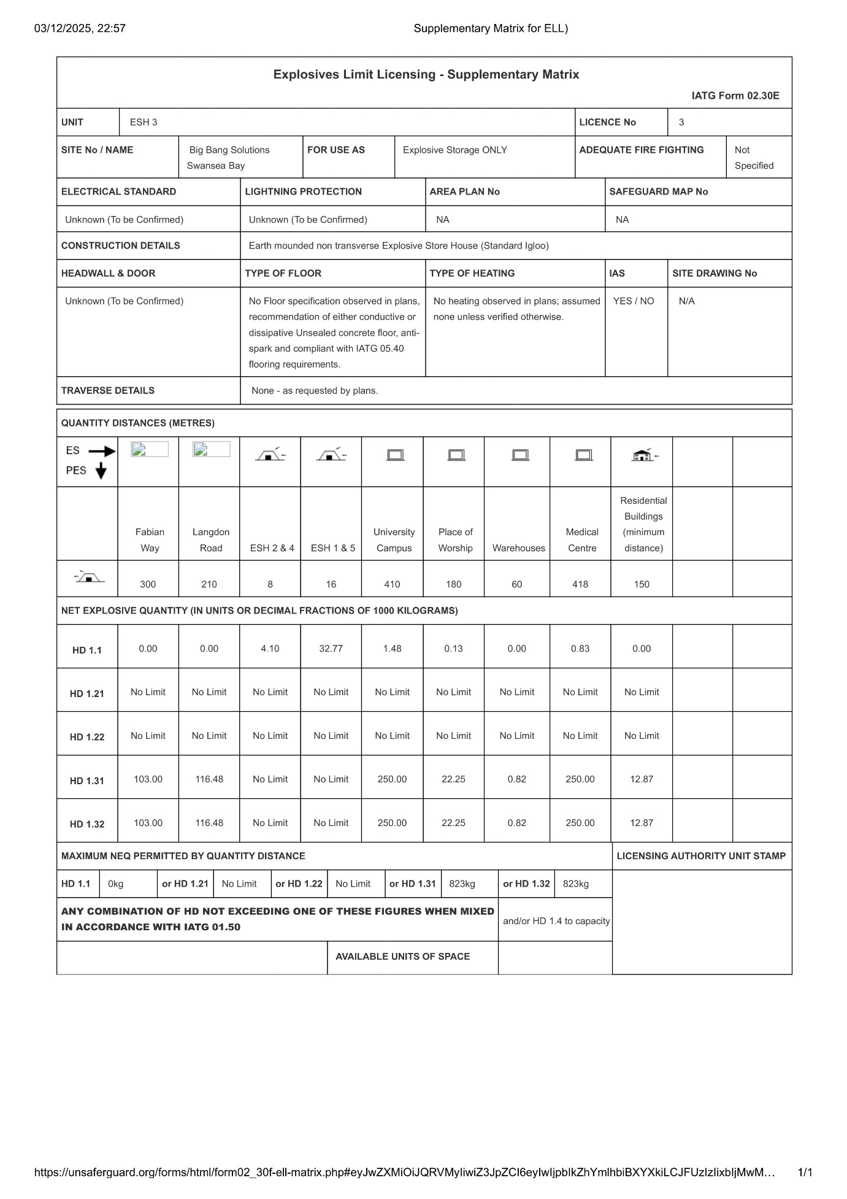
Figure 4: The Supplementary matrix for ESH 3, QD distances were established based on the proximity of civilian population nearby. Therefore D15, and D17 apply to Vulnerable buildings, Inhabited Buildings and Public Routes of Transport.
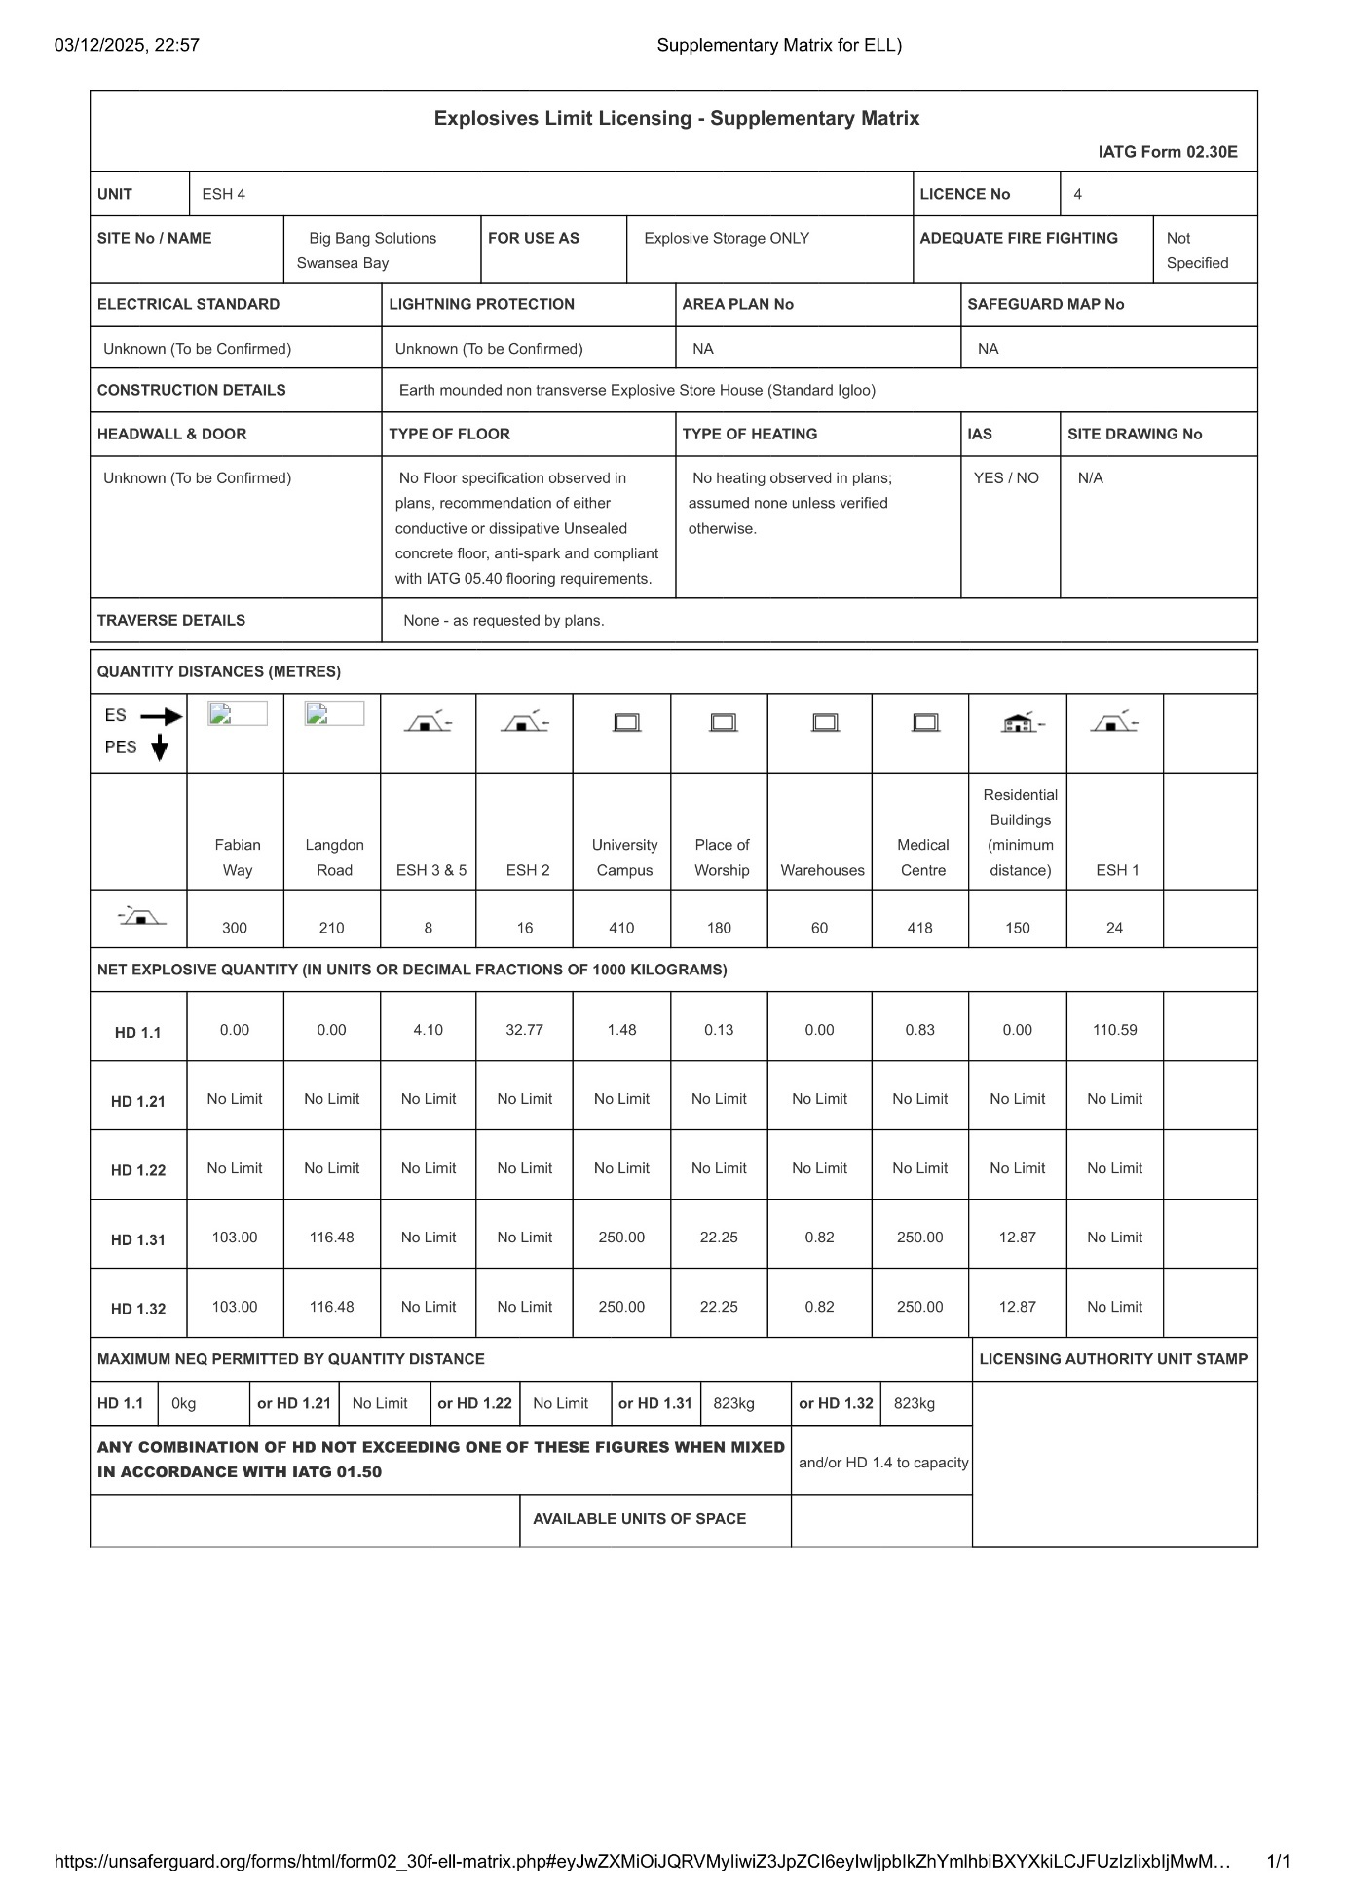
Figure 5: The Supplementary matrix for ESH 4, QD distances were established based on the proximity of civilian population nearby. Therefore D15, and D17 apply to Vulnerable buildings, Inhabited Buildings and Public Routes of Transport.
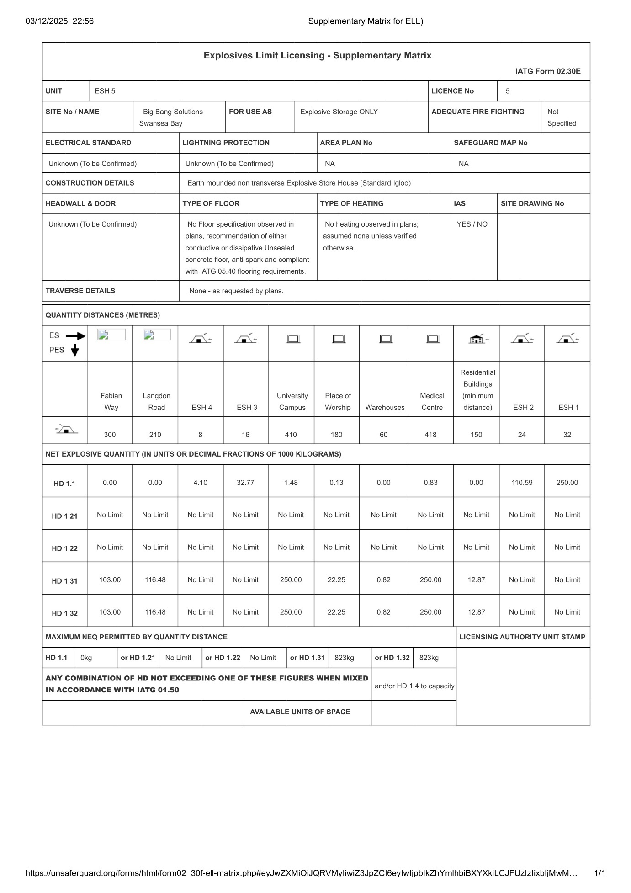
Figure 6: The Supplementary matrix for ESH 5, QD distances were established based on the proximity of civilian population nearby. Therefore D15, and D17 apply to Vulnerable buildings, Inhabited Buildings and Public Routes of Transport.

Annex E: Additional calculations used to support this report

Calculating Inter-magazine distance (IMD) & conversions to coordinates
Convert displacement in meters to degrees longitude at a given latitude:
Equation 2: displays how displacement in meters to degrees longitude at a given latitude was calculated for form Table 4.

$$\text{meters per degree longitude}=\frac{π}{180}⋅R⋅cos⁡(ϕ)$$
- $R=6,371,000\text{ m}$(Earth radius)
- $ϕ$= latitude in radians
2. Apply offset to the reference longitude for each ESH:
$${\text{lon}}_{\text{new}}={\text{lon}}_{\text{centre}}+Δ\text{lon}$$
- IMD = 8 m (centre-to-centre distance for D3 column) based on equation 1.

Table 4: displays the ESH displacement within the planned PES proposed by Bigband Solutions Ltd, based on Longitudinal displacement mathematics.

11. References

[1] | United Nations Office for Disarmament Affairs (UNODA), “International Ammunition Technical Guidelines (IATG) 04.10: Explosive Facilities – Siting and Design,” United Nations, New York, 2021.
[2] | P. W. Cooper, “Chapter 10: Sympathetic Detonation,” in Explosives Engineering, Weinheim, Wiley-VCH, 1996, pp. 285-302.
[3] | P. W. Cooper, “Chapter 11: Effects of Groud, Barriers and Mass,” in Explosives Engineering, Weinheim, Wiley-VCH, 1996, pp. 315-340.
[4] | U.S. Department of Defence, “UFC 3-340-02 – Structures to Resist the Effects of Accidental Explosions,” USACE/ NAVFAC/ AFCEC, Washington D.C. , 2014.
[5] | D. Bogosian and J. Chrostowski, “Comparison of Quantity-Distance Standards for Earth-Covered Magazines in Various National/International Manuals,” BakerRisk & ACTA, San Antonio, TX, 2017.
[6] | Institute of Makers of Explosives, “Safety Library Publication No. 22: Recommended Practices for the Design and Use of Earth-Covered Magazines,” IME, Washington, D.C. , 2013.
[7] | UK Ministry of Defence, “JSP 482 Edition 4: Buildings Associated with Military Explosives, Chapter 6,” UK Ministry of Defence, London, 2013.
[8] | United Nations Office for Disarmament Affairs (UNODA), “International Ammunition Technical Guidelines (IATG) 02.20: Quantity and Separation Distances,” United Nations, New york, 2021.
[9] | United Nations Office for Disarmament Affairs (UNODA), “International Ammunition Technical Guidelines (IATG) 05.20: Types of Buildings for Explosives Storage,” United Nations, New York, 2015.
[10] | M. G. Stewart and J. Mueller, “Risk Assessment of Terrorist Explosive Attacks Against Critical Infrastructure,” Risk Analysis, vol. 33, no. 2, pp. 282-299, 2013.
[11] | D. Cormie, G. Mays and P. Smith, Blast Effects on Buildings, London: ICE Publishing, 2019.
[12] | United Nations Office for Disarmament Affairs (UNODA), “International Ammunition Technical Guidelines (IATG) 01.50: UN SaferGuard,” United Nations, New York, 2021.
[13] | United Nations Office for Disarmament Affairs (UNODA), “International Ammunition Technical Guidelines (IATG) 05.10: Planning and Siting of Explosives Facilities,” United Nations, New York, 2015.
[14] | United Nations Office for Disarmament Affairs (UNODA), “International Ammunition Technical Guidelines (IATG) 05.60: Radio Frequency Hazards,” United Nations, New York, 2021.
[15] | UK Defence Safety Authority, “JSP 482: Ministry of Defence Explosives Regulations, Part 2, Chapter 24 – HERO,” DSA, Bristol, 2019.
[16] | United Nations Office for Disarmament Affairs (UNODA), “International Ammunition Technical Guidelines (IATG) 08.10: Transport of Ammunition,” United Nations, New York, 2011.
[17] | United Nations Office for Disarmament Affairs (UNODA), “International Ammunition Technical Guidelines (IATG) 06.20: Storage Space Requirements,” United Nations, New York, 2021.
[18] | United Nations Office for Disarmament Affairs (UNODA), “International Ammunition Technical Guidelines (IATG) 03.10: Inventory Management,” United Nations, 2021, 2021.
[19] | Geneva International Centre for Humanitarian Demining, “PSSM Identification Cards: Stacks, Aisles and Dunnage,” GIHCD, Geneva, 2015.
[20] | A. J. Beck and e. al., “Spread, behavior, and ecosystem consequences of conventional munitions compounds in coastal marine waters,” Frontiers in Marine Science, vol. 5, no. 1, p. 141, 2018.
[21] | MDPI, “Sea-dumped munitions: Detection, analysis and risk assessment,” Toxics Journal, no. (Special Issue), 2020.
[22] | P. A. Davies, “A Methodology for the Quantitative Risk Assessment of the Road and Rail Transport of Explosives,” Loughborough University, Loughborough , 1998.
[23] | B. Fabiano, F. Curro, A. Pastorino and R. Pastorino, “Dangerous goods transportation by road: from risk analysis to emergency planning,” Journal of Loss Prevention in the Process Industries, vol. 18, no. 1, pp. 403-413, 205.
[24] | UK Home Office, “Generic Risk Assessment 5.7: Incidents Involving Explosives,” Home Office, London, 2015.
[25] | United Nations Office for Disarmament Affairs (UNODA), “International Ammunition Technical Guidelines (IATG) 07.10 and 07.30: Surveillance, Proof and Inspection,” United Nations, New York, 2015-2021.
[26] | United Nations Office for Disarmament Affairs (UNODA), “International Ammunition Technical Guidelines (IATG) 06.10: Control of Explosives Facilities,” United Nations, 2021, 2021.
[27] | CrimeRate.co.uk, “Swansea Crime and Safety Statistics,” 2025. [Online]. Available: https://www.crimerate.co.uk. [Accessed 01 December 2025].
[28] | United Nations Office for Disarmament Affairs (UNODA), “International Ammunition Technical Guidelines (IATG) 09.10: Security Principles and Systems,” New York, New York, 2021.
[29] | United Nations Office for Disarmament Affairs (UNODA), “International Ammunition Technical Guidelines (IATG) 02.50: Fire Safety,” United Nations, New York, 2021.
[30] | United Nations Office for Disarmament Affairs (UNODA), “International Ammunition Technical Guidelines (IATG) 05.40: Electrical Installations,” United Nation, 2021, 2021.
[31] | National Fire Protection Association, “NFPA 780: Standard for the Installation of Lightning Protection Systems,” NFPA, Quincy, MA, 2019.
[32] | R. E. Hileman, “Lightning Protection at Military Explosives Storage Facilities,” Vaisala, 2011.
[33] | R. E. Hileman, “Lightning Protection at Military Explosives Storage Facilities,” Vaisala, 2011.

