
APPENDIX GA36c

LEVEL 6 ASSESSMENT SPECIFICATION

Student name: | Sasha Williams | Student ID number: | 1600234
Programme: | Primary BA Ed
Module: | Enterprising and Creative Teaching and Learning
Module code: | ECAD6011 | Contribution to Overall Module Assessment (%): | 100%
Lecturer: | Mr T. Cox | Internal Verifier:
Assignment Title: | Utilising the Entrecomp Framework, critically evaluate your own creativity and enterprise and consider how you might be able to develop the creative and enterprising skills of primary learners through your own pedagogy. | Word count (or equivalent): | 3000
Submission deadline: | 28/1/19 | Return date of provisional marks & written feedback: | 25/2/19
Submission method: | All written assessments, where practical and possible, must be submitted via Turnitin unless otherwise instructed by the Lecturer. (Please DO NOT put this assessment specification into Turnitin or it will match many similarities with other students’ submissions.)  Alternative submission method (if applicable):  Late submission of the assessment will result in a late penalty mark. Penalties for late submission: Up to one week late, maximum mark of 40%. Over one week late, 0%. Only the Extenuating Circumstances Panel may approve a change to submission dates.
Academic honesty / referencing: | Academic honesty is required. In the main body of your submission you must give credit to authors on whose research and ideas your work is based. Append to your submission a reference list that indicates the books, articles, etc. that you have used, cited or quoted in order to complete this assessment.

Utilising the Entrecomp Framework, critically evaluate your own creativity and enterprise and consider how you might be able to develop the creative and enterprising skills of primary learners through your own pedagogy.
Creativity is more than expressive arts; it is a way of thinking and an attitude to work. Those who are creative are “characterized by having a desire to grow and a capability to be puzzled, spontaneous, a divergent thinker, open to new experiences, persistent, and a hard worker” (Kanematsu, 2016; 9). I believe it should be promoted for every year group and present in each subject. The entrecomp framework has been created to promote the skills to think in a diverse manner and to think of new creative, innovating ideas that they value. Creativity and the entrecomp framework do not need to be incorporated together, however can work simultaneously. Creativity is the basis of enterprise; it is the original thinking whereas enterprise is taking this idea and putting it into action; innovating and reflecting is a major part of enterprise.
Robinson acknowledges the importance of creativity, believing it should have the same importance as leading subjects such as literacy and numeracy, which have been integrated into lessons since the LNF framework in 2013. He states that the education system is constructed on knowledge for future careers, therefore we should adapt to accommodate these needs (Robinson, 2006). However, jobs in the future may require different domains of knowledge, therefore teachers need to take this into consideration. Fitch and Svengalis (1979) state that teaching pupils to prepare for the future will provide them with meaningful knowledge and skills with the appropriate guidance (cited in Hicks and Holden; 1995; 3). Creativity is present in the school curriculum, mainly being present through the expressive arts. Creativity and enterprise skills have been viewed as a concept where children must present a physical, audible or visual piece of high-quality work to become creative. Helson (1983) and Roe (1952) both agree that the concept of a creative job have been initially viewed as a designer or artist; recently it has incorporated the work of engineers or scientists (1983, 1952, cited in Cropley, 2001; 5). Whilst these jobs are not considered creative in themselves, they need a great deal of creative thinking, otherwise known as divergent thinking (Guilford, 1967). Previously, the curriculum included creativity within the education system in a more traditional and formal sense, however Donaldson’s perception of creativity has changed this. In his report, Successful Futures (2015), he states that “there are significant moves away from ‘learning to’ with a growing skills focus and an emphasis on application and development of higher-order skills, particularly creativity (entrepreneurship) and digital literacy” (Donaldson, 2015; 18). As educators, teachers should equip children with the skills and knowledge to fulfil their potential and make a positive contribution to society in the future.
Teaching in a creative manner allows pupils to thrive in different areas; it also allows for the expression of three different types of teaching and learning styles: namely, pedagogy, which is instructor led and is widely witnessed in schools, andragogy, which fully engages the pupils and learners contribute to their learning by self-directing their learning, and finally, heutagogy, which is self-determined learning where pupils create their learning. Heutagogy allows pupils to become confident in their knowledge and skills and acquire the ability to solve a variety of different problems. Yet, this is the teaching style that is least likely to be seen in schools, especially for a variety of different subjects. It is proven that pupils learn in different ways unique to their personalities; Gardner (1999) provides evidence that there are eight types of intelligences in his theory ‘multiple intelligence’ (MI). A heutagogy approach to learning will allow pupils to express their work through a domain of their preference. They can explore new problems and topics through an area they exceed through, providing an increase in motivation, success and discovery. Intelligence comes in many forms and it is distinct, diverse, and dynamic; therefore, the curriculum should exemplify this. Mistakes allow creativity, expanding the mind and imagination, providing opportunities to practise divergent thinking. A child is taught mistakes equate to failure; without this perspective children are more willing to experiment and discover new ideas, leading to enterprise education and creative learners (Robinson, 2006).
Before, creativity was a talent, it was believed that only those who were born with a creative ability could strive in creativity. Despite that, many theorists and researchers such as Lin (2011), Fryer (1996) and Craft (2001) now believe creativity can be developed through perseverance and education. Contradicting these researchers, Gardner believes creativity is one of the eight multiple intelligences. His theory states that individuals are stronger in a certain intelligence, and weaker in another, so even though it can be taught and strengthened it will always be more effective in some pupils more than others.
There are a variety of different definitions of creativity; Runco and Sakamoto (1999) explain “some psychologists believe creativity to arise from unconscious drives, while some psychological researchers define creativity as a syndrome or a complex” (cited in Lin, 2011; 150). Whereas Sternberg (1999) mentions how “some other researchers deem creativity as thinking skills, a product of creative thinking, or personal qualities” (cited in Lin, 2011; 150). The different views on creativity can lead to difficulties in how to promote and support children to become creative, as it relates to “the personal, the process, and the outcomes considered” (McCammon, et all, date unknown;2). It is a complex and complicated area to measure and has proven very difficult to define as a concept. On the one hand, this puts strain on educators who must quantify performance in terms of levels and specify from a prescribed framework how the individual measures up, their thinking behind it and the outcomes. On the other hand, it allows both educators and children to think creatively and push boundaries and make new discoveries. Torrance (1966, 1974) believed there are four components to be able to assess creativity, these are: fluency, flexibility, elaboration and originality. These components link into divergent thinking as they express the different elements such as complexity, elaboration, imagination and risk taking. Tina Seelig challenges this and believes to accomplish a creative mind set knowledge, attitude, imagination, habitat, culture and resources are vital (2012).
For children to become creative learners, teachers need to adapt a creative teaching approach and environment. Lin (2011) defines creative teaching in three different perspectives which are: creative learning, creative teaching and teaching for creativity which create a creative pedagogy. These three different perspectives all focus on different important factors that influence the creative process: teachers’ actions, children’s actions and the creative environment. As a teacher, it is important to be ‘adaptable’ and to be able to ‘cope with ambiguity, uncertainty and risk’. Each of these areas are part of the entercomp framework which allow people to change ideas into actions and innovation. They allow teachers to become imaginative and create a more interesting and effective teaching mechanism, promoting higher achievement in children’s own creative thinking. Educators can enable a curriculum that is rich with creativity with emphasis on pupil voice. This vision will be implemented in schools across Wales in 2020. This isn’t the first curriculum to give priority to creativity as the Norwegian national curriculum demonstrates the importance of creative energy and the need to improve the quality of life (Hagness, 1994; 11 cited by Beetlestone 1998;1).
Enterprise is applying creative thinking and innovating them for practical situations, whereas entrepreneurship is applying enterprise skills and knowledge in specific contexts. Both definitions slightly differ however include the same skills and knowledge. The entercomp framework allows creativity to thrive inside and outside of the classroom and is adapted for schools and businesses. It consists of three competence areas, fifteen competencies (five under each area) and a variety of learning outcomes. The priority of teaching this framework is to allow children to develop their innovated thinking and to put ideas into action, creating original pieces of work. The purpose is to have learners to be more effective in the 21st century for the future economy (European training foundation, 2017). The entercomp framework reflects on the different competencies involved to allow the “capacity to turn ideas into action, ideas that generate value for someone other than oneself” (Bacigalupo, et al., 2016; 7). For this reason, it is important to allow pupils to understand and gain entrepreneurship skills to prepare them for future qualifications and career opportunities. Pupils being taught in schools are being prepared for a future that is uncertain with the knowledge and skills needed for future careers within the fast-changing world (Parkhurst, 1999). In the future it is possible that pupils will be working in jobs that are non-existent now. The purpose of the entrecomp framework is “to build a bridge between the worlds of education and work” as it allows children to think in a variety of different ways (Bacigalupo, et al., 2016; 7). It is a flexible design that can be used in a variety of different ways, it is adaptable for different teaching styles and environments. It is meant to be a learning sequence, allowing teaching and learning to be more effective and meaningful for the pupils’ futures aspirations and it can be used for pupils to self or peer assess their work (European training foundation, 2017). The framework compliments Costas theory ‘16 habits of mind’ (2000) which is the variety of different thinking strategies, creativity, and innovation to allow individuals to think of answers for unfamiliar problems which is important to teach children who will being living in a world of work which is non-existent now.
This framework concentrates greatly on innovation and how to incorporate ideas, opportunities and resources and to put them into action, creating enterprise skills in pupils and teachers. Along with encouraging enterprise skills, it is also a motivator to be creative and think divergently. As a trainee teacher, on professional teaching experience, I was able to develop ideas which is a thread under the ‘creativity’ competency in the entercomp framework. Assessing against their outcomes I associate myself as level 6 as “I can set up processes to involve stakeholders in finding, developing and testing ideas”. Throughout placement in schools I have discussed ideas and developed them to suit the needs of the class and incorporate a range of learning styles. For example, one activity planned was to take an Art and Design activity with half of the class where they were ‘spot painting’ Indian animals. This lesson was led by the class teacher; however, I completed all the planning and preparation. While I took the other half of the class to do a different activity where they created Indian animals out of the medium they preferred, mixing mediums, focusing on shapes and textures, see appendix 1 for the lesson plan. While I was able to plan and prepare work/ activities for other members of staff I was able to become confident in my leadership skills and collaboration which are both important elements of enterprise (see appendix 2). The objectives for these two separate activities had different creative outcomes where pupils were able to experiment with different styles and mediums, unleashing their imagination. Even though both activities were different they still allowed learners to transform ideas making them valuable. It allowed learners to be curious and they accomplished level 3 as they experimented with “skills and competences in situations that are new” (Bacigalupo, et al.; 24). Both activities involved innovating, whether it was through introducing a new method or product. Reflecting on these tasks I would ensure I encouraged the children to experiment further and find new solutions, which would match them with level 4 and 5 in the entrecomp framework under the creative competence, see appendix 3 for further reflection. Reflecting on my own creativity I was able to reach level 6 where “I can combine my understanding of different contexts to transfer knowledge, ideas and solutions across different areas” (Bacigalupo, et al.; 24) Developing the learner’s knowledge further next time I will demonstrate how knowledge from other contexts can be used to make original ideas.
One of the competencies in the framework that I consider to be important for personal growth is ‘self-awareness and self-efficacy’. I can reflect on my own strengths and weaknesses, however, to overcome these weaknesses I will work closely with other members of staff to compensate for my weaknesses and to create new opportunities (Bacigalupo, et al.;27). Reflecting on my personal experiences on professional teaching experience I have accomplished the levels up to level 6. I was able to “help others identify their strengths and weaknesses” through a variety of assessment for learning strategies (AfL), the most favourable being the one I introduced to the class, emoji exit cards (see appendix 4). These cards allowed them to take time to reflect on the topic in confidence by circling the relevant emojis for them and their work. Reviewing on the success and excitement on these exit cards it will be something I take into my teaching career and can be adapted to suit a variety of different needs, interests or topics (see appendix 5).
Another competency I have accomplished through teaching is to ‘be flexible and adaptable to change’; this is an important aspect to be able to overcome especially with areas such as ICT or outdoor learning. Throughout my own experience I have been able to “adapt my plans to achieve my goals in light of changes that are outside my control” (Bacigalupo, et al.; 32) by ensuring I have a back up plan to assist my lessons if they are needed. For instance, my research lessons when pupils were researching information about Chembakolli in preparation for their next lesson where they were writing a report. The day of this lesson the ICT systems had all crashed, resulting in having to adapt the whole lesson to be on paper, fortunately the system was running by the time of my lesson. However, without my extra preparation this lesson wouldn’t have been able to go ahead. This also covers the thread ‘plan and organise’ as due to my planning and knowledge I was able to support children with enough resources for them to carry on research offline and consider the possibility of changes to my plans. Reflecting on this lesson I was thankful for my extra preparation as it allowed me to feel comfortable about my lesson and the same level of work was still able to be accomplished (appendix 6).
To improve my teaching and the learning of my pupils I will include the entercomp framework in my teaching strategies, allowing pupils to become aware of enterprise and build on their own skills benefiting their learning. Innovation has become important in the work place for many jobs and should be considered a priority to teach in skills as it is an important skill for their future. It is considered an important aspect to be successful in industry leading companies (Conley, 2000 cited in Seelig, 2012). Similarly, Seelig states that resources, imagination, attitudes, knowledge are all vital elements needed in creativity and innovation; these are all present under the entercomp framework through different competencies’ ideas and opportunities, resources and placing ideas into action. However, the framework has ‘culture’ and ‘habitat’ absent resulting in a weakness in the framework, whereas Seelig believes these are equally as important. The different elements in her innovation engine state the inside factors are the individual: attitude, imagination and knowledge. The outside influences of habitat, resources and culture are equally as important and none of these factors can be isolated if innovation is to be accomplished (2012).
Creative teaching and learning allow pupils to understand and interpret abstract concepts in areas they regularly find difficult (Beetlestone, 1998;17). Creativity and entrepreneurship provide opportunities for children to reflect on ideas and innovations, being able to improve them and encourage new ideas for adaption. This is a way of thinking, teaching pupils to think with this perspective allows them to have the skills to be able to reflect on any piece of work or idea, increasing their chances of success, knowledge and intelligence.
A drawback to creativity and enterprise thinking is the change in thinking when a reward is available. Amabile, Hennessey and Grossman (1986) and others previously acknowledged the fact that Eisenverger and Cameron (1996) left out key issues and experiments regarding a variety of different creative activities, providing evidence that the level of creativity and originality were decreased in work where they were seeking a reward (cited in Hennessey, et al,. 1998; p.674). Whereas a reward is designed to motivate pupils, it can hinder creativity. ‘Functional fixedness’ also hinders creativity (Glucksberg, 1962) this is where individuals need to find a different solution, they also develop greater levels of intrinsic motivation to problems that allow divergent thinking rather than convergent thinking (Deci, 1971 cited in Ramm, et al., 2013; p. 4).
These areas can be a difficult obstacle for some pupils in the classroom for example those with additional learning needs (ALN). Some children with autism struggle with hypersensitivity and find it overwhelming to have a loud room or may struggle with imaginative work (National autistic society; 2018). However, those children can thrive in creative thinking, especially in areas such as Maths and Science where functional fixedness may prevent other pupils from experimenting. Dr Catherine Best discovered that those with autism have a higher chance of creating original and unique answers to creative problems as they can approach these problems in an original way (Cited by McVeigh, 2015).
The learning environment can affect learning in a variety of ways; teachers can adapt the classroom to best fit the lesson and their pupils’ preferences. The quality assurance agency state that a classroom that encourage creativity and innovation development are unusual combination, nonetheless, are essential factors for enterprise education (QAA, 2012; 7). According to Oppezzo and Schwartz, walking boosts creativity and inspiration, allowing people to generate new ideas at a higher and fast quality. Their theory showed evidence that the creativity levels of those who were involved were consistently higher than those who were sitting down (2014). They tested their theory taking into consideration the environment, but no difference was found, suggesting that it is the movement of walking that kindles creativity and imagination, not the environment. Complimenting this research, a teacher’s creative abilities and the classroom atmosphere influence the creative abilities in pupils as they are more likely to be nurtured (NACCCE, 1999). During professional teaching experience I moved the whole classroom around to look like a court room, in preparation for our persuasive lesson, to set the atmosphere and to fully engage the pupils (see appendix 7). The new environment aided their motivation and memory, suggesting that the environment and habitat has a great influence on a pupil learning and creative thinking (Seelig) also, it made meaning to the learning and gave a perspective.
All things considered, creativity and the entrepreneurship are separate entities as one is to develop original and imaginative ideas whereas the other is the creation of the idea and putting it into action. Integrating this into the curriculum will be beneficial for pupils as they learn how to interpret things differently, innovate and think creatively. Combining these skills, attitudes, knowledge and engagement will increase their successes in their future careers, careers that may not exist yet. Throughout my own professional teaching experiences, I have been able to teach in a creative way, taking into consideration the different values each pupil has. In the future I will integrate the entrecomp framework further in my teaching, to allow pupils to understand different ways of learning, but to also benefit my own reflection and teaching practice.

Reference list
Bacigalupo, M., et al,. (2016). ‘EntreComp: The Entrepreneurship Competence Framework’. Luxembourg: Publication Office of the European Union; EUR
Beetlestone, F. (1998) ‘Creative children, imaginative teaching’. Buckingham; Open University Press.
Bronfenbrenner, U. (2005). Ecological systems theory (1992). In U. Bronfenbrenner (Ed.), Making human beings human: Bioecological perspectives on human development (pp. 106-173). Thousand Oaks, CA, : Sage Publications Ltd.
Costa, A. (2000) ‘Discovering and exploring habits of mind. A developmental series’. University of California; Association for supervision and curriculum development.
Cropley, A. J. (2001) ‘Creativity in education and learning, a guide for teachers and educators’. Oxon; RoutledgeFalmer.
Earp, J. (2017) ‘Classroom layout- what does the research say?’ Available on: https://www.teachermagazine.com.au/articles/classroom-layout-what-does-the-research-say [Last accessed: 19/01/2019]
Gardner, H. (1999) ‘Multiple Intelligences- new horizons’. New York; Basic books.
Glucksbery, S. (1962) ‘The influence of strength of drive on functional fixedness and perceptual recognition’. Journal of experimental psychology 63, 36- 41.
Guilford, J. P. (1967) ‘The nature of human intelligence’. New York: McGraw-Hill.
Hennessey, B. A. et, al,. (1998) ‘Reward, intrinsic motivation, and creativity.’ Wellesley college and Harvard university; American psychologist.
Hicks, D et al,. (1995) ‘Visions of the future, why we need to teach for tomorrow.’ London; Trentham Books.
Lin (2011) ‘Fostering creativity through education- a conceptual framework of creative pedagogy.’ Volume 2, number 3. China; Scientific research.
McVeigh, T. (2015) ‘People with autism and learning disabilities excel in creative thinking, study shows.’ The guardian. 22nd August. Available at: https://www.theguardian.com/society/2015/aug/22/autism-creative-thinking-study (Accessed 23rd January 2019).
Kanematsu, H. (2016) ‘Theory of creativity.’ Switzerland; Springer International Publishing.
NACCCE (1999) ‘All our futures: creativity, culture and educations.’ London; DfEE.
National autistic society (2018) ‘Teaching you children on the autism spectrum.’ Available on: https://www.autism.org.uk/professionals/teachers/teaching-young-children.aspx (Last accessed: 24th January 2019).
Oppezzo, M. et al,. (2014) ‘Give your ideas some legs: the positive effect of walking on creative thinking.’ Journal of experimental psychology: Learning, memory and cognition. Volume 40. URL: https://www.apa.org/pubs/journals/releases/xlm-a0036577.pdf (accessed 19th January 2019).
Quality assurance agency (2012) ‘Enterprise and entrepreneurship education: Guidance for UK higher education providers’ Available at: https://moodle.uwtsd.ac.uk/pluginfile.php/184473/mod_resource/content/1/enterprise-entrepreneurship-guidance.pdf (Accessed: 25th January 2019).
Ramm, J. et al,. (2013) ‘Incentives and creativity in groups.’ University of Bergn; Ministery of local government and regional development.
Robinson, K. (2006) ‘Do schools kill creativity?’ TED [blog] Available at: https://www.ted.com/talks/ken_robinson_says_schools_kill_creativity/details (Accessed: 17th January 2019).
McCammon, L, A. et al,. (date unknown) Exploring teaching creativity and creative teaching: the first step in an international research project. University of Arizona, Tucson, USA.
Seelig, T. (2012) ‘A crash course in creativity: Tina Seelig’ [video]. Available at: https://www.youtube.com/watch?v=gyM6rx69iqg (Last accessed: 19th January 2019).
Torrance, P. (1972) ‘Can we teach children to think creatively?’ Georgia university, Athens; Dept of educational psychology.

Appendix 1
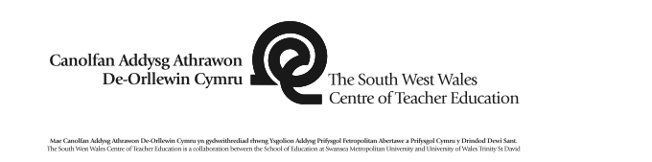 |  |  |  |  |  |  |  |  |  |  |  |  | 1B

Session Plan – Key Stage 2
Name of trainee: |  |  | XXX |  |  |  | Session ref: |  |  | 1
Personal target(s) in relation to QTS: |  |  |  |  | S.2. Ability to use own subject knowledge in an appropriate way to motivate learners.  S.3.3. Demonstrate appropriate organisation and management skills within a range of physical teaching spaces, effectively using tools, materials, texts and other resources safely and effectively.
Year group: |  | 5 |  | No. of learners: |  | 28 |  | ALN: | 11
Additional Adults: 2 |  |  |  | Miss Evans- Activity 1  Myself and Miss Antonia- Activity 2
Learning objective(s): Can I Use different medium to create an Indian animal? |  |  |  |  |  |  |  | Success criteria: To be able to choose an art material to create their art piece with.  To be able to use their imagination and creativity as well as their knowledge of what the animal looks like.
Links to previous learning: Linking into the terms theme- Chembakolli.
Curriculum coverage (range, skills)
Curriculum coverage (range, skills) Art and Design in the National curriculum.
Skills- Making
Pupils should be given opportunities to:
1. Explore, experiment with and apply the elements of the visual, tactile and sensory language of art, craft and design which include: Line e.g. long lines, short lines, wavy lines, heavy lines. Tone e.g. light, medium and dark tones. Colour e.g. primary and tertiary, matching colours, cold, warm. Pattern e.g. Natural, made patterns, patterns from other cultures, repetitive patterns. Texture e.g. Rough and smooth textures in a range of materials. Shape e.g. shapes from nature, from the made world, and from their imagination.Form e.g. various three dimensional shapes.
2. Design and make: Two dimensional images. Three dimensional objects and artefacts.
Range- Understanding
Pupils should be stimulated and inspired, where appropriate by:
Other artists, craftworkers and designers. Methods and processes. Media. Styles. Ideas. Local and Welsh art, craft and design. Images and artefacts from a variety of historical and contemporary cultures and contexts.
3. Making- They should use a variety of: Tools and equipment. Materials e.g. paints, pencils, crayons, pastels, charcoal, inks, resistant materials, clays, sustainable materials, textiles, digital based media, etc. Processes e.g. drawing, painting, printing, multimedia, craft processes, three dimensional processes, digital based processes, etc.

Literacy(LNF)  N/A |  |  |  |  |  |  | Numeracy (LNF)  N/A
DCF- N/A |  |  |  | Thinking- Creative- Using the materials available to them they need to create an Indian animal either as 2D OR 3D. |  |  | ESDGC- N/A |  |  |  |  | YCC- N/A
Key vocabulary(English/Welsh):
Medium, India, Indian, spotted, royal, sacred, animal names, materials, resources, form, texture, shape, lines, tones, pattern, spotted, spotting, spot.

Time | Session activities, organisation and management |  |  |  |  |  |  |  |  |  | Key questions & Assessment for Learning opportunities
5 minutes | Introduction  Both activities: Will settle into their different rooms. My room will be the Arts room. Miss Evans will stay in the classroom. There will be a display of different photographs and some examples of them in art form. Ask the children to name different Indian animals and ask if they have a favourite one. There will be different areas prepared before the lesson. Different artists will be introduced, especially artists they will be studying during the term.
30 minutes | Main activities
30 minutes | My group- Using the medium they have chosen, they will create an Indian animal, this can be a drawing, painting or sculpture. They will have photographs available of both art completed in that form and the animal for guidance and inspiration. Miss Antonia will be available to support pupils too, especially those experimenting in new medium.  Miss Evans group- This group will be looking at a specific type of art, spot painting. Using their fingers, they will create colourful Indian animals using only spots, the aim of this activity is to form correct shaping and create it abstract using vivid colours. |  |  |  |  |  |  |  |  |  | Through the activity myself, miss Evans and Miss Antonia will ask if everyone needs any help and if everyone is fine and what they find difficult.
15 minutes | Plenary  To end the lesson pupils will be walking around the two classrooms to observe the different work created by their peers and feed back to the class a piece of work they thought was good and give a reason why. 5 minutes will be left at the end to tidy up. |  |  |  |  |  |  |  |  |  | 2 stars- This way the children can say what they like about someone’s work. I have left the wish out so no one can put a negative on someone else’s creativity.
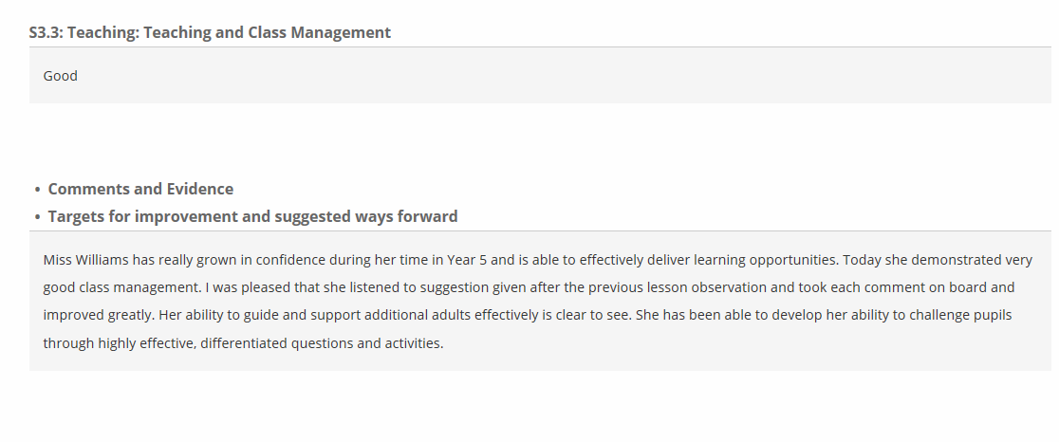
Appendix 2

Appendix 3
Model Beirniad Wedi Adfyfyrio (BWA)
Assisted Reflective Conclusions (ARC) Model
Dyddiad/Date: 15th November 2017
Digwyddiad critigol (Ffocws)/Critical incident (focus): Indian animal art.
Profiad/ Experience

Teimladau/  Feelings  Beth yw eich teimladau ynghylch y profiad?  “What are your feelings regarding the experience?”  Cofio a Deall/  Remember and Understand  Allwch chi restru’r agweddau ar y profiad dysgu a aeth yn dda?  “Can you list the aspects of the learning experience that went well?”  Pa elfennau o’r profiad dysgi oedd yn siomedig?  “What were the elements of the learning experience that were disappointing?”  Gwerthuso a dadansoddi/  Evaluate and analyse  Beth fyddwch chi’n cadw’r un fath i sicrhau dysgu ac addysgu effeithiol yn y dyfodol?  “What will you keep the same to ensure effective teaching and learning in the future?”  Beth oedd achos yr elfen siomedig bwysicaf?  “What was the cause of the most important disappointing element?”  Casgliadau a chamau gweithredu/  Conclusions and actions  Beth yw eich atebion posibl i’r materiaon siomedig a nodwyd?  “What are your possible solutions to the disappointing issues identified?”  Beth ydych yn mynd i’w wneud nesaf?  “What will you do next?” | Today I felt confident and excited to teach the whole class for most of the day. I had all my lessons prepared with the resources printed out before I went into school so all I had to do was prepare the classroom during break times.  My final lesson of the day was Art and we were creating an Indian animal. I laid the room out beforehand so I had all the resources ready and I had different photographs of animals printed and cut out so they can look at them while creating their animal. I allowed the children to decide what they used to create their animal, there was an option to draw, paint or sculpt their animal.  Miss Evans’ group were painting animals using spot painting, the feedback received from the pupils and teacher were positive and the group were thoroughly engaged.  For this lesson I only had half the class in the art room, this was just enough room for them all, if I had the whole class there wouldn’t be enough room for them to work. Some of the boys in the last 5 minutes got a bit silly because they had finished their work and we were waiting to go back to class. To control this, I had them to help clean the room.  Reflecting on this lesson I have realised how pupils were resistant to mix different mediums and I had to reinforce how this is allowed and to be as creative and original as they pleased. Even though there were some photographs of artistic examples of animal art looking back I could have created my own or recreated some so they were able to see it in three-dimensional form. Allowing them the opportunity to see that the different shapes and textures involved.
Y profiad newydd / Transformed experience

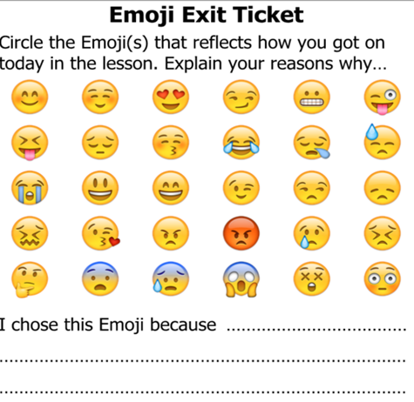
Appendix 4

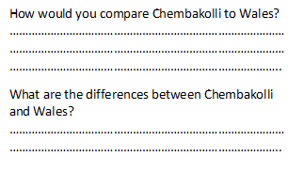

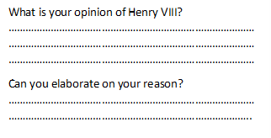
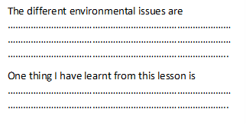

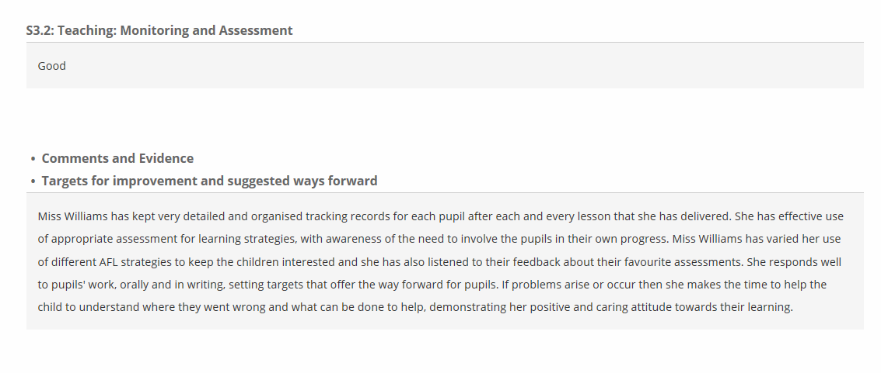
Appendix 5

Appendix 6
Model Beirniad Wedi Adfyfyrio (BWA)
Assisted Reflective Conclusions (ARC) Model
Dyddiad/Date: 21st November 2017
Digwyddiad critigol (Ffocws)/Critical incident (focus): Research lesson.
Profiad/ Experience

Teimladau/  Feelings  Beth yw eich teimladau ynghylch y profiad?  “What are your feelings regarding the experience?”  Cofio a Deall/  Remember and Understand  Allwch chi restru’r agweddau ar y profiad dysgu a aeth yn dda?  “Can you list the aspects of the learning experience that went well?”  Pa elfennau o’r profiad dysgi oedd yn siomedig?  “What were the elements of the learning experience that were disappointing?”  Gwerthuso a dadansoddi/  Evaluate and analyse  Beth fyddwch chi’n cadw’r un fath i sicrhau dysgu ac addysgu effeithiol yn y dyfodol?  “What will you keep the same to ensure effective teaching and learning in the future?”  Beth oedd achos yr elfen siomedig bwysicaf?  “What was the cause of the most important disappointing element?”  Casgliadau a chamau gweithredu/  Conclusions and actions  Beth yw eich atebion posibl i’r materiaon siomedig a nodwyd?  “What are your possible solutions to the disappointing issues identified?”  Beth ydych yn mynd i’w wneud nesaf?  “What will you do next?” | For my second lesson of the day I had my first observation. This lesson was researching information about Chembakolli ready to write their report tomorrow. At the beginning of the day this was a worry because all of the computers in the school were down which effected my lesson greatly, but they were working by my lesson. However, I had planned the lesson where they could still participate and find information offline if this was to happen. At lunch time I made sure each laptop logged on and had internet ready so I wouldn’t have any problems in my lesson. Through the lesson 1 laptop did stop working but we had the main class laptop free for that pair to work on.  Through this task I had them working in pairs, which was my target from last week that I recorded in my end of week review, which I carefully paired to get a high standard of work from. Yesterday we did have a new girl join our class which I had to try and work out who she would work well with at last minute and they did work well, even though there was a bit of a disagreement at first.  Before my lesson I told everyone who their pair was and what table they will be on, this worked well in my favor and they all managed to remember with no problems.  To improve my lesson, I should have had some texts, or looked at some websites beforehand, to make sure some of the headings had some understandable information for them to find. There were some problems with finding some information about culture and landscape so instead they wrote about life style or changed their headings.
Y profiad newydd / Transformed experience

Appendix 7
Classroom layout
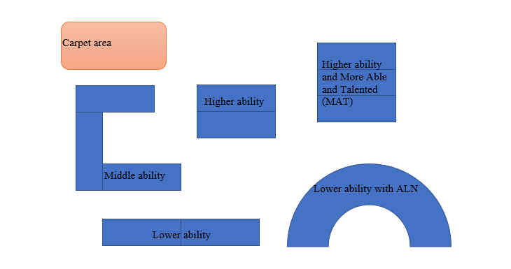
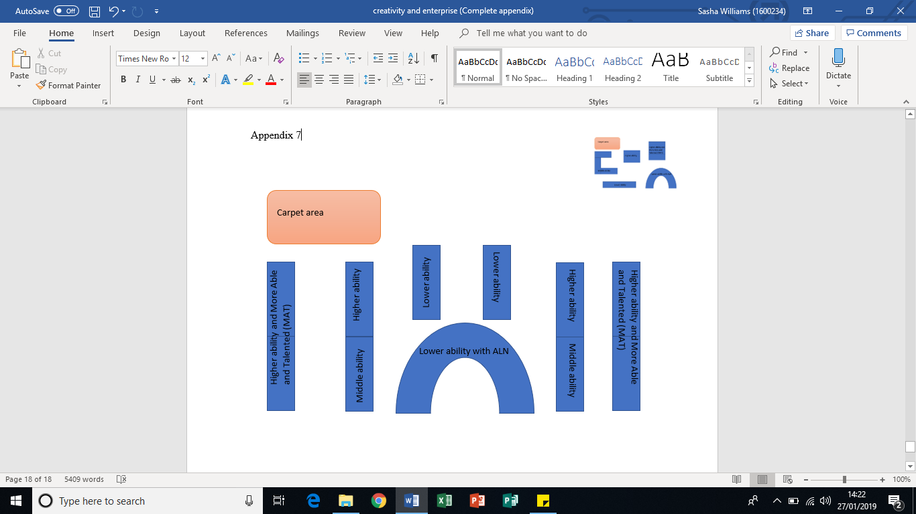
‘The court room’ classroom layout for the persuasion debate

