

Reflective Portfolio
  - Professional career development
Emma Strawford | BMSW4005 | Farah Islam
Contents
Introduction 2
SWOT Analysis and Personal Development Plan 3
What skills are needed to be a good midwife and a matron. 5
Assessing the concepts, I have learnt 7
Conclusion 9

Introduction
In this reflective portfolio I will be writing about SWOT analysis and how a personal development plan has helped me recognize my strengths and weaknesses. I will also be writing about career development and how this process of learning has helped me recognize the skills I need to progress to better job roles.
I will also be writing about in this portfolio my chosen career and what skills are needed to be an effective manager in my career choice.
I will assess the concepts I have leaned which will include SMART, the UK Employment Law, learning theories and self-awareness methods.

SWOT Analysis and Personal Development Plan
SWOT stands for strengths, weaknesses, opportunities, and threats. Swot Analysis was introduced by Albert Humprey in the 1960’s. It is a good way to understand and breakdown key factors the in four aspects. I will apply a Swot analysis to myself and my career.
My Swot Analysis
Strengths  Ambitious  Team Player  Good People Skills  Caring | Weaknesses  Self-Criticism  Overthinker  Try to please everyone  Public Speaking
Opportunities  Increased student enrolment  More midwifes needed since covid  Placements while learning at university  Professional Development | Threats  Competition to enroll onto the midwifery course  Negative press regarding the immunizations for NHS staff
“SWOT is a convenient tool at the evaluation stage in order to gain an initial idea of possible future consequences. The SWOT analysis is a simple analysis method that can provides a realistic interpretation of the strengths and weaknesses of a business. As well as, it helps in having an overview of differences between the actual and future plan and analyses the current competition situation” (Benzaghta et al, 2021, p,58).
My Personal Development Plan
A PDP is an action plan where you can self-evaluate and reflect on things you want to achieve in life e.g., career or education. I feel that a PDP can set clear goals and will help identify strengths and weaknesses and can keep track on your goals and how to achieve them.
I have created a PDP plan for myself and for my ongoing career.

Personal Target | How will I achieve this? | How will this improve my employability prospects? | How will I know that I have achieved this? | When will I achieve this by?
1. Becoming a midwife | Completing midwifery BSc (Hons) course | It will improve my employability by 100% | I will have achieved this by graduating. | Course starts in January 2022 as is for 3 years
2.Progressing onto Neonatal | Neonatal Training | Can become a Neonatal nurse | By completing necessary training | 6 months of training
3. Matron | Have experience as a nurse. | It will improve 100% | Learning and gaining experience. | 3-5 years’ experience as a nurse or midwife.

“A PDP is able to reflect on the past and adopt a future orientation is certainly among the main advantages. It can in addition serve both summative and formative purposes. In the first instance, a PDP functions as a learning assessment tool. Gaining vital insight which can help improve performance is the main characteristic of its formative guise. Those who use a PDP voluntarily are inclined to view it in this respect. On the contrary, mandatory PDPs seem to be more summative in nature” (Greenan, 2016, p.322).
Both analysis tools will help me in achieving my goals in my career and I can reflect on what I have achieved and what I need to do to get to the achieve my next goal.

What skills are needed to be a good midwife and a matron.
I have always been fascinated with birth and how babies are born since I was a child, in fact that feeling has only gotten stronger since becoming a mom myself and feel that becoming a midwife would be so rewarding.
The skill set for being a midwife however is very particular as I believe its one of the most important job roles in the world. The most obvious being medical skills which include monitoring the baby’s heart rate, observing the baby’s position, and keeping track of the mothers and baby’s health. They also must administer medicines when necessary. All of these are the basics of medical skills which I would obtain from attending university and working alongside registered midwifes while on placement. Once I have acquired these skills and successfully put them into practice, I then would become a registered midwife. “To apply knowledge means to be able to put it into operation in order to help you to organise and make sense of your experiences. You should be able to use what you have learnt in university to enhance your learning during your placement” (Scanlan and Walker, 2013, p.81) Having these medical skills will ensure the care and safety of the mother and the baby. Being observant is another important skill, to observe I can act when needed, if I don’t observe then I will not know how many centimeters a mother is dilated and when she needs to push the baby out. With being observant comes patience, a mother could be labor for hours, so patience is important.
Midwives also need good communication skills and will listen and work to what the mother wants and needs during her labor having empathy towards the mother will help us listen with understanding. “Empathy is the ability to feel a continuing desire to understand … the client’s feelings and communications as they seem to him at that moment” (Sully and Dallas, 2010 p.9). A midwife is the main contact between a mother and her baby so a repour must be built quickly. A Midwife is responsible for the care of all parties involved so not only have they got to communicate with parents but also with health care professionals. If a midwife provides good communication, then trust can be built which will be vital to the quality and safety of care. A midwife will work towards strengthening a mother’s capabilities to care for themselves and their newborn.
Excellent people skills are a must as offering care to a huge diversity of women is a big responsibility. I will need to be assertive and be good at making quick decisions maybe in crucial moments, so having good people skills can be beneficial and vital for keeping mother’s calm. “It is important to remember the key elements of effective communication, since there may be differences when working across cultures. Factors to be considered include the language used and how it is delivered.” (Sully and Dallas, 2010, p.5)
With all these skills however I will need an ability to cope with distressing situations and will need to remain calm in stressful situations. I will need to be emotional and mentally strong to deal with these when necessary.
Using these skills and building on them and gaining experience I then could progress onto being a matron and sharing my experienced skillset with other midwives. Showing leadership ability has developed posts where there are now consultant midwives and practice development midwives. To fulfill these roles needs a different set of skills that include clinical and knowledge. A more senior role will need commitment in providing a quality service in women’s needs. They will also need to recognize potential next generation leaders and coach colleagues to other leadership roles. With the clinical skills and knowledge that a consultant midwife has gained they will need to support midwives in realizing their full potential and capability in supporting women through pregnancy and labor. “Nobody can teach you leadership. It is something you have to learn. You learn principally from experience. But experience or practice has to be illuminated by principles or ideas” (Adair, 2013, p.1).

Assessing the concepts, I have learnt
When setting goals and objectives its important to have a plan. Previously I have written about in my reflective portfolio that I have used SWOT analysis and a PDP plan to help me evaluate and reflect on these goals. While studying this module I have been learning concepts and tools that can help me produce a plan. One of those concepts is SMART Goals which stands for Specific, Measurable, Achievable, Realistic and Timely. This is a good guide to help goals become reachable. This guide can help answer questions like what do I want to achieve? Why is this goal important? And how realistic is the goal? I felt that when using this concept when planning my goals for my career that I have been more motivated and have a clearer focus on what I want to achieve. I also have a clear timeframe on when I want to achieve these goals. As time goes on, I will continue to use this tool to set future goals once I have achieved the ones I have set now. Breakdown of SMART goals consists of the following five characterizations: ‘specific – target a specific area for improvement; measurable – quantify or at least suggest an indicator of progress; assignable – specify who will do it; realistic – state what results can realistically be achieved, given available resources; and time-related – specify when the result(s) can be achieved’. Assignable is frequently swapped for attainable, which is one’s belief in whether or not the goal can be accomplished (Weintraub, Cassell and DePatie, 2021, p.230).
Another concept that I have learnt and enjoy is keeping a learning log. This is a good way to reflect on what I have learnt and look back on what I have achieved and to remind myself on how far I have come whist learning this module. As I continue my career, I will continue to use this so when I learn something new, I will keep a log so I can reflect. During this module we also had mock interviews to help us prepare when we have that important job interview, and I was very pleased with the feedback. I know from the feedback I have learnt that I will need to have references prepared upon request and not to just till silences with empty words so in the future these are things that I will improve on. “Preparation makes all the difference in whether you get the best offers as you face intense scrutiny, field probing questions, and reassure employers who are afraid of making hiring mistakes. You must show that you are tuned into the company’s needs, that you have skills to get up to speed quickly” (Kennedy, 2011, p.17).

We have also learned about self-awareness methods and one of favorite things is the Johari window. The Johari window is a psychological tool that was created by Joseph Loft and Harry Ingham in 1995 hence Johari. It looks at yourself and how you see yourself and how others see you. It improves your self-awareness, like how you trust others with information about yourself and how you learn things about yourself with feedback of other people. Here is an example of a Johari window.
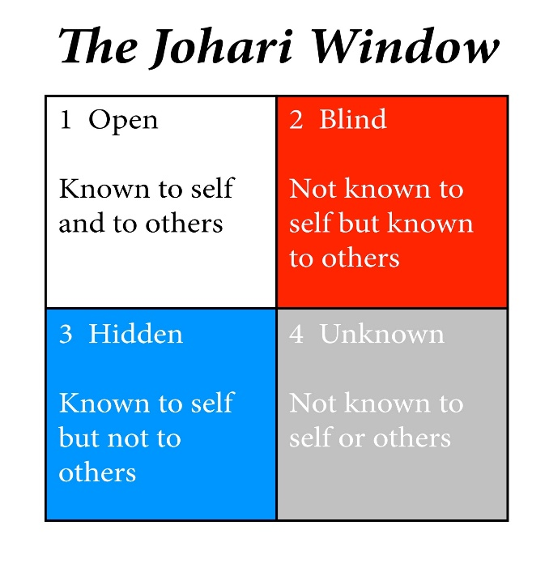
The first box is open which suggests what parts of your personality are open and known to yourself and others. For me the first box would be I want to be a midwife and people around me know this. The second box is blind what parts of your personality are not known to yourself but are known to others. For me others say I am stubborn, but I don’t think I am. The third box is hidden what parts your personality is known to self but not others. I wanted to be a dance teacher when I was younger but no one else knows this. Last box is unknown not known to self or others. For me I do not know if I will accomplish my goal of becoming a midwife neither do others. “The Johari window was originally designed to encourage self-awareness and communication about behavior. Rather than use it to investigate knowledge about ourselves as individuals, we have adapted it to analyse knowledge (and assumptions) about our world accrued from the perspectives open to different groups of people” (Oliver and Ducan, 2019, p.1).
As part of the self-awareness method, we also took part in some personality tests one of them called sixteen personalities and I was fascinated by the results as it fitted to who I was. It suggested that my personality trait was consul who was described as practical and caring and kind, these three things are key to who I am as a person.
We have also looked at the UK Employment Law and what it stands for. This law is important as regulates the relationship between employers and employees. It sets out rules of what employers expect of employees and what rights employees have at work. The things that covered by the law include recruitment, data protection, working times, discrimination, discipline and grievance, employment contracts, pay and holiday entitlement, health and safety and dismissals and redundancies. This law was designed to protect employees from exploitation. This law goes into detail of employments rules and regulations, rights on employment law statues, staff working hours, wages and taking time off work. It also applies to sickness, maternity leave, and holidays. It also acts as a safeguard against workplace discrimination. “Employment law is concerned with the relationship between employer and employee, this relationship is based legally on contract. There is generally an imbalance of power between the employer and the employee.” (Ross, 2010, p.1)

Conclusion
During this reflective portfolio I have understood and will continue to use a PDP plan. I will also continue to use a learning log while progressing with my career. I have also understood the skills needed to be a consultant midwife and what I need to do to be able to fulfill this role. I have also developed more self-awareness with the concepts of Johari window and personality tests and now I’m more aware of the UK Employment Law and what it stands for. This module has helped me where I am and where I need to be in the future with my career and I will take the skills and concepts I have learnt with me.

.

